Appendix
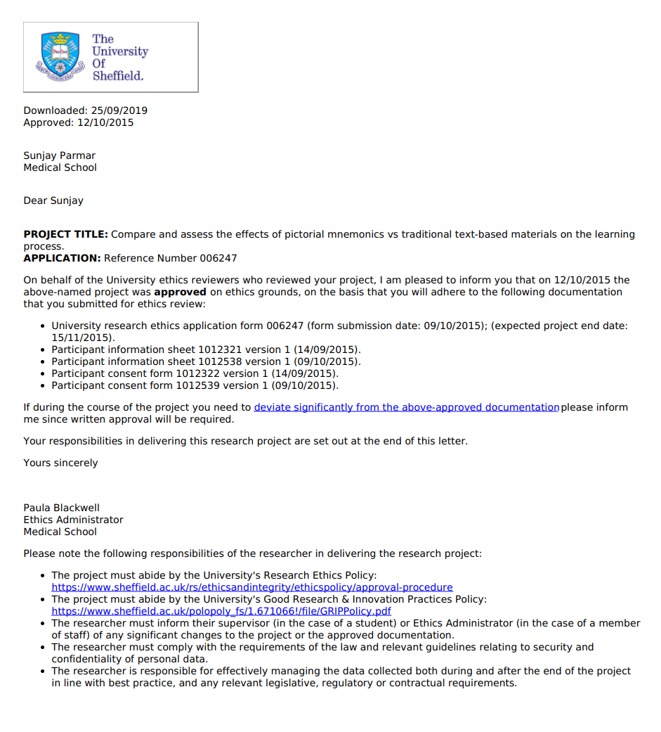
Appendix 1: Ethical Approval Confirmation

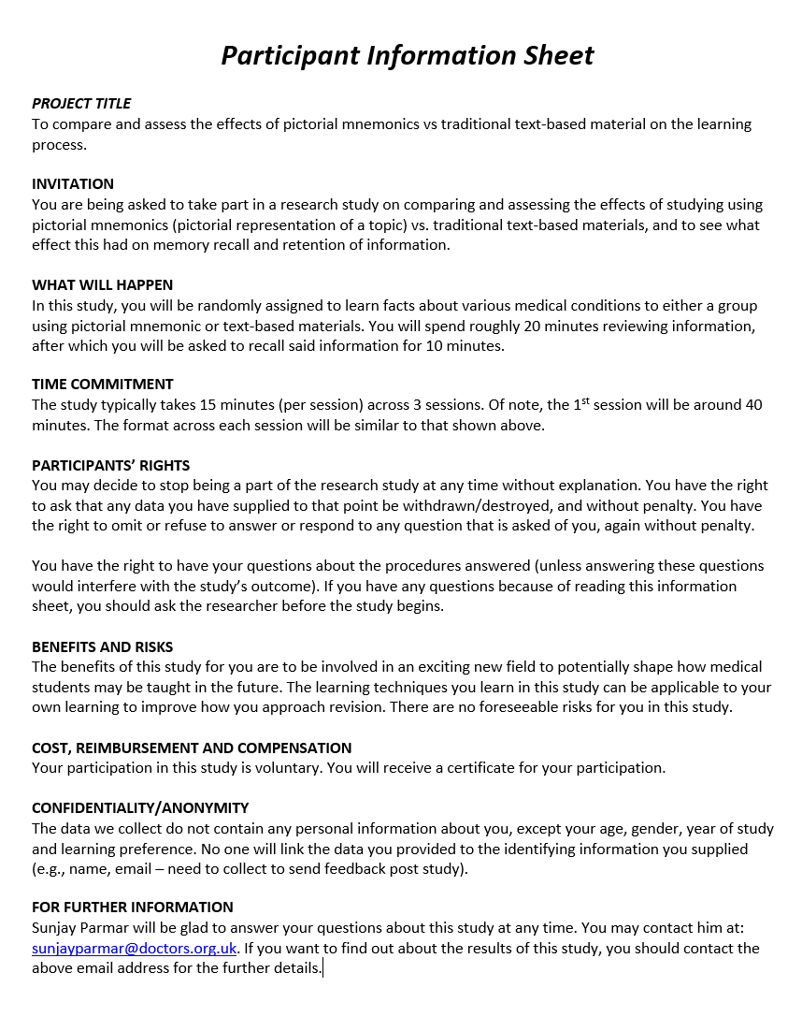
Appendix 2: Participant Information Sheet

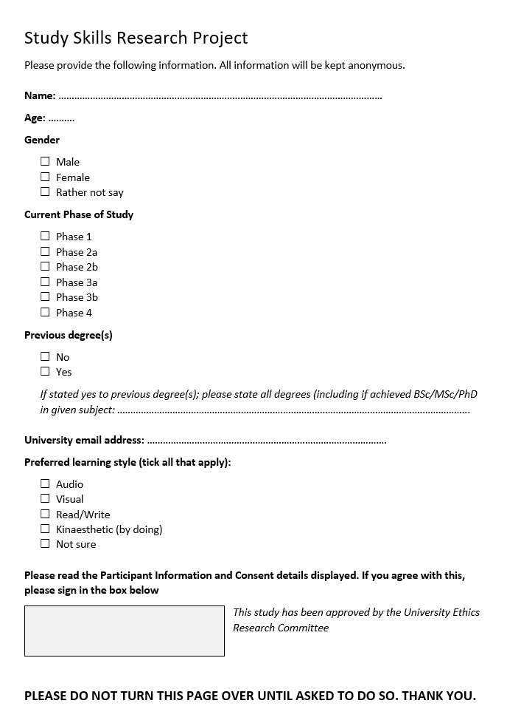
Appendix 3: Participant Signup Sheet

Appendix 4: Baseline test – free-recall
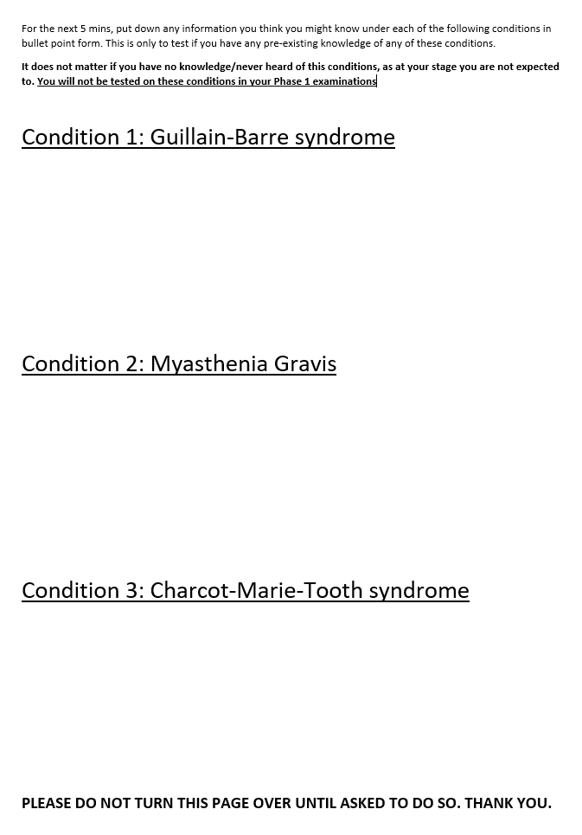
Subsequent recall sheets were similar to this except the heading order was switched around
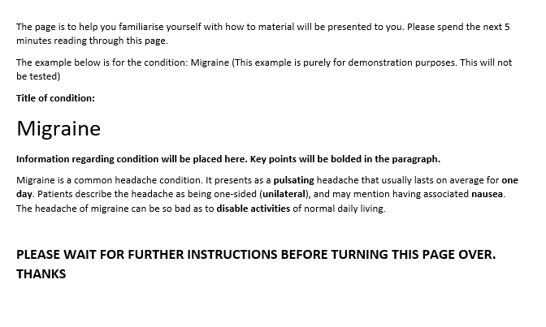
Appendix 5: Control group – Test Familiarisation exercise

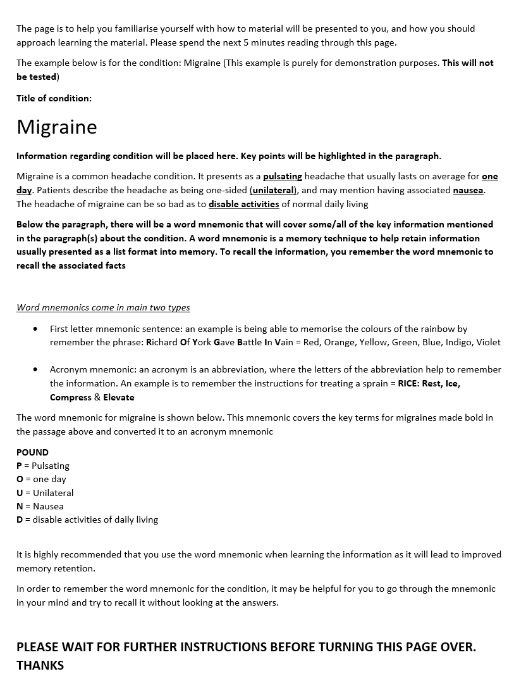
Appendix 6: Word mnemonic group – Test familiarisation exercise
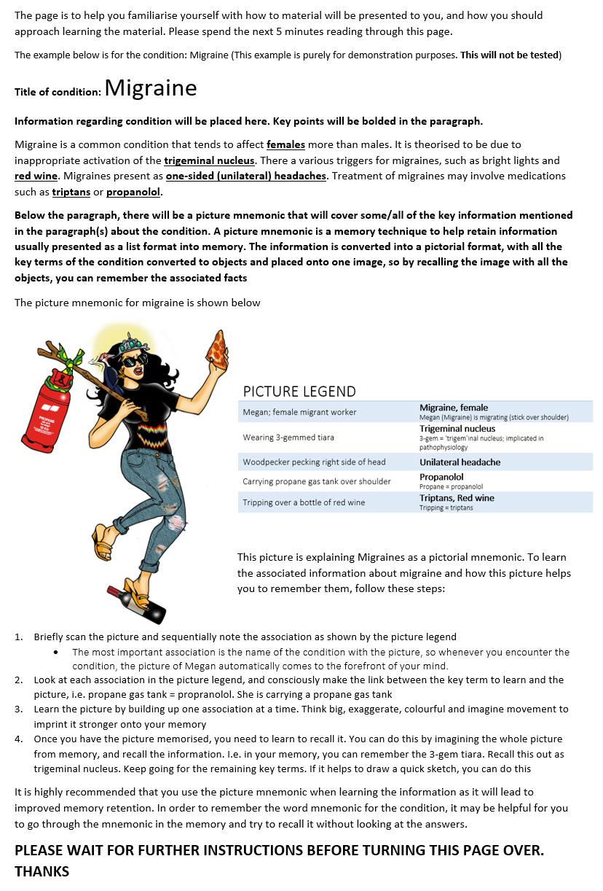
Appendix 7: Visual mnemonic group – Test familiarisation exercise
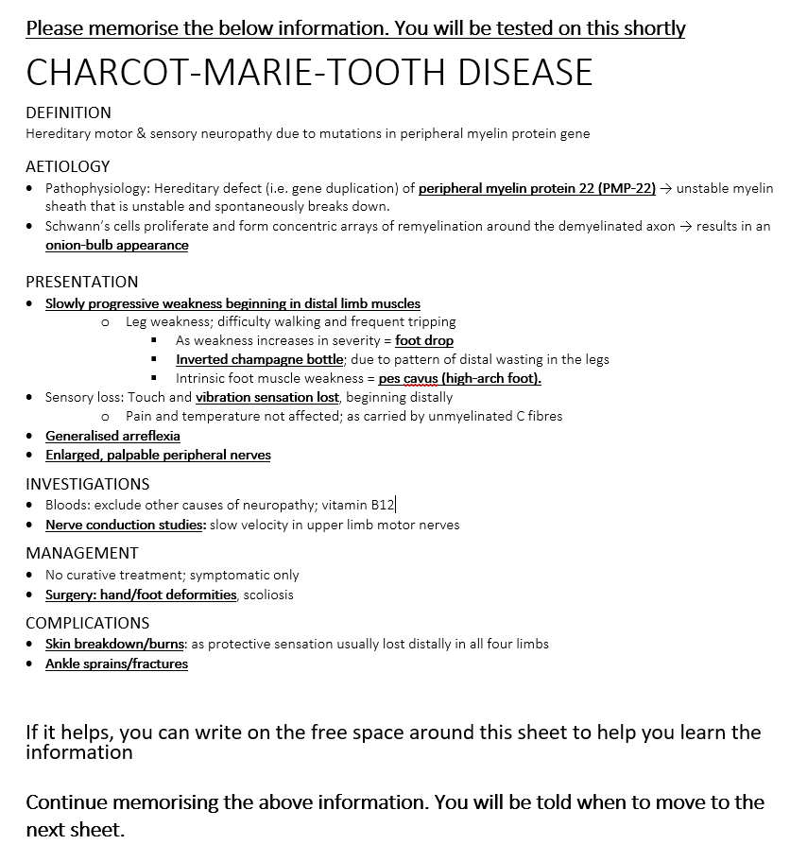
Appendix 8: Control group – Charcot-Marie-Tooth Disease

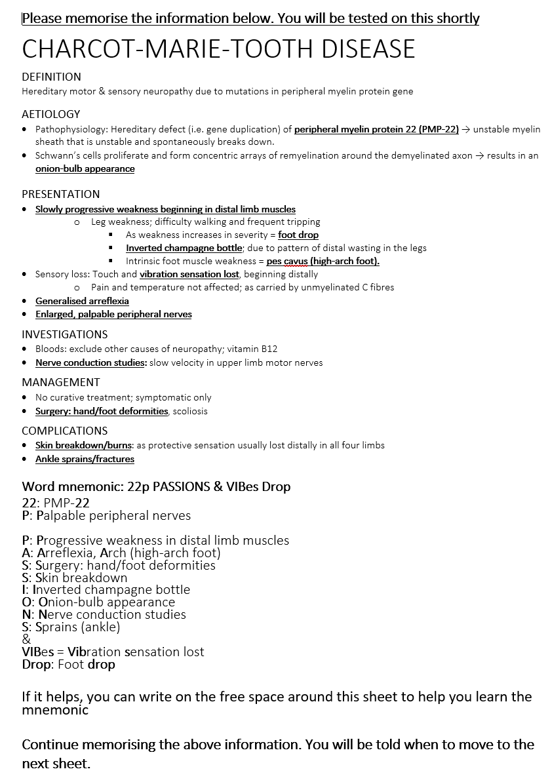
Appendix 9: Word Mnemonic group - Charcot-Marie-Tooth Disease
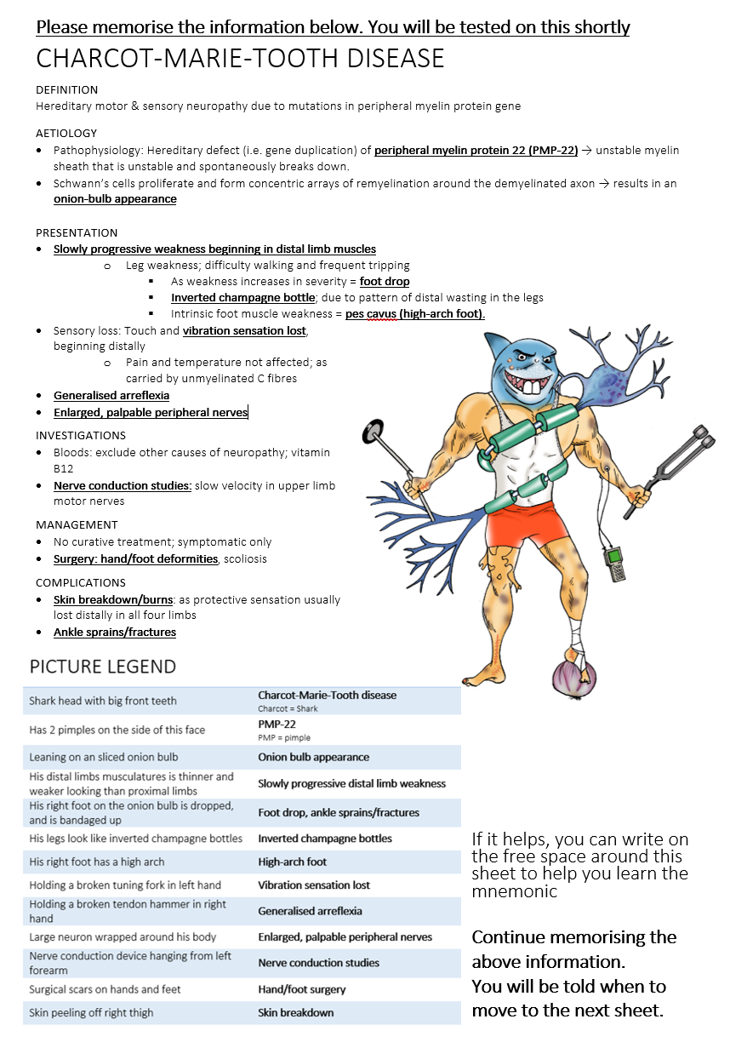
Appendix 10: Visual Mnemonic group - Charcot-Marie-Tooth Disease
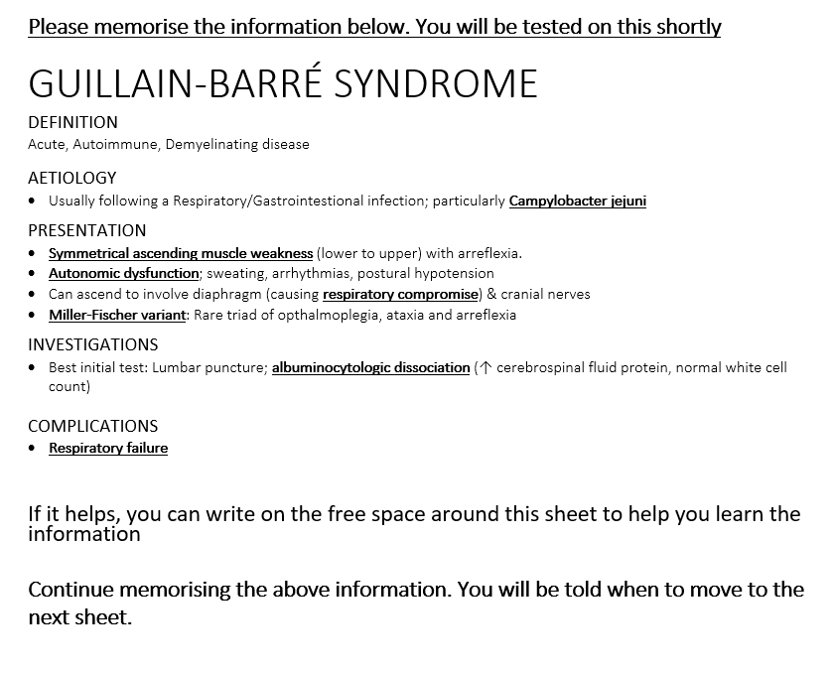
Appendix 11: Control group – Guillain-Barre Syndrome

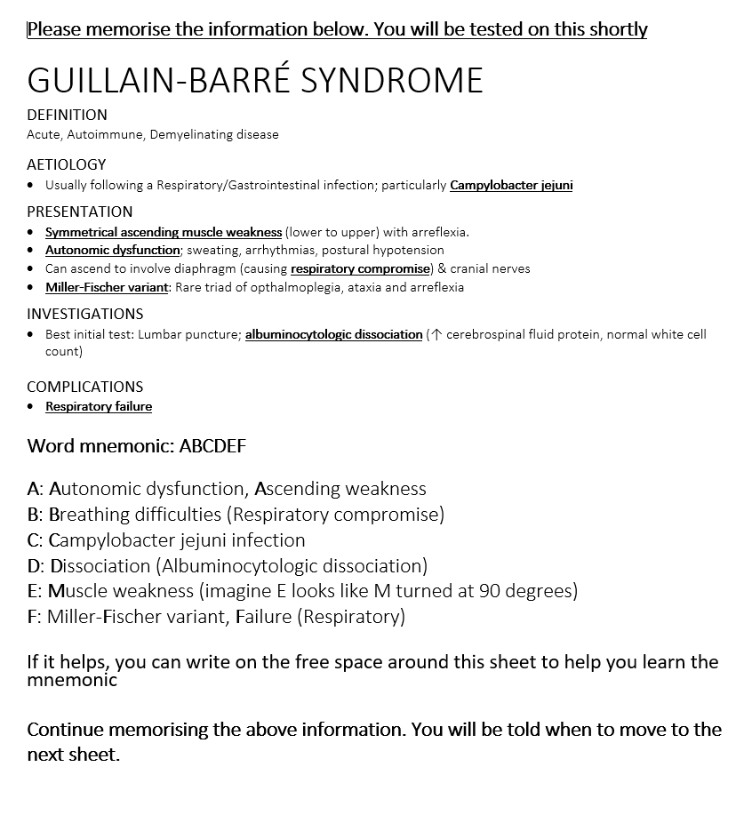
Appendix 12: Word Mnemonic Group – Guillain-Barre Syndrome

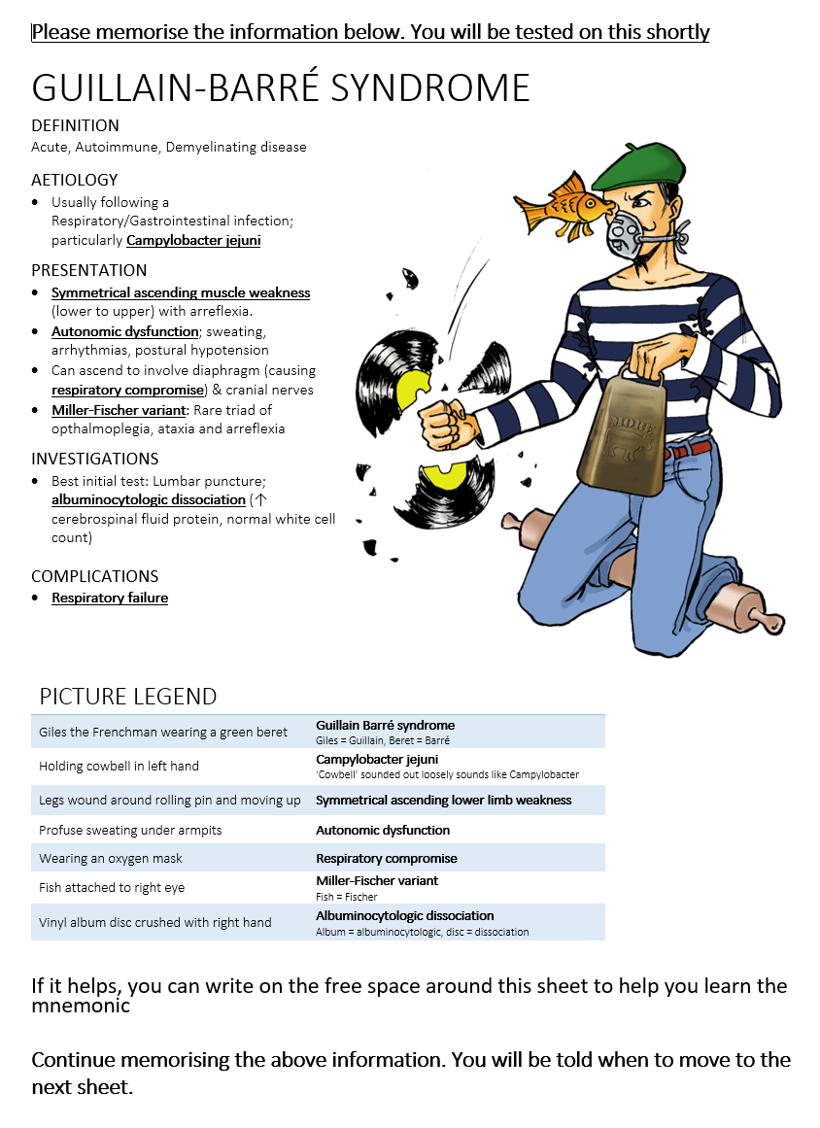
Appendix 13: Visual Mnemonic Group – Guillain-Barre Syndrome
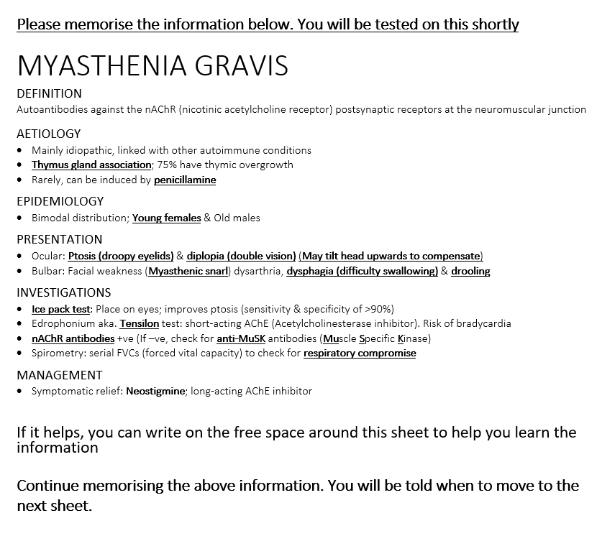
Appendix 14: Control group – Myasthenia gravis

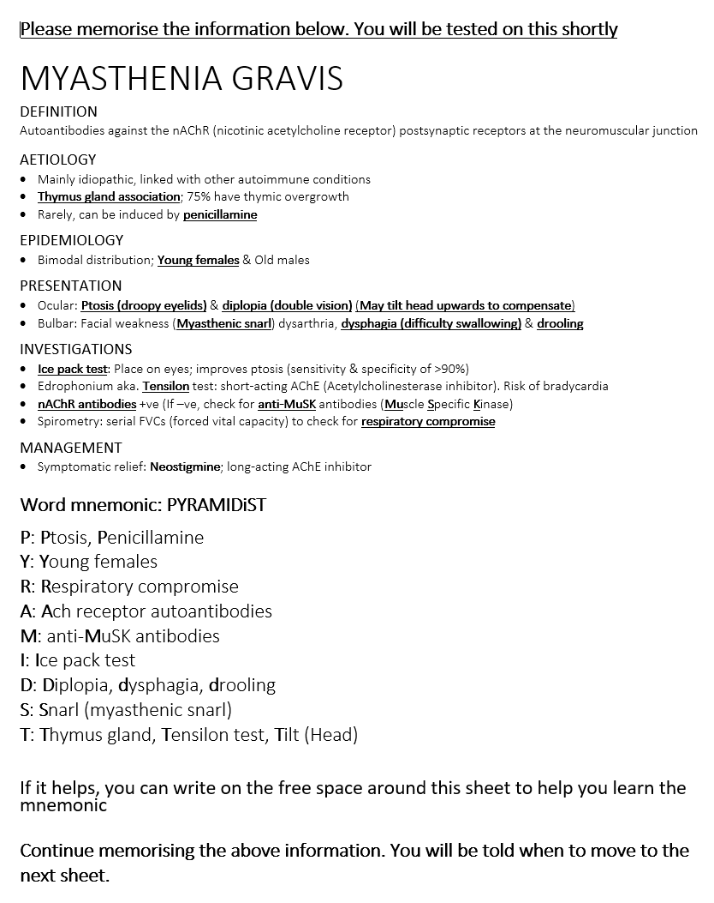
Appendix 15: Word Mnemonic group – Myasthenia gravis

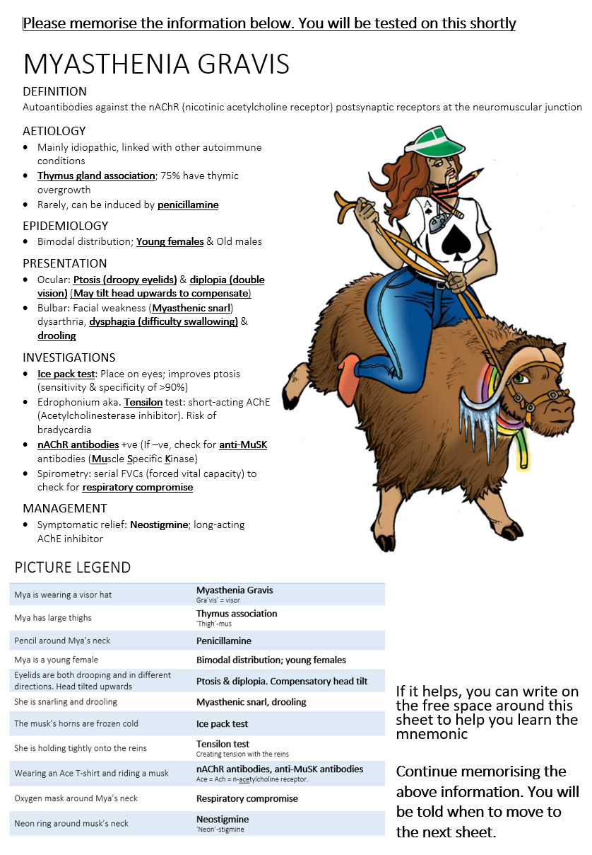
Appendix 16: Visual Mnemonic group – Myasthenia gravis
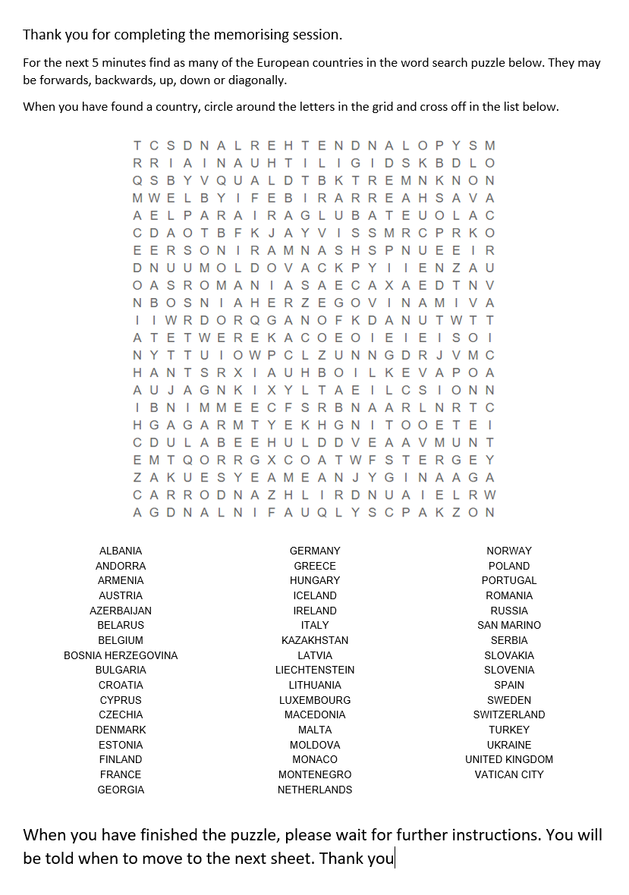
Appendix 17: Post-memorisation word search distraction test
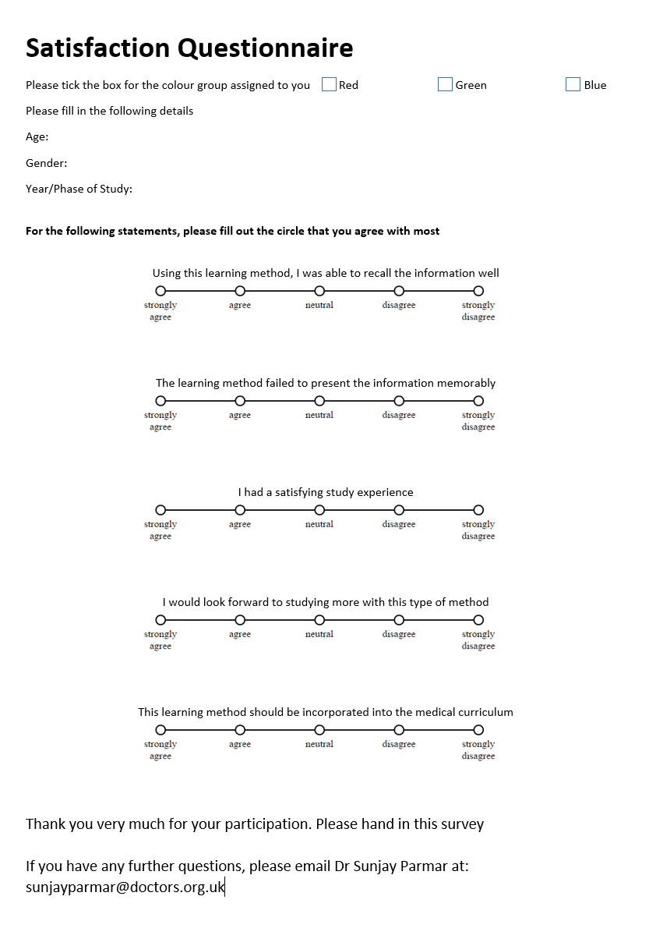
Appendix 18: Satisfaction questionnaire
Appendix 19: Statistical Analysis Breakdown
Tables 19A to 19E show the ANOVA and post-hoc analysis for each group across time
Time-point ANOVA Results By Group
Group | n | F-Statistic | df1, df2 | p-value
Control | 18 | 20.966 | 2, 35 | 0.00003
Visual | 19 | 45.895 | 2, 35 | <0.00001
Word | 19 | 18.192 | 2, 35 | 0.00008

Table 19A: ANOVA results for each group looking at how time-points affect recall ability
Tukey’s HSD Results For Each Group
Group | Mean (SD)
Control
Immediate* | 8.64 (6.67)
1-week | 4.18 (5.15)
1-month | 3.27 (4.86)
Visual
Immediate* | 20.92 (4.80)
1-week | 11.33 (5.33)
1-month | 11.00 (5.88)
Word
Immediate* | 11.20 (7.93)
1-week | 4.73 (4.77)
1-month | 3.33 (2.69)

Table 19B: Post-hoc analysis for each group looking at which time-points were significantly different.
* – Time-points with a significant difference for each group. Time-points without * are not significant for any group

Group ANOVA Results By Time-point
Time-point | n | F-Statistic | df1, df2 | p-value
Immediate | 56 | 13.197 | 2, 53 | 0.00002
1-week | 44 | 8.294 | 2, 53 | 0.00074
1-month | 38 | 4.322 | 2, 53 | 0.0182

Table 19C: ANOVA results at each time-point to see if being in a particular group affects recall

Tukey’s HSD Results For Each Time-point
Group | Mean (1 S.D)
Immediate
Control | 8.64 (6.67)
Visual* | 20.92 (4.80)
Word | 11.20 (7.93)
1-week
Control | 4.18 (5.15)
Visual* | 11.33 (5.33)
Word | 4.73 (4.77)
1-month
Control | 3.27 (4.86)
Visual* | 11.00 (5.88)
Word | 3.33 (2.69)

Table 19D: Post-hoc analysis at each time-point looking at which group(s) were significantly different.
* – Group with a significant difference at each time-point. Groups without * not significant at any time-point

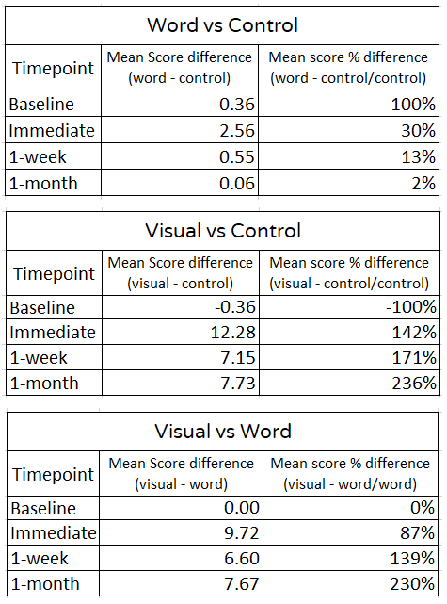

Table 19E: Mean score percentage differences between all groups at various time-points

Appendix 20: Satisfaction questionnaire responses
Figures 20A to 20E show the modal response for each statement on the satisfaction questionnaire.

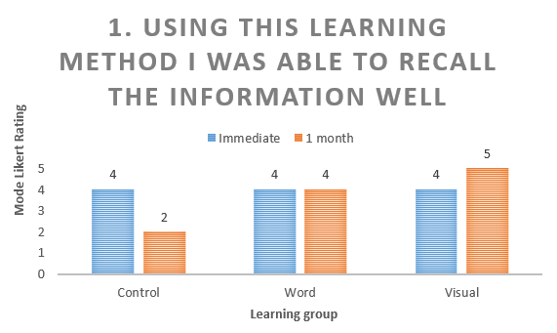

Figure 20A: Satisfaction questionnaire response to “Using this learning method, I was able to recall the information well”
Interestingly, at immediate testing, all groups agreed with this statement equally. However, at 1 month, the control group disagreed with this statement, while the word mnemonic group continued to agree and the visual mnemonic group strongly agreed with this statement. This change from agreeing to strongly agreeing is subtle but may highlight that the students in the visual mnemonic group genuinely felt surprised that one month after memorisation, they were able to recall as much information as they did.

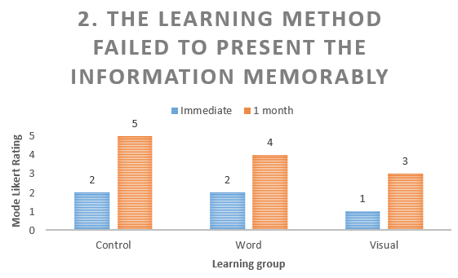

Figure 20B: Satisfaction questionnaire response to “The learning method failed to present the information memorably”
This is generally an inverse statement to the former but focuses more on the presentation of the information. On immediate testing, both the control and word mnemonic groups disagreed with this, while the visual mnemonic group strongly disagreed. At 1 month, the control group strongly agreed with this statement, correlating with the responses on the previous chart. The word mnemonic group agreed with this statement, and the visual mnemonic group were neutral. This neutral finding is interesting and would warrant further clarification. I did not include any free-text responses in the satisfaction survey, but in hindsight, this may have helped to obtain a deeper understanding.

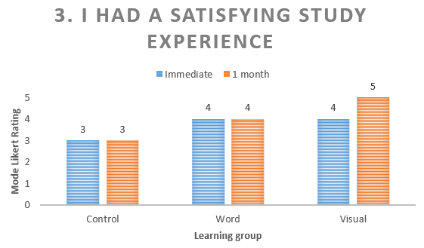

Figure 20C: Satisfaction questionnaire response to “I had a satisfying study experience”
The control and word mnemonic groups had no difference from neutral to agree at all time-points respectively. The visual mnemonic group increased from agreeing at immediate testing to strongly agreeing at 1 month. This may be explained by the satisfaction of being able to recall a larger amount of information than they may have thought. This statement is anchored in the present and is important to help understand the continued motivation to study with a given method.
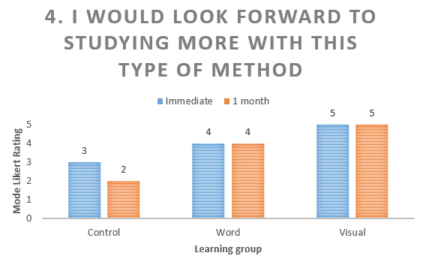

Figure 20D: Satisfaction questionnaire response to “I would look forward to studying more this type of method”
This statement makes the learner look to the future and consider long-term motivation to continue using a particular learning method. The control group decreased from neutral to disagree with this statement at 1 month. The word mnemonic group continued to agree, while the visual mnemonic group strongly agreed with this statement.

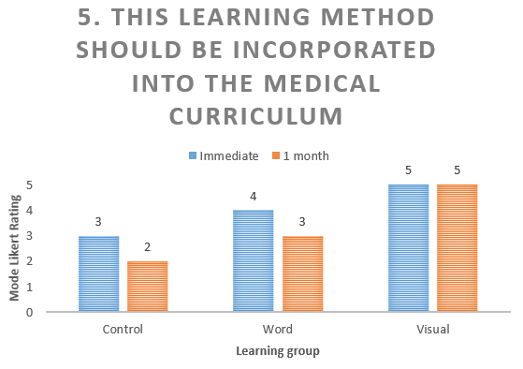

Figure 20E: Satisfaction questionnaire response to “This learning method should be incorporated into the medical curriculum”
In both the control and word mnemonic groups, there was a reduction in rating to disagree and neutral respectively at 1 month. The visual mnemonic group continued to strongly agree that visual mnemonics should be incorporated into the medical curriculum. This last statement has a lot of weight, as using learning methods that students themselves want to use might suggest they engage more with it.

