Supplementary information
Aharonov-Bohm interference and the evolution of phase jumps in fractional quantum Hall Fabry-Perot interferometers based on bi-layer graphene
Jehyun Kim¹, Himanshu Dev¹, Ravi Kumar¹, Alexey Ilin¹, André Haug¹, Vishal Bhardwaj¹, Changki Hong¹, Kenji Watanabe², Takashi Taniguchi³, Ady Stern¹, and Yuval Ronen¹*
¹ Department of Condensed Matter Physics, Weizmann Institute of Science, Rehovot, Israel
² Research Center for Functional Materials, National Institute for Materials Science, Tsukuba, Japan
³ International Center for Materials Nano architectonics, National Institute for Materials Science, Tsukuba, Japan
* Corresponding author: yuval.ronen@weizmann.ac.il

Supplementary Section 1: Device characterization
Supplementary Section 2: QPCs characterization
Supplementary Section 3: V_{CG} dependence of the interference at IQHE
Supplementary Section 4: V_{CG} dependence of the interference at FQHE
Supplementary Section 5: Gate tunable AB interference
Supplementary Section 6: Trajectory dependence of 1/3 interference
Supplementary Section 7: Constant density/filling in the reservoirs/interference area
Supplementary Section 8: Phase slips
Supplementary Section 9: Extracting the values of phase slips from 1D-FFT
Supplementary Section 10: AB interference at ν = - 1/3 fractional filling

Supplementary Section 1: Device characterization
Fig. S1a shows the optical microscope image for one of our FPI devices, fabricated at the same batch. One of the widely used methods to characterize the quality of a device is measuring its mobility. Devices with high mobility are required to observe fractional quantum Hall states, thus, we perform the mobility analysis on another Hallbar device fabricated in a similar condition, by measuring the four-probe resistance R_{xx} as a function of V_{BG} while applying 10 nA at 30 mK (B = 0 T). The measured R_{xx} is fitted with the equation as follows ¹,
$R_{xx}= \frac{L}{Weμ\sqrt{n_{0}^{2}+{(\frac{C_{BG}(V_{BG}-V_{DP})}{e})}^{2}}}$ (S1)
where n₀ is the intrinsic carrier concentration induced by the charged impurity, C_{BG} is the capacitance per unit area of the bottom graphite gate, V_{BP} is the voltage corresponding the charge neutrality point, and L, W, µ, and e are the length between the two probe contacts, width of the channel, mobility, and electron charge, respectively. We extract ~240,000 cm²/Vs mobility, high enough to observe the fractional quantum Hall states, and $n_{0}=1.8×{10}^{9} {cm}^{-2}$, reflecting the low charged impurity density in our FPI devices ^{1,2}.
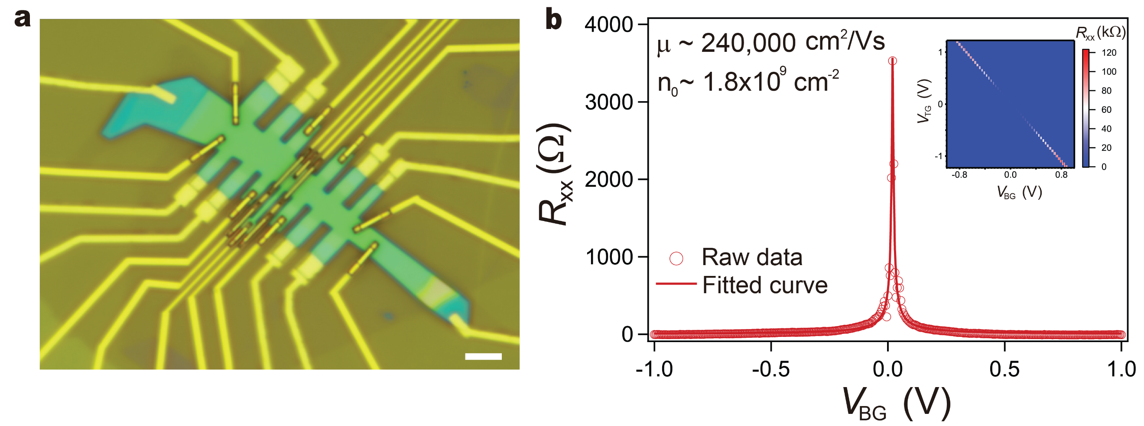
Fig. S1 | Mobility analysis. a, Optical microscope image of a bilayer graphene-based FPI. Scale bar indicates 5µm. b, Four probe resistance R_{xx} measured as a function of V_{BG} while applying 10 nA at 30 mK under 0 T. All top graphite gates are set to 0 V. Inset: R_{xx} measured in V_{TG}-V_{BG} plane where displacement field is generated in a bilayer graphene.
Supplementary Section 2: QPCs characterization
In this section, we describe the characterization of the left and right QPC (L/RQPC) in both IQHE and FQHE. Two air bridges (L/RBG) are employed to control the transmission of the QPCs’ separately. Forming each of the QPCs (LQPC or RQPC) separately, we can tune the voltage applied on L/RBG to control the density of each QPC region, thereby tunning the QPCs’ transmission given by $t_{L or R}=G_{D}\frac{h}{ⅇ^{2}}$ where the diagonal conductance $G_{D}=\frac{1}{R_{D}}$.
To form LQPC (RQPC), the filling factors are set to 0 beneath LSG (RSG) and PG regions. Fig. S2a and S2b show LQPC (RQPC) characterization measured with G_{D} as a function of V_{LBG} (V_{RBG}) in the condition where ν beneath LR/G, CG, and RSG (LSG) is set to ν=1, for Fig. S2a, and ν=2 for Fig. S2b while applying 500 pA of I_{SD} under 12 T, clearly showing the QPC partitioning probed by step-like behavior with the plateaus indicating that IQHE edges are fully transmitted across the QPC. In the measurements in Fig. 2 of the main text, t_{L} and t_{R} are set to ~0.5 for the interference of LL1, and ~1.5 for the interference of LL2, respectively.
Fig. S2c and S2d also show similar LQPC (RQPC) characterization measured at the condition where ν beneath LR/G, CG, and RSG (LSG) is set to 1/3 while applying 50 pA of I_{SD} under 12 T for Fig. S2c and 10.5 T for Fig. S2d, respectively. One distinct feature which is not observed in Fig. S2a-b is many peaks emerging on the plateau, which may be attributed to FQHE edges vulnerable to the charge disorder near QPCs saddle point and etched trenches. In the measurements in Fig. 3 and 4 of the main text, t_{L} and t_{R} are set to ~0.75 and ~0.95, respectively.
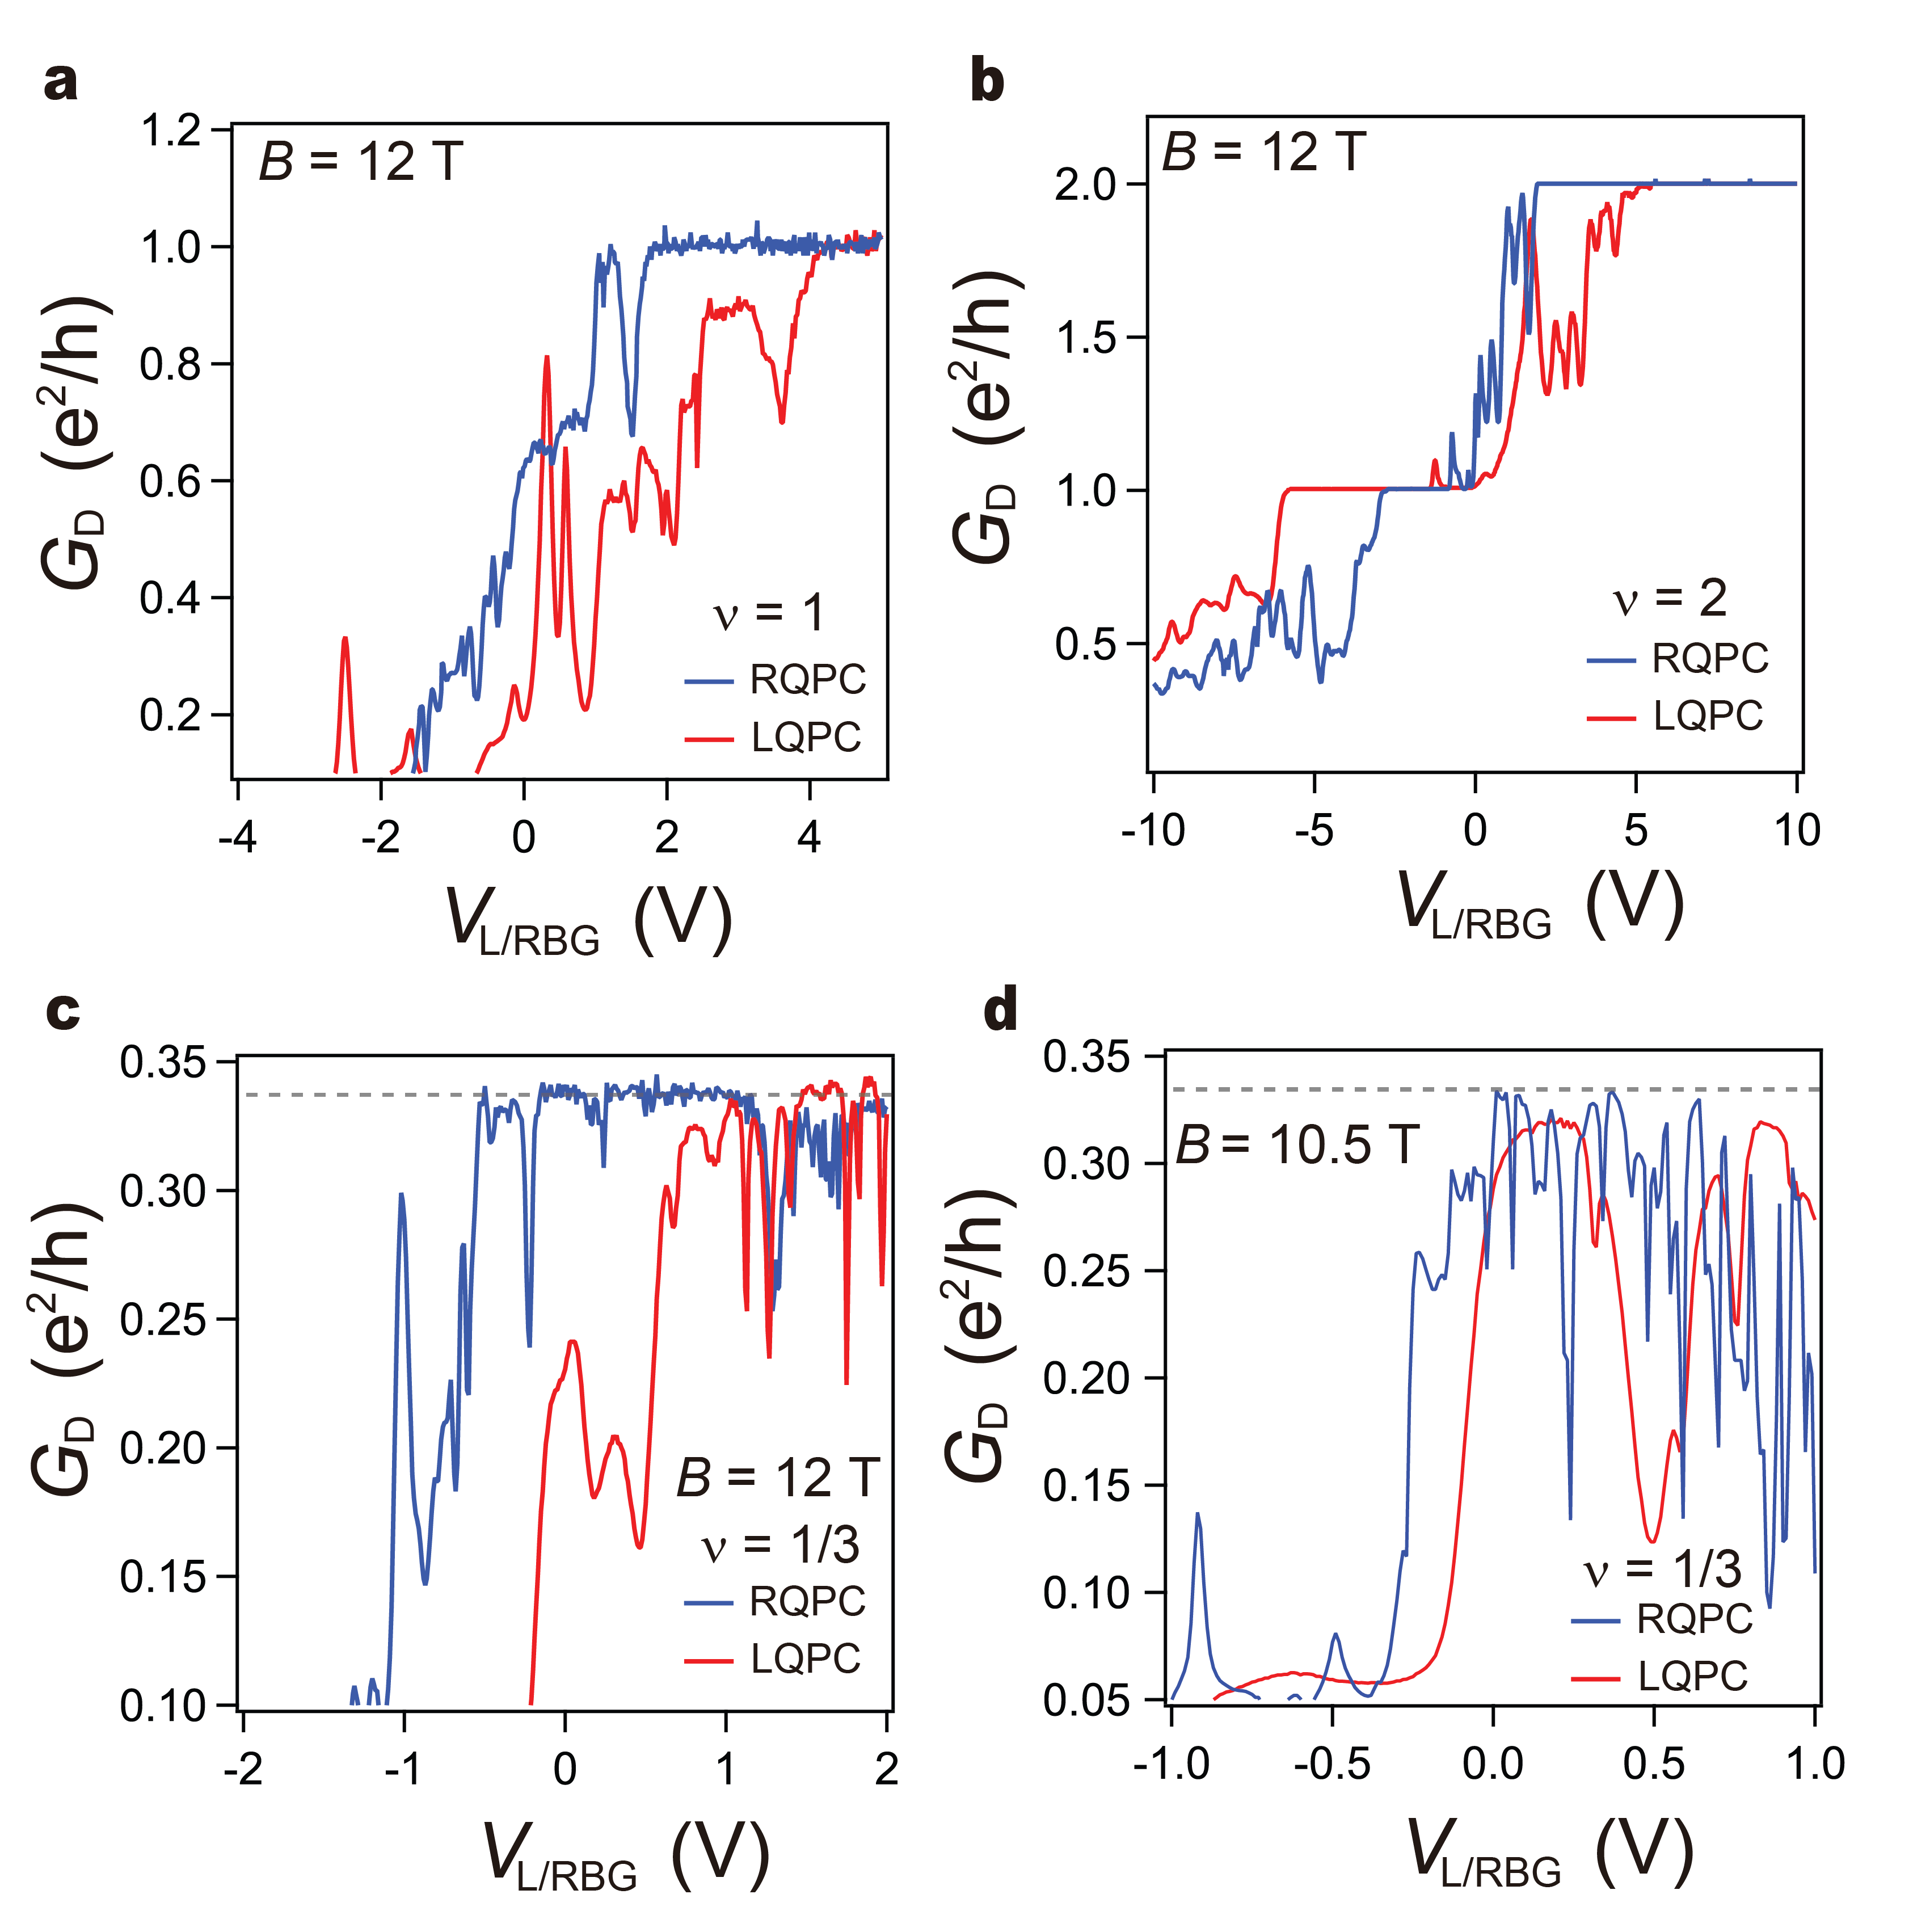
Fig. S2 | QPCs characterization in the IQHE and FQHE. a-d, Diagonal conductance G_{D} for LQPC (red) and RQPC (blue) as a function of either V_{LBG} or V_{RBG} at different filling factors. (a) ν = 1 at 12 T. (b) ν = 2 at 12 T. (c) ν = 1/3 at 12 T. (d) ν = 1/3 at 10.5 T. Note a single ground is employed in these measurements.

Supplementary Section 3: V_{CG} dependence of the interference at IQHE
We present all the 2D pajama plots and the corresponding 2D-FFT results used for analyzing V_{CG} dependence of the LL1 and LL2 interference shown in Fig. 2 of the main text. Fig. S3 (S5) and S4 (S6) show 2D pajama of R_{D} as a function of B and V_{PG} measured at different V_{CG}, and the corresponding 2D-FFT, relevant to the interference of LL1 (LL2). Note that 2D pajama at V_{CG} = 0.2 V in Fig. S3b shows the intermediate regime between CD and AB regimes where the phase of the oscillating R_{D} is not stable.
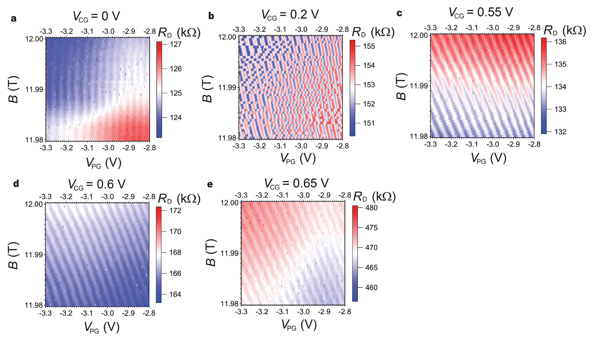
Fig. S3 | V_{CG} dependence of LL1 interference. a-e, Oscillating R_{D} as a function of B and V_{PG} at different V_{CG}.
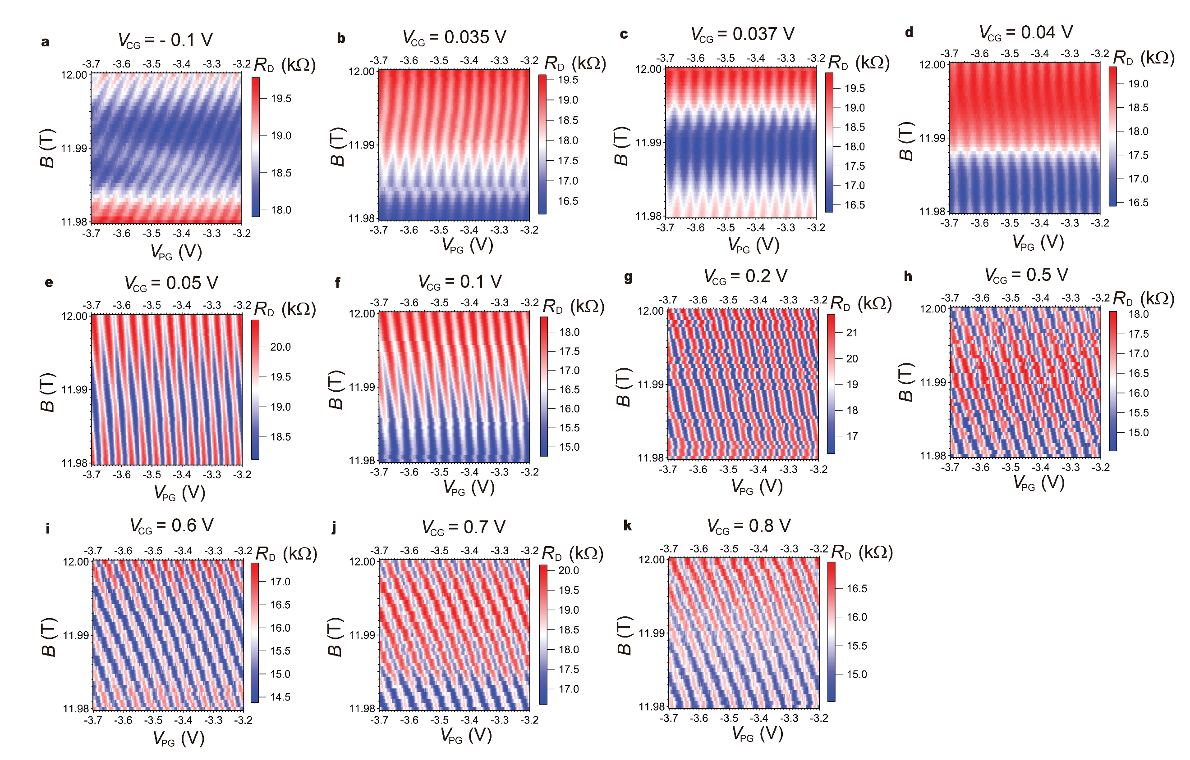
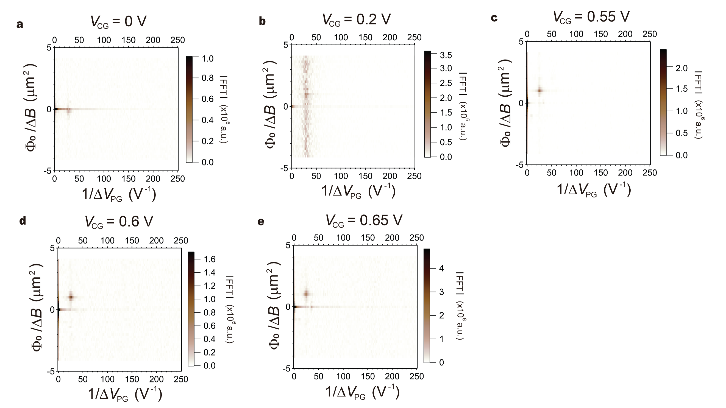
Fig. S4 | 2D-FFT analysis on V_{CG} dependence of LL1 interference. a-e, 2D-FFT corresponding to Fig. S3 a-e, respectively.

Fig. S5 | V_{CG} dependence of LL2 interference. a-k, Oscillating R_{D} as a function of B and V_{PG} at different V_{CG}.
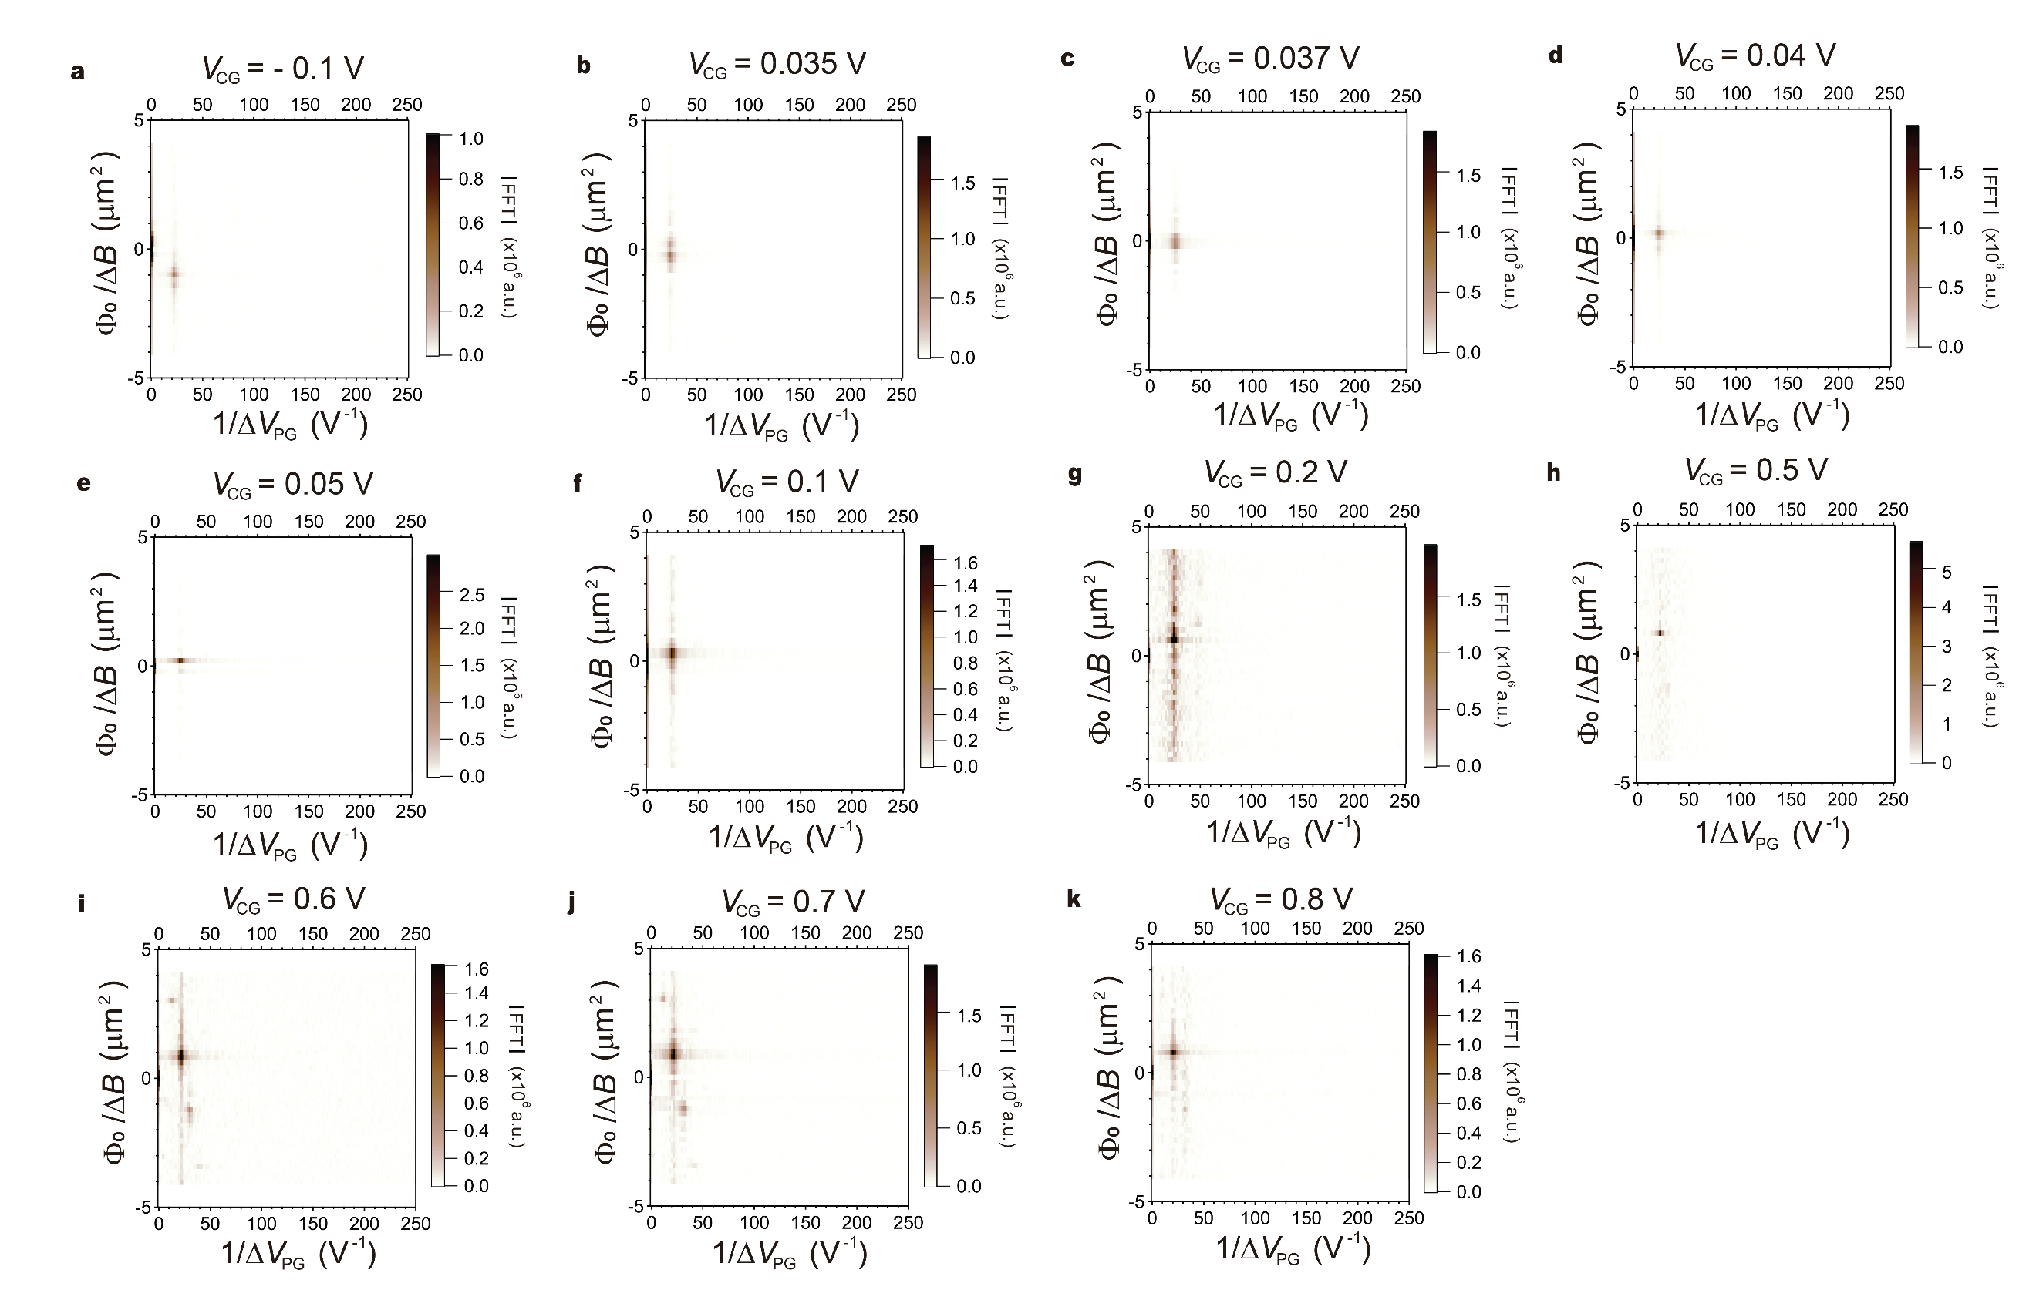
Fig. S6 | 2D-FFT analysis on V_{CG} dependence of LL2 interference. a-k, 2D-FFT corresponding to Fig. S5 a-k, respectively.

Supplementary Section 4: V_{CG} dependence of the interference at FQHE
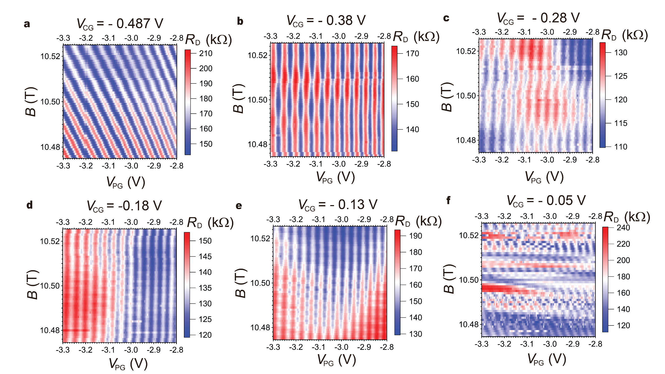
We present all 2D pajama plots and the corresponding 2D-FFT results used for analyzing V_{CG} dependence of the interference at a 1/3 fractional filling shown in Fig. 3 of the main text. Fig. S7 and S8 show 2D pajama of R_{D} as a function of B and V_{PG} measured at different V_{CG}, and the corresponding 2D-FFT, clearly showing the crossover from AB to CD-dominated oscillations. As V_{CG} is increased further, at V_{CG} = - 0.05 V (Fig. S7f), 2D oscillations with negative slopes of the constant phase lines start to emerge in the intermediate regime between CD and AB regimes where the phase of the oscillating R_{D} is not stable, implying the interfering edge is not fully developed, similar to the result shown in Fig. S3b. The same measurements are performed at a higher magnetic field near 11.985 T, shown in Fig. S9 for 2D pajama plots and Fig. S10 for the corresponding 2D-FFT, showing similar behavior (AB → CD → AB-dominated oscillations) with increasing V_{CG}. Note that Fig. S9a is measured at a constant density condition where non-linearity in the constant phase lines emerges.
Fig. S7 | V_{CG} dependence of an interference at a 1/3 fractional filling near 10.5 T. a-f, Oscillating R_{D} as a function of B and V_{PG} at different V_{CG}.
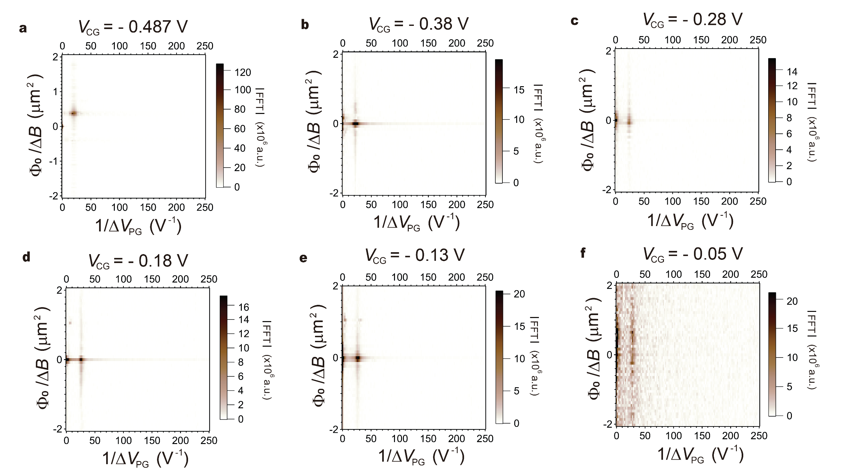
Fig. S8 | 2D-FFT analysis on V_{CG} dependence of an interference at a 1/3 fractional filling near 10.5 T. a-f, 2D-FFT corresponding to Fig. S7a-f, respectively.
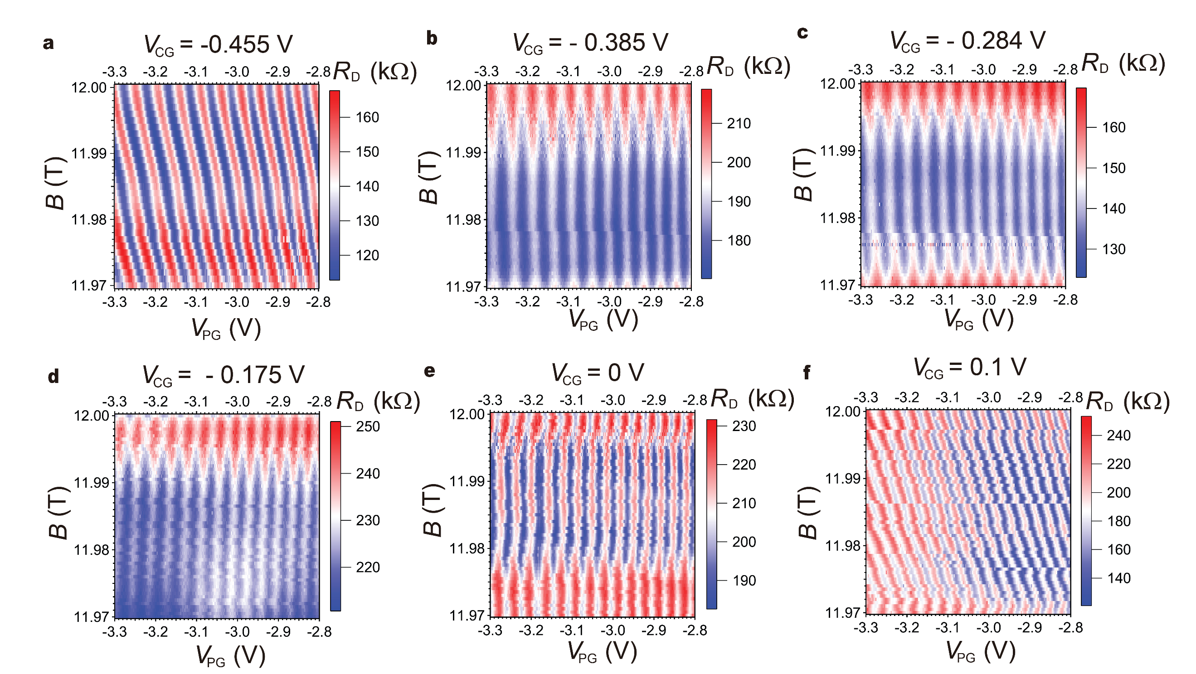
Fig. S9 | V_{CG} dependence of an interference at a 1/3 fractional filling near 11.985 T. a-f, Oscillating R_{D} as a function of B and V_{PG} at different V_{CG}.
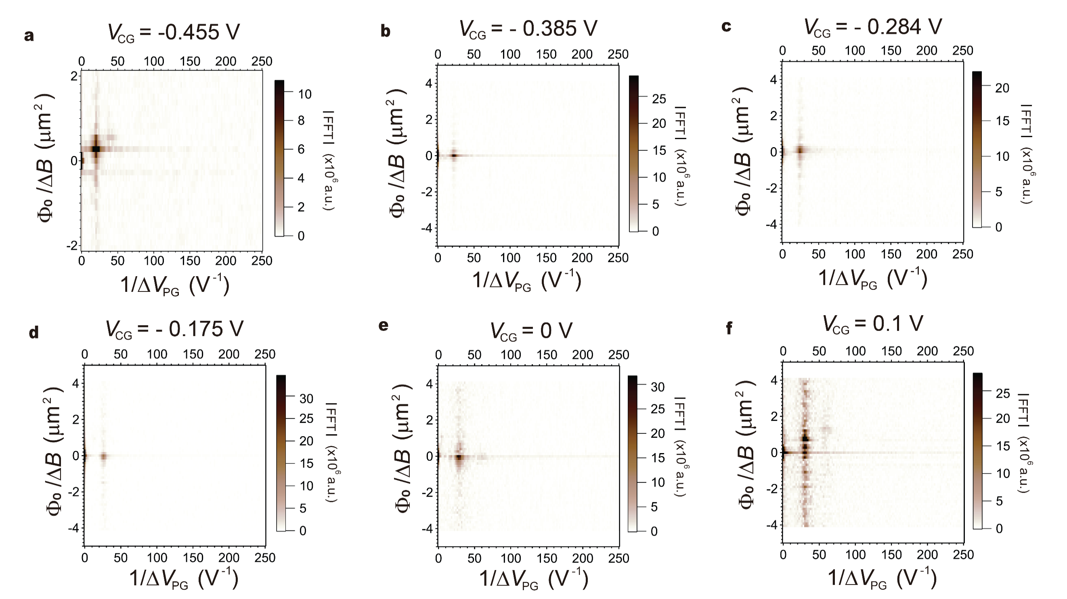
Fig. S10 | 2D-FFT analysis on V_{CG} dependence of an interference at a 1/3 fractional filling near 11.985 T. a-f, 2D-FFT corresponding to Fig. S9a-f, respectively.
Supplementary Section 5: Gate tunable AB interference
In this section, we study the electrostatics of the plunger gate by analyzing the V_{PG} dependence of AB oscillation frequency. In a similar measurement condition used in Fig. 3b, as shown in Fig. S11c, AB oscillations are measured as a function of V_{PG} plotted with R_{D} at ν = 1/3 beneath LG, CG, and RG regions under 12 T, clearly showing the oscillating frequency depending on V_{PG}, which is the same behavior as that reported in the previous studies in mono and bi-layer graphene-based FPI ^{3–5}. From eq. 1 in the main text, periodicity in V_{PG}, ΔV_{PG}, can be derived as $ΔV_{PG}=\frac{e}{Be^{*}}\frac{Φ_{0}}{dA/dV_{PG}}$, where $\frac{dA}{dV_{PG}}$ is the lever arm indicating the effect of V_{PG} on the interfering area A ⁶. As long as $\frac{dA}{dV_{PG}}$ is constant value at different electrostatic environment near the interference loop, ΔV_{PG} can give the information of the interfering charge. However, in graphene-based FPI, $\frac{dA}{dV_{PG}}$ is a function of V_{PG}, as shown in Fig. S11c, which implies that the spatial distance between the trajectory of the QH edge channel and the PG can be affected by ν beneath PG region. Moreover, it is reported that $\frac{dA}{dV_{PG}}$ varies with the different ν beneath CG region ³. Therefore, this complexity in $\frac{dA}{dV_{PG}}$ depending on ν beneath both CG and PG regions makes it harder to extract the correct interfering charge from the measured ΔV_{PG}. We note that the visibility of the oscillations, defined as $\frac{R_{D,max}-R_{D,min}}{R_{D,max}+R_{D,min}}$ where R_{D,max} and R_{D,min} are maximum and minimum values, respectively, is rather high, around 35%, indicating the high fractional edge mode velocity in our FPI ^{3,4,6}.
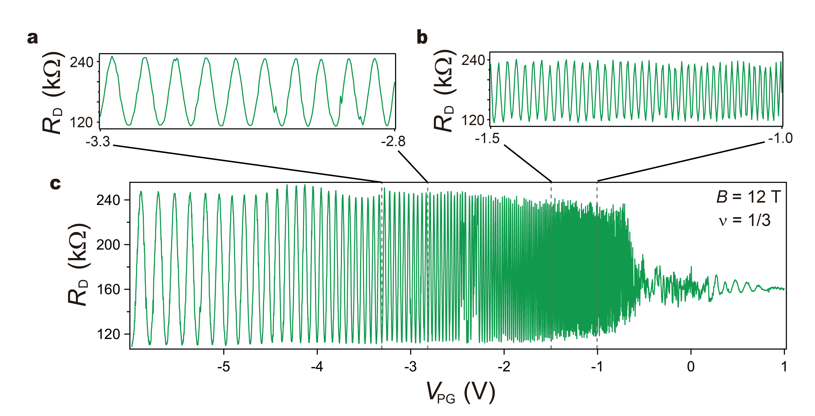
Fig. S11 | Plunger gate dependence of 1/3 filling. a-c, Diagonal resistance R_{D} oscillations as a function of plunger gate voltage (V_{PG}) measured for ν = 1/3 at a fixed magnetic field 12 T, (a) R_{D} oscillations on partial V_{PG} range from -3.3 to -2.8 V. (b) R_{D} oscillations on partial V_{PG} range from -1.5 to -1.0 V, showing higher oscillating frequency as V_{PG} is increased. (c) R_{D} oscillations in a whole range of V_{PG}, showing the suppression of the oscillations amplitude above -0.6 V of V_{PG} corresponding to the charge neutrality point. I_{SD}=50 pA is applied with QPCs transmission of t_{L} ~ 0.75 and t_{R} ~ 0.95 under 12 T. V_{BG} is set to 0.5 V.

Supplementary Section 6: Trajectory dependence of 1/3 interference
We present all the 2D pajama plots and the corresponding 1D-FFT results used for analyzing trajectory dependence of 1/3 interference shown in Fig. 4e of the main text. Fig. S12 and S13 show the 2D pajama of R_{D} as a function of B and V_{PG} measured at different trajectories, and the corresponding 1D-FFT, respectively. 1D-FFT analysis is performed on the results in Fig. S12a-n to obtain the phase evolution $\frac{θ}{2π}$ as a function of $B,$ plotted in Fig. S13a-n. The detailed method for 1D-FFT is explained in the supplementary section 9. To quantify the linearity of the constant phase lines in the 2D oscillations, we employ a least-squares fitting on 1D-FFT results with the linear function, yielding $\frac{∂θ}{∂B}$ and $χ_{fit}$ where $\frac{∂θ}{∂B}$ is the slope obtained from the least-squares fits (black dashed line) in the unit of (2πT)⁻¹, and $χ_{fit}$ is the standard deviation calculated in the least-squares fitting process. The $B/V_{CG}$ slope α = 45 T/V, in which $χ_{fit}$ is in its minimum corresponds to the constant filling condition where pristine AB oscillations are observed.
The linear behavior of $\frac{∂θ}{∂B}$ with $\frac{1}{α}$, shown in Fig. 4e of the main text, can provide the simple relation between the phase and the number of electrons in the interference loop, as described in the main text. The slope α that defines the trajectory can be rewritten:
$\frac{1}{α}=\frac{∂V_{CG}}{∂B}=\frac{1}{C}\frac{∂Q}{∂B}=\frac{e}{C}\frac{∂N}{∂B}$ (S2)
where Q and N are total charge and the number of electrons in the interference loop, respectively, and C is the capacitance between CG and the bulk of the interference region.
Using eq. S2, the slope, β ,obtained from the least-squares fits of the result in Fig. 4e of the main text is then:
$β=\frac{\frac{1}{2π}\frac{∂θ}{∂B}}{\frac{e}{C}\frac{∂N}{∂B}}=\frac{C}{2πe}\frac{∂θ}{∂N}$ . (S3)
From eq. S3, the phase difference can be expressed as follows:
$∂θ=∂N 2π(β\frac{e}{C})$ (S4)
To calculate the capacitance, C, including the quantum capacitance, we use the Streda formula. For a 1/3 filling, $1/3=$ ${n_{e}}/{n_{ϕ}}=Φ_{0}∙\frac{C∙V_{CG}}{e∙A∙B}$ leading to $C=\frac{e^{2}}{3∙h}∙A∙\frac{dB}{dV_{CG}}$. Taking $A=1.05{μm}^{2}$, 3 times the area measured from the constant filling trajectory and $\frac{dB}{dV_{CG}}=45T/V$, we calculate $C= 6.08×{10}^{-16} F$, somewhat lower than the geometric capacitance $C \sim 6.6×{10}^{-16} F.$ The value of $\frac{dB}{dV_{CG}}$ is measured both from the average of the black dashed lines in Fig. 4a as well as from the min-error fit in Fig. 4e.
Using the values of $C \sim 6.08×{10}^{-16} F, e \sim 1.6×{10}^{-19} C$, and β ~ 3500 V⁻¹, we obtain $\frac{∂θ}{∂N}=2π(0.92)$, yielding $θ≈0.92·\left(2πN\right)$, mentioned in the main body of the paper.

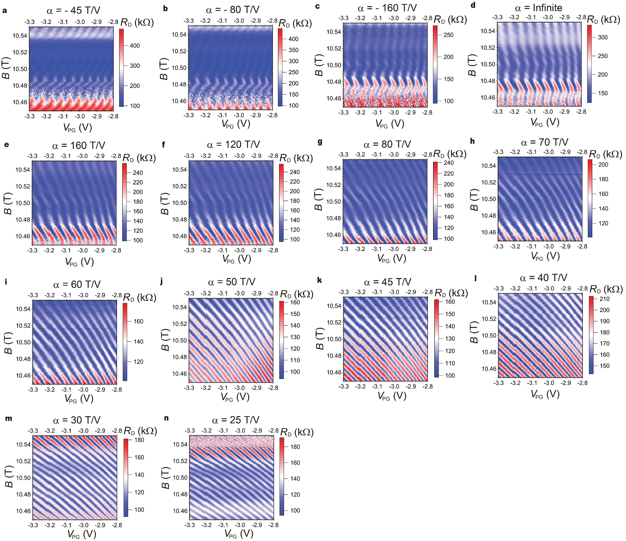
Fig. S12 | Trajectory dependence of an interference at a 1/3 fractional filling. a-n, Oscillating R_{D} as a function of B and V_{PG} at different trajectories. α written above every single image means the trajectory direction where three top gates (L/RG and CG) and B change together.

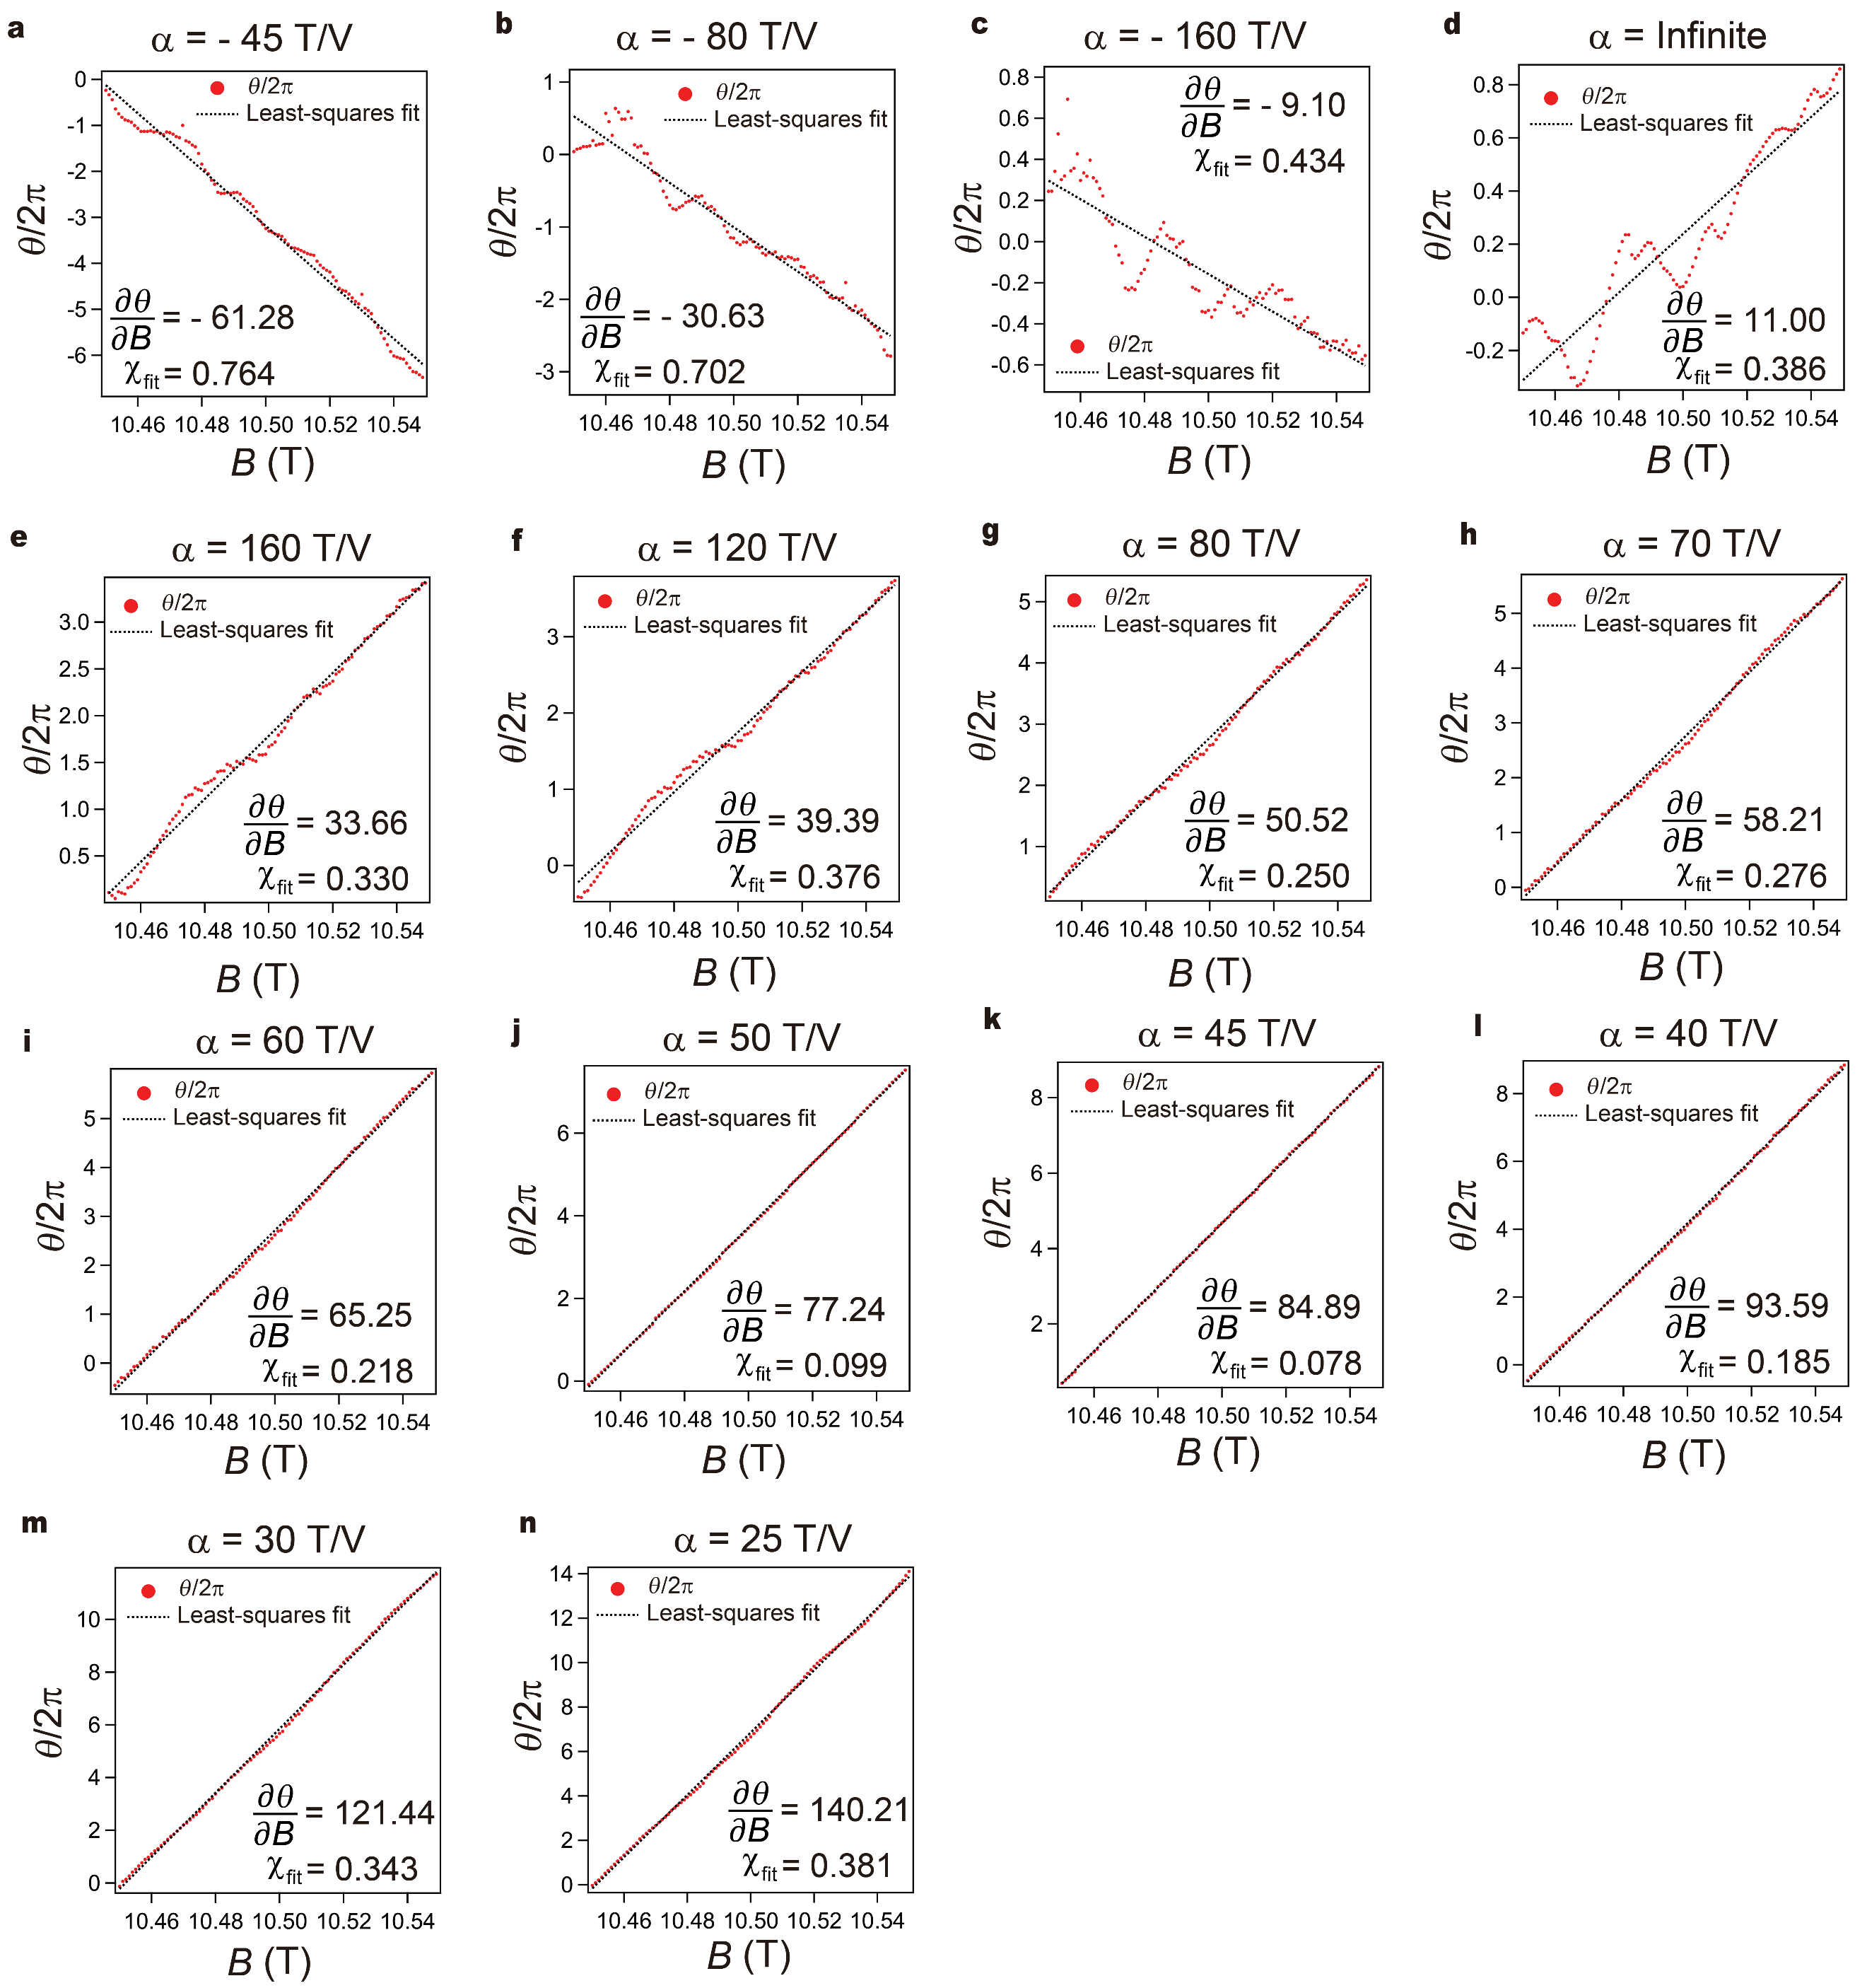
Fig. S13 | 1D-FFT of trajectory dependence of 1/3 interference. a-n, Scaled phase difference θ/2π extracted from 1D-FFT of Fig. S12a-n, and corrpesponding least-squares fits, as a function of B. Inset: Fitting values $\frac{∂θ}{∂B}$ and $χ_{fit}$ are presented.

Supplementary Section 7: Constant density/filling in the reservoirs/interference area
As an extension of the measurements in Fig. 4 of the main text, we perform a measurement aimed to confirm the absence of the relative contributions to $θ$ by quasi-particles in the L/RG and CG regions. Fig. S14a shows the 2D oscillations measured at the condition where L/RG regions are in constant density, and CG region is in constant filling, showing pure AB oscillations similar to the result in Fig. 4b of the main text. This result means that the change in N_{qp} in the bulk beneath L/RG regions does not distort the linear lines of the constant phase in AB oscillations. On the other hand, as shown in Fig. S14b, when L/RG regions are in constant filling, and CG region is in constant density, the 2D oscillations show the non-linearity in the lines of the constant phase, resulting in the same behavior as that shown in Fig. 4d of the main text. Therefore, from these control experiments, we can demonstrate that ΔN_{qp} in eq. 1 of the main text is the number of quasiparticles localized in bulk beneath CG region rather than L/RG regions, and the non-linearity in the lines of the constant phase results from the effect of quasiparticles within the interference loop.

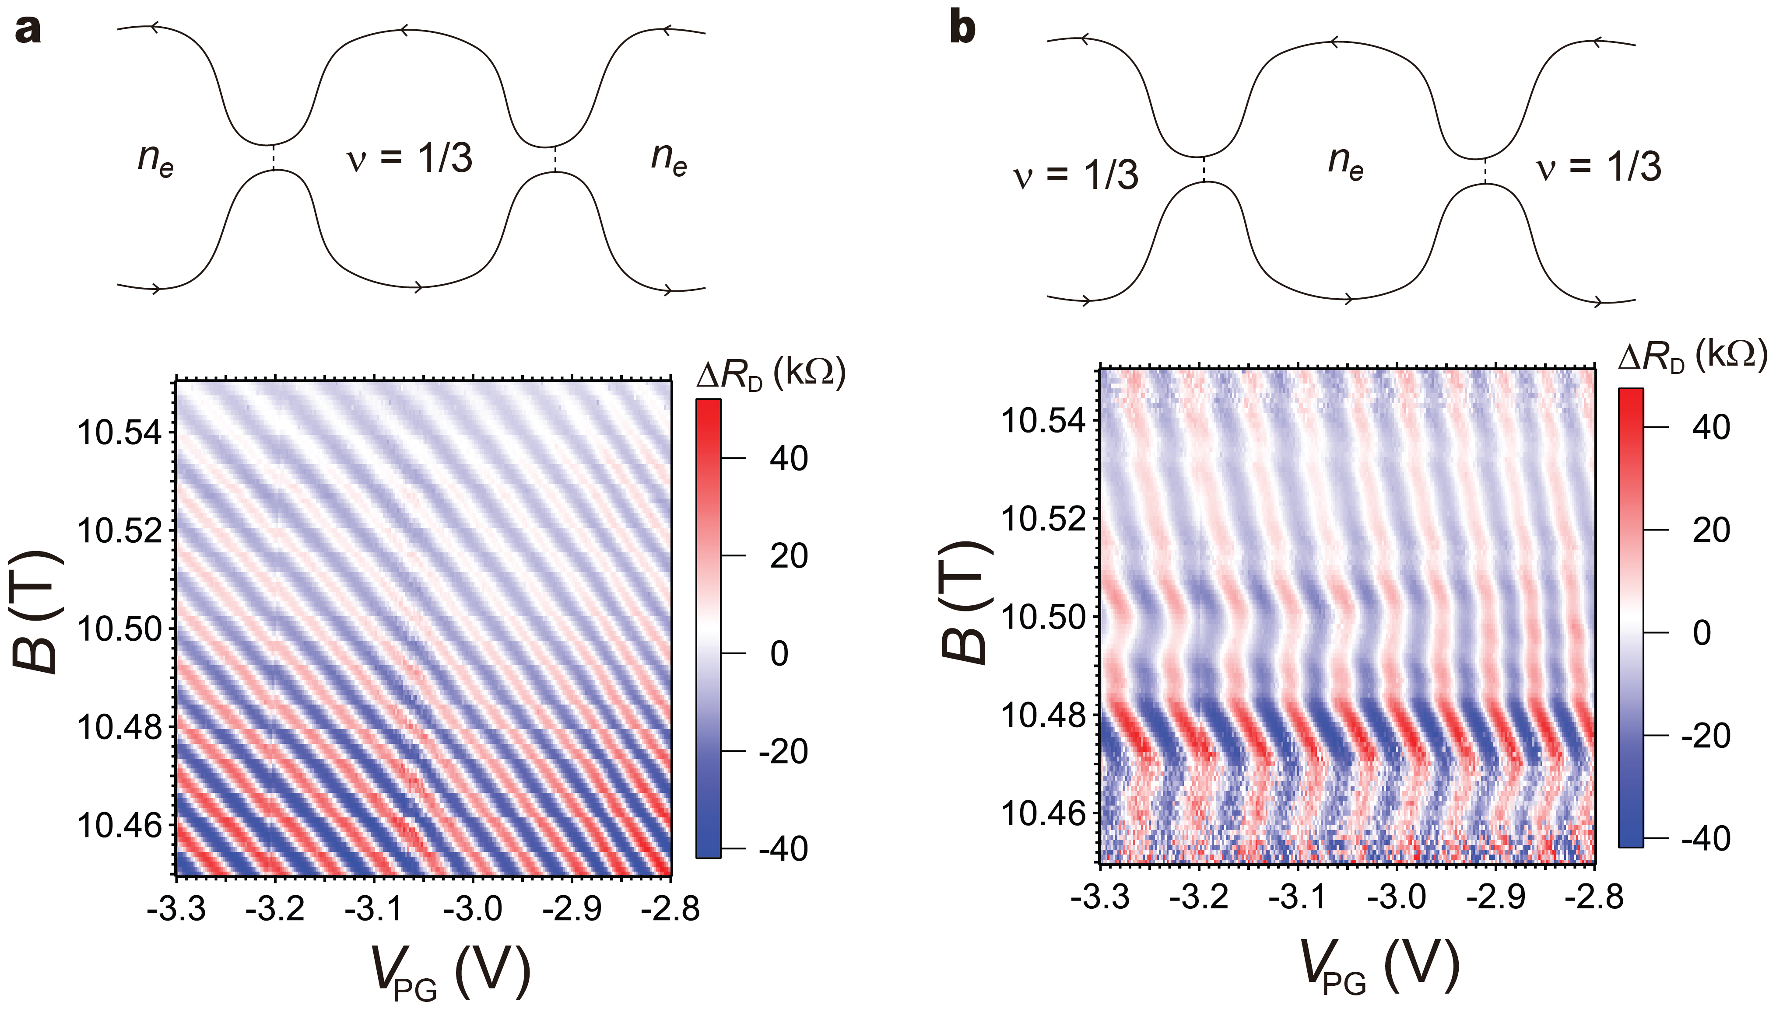
Fig. S14 | Constant density/filling in the reservoirs/interference area. a-b, Oscillating ΔR_{D} as a function of B and V_{PG} at different measurement conditions. (a) L/RG regions are in constant density, and CG region is in constant filling. (b) L/RG regions are in constant filling, and CG region is in constant density. n_{e} in the upper schematic of edge channels decribes constant density.

Supplementary Section 8: Phase slips
In this section, we present the observed phase slips at ν = 1/3 interfering edge mode. We operate the FPI at a higher B = 12T to increase the 1/3 energy gap Δ_{1/3}, expecting a bigger ΔB_{C} where an increased number of phase slips can occur in a wider continuous AB regime. In these measurement conditions, we observed a large number of phase slips (Fig. S15a). We concentrate on three phase slips occurring at 11.99 T, 11.978 T, and 11.961 T, indicated by gray dashed arrows in Fig. S15b. To extract the quantitative value of the phase slips, 1D-FFT along the horizontal lines where phase slips occur is performed. Subsequently, AB phase contribution is subtracted from the total phase difference θ, as shown in Fig. S15c. The values of the phase slips, Δθ/2π, are calculated by taking a difference between the average values on two adjacent plateaus depicted as dashed lines in Fig. S15c, returning the values of Δθ/2π = -0.14, -0.29, and -0.34 deviating from the value of -1/3 predicted in the theory. This deviation can be understood by employing the bulk-to-edge coupling in Δθ/2π, which can be modified at ν = 1/3 interference as follows ^{7,8}:
$\frac{Δθ}{2π}=-\frac{θ_{anyon}}{2π}+\frac{3K_{IL}}{K_{I}}{(\frac{ⅇ^{*}}{e})}^{2}$ (S5)
, where K_{IL} represents the coupling of the bulk-to-edge channel, and K_{I} is the edge stiffness describing the energy cost to vary the interfering area A. According to eq. S5, the absolute value of the phase slips can decrease when non-negligible K_{IL} exists, explaining Δθ/2π = -0.14 and -0.29 at 11.99 T and 11.978 T, respectively. In addition, the behavior of different Δθ/2π may be attributed to the fact that $\frac{K_{IL}}{K_{I}}$ can be affected by ΔN_{qp}. Another important point is that discrete phase slips occur along the horizontal lines, without depending on V_{PG} (at these ranges), different then the reported previous work where these phase slips occur along the lines with the positive slope in B-V_{PG} plane ^{8,9}, implying that the main reason for ΔN_{qp} is the change in the degeneracy of the bulk within the interference loop while changing B.
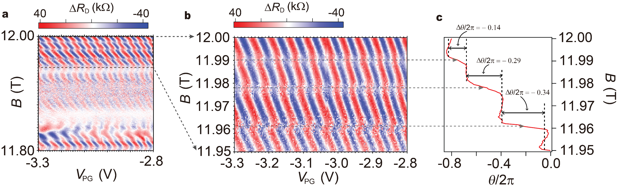
Fig. S15 | Phase slips. a-b, Oscillating ΔR_{D} in the B-V_{PG} plane. (a) Large range of B. (b) Zoom-in to small range of B beween 11.95 and 12 T. Three dashed lines indicate where the phase slips occur and point to the corresponding phase slips in Fig. S15c. c, scaled phase difference θ/2π extracted from 1D FFT of Fig. S15b as a function of B. The AB contribution is subtracted to make plateaus depicted by the dashed lines. The values of the phase slips, Δθ/2π, are presented between two adjacent plateaus.

Supplementary Section 9: Extracting the values of phase slips from 1D-FFT
A pajama plot of ΔR_{D} as a function of plunger gate voltage V_{PG} and external magnetic field B is shown in Fig. S16a, the same figure shown in Fig. S15b. To accurately determine the values of the phase slips associated with the quasiparticle inside the interferometer, we employ the Fast Fourier transform method to acquire phase ⁸. FFT is performed along the line cut as shown in Fig. S16a with a black dashed line from which ΔR_{D} is extracted at a fixed B. In this way, we obtain real and imaginary amplitudes associated with that ΔR_{D} along that line cut, and the frequency where the amplitude is maximum is determined for further phase calculation. The phase θ is obtained from inverse tangent function i.e., $θ\left(z\right)= atan2\left(Imz,Rez\right)$, which takes care of the sign of quadrant. To avoid discontinuities while crossing the range from - π to +π, we patch up the phase by a shift of 2π whenever there is a crossover in this range as shown in Fig. S16b, yielding a smooth curve shown in Fig. S16c. Phase increases linearly until the phase slip emerges as shown in Fig. S16c, which corresponds to the Aharonov-Bohm (AB) phase contribution. To distinguish between AB and quasi-particle phase contributions, constant slopes of all dashed lines representing the AB contribution are averaged out and subtracted from the phase. In this way, we achieve a smooth curve of the phase where the phase slips from anyonic phase contribution become more predominant as shown in Fig. S16d. The same 1D-FFT analysis is performed in Fig. 4e of the main text.
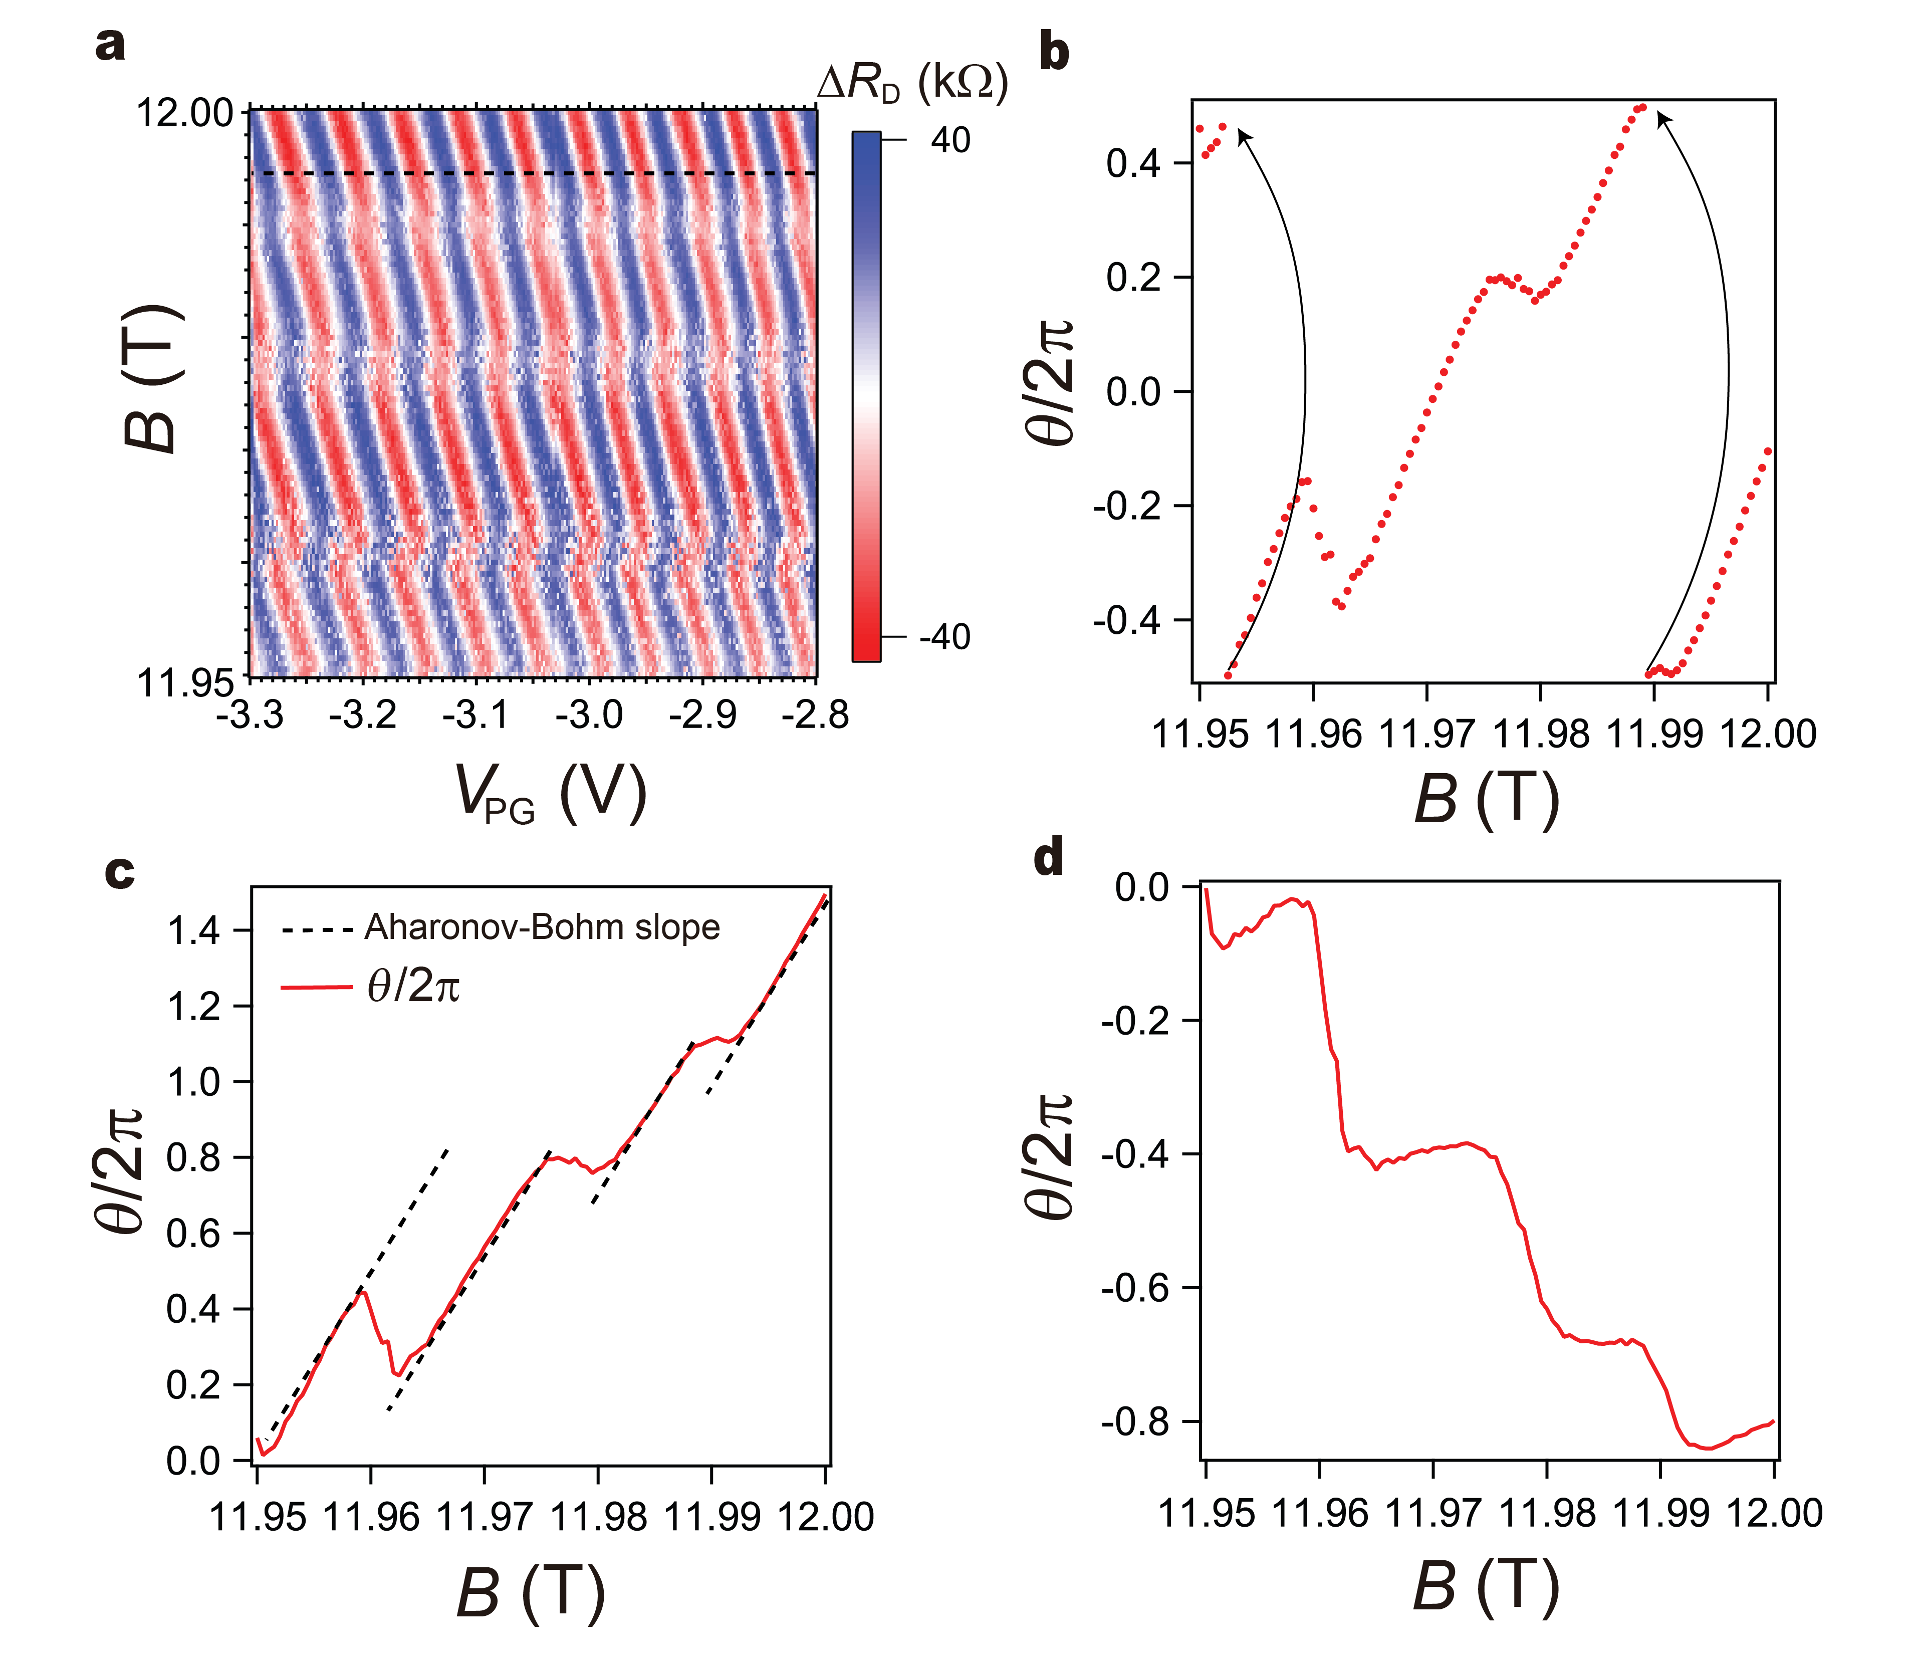
Fig. S16 | 1D-FFT analysis. a, Oscillating ΔR_{D} as a function of B and V_{PG} for ν = 1/3 at constant density. b, The phases accumulated from Fast Fourier Transform for each B value, plotted with the scaled phase θ/2π as a function of B. Discontinuities in the phase is avoided by patching up the phase by a shift of 2π whenever there is crossover of - π to + π, depicted by the black arrows. c, The phase after patching up. The black dashed lines represent the constant Aharonov-Bohm phase slope. d, The phase with the Aharonov-Bohm slope subtracted to segregate the contribution from the associated phase slips.

Supplementary Section 10: AB interference at ν = - 1/3 fractional filling
One of the distinct tunabilities of graphene-based FPI is the fact that the type of interfering charge, either electron or hole, can be controlled by simple gate operations. Now, we demonstrate the possibility of AB oscillations at different filling factor ν = -1/3 where the type of the charge carriers are holes. Figure S17a shows R_{xy} measured at the right side of the FPI while applying 12 T of a magnetic field at fixed 0 V of V_{BG}, showing the clear plateaus for IQHE and FQHE. We perform similar measurement performed in Fig. 4d of the main text. We tune to ν = -1/3 in L/RG, and CG regions, and ν = 0 beneath the split gates L/RSG, while measuring oscillating R_{D} under I_{SD} = 50 pA with t_{L} ~ 0.95 and t_{R} ~ 0.75, at constant density regime. Figure S17b shows that AB oscillations measured in B and V_{PG} space have mirror symmetry with respect to B axis, as expected between electron and hole carriers, demonstrating that graphene-based FPI is a promising platform to study both hole and electron types of the interfering charge, and the interplay between them.
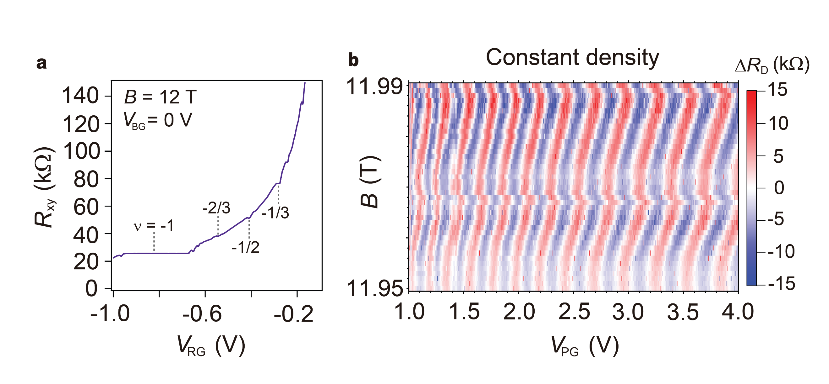
Fig. S17 | AB interference at a -1/3 fractional filling. a, R_{xy} measured while applying 2 nA as a function of V_{RG} under 12 T at fixed V_{BG} = 0 V, showing the clear plateau for ν = -1/3. b, Oscillating ΔR_{D} as a function of B and V_{PG} at constant density condition where the voltages applied on L/RG, and CG are fixed. V_{BG} is set to 0 V.
References
1. Venugopal, A. et al. Effective mobility of single-layer graphene transistors as a function of channel dimensions. J. Appl. Phys. 109, 104511 (2011).
2. Gosling, J. H. et al. Universal mobility characteristics of graphene originating from charge scattering by ionised impurities. Commun. Phys. 4, 30 (2021).
3. Ronen, Y. et al. Aharonov–Bohm effect in graphene-based Fabry–Pérot quantum Hall interferometers. Nat. Nanotechnol. 16, 563–569 (2021).
4. Déprez, C. et al. A tunable Fabry-Pérot quantum Hall interferometer in graphene. Nat. Nanotechnol. 16, 555–562 (2021).
5. Fu, H. et al. Aharonov–Bohm Oscillations in Bilayer Graphene Quantum Hall Edge State Fabry–Pérot Interferometers. Nano Lett. 23, 718–725 (2023).
6. Nakamura, J. et al. Aharonov–Bohm interference of fractional quantum Hall edge modes. Nat. Phys. 15, 563–569 (2019).
7. Halperin, B. I., Stern, A., Neder, I. & Rosenow, B. Theory of the Fabry-Pérot quantum Hall interferometer. Phys. Rev. B 83, 155440 (2011).
8. Nakamura, J., Liang, S., Gardner, G. C. & Manfra, M. J. Impact of bulk-edge coupling on observation of anyonic braiding statistics in quantum Hall interferometers. Nat. Commun. 13, 344 (2021).
9. Nakamura, J., Liang, S., Gardner, G. C. & Manfra, M. J. Direct observation of anyonic braiding statistics. Nat. Phys. 16, 931–936 (2020).

