Supplementary appendix

Part I

Roadmaps of countries along the Belt and Road and their history
China's Silk Road has a long history of cultural, economic, and human interaction. The Land Silk Road（LSR）began in 114 B.C., starting from Chang ‘an (present-day Xi'an), travelling through Gansu and Xinjiang to Central and West Asia and connecting with the land routes of the Mediterranean countries, and finally entering the European continent^{1,2}. MSR is a little later than the LSR, was started in 110 BC, early only in China's East China Sea and the South China Sea near the area of navigation, with the development of shipbuilding technology, routes gradually to Southeast Asia, the Strait of Malacca, the Indian Ocean, the Red Sea, as well as the opening of the African continent, the last and the LSR to join the convergence of Europe³. LSR through the countries were economically prosperous strong countries, because in ancient times the traffic is extremely inconvenient situation, only powerful countries can carry out this kind of super long-distance trade and cultural exchanges. On the other hand, the countries along the MSR (except Europe) were basically poor and backward regions before the end of the Second World War and had been colonized for a long time. Therefore, the health poverty of the countries along the B&R is formed because of their traditional poverty.
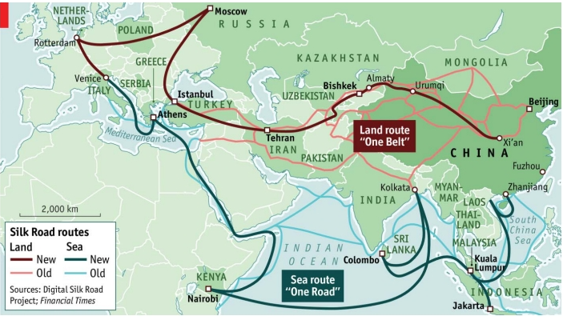
Figure1 The geographical coverage of the One Belt, One Road Initiative. Source: The Economist Newspaper Limited, London (2 July 2016)

Part II

Analysis of the literature search on health poverty research
We searched the web of science on 20 December 2023 using the subject term health poverty and found 115 articles. After excluding the literature on health and poverty, only 27 articles proposed and researched the separate term 'health poverty'(as shown in Table 1).
Table 1 Literature using the term "health poverty" alone.
No. | Title | Journal | Publication year | Description of health poverty
1 | Multidimensional measurement of poverty and its spatio-temporal dynamics in China from the perspective of development geography | Journal of Geographical Sciences | 2021 | Part of multidimensional poverty
2 | Multidimensional Poverty among Female Householders in Korea: Application of a Latent Class Model | Sustainability | 2020 | Part of multidimensional poverty
3 | Long-term care insurance and multidimensional poverty of middle-aged and elderly: Evidence from China | Frontiers in Public Health | 2023 | Part of multidimensional poverty
4 | Regional Differentials in Multidimensional Poverty in Nepal: Rethinking Dimensions and Method of Computation | SAGE Open | 2019 | Part of multidimensional poverty
5 | Poverty Vulnerability and Health Risk Action Path of Families of Rural Elderly With Chronic Diseases: Empirical Analysis of 1,852 Families in Central and Western China | Frontiers in Public Health | 2022 | poverty caused by illness
6 | Spatial Comparisons of Poverty and Inequality in Living Standards in Malawi | South African Journal of Economics | 2013 | Part of multidimensional poverty
7 | Allocation of development assistance for health: is the predominance of national income justified? | Health Policy and Planning | 2018 | 因病致贫
8 | Health and wealth in Mesoamerica: findings from Salud Mesomérica 2015 | BMC Medicine | 2015 | Part of multidimensional poverty
9 | Does the medical insurance system really achieved the effect of poverty alleviation for the middle-aged and elderly people in China? Characteristics of vulnerable groups and failure links | BMC Public Health | 2020 | poverty caused by illness
10 | Can rural health insurance coverage improve educational attainment? Evidence from new cooperative medical scheme in China | International Review of Economics & Finance | 2023 | Part of multidimensional poverty
11 | Health justice and economic segregation in climate risks: Tracing vulnerability and readiness progress | Health & Place | 2023 | poverty caused by illness
12 | Does exposure to democracy decrease health inequality? | Journal of Public Policy | 2023 | Health stock deficits
13 | Can government subsidies and public mechanisms alleviate the physical and mental health vulnerability of China’s urban and rural residents? | International Journal for Equity in Health | 2023 | Health stock deficits
14 | Energy poverty, climate shocks, and health deprivations | Energy Economics | 2021 | Health stock deficits
15 | Modelling Two Dimensions of Poverty in Selected Developing Countries: The Impact of Fossil Fuel Subsidies | Social Indicators Research | 2022 | Health stock deficits
16 | Measurement and determinants of health poverty and richness: evidence from Portugal | Empirical Economics | 2016 | Health stock deficits
17 | Nexus between health poverty and climatic variability in Pakistan: a geospatial analysis | Frontiers in Environmental Science | 2023 | Part of multidimensional poverty
18 | Defining and measuring health poverty | Social Science & Medicine | 2020 | Health stock deficits
19 | Health and Wealth on the Roller-Coaster: Ireland, 2003–2011 | Social Indicators Research | 2015 | Health stock deficits
20 | Modeling the impact of energy poverty on income poverty, health poverty, educational poverty, and environmental poverty: a roadmap towards environmental sustainability | Environmental Science and Pollution Research | 2023 | Health stock deficits
21 | The impact of informal social support on the health poverty vulnerability of the elderly in rural China: based on 2018 CHARLS data | BMC Health Services Research | 2022 | Health stock deficits
22 | Dynamic reflections of multidimensional health poverty in Pakistan | PLOS ONE | 2021 | Part of multidimensional poverty
23 | The dynamics of health poverty in Spain during the economic crisis (2008–2016) | Health Policy | 2019 | Health stock deficits
24 | Health vulnerability and health poverty of rice farmers: evidence from Hubei province in China | China Agricultural Economic Review | 2023 | Part of multidimensional poverty
25 | Measurement and Decomposition of the Health Poverty of Rural Residents in China | International Journal of Environmental Research and Public Health | 2022 | Part of multidimensional poverty
26 | Accounting for trends in health poverty: a decomposition analysis for Britain, 1991–2008 | The European Journal of Health Economics | 2015 | Health stock deficits
27 | Measuring Multidimensional Health Poverty in China | Frontiers in Public Health | 2022 | Part of multidimensional poverty

Part III

Interpretation of the connotations of health poverty
Health poverty consists of two core thematic terms: health and poverty, where health refers to the state of loss of health due to the sustained depletion of individual health endowments, basic capabilities and resources brought about by disease, etc.; and poverty is not a single kind of poverty but a multidimensional one, a state of multidimensional poverty and relative deprivation that is characterized by economic poverty at its core. It is not difficult to see that the connotation and extension of the definition of health poverty has been greatly expanded, which has gone beyond the traditional economic perspective of low income and insufficient to refer to the poverty, covering the health stock of this basic endowment of survival as the core driving mechanism induced by the lack of economic poverty, poverty of opportunity, poverty of ability, institutional poverty, and with the formation of health risks and diseases of the multi-negative chain effect, the cause and effect of each other superimposed on the diffusion of the coupled The health risks and diseases form a multi-dimensional negative chain effect, which is mutually causative, superimposed, diffused and coupled.

Part IV

Theoretical mechanisms of health poverty formation

The creation and spread of health poverty
As the most classic core theory of poverty research, the theory of capability poverty holds that the essence of poverty is the deprivation of national individual rights and the loss of viable capabilities, which are determined by the conditions or relations of rights in the society, such as politics, culture, economy and so on⁴. Based on the viability perspective, health, as the basic survival endowment of human beings, is the basis of their externally derived developmental capabilities, such as economic development, access to education, and possession of resources. The degree of absence of health stock determines the risk of zeroing out the above external capabilities. The loss of the national health stock is inevitably accompanied by a decline in the quality of existence and economic capacity, and to restore health, the risk of catastrophic health expenditures and poverty due to illness due to the payment of health care costs in the process of health service utilization is also greatly increased. Health poverty cycles negatively between the causal chains of disease, lack of developmental capacity, and insufficient access to resources, ultimately leading to an abyss of poverty and disease. The lack of a national health stock and the deprivation of capabilities and opportunities eventually accumulate into differences in the accessibility and availability of institutional resources such as the health insurance system and pro-poor policies for homogeneous groups of poor people. At the same time, the country's inherent cultural practices, lifestyle risks, natural environmental exposure risks and social environmental risks deepen the incidence of health poverty. The accumulation of individual health poverty and the coupling and transmission mechanism of multiple vulnerability attributes ultimately lead to the solidification of health poverty in the country, and the iterative chain of risk imposes a constraint on the sustainable development of the society.

The entrenchment of health poverty
In 1953, the United States development economist Rogner Nukes put forward the famous theory of the "vicious circle of poverty" after carrying out an in-depth and systematic analysis of the poverty problem in developing countries⁵. The core idea is that the lack of capital is the root cause of the continuous cycle of poverty, while the lack of capital development is due to the slow pace of economic development. When the low-income poor are in poor health, it is difficult for them to have access to adequate health services, and even if they do have access to some health resources, the high cost of health care often exacerbates their poverty, making them vulnerable to the spread of the vicious circle of poverty-disease-exacerbation of poverty. The vicious circle of "poverty-disease" becomes the core interplay of health poverty, but its negative impact goes far beyond the entanglement of the above two dilemmas, resulting in economic poverty, loss of development capacity and opportunities, lack of resources and power, and exposure to more health risks, and ultimately falling into a closed loop of unbreakable health poverty. This will lead to economic poverty, loss of development capacity and opportunities, lack of resources and power to maintain health, and exposure to more health risks.

Eradication of health poverty
Based on the theory of the polarization-trickle-down effect, the development of economically developed regions can have both favorable and unfavorable effects on the development of economically less developed regions⁶. The polarization effect refers to the fact that the development of economically developed regions is based on the siphoning of resources from the less developed regions around them; while the trickle-down effect is that the developed regions drive the development of the less developed regions through the development dividend. Polarization and trickle-down are symbiotic and complementary in development, ultimately bringing about sustainable regional development. Then, for the elimination of health poverty, we should also start from the perspective of regional balanced development strategy and consider promoting the expansion of the trickle-down effect in areas with high incidence of health poverty through the growth poles formed in regions with high health level, and ultimately realizing the elimination of health poverty in the region. The theory's regional symbiosis and synergistic development provides a theoretical basis for subsequent synergistic governance strategies for health poverty reduction.
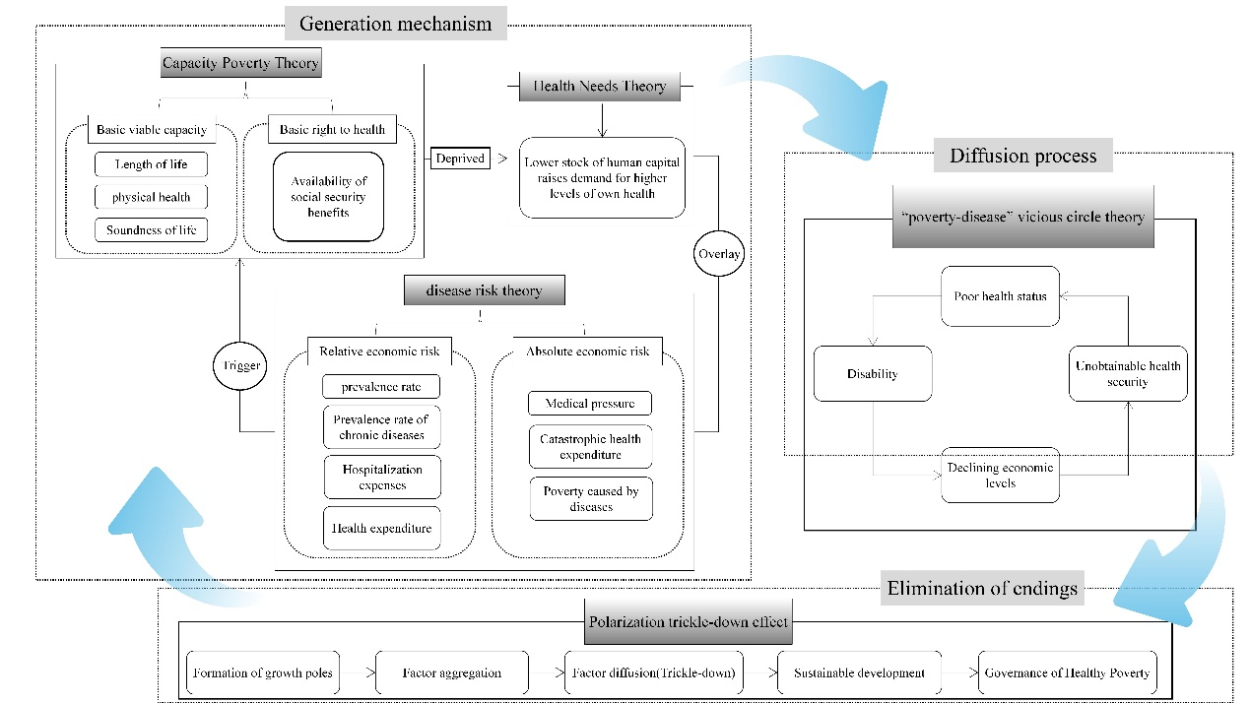
Figure3 Diagram of the theoretical analytical framework of health poverty formation mechanisms

Part V

Data Processing
As of June 2023, the total number of countries participating in the B&R Co-operation Initiative, as well as countries along the traditional Silk Road, is 156. However, based on the availability of data on the indicators chosen to calculate the Health Poverty Index in our theoretical framework and the data on their influencing factors, we deleted some countries, as shown in Figure 2 below.
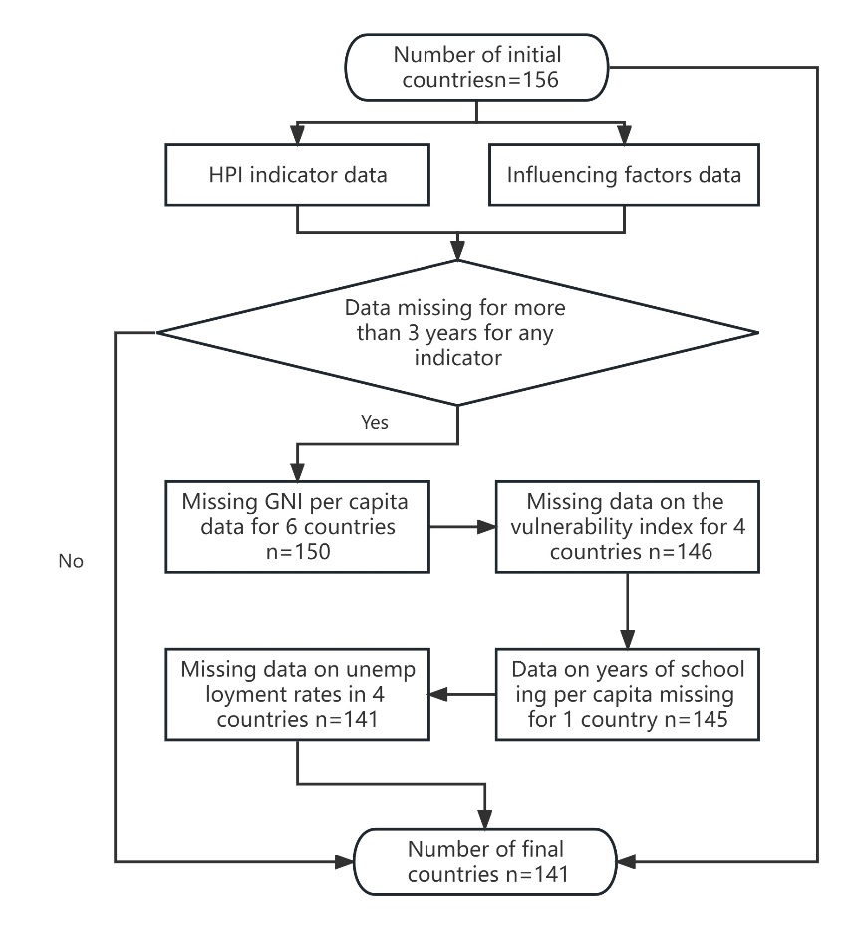
Figure4 Data Processing of the Health Poverty Index and its Influencing Factors
Of the 141 countries that were ultimately retained, there were also some countries that were missing data on an indicator for up to three years, so to ensure data completeness we used the MissForest-non-parametric methodology proposed by Daniel J. Stekhoven 2012 to fill in the missing data for the relevant countries , which outperforms established imputation methods such as k-nearest neighbors imputation or multivariate imputation using chained equations⁷. The data filling is shown in the table below:
Table 2 HPI Calculation Indicator Data Filling - Country and Year
Indicator | Countries | Year
Average years of education | Turkmenistan | 2008、2009
Average years of education | Georgia | 2013、2015、2018
Average years of education | Turkey | 2018
People using at least basic sanitation services (% of population) | Bosnia and Herzegovina | 2019
 | Brunei Darussalam | 2016、2017、2018
 | Equatorial Guinea | 2018、2019
 | Malaysia | 2019
 | Argentina | 2017、2018、2019
Gross national income per capita | Afghanistan | 2008
Gross national income per capita | Venezuela (Bolivarian Republic of) | 2015、2016、2017
Gross national income per capita | Yemen | 2019

Table 3 HPI influence factors Data Filling - Country and Year
Influence factors | Countries | Year
Domestic general government health expenditure（% of GDP） | Albania | 2019
Domestic general government health expenditure（% of GDP） | Montenegro | 2008、2009、2010
Domestic general government health expenditure（% of GDP） | Yemen | 2016、2017、2018
Domestic general government health expenditure（% of GDP） | Zimbabwe | 2008、2009
Individuals using the Internet（% of population） | Congo | 2018、2019
Individuals using the Internet（% of population） | Comoros | 2019
Individuals using the Internet（% of population） | Equatorial Guinea | 2018
Individuals using the Internet（% of population） | Guyana | 2018
Individuals using the Internet（% of population） | Cambodia | 2018
Individuals using the Internet（% of population） | Sri Lanka | 2008、2009、2010、
Individuals using the Internet（% of population） | Niger | 2018
Individuals using the Internet（% of population） | Papua New Guinea | 2018
Individuals using the Internet（% of population） | Sudan | 2008、2009、2012、
Individuals using the Internet（% of population） | Solomon Islands | 2018
Individuals using the Internet（% of population） | Tajikistan | 2018、2019
Individuals using the Internet（% of population） | Turkmenistan | 2018、2019
Individuals using the Internet（% of population） | Trinidad and Tobago | 2018
Individuals using the Internet（% of population） | Venezuela (Bolivarian Republic of) | 2018、2019
Individuals using the Internet（% of population） | Yemen | 2018、2019
Individuals using the Internet（% of population） | Libya | 2018、2019

Table4 Data sources for HPI calculation indicators
Indicator | Data source
People using at least basic sanitation services (% of population) | World Bank Open Data(https://data.worldbank.org.cn/)
Immunization(measles,DPT,HepB3,% of corresponding age group) | World Bank Open Data(https://data.worldbank.org.cn/)
Out-of-pocket expenditure (% of current health expenditure) | Global Burden of Disease Study 2019 (https://ghdx.healthdata.org/gbd-2019)
Number of health workers (per 10,000 population) | Global Burden of Disease Study 2019 (https://ghdx.healthdata.org/gbd-2019)
Average years of education | Human Development Report 2020-UNDP (https://hdr.undp.org/content/human-development-report-2020)
Life expectancy at birth, total (years) | World Bank Open Data(https://data.worldbank.org.cn/)
Healthcare Access and Quality Index | Global Burden of Disease Study 2019 (https://ghdx.healthdata.org/gbd-2019)
Gross national income per capita | World Bank Open Data(https://data.worldbank.org.cn/)
PM2.5 air pollution, mean annual exposure (micrograms per cubic meter) | Washington University in St. Louis-Atmospheric Composition Analysis Group (https://sites.wustl.edu/acag/datasets/surface-pm2-5/#V5.GL.03)
Fragile State Index | The fund for peace (https://fragilestatesindex.org/indicators/)

Table5 Data sources for HPI influence factors
Variable | Data source
Population ages 65 and above（% of total population） | World Bank Open Data(https://data.worldbank.org.cn/)
Domestic general government health expenditure（% of GDP） | World Bank Open Data(https://data.worldbank.org.cn/)
Individuals using the Internet（% of population） | World Bank Open Data(https://data.worldbank.org.cn/)
Forest area（% of land area） | World Bank Open Data(https://data.worldbank.org.cn/)
CO₂ emissions（metric tons per capita） | World Bank Open Data(https://data.worldbank.org.cn/)
Urban population（% of total population） | World Bank Open Data(https://data.worldbank.org.cn/)
Unemployment, total（% of total labor force） | World Bank Open Data(https://data.worldbank.org.cn/)
GDP growth（annual %） | World Bank Open Data(https://data.worldbank.org.cn/)

Part VI

Supplementary figures and tables

Study area.
TableS1 The study area of B&R
Continent |  | Region | Country | Number
Asia | East Asia |  | China，Mongolia | 2
Asia | Central Asia |  | Kazakhstan，Kyrgyzstan，Tajikistan，Turkmenistan，Uzbekistan | 5
Asia | South Asia |  | Afghanistan，Bangladesh，Sri Lanka，Maldives，Nepal，Pakistan，Bhutan，India | 8
Asia | Southeast Asia |  | Brunei Darussalam，Indonesia，Cambodia，Republic of Korea，Lao People's Democratic Republic，Myanmar，Malaysia，Philippines，Singapore，Thailand，Timor-Leste，Viet Nam | 12
Asia | West Asia |  | United Arab Emirates，Armenia，Azerbaijan,Bahrain,Iran (Islamic Republic of),Iraq,Kuwait,Lebanon,Oman,Qatar,Saudi Arabia,Yemen,Israel,Jordan,Georgia,Turkey,Syrian Arab Republic | 17
Africa | North Africa |  | Algeria,Egypt,Morocco,Sudan,Tunisia,Libya | 6
Africa | East Africa |  | Burundi,Ethiopia,Kenya,Rwanda,United Republic of Tanzania,Uganda | 6
Africa | Central Africa |  | Central African Republic,Cameroon,Democratic Republic of the Congo,Congo,Gabon,Equatorial Guinea,Chad,Sao Tome and Principe | 8
Africa | South Africa |  | Angola,Botswana,Comoros,Lesotho,Madagascar,Mozambique,Namibia,The Republic of South Africa,Zambia,Zimbabwe,Malawi | 11
Africa | West Africa |  | Benin,Côte d'Ivoire,Cabo Verde,Ghana,Guinea,Gambia,Guinea-Bissau,Liberia,Mali,Mauritania,Niger,Nigeria,Senegal,Sierra Leone,Togo,Burkina Faso | 16
Europe | / |  | Albania,Austria,Bulgaria,Bosnia and Herzegovina,Belarus,Cyprus,Czechia,Estonia,Greece,Croatia,Hungary,Italy,Lithuania,Luxembourg,Latvia,Republic of Moldova,North Macedonia,Malta,Montenegro,Poland,Portugal,Romania,Russian Federation,Serbia,Slovakia,Slovenia,Ukraine | 27
South America | / |  | Bolivia (Plurinational State of),Chile,Ecuador,Guyana,Peru,Suriname,Uruguay,Venezuela (Bolivarian Republic of),Argentina | 9
Oceania | / |  | Fiji,New Zealand,Papua New Guinea,Solomon Islands,Samoa | 5
Caribbean | / |  | Barbados,Costa Rica,Cuba,Jamaica,Panama,El Salvador,Trinidad and Tobago,Nicaragua,Dominican Republic | 9

Logical relationships between the elements of health poverty.
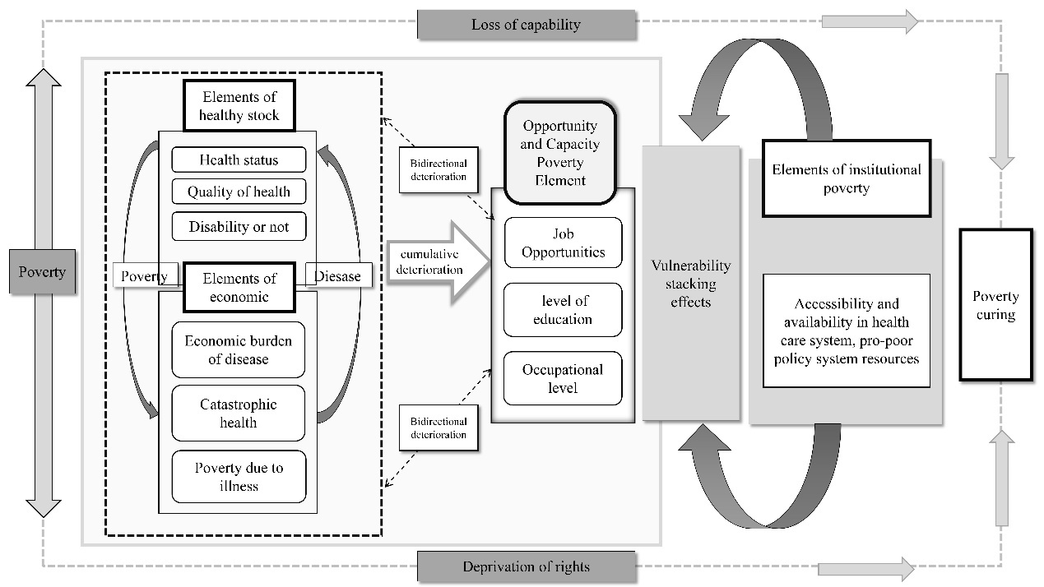
Figure S1 Interaction between health poverty and its influencing factors. This figure shows that the dual interaction between health stocks and economic poverty creates a vicious chain of disease-poverty cycles, which is further exacerbated by the superimposition of opportunity and capability factors, and finally solidifies health poverty under the influence of institutional factors.

Distribution of HPI in B&R countries under different economic subgroups
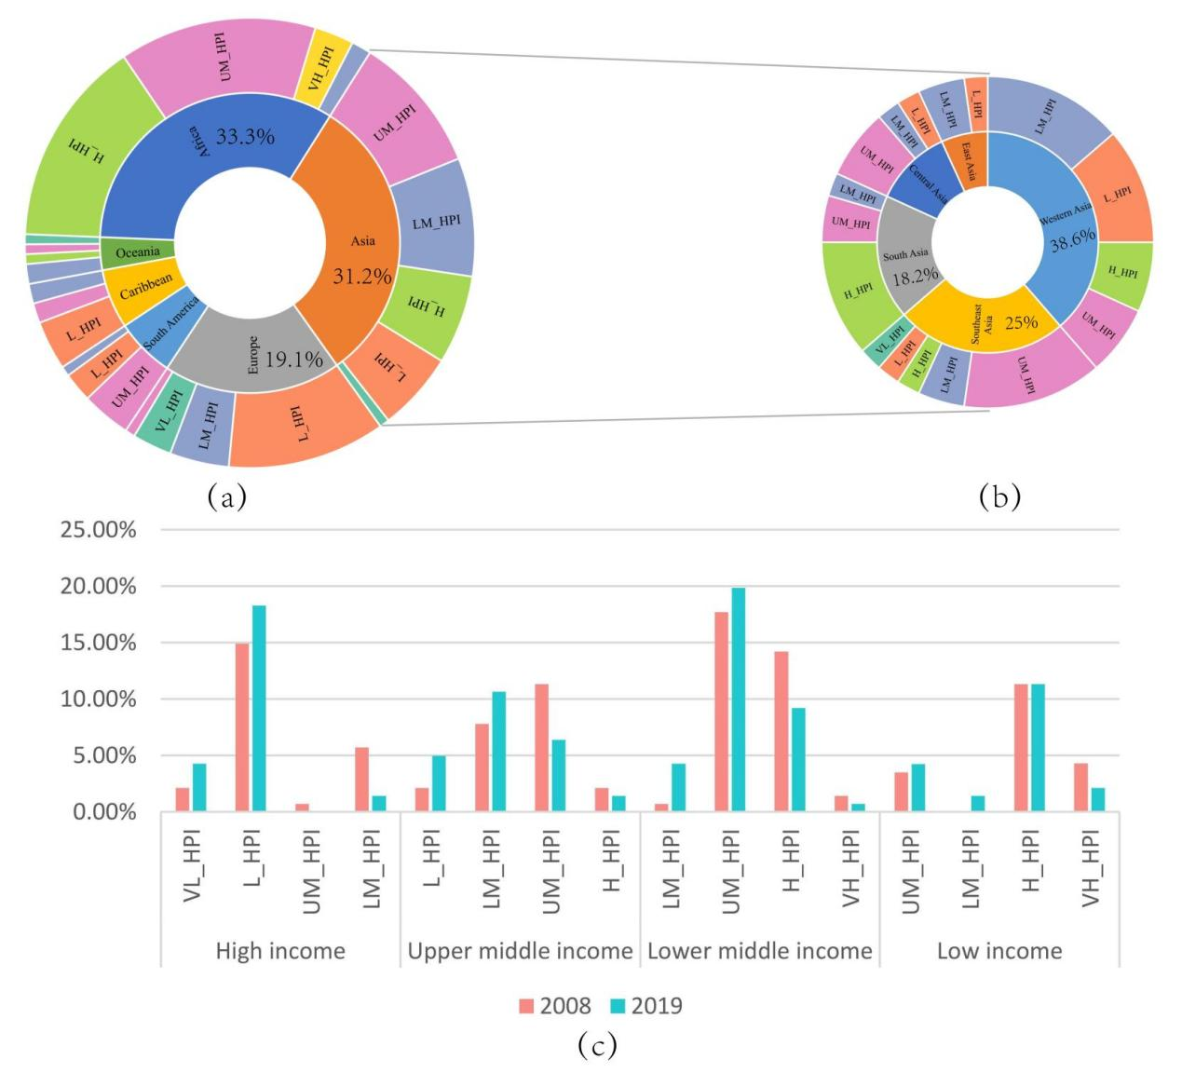
Figure S2. HPI distribution in different income groups. Sector chart (a) shows the percentage of countries in the sample (N=141) for each continent and their share of each HPI category, and sector chart (b) further shows the health poverty situation in the respective regions of Asia. Bar chart (c) then shows the health poverty status in each economic subgroup in 2008 and 2019.

Comparison of the OLS model and the GTWR model
TableS2. Estimated coefficients of OLS and VIF value.
HPI | Coef. | St.Err. | t-value | p-value | 95%CI | VIF
X1 | -0.9088 | 0.0554 | -16.4000 | p <.001 | (-1.0175,-0.8001) | 3.25
X2 | -3.8381 | 0.1492 | -25.7300 | p <.001 | (-4.1306,-3.5455) | 2.53
X3 | -0.2138 | 0.0122 | -17.5300 | p <.001 | (-0.2377,-0.1899) | 2.1
X4 | -0.0554 | 0.0079 | -6.9900 | p <.001 | (-0.0710,-0.0399) | 2.03
X5 | -0.7935 | 0.0491 | -16.1700 | p <.001 | (-0.8897,-0.6973) | 1.16
X6 | -0.1082 | 0.0124 | -8.7300 | p <.001 | (-0.1325,-0.0839) | 2.15
X7 | 0.1915 | 0.0360 | 5.3100 | p <.001 | (0.1208,0.2622) | 1.08
X8 | -0.1593 | 0.0374 | -4.2600 | p <.001 | (-0.2326,-0.0860) | 1.06
Constant | 81.9275 | 0.6690 | 122.4700 | p <.001 | (80.6155,83.2396)

TableS3. Estimated coefficients of influencing factors in GTWR
 | Intercept | X1 | X2 | X3 | X4 | X5 | X6 | X7 | X8
MIN | 59.1996 | -3.6724 | -12.6698 | -0.6821 | -0.3286 | -2.2622 | -0.6103 | -1.3560 | -1.0762
LQ | 76.4332 | -1.5492 | -6.2449 | -0.2937 | -0.0900 | -0.7666 | -0.2797 | -0.2290 | -0.2867
MEAN | 82.4098 | -0.3958 | -4.2075 | -0.2039 | -0.0422 | -0.4545 | -0.1541 | 0.0798 | -0.1325
UQ | 87.4093 | -0.4349 | -2.2602 | -0.0988 | -0.0045 | -0.2751 | -0.0582 | 0.4649 | 0.0343
MAX | 109.6431 | 8.7806 | 0.3242 | 0.2546 | 0.2224 | 4.5107 | 0.5429 | 1.9095 | 1.0924
TableS4. Comparison of OLS and GTWR models
 | OLS | GTWR
Neighbor | / |  | 170
RSS | 100469.73 | 35096.2
R-square | 0.85891 | 0.950744
AICc | 11729.7 | 10255.5
TableS5. Results of spatial nonstationary test
Variable | Interquartile Range | 2*SE(OLS) | Extra local variation
X1 | 1.1143 | 0.1108 | Y
X2 | 3.9847 | 0.2984 | Y
X3 | 0.1949 | 0.0244 | Y
X4 | 0.0855 | 0.0158 | Y
X5 | 0.4915 | 0.0982 | Y
X6 | 0.2215 | 0.0248 | Y
X7 | 0.6939 | 0.072 | Y
X8 | 0.3210 | 0.0748 | Y

Reference
1 Feng Y. The History of the Silk Road and Complex in Contemporary China. In: Wang X, Zhu L, eds. 2017 4TH INTERNATIONAL CONFERENCE ON LITERATURE, LINGUISTICS AND ARTS (ICLLA 2017). London: Francis Acad Press, 2017: 15–9.
2 Deniz T. Ancient Silk Road Geography in the Light of New Hopes. Marmara Geogr Rev 2016; : 195–202.
3 Xu S, Qiao B, Yang Y. The rise of the Maritime Silk Road about 2000 years ago: Insights from Indo-Pacific beads in Nanyang, Central China. J Archaeol Sci-Rep 2022; 42: 103383.
4 Poverty and Famines. https://sc.panda321.com/extdomains/books.google.com/books/about/Poverty_and_Famines.html?hl=zh-CN&id=FVC9eqGkMr8C (accessed Feb 1, 2023).
5 Shamim T. Nurkse’s model of vicious circle of poverty theory: Is it applicable for dental profession in India. J Fam Med Prim Care 2022; 11: 1221–2.
6 Yang Y, Dong S, Li F, et al. Interregional polarized and trickling-down effect of carbon emission space and the optimization policies: Case studies of the Jing-Jin-Ji region. Journal of Cleaner Production 2022; 370: 133426.
7 Stekhoven DJ, Buehlmann P. MissForest-non-parametric missing value imputation for mixed-type data. Bioinformatics 2012; 28: 112–8.

