Hyperexpansion of genetic diversity and metabolic capacity of extremophilic bacteria and archaea in ancient Andean Lake sediments
María Ángeles Lezcano^{1,2*}, Till L.V. Bornemann³, Laura Sánchez-García¹, Daniel Carrizo¹, Panagiotis S. Adam^{3,4}, Sarah P. Esser³, Nathalie A. Cabrol⁵, Alexander J. Probst^{3,6}, Víctor Parro¹

¹ Centro de Astrobiología (CAB), CSIC-INTA, 28850 Torrejón de Ardoz, Madrid, Spain
² IMDEA Water Institute, Avenida Punto Com 2, 28805 Alcalá de Henares, Madrid, Spain
³ Environmental metagenomics, Research Center One Health Ruhr of the University Alliance Ruhr, University of Duisburg-Essen, Essen, Germany
⁴ Institute of General Microbiology, Kiel University, Kiel, Germany
⁵ SETI Institute & NASA-ARC, Carl Sagan Center, Mountian View, CA, United States of America
⁶ Centre of Water and Environmental Research (ZWU), University of Duisburg-Essen, Essen, Germany

*Corresponding author: María Ángeles Lezcano (mangeles.lezcano@gmail.com, mangeles.lezcano@imdea.org)

Table of contents
Figure S1. Conventional ¹⁴C dates for total organic fraction and reservoir-corrected age-depth relationship for samples A, C and F from the Laguna Lejía terrace.
Figure S2. Molecular distribution of lipids extracted in the non-polar fraction in the six sediment samples from the Laguna Lejía terrace.
Figure S3. Molecular distribution of the lipids extracted in the acidic fraction (alkanoic or fatty acids) in the six sediment samples from Laguna Lejía terrace.
Figure S4. Molecular distribution of the lipids extracted in the polar fraction in the six sediment samples from Laguna Lejía terrace.
Figure S5. Diversity (Shannon-Wiener index) and richness (number of different rpS3 genes) of Laguna Lejía sediment samples.
Figure S6. Principal Component Analysis (PCA) triplot of the prokaryotic community composition at the taxonomic phylum level of the Laguna Lejía sediments.
Figure S7. Principal coordinate analysis (PCoA) showing the dissimilarities of the Lejía sediment samples based on the Bray-Curtis index
Table S1. Concentration of standards used in semiquantitative determination by ICP-MS.
Table S2. Relative abundance (coverage and % coverage) and number of rpS3 genes identified in the Laguna Lejía terrace at the kingdom, phylum and family level (separated Excel file).
Table S3. Key enzymes and encoding genes used for metabolic pathway annotations of assembled reads from the prokaryotic community and metagenome-assembled genomes (MAGs) from the Laguna Lejía terrace (separated Excel file).
Table S4. Pearson correlations between the abundance of phyla and soluble element concentrations in the sediments from the Laguna Lejía terrace.
Table S5. Pearson correlations between the abundance of phyla and minerals in the sediment samples from the Laguna Lejía terrace.
Table S6. Prediction of metabolic potencial of the prokaryotic community (metagenome assemblies) of the Laguna Lejía terrace based on the identification of key enzymes and encoding genes (separated Excel file).
Table S7. Map of predicted metabolic potential and estimated in silico replication rates of the 591 metagenome-assembled genomes (MAGs) reconstructed from the Laguna Lejía terrace (separated Excel file).

Figure S1. Conventional ¹⁴C dates for total organic fraction (blue squares) and reservoir-corrected age-depth relationship (blue diamonds on the dashed black line) for samples A, C and F from the Laguna Lejía terrace based on data calculations from Geyh et al. (1999) (dark/grey circles and squares). Reservoir-corrected age of sample A is ~11,000 yr BP, that of sample C is ~10,650 yr BP, and that of sample F is ~10,300 yr BP. The figure used as the basis for our calculations is extracted from Geyh et al. (1999) (Cambridge University Press, reproduced with permission).
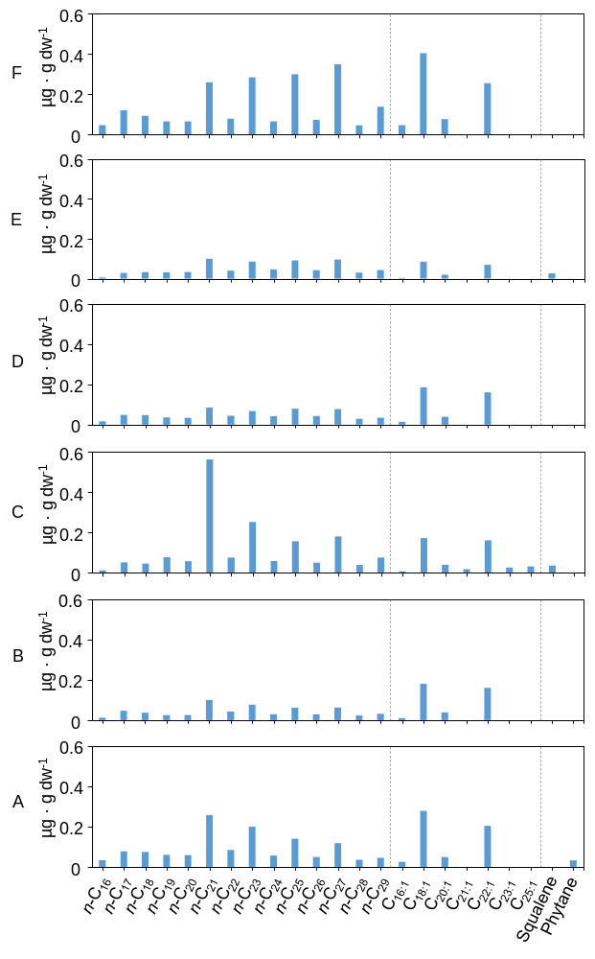
Figure S2. Molecular distribution of lipids extracted in the non-polar fraction in the six sediment samples from Laguna Lejía terrace: linear and saturated alkanes (n-alkanes or n-C_{n}), alkanes with one double bond (alkenes or C_{n:1}), and isoprenoids (squalene and phytane). The dashed lines separate the distinct groups of lipid families.

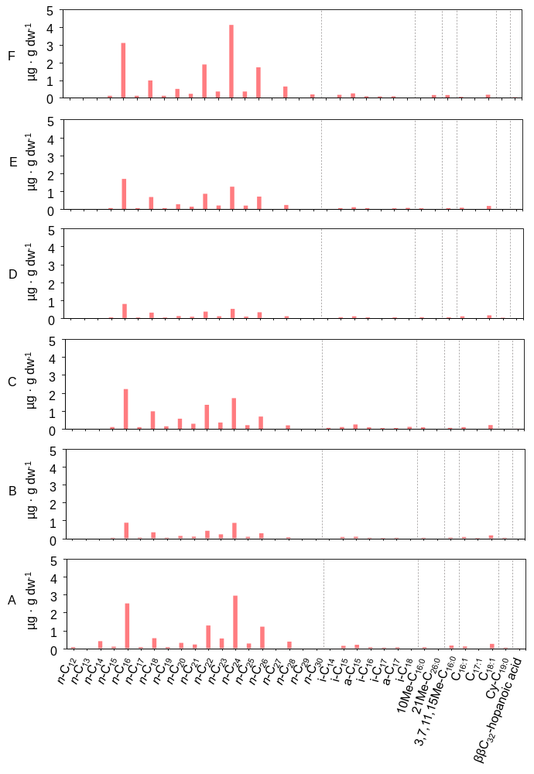
Figure S3. Molecular distribution of the lipids extracted in the acidic fraction (alkanoic or fatty acids) in the six sediment samples from Laguna Lejía terrace: straight chain fatty acids (n-fatty acids), fatty acids with a methyl group in the N-1 (iso or -i) or N-2 (anteiso or a-) carbon, other monomethylated fatty acids (e.g., 10Me-C_{16:0}), tetramethylated (i.e., 3,7,11,15Me-C_{16:0}) fatty acids, monounsaturated fatty acids (e.g., C_{16:1}), cyclopropyl fatty acids (i.e., Cy-C_{19:0}), and hopanoic acid (i.e., 17β(H),21β(H)-bishomohopanoic acid or ββ-C₃₂-hopanoic acid). The dashed lines separate the distinct groups of lipid families.
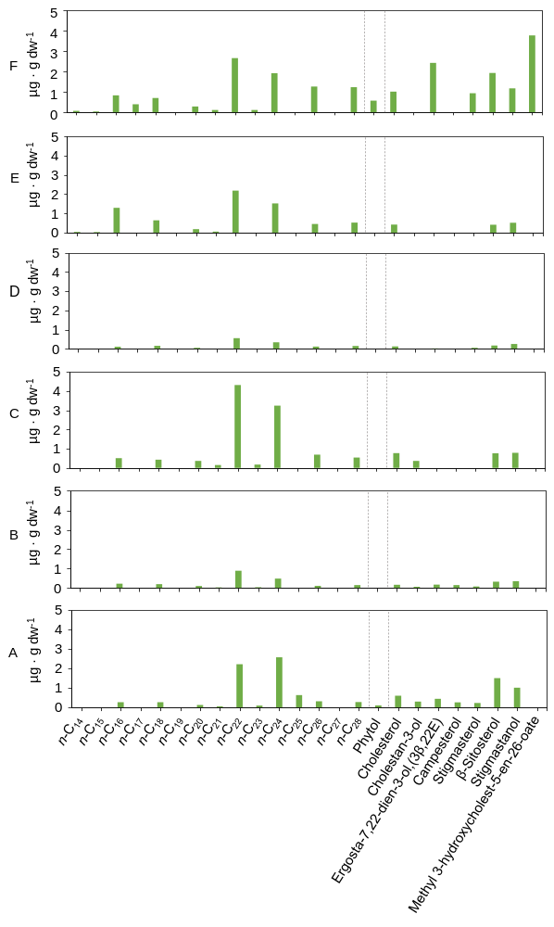
Figure S4. Molecular distribution of the lipids extracted in the polar fraction in the six sediment samples from Laguna Lejía terrace: n-alkanols, alkanodiols, phytol, and sterols. The dashed lines separate the distinct groups of lipid families.

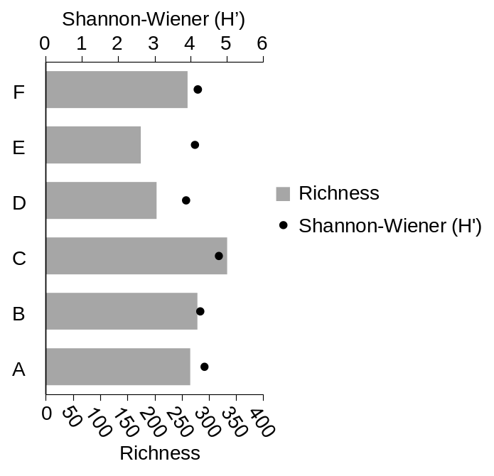
Figure S5. Diversity (Shannon-Wiener index) and richness (number of different rpS3 genes) of Laguna Lejía sediment samples.

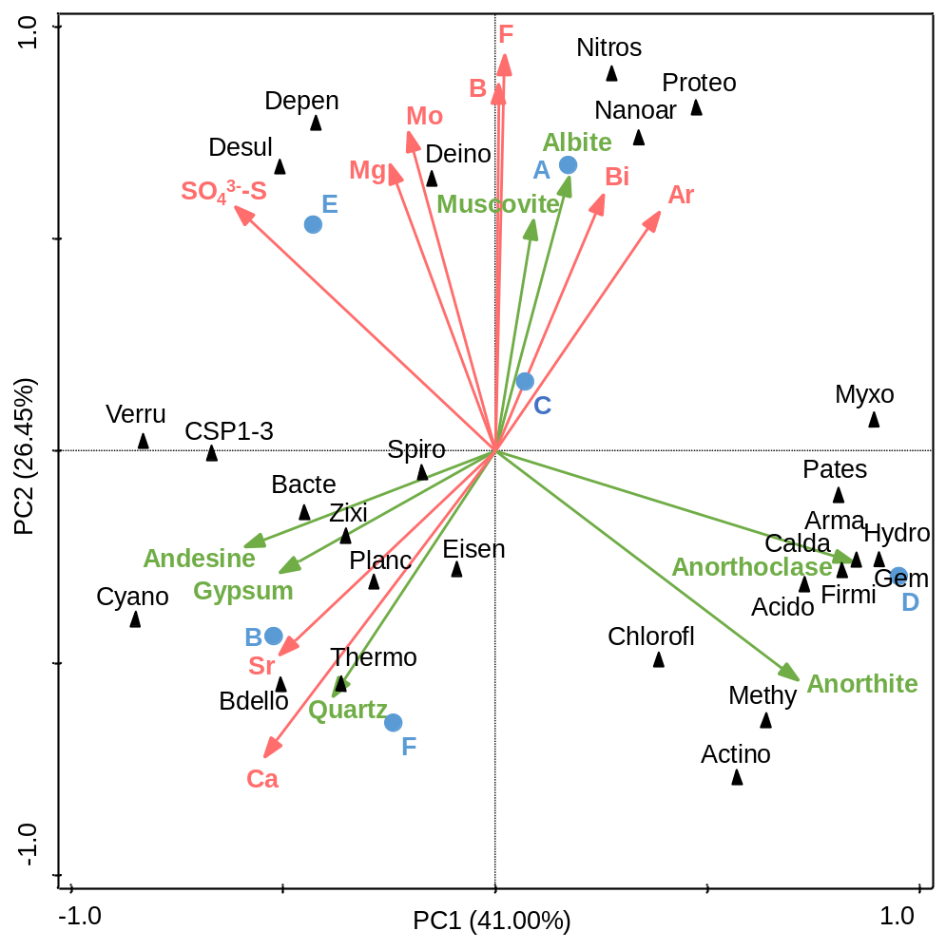
Figure S6. Principal Component Analysis (PCA) triplot of the prokaryotic community composition at the taxonomic phylum level (black triangles) of the Laguna Lejía sediments (blue dots). Soluble elements (red vectors) and minerals (red vectors) with high positive (r>0.8) or negative (r<-0.8) correlation with phyla (Table S4 and S5) were post hoc included in the PCA as supplementary variables to aid interpretation. Labels from prokaryotes are: Acido, Acidobacteriota; Actino, Actinobacteriota; Arma, Armatimonadota; Bacte, Bacteroidota; Bdello, Bdellovibrionota; Calda, Caldatribacteriota; Chlorofl, Chloroflexota; Cyano, Cyanobacteria; Deino, Deinococcota; Depen, Dependentiae; Desul, Desulfobacterota; Eisen, Eisenbacteria; Firmi, Firmicutes; Gem, Gemmatimonadota; Hydro, Hydrogenedentota; Methy, Methylomirabilota; Myxo, Myxococcota, Nanoar, Nanoarchaeota; Nitros, Nitrospirota; Pates, Patescibacteria; Planc, Planctomycetota; Proteo, Proteobacteria; Spiro, Spirochaetota; Thermo, Thermoproteota; Verru, Verrucomicrobiota; Zixi, Zixibacteria.

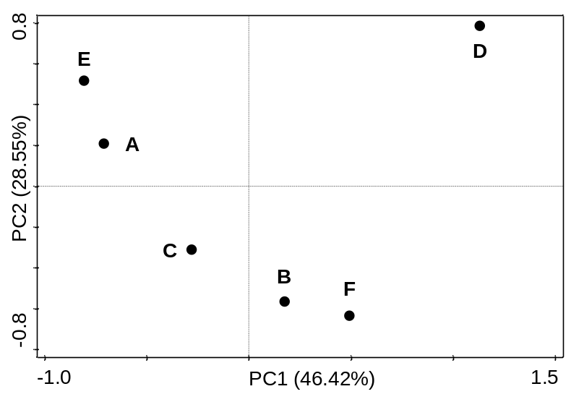
Figure S7. Principal coordinate analysis (PCoA) showing the dissimilarities of the Lejía sediment samples (black dots) based on the Bray-Curtis index calculated from the relative abundances of the rpS3 genes.
Element | External Standard (ppb) | QC.Std (ppb)
Ag | 50 | 100
Al | 49 | 98
As | 490 | 980
B | 490 | 980
Ba | 48.5 | 97
Be | 510 | 1020
Bi | 49 | 98
Ca | 4945 | 9890
Cd | 49.5 | 99
Co | 49.5 | 99
Cr | 49.5 | 99
Cu | 49.5 | 99
Fe | 500 | 1000
Ga | 49.5 | 99
K | 49 | 98
Li | 49.5 | 99
Mg | 49 | 98
Mn | 49.5 | 99
Mo | 49.5 | 99
Na | 48.5 | 97
Ni | 49.5 | 99
Pb | 49 | 98
Rb | 49.5 | 99
Se | 505 | 1010
Sr | 500 | 1000
Te | 49.5 | 99
Tl | 49.5 | 99
U | 49 | 98
V | 49 | 98
Zn | 495 | 990
Ce | 50 | 100
Dy | 50 | 100
Er | 50 | 100
Eu | 50 | 100
Gd | 50 | 100
Ho | 50 | 100
La | 50 | 100
Lu | 50 | 100
Nd | 50 | 100
Pr | 50 | 100
Sm | 50 | 100
Sc | 50 | 100
Tb | 50 | 100
Th | 50 | 100
Tm | 50 | 100
Y | 50 | 100
Yb | 50 | 100
Table S1. Concentration of standards used in semiquantitative determination by ICP-MS.

Table S4. Pearson correlations between the abundance of phyla (calculated as the sum of rpS3 coverage) and soluble element concentrations in the sediments from the Laguna Lejía terrace. Red numbers indicate statistically significant positive correlations (r>0.8, p-value<0.05), and blue numbers indicate statistically significant negative correlations (r<-0.8, p-value<0.05).
Phyla | Cl | Na | Mg | K | Ca | SO₄³⁻-S | B | F | Li | NO₃⁻-N | Br | Ar | V | Rb | Sr | Mo | Bi
Acidobacteriota | -0.30 | -0.39 | -0.55 | 0.00 | 0.00 | -0.75 | -0.36 | -0.28 | -0.34 | -0.08 | -0.07 | 0.39 | 0.13 | -0.12 | 0.07 | -0.53 | -0.19
Actinobacteriota | -0.67 | -0.69 | -0.65 | -0.28 | 0.10 | -0.85 | -0.62 | -0.69 | -0.62 | -0.61 | -0.40 | -0.22 | 0.04 | -0.53 | -0.07 | -0.68 | -0.24
Armatimonadota | -0.45 | -0.36 | -0.25 | -0.28 | -0.37 | -0.63 | -0.10 | -0.32 | -0.36 | -0.57 | -0.52 | 0.09 | 0.30 | -0.52 | -0.44 | -0.27 | 0.29
Bacteroidota | -0.05 | -0.22 | -0.31 | -0.18 | 0.35 | -0.01 | -0.46 | -0.01 | -0.23 | 0.14 | 0.17 | -0.35 | -0.53 | 0.07 | 0.26 | -0.27 | -0.70
Bdellovibrionota | -0.31 | -0.46 | -0.61 | 0.22 | 0.98 | -0.24 | -0.78 | -0.68 | -0.30 | 0.03 | 0.30 | -0.47 | -0.39 | 0.12 | 0.81 | -0.64 | -0.70
Caldatribacteriota | -0.45 | -0.36 | -0.25 | -0.28 | -0.37 | -0.63 | -0.10 | -0.32 | -0.36 | -0.57 | -0.52 | 0.09 | 0.30 | -0.52 | -0.44 | -0.27 | 0.29
Chloroflexota | -0.70 | -0.81 | -0.94 | -0.37 | 0.38 | -0.89 | -0.75 | -0.51 | -0.77 | -0.33 | -0.34 | -0.09 | -0.58 | -0.43 | 0.13 | -0.91 | -0.22
CSP1-3 | -0.28 | -0.16 | 0.07 | -0.24 | 0.30 | 0.26 | -0.12 | -0.33 | -0.15 | -0.44 | -0.29 | -0.78 | -0.33 | -0.33 | -0.04 | 0.01 | 0.18
Cyanobacteria | -0.18 | -0.20 | -0.19 | 0.26 | 0.85 | 0.16 | -0.44 | -0.61 | -0.05 | -0.10 | 0.22 | -0.65 | -0.20 | 0.09 | 0.64 | -0.26 | -0.34
Deinococcota | 0.30 | 0.22 | 0.22 | -0.19 | -0.37 | 0.22 | 0.11 | 0.46 | 0.11 | 0.20 | 0.12 | 0.03 | -0.01 | 0.13 | -0.23 | 0.27 | -0.40
Dependentiae | 0.32 | 0.36 | 0.30 | -0.04 | -0.34 | 0.31 | 0.57 | 0.68 | 0.24 | 0.39 | -0.02 | 0.51 | -0.24 | 0.16 | -0.25 | 0.35 | 0.65
Desulfobacterota | 0.12 | 0.21 | 0.31 | -0.31 | -0.22 | 0.44 | 0.40 | 0.48 | 0.07 | 0.05 | -0.24 | -0.09 | -0.49 | -0.11 | -0.35 | 0.34 | 0.58
Eisenbacteria | 0.28 | 0.08 | -0.10 | 0.29 | 0.25 | 0.05 | -0.28 | 0.03 | 0.14 | 0.42 | 0.56 | 0.05 | 0.11 | 0.45 | 0.46 | -0.07 | -0.89
Firmicutes | -0.38 | -0.33 | -0.23 | -0.36 | -0.48 | -0.61 | -0.12 | -0.18 | -0.36 | -0.50 | -0.47 | 0.10 | 0.27 | -0.49 | -0.51 | -0.23 | 0.10
Gemmatimonadota | -0.40 | -0.37 | -0.31 | -0.32 | -0.41 | -0.68 | -0.17 | -0.22 | -0.39 | -0.46 | -0.44 | 0.17 | 0.25 | -0.46 | -0.43 | -0.31 | 0.08
Hydrogenedentota | -0.45 | -0.36 | -0.25 | -0.28 | -0.37 | -0.63 | -0.10 | -0.32 | -0.36 | -0.57 | -0.52 | 0.09 | 0.30 | -0.52 | -0.44 | -0.27 | 0.29
Methylomirabilota | -0.52 | -0.43 | -0.31 | -0.32 | -0.31 | -0.67 | -0.18 | -0.40 | -0.43 | -0.63 | -0.55 | 0.01 | 0.25 | -0.57 | -0.42 | -0.33 | 0.25
Myxococcota | -0.45 | -0.35 | -0.26 | -0.34 | -0.44 | -0.66 | -0.04 | -0.21 | -0.38 | -0.53 | -0.56 | 0.20 | 0.22 | -0.54 | -0.51 | -0.27 | 0.41
Nanoarchaeota | 0.16 | 0.18 | 0.08 | -0.15 | -0.38 | 0.04 | 0.42 | 0.60 | 0.05 | 0.30 | -0.14 | 0.58 | -0.30 | 0.03 | -0.31 | 0.15 | 0.62
Nitrospirota | 0.76 | 0.81 | 0.82 | 0.12 | -0.76 | 0.69 | 0.90 | 0.98 | 0.66 | 0.53 | 0.22 | 0.59 | 0.32 | 0.40 | -0.43 | 0.87 | 0.40
Patescibacteria | -0.41 | -0.42 | -0.44 | -0.51 | -0.47 | -0.74 | -0.16 | 0.03 | -0.51 | -0.33 | -0.51 | 0.31 | -0.14 | -0.48 | -0.52 | -0.39 | 0.17
Planctomycetota | -0.62 | -0.62 | -0.45 | -0.66 | 0.34 | -0.21 | -0.59 | -0.43 | -0.65 | -0.61 | -0.51 | -0.91 | -0.78 | -0.60 | -0.13 | -0.46 | -0.20
Proteobacteria | 0.17 | 0.23 | 0.23 | -0.33 | -0.75 | 0.01 | 0.57 | 0.73 | 0.05 | 0.14 | -0.31 | 0.62 | -0.13 | -0.12 | -0.65 | 0.30 | 0.70
Spirochaetota | 0.10 | 0.02 | 0.07 | -0.31 | -0.21 | 0.12 | -0.10 | 0.23 | -0.07 | 0.00 | 0.00 | -0.25 | -0.15 | -0.04 | -0.21 | 0.11 | -0.49
Thermoproteota | -0.11 | -0.28 | -0.53 | 0.47 | 0.91 | -0.23 | -0.61 | -0.54 | -0.10 | 0.29 | 0.50 | -0.08 | -0.16 | 0.35 | 0.91 | -0.55 | -0.64
Verrucomicrobiota | 0.23 | 0.05 | -0.20 | 0.59 | 0.83 | 0.19 | -0.36 | -0.22 | 0.20 | 0.56 | 0.72 | -0.05 | -0.12 | 0.61 | 0.93 | -0.21 | -0.69
Zixibacteria | -0.27 | -0.37 | -0.55 | -0.04 | 0.57 | -0.26 | -0.40 | -0.19 | -0.33 | 0.13 | 0.02 | -0.03 | -0.68 | 0.00 | 0.40 | -0.52 | -0.05

Table S5. Pearson correlations between the abundance of phyla (calculated as the sum of rpS3 coverage) and minerals in the sediment samples from the Laguna Lejía terrace. Red numbers indicate statistically significant positive correlations (r>0.8, p-value<0.05), and blue cells indicate statistically significant negative correlations (r<-0.8, p-value<0.05).
Phyla | Magnesium Calcite | Albite | Andesine | Anorthite | Anorthoclase | Muscovite | Gypsum | Halite | Quartz
Acidobacteriota | -0.11 | 0.07 | -0.70 | 0.84 | 0.66 | 0.02 | -0.54 | -0.06 | 0.03
Actinobacteriota | -0.42 | -0.42 | -0.18 | 0.89 | 0.82 | -0.40 | -0.10 | -0.55 | 0.14
Armatimonadota | -0.46 | -0.27 | -0.27 | 0.87 | 1.00 | -0.23 | -0.28 | -0.37 | -0.43
Bacteroidota | 0.29 | 0.22 | 0.08 | -0.49 | -0.61 | 0.01 | 0.22 | 0.07 | 0.83
Bdellovibrionota | -0.04 | -0.30 | 0.30 | 0.00 | -0.40 | -0.17 | 0.42 | -0.34 | 0.77
Caldatribacteriota | -0.46 | -0.27 | -0.27 | 0.87 | 1.00 | -0.23 | -0.28 | -0.37 | -0.43
Chloroflexota | -0.50 | 0.26 | -0.17 | 0.45 | 0.26 | 0.34 | 0.13 | -0.49 | 0.26
CSP1-3 | -0.41 | -0.40 | 0.98 | -0.44 | -0.30 | -0.18 | 0.87 | -0.55 | 0.00
Cyanobacteria | -0.12 | -0.58 | 0.73 | -0.20 | -0.43 | -0.35 | 0.67 | -0.42 | 0.44
Deinococcota | 0.53 | 0.25 | -0.28 | -0.37 | -0.25 | -0.13 | -0.29 | 0.45 | 0.41
Dependentiae | -0.03 | 0.82 | -0.11 | -0.50 | -0.36 | 0.90 | -0.02 | 0.35 | -0.56
Desulfobacterota | -0.20 | 0.54 | 0.49 | -0.81 | -0.55 | 0.65 | 0.51 | 0.02 | -0.37
Eisenbacteria | 0.69 | -0.05 | -0.42 | -0.06 | -0.31 | -0.36 | -0.39 | 0.43 | 0.82
Firmicutes | -0.27 | -0.17 | -0.41 | 0.77 | 0.92 | -0.28 | -0.40 | -0.22 | -0.24
Gemmatimonadota | -0.29 | -0.13 | -0.47 | 0.83 | 0.93 | -0.21 | -0.43 | -0.22 | -0.23
Hydrogenedentota | -0.46 | -0.27 | -0.27 | 0.87 | 1.00 | -0.23 | -0.28 | -0.37 | -0.43
Methylomirabilota | -0.50 | -0.32 | -0.21 | 0.88 | 1.00 | -0.27 | -0.21 | -0.45 | -0.38
Myxococcota | -0.50 | -0.08 | -0.33 | 0.83 | 0.98 | -0.03 | -0.30 | -0.34 | -0.53
Nanoarchaeota | -0.14 | 0.91 | -0.28 | -0.29 | -0.17 | 0.97 | -0.12 | 0.27 | -0.55
Nitrospirota | 0.53 | 0.53 | -0.35 | -0.52 | -0.27 | 0.32 | -0.46 | 0.78 | -0.43
Patescibacteria | -0.33 | 0.42 | -0.57 | 0.55 | 0.68 | 0.31 | -0.38 | -0.13 | -0.23
Planctomycetota | -0.49 | -0.11 | 0.79 | -0.40 | -0.28 | -0.04 | 0.88 | -0.67 | 0.43
Proteobacteria | -0.11 | 0.87 | -0.40 | -0.18 | 0.10 | 0.81 | -0.30 | 0.32 | -0.68
Spirochaetota | 0.38 | 0.09 | -0.05 | -0.37 | -0.25 | -0.25 | -0.05 | 0.21 | 0.54
Thermoproteota | 0.12 | -0.18 | -0.04 | 0.17 | -0.31 | -0.07 | 0.08 | -0.10 | 0.63
Verrucomicrobiota | 0.44 | -0.08 | 0.01 | -0.24 | -0.69 | -0.06 | 0.08 | 0.20 | 0.72
Zixibacteria | -0.29 | 0.46 | 0.14 | -0.21 | -0.44 | 0.66 | 0.39 | -0.21 | 0.19

