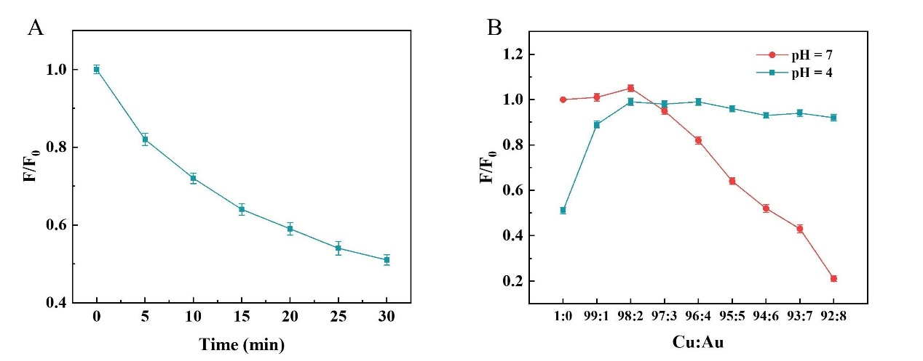
Fig. S1 (A) The change of fluorescence intensity at 655nm of CuNCs at pH 7. (B) The change of fluorescence intensity at 655nm of BSA-CuAuNCs at pH 7 and 4

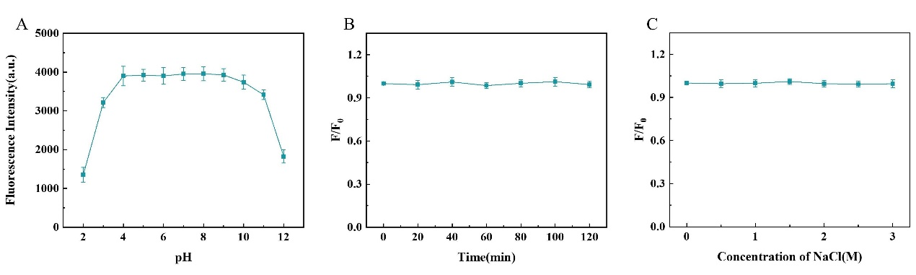
Fig. S2 Effects of pH value (A), illumination time (B) and ionic strength (C) on the stability of BSA-CuAuNCs

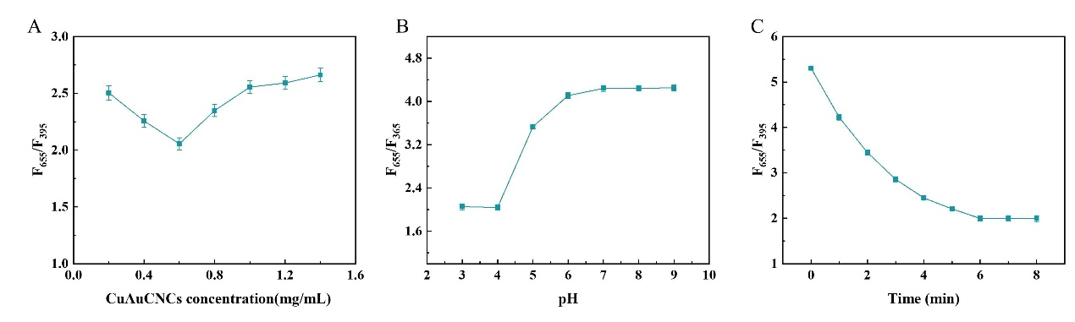
Fig. S3 Effects of CuAuNCs concentration (A), pH value (B) and reaction time (C) on the F₆₅₅/F₃₉₅ of detection system

