SUPPLEMENTARY MATERIAL FOR:

The Influence of Air Masses on Human Mortality in the United States

Cameron C. Lee^{1*}
Alindomar Silva¹
Chibuike Ibebuchi¹
Scott C. Sheridan¹

1 – Kent State University, Department of Geography, ClimRISE Laboratory
* - Corresponding Author Information:
433 McGilvrey Hall
325 S. Lincoln St.
Kent, Ohio 44242 USA
Ph: +1 (330) 672-0360
Email: cclee@kent.edu

FIGURES:

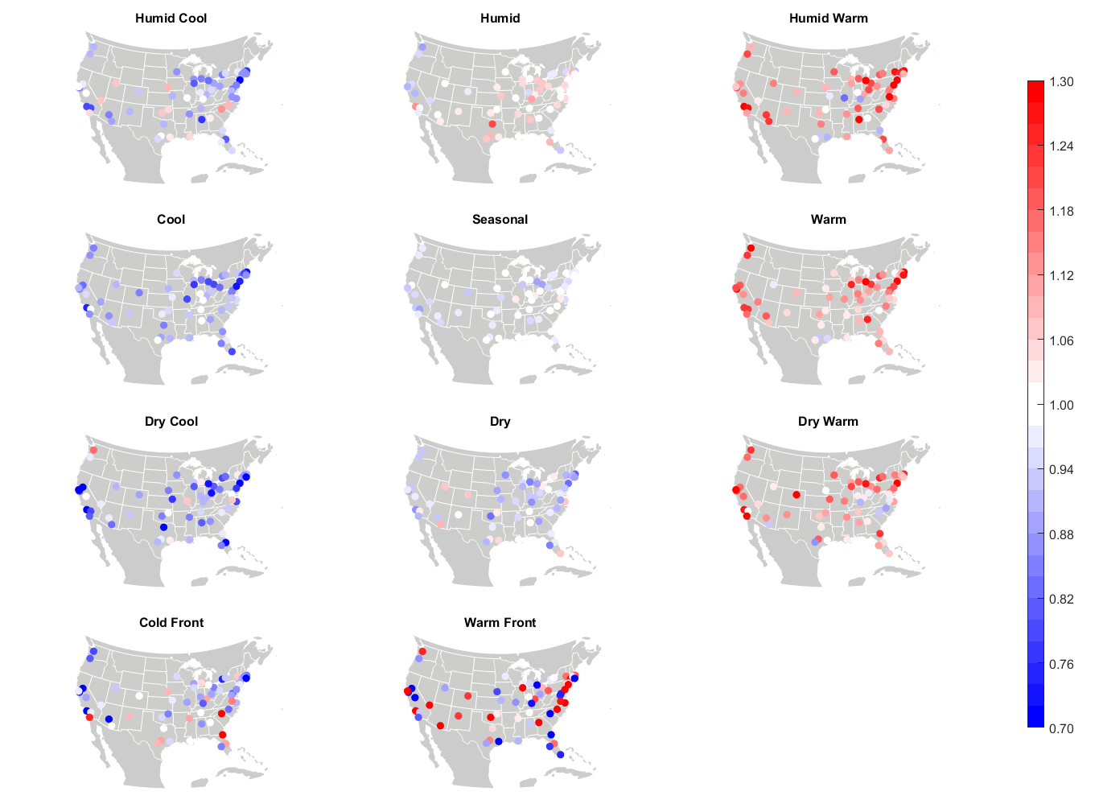
Summer – Lag 0
Figure S1: City-by-city relative risk of excess mortality in summer at Lag0 for each air mass.

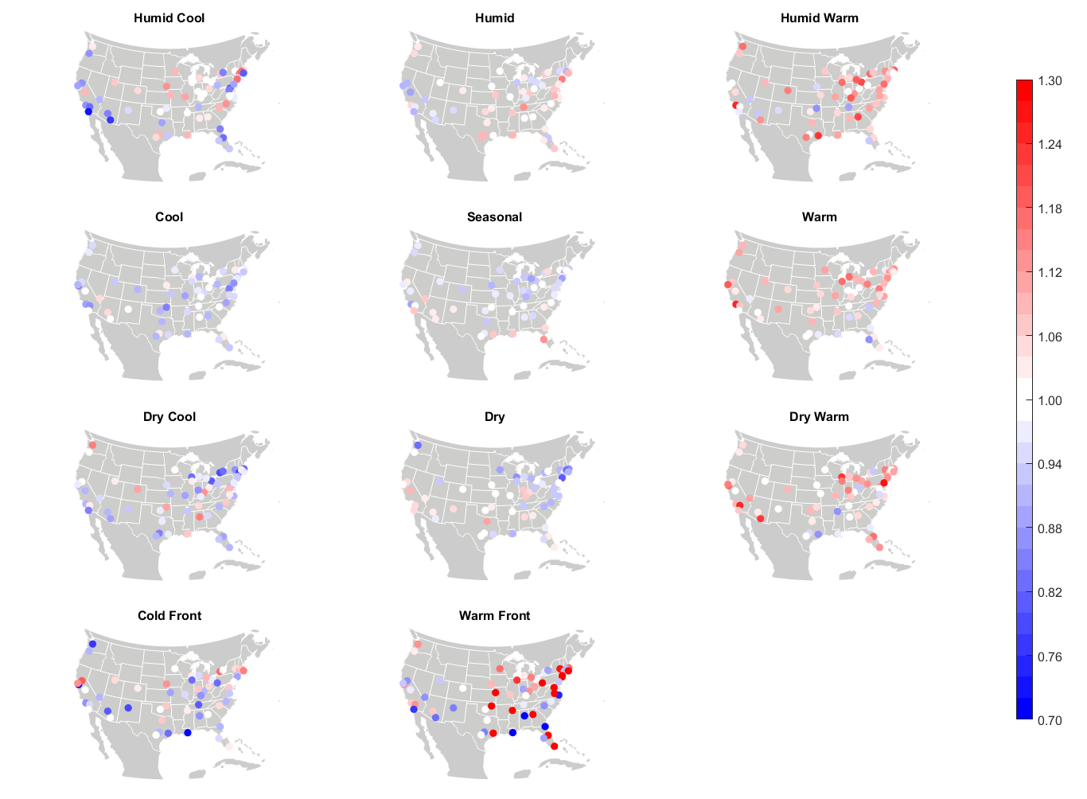
Autumn – Lag 0
Figure S2: Same as Figure S1, but for autumn.

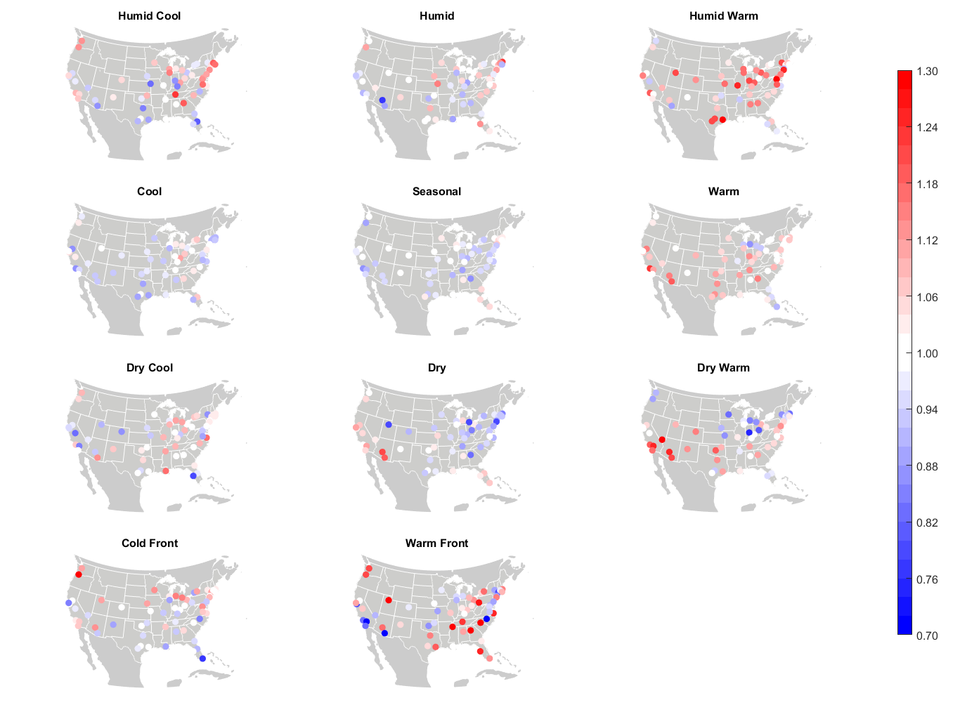
Winter – Lag 0
Figure S3: Same as Figure S1, but for winter.

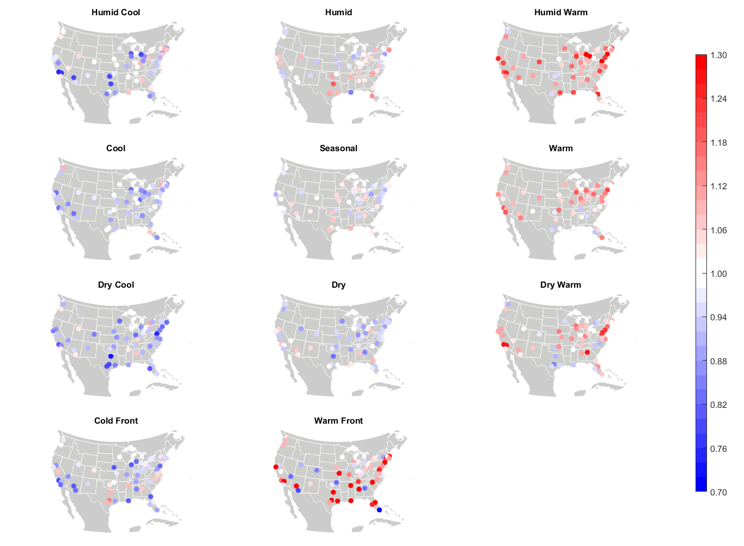
Spring – Lag 0
Figure S4: Same as Figure S1, but for spring.

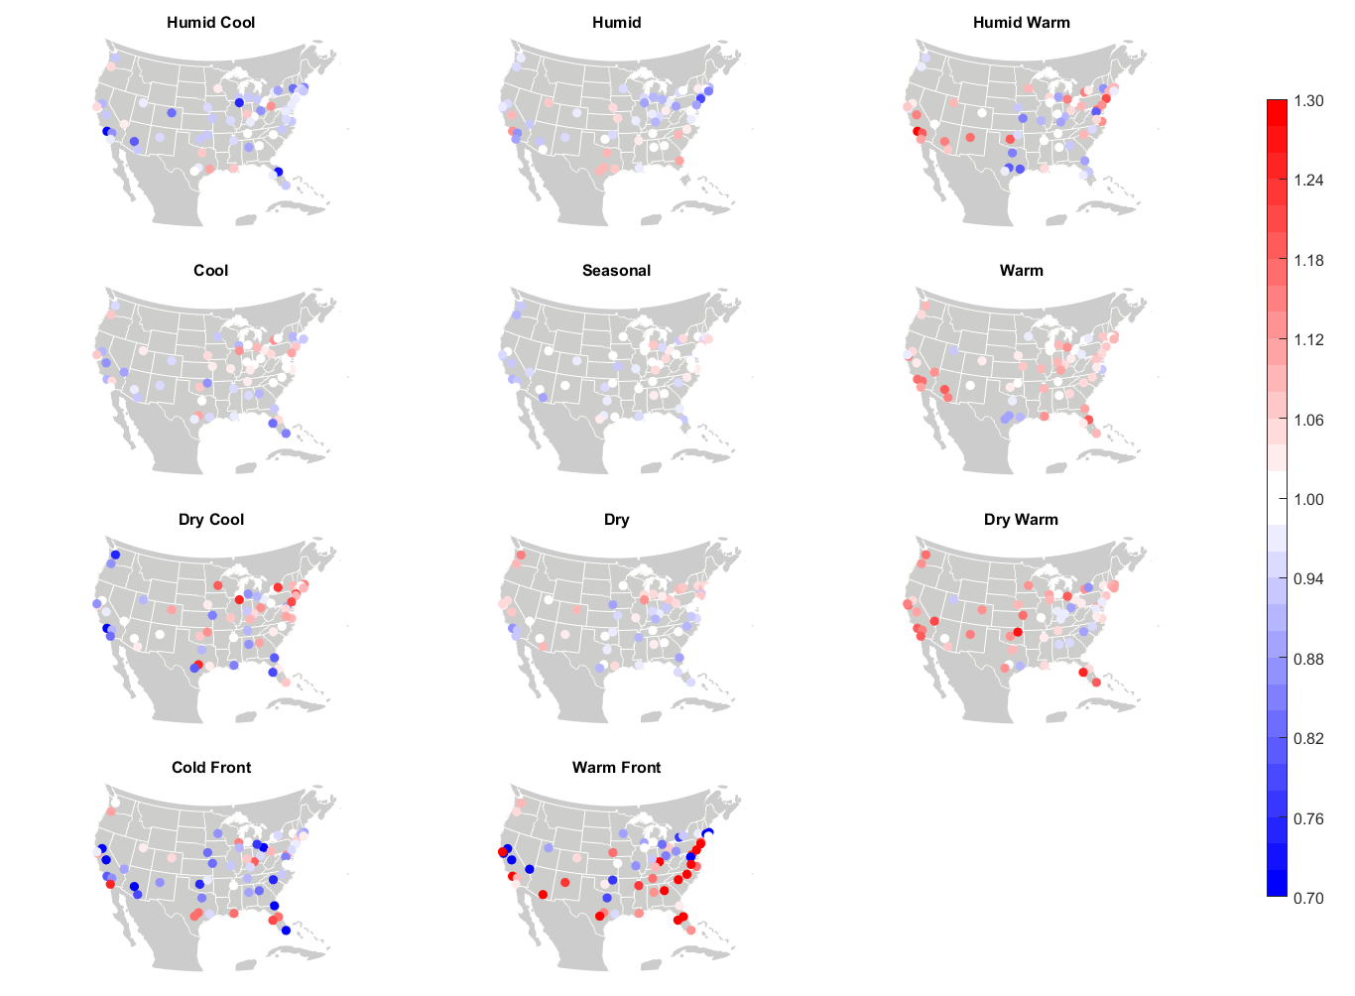
Summer – Lag 2
Figure S5: City-by-city relative risk of excess mortality in summer at Lag2 for each air mass.

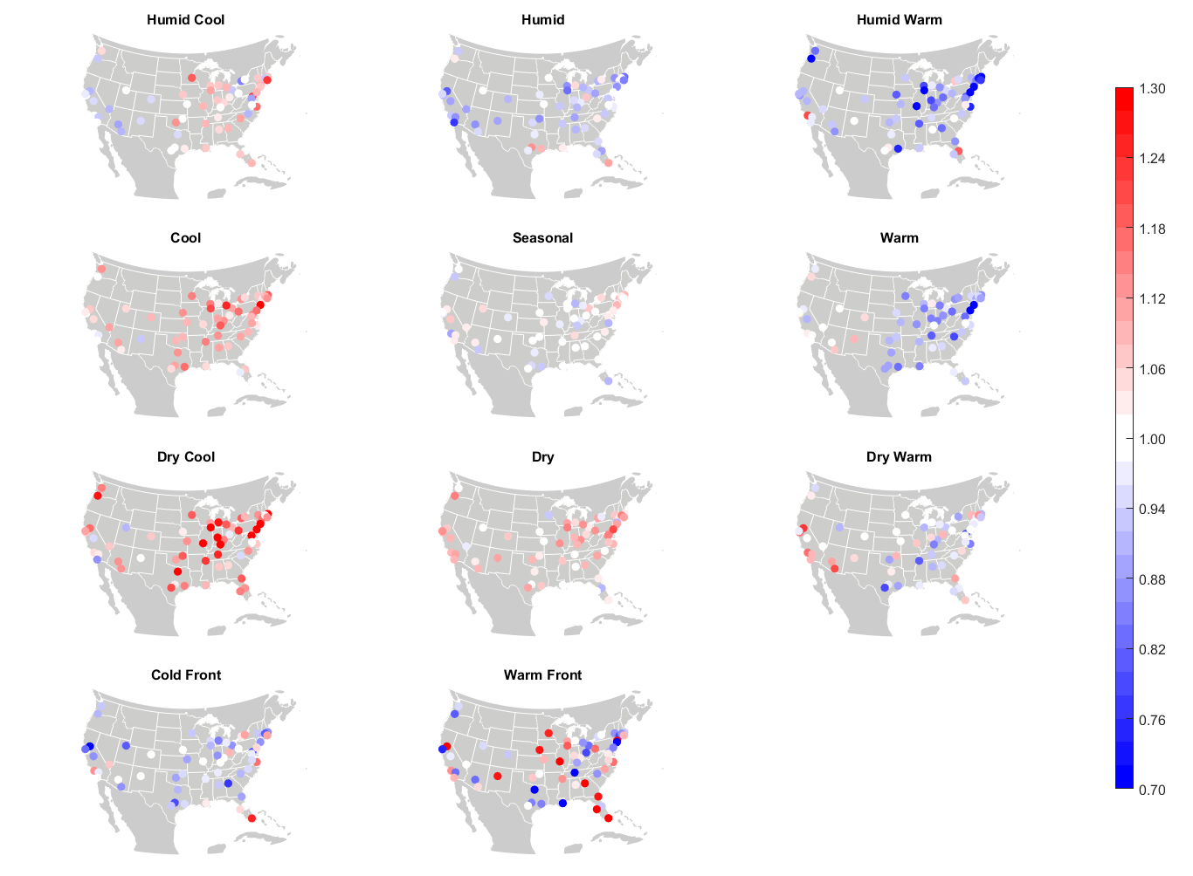
Autumn – Lag 2
Figure S6: Same as Figure S5, but for autumn.

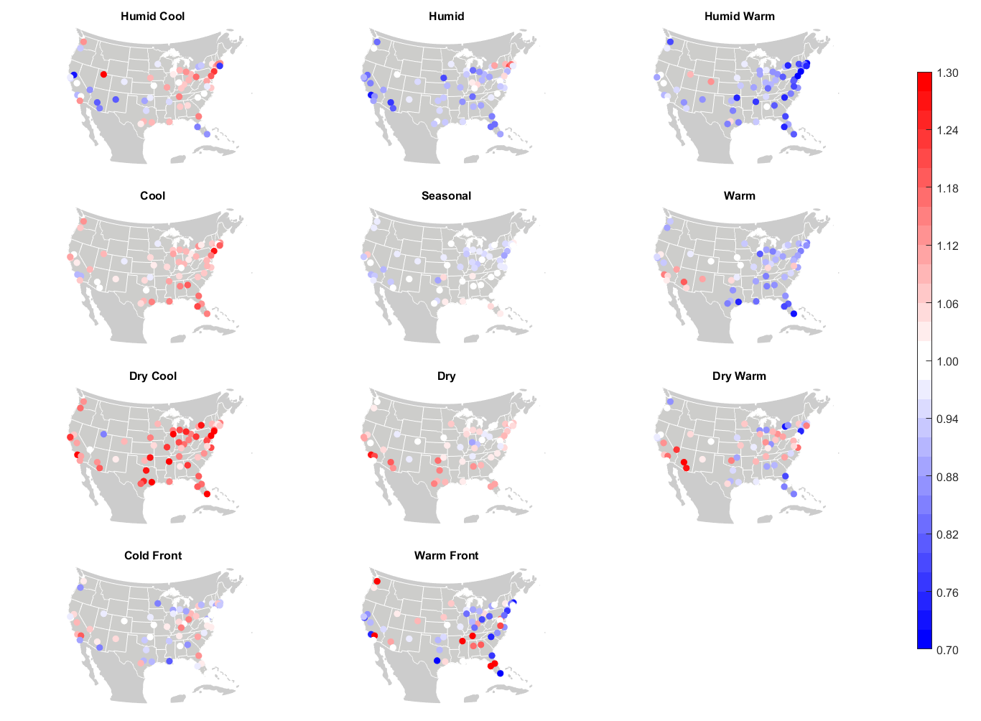
Winter – Lag 2
Figure S7: Same as Figure S5, but for winter.

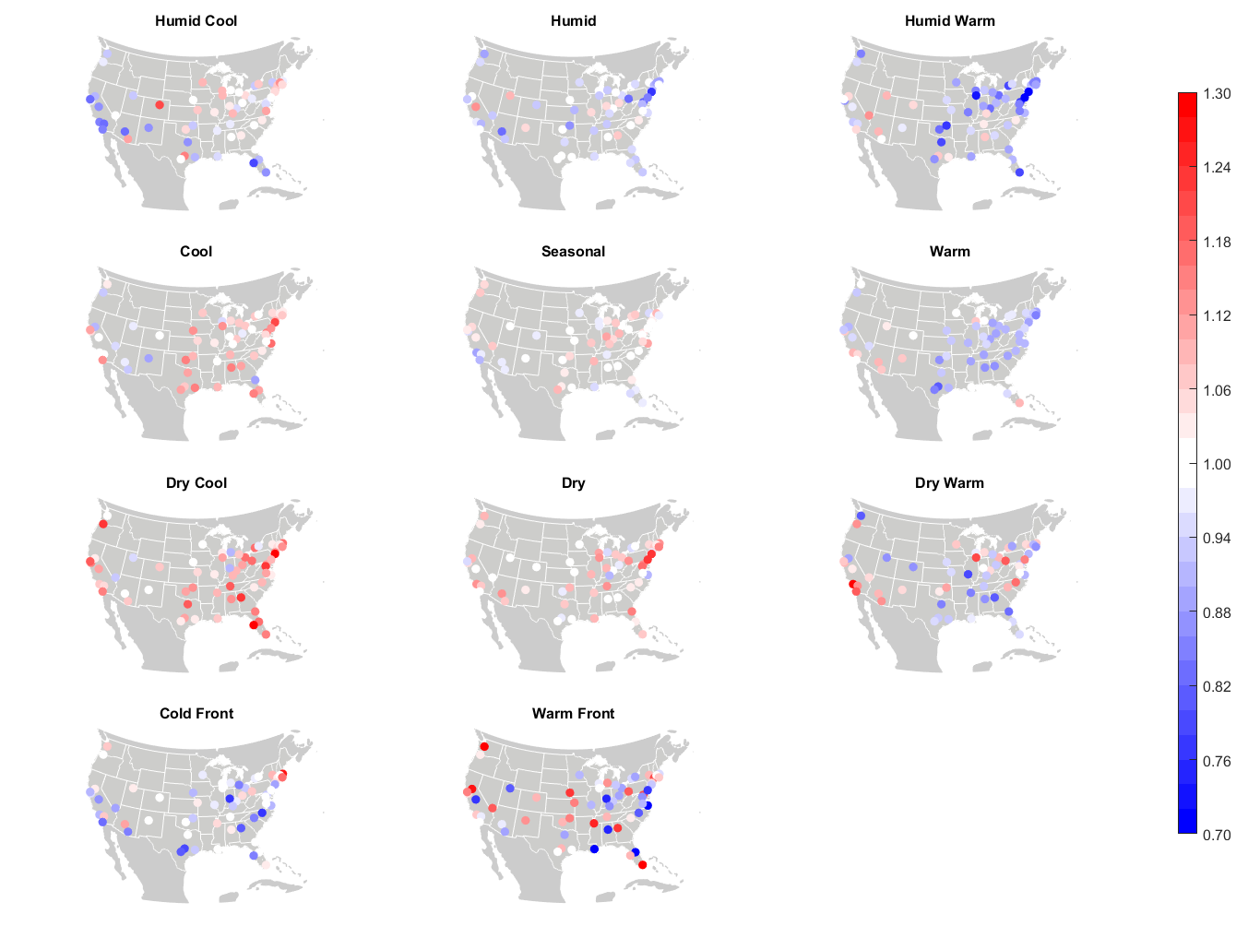
Spring – Lag 2
Figure S8: Same as Figure S5, but for spring.

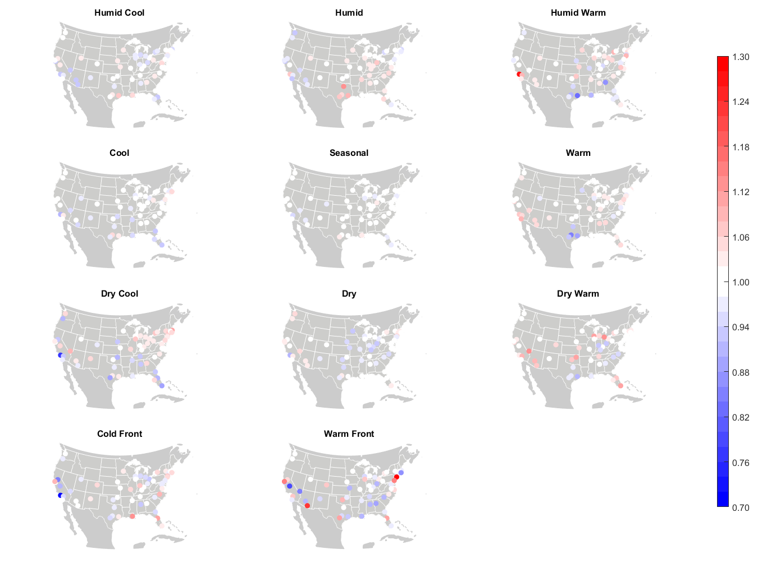
Summer
Lags 0-20
Figure S9: City-by-city relative risk of excess mortality in summer, averaged over Lags 0-20.

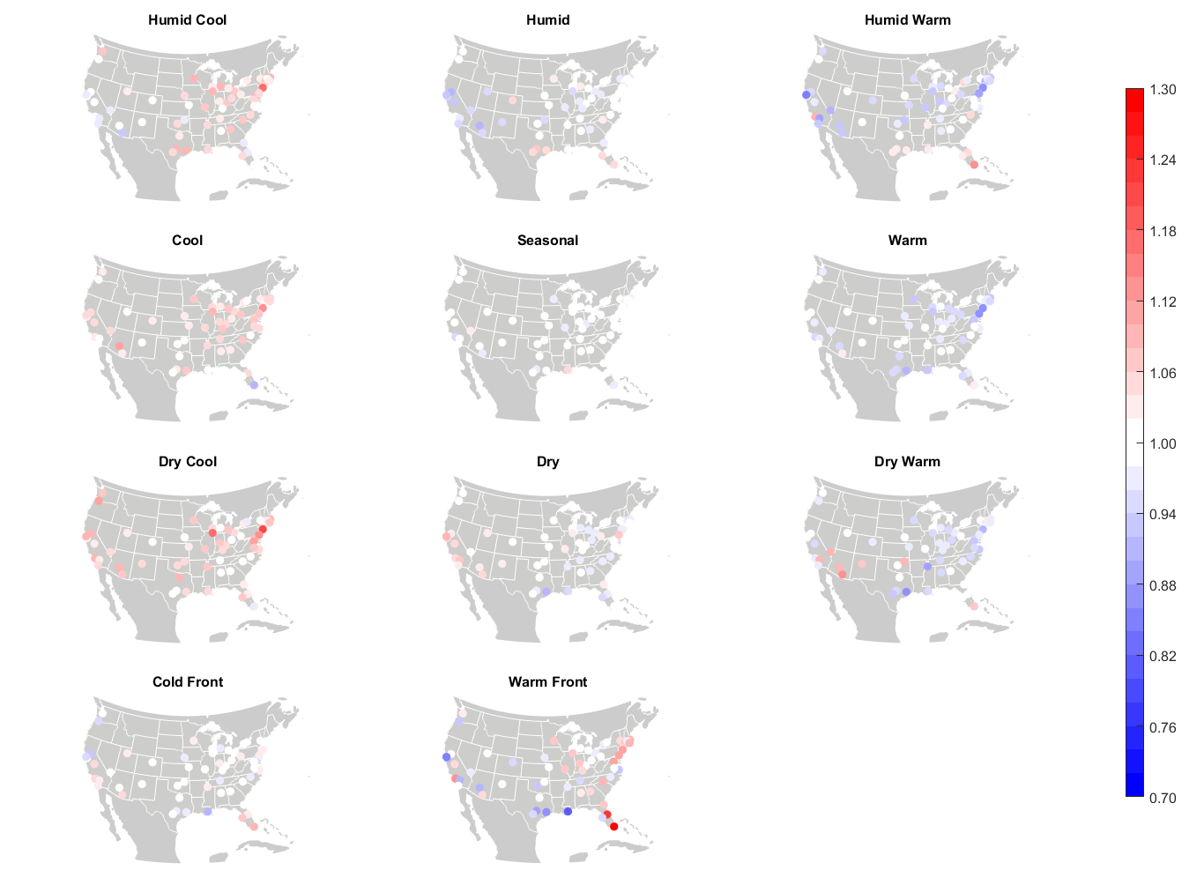
Autumn
Lags 0-20
Figure S10: Same as Figure S9, but for autumn.

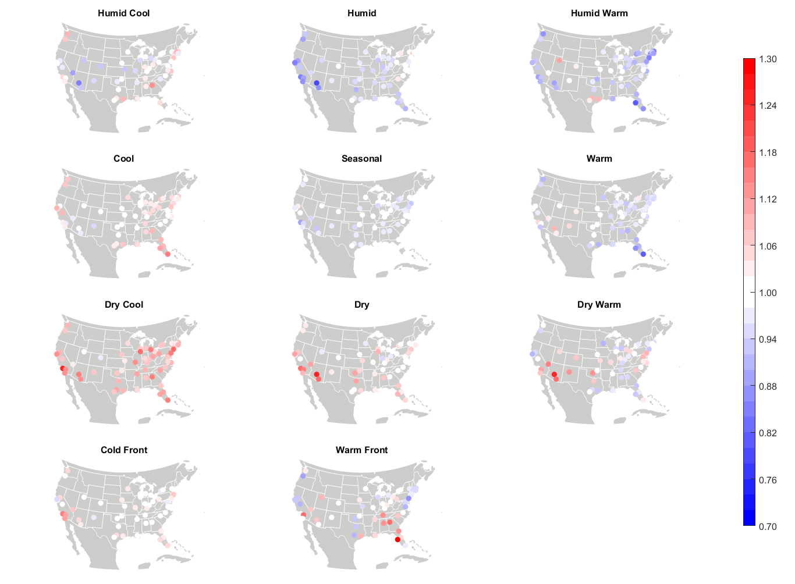
Winter
Lags 0-20
Figure S11: Same as Figure S9, but for winter.

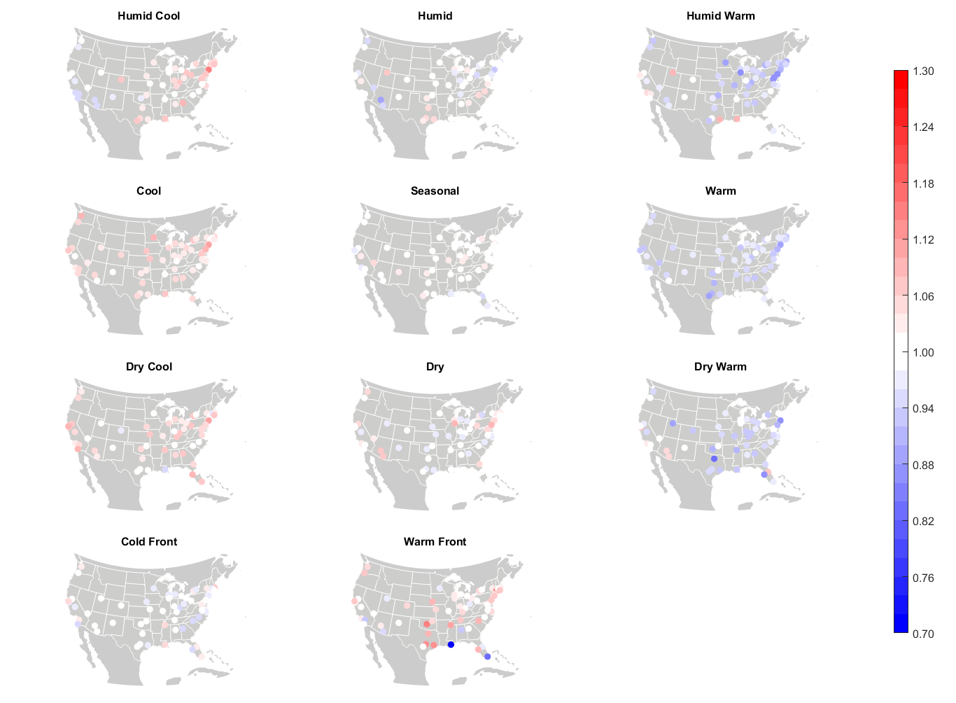
Spring
Lags 0-20
Figure S12: Same as Figure S9, but for spring.

