Supplementary materials
Effect of bedrock, tree size and time on growth and climate sensitivity of Norway spruce in the High Tatras
Saroj Basnet^{1*}, Andreas Burger¹, Zuzana Homolová², Frederik Märker¹, Mario Trouillier¹, Martin Wilmking¹
¹ Institute of Botany and Landscape Ecology, University of Greifswald, 17487 Greifswald, Germany
² Podtatra Museum in Poprad, Vajanského 72/4, Slovakia
*Corresponding author: Saroj Basnet
ORCID: 0000-0002-9584-3160
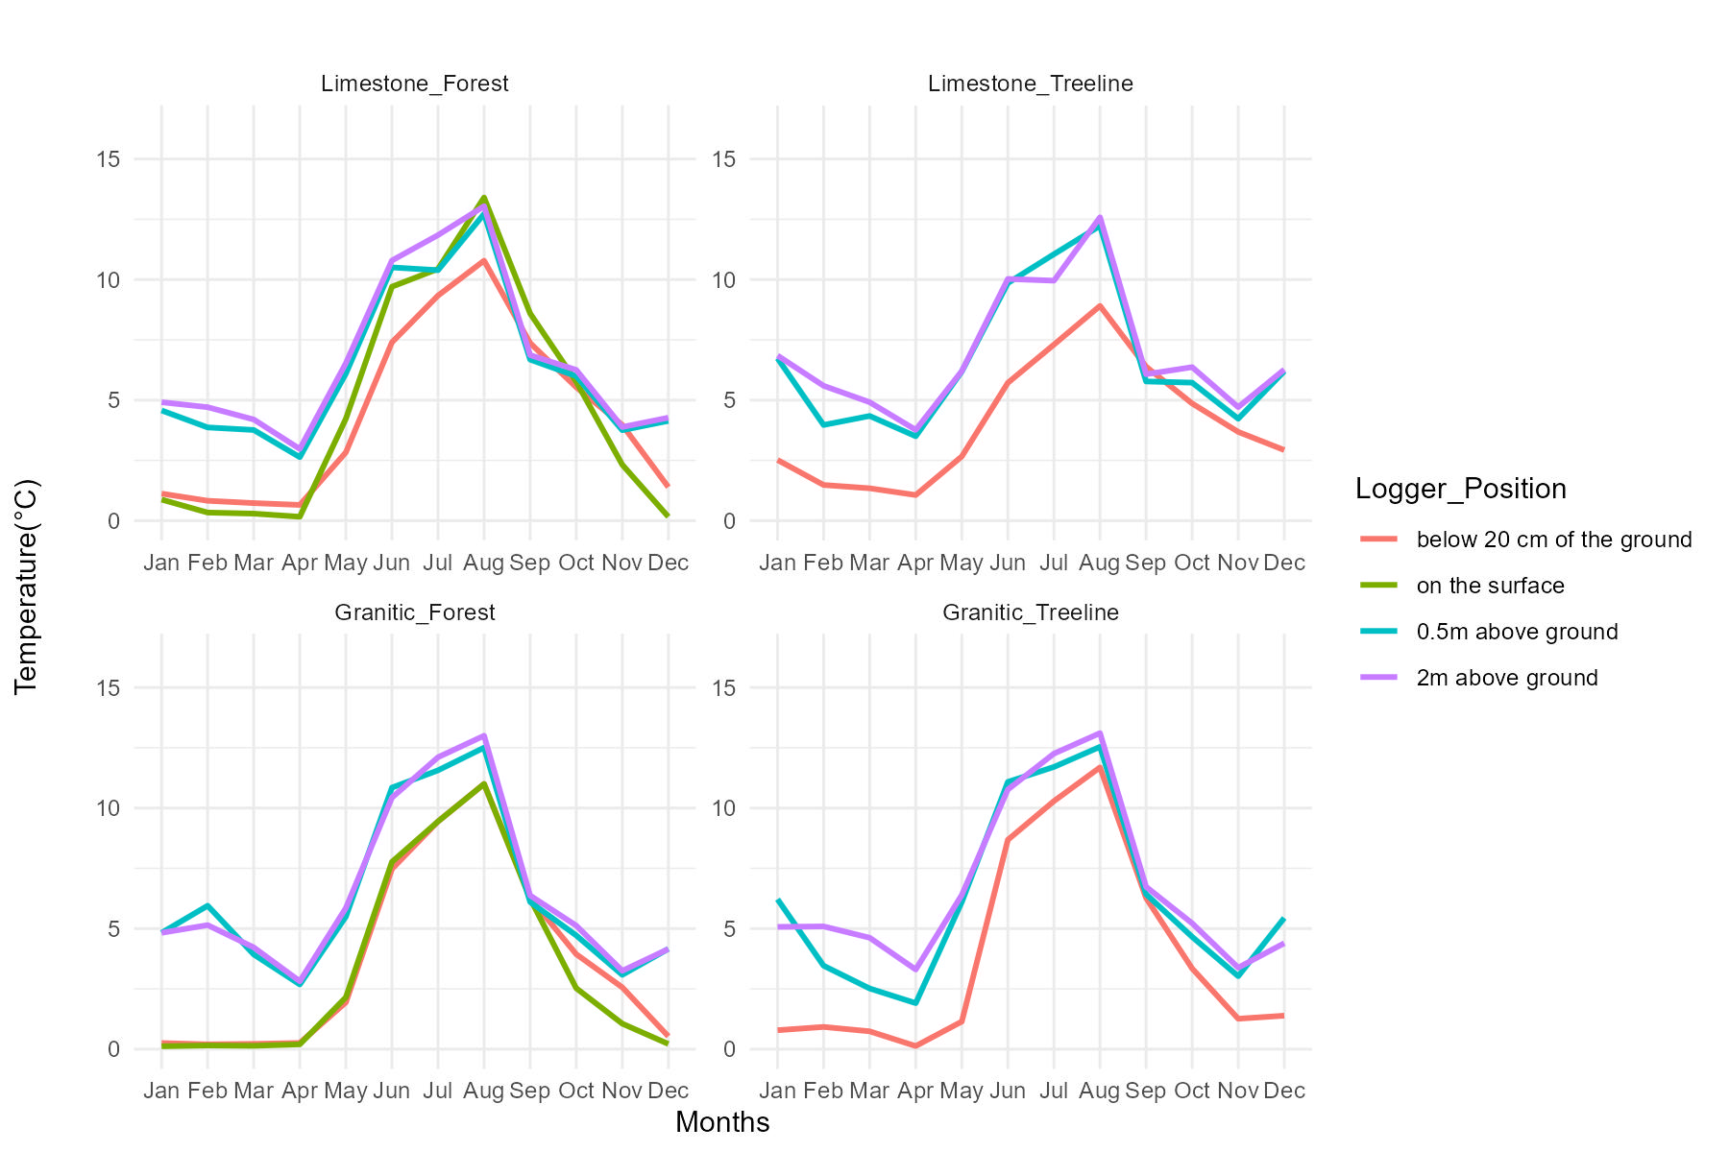
Email: saroj.basnet@uni-greifswald.de
Fig. S1 Temperature variation by site and height in Treeline and Forest Plots: Comparison between Limestone and Granitic Sites
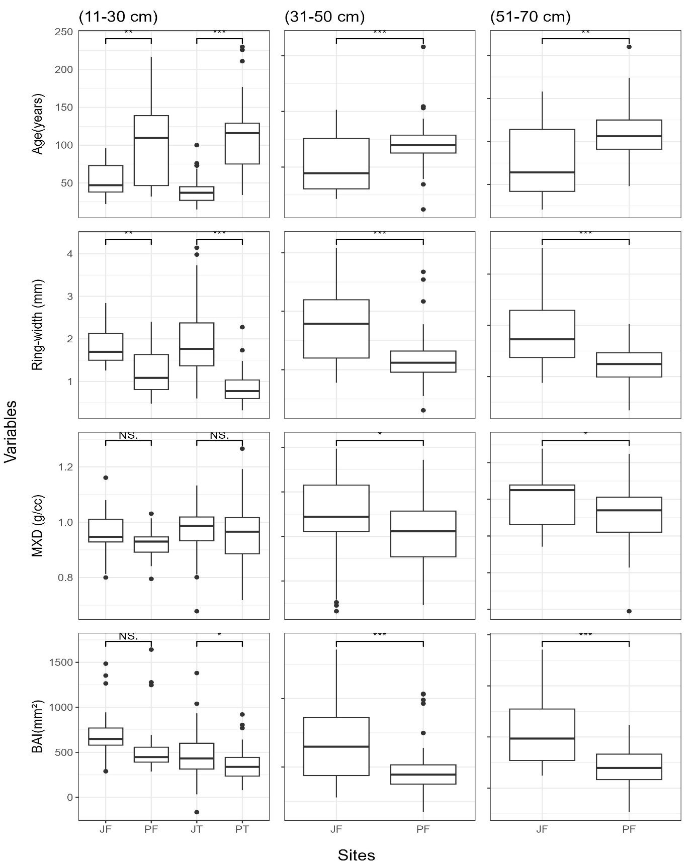
Fig. S2 Boxplots comparing limestone (JF= Limestone Forest and JT= Limestone Treeline) and granitic (PF=Granitic Forest and PT= Granitic Treeline) sites with respect to tree age, ring-width, MXD, and BAI. Symbol * represent significance level: * = p < 0.05, ** = p < 0.01, *** = p < 0.001 and (NS) = not significant.
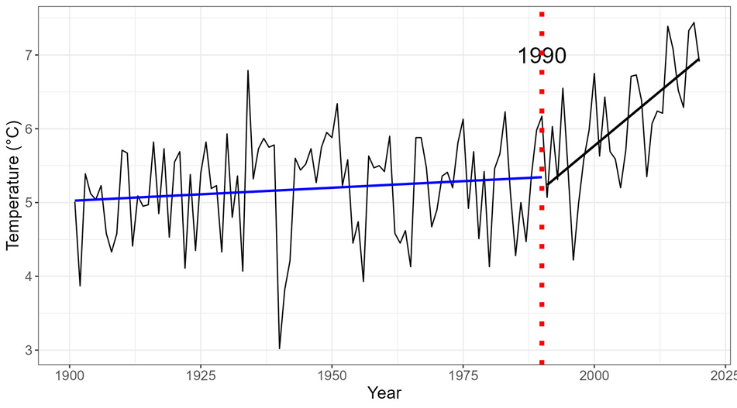
Fig. S3 Annual temperature trends for the period 1901–2022: Based on the breakpoint analysis (which is in the year 1990: represented by red dotted line), two equal sub periods i.e. 1960–1990 (blue) and 1990–2020 (black) were used to check the change of climate sensitivity over time.
Table S1 Site characteristics and chronology (maximum latewood density (MXD)) statistics of Picea abies. The dendrochronological statistics were computed based on the span of each DBH class chronology. Mean Annual Radial Growth Rate (Mean AGR; standard deviation (SD); mean sensitivity (MS); first year autocorrelation (AR1); mean inter-series correlation (Rbar); EPS, expressed population signal (EPS) and Signal to Noise Ratio (SNR) were calculated after detrending.
Statistics | Sites | Plots | DBH classes | Elevation (m a.s.l.) | Exposure | Trees | First year | Last year | Average series length (year) | Mean MXD (g/cm³) | SD MXD | Rbar | AR1 | MS | EPS | SNR
MXD | Limestone | Forest | (10-30 cm) | 1500m | South | 23 | 1910 | 2021 | 50 | 0.96 | 0.11 | 0.44 | 0.37 | 0.09 | 0.86 | 6.45
MXD | Limestone | Forest | (31-50cm) | 1500m | South | 35 | 1820 | 2021 | 107 | 0.94 | 0.12 | 0.56 | 0.38 | 0.11 | 0.95 | 16.37
MXD | Limestone | Forest | (51-70 cm) | 1500m | South | 26 | 1822 | 2021 | 118 | 0.9 | 0.12 | 0.53 | 0.29 | 0.19 | 0.92 | 10.82
MXD | Limestone | Treeline | (10-30 cm) | 1650m | South | 69 | 1923 | 2022 | 38 | 0.97 | 0.12 | 0.45 | 0.20 | 0.10 | 0.92 | 11.06
MXD | Granitic | Forest | (10-30 cm) | 1500m | South | 21 | 1802 | 2021 | 105 | 0.92 | 0.11 | 0.45 | 0.34 | 0.10 | 0.86 | 6.44
MXD | Granitic | Forest | (31-50cm) | 1500m | South | 46 | 1724 | 2021 | 134 | 0.9 | 0.12 | 0.61 | 0.28 | 0.11 | 0.97 | 32.52
MXD | Granitic | Forest | (51-70 cm) | 1500m | South | 31 | 1762 | 2021 | 151 | 0.85 | 0.12 | 0.59 | 0.35 | 0.12 | 0.95 | 20.71
MXD | Granitic | Treeline | (10-30 cm) | 1580m | South | 39 | 1792 | 2021 | 101 | 0.99 | 0.09 | 0.37 | 0.44 | 0.07 | 0.9 | 9.04

Statistics | Sites | Plots | DBH classes | Elevation (m a.s.l.) | Exposure | Trees | First year | Last year | Average series length (year) | Mean TRW [mm] | SD TRW | Rbar | AR1 | MS | EPS | SNR
TRW | Limestone | Forest | (10-30 cm) | 1500m | South | 25 | 1909 | 2021 | 72 | 1.84 | 0.64 | 0.52 | 0.72 | 0.16 | 0.90 | 8.48
TRW | Limestone | Forest | (31-50cm) | 1500m | South | 39 | 1819 | 2021 | 104 | 1.76 | 0.74 | 0.54 | 0.8 | 0.17 | 0.95 | 18.86
TRW | Limestone | Forest | (51-70 cm) | 1500m | South | 25 | 1814 | 2021 | 126 | 1.87 | 0.81 | 0.59 | 0.76 | 0.18 | 0.94 | 15.99
TRW | Limestone | Treeline | (10-30 cm) | 1650m | South | 79 | 1949 | 2022 | 74 | 0.99 | 0.27 | 0.42 | 0.59 | 0.2 | 0.93 | 13.98
TRW | Granitic | Forest | (10-30 cm) | 1500m | South | 22 | 1805 | 2021 | 101 | 1.28 | 0.47 | 0.54 | 0.73 | 0.18 | 0.91 | 9.97
TRW | Granitic | Forest | (31-50cm) | 1500m | South | 48 | 1706 | 2021 | 142 | 1.15 | 0.41 | 0.61 | 0.76 | 0.17 | 0.97 | 37.93
TRW | Granitic | Forest | (51-70 cm) | 1500m | South | 31 | 1762 | 2021 | 158 | 1.23 | 0.49 | 0.61 | 0.78 | 0.17 | 0.96 | 24.33
TRW | Granitic | Treeline | (10-30 cm) | 1580m | South | 43 | 1792 | 2021 | 109 | 0.88 | 0.37 | 0.49 | 0.77 | 0.19 | 0.95 | 17.65
Table S2 Site characteristics and chronology (tree-ring width (TRW)) statistics of Picea abies. The dendrochronological statistics were computed based on the span of each DBH class chronology. Mean Annual Radial Growth Rate (Mean AGR; standard deviation (SD); mean sensitivity (MS); first year autocorrelation (AR1); mean inter-series correlation (Rbar); EPS, expressed population signal (EPS) and Signal to Noise Ratio (SNR) were calculated after detrending.
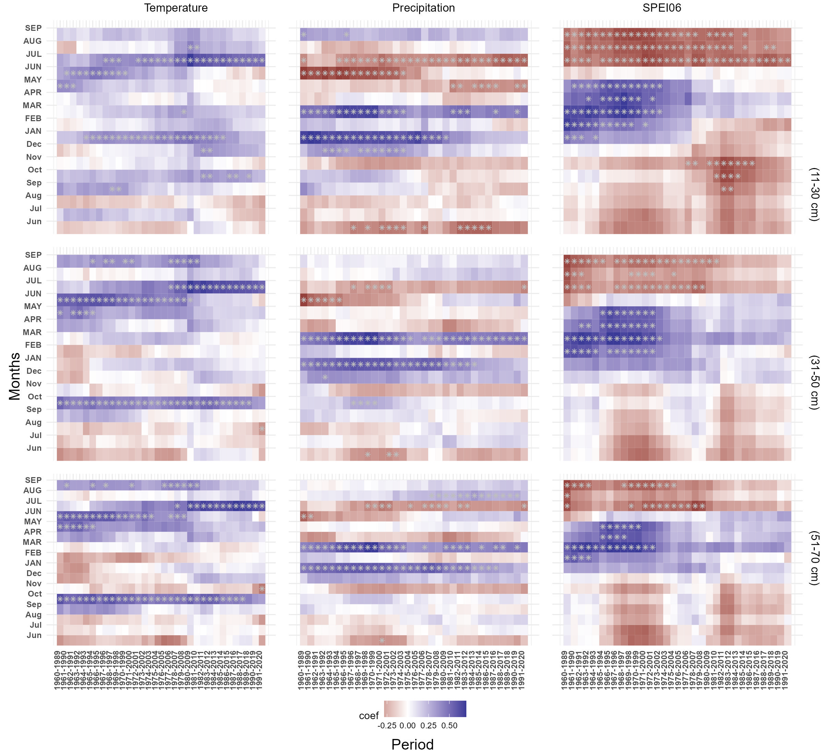
Fig. S4 Moving correlations between Picea abies tree-ring chronologies from limestone forest plot (different DBH size classes) and monthly temperature, precipitation and SPEI06 data using 30-year moving windows with a one-year offset for the common period 1960–2020.
Fig. S5 Moving correlations between Picea abies tree-ring chronologies from granitic forest plot (different DBH size classes) and monthly temperature, precipitation and SPEI06 data using 30-year moving windows with a one-year offset for the common period 1960–2020.
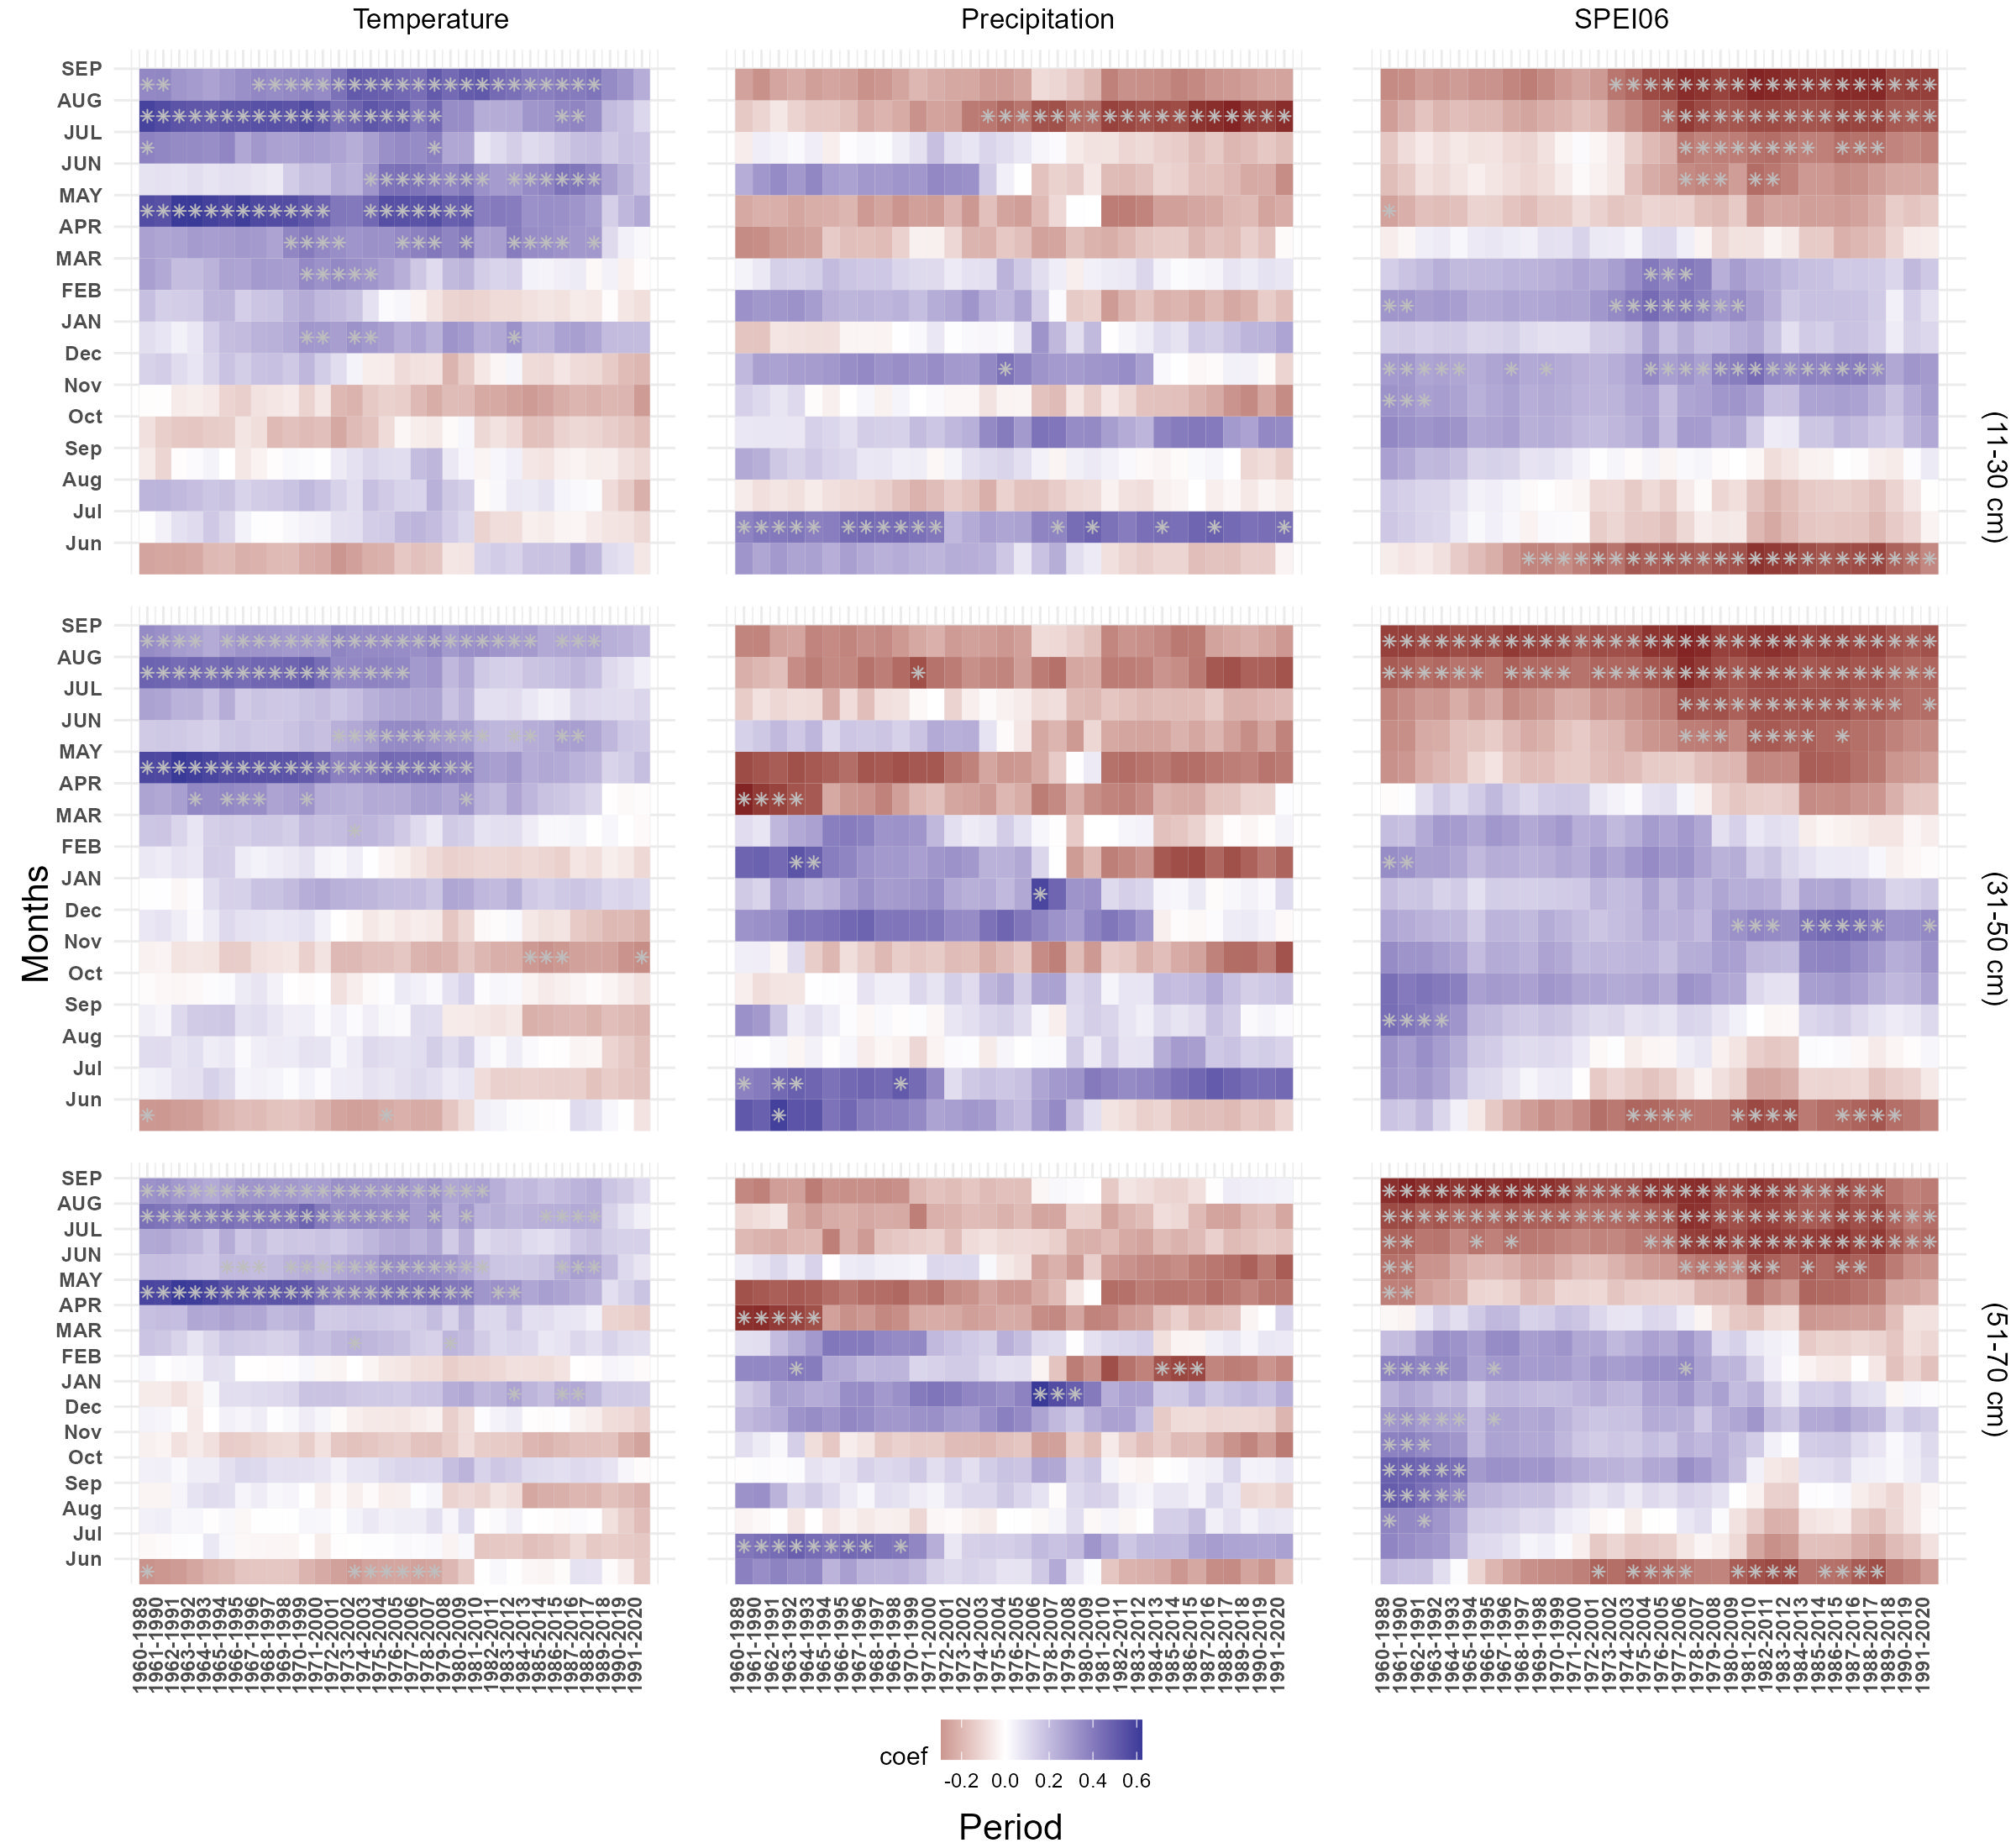
Fig. S6 Moving correlations between Picea abies MXD chronologies from limestone forest plot (different DBH size classes) and monthly temperature, precipitation and SPEI06 data using 30-year moving windows with a one-year offset for the common period 1960–2020.
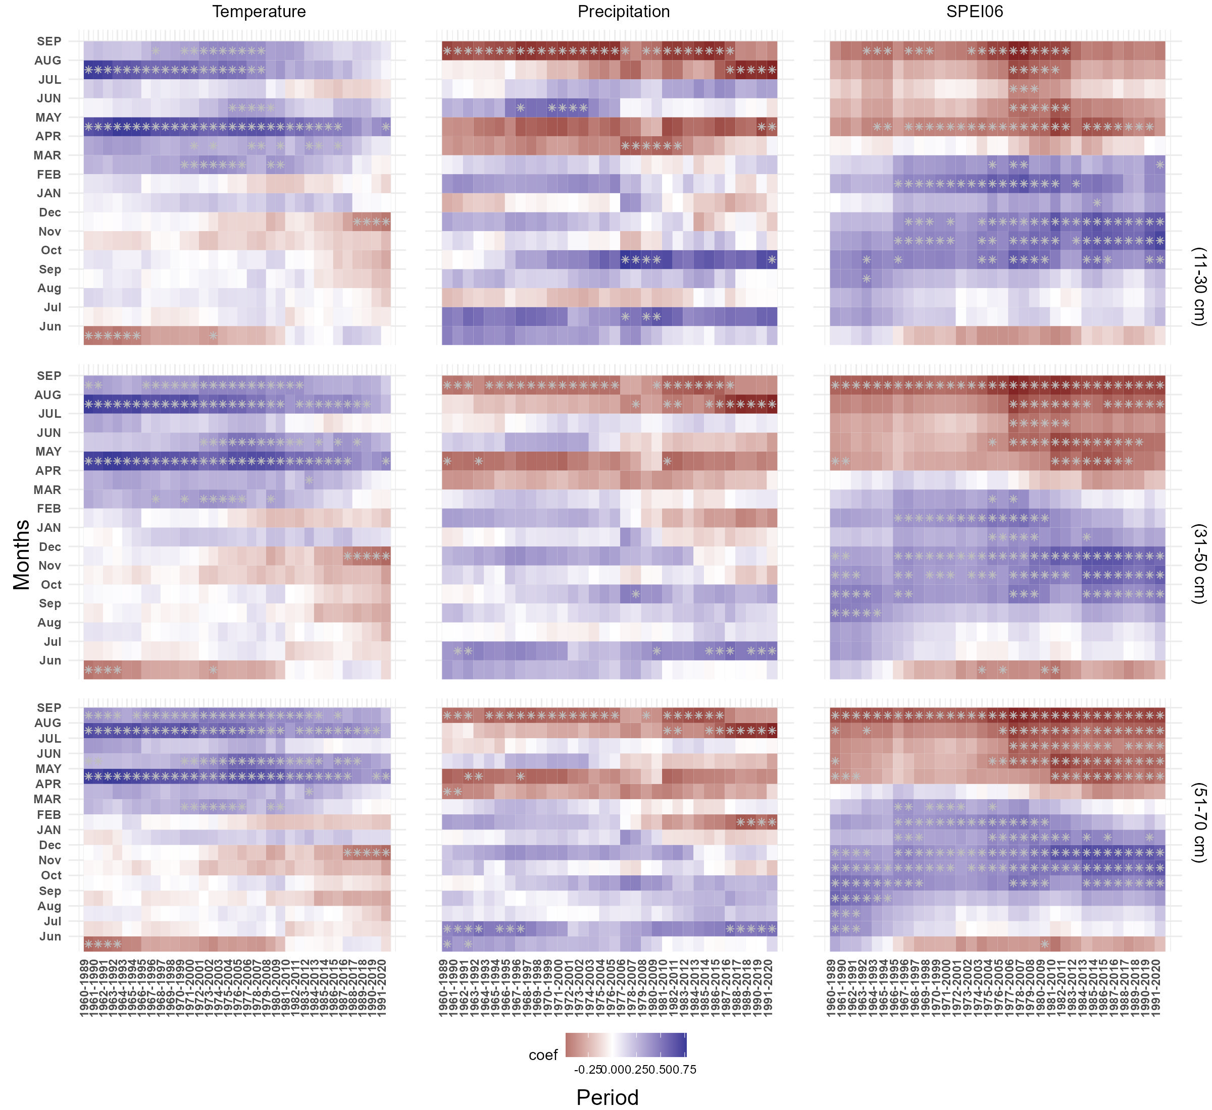
Fig. S7 Moving correlations between Picea abies MXD chronologies from granitic forest plot (different DBH size classes) and monthly temperature, precipitation and SPEI06 data using 30-year moving windows with a one-year offset for the common period 1960–2020.
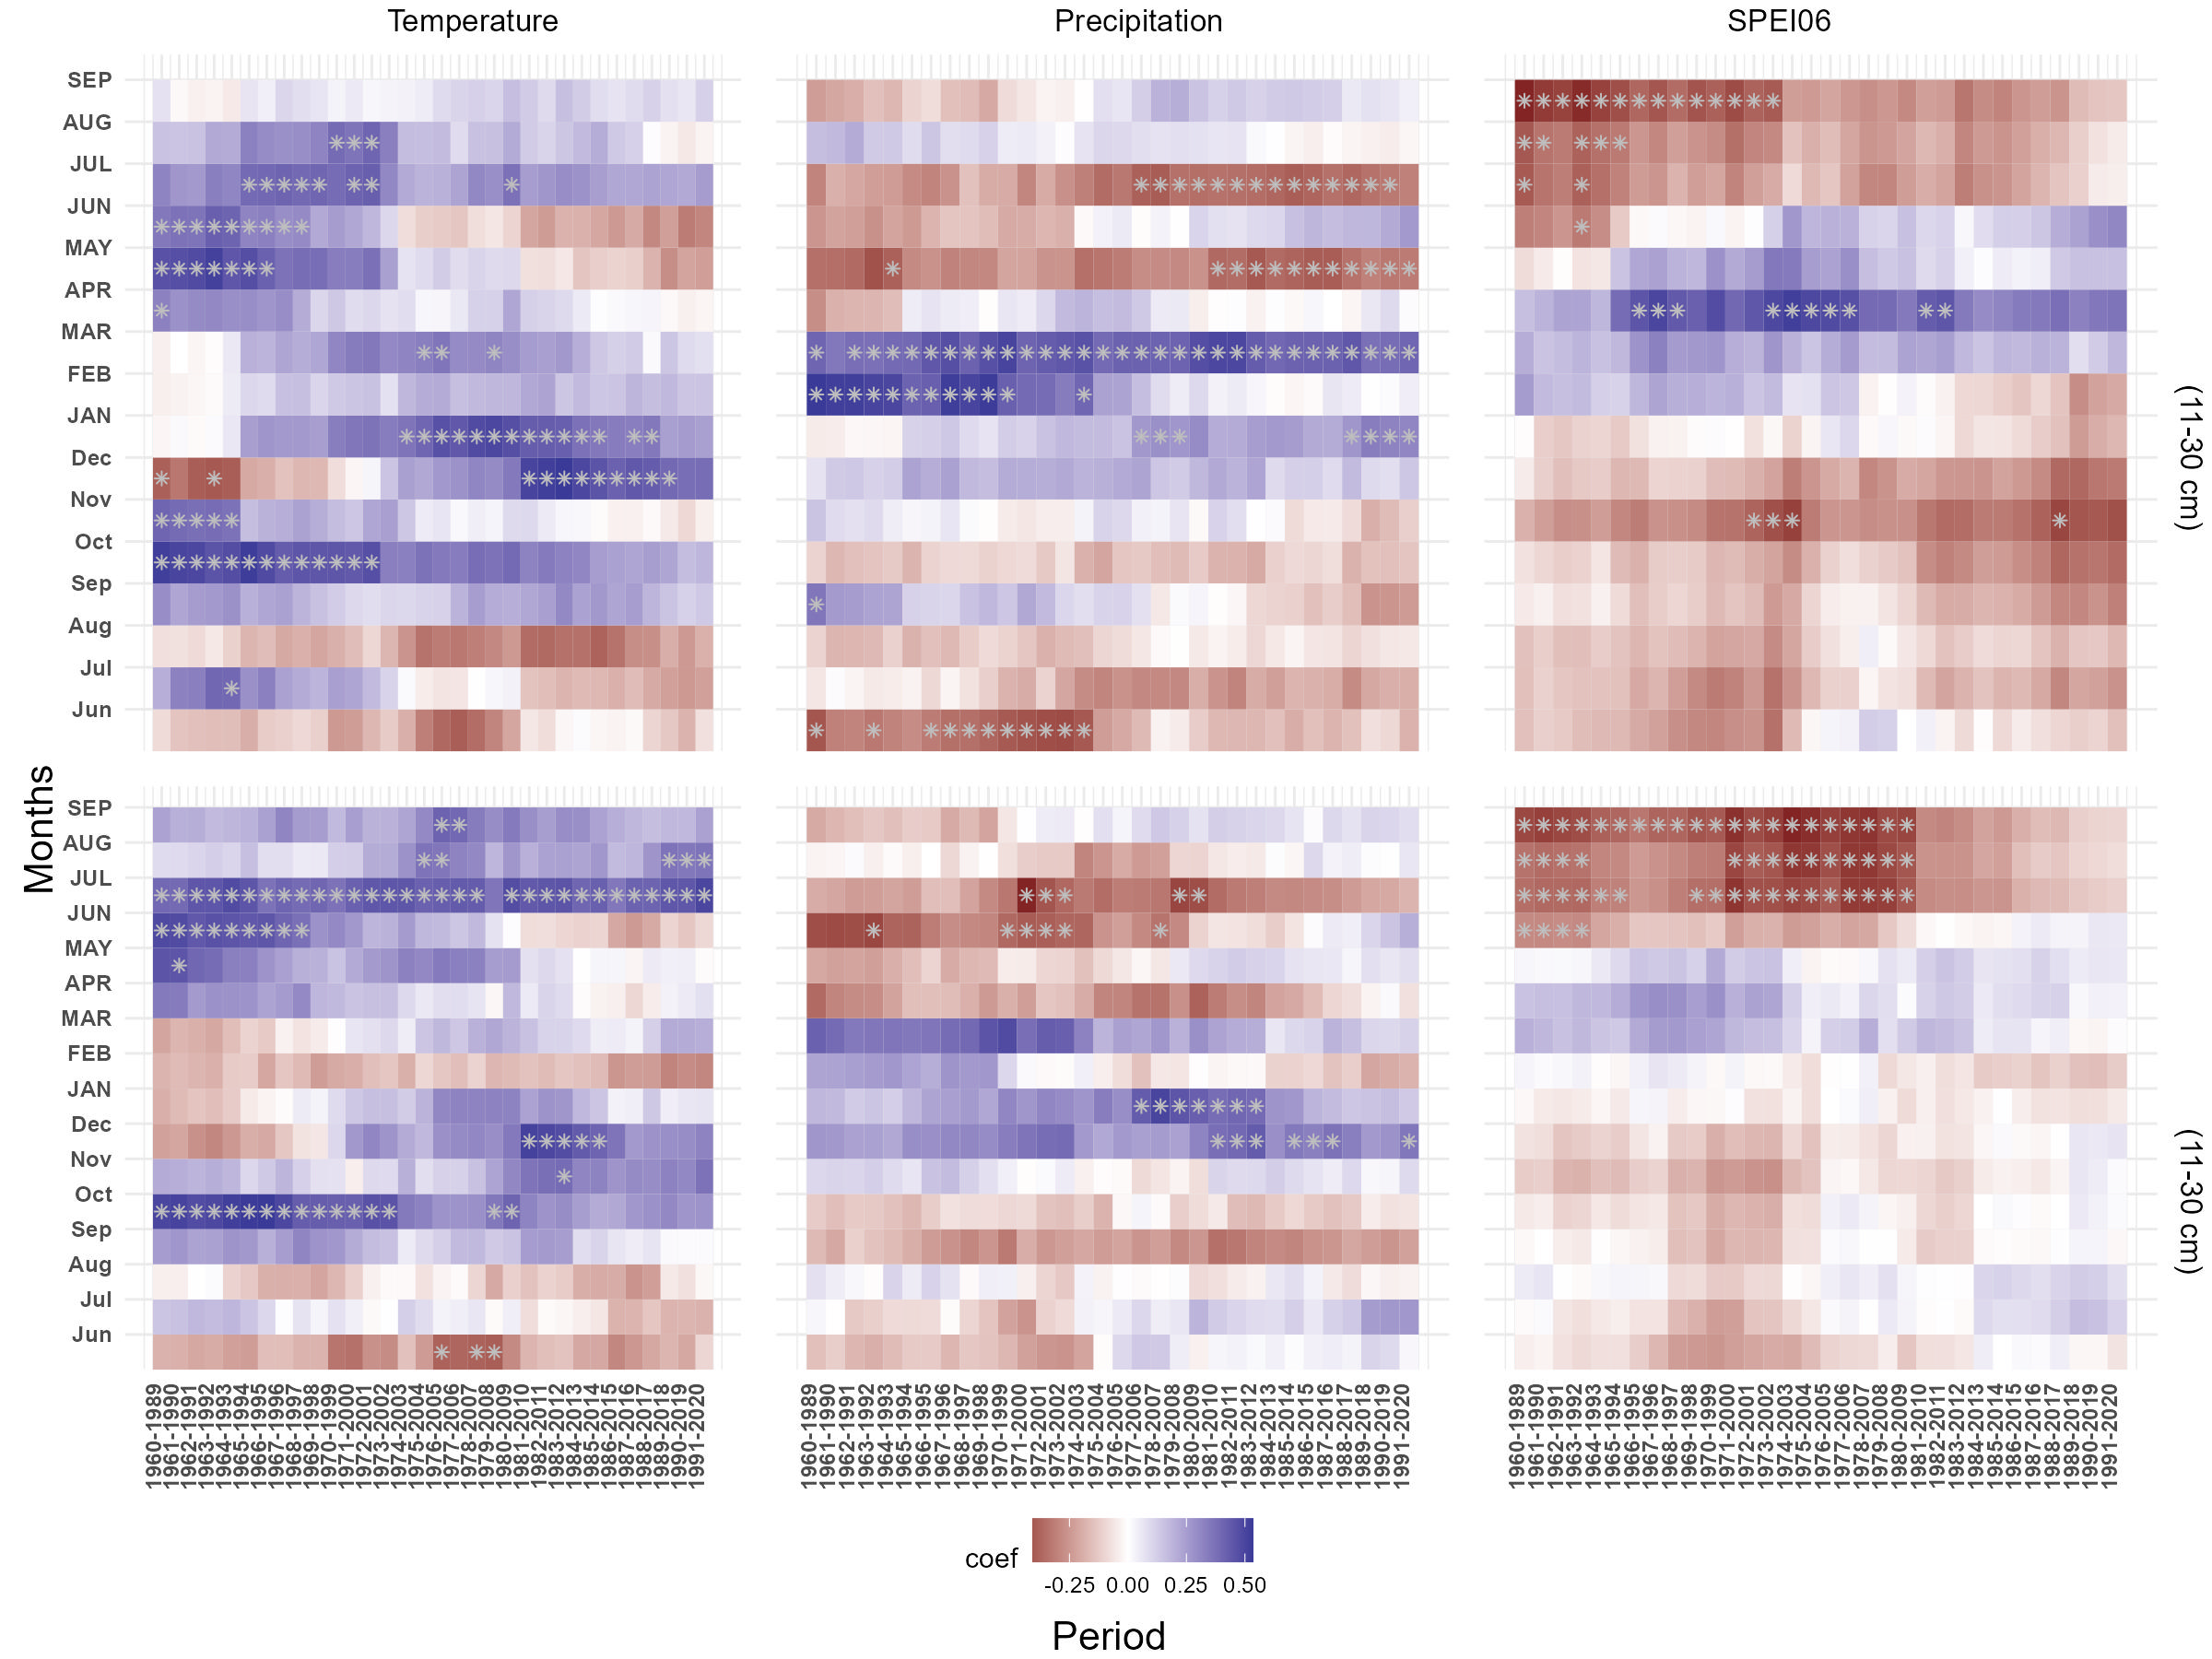
Fig. S8 Moving correlations between Picea abies tree-ring chronologies from treeline plots ((11-30 cm) DBH size class) (upper graphs are from limestone site and lower ones are from granitic site) and monthly temperature, precipitation and SPEI06 for the common period 1960–2020.
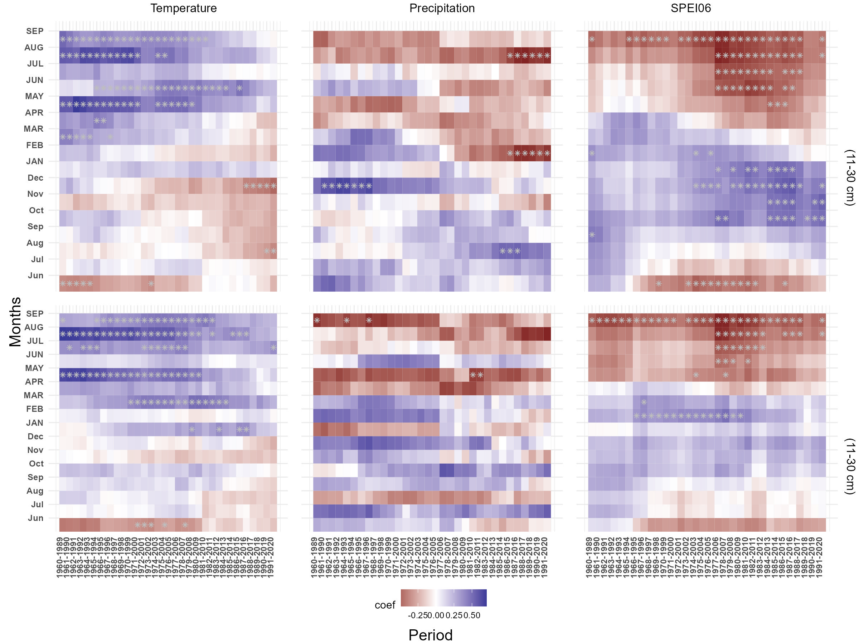
Fig. S9 Moving correlations between Picea abies MXD chronologies from treeline plots (11-30 cm) DBH size class) (upper graphs are from limestone site and lower ones are from granitic site) and monthly temperature, precipitation and SPEI06 for the common period 1960–2020.
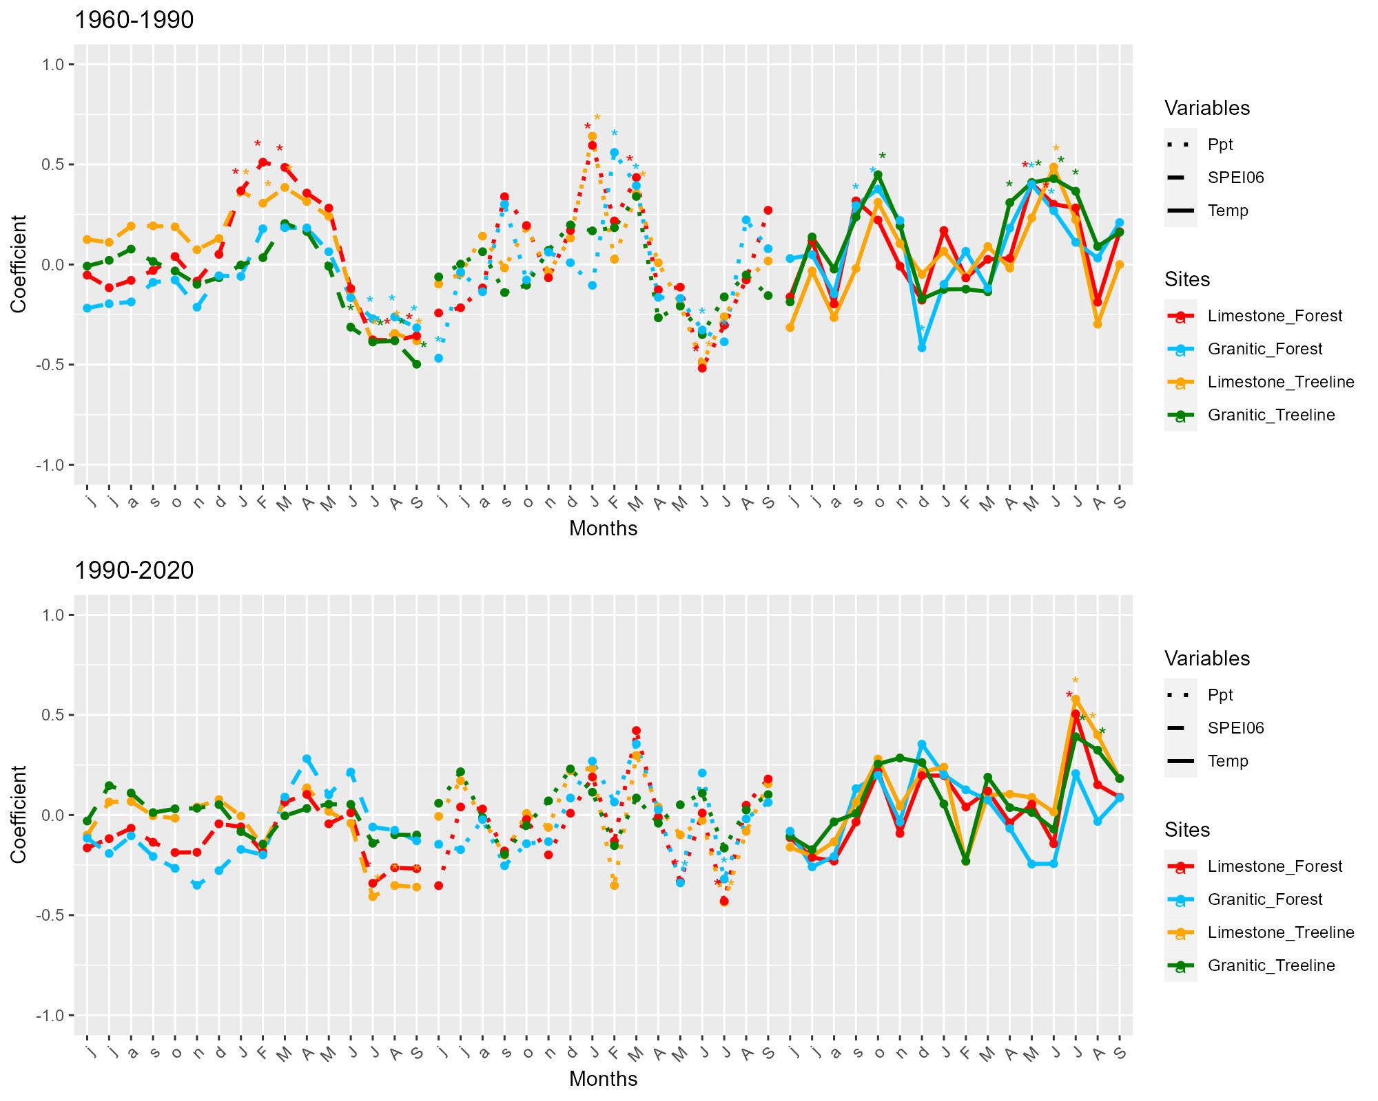
Fig. S10 Monthly correlation coefficients of Picea abies (11-30 cm) tree-ring chronologies from forest and treeline plots at two different bedrock conditions with monthly temperature, precipitation and SPEI06 over two different time period 1960-1990 (upermost plot) and 1990-2020 (lower plot). Bright red color lines indicates trees from limestone forest, Deep sky blue lines indicates trees from granitic forest, Orange color lines indicates trees from limestone treeline and Green colour line indicates trees from granitic treeline settings. Correlations analysis was computed for a 16 months windows from previous year June to current year September. Asterisk symbol (*) indicate the 95 % confidence level respectively.
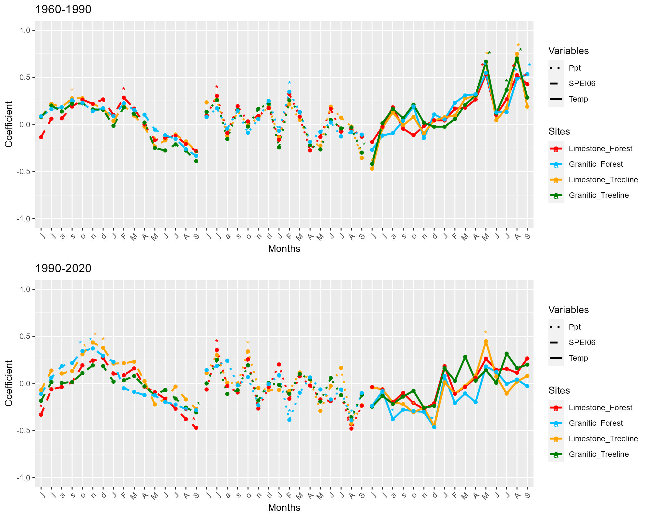
Fig. S11 Monthly correlation coefficients of Picea abies (11-30 cm) MXD chronologies from forest and treeline plots at two different bedrock conditions with monthly temperature, precipitation and SPEI06 over two different time period 1960-1990 (upermost plot) and 1990-2020 (lower plot). Bright red color lines indicates trees from limestone forest, Deep sky blue lines indicates trees from granitic forest, Orange color lines indicates trees from limestone treeline and Green colour line indicates trees from granitic treeline settings. Correlations analysis was computed for a 16 months windows from previous year June to current year September. Asterisk symbol (*) indicate the 95 % confidence level respectively.

