Table 1. Positive and negative controls performed in single and double immunohistochemistry to investigate immunoreagents specificity rigorously.
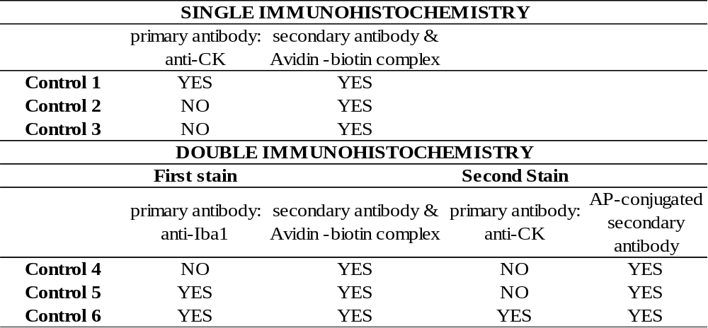
CK, cytokeratin; Iba1, ionized calcium-binding adapter molecule-1; Controls 1 and 2 for the single immunohistochemistry (S-IHC), were performed in bovine endometrium while Controls 3 (S-IHC)), 4, 5 and 6 (double immunohistochemistry (D-IHC)) were carried out in both bovine jejunal lymph nodes and distal jejunum. For D-IHC, in the first stain, we used rabbit polyclonal anti-Iba1 as primary antibody and biotinylated goat anti-rabbit IgG as secondary antibody with avidin-biotin complex and in the second stain rabbit polyclonal anti-CK antibody and alkaline phosphatase (AP)-conjugated anti-rabbit IgG were used as primary and secondary antibodies, respectively.

Table 2. Infection status and infection score of the animals used in this study classified according to the type of paratuberculosis-associated histological lesions present in their gut tissues and regional lymph nodes.
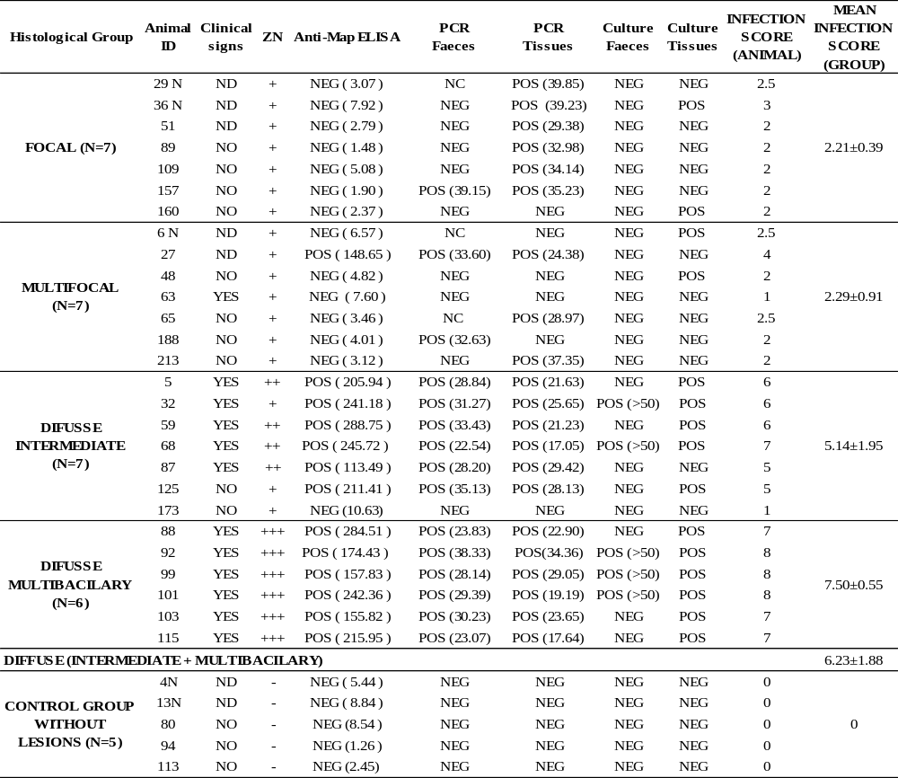
ID, cows’ identification; ND, unknown; the number of + shown in parenthesis in the Ziehl-Neelsen (ZN) column indicates the amount of acid-alcohol resistant bacteria present; in the anti-Map ELISA column the numerical value obtained in the ELISA is shown in parenthesis; the number shown in parenthesis in the PCR columns corresponds to the cycle threshold (Ct) obtained in the amplification of the F57 sequence; NC, non-conclusive result; >50, refers to the number of colonies isolated in the bacteriological culture. DIFUSSE, refer to all the animals showing diffuse lesions (intermediate and multibacillary). The mean infection score of each histopathological group was calculated as the sum of the total number of positive diagnosis test (counting 1 for each positive, 0.5 for each non concluding result and 0 for each negative result) plus the total number of ZN positive results (1 if there is one + in the ZN result, 2 for two ++ and 3 for +++) divided by the total number of animals in the group.

Table 3. Quantification of cytokeratin and Iba1 expressing cells in jejunal lymph nodes granulomatous lesions of cattle with different histopathological forms of bovine paratuberculosis.
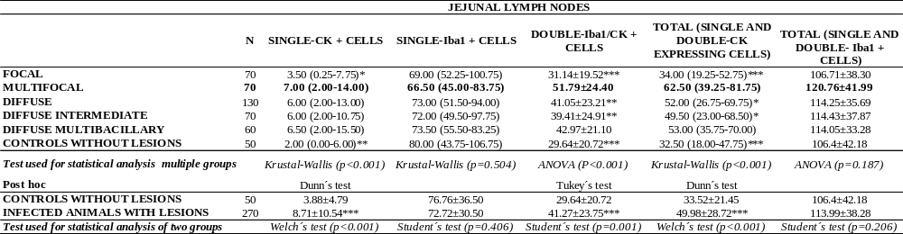
CK, cytokeratin; Iba1, ionized calcium-binding adapter molecule-1; +, positive; N, number of fields examined per histopathological group; Results are expressed as mean or median values of the number of immunolabelled cells per field and histopathological group depending of the statistical test used to analyse the data (means ± standard deviation for parametric tests and median (interquartile range P25-P55) for non-parametric tests); Asterisks, indicate for multiple groups the comparisons where the differences between the multifocal group and the rest of the groups and for two groups the comparisons where the differences between infected and control animals are significant (*p-value<0.05, **p-value<0.01 ***p-value<0.001). Results obtained for the multifocal group are shown in bold face.

Table 4. Quantification of cytokeratin and Iba1 expressing cells in distal jejunum granulomatous lesions of cattle with different histopathological forms of bovine paratuberculosis.
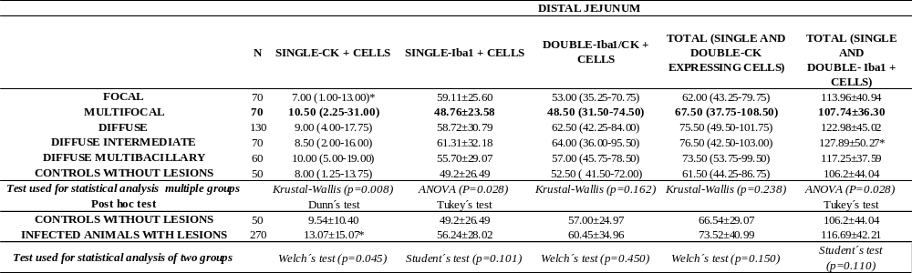
CK, cytokeratin; Iba1, ionized calcium-binding adapter molecule-1; +, positive; N, number of fields examined per histopathological group; Results are expressed as mean or median values of the number of immunolabelled cells per field and histopathological group depending of the statistical test used to analyse the data (means ± standard deviation for parametric tests and median (interquartile range P25-P55) for non-parametric tests); Asterisks indicate, for multiple groups if the differences between each histopathological group and the multifocal group and for two groups if the differences between infected and control animals, are significant or not (*p-value<0.05, **p-value<0.01 ***p-value<0.001). Results obtained for the multifocal group are shown in bold face.
Table 5. Ratios of double-Iba1/CK-immunolabeled epithelioid macrophages to single-Iba1 cells and to total macrophages (single Iba1 and double Iba1/CK-immunolabeled cells) in animals with different pathological forms of bovine paratuberculosis.
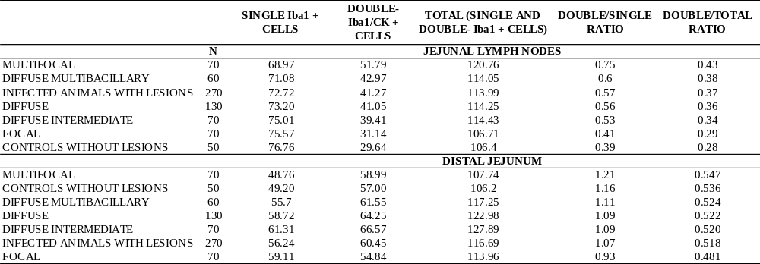
N, number of fields counted for each pathological group; CK, cytokeratin; Iba1, ionized calcium-binding adapter molecule-1; Numbers, indicate the mean number of positive cells per field and pathological group; For each section of tissue, the results are ordered from the highest to the lowest ratio.

