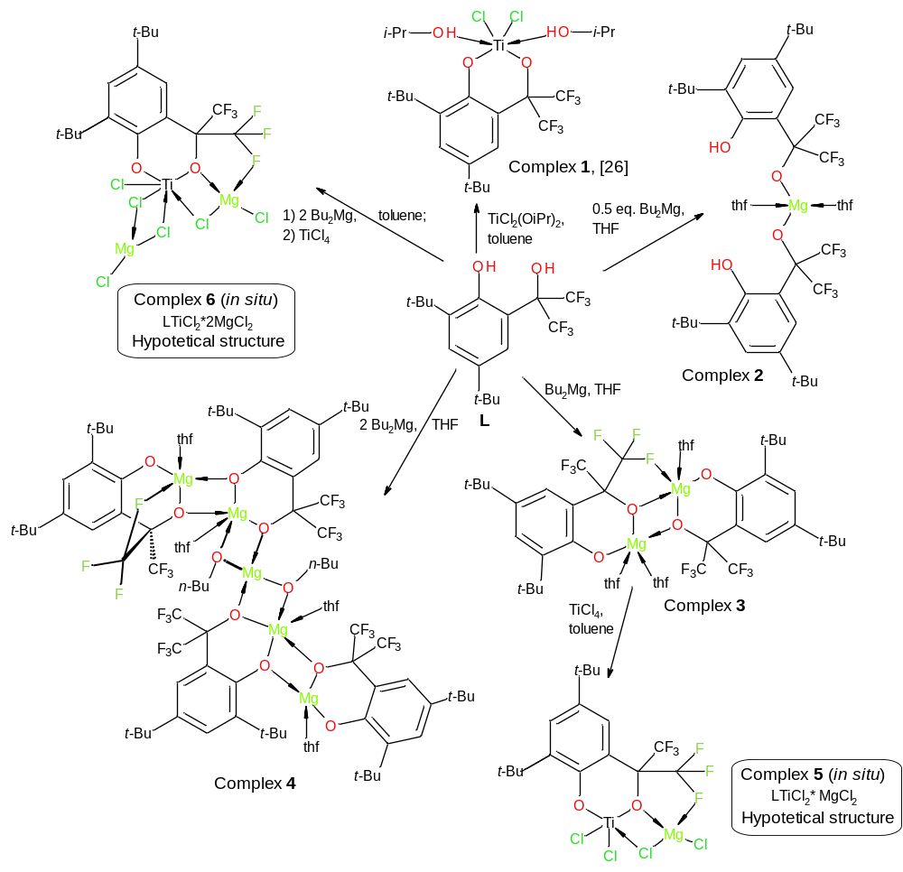
Scheme 1. Synthesis of the Mg-complexes 2-4 and precatalysts 5-6 for ethylene polymerization

