SUPPORTING INFORMATION
Various approaches to the introduction of magnesium ions into post-metallocene (OO)TiCl₂-type catalytic systems. Comparison of the catalytic activity of the titanium saligenin complex activated by an Al/Mg co-catalyst (Alk_{n}AlCl_{3-n}+Alk₂Mg) and Ti/Mg precatalysts obtained in situ in ethylene polymerization
Vladislav A. Tuskaev, Dmitry A. Kurmaev, Svetlana Ch. Gagieva, Evgenii K. Golubev, Mikhail I. Buzin, Maria D. Evseeva, Viktor N. Khrustalev, Svetlana A. Aksenova, Kasim F. Magomedov, Boris M. Bulychev

Table S1. Crystal data and structure refinement for 3 and 4.

Identification code | 2 | 4 • 2(C₇H₁₆) | 3 • C₅H₁₂
Empirical formula | C₄₂H₅₈F₁₂MgO₆ | C₁₀₆H₁₆₂F₂₄Mg₅O₁₄ | C₅₁H₇₆F₁₂Mg₂O₇
Formula weight | 911.19 | 2237.91 | 1077.74
Crystal size, mm |  | 0.13×0.15×0.22 | 0.15×0.18×0.23
Temperature, K | 120 | 100 | 100
Wavelength, Å |  | 1.54184 | 1.54184
Crystal system | Monoclinic | Triclinic | Triclinic
Space group | P2₁/c | P-1 | P-1
a, Å | 14.8157(8) | 16.65075(14) | 10.56804(11)
b, Å | 17.5428(10) | 19.78626(14) | 14.71830(16)
c, Å | 18.5639(10) | 19.94495(13) | 18.7621(2)
α, deg. | 90 | 100.2822(6) | 70.8370(10)
β, deg. | 108.100(3) | 111.1983(7) | 89.7664(8)
γ, deg. | 90 | 98.2954(6) | 87.4357(8)
V, Å³ | 4586.2(4) | 5869.72(9) | 2753.68(5)
Z | 4 | 2 | 2
Density (calc.), Mg/m³ | 1.320 | 1.266 | 1.300
μ, mm⁻¹ |  | 1.155 | 1.159
F(000) | 1912 | 2372 | 1140
Theta range, deg. |  | 2.33 – 78.16 | 2.49 – 77.95
Index ranges |  | -20 ≤ h ≤ 21,  -24 ≤ k ≤ 25,  -25 ≤ l ≤ 24 | -13 ≤ h ≤ 13,  -18 ≤ k ≤ 18,  -22 ≤ l ≤ 23
Reflections collected | 66573 | 150525 | 82994
Independent reflections, R_{int} | 8927 | 24602, 0.057 | 11631, 0.046
Reflections observed | 7394 | 21721 | 10769
R₁ / wR₂ (I > 2σ(I)) |  | 0.055 / 0.147 | 0.048 / 0.127
R₁ / wR₂ (all data) |  | 0.061 / 0.155 | 0.051 / 0.129
Goodness-of-fit on F² | 1.018 | 1.028 | 1.033
Extinction coefficient |  | ─ | 0.00053(5)
T_{min} / T_{max} |  | 0.133 / 1.000 | 0.928 / 1.000
Δρ_{max} / Δρ_{min}, e.Å⁻³ | 0.402/ -0.261 | 1.181 / -0.713 | 0.760 / -0.713

Table S2. Bond distances (Å) and angles (°) for Mg(II) in 4 and 3.

Compound 4
Mg1─O1 | 1.8937(14) | Mg3─O10 | 1.9548(13)
Mg1─O2 | 1.9763(13) | Mg3─F10 | 2.4423(12)
Mg1─O3 | 1.9752(13) | Mg3─F15 | 2.4401(12)
Mg1─O11 | 2.0244(14) | Mg4─O5 | 2.0215(13)
Mg1─F2 | 2.4881(13) | Mg4─O6 | 2.0579(13)
Mg1─F7 | 2.5564(12) | Mg4─O7 | 1.9787(13)
Mg2─O2 | 1.9931(13) | Mg4─O10 | 1.9669(13)
Mg2─O3 | 2.0568(13) | Mg4─O13 | 2.1053(14)
Mg2─O4 | 2.0247(13) | Mg5─O6 | 1.9908(13)
Mg2─O9 | 1.9652(13) | Mg5─O7 | 1.9791(13)
Mg2─O12 | 2.0967(13) | Mg5─O8 | 1.9008(14)
Mg3─O4 | 2.0152(13) | Mg5─O14 | 2.0214(13)
Mg3─O5 | 2.0055(12) | Mg5─F16 | 2.5285(12)
Mg3─O9 | 1.9549(13) | Mg5─F22 | 2.3783(12)
O1─Mg1─O2 | 91.08(6) | O2─Mg2─O9 | 122.61(6)
O1─Mg1─O3 | 126.96(6) | O2─Mg2─O12 | 98.00(5)
O1─Mg1─O11 | 99.74(6) | O3─Mg2─O4 | 83.59(5)
O1─Mg1─F2 | 82.09(5) | O3─Mg2─O9 | 154.58(6)
O1─Mg1─F7 | 150.80(5) | O3─Mg2─O12 | 90.80(5)
O2─Mg1─O3 | 84.60(5) | O4─Mg2─O9 | 79.94(5)
O2─Mg1─O11 | 150.16(6) | O4─Mg2─O12 | 144.40(6)
O2─Mg1─F2 | 71.97(5) | O9─Mg2─O12 | 91.42(5)
O2─Mg1─F7 | 78.16(5) | O4─Mg3─O5 | 148.31(6)
O3─Mg1─O11 | 109.72(6) | O4─Mg3─O9 | 80.41(5)
O3─Mg1─F2 | 143.51(5) | O4─Mg3─O10 | 118.26(6)
O3─Mg1─F7 | 79.46(5) | O4─Mg3─F10 | 68.10(4)
O11─Mg1─F2 | 82.02(5) | O4─Mg3─F15 | 86.30(5)
O11─Mg1─F7 | 78.99(5) | O5─Mg3─O9 | 116.81(5)
F2─Mg1─F7 | 68.79(4) | O5─Mg3─O10 | 80.43(5)
O2─Mg2─O3 | 82.07(5) | O5─Mg3─F10 | 87.38(4)
O2─Mg2─O4 | 115.83(6) | O5─Mg3─F15 | 68.13(4)
O9─Mg3─O10 | 114.36(6) | O6─Mg5─F22 | 144.32(5)
O9─Mg3─F10 | 146.56(5) | O7─Mg5─O8 | 90.66(5)
O9─Mg3─F15 | 90.63(5) | O7─Mg5─O14 | 152.65(6)
O10─Mg3─F10 | 91.11(5) | O7─Mg5─F16 | 76.55(5)
O10─Mg3─F15 | 146.56(5) | O7─Mg5─F22 | 73.83(5)
F10─Mg3─F15 | 76.79(4) | O8─Mg5─O14 | 100.76(6)
O5─Mg4─O6 | 84.17(5) | O8─Mg5─F16 | 150.33(5)
O5─Mg4─O7 | 114.49(6) | O8─Mg5─F22 | 82.23(5)
O5─Mg4─O10 | 79.74(5) | O14─Mg5─F16 | 81.51(5)
O5─Mg4─O13 | 146.78(6) | O14─Mg5─F22 | 83.12(5)
O6─Mg4─O7 | 82.66(5) | F16─Mg5─F22 | 68.59(4)
O6─Mg4─O10 | 154.21(6) | Mg1─O2─Mg2 | 97.60(6)
O6─Mg4─O13 | 90.14(5) | Mg1─O3─Mg2 | 95.57(5)
O7─Mg4─O10 | 122.40(6) | Mg2─O4─Mg3 | 97.72(5)
O7─Mg4─O13 | 97.07(5) | Mg2─O9─Mg3 | 101.81(6)
O10─Mg4─O13 | 92.36(6) | Mg3─O5─Mg4 | 98.04(5)
O6─Mg5─O7 | 84.39(5) | Mg3─O10─Mg4 | 101.65(6)
O6─Mg5─O8 | 126.72(6) | Mg4─O6─Mg5 | 94.99(5)
O6─Mg5─O14 | 107.45(5) | Mg4─O7─Mg5 | 97.92(5)
O6─Mg5─F16 | 79.18(4)
Compound 3
Mg1─O1 | 1.8802(12) | Mg2─O2 | 2.1138(12)
Mg1─O2 | 1.9741(12) | Mg2─O3 | 1.9394(13)
Mg1─O4 | 1.9492(11) | Mg2─O4 | 1.9838(12)
Mg1─O5 | 1.9931(12) | Mg2─O6 | 2.0363(12)
Mg1─F7 | 2.3148(11) | Mg2─O7 | 2.0473(12)
O1─Mg1─O2 | 93.74(5) | O4─Mg1─O5 | 119.66(5)
O1─Mg1─O4 | 118.87(5) | O4─Mg1─F7 | 71.40(4)
O1─Mg1─O5 | 115.05(5) | O5─Mg1─F7 | 81.28(5)
O1─Mg1─F7 | 92.68(5) | O2─Mg2─O3 | 162.85(5)
O2─Mg1─O4 | 83.62(5) | O2─Mg2─O4 | 79.26(4)
O2─Mg1─O5 | 118.05(5) | O2─Mg2─O6 | 91.94(5)
O2─Mg1─F7 | 154.17(5) | O2─Mg2─O7 | 98.17(5)
O3─Mg2─O4 | 87.54(5) | O4─Mg2─O7 | 108.19(5)
O3─Mg2─O6 | 89.38(5) | O6─Mg2─O7 | 117.77(5)
O3─Mg2─O7 | 96.33(5) | Mg1─O2─Mg2 | 95.19(5)
O4─Mg2─O6 | 133.99(5) | Mg1─O4─Mg2 | 100.32(5)

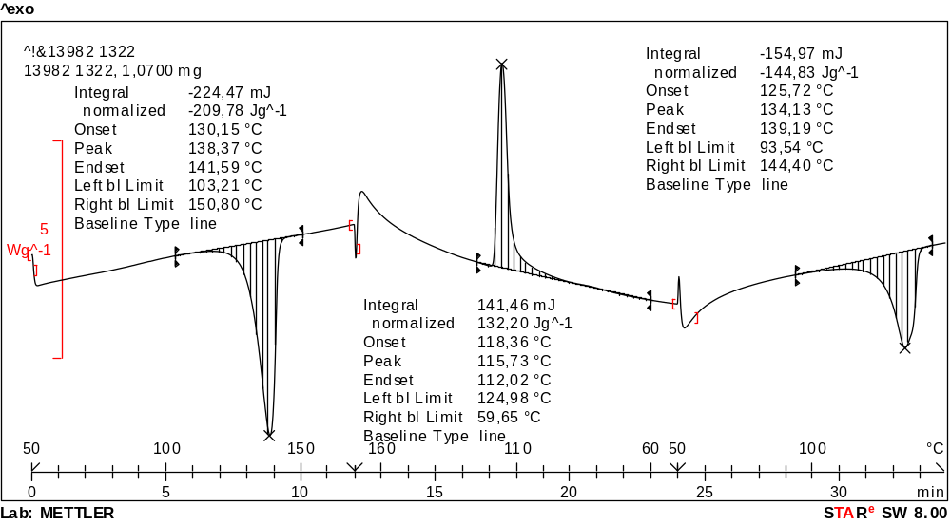
Figure S1. DSC curves corresponding to UHMWPE produced on complex 1+Et₂AlCl/Bu₂Mg (entry 1, table 1).
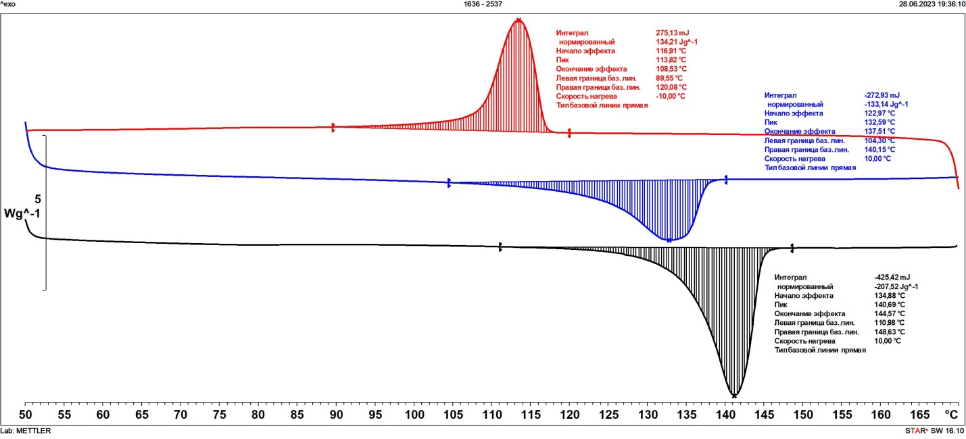
Figure S2. DSC curves corresponding to UHMWPE produced on precatalyst 1+Me₃Al (entry 5, table 1).
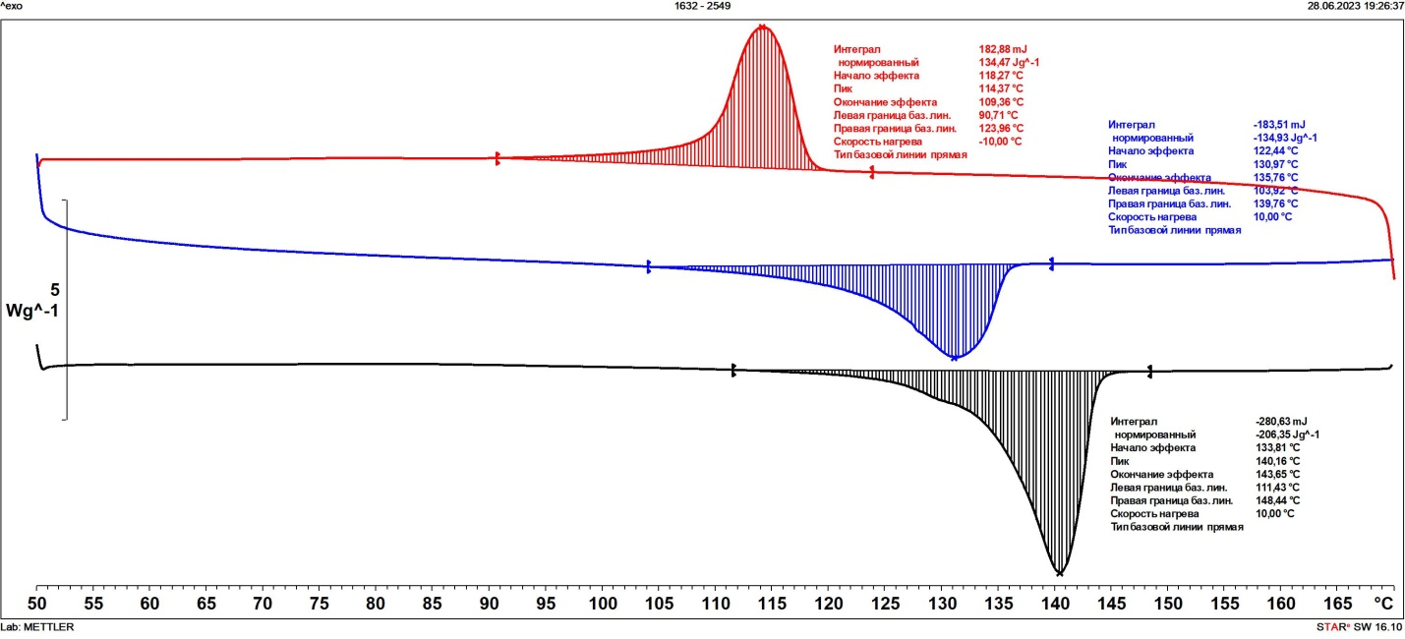
Figure S3. DSC curves corresponding to UHMWPE produced on precatalyst 1+Me₃Al in nefras (entry 6, table 1).

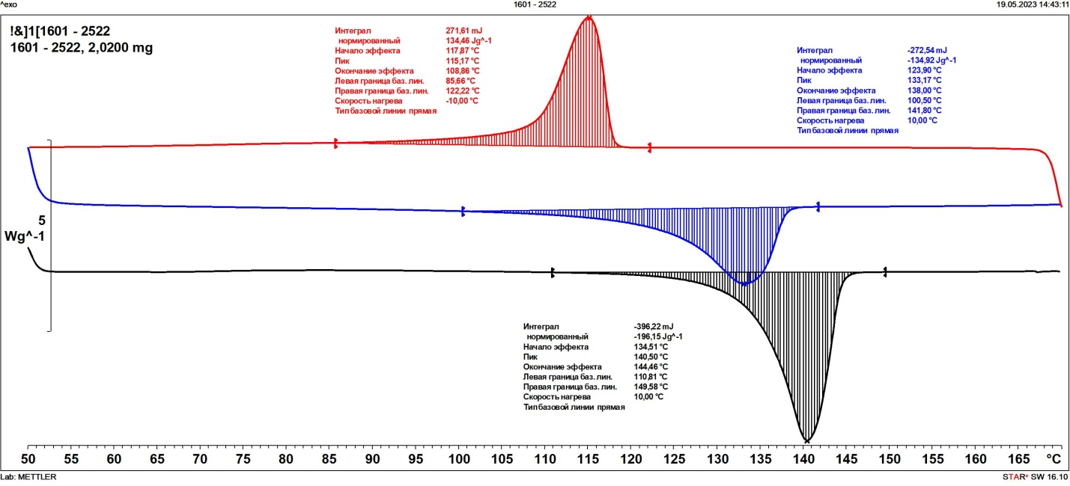
Figure S4. DSC curves corresponding to UHMWPE produced on precatalyst 1+Et₃Al (entry 7, table 1).
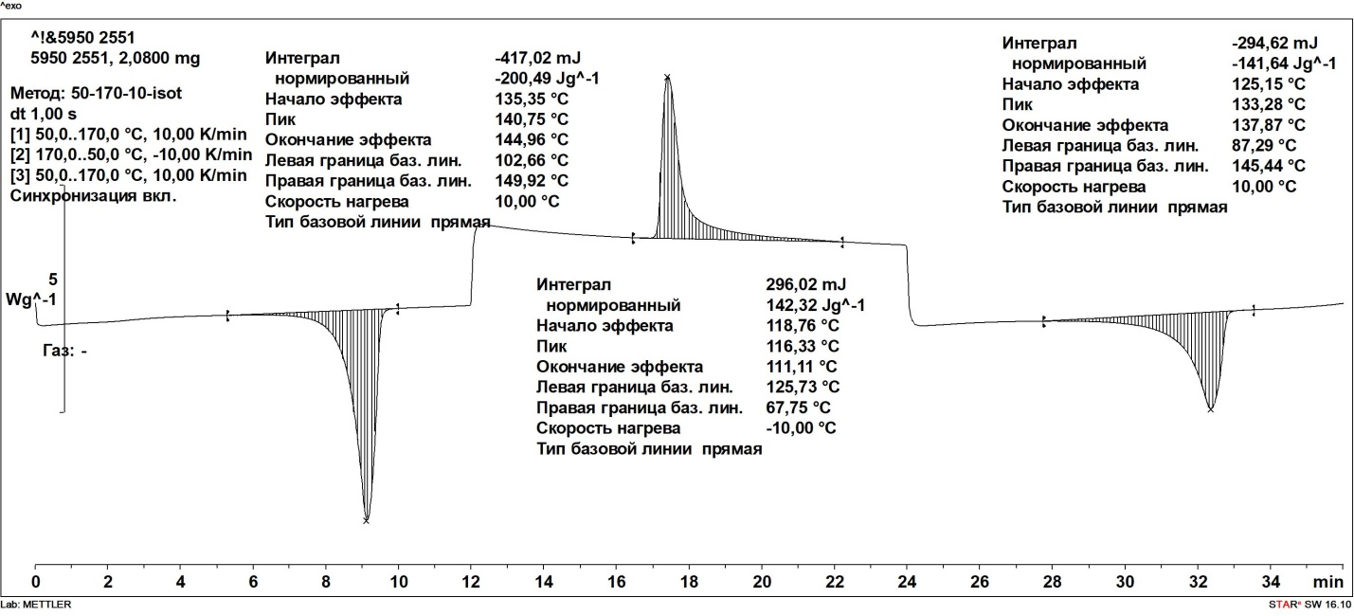
Figure S5. DSC curves corresponding to UHMWPE produced on precatalyst 1+Et₃Al in nefras (entry 8, table 1).

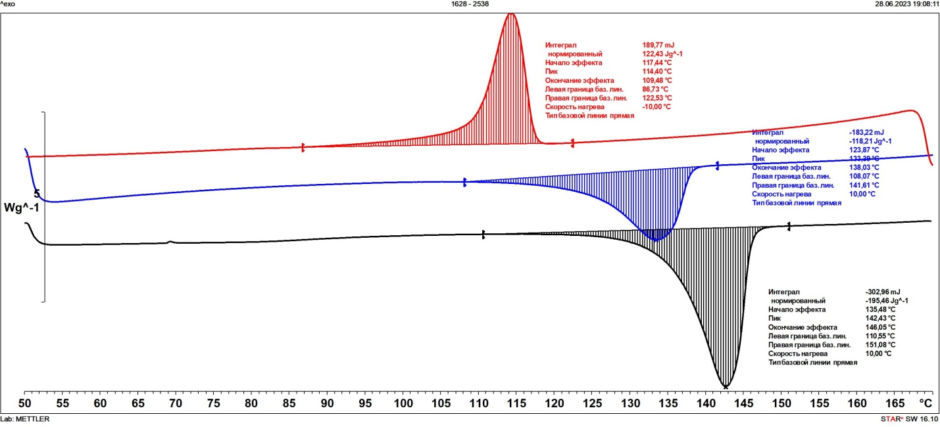
Figure S6. DSC curves corresponding to UHMWPE produced on precatalyst 1+ iBu₃Al (entry 9, table 1).

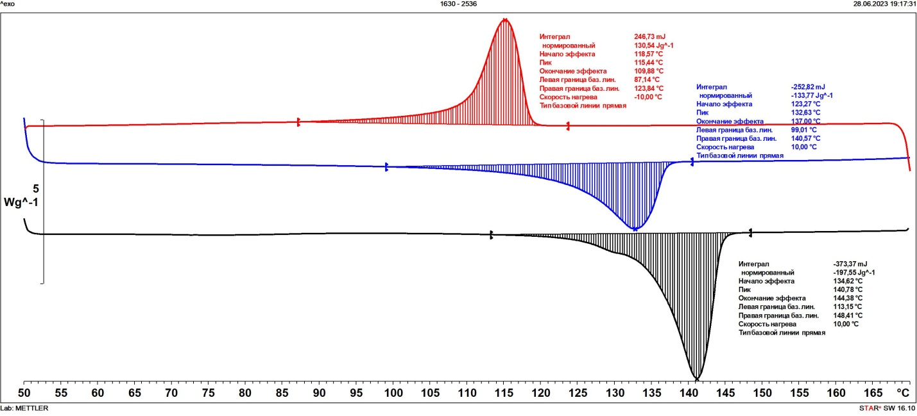
Figure S7. DSC curves corresponding to UHMWPE produced on precatalyst 1+MAO (entry 10, table 1).
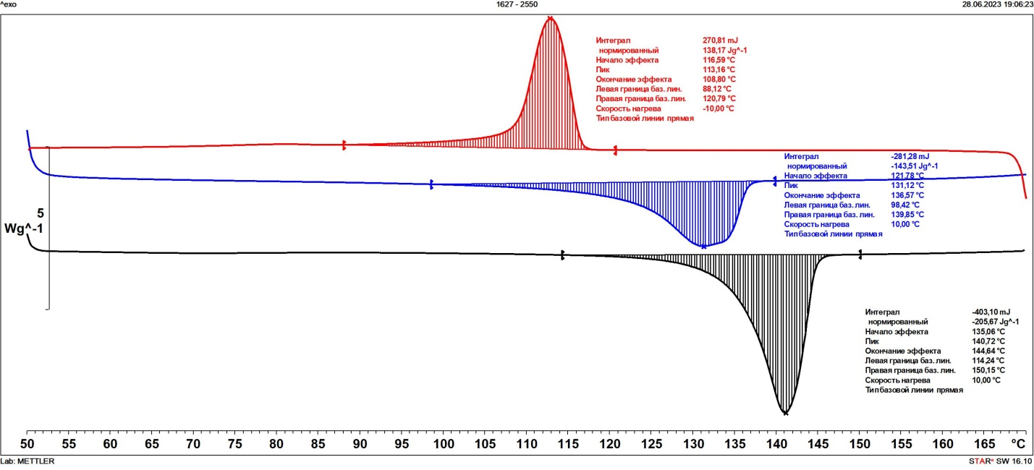
Figure S8. DSC curves corresponding to UHMWPE produced on precatalyst 1+MAO in nefras (entry 11, table 1).

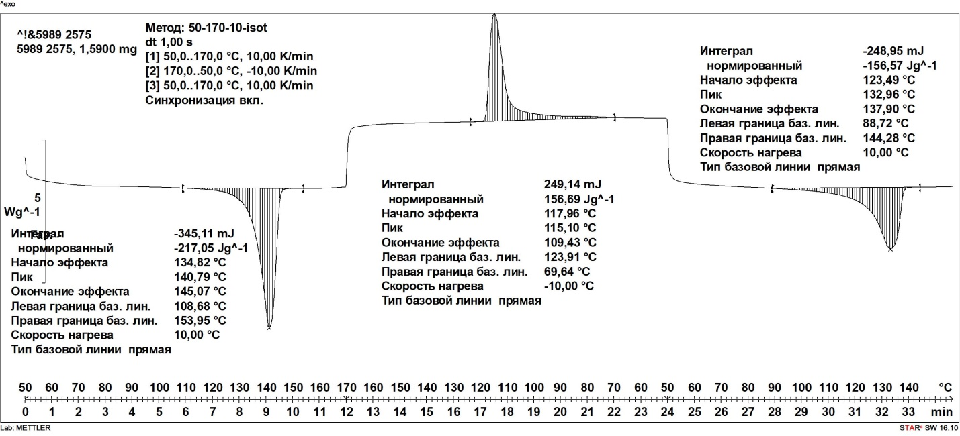
Figure S9. DSC curves corresponding to UHMWPE produced on precatalyst 2+Me₃Al in toluene (entry 12, table 1).
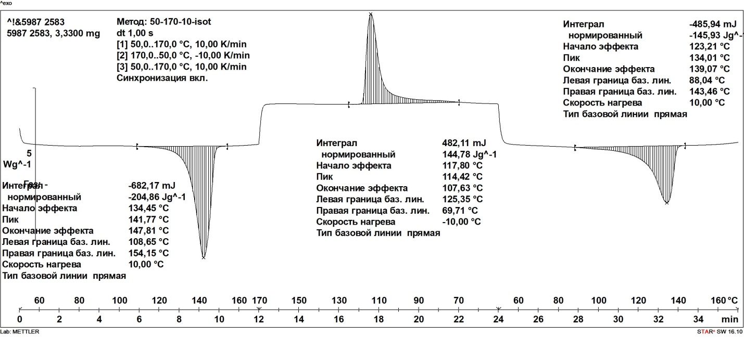
Figure S10. DSC curves corresponding to UHMWPE produced on precatalyst 2+Me₃Al in nefras (entry 13, table 1).

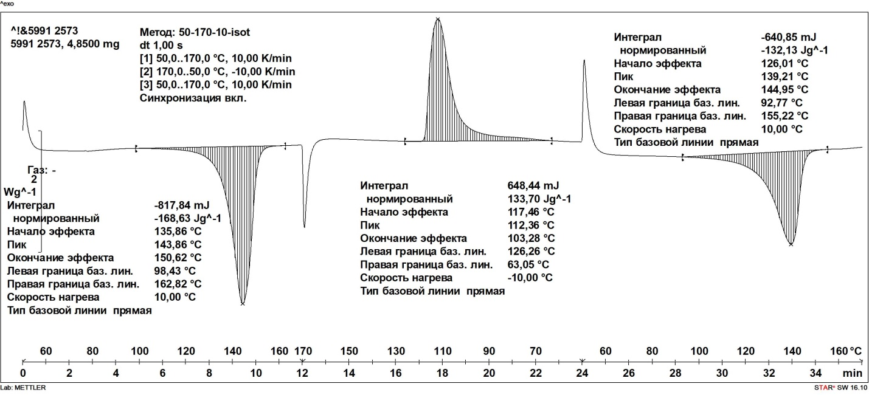
Figure S11. DSC curves corresponding to UHMWPE produced on precatalyst 1+Et₃Al in toluene (entry 14, table 1).
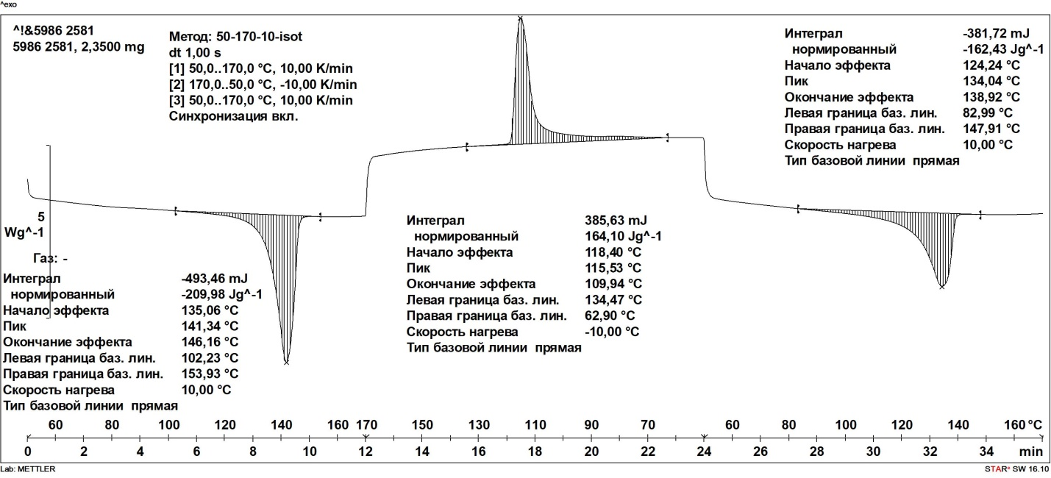
Figure S12. DSC curves corresponding to UHMWPE produced on precatalyst 2+Et₃Al in nefras (entry 15, table 1).

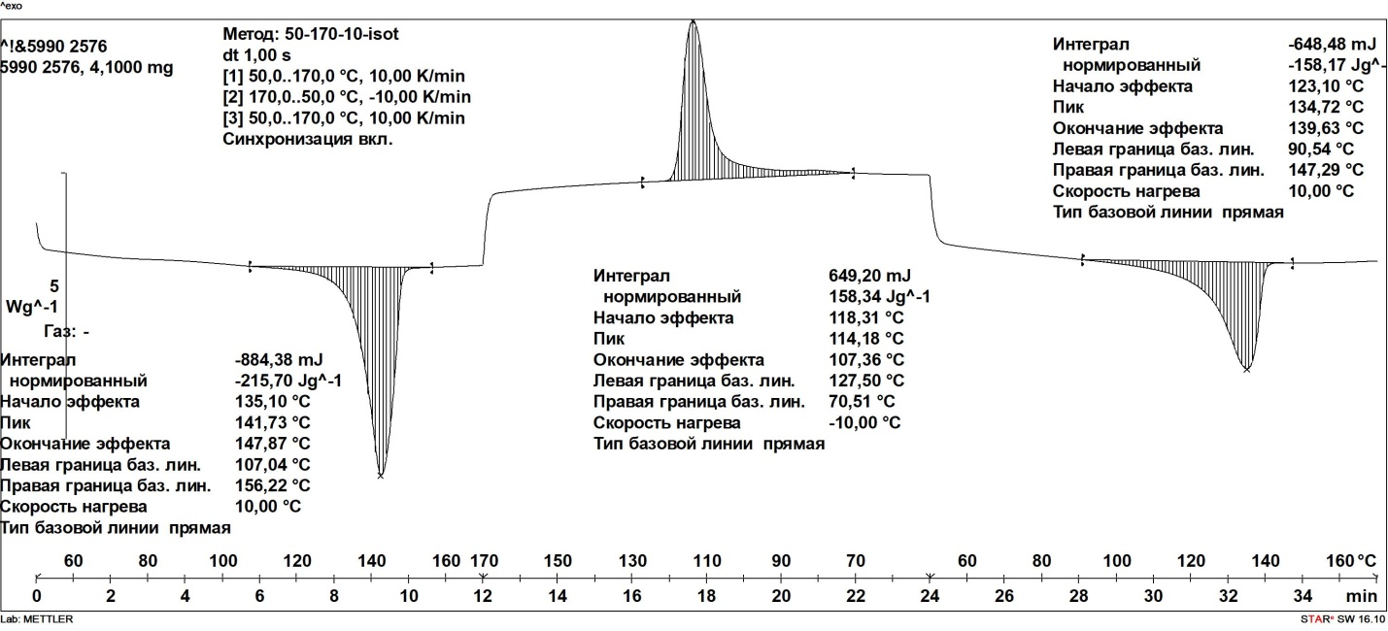
Figure S13. DSC curves corresponding to UHMWPE produced on precatalyst 2+iBu₃Al in toluene (entry 16, table 1).

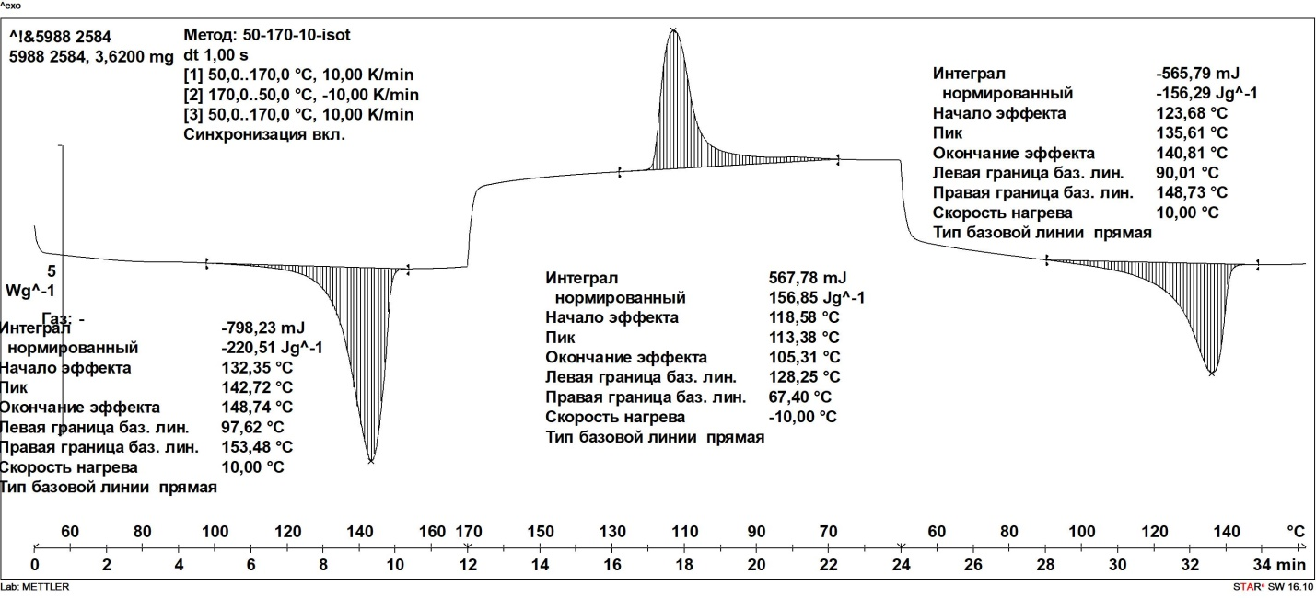
Figure S14. DSC curves corresponding to UHMWPE produced on precatalyst 2+iBu₃Al in nefras (entry 17, table 1).

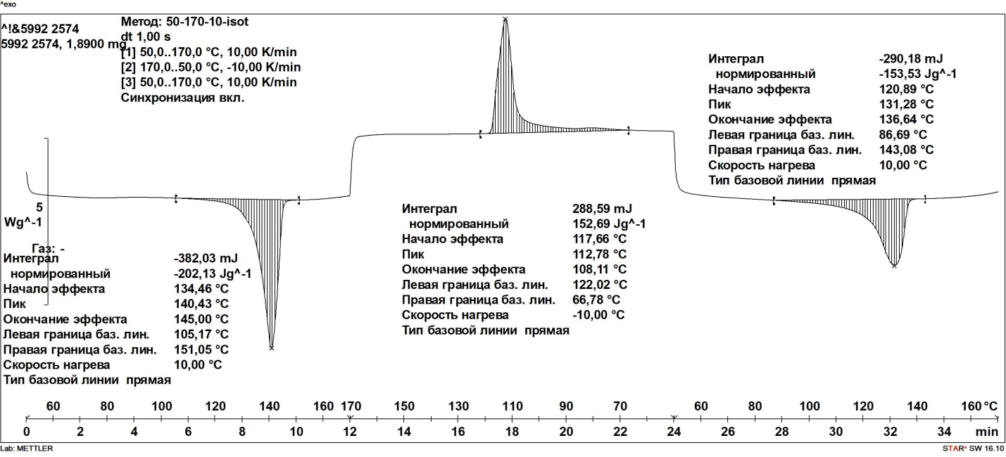
Figure S15. DSC curves corresponding to UHMWPE produced on precatalyst 2+MAO in toluene (entry 18, table 1).

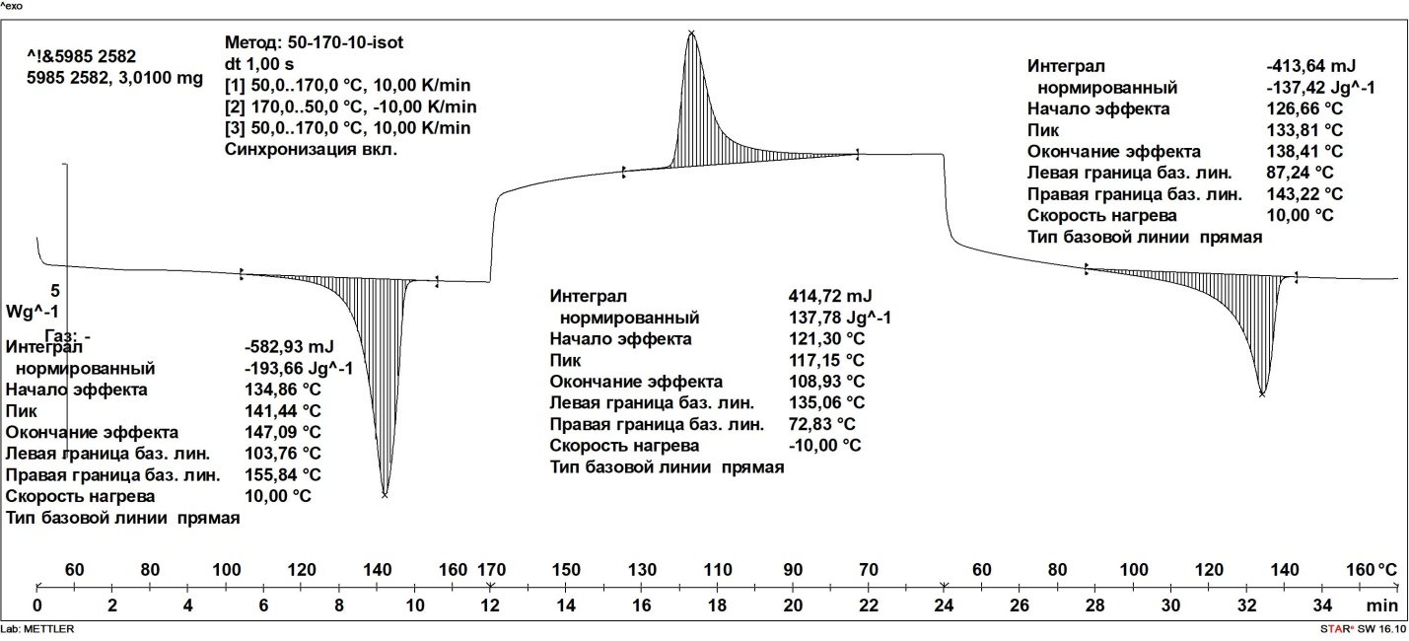
Figure S16. DSC curves corresponding to UHMWPE produced on precatalyst 2+MAO in nefras (entry 19, table 1).

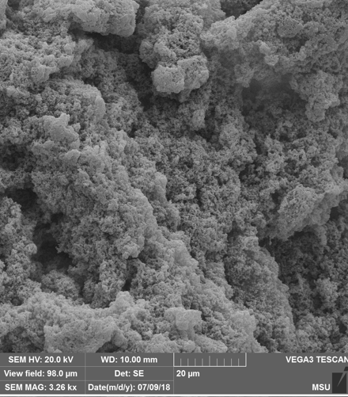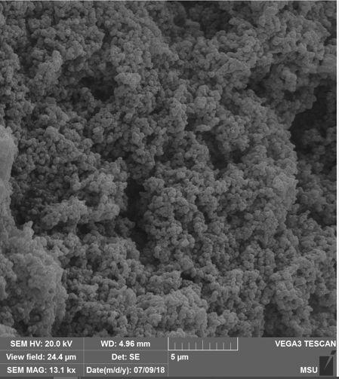
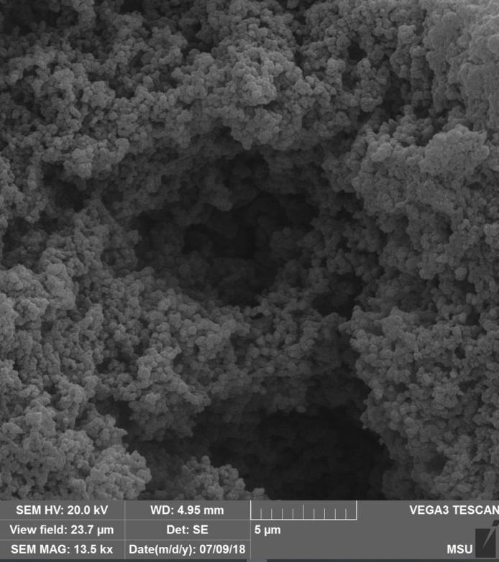
Figure S17. SEM images of the surface morphology of UHMWPE powders obtained with catalytic system 1+Et₂AlCl/Bu₂Mg (entry 1, table 1).

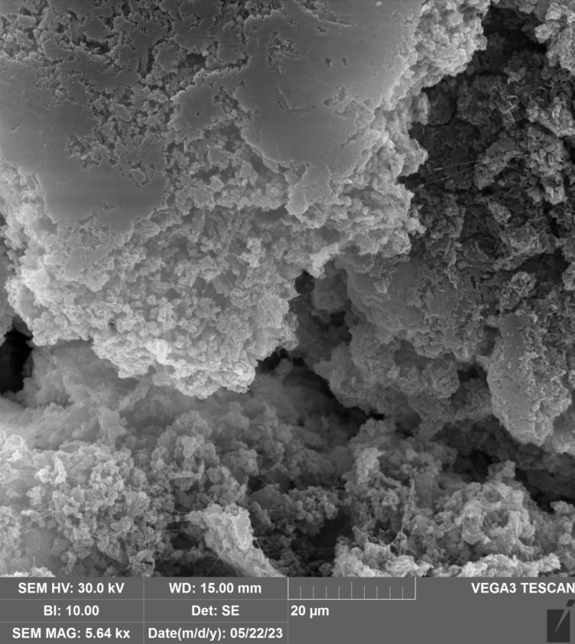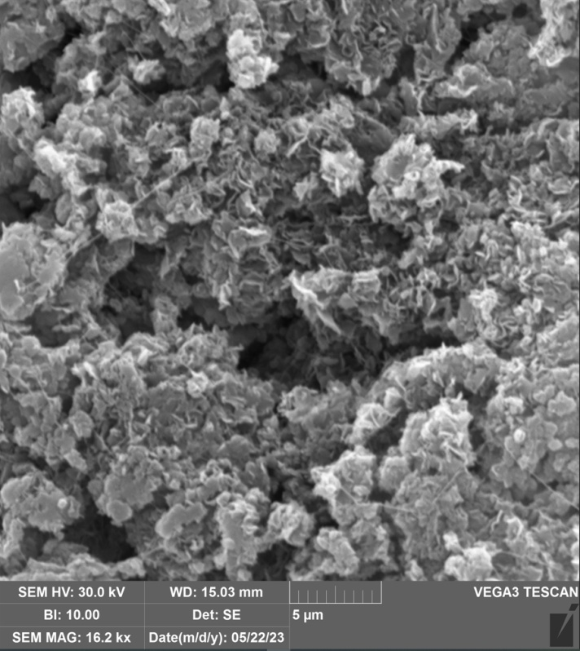
Figure S18. SEM images of the surface morphology of UHMWPE powders obtained with catalytic system {Complex 1 on MgCl₂} /Et₂AlCl (entry 2, table 1).

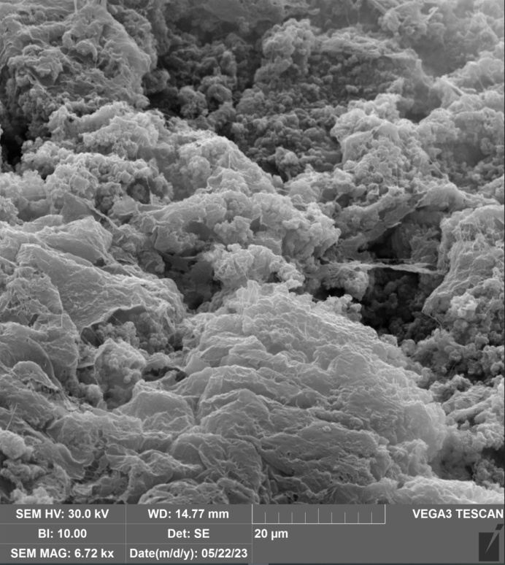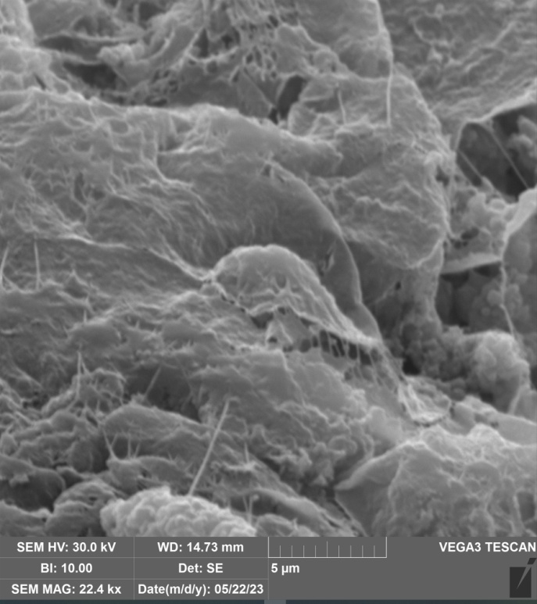

Figure S19. SEM images of the surface morphology of UHMWPE powders obtained with catalytic system {Complex 1 on MgCl₂} / Et₃Al (entry 3, table 1).

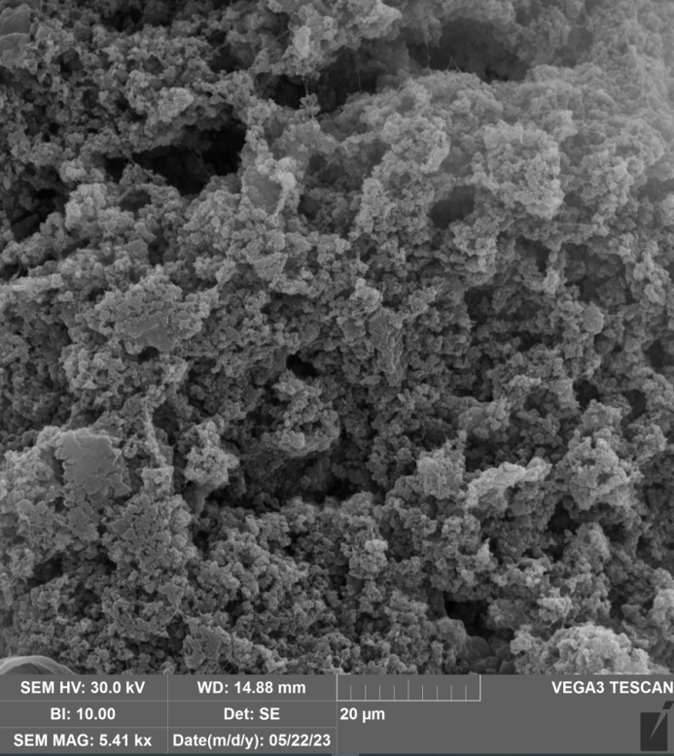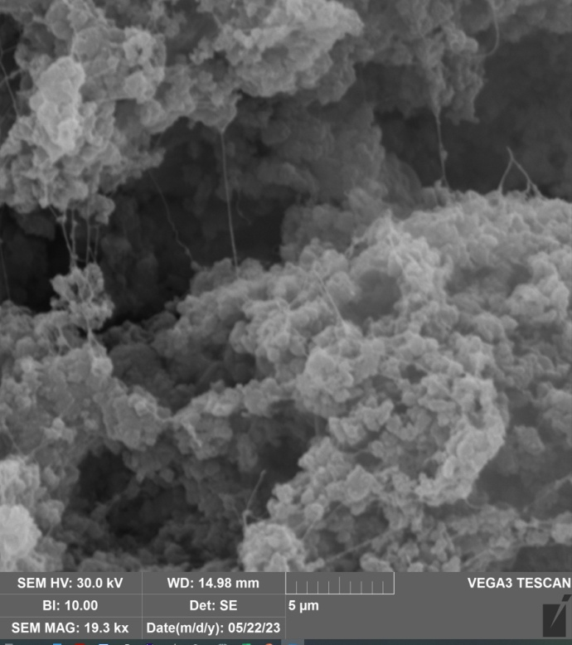
Figure S20. SEM images of the surface morphology of UHMWPE powders obtained with catalytic system {Complex 1 on MgCl₂} / Et₂AlCl/Et₃Al (entry 4, table 1).
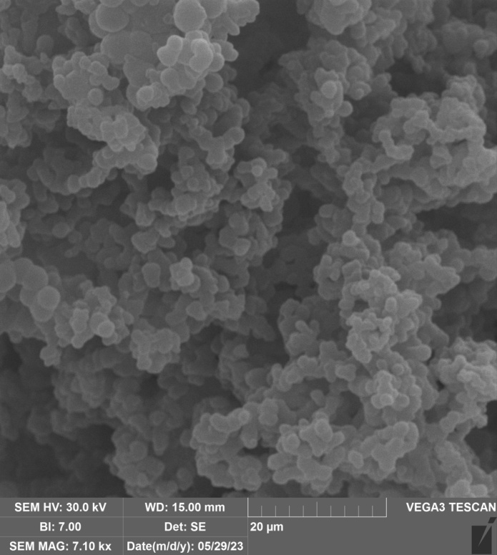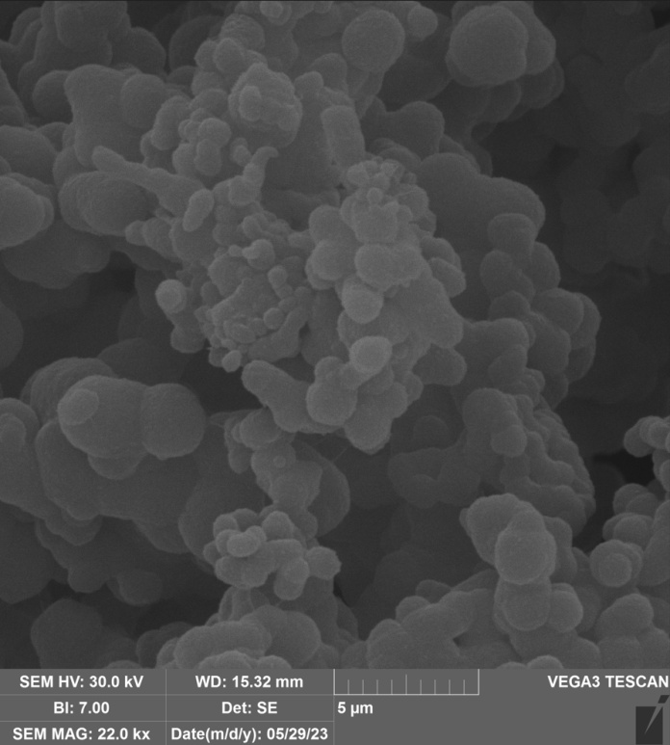
Figure S21. SEM images of the surface morphology of UHMWPE powders obtained with catalytic system Precatalyst 1/Me₃Al (entry 5, table 1).
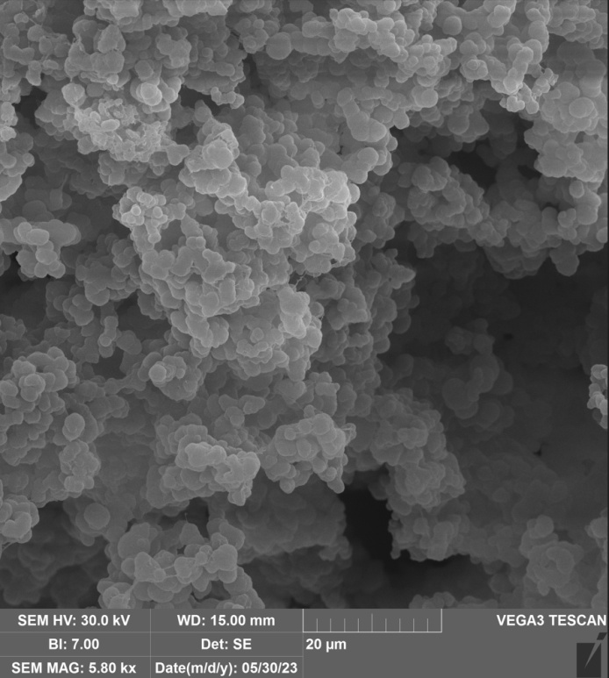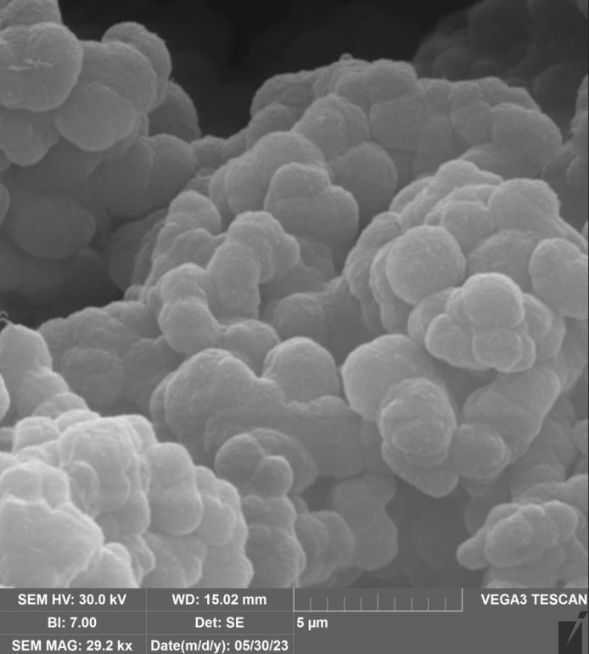

Figure S22. SEM images of the surface morphology of UHMWPE powders obtained with catalytic system Precatalyst 1/Me₃Al in nefras (entry 6, table 1).

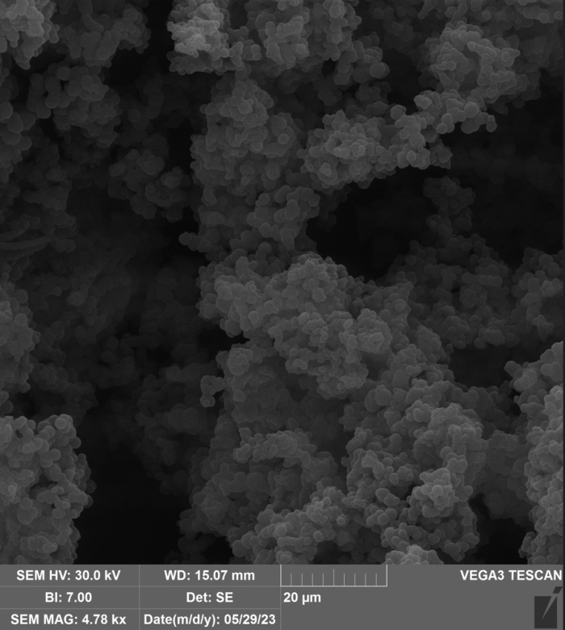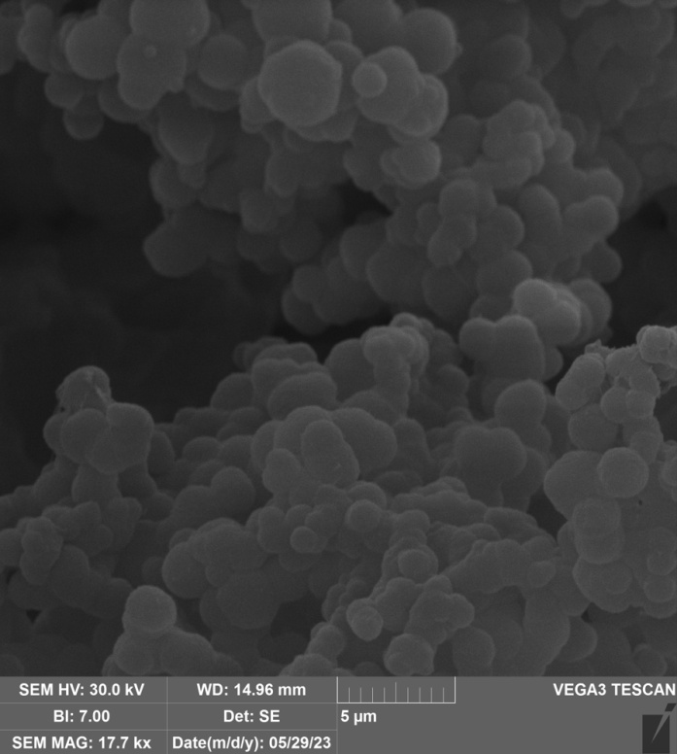
Figure S23. SEM images of the surface morphology of UHMWPE powders obtained with catalytic system Precatalyst 1/ Et₃Al in toluene (entry 7, table 1).

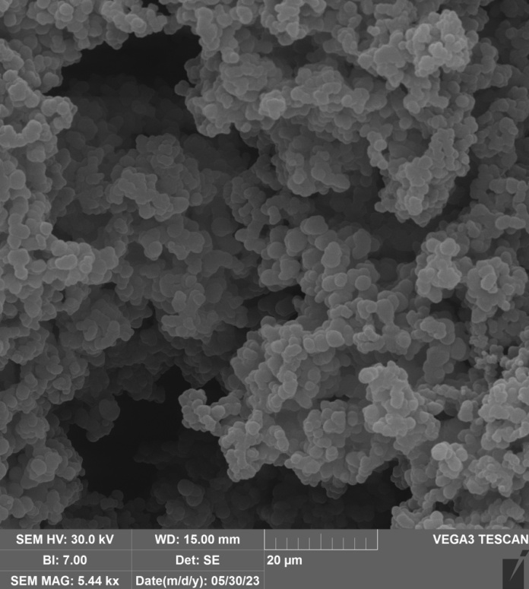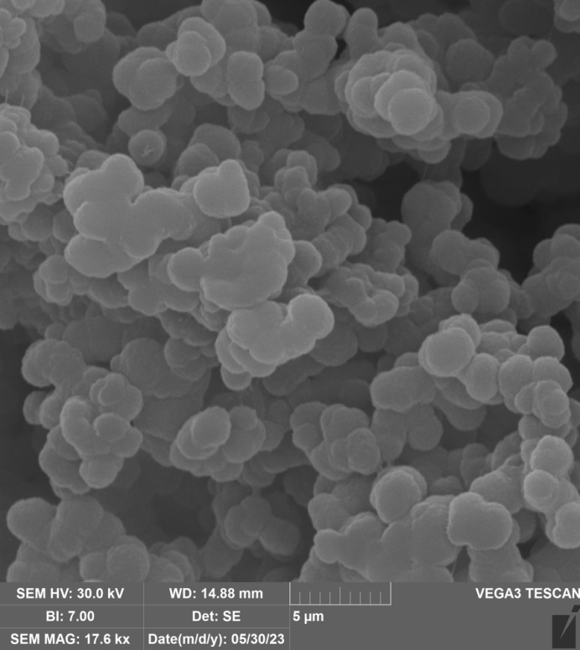
Figure S24. SEM images of the surface morphology of UHMWPE powders obtained with catalytic system Precatalyst 1/ Et₃Al in nefras (entry 8, table 1).

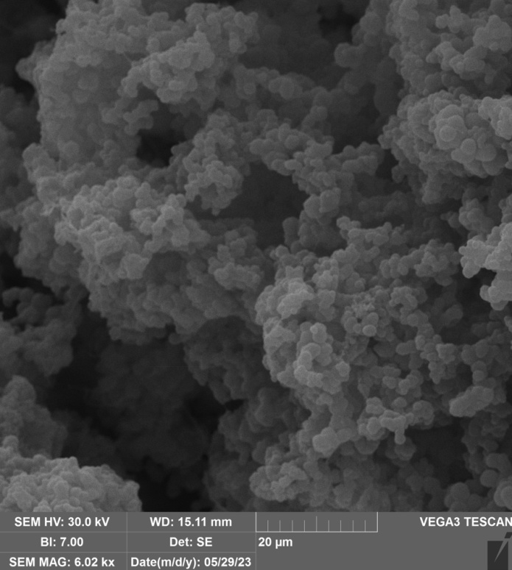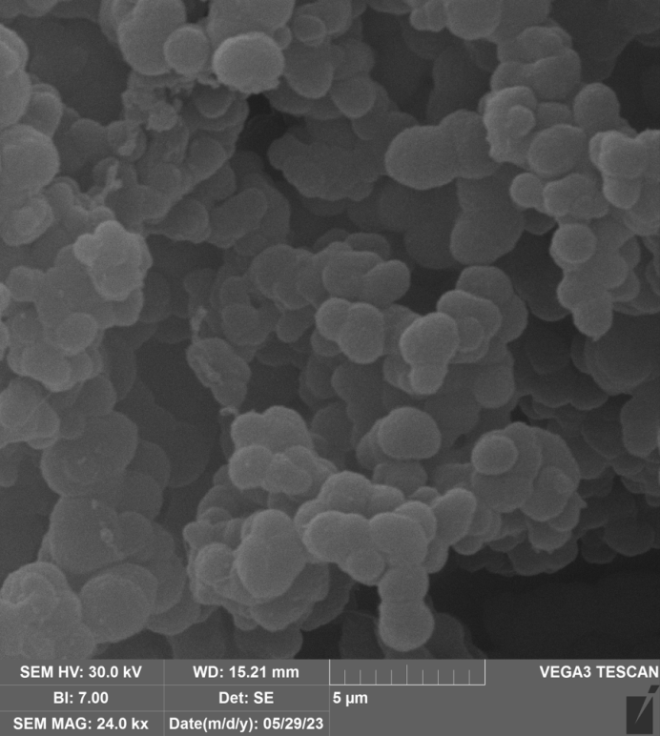
Figure S25. SEM images of the surface morphology of UHMWPE powders obtained with catalytic system Precatalyst 1/ iBu₃Al (entry 9, table 1).

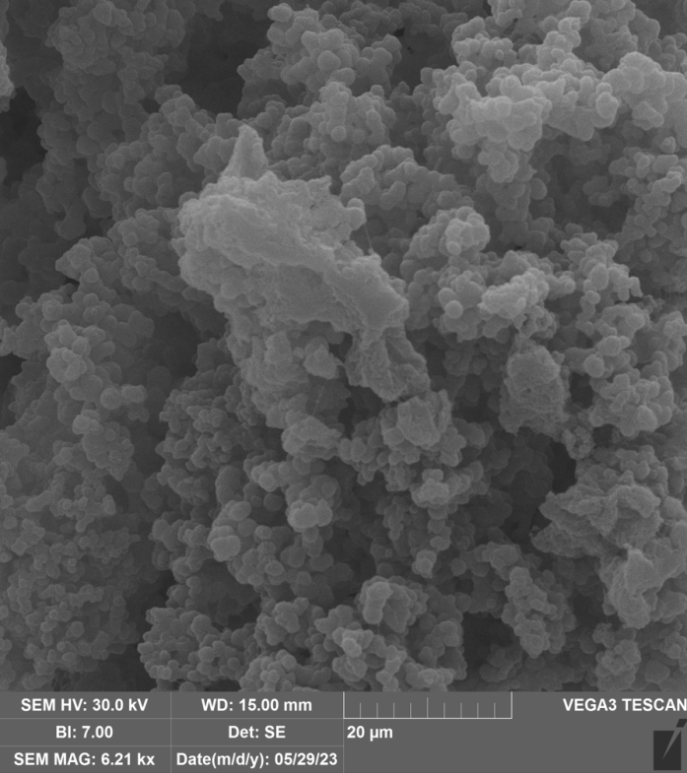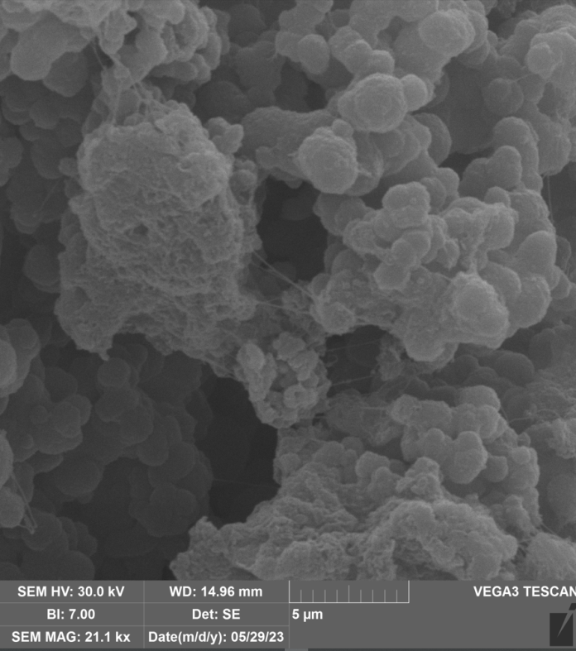
Figure S26. SEM images of the surface morphology of UHMWPE powders obtained with catalytic system Precatalyst 1/ MAO in toluene (entry 10, table 1).
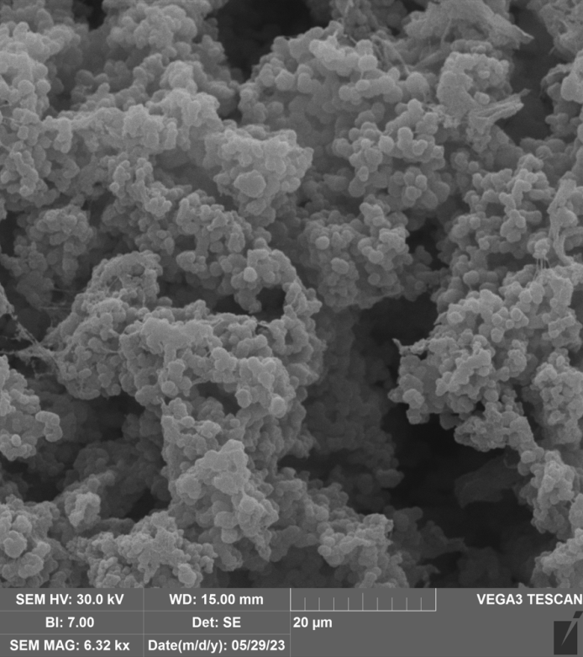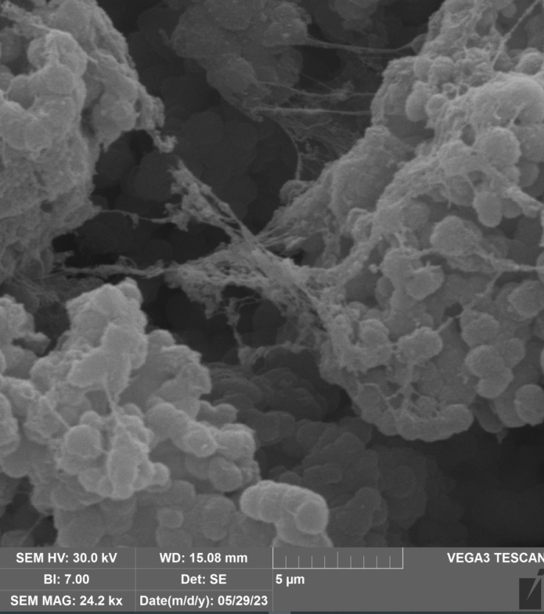
Figure S27. SEM images of the surface morphology of UHMWPE powders obtained with catalytic system Precatalyst 1/ MAO in nefras (entry 11, table 1).
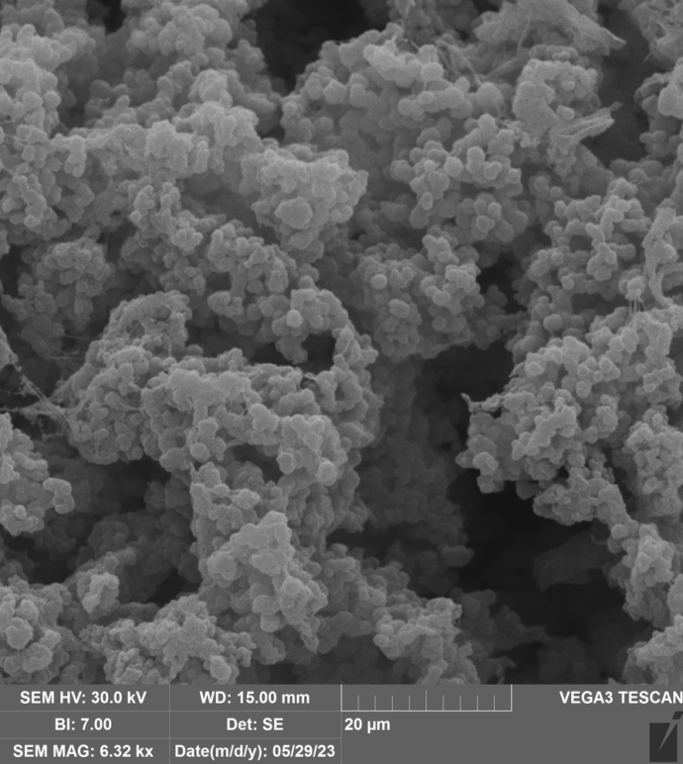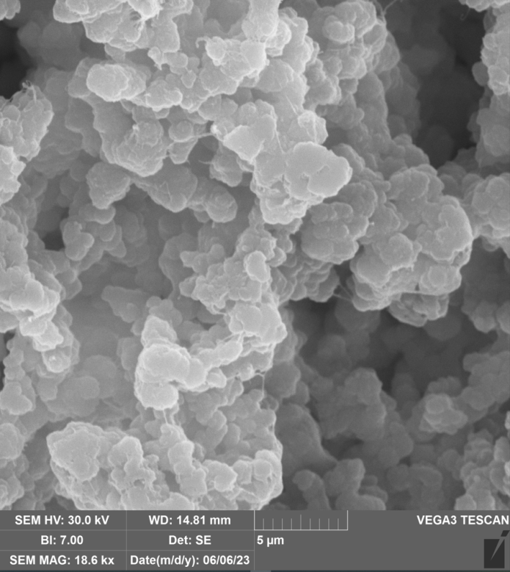

Figure S28. SEM images of the surface morphology of UHMWPE powders obtained with catalytic system Precatalyst 2/ Me₃Al in toluene (entry 12, table 1).
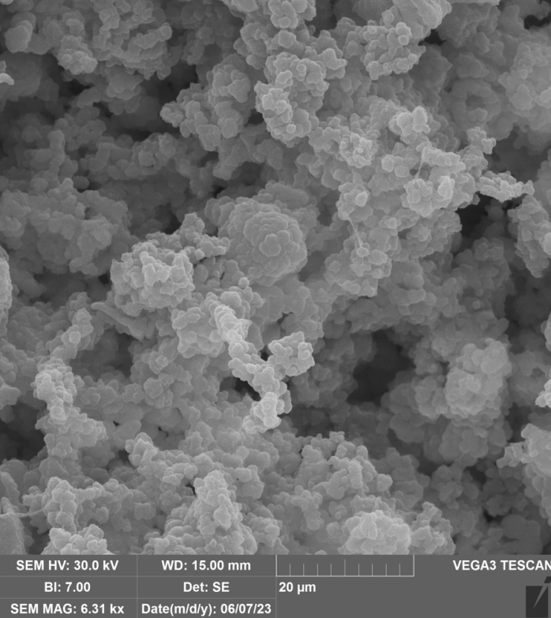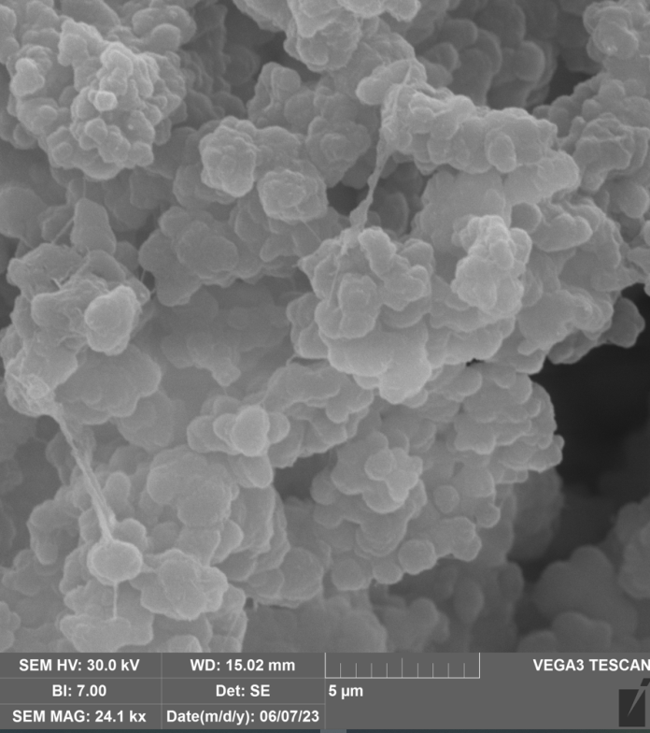
Figure S29. SEM images of the surface morphology of UHMWPE powders obtained with catalytic system Precatalyst 2/ Me₃Al in nefras (entry 13, table 1).
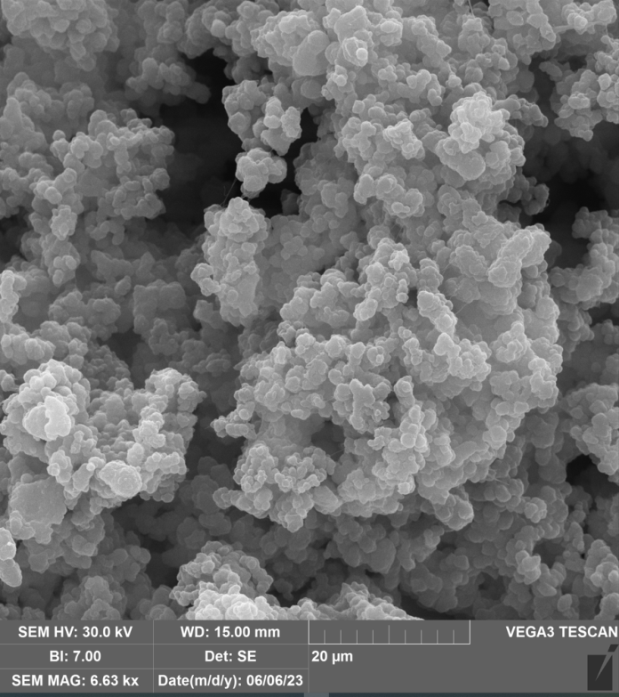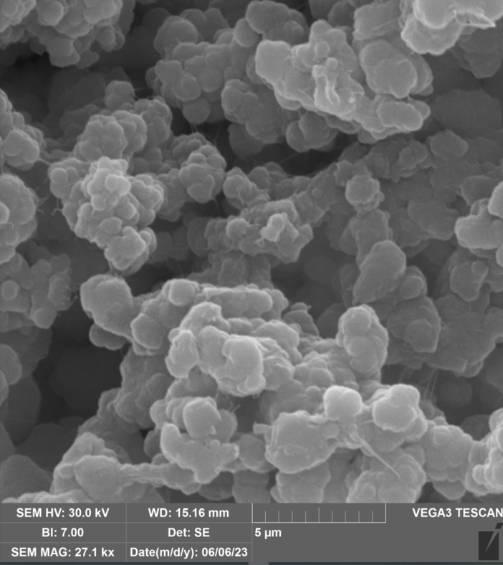
Figure S30. SEM images of the surface morphology of UHMWPE powders obtained with catalytic system Precatalyst 2/ Et₃Al in toluene (entry 14, table 1).

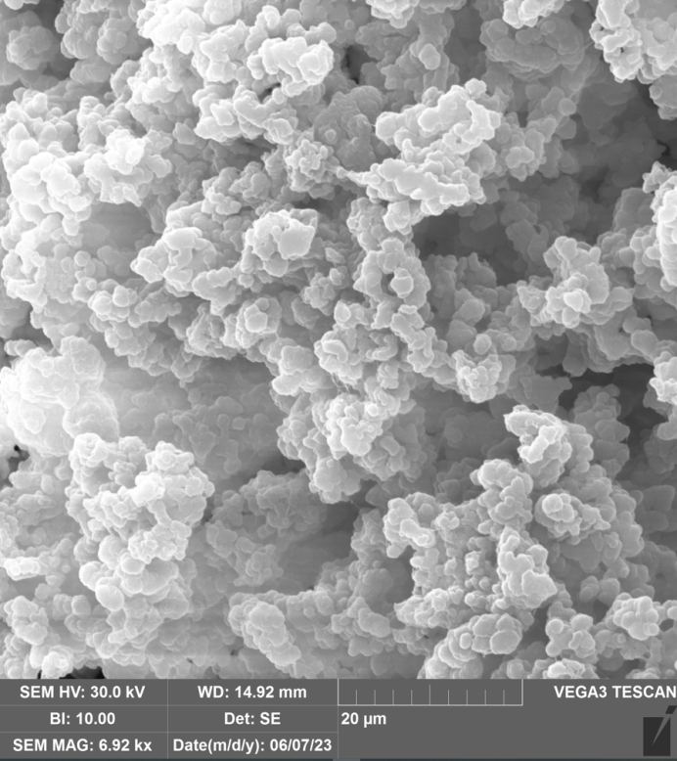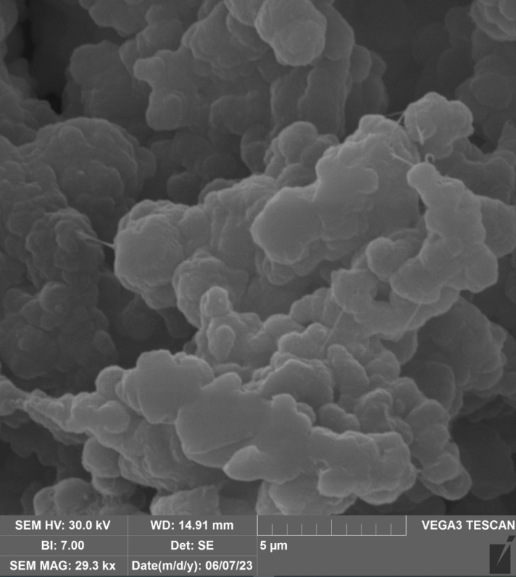

Figure S31. SEM images of the surface morphology of UHMWPE powders obtained with catalytic system Precatalyst 2/Et₃Al in nefras (entry 15, table 1).

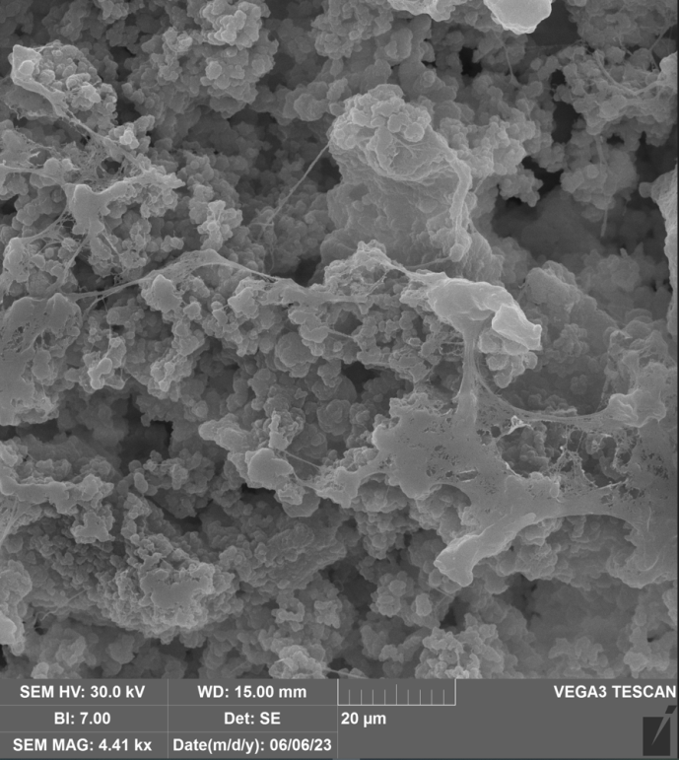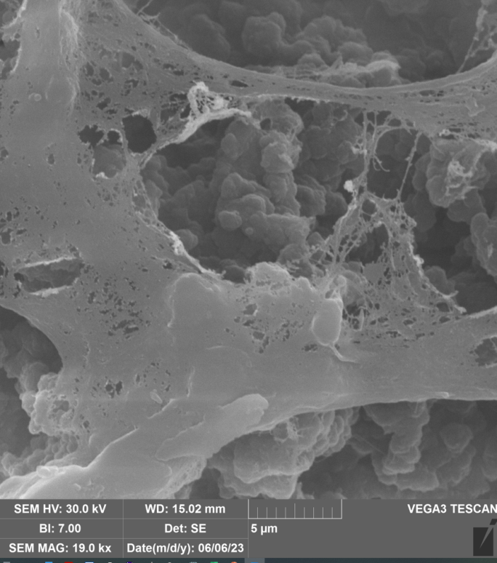
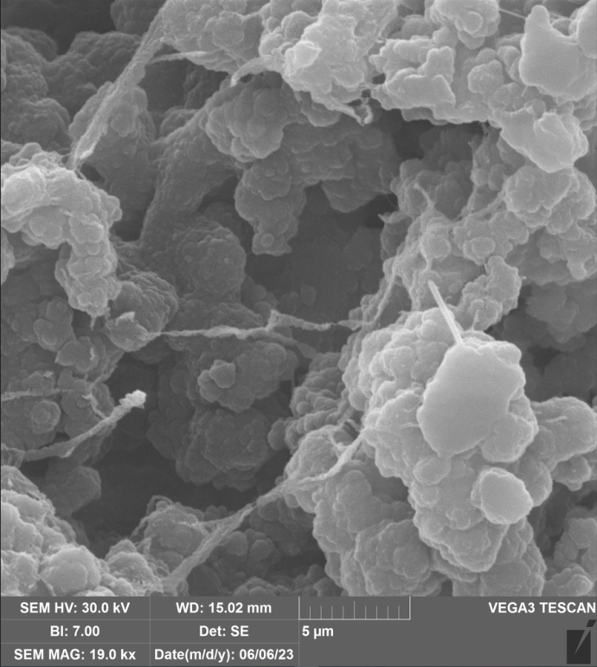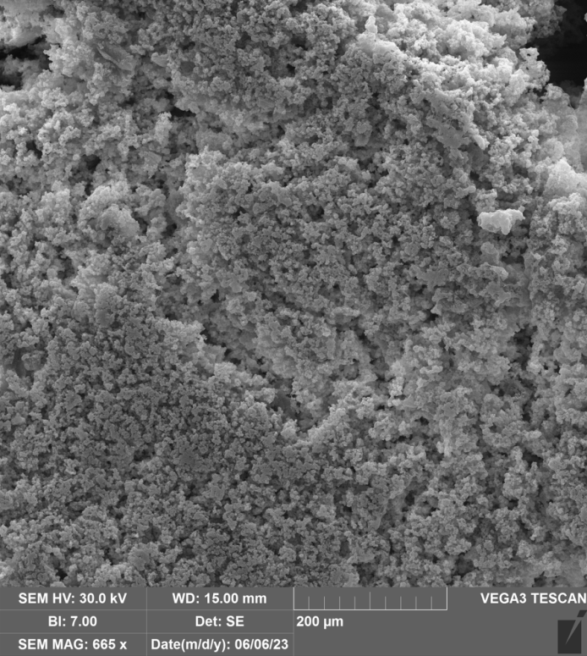
Figure S32. SEM images of the surface morphology of UHMWPE powders obtained with catalytic system Precatalyst 2/iBu₃Al in toluene (entry 16, table 1).
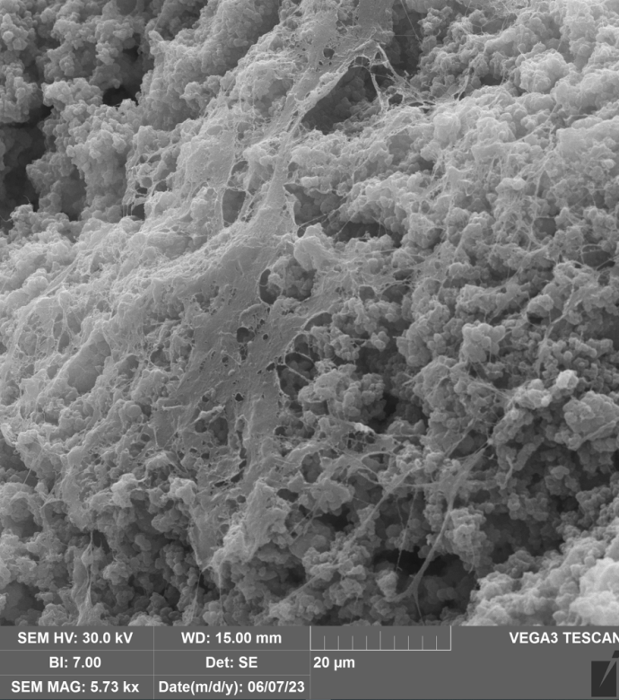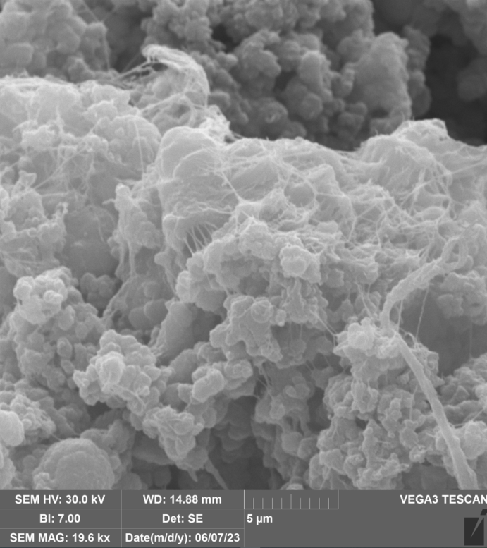
Figure S33. SEM images of the surface morphology of UHMWPE powders obtained with catalytic system Precatalyst 2/iBu₃Al in nefras (entry 17, table 1).
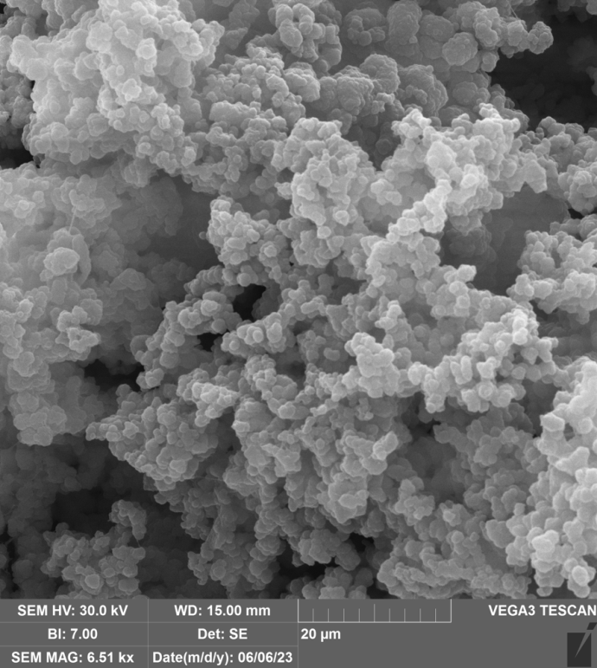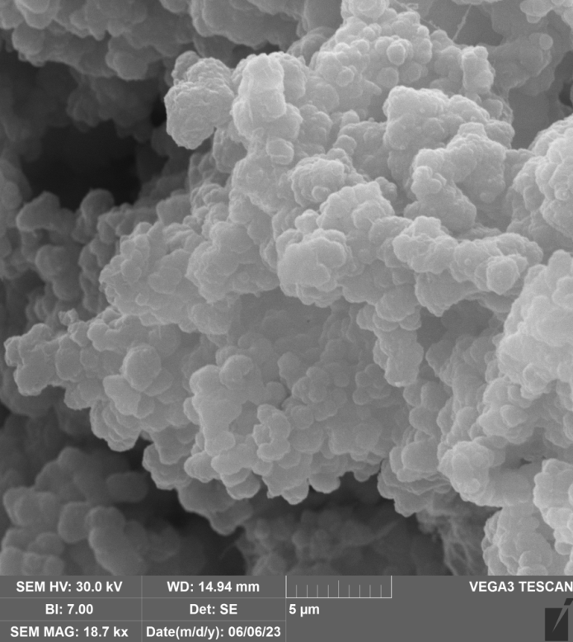

Figure S34. SEM images of the surface morphology of UHMWPE powders obtained with catalytic system Precatalyst 2/MAO in toluene (entry 18, table 1).
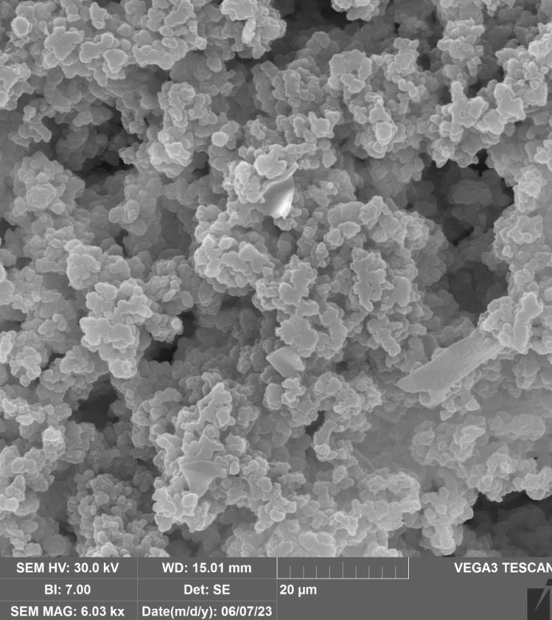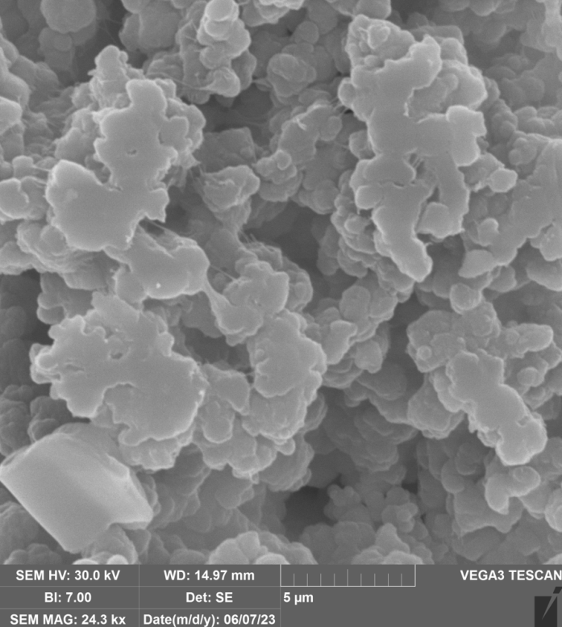

Figure S35. SEM images of the surface morphology of UHMWPE powders obtained with catalytic system Precatalyst 2/iBu₃Al in nefras (entry 19, table 1).

