Online Appendix - Trial duration and the use of trial-avoiding procedures:
Data referred to the territory of second-instance judicial districts
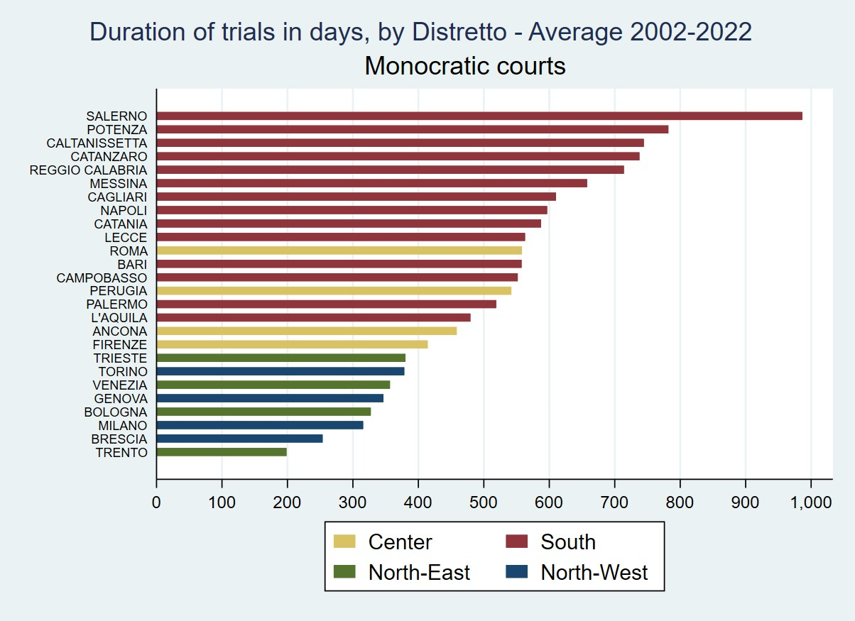
Fig. 1 Duration of trials in monocratic courts

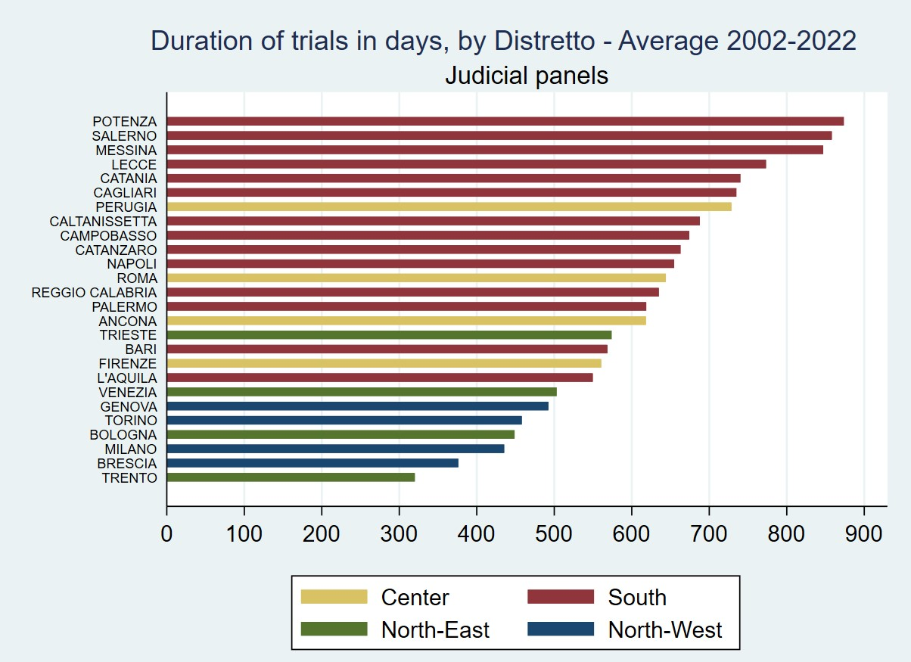
Fig. 2 Duration of trials in judicial panels
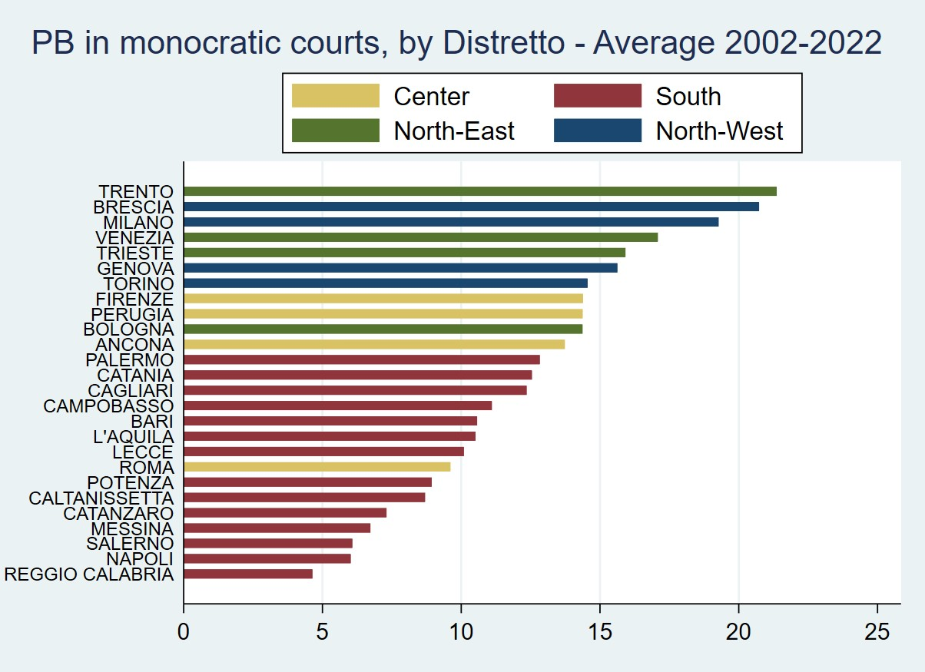
Fig. 3 Plea bargaining in monocratic courts
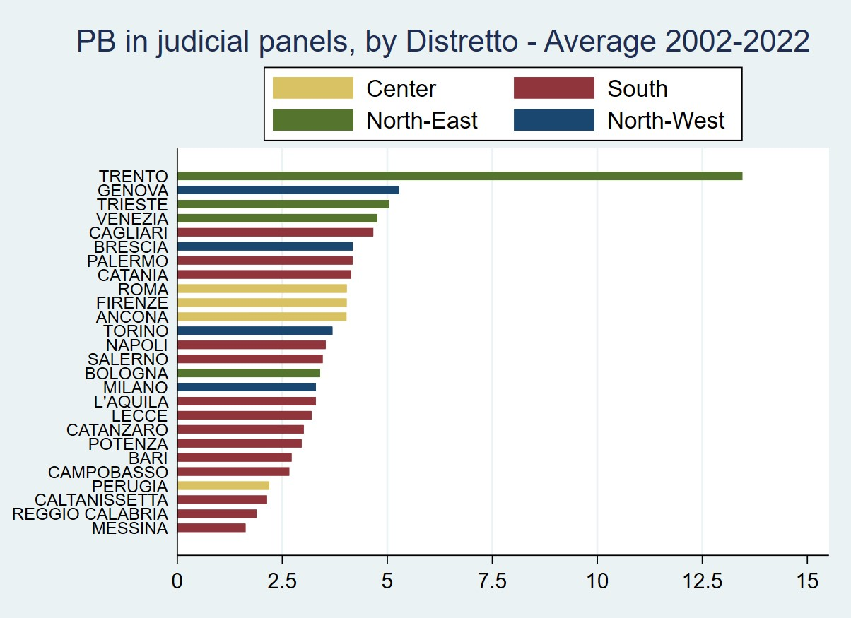
Fig. 4 Plea bargaining in judicial panels
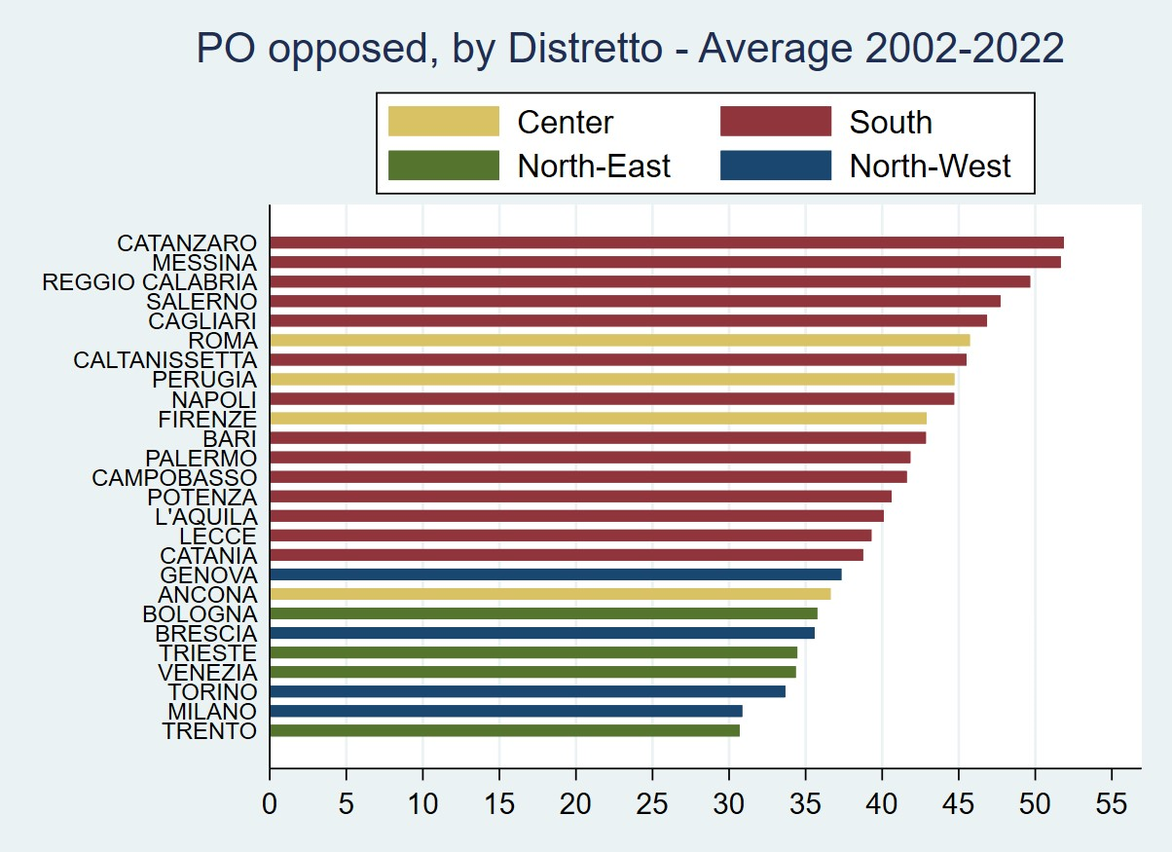
Fig. 5 Oppositions to penal orders

