Article title:
Journal name: European Journal of Forest Research
Author names: Paremmal Sarath^{1,4}, Abdul Bari Muneera Parveen³, Sreekumar VB² and Modhumita Dasgupta³, Suma Arun Dev ^{1, *}
*Corresponding author
Suma Arun Dev
sumadev@kfri.res.in
ORCID ID 0000-0002-6076-9693

¹Forest Genetics and Biotechnology Division,
Kerala Forest Research Institute, Peechi, Thrissur, Kerala 680653, India

²Forest Ecology and Biodiversity Conservation Division,
Kerala Forest Research Institute, Peechi, Thrissur, Kerala 680653, India

³Division of Plant Biotechnology and Cytogenetics,
Institute of Forest Genetics and Tree Breeding, Forest Campus, R.S. Puram,
Coimbatore 641002, India

⁴Forest Research Institute Deemed to be University, 248006, Uttarakhand, India

Supplementary Table 1. SSR loci used for genotyping Calamus species under study
Primer ID | Primer (5’-3’) | SSR motif | Ta | Cross-species transferability
Cbr02 | F – GCCGGTGTTAGTCTCCTTGG  R - ACGCAAGGTTGAGCCAAGTA | (AGG)6 | 61.8 | C.acanthospathus, C. nambariensis C. andamanicus
Cbr06 | F- CAACCTCTCACCTGGACCAC  R- AAGGATGTGGGAGGTGACCA | (GTAT)5 | 61.8 | C.acanthospathus, C. nambariensis C. andamanicus
Cbr07 | F- AGTGCCAGGAAGGACGACTA  R- TACGTTTAGCTAGGCTGCGG | (ATCT)6 | 58.3 | -
Cbr08 | F- GCTGAAAACCGCCCATAACC  R- ACGGCTAGCTTTAAGGGCTC | (AAAT)5 | 61.8 | -
Cbr09 | F- GCAGTTGCAGGTCCAGTTTT  R- AGGTAGGCGGATTACCTGGA | (ACAT)6 | 58.3 | -
Cbr11 | F- TGATGCATCCACAGTGCCAT  R- TTGTTTTGCGTGCGTACTGG | (GGAGA)6 | 59.5 | -
Cbr12 | F- GGCAATCCAATCATGTGGCC  R- GAGCTACCTACATGCGTGCT | (GTGTG)5 | 61.8 | C.acanthospathus, C. nambariensis
Cbr13 | F- CCCACTTACAAAAACCACAGCC  R- AGAGCAGAGTGAAGGAAGCAG | (AACTC)5 | 58 | C. andamanicus
Cbr14 | F- TCGTTCAGCCTCCTCCACTA  R- ATGGTACCTGGGGGTGTCAT | (TTC)6 | 61.8 | C. nambariensis
Cbr16 | F- TGTGGGGATCCGAACACTTC  R- CCAAAAGGGAAAGAGAGGGGG | (GAG)6 | 59.5 | C. andamanicus
Cbr18 | F- AGCTCTTCTGCTGGCCATTT  R- CCTATCAACACCCCTCACCC | (ATCG)5 | 58.3 | C. andamanicus  C.acanthospathus
Cbr19 | F- GAGAGGGAGAGAAGGGGAGG  R- TCTCACCTGACGCGGAAATC | (CGCT)6 | 61.8 | C. andamanicus  C.acanthospathus
Cbr20 | F- AATTGGCTTGTGACACCCGA  R- GGTACTACCTCCACCACCCA | (AGAA)6 | 58.3 | C.acanthospathus, C. nambariensis
Cbr21 | F- TCAAGAAGTCACGGCAGGAC  R- CGATTCCGGGCTACATGGAG | (TTTATT)5 | 59.5 | -
Cbr23 | F- GAAGCTCTCTCTAGGTGGGC  R- GCGACCCTTGCCCTTCTATT | (TTA)8 | 58 | -
Cbr30 | F- AGGACTCTTGTCATGAGTGTCA  R- TCCAGGCATGTGTGTTGTCT | Tri | 60.1 | -
Cbr31 | F- GGTGGTGGTGGGGGTAATTT  R- GCCCGACTCAACCATCAGAA | (ATA)13 | 65.6 | -
Cbr33 | F- CGGGACGTTTGTTTGTTTCT  R- GCGTCGCTCTAGTCCTTGAA | (TTA)8 | 60.9 | -
Cbr35 | F- TGCCAGCGTAGATCTCTAGC  R- CCGACGCCACCATTGTTGTA | (TTA)7 | 60.9 | -
Cbr36 | F- ATGGTACCTGGGGGTGTCAT  R- TCCGTTCGACCTCCTCCATT | (GAA)6 | 60.9 | -
Cbr38 | F- ACAGGCTTATCCACAACA  R- TACCAGCTAACACTCAGAAC | (GCA)5 |  | C. andamanicus
Cbr40 | F- TATTAGTAGTGGCTTCAGTTCC  R- ACCAGACGCCCGATCCTT | (CT)11 |  | C.acanthospathus, C. nambariensis C. andamanicus
Cbr41 | F- TCAGCCCAAGCCAACTCC  R- CGGGTGGGTAACGTAATGGT | (CAG)7 |  | C. nambariensis C. andamanicus
Cbr42 | F- ATTGGGCAGGATATTCGT  R- TGTTGAGGCACTGTTGGT | (TTCAT)3
Cbr45 | F- CAGCAGGAACAGGAAGAT  R- GTGGTGGAGTAAATAGTGAAGG | (TAG)5 |  | C.acanthospathus, C. nambariensis
Cbr46 | F- ACTTGGAATGACATCGCTAA  R- GGCCTTTCTTCTGGTGCA | (TGAGT)4 |  | C. nambariensis
Cbr47 | F- GGGGACTAATTGAGGACACG  R- CCAATAAATTCTACCAGGGTC | (CT)7
Cbr50 | F- CTGCTGCTAAGGCTGATA  R- TCCTCATCTTCCTCGTCA | (TGA)5 |  | C. nambariensis C. andamanicus

Supplementary Table 2 Prop.pops.out.of.HWE for C.brandisii
pop | Chisq | MC | Chisq.fdr | MC.fdr
Acbr53 | 0.5217391 | 0.5652174 | 0.5217391 | 0.3913043
Pcbr26 | 0.4347826 | 0.3478261 | 0.3478261 | 0.2608696
Zcbr24 | 0.5652174 | 0.4782609 | 0.5217391 | 0.3478261

Supplementary Table 3 Prop.loci.out.of.HWE for C.brandisii
Loci | Chisq | MC | Chisq.fdr | MC.fdr
Cbrssr18 | 0.6666667 | 0.6666667 | 0.6666667 | 0.3333333
Cbrssr11 | 0.3333333 | 0.0000000 | 0.0000000 | 0.0000000
Cbrssr33 | 1.0000000 | 1.0000000 | 1.0000000 | 1.0000000
Cbrssr19 | 0.3333333 | 0.3333333 | 0.3333333 | 0.3333333
Cbrssr23 | 1.0000000 | 0.6666667 | 1.0000000 | 0.6666667
Cbrssr30 | 0.0000000 | 0.0000000 | 0.0000000 | 0.0000000
Cbrssr31 | 0.6666667 | 0.6666667 | 0.3333333 | 0.3333333
Cbrssr35 | 0.3333333 | 0.3333333 | 0.3333333 | 0.3333333
Cale4 | 0.3333333 | 0.3333333 | 0.3333333 | 0.3333333
Cale9 | 0.0000000 | 0.0000000 | 0.0000000 | 0.0000000
Cale10 | 0.3333333 | 0.3333333 | 0.3333333 | 0.0000000
Cale22 | 0.6666667 | 0.3333333 | 0.6666667 | 0.0000000
Cale23 | 1.0000000 | 1.0000000 | 1.0000000 | 0.6666667
Cale25 | 1.0000000 | 1.0000000 | 0.6666667 | 0.3333333
Cale31 | 0.3333333 | 0.3333333 | 0.3333333 | 0.3333333
Cale36 | 0.6666667 | 0.6666667 | 0.6666667 | 0.6666667
Cbrssr2 | 0.3333333 | 0.3333333 | 0.3333333 | 0.3333333
Cbrssr9 | 0.3333333 | 0.3333333 | 0.3333333 | 0.3333333
Cbrssr16 | 0.3333333 | 0.3333333 | 0.3333333 | 0.3333333
Cbrssr7 | 0.6666667 | 0.6666667 | 0.6666667 | 0.3333333
Cbrssr8 | 0.6666667 | 0.6666667 | 0.6666667 | 0.6666667
cbrssr20 | 0.3333333 | 0.0000000 | 0.3333333 | 0.0000000
Cbrssr14 | 0.3333333 | 0.6666667 | 0.3333333 | 0.3333333

Supplementary Table 4 Prop.pops.out.of.HWE after FDR for C. acanthospathus
 | Chisq | MC | Chisq.fdr | MC.fdr
Acap25 | 0.125 | 0.125 | 0.125 | 0.125
Bcap50 | 0.750 | 0.500 | 0.625 | 0.250
Ccap58 | 0.250 | 0.125 | 0.125 | 0.000
Dcap68 | 0.125 | 0.125 | 0.000 | 0.000

Supplementary Table 5 Prop.loci.out.of.HWE after FDR C. acanthospathus
 | Chisq | MC | Chisq.fdr | MC.fdr
Cale9 | 0.25 | 0.00 | 0.25 | 0.00
Cale23 | 0.50 | 0.50 | 0.25 | 0.00
Cbr2 | 0.25 | 0.25 | 0.25 | 0.00
Cbr6 | 0.50 | 0.00 | 0.00 | 0.00
Cbr12 | 0.50 | 0.50 | 0.50 | 0.50
Cbr18 | 0.25 | 0.25 | 0.25 | 0.00
cbr19 | 0.00 | 0.00 | 0.00 | 0.00
Cbr20 | 0.25 | 0.25 | 0.25 | 0.25

Supplementary Table 6 Prop.pops.out.of.HWE after FDR for C. nambariensis
 | Chisq | MC | Chisq.fdr | MC.fdr
CNI26 | 0.1111111 | 0.0000000 | 0.0000000 | 0
CNI36 | 0.0000000 | 0.0000000 | 0.0000000 | 0
CNI55 | 0.1111111 | 0.0000000 | 0.1111111 | 0
CNI72 | 0.2222222 | 0.2222222 | 0.0000000 | 0

Supplementary Table 7 Prop.loci.out.of.HWE after FDR C. nambariensis
 | Chisq | MC | Chisq.fdr | MC.fdr
Cale9 | 0.00 | 0.00 | 0.00 | 0
Cale10 | 0.25 | 0.25 | 0.00 | 0
Cale25 | 0.25 | 0.00 | 0.25 | 0
Cale36 | 0.00 | 0.00 | 0.00 | 0
Cale23 | 0.25 | 0.00 | 0.00 | 0
Cbr12 | 0.00 | 0.00 | 0.00 | 0
Cbr6 | 0.00 | 0.00 | 0.00 | 0
Cbr14 | 0.25 | 0.25 | 0.00 | 0
Cbr20 | 0.00 | 0.00 | 0.00 | 0

Supplementary Table 8 Prop.pops.out.of.HWE after FDR for C. andamanicus
 | Chisq | MC | Chisq.fdr | MC.fdr
NAS7 | 0.4 | 0.4 | 0.4 | 0.4
BEA6 | 0.7 | 0.6 | 0.7 | 0.6
BA14 | 0.6 | 0.6 | 0.5 | 0.6
MOULP | 0.7 | 0.6 | 0.7 | 0.6
RTA11 | 0.4 | 0.7 | 0.3 | 0.5
LA13 | 0.6 | 0.8 | 0.6 | 0.8

Supplementary Table 9 Prop.loci.out.of.HWE after FDR C. andamanicus
 | Chisq | MC | Chisq.fdr | MC.fdr
Cbr12 | 0.6666667 | 0.8333333 | 0.6666667 | 0.8333333
Cale4 | 0.5000000 | 0.1666667 | 0.5000000 | 0.1666667
Cale9 | 0.5000000 | 0.8333333 | 0.5000000 | 0.8333333
Cale36 | 0.5000000 | 0.1666667 | 0.5000000 | 0.0000000
Cale10 | 0.8333333 | 0.6666667 | 0.6666667 | 0.6666667
Cbr6 | 0.6666667 | 1.0000000 | 0.6666667 | 0.8333333
Cbr8 | 0.6666667 | 0.8333333 | 0.6666667 | 0.8333333
Cbr13 | 0.3333333 | 0.3333333 | 0.3333333 | 0.3333333
Cbr16 | 0.6666667 | 0.8333333 | 0.6666667 | 0.8333333
Cbr19 | 0.3333333 | 0.5000000 | 0.1666667 | 0.5000000

Supplementary Table 10 Mean allelic richness in each population
Species | Population
C. brandisii | Acbr | Pcbr | Zcbr
C. brandisii | 4.039 | 3.89 | 4.47
C. acanthospathus | Maw | Nag | Frcbr | PhLui
C. acanthospathus | 2.7 | 2.9 | 2.08 | 2.547
C. nambariensis | Kaw | Frcbr | Ngopa | Dih
C. nambariensis | 2.146 | 1.933 | 2.057 | 2.381
C. andamanicus | NA | MA | BA | SA | RT | LA
C. andamanicus | 2.842 | 3.644 | 4.381 | 3.399 | 3.458 | 3.919

Supplementary Table 11. Pairwise Population Fst and Nei genetic distance of studied populations
Pairwise Population Fst and Nei genetic distance of C. bradisii
Pairwise Population Fst Values |  |  |  | Pairwise Population Nei’s genetic distance
AgM | PadM | PaP |  | AgM | PadM | PaP
0 |  |  | AgM | 0
0.072 | 0 |  | PadM | 0.11 | 0
0.067 | 0.027 | 0 | PaP | 0.121 | 0.044 | 0
Pairwise Population Fst and Nei Genetic Distance of C. acanthospathus
Pairwise Population Fst Values |  |  |  |  | Pairwise Population Matrix of Nei Genetic Distance
Maw | Nag | Frcbr | PhLui |  | Maw | Nag | Frcbr | PhLui
0 |  |  |  | Maw | 0
0.078 | 0 |  |  | Nag | 0.21 | 0
0.114 | 0.085 | 0 |  | Frcbr | 0.371 | 0.2 | 0
0.106 | 0.057 | 0.091 | 0 | PhLui | 0.29 | 0.131 | 0.197 | 0
Pairwise Population Fst and Nei genetic distance C. nambariensis
Pairwise Population Fst Values |  |  |  |  | Pairwise Population Matrix of Nei Genetic Distance
Kaw | Frcbr | Ngopa | Dih |  | Kaw | Frcbr | Ngopa | Dih
0 |  |  |  | Kaw | 0
0.274 | 0 |  |  | Frcbr | 0.114 | 0
0.288 | 0.183 | 0 |  | Ngopa | 0.113 | 0.099 | 0
0.256 | 0.165 | 0.134 | 0 | Dih | 0.091 | 0.071 | 0.059 | 0
Pairwise Population Fst and Nei genetic distance C. andamanicus
Pairwise Population Matrix of Nei Genetic Distance |  |  |  |  |  |  | Pairwise Population Fst Values
NA | MA | BA | SA | RT | LA |  | NA | MA | BA | SA | RT | LA
0 |  |  |  |  |  | NA | 0
0.174 | 0 |  |  |  |  | MA | 0.083 | 0
0.248 | 0.101 | 0 |  |  |  | BA | 0.096 | 0.024 | 0
0.054 | 0.177 | 0.203 | 0 |  |  | SA | 0.035 | 0.056 | 0.055 | 0
0.096 | 0.107 | 0.149 | 0.11 | 0 |  | RT | 0.057 | 0.028 | 0.034 | 0.036 | 0
0.406 | 0.207 | 0.167 | 0.402 | 0.25 | 0 | LA | 0.132 | 0.044 | 0.032 | 0.091 | 0.053 | 0

Supplementary Table 12. Bottleneck analysis of studied populations
Wilcoxon test for bottleneck analysis C. acanthospathus
Population | TPM | Mode-Shift
AgM | 0.28388 | L-shaped distribution
PadM | 0.98075 | L-shaped distribution
PaP | 0.92298 | L-shaped distribution
Wilcoxon test for bottleneck analysis C. acanthospathus
Population | TPM | Mode-Shift
Maw | 0.00977 | L-shaped distribution
Nag | 0.72656 | L-shaped distribution
Frcbr | 0.00781 | L-shaped distribution
PhLui | 0.96094 | L-shaped distribution
Wilcoxon test for bottleneck analysis C. nambariensis
Population | TPM | Mode-Shift
Kaw | 0.23047 | L-shaped distribution
Frcbr | 0.03906 | L-shaped distribution
Ngopa | 0.99805 | L-shaped distribution
Dih | 0.87500 | L-shaped distribution
Wilcoxon test for bottleneck analysis C. andamanicus
Population | TPM | Mode-Shift
NA | 0.84961 | L-shaped distribution
MA | 0.61523 | L-shaped distribution
BA | 0.42285 | L-shaped distribution
SA | 0.81250 | L-shaped distribution
RT | 0.54492 | L-shaped distribution
LA | 0.04199 | L-shaped distribution

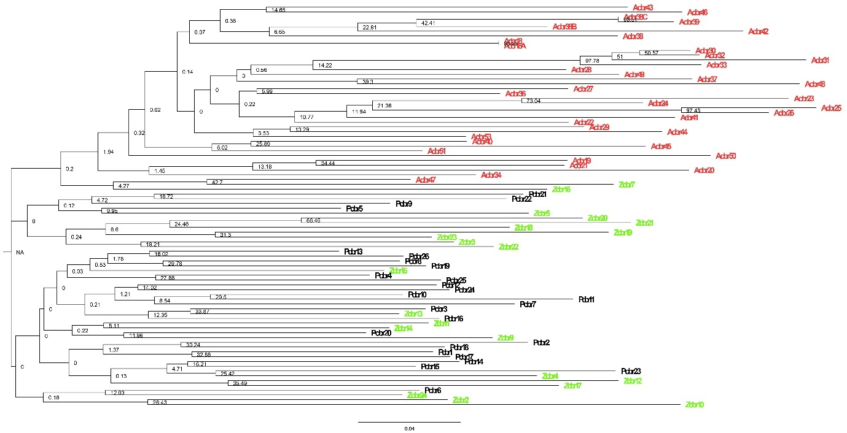

AgM

PadM & PaP
Supplementary Fig.1 NJ dendrogram of individuals per population clustering pattern for C. brandisii.
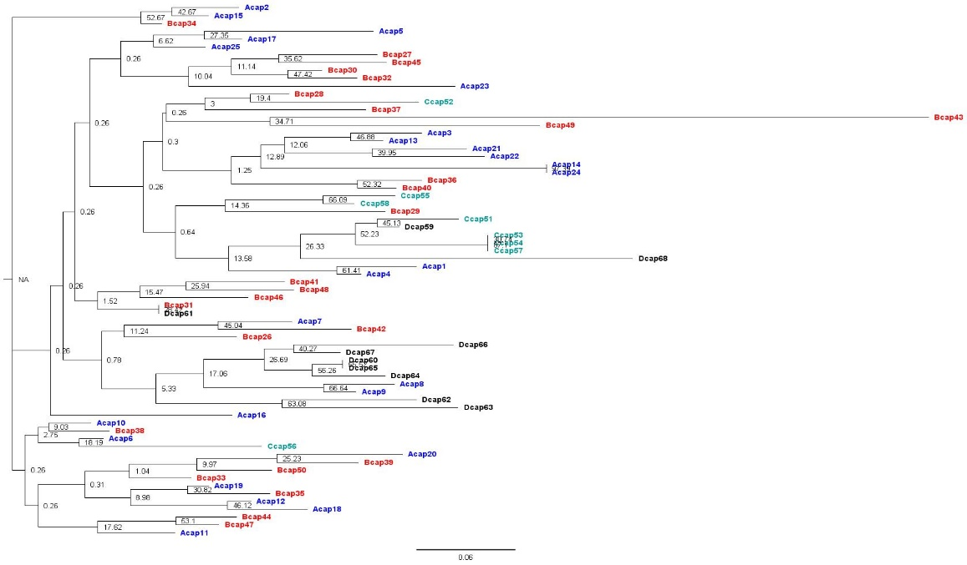

Supplementary Fig.2. NJ dendrogram of individuals per population clustering pattern of C. acanthospathus
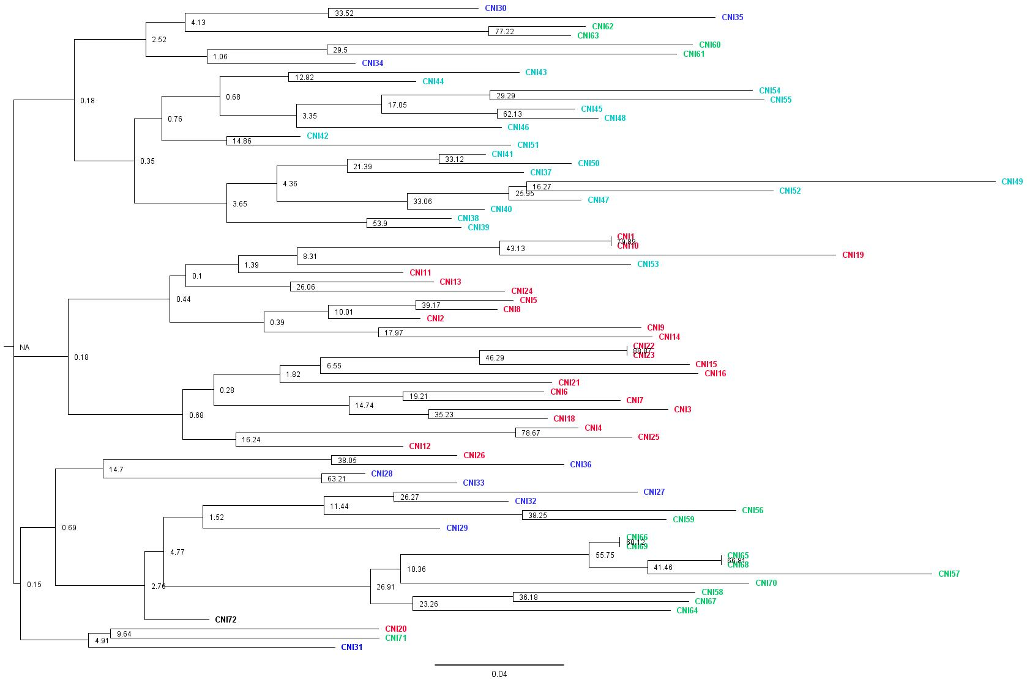
Supplementary Fig.3. NJ dendrogram of individuals per population clustering pattern of C. nambariensis

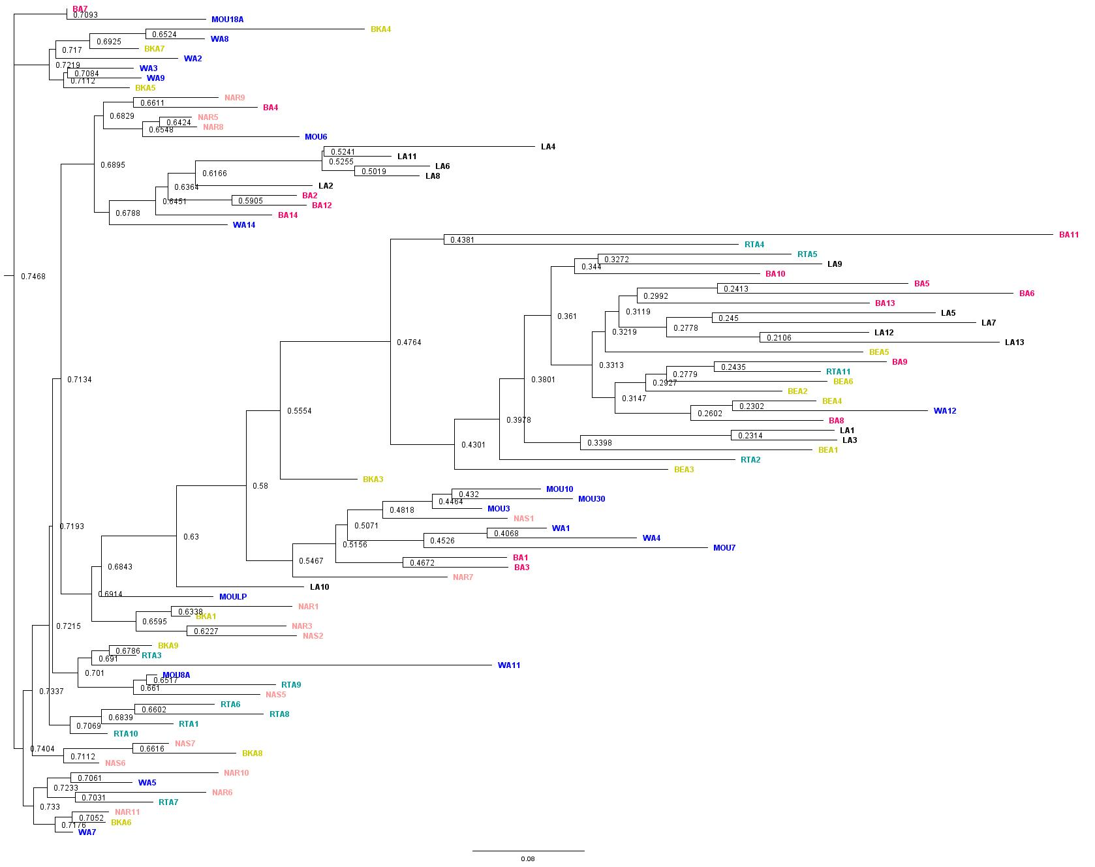

Supplementary Fig.4. NJ dendrogram of individuals per population clustering pattern of C. andamanicus

