a  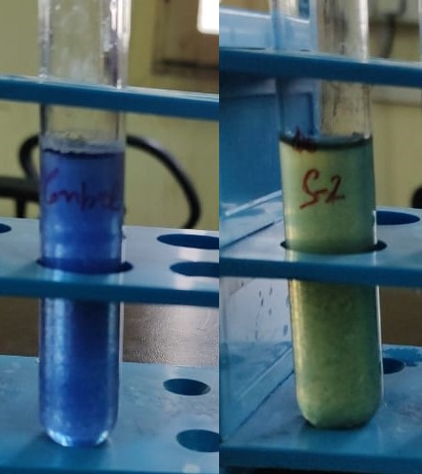 | b  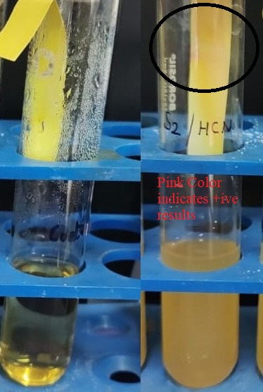
C  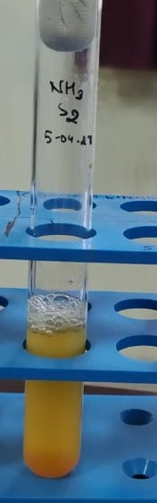 | d  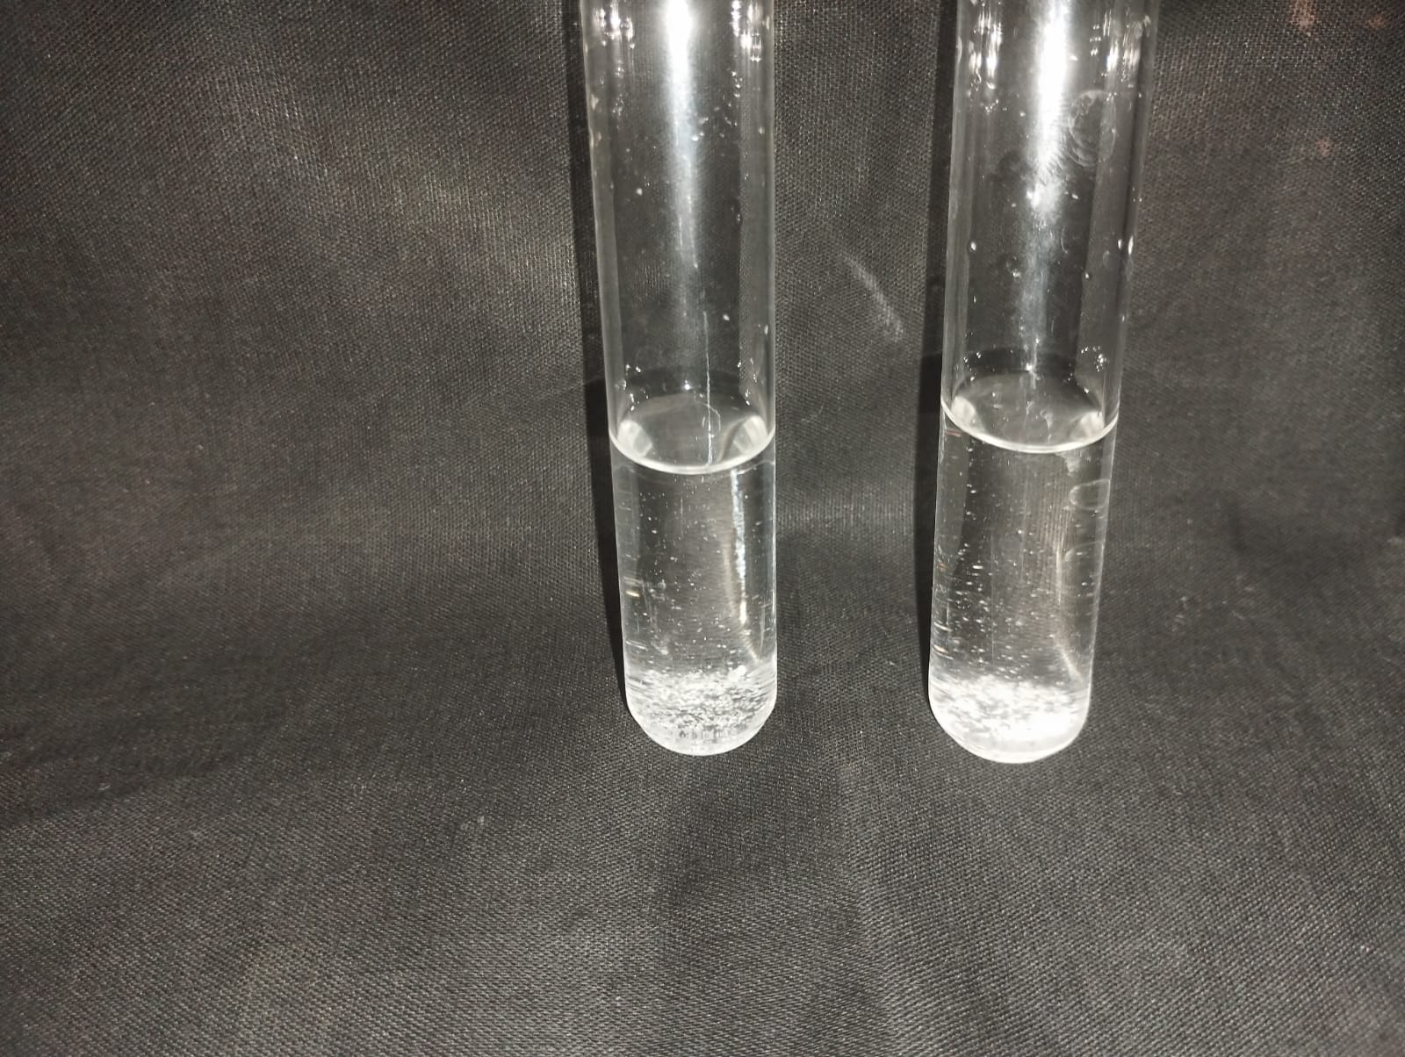
Fig 1a. Siderophore activity of SSAU-2, blue color disappearance shows the +ive result, Fig 1b. HCN production by SSAU-2, change of filter paper color to pink shows the positive result, Fig 1c. NH₃ production by SSAU-2, brownish precipitation shows the positive result (bottom of the test tube), Fig 1d. Crude EPS synthesis by SSAU-2, white precipitate in the bottom

