Supplymentary Materials
Table 1S : Demographic characteristics of all patients.
 | Patient class
 | SARS-COV-2 (COVID19) | Infuenza A (INFA) | Respiratory Syncytial  Virus (RSV) | Controls
Number | 55 | 55 | 56 | 44
Collection year  (monthly variation) | 2020 (Jan–Apr) | 2019–2020 (Dec–Mar) | 2019–2020 (Dec–Mar) | 2020 (Sept)
Age range | 55 years  (20–85 years) | 62 years  (27 days–94 years) | 16 months  (21 days– 91 years) | 24 years  (19–43 years)
Sex (%) | M 27%  F 42%  n/a 31% | M 54%  F 44%  n/a 2% | M 40%  F 46%  n/a 14% | M 25%  F 75%
Median CTa (range) | 26.2 (17.76–37.24) | 28.6 (21.43–38.6) | 26.3 (18.54–36.87) | N/A

Table 2S : List of metabolites

 |  | Acylcarnitines
 |  | C0 Carnitine  C2 Acetylcarnitine  C3:1 Propenoylcarnitine  C3 Propionylcarnitine  C4:1 Butenylcarnitine  C4 Butyrylcarnitine  C3OH Hydroxypropionylcarnitine  C5:1³ Tiglylcarnitine  C5 Valerylcarnitine  C4OH Hydroxybutyrylcarnitine  C6:1 Hexenoylcarnitine  C6 Hexanoylcarnitine  C5OH Hydroxyvalerylcarnitine  C5:1DC Glutaconylcarnitin  C5DC Glutarylcarnitine  C8 Octanoylcarnitine  C5MDC Methylglutarylcarnitine  C9 Nonaylcarnitine  C7DC Pimelylcarnitine  C10:2 Decadienylcarnitine |  |  |  | C10:1 Decenoylcarnitine  C10 Decanoylcarnitine  C12:1 Dodecenoylcarnitine  C12 Dodecanoylcarnitine  C14:2 Tetradecadienylcarnitine  C14:1^{1,2} Tetradecenoylcarnitine  C14 Tetradecanoylcarnitine  C12DC Dodecanedioylcarnitine  C14:2OH Hydroxytetradecadienylcarnitine  C14:1OH Hydroxytetradecenoylcarnitine  C16:2 Hexadecadienylcarnitine  C16:1 Hexadecenoylcarnitine  C16 Hexadecanoylcarnitine  C16:2OH Hydroxyhexadecadienylcarnitine  C16:1OH² Hydroxyhexadecenoylcarnitine  C16OH Hydroxyhexadecanoylcarnitine  C18:2 Octadecadienylcarnitine  C18:1 Octadecenoylcarnitine  C18 Octadecanoylcarnitine  C18:1OH Hydroxyoctadecenoylcarnitine
 |  | Amino Acids
 |  | Ala^{1,2,3} Alanine  Arg^{1,3} Arginine  Asn^{1,2} Asparagine  Asp^{1,2,3} Aspartate  Cit^{1,2} Citrulline  Gln^{1,2} Glutamine  Glu Glutamate  Gly^{1,2,3} Glycine  His^{1,2,3} Histidine  Ile^{1,2,3} Isoleucine  Leu^{1,2} Leucine |  |  |  | Lys^{1,2,3} Lysine  Met^{1,2,3} Methionine  Orn^{1,2,3} Ornithine  Phe^{1,2,3} Phenylalanine  Pro^{1,2,3} Proline  Ser^{1,2,3} Serine  Thr^{1,2.3} Threonine  Trp Tryptophan  Tyr^{1,2,3} Tyrosine  Val^{1,2,3} Valine
 |  | Benzenoids
 |  | Tyramine  Hippuric acid |  |  |  | Homovanillic acid
 | Biogenic Amines
 | Ac-Orn |  |  | Acetylornithine |  | Met-SO^{1,2,3} |  |  | Methionine sulfoxide
 | ADMA |  |  | Asymmetric dimethylarginine |  | PEA |  |  | Phenylethylamine
 | alpha-AAA |  |  | alpha-Aminoadipic acid |  | Putrescine^{1,2,3} |  |  | Putrescine
 | c4-OH-Pro |  |  | cis-4-Hydroxyproline |  | Sarcosine^{1,2} |  |  | Sarcosine
 | Carnosine³ |  |  | Carnosine |  | Serotonin |  |  | Serotonin
 | Creatinine^{1,2} |  |  | Creatinine |  | Spermidine^{1,2} |  |  | Spermidine
 | Dopamine |  |  | Dopamine |  | Spermine^{1,2} |  |  | Spermine
 | Histamine^{1,2,3} |  |  | Histamine |  | t4-OH-Pro^{1,2} |  |  | trans-4-Hydroxyproline
 | Kynurenine^{1,2,3} |  |  | Kynurenine |  | Taurine^{1,2} |  |  | Taurine
 | Methylhistidine |  |  | Methylhistidine |  | total DMA^{1,2} |  |  | Dimethylamine
 | Glycerophospholipids
 | LysoPC a C14:0^{1,2} |  |  | LysoPhosphatidylcholine acyl C14:0 |  |  | LysoPC a C28:1 |  | LysoPhosphatidylcholine acyl C28:1
 | LysoPC a C16:1^{1,2} |  |  | LysoPhosphatidylcholine acyl C16:1 |  |  | LysoPC a C28:0 |  | LysoPhosphatidylcholine acyl C28:0
 | LysoPC a C16:0^{1,2} |  |  | LysoPhosphatidylcholine acyl C16:0 |  |  | PC aa C32:2 |  | Phosphatidylcholine diacyl C32:2
 | LysoPC a C17:0^{1,2} |  |  | LysoPhosphatidylcholine acyl C17:0 |  |  | PC ae C36:0 |  | Phosphatidylcholine acyl-alkyl C36:0
 | LysoPC a C18:2^{1,2,3} LysoPhosphatidylcholine acyl C18:2 |  |  |  |  |  | PC aa C36:6 |  | Phosphatidylcholine diacyl C36:6
 | LysoPC a C18:1^{1,2} |  |  | LysoPhosphatidylcholine acyl C18:1 |  |  | PC aa C36:0 |  | Phosphatidylcholine diacyl C36:0
 | LysoPC a C18:0^{1,2} |  |  | LysoPhosphatidylcholine acyl C18:0 |  |  | PC aa C38:6 |  | Phosphatidylcholine diacyl C38:6
 | LysoPC a C20:4 |  |  | LysoPhosphatidylcholine acyl C20:4 |  |  | Pc aa C38:0 |  | Phosphatidylcholine diacyl C38:0
 | LysoPC a C20:3² |  |  | LysoPhosphatidylcholine acyl C20:3 |  |  | Pc ae C40:6 |  | Phosphatidylcholine acyl-alkyl C40:6
 | LysoPC a C24:0 |  |  | LysoPhosphatidylcholine acyl C24:0 |  |  | PC aa C40:6 |  | Phosphatidylcholine diacyl C40:6
 | LysoPC a C26:1 |  |  | LysoPhosphatidylcholine acyl C26:1 |  |  | PC aa C40:2 |  | Phosphatidylcholine diacyl C40:2
 | LysoPC a C26:0 |  |  | LysoPhosphatidylcholine acyl C26:0 |  |  | PC aa C40:1 |  | Phosphatidylcholine diacyl C40:1
 | Lipids and lipid-like molecules
 | Butyric acid
 | Organic acids and derivatives
 | Betaine² |  |  |  |  | Citric acid³
 | Creatine² |  |  |  |  | Succinic acid³
 | Diacetylspermine |  |  |  |  | Fumaric acid^{1,2}
 | Lactic acid^{1,2,3} |  |  |  |  | Pyruvic acid
 | beta-Hydroxybutyric acid^{1,2,3} |  |  |  |  | Isobutyric acid
 | alpha-Ketoglutaric acid |  |  |  |  | Methylmalonic acid
 | DOPA |  |  | l-3,4-dihydroxyphenylalanine |  | Nitro-Tyr |  |  | Nitrotyrasine
 | Propionic acid |  |  |  |  | p-Hydroxyhippuric acid |  |  | para-hydroxyhippuric acid
 | Organoheterocyclic compounds
 | Indole acetic acid |  |  |  |  | Uric acid^{1,2}
 | Organic nitrogen compounds
 | Choline^{1,2} |  |  | Choline |  | TMAO |  |  | Trimethylamine N-oxide
 | Hexose
 | Glucose³
 | Phenylpropanoids and polyketides
 | HPHPA 3-(3-Hydroxyphenyl)-3-hydroxypropanoic acid
 | Sphingomyelins
SM(OH) C14:1 |  |  | Hydroxysphingomyeline C14:1 |  | SM C18:0 |  |  | Sphingomyeline C18:0
SM C16:1 |  |  | Sphingomyeline C16:1 |  | SM C20:2 |  |  | Sphingomyeline C20:2
SM C16:0^{1,2.3} |  |  | Sphingomyeline C16:0 |  | SM(OH) C22:2 |  |  | Hydroxysphingomyeline C22:2
SM(OH) C16:1 |  |  | Hydroxysphingomyeline C16:1 |  | SM(OH) C22:1 |  |  | Hydroxysphingomyeline C22:1
SM C18:1 |  |  | Sphingomyeline C18:1 |  | SM(OH) C24:1 |  |  | Hydroxysphingomyeline C24:1

Table 3S : Top performed models results for Control Vs RSV.
Control Vs RSV
Classifier | Accuracy | Precision | Recall | Specificity | F1-score | Auc
LinearDiscriminantAnalysis | 96.08 | 96.13 | 96.08 | 95.38 | 96.07 | 0.959248
ExtraTreesClassifier | 96.08 | 96.33 | 96.08 | 94.83 | 96.05 | 0.989812
RandomForest_untuned | 96.08 | 96.33 | 96.08 | 94.83 | 96.05 | 0.990008
AdaBoost_untuned | 95.1 | 95.11 | 95.1 | 94.63 | 95.09 | 0.94906
MLPClassifier | 94.12 | 94.15 | 94.12 | ` | 94.09 | 0.967868
SVM | 94.12 | 94.15 | 94.12 | 93.34 | 94.09 | 0.951803
KNeighborsClassifier | 94.12 | 94.34 | 94.12 | 92.8 | 94.08 | 0.949451
LGBM_untuned | 94.12 | 94.12 | 94.12 | 93.89 | 94.12 | 0.967476
LogisticRegression | 93.14 | 93.13 | 93.14 | 92.6 | 93.13 | 0.956897
GradientBoostingClassifier | 93.14 | 93.13 | 93.14 | 92.6 | 93.13 | 0.963558

Table 4S : Top performed models results for Control Vs Influenza A.
Control Vs Influenza A
Classifier | Accuracy | Precision | Recall | Specificity | F1-score | Auc
SVM_untuned | 97.94 | 98.01 | 97.94 | 97.51 | 97.93 | 0.996998
LinearDiscriminantAnalysis | 96.91 | 96.92 | 96.9 | 96.66 | 96.91 | 0.960978
KNeighborsClassifier | 96.91 | 97.07 | 96.91 | 96.27 | 96.9 | 0.97663
CatBoost_untuned | 96.91 | 96.92 | 96.9 | 96.66 | 96.91 | 0.990566
MLPClassifier | 95.88 | 95.88 | 95.88 | 95.8 | 95.88 | 0.970412
LogisticRegression | 95.88 | 95.88 | 95.88 | 95.8 | 95.88 | 0.957547
XGB_untuned | 95.88 | 95.94 | 95.87 | 95.42 | 95.87 | 0.972341
ElasticNet_untuned | 95.88 | 95.88 | 95.88 | 95.8 | 95.88 | 0.957976
GradientBoostingClassifier | 94.85 | 94.99 | 94.84 | 94.18 | 94.82 | 0.982204
ExtraTreesClassifier | 93.81 | 93.87 | 93.82 | 93.32 | 93.8 | 0.986707

Table 5S : Top performed models results for Control Vs Covid 19.
Control Vs Covid 19
Classifier | Accuracy | Precision | Recall | Specificity | F1-score | Auc
SVM | 95.96 | 96.02 | 95.96 | 95.4 | 95.95 | 0.972314
LinearDiscriminantAnalysis | 94.95 | 94.96 | 94.95 | 94.59 | 94.94 | 0.965083
LogisticRegression | 94.95 | 94.96 | 94.95 | 94.59 | 94.94 | 0.96405
AdaBoostClassifier | 94.95 | 95.08 | 94.95 | 94.14 | 94.93 | 0.96157
GradientBoostingClassifier | 94.95 | 95.08 | 94.95 | 94.14 | 94.93 | 0.969628
ElasticNet_untuned | 94.95 | 94.96 | 94.95 | 94.59 | 94.94 | 0.964463
MLPClassifier | 93.94 | 93.94 | 93.94 | 93.79 | 93.94 | 0.955785
CatBoost_untuned | 93.94 | 93.98 | 93.94 | 93.33 | 93.92 | 0.982645
RandomForestClassifier | 92.93 | 92.93 | 92.93 | 92.53 | 92.92 | 0.974793
ExtraTreesClassifier | 92.93 | 92.93 | 92.93 | 92.53 | 92.92 | 0.965289
Table 6S : Top performed models results for Control Vs All Respiratory Virus.
Control Vs All Respiratory Virus
Classifier | Accuracy | Precision | Recall | Specificity | F1-score | Auc
RandomForestClassifier | 98.1 | 98.09 | 98.1 | 94.48 | 98.08 | 0.97782
ExtraTreesClassifier | 97.62 | 97.6 | 97.62 | 94.36 | 97.61 | 0.990416
XGB_untuned | 97.62 | 97.62 | 97.62 | 92.69 | 97.59 | 0.972207
MLPClassifier | 97.14 | 97.14 | 97.14 | 94.23 | 97.14 | 0.970427
LogisticRegression | 97.14 | 97.14 | 97.14 | 94.23 | 97.14 | 0.981243
KNeighborsClassifier | 97.14 | 97.14 | 97.14 | 94.23 | 97.14 | 0.961254
AdaBoost_untuned | 97.14 | 97.14 | 97.14 | 94.23 | 97.14 | 0.944209
SVC_untuned | 97.14 | 97.14 | 97.14 | 94.23 | 97.14 | 0.930997
ElasticNet_untuned | 97.14 | 97.14 | 97.14 | 94.23 | 97.14 | 0.982202
CatBoost_untuned | 96.67 | 96.64 | 96.67 | 90.77 | 96.62 | 0.986446

Table 7S : Top performed models results for Control Vs Covid 19 Vs (Influenza A/RSV).
Control Vs Covid 19 Vs (Influenza A/RSV)
Classifier | Accuracy | Precision | Recall | Specificity | F1-score | Auc
LogisticRegression_untuned | 86.14 | 85.97 | 86.14 | 80.3 | 85.97 | 0.876822
ElasticNet_untuned | 86.14 | 85.97 | 86.14 | 80.3 | 85.97 | 0.876822
SVM | 85.54 | 85.36 | 85.54 | 80 | 85.4 | 0.87027
ExtraTreesClassifier | 85.54 | 85.45 | 85.54 | 77.24 | 85.13 | 0.84955
KNeighborsClassifier | 85.54 | 85.45 | 85.54 | 77.24 | 85.13 | 0.826126
CatBoost_untuned | 84.94 | 85.02 | 84.94 | 75.1 | 84.34 | 0.841441
MLPClassifier | 84.34 | 84.1 | 84.34 | 76.64 | 83.99 | 0.837838
RandomForestClassifier | 84.34 | 84.1 | 84.34 | 76.64 | 83.99 | 0.821376
XGB_untuned | 83.13 | 82.96 | 83.13 | 73.3 | 82.53 | 0.820803
LinearDiscriminantAnalysis | 82.53 | 82.33 | 82.53 | 76.67 | 82.4 | 0.851597
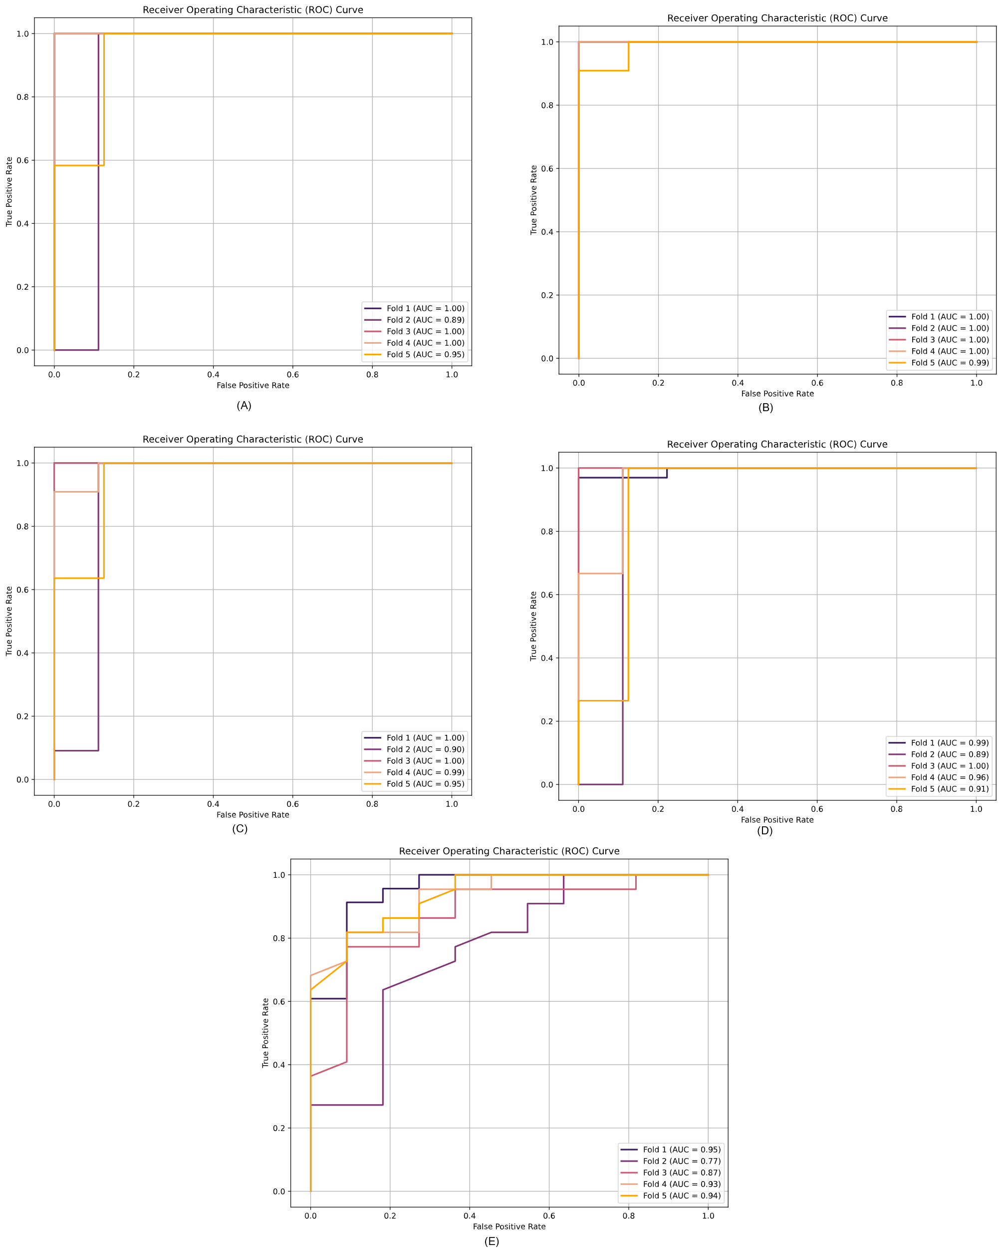
Figure 3S: AUC curve for different cases (A) Control Covid 19 Vs (Influenza A/RSV)Vs RSV (B) Control Vs Influenza A (C) Control Vs Covid 19 (D) Control Vs All Respiratory Virus (E) ) Covid 19 Vs (Influenza A/RSV).
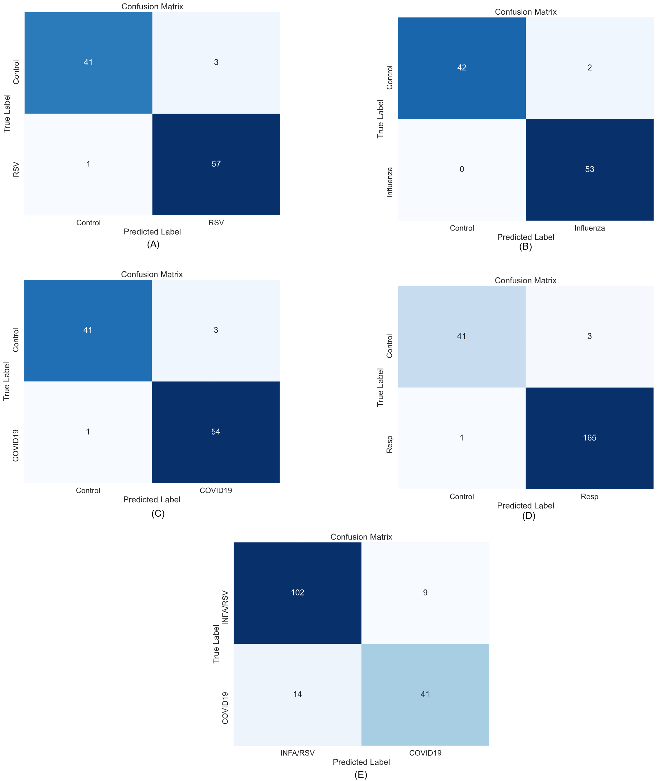
Figure 4S: Confusion Matrix curve for different cases (A) Control Covid 19 Vs (Influenza A/RSV)Vs RSV (B) Control Vs Influenza A (C) Control Vs Covid 19 (D) Control Vs All Respiratory Virus (E) ) Covid 19 Vs (Influenza A/RSV).

