Supplementary Tables
Supplementary Table 1 Input parameters for the calculation of the technologies involved in the DACCS and DACCU pathways. To calculate the CAPEX of water electrolysers in €/kgH₂, we assume an electrolyser lifetime of 20 years, a stack lifetime of 7 years, and 8760 hours of operation per year. Starred technologies indicate values on which a sensitivity analysis was performed.
Technology | CAPEX |  | Installed capacity
 | 2020 | Ref. | 2020 | Ref.
DAC* | 870 €/tCO₂ | c | 10 ktCO₂ | ⁸⁸
Polymer membrane eletrolysis | 920 €/kW | ⁸⁹ | 7 MtH₂ | ²²
Alkaline electrolysis | 758 €/kW | ^{89,90} | 7 MtH₂ | ²²
Reverse-Water-Gas-Shift | 4.98 €/tCO | ^{28,91} | 0.002 MtCO | ²²
Electrochemical CO₂ reduction | 421.53 €/tCO | ^{92,93} | 0.002 MtCO | ²²
Capital and operational costs assumed constant
Fischer-Tropsch synthesis CAPEX | 0.108 €/kg_{fuel} assumed constant | ²²
Low-temperature heat | 10 €/kWh_{th} | ⁹⁴
High-temperature heat | 40 €/kWh_{th} | ⁹⁴
CO₂ transport and storage cost | 20 €/tCO₂
Cost fossil fuels* | 0.6 €/L
Electricity cost* | 0.03 €/kWh | ⁶¹

Supplementary Table 2 Input parameters for the yearly energy consumption of the technologies involved in the DACCS and DACCU pathways.
Technology | Electricity consumption |  |  |  | Heat consumption
 | 2020 | Ref. | 2050 | Ref. |  | Ref.
DAC | 0.5 MWh_{e}/tCO₂ | ³² | 0.25 | ²² | 1.75 MWh_{th}/tCO₂ | ⁹⁵
Polymer membrane eletrolysis | 57 kWh_{e}/kg_{H2} | ^{89,96–100} | 47.5 kWh_{e}/kg_{H2}
Alkaline electrolysis | 53 kWh_{e}/kg_{H2} | ^{22,89,103–106} | 45.5 kWh_{e}/kg_{H2}
Reverse-Water-Gas-Shift | 0.11 kWh_{e}/kg_{CO} | ¹⁰⁷ | 0.11 kWh_{e}/kg_{CO} | ¹⁰⁷ | 0.49 kWh_{th}/kg_{CO} | ¹⁰⁷
Electrochemical CO₂ reduction | 6.34 kWh_{e}/kg_{CO} | ^{22,92,93} | 6.34 kWh_{e}/kg_{CO} | ^{22,92,93}
Fischer-Tropsch synthesis | 0.26 kWh/kg_{fuel} | ²⁸ | 0.26 kWh/kg_{fuel} | ²⁸

Supplementary Table 3 Other input parameters and assumptions. Starred parameters indicate values on which a sensitivity analysis was performed.
Parameter | Value | Reference
Growth aviation demand* | 2% | ^{10,70–75}
Fuel efficiency increase* | 2% | ⁷⁶
Learning rate DAC* | 12% | ³⁹
Learning rate electrolysers* | 8% | Based on future CAPEX estimates from ^{89,108–110}
Learning rate CO reduction* | 7.5% | ¹¹¹

Parameter | Description
Occupancy aircraft | 80%
 | London - Berlin | London – New York | London - Perth
Number passengers | 178 | 318.5 | 296
Distance flown (km) | 964 | 5570 | 14500
Average 2023 cost⁶⁰ | 65 | 300 | 1500
Percentage of cost due to fuel | 20% | 25% | 13%

Supplementary Table 4 Input parameters and basic assumptions to calculate increase in price per passenger per flight.
Supplementary Table 5 Input parameters and basic assumptions for the policy scenarios.
Parameter | Description
Cost on CO₂ emissions | €100/tCO₂ in 2020 and then increase by 1% yearly
Cost on all aviation climate impacts | €100/tCO₂e* in 2020 and then increase by 1% yearly
Subsidy on DACCS | €100/tCO₂ in 2020 and then decrease by 1% yearly
Subsidy on DACCU | €100/tCO₂ (€33/t_{fuel}) in 2020 and then decrease by 1% yearly
Excess electricity | Electricty cost is 10% of basic assumption (€0.003/kWh)

Supplementary Figures
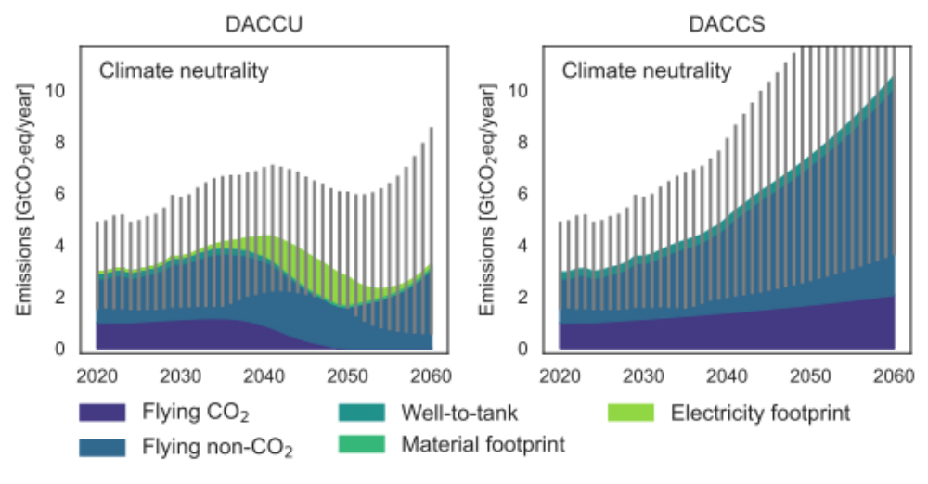
Supplementary Figure 1 Absolute emissions of DACCS and DACCU pathway (without including the offsets via DACCS). Grey bars show uncertainties due to the non-CO₂ effects of aviation.

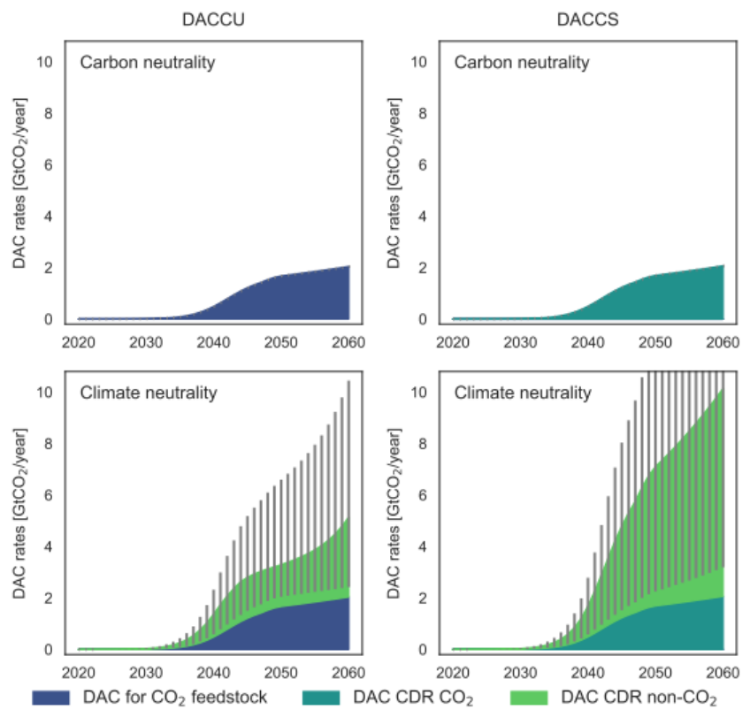
Supplementary Figure 2 Installed DAC rates under different climate targets and technology scenarios.

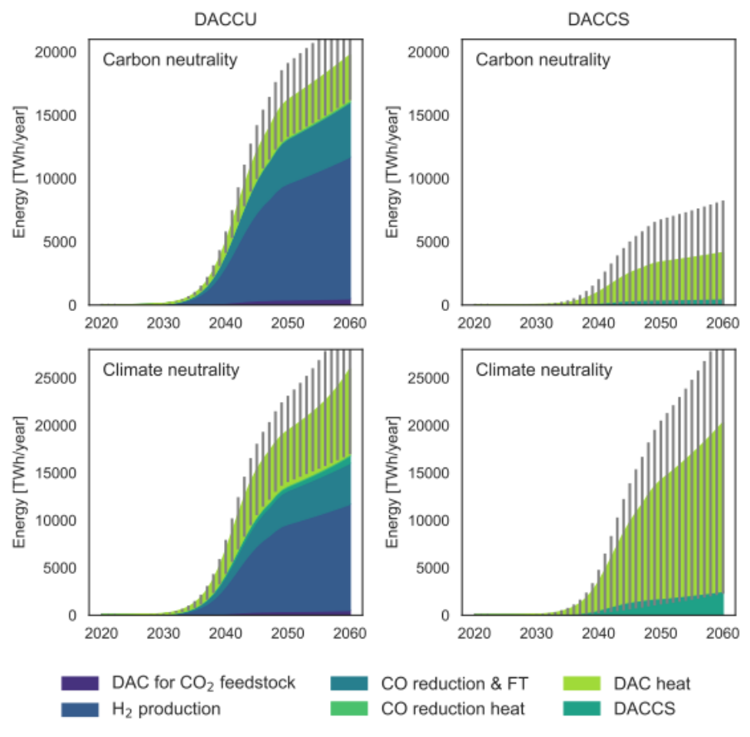
Supplementary Figure 3 Energy needed under different climate targets and technology scenarios.
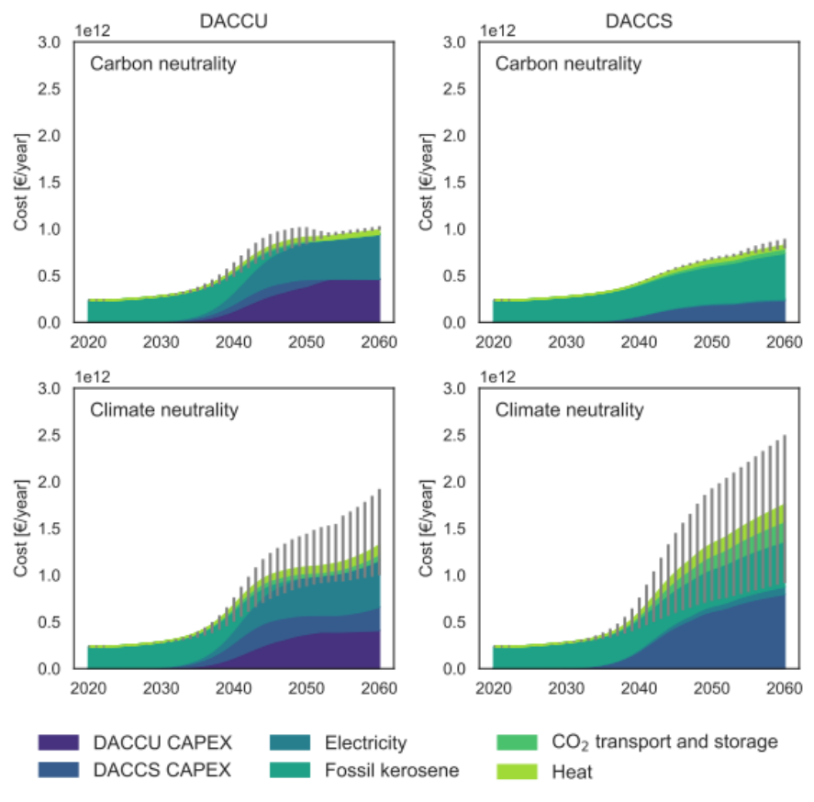
Supplementary Figure 4 Total cost of the two pathways until 2060.
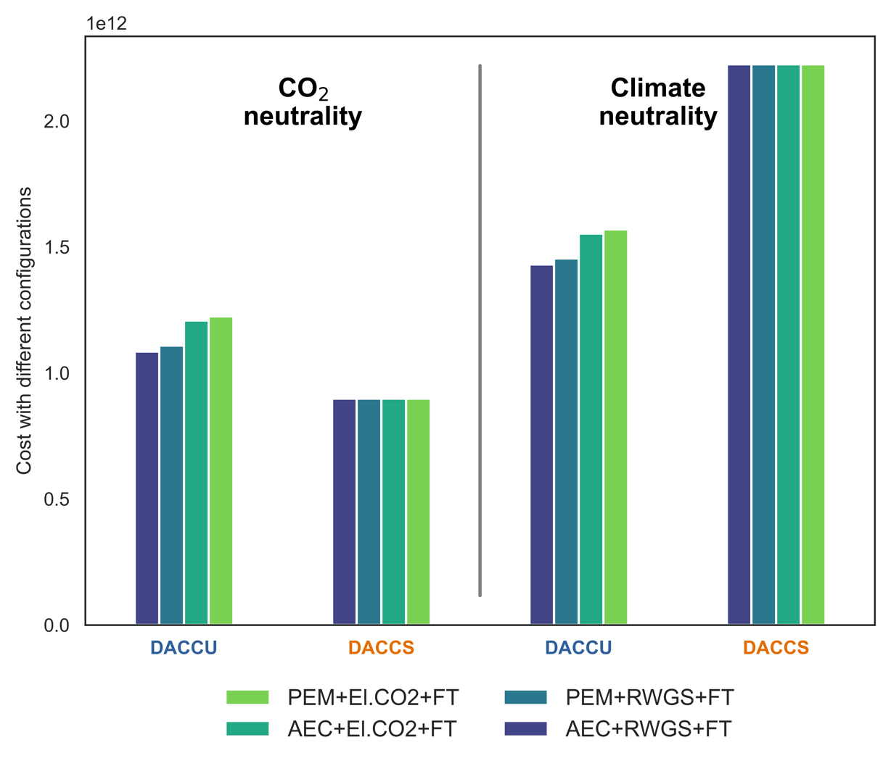Supplementary Figure 5 Final cost by 2050 in € for different configurations of DACCU, resulting from the different combination of polymer membrane electrolysis (PEM), alkaline electrolysis (AEC), electrochemical CO₂ reduction (El.CO₂), reverse-water-gas-shift (RWGS), and Fischer-Tropsch synthesis (FT).

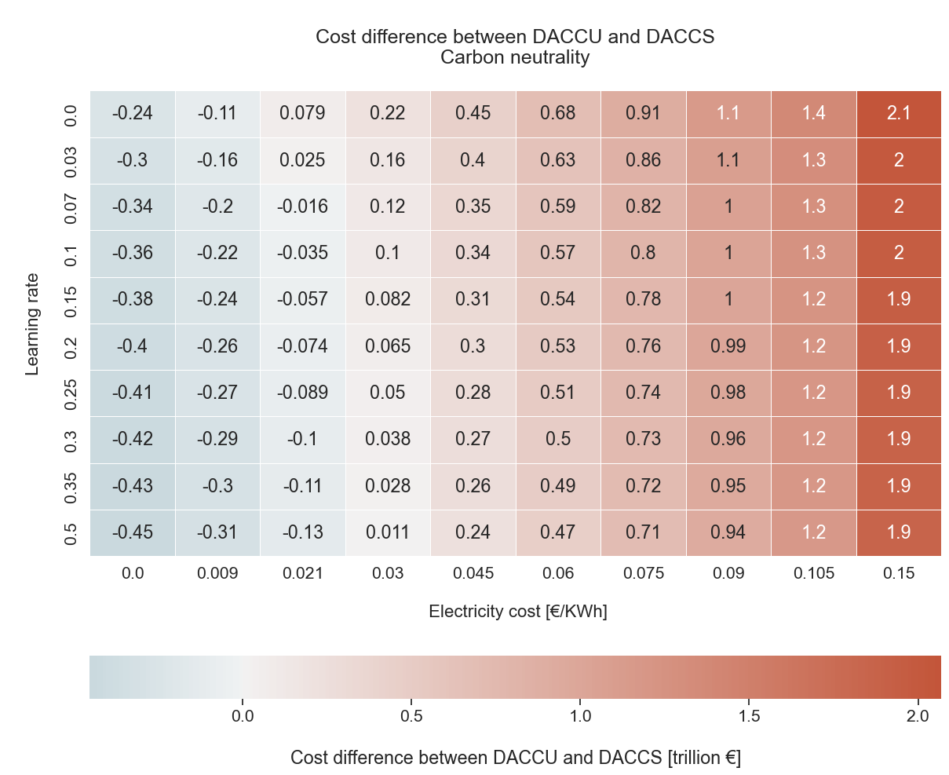
Supplementary Figure 6 Impact of electricity cost and learning rate on the difference in cost by 2060 of DACCS and DACCU pathways to reach CO₂ neutrality. Each cell shows the difference in cost between DACCU and DACCS pathways under varying assumptions on the learning rate (y-axis) and electricity cost (x-axis).
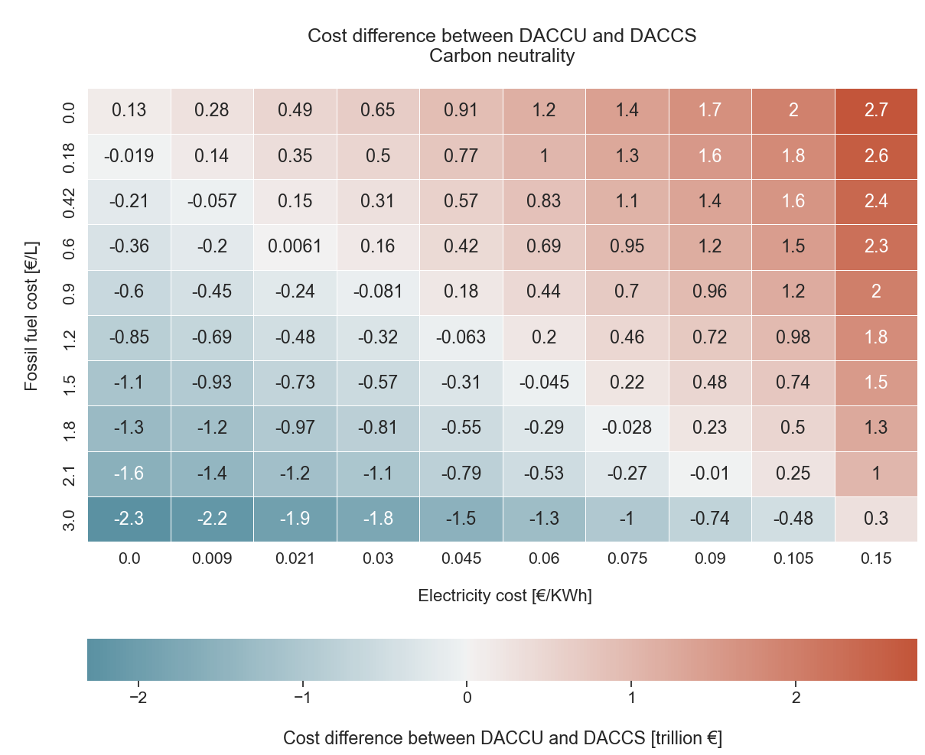
Supplementary Figure 7 Impact of electricity cost and fossil fuel cost on the difference in cost by 2060 of DACCS and DACCU pathways to reach CO₂ neutrality. Each cell shows the difference in cost between DACCU and DACCS pathways under varying assumptions on the learning rate (y-axis) and fossil fuel cost (x-axis).
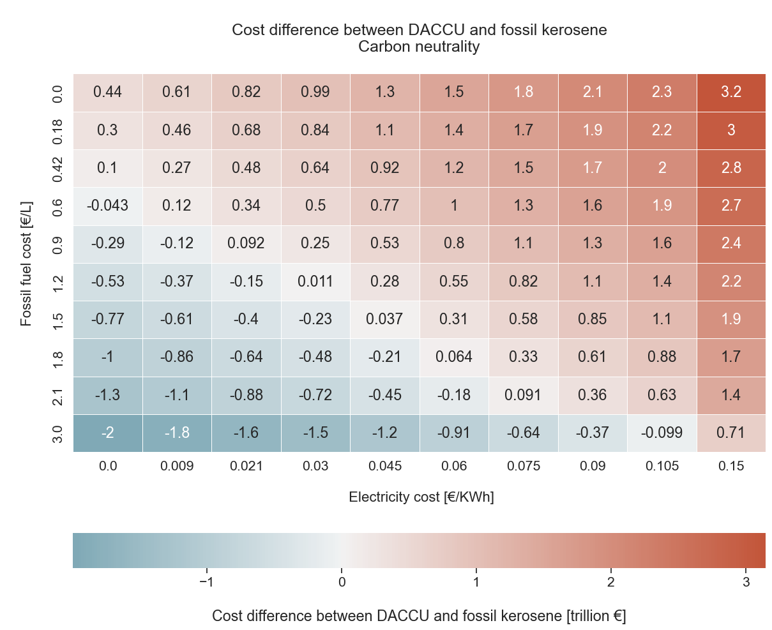
Supplementary Figure 8 Impact of electricity cost and fossil fuel cost on the difference in cost by 2060 of DACCU and fossil kerosene. Each cell shows the difference in cost between DACCU and fossil kerosene under varying assumptions on the learning rate (y-axis) and fossil fuel cost (x-axis).

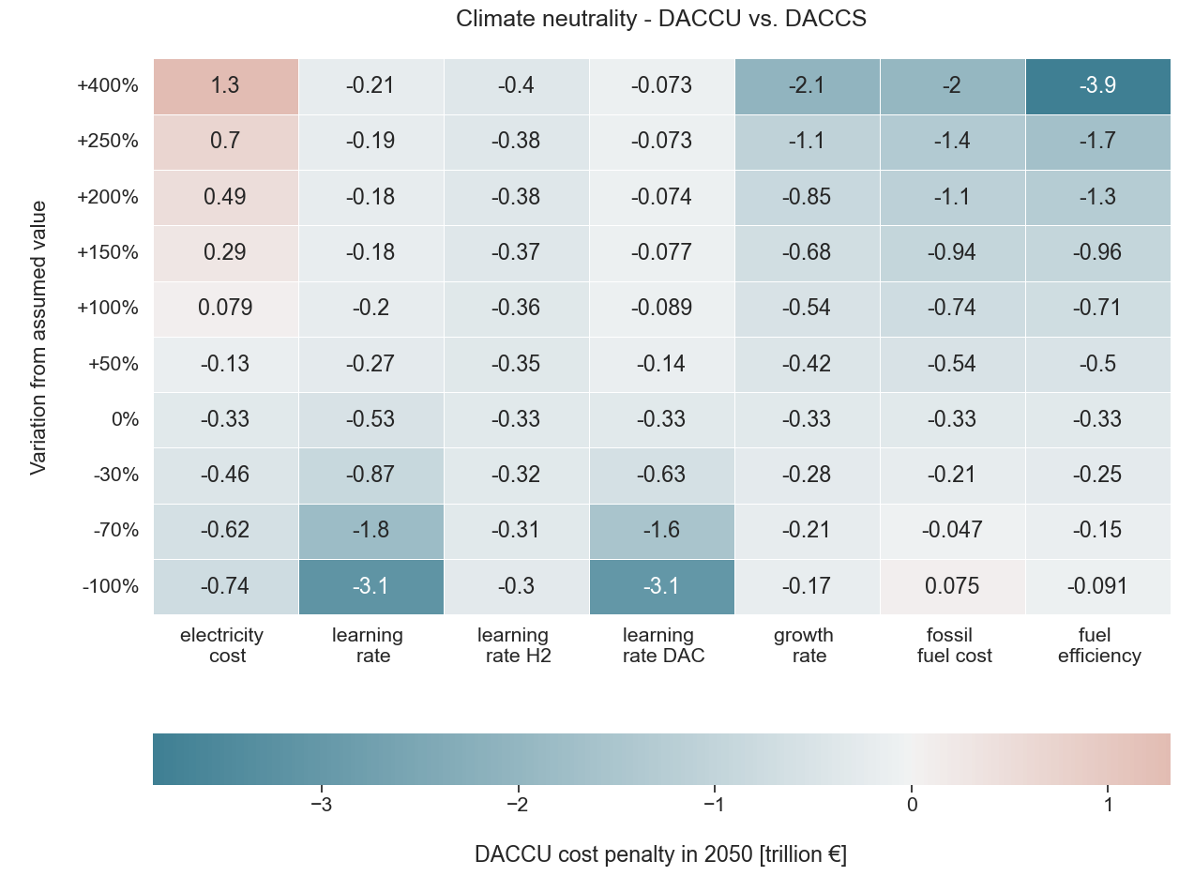
Supplementary Figure 9 Impacts of the local variation in important input parameters on the 2050 difference between DACCU and DACCS pathway to achieve climate neutrality. Blue cells indicate when DACCU becomes cheaper than fossil kerosene, while red cells are the opposite.

With Boeing 787-9 Dreamliner
Average of Boeing 787-9 Dreamliner, Boeing 777-200LR, Boeing 777-3000LR, and Boeing 767-300
With Boeing 737-900

