Supplementary information

Lowering the Barrier: Importance of A-site Cation Chemistry in Superionic Halide Solid Electrolytes

Kit Barker¹, Sarah L. McKinney^{2,3}, Raul Artal², Ricardo Jimenez⁴, Nuria Tapia-Ruiz² ,Stephen J. Skinner¹, Ainara Aguadero^{1,4} and *Ieuan D. Seymour^{1,5}

¹Department of Materials, Imperial College London, UK
²Department of Chemistry, Imperial College London, UK
³Department of Chemistry, Lancaster University, UK
⁴Instituto de Ciencia de Materiales de Madrid, CSIC, Spain
⁵Department of Chemistry, University of Aberdeen, UK

*Corresponding author: ieuan.seymour08@imperial.ac.uk

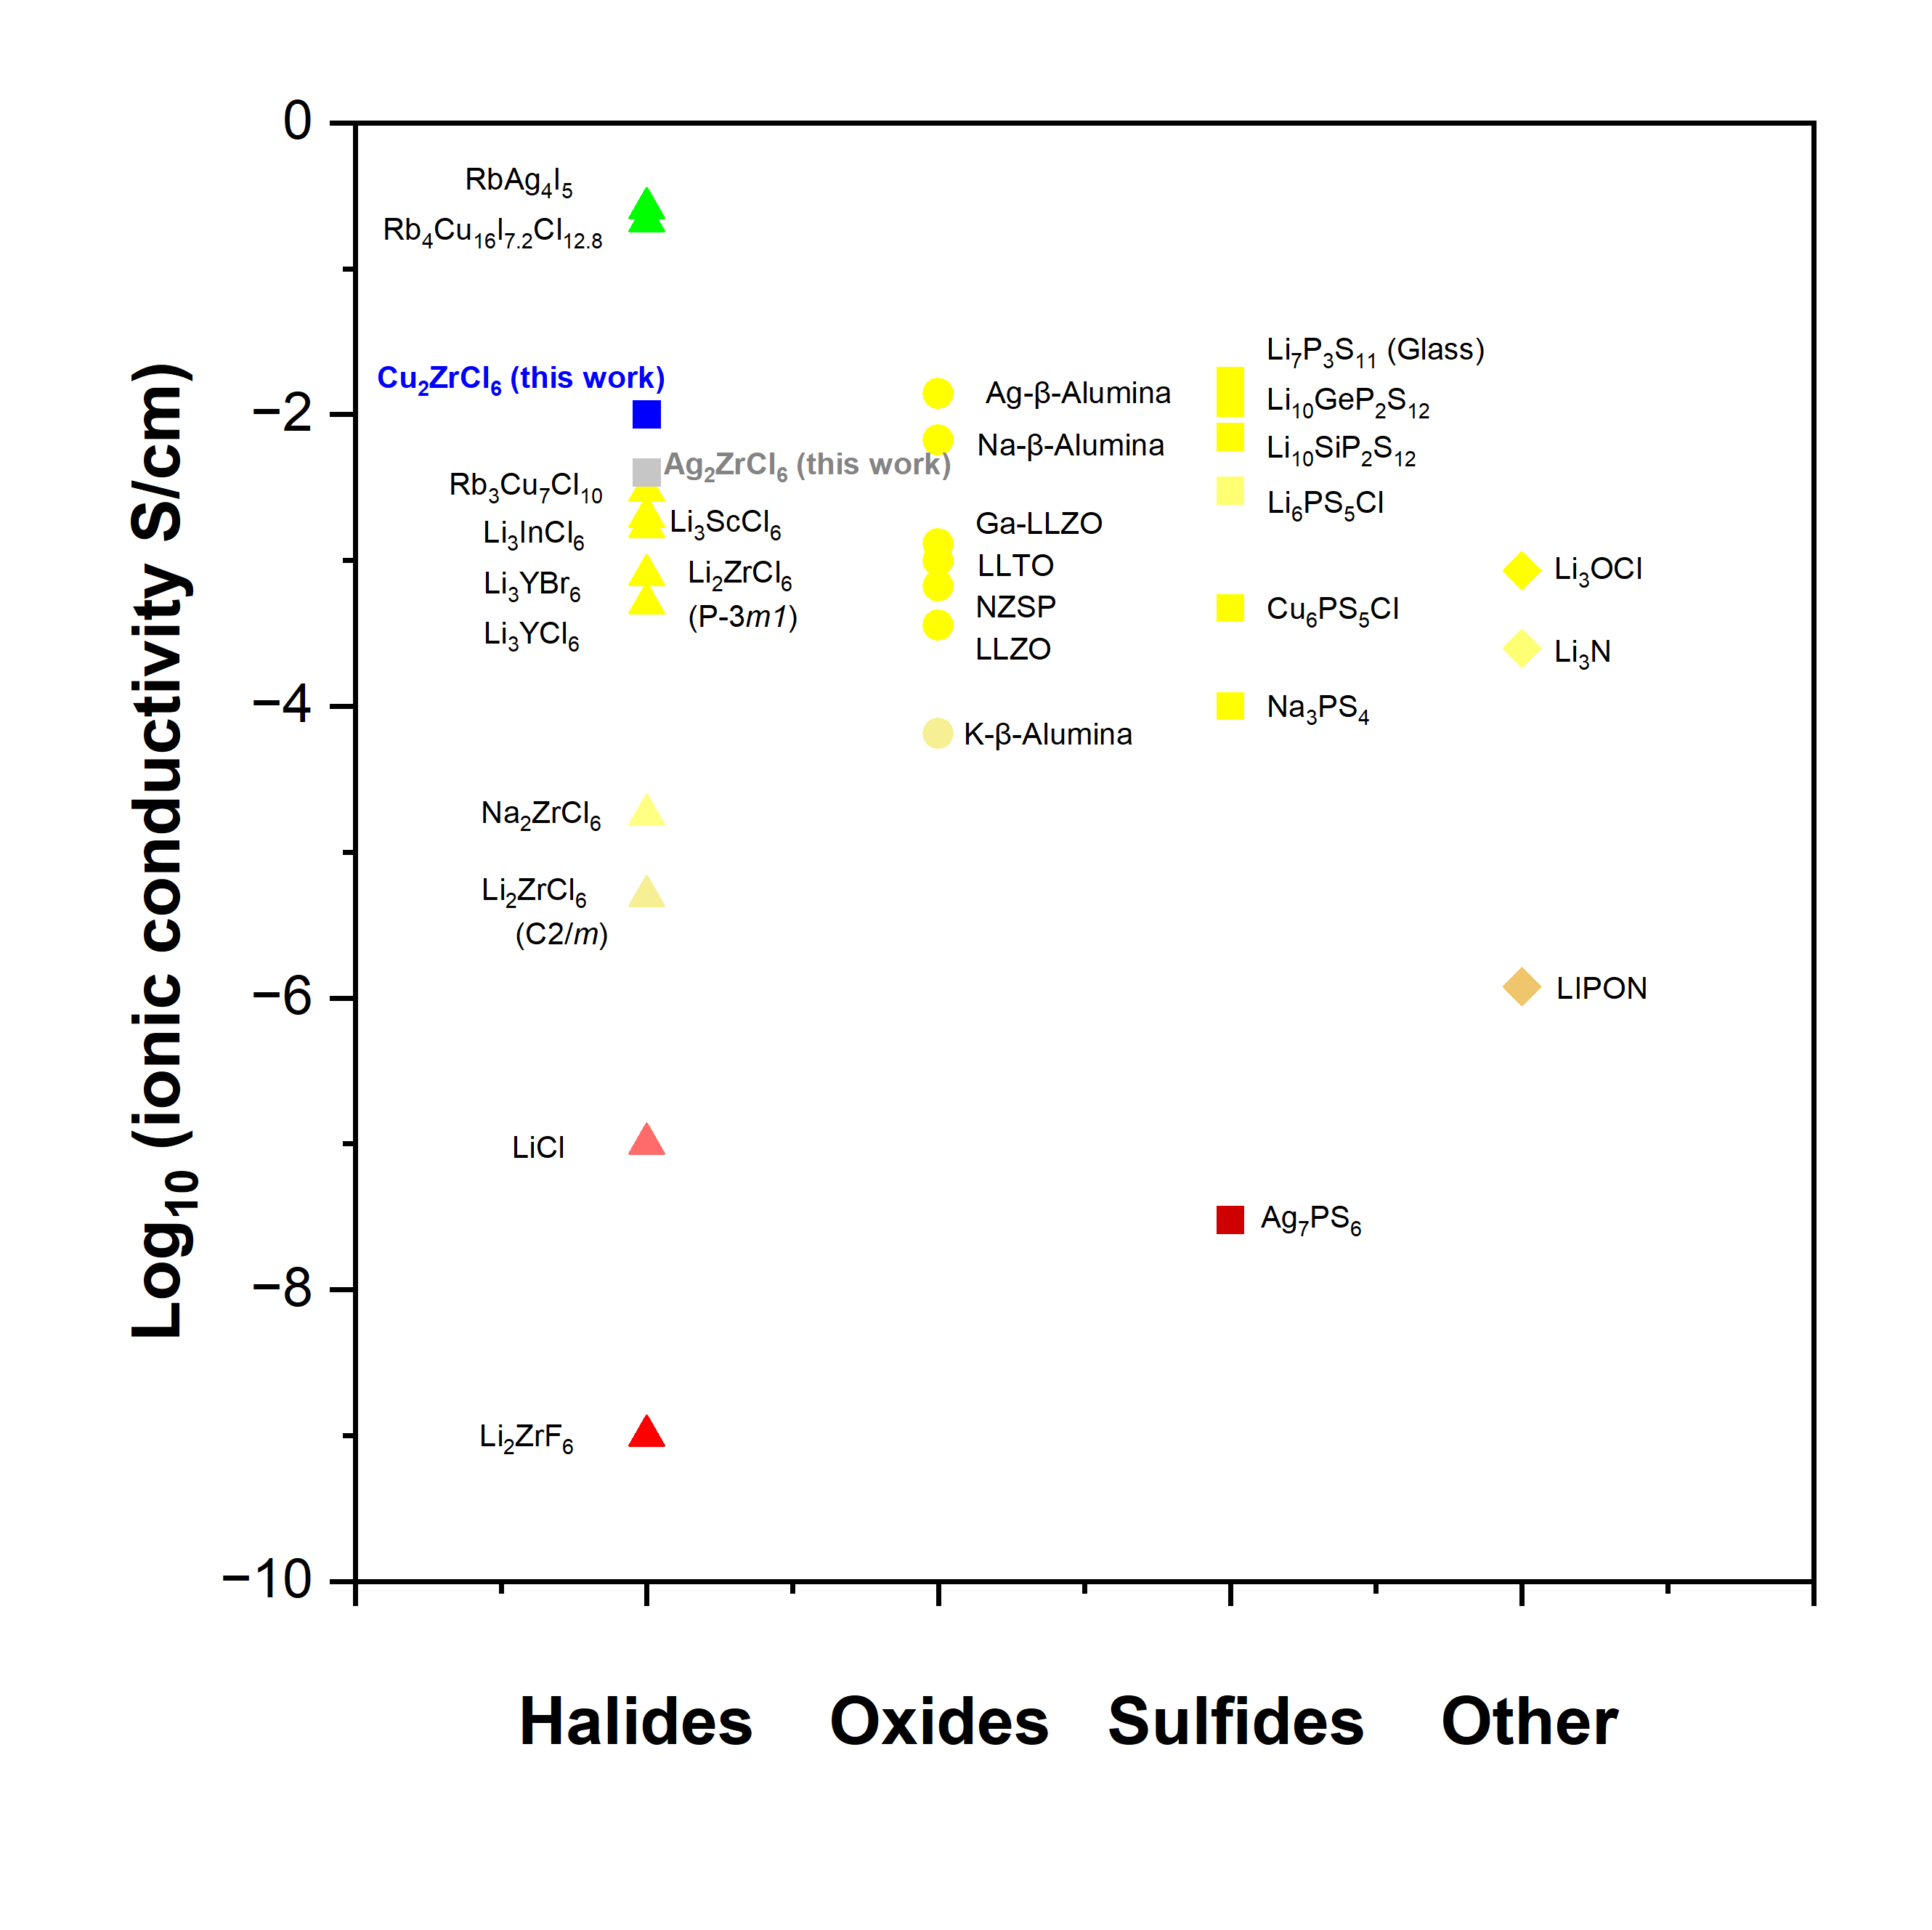
Figure S1: Room temperature conductivities of various ion conductors[1-26].
Supplementary note 1: Structural considerations for ionic conduction in halides
In Na₂ZrCl₆, the more commonly reported $P\overline{3}m1$ structure reflects that of Li₃YCl₆[27]. The alternative P2₁n structure for Na₂ZrCl₆ contains prismatic Na⁺ sites and octahedral Zr⁴⁺ sites. The reported ionic conductivity of Na₂ZrCl₆ is relatively low and depends heavily on the disorder in the system. Sebti et al[27] showed that a slow cooled sample of Na₂ZrCl₆ displayed the lowest conductivity of their samples (6.6 × 10⁻⁸ S cm⁻¹) while a twice milled sample achieved ionic conductivities of up to 2.6 × 10⁻⁵ S cm⁻¹, further supporting the idea that disorder is beneficial for fast ion transport in halide systems.
The main difference in Cu₂ZrCl₆ is that the Cu⁺ ions were found to be located on tetrahedral sites rather than octahedral sites within the same HCP framework. Dattelbaum et al.[28]also found a fully ordered zirconium sublattice as opposed to partial occupancies across the octahedral sites. The copper ions form clusters of edge sharing tetrahedra around the vacant zirconium octahedral sites c = 0.5.
α-AgI, an advanced superionic conductor displays an ionic conductivity of around 1 S cm⁻¹ above 146 °C[29] which is more than 4 orders of magnitude faster than the low temperature β-AgI phase. The average structure is considered to be where the silver ions are partially occupied across 1/6 of the face sharing tetrahedral sites[30]. The high conductivity in this system has been attributed to the high ratio of available sites to mobile charge carriers (Ag⁺ ions) as well as the face sharing tetrahedra that provide a three dimensional transport network.

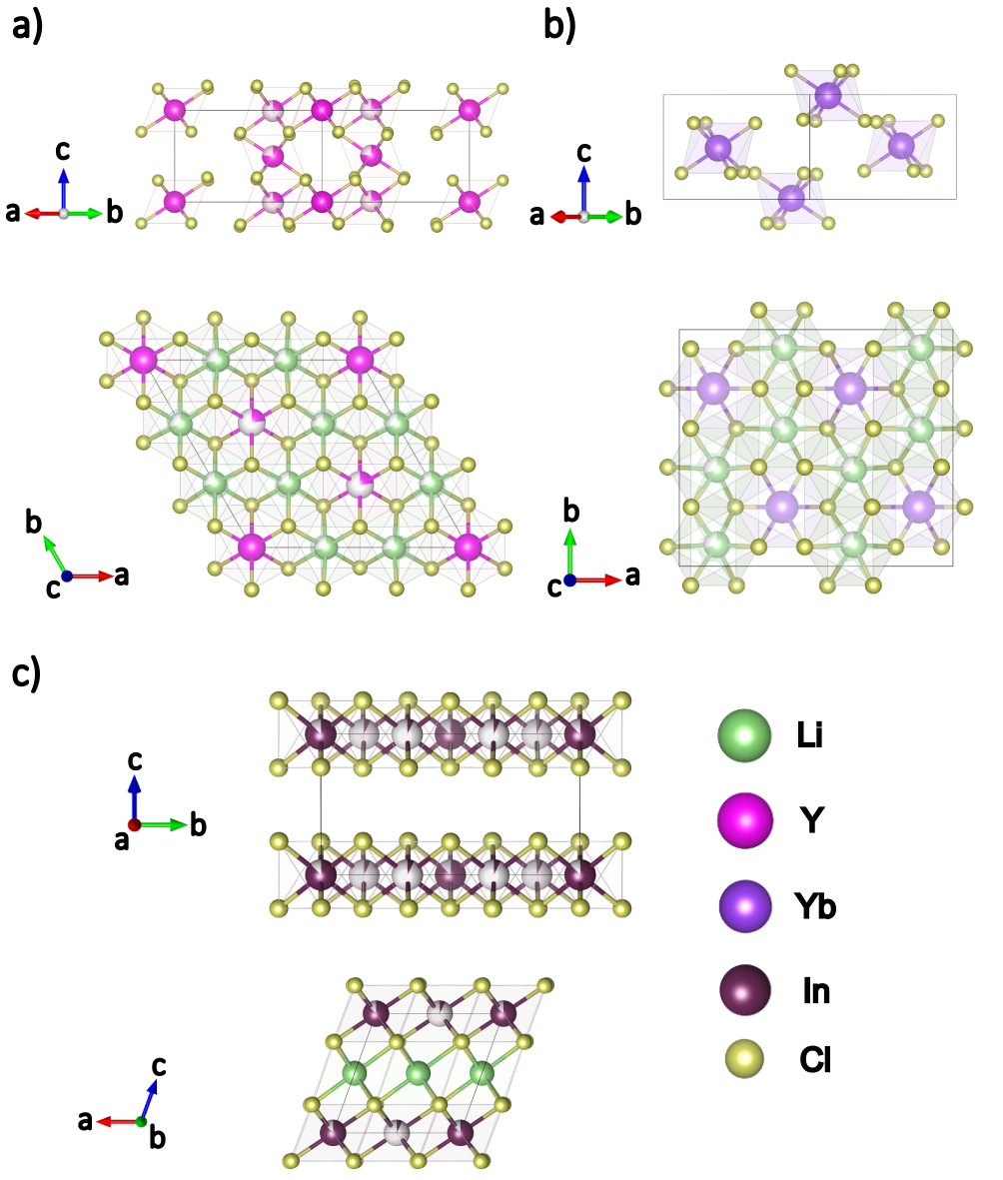

Figure S2: (a) Structure of Li₃YCl₆ showing the large degree of disorder of cations within the $P\overline{3}m1$ space group. The Y in this structure is edge sharing with Li while face sharing with itself, Li in this structure is disordered over 2 sites. Li(1) positions are edge sharing with themselves but face sharing with Li(2) positions in the c-direction. The chloride sublattice is also HCP in this structure[31]. (b) The Pnma structure of Li₃YbCl₆. Yb is fully ordered and located on one site in a mixed Li, Yb layer. Li is disordered over two sites which are face sharing with each other. The chloride sublattice is HCP [32]. (c) Structure of Li₃InCl₆ showing the InCl₆³⁻ octahedra and Li⁺ positions. Li is ordered in octahedral sites of one layer while indium has partial disorder across the octahedral sites in a separate layer, both the InCl₆³⁻ and LiCl₆⁵⁻ are edge sharing and the Cl⁻ sublattice is CCP in nature[33].
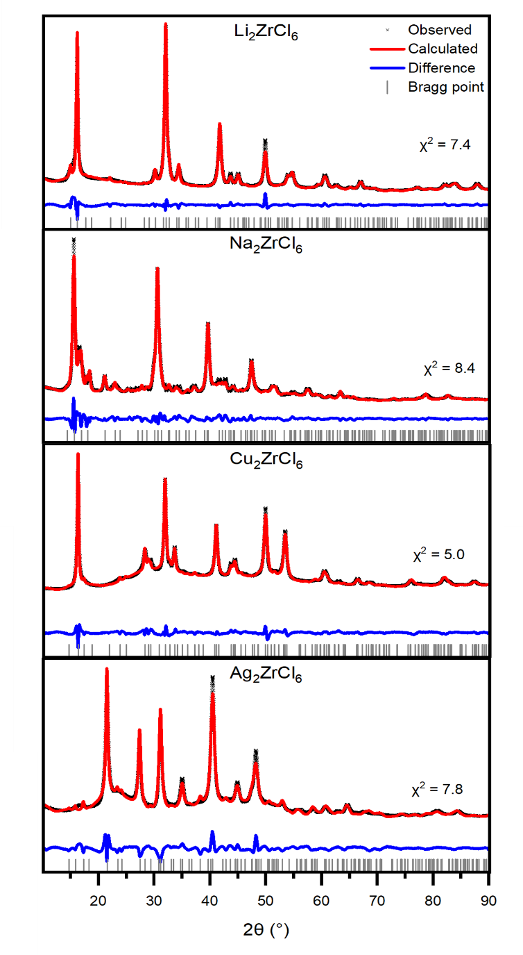
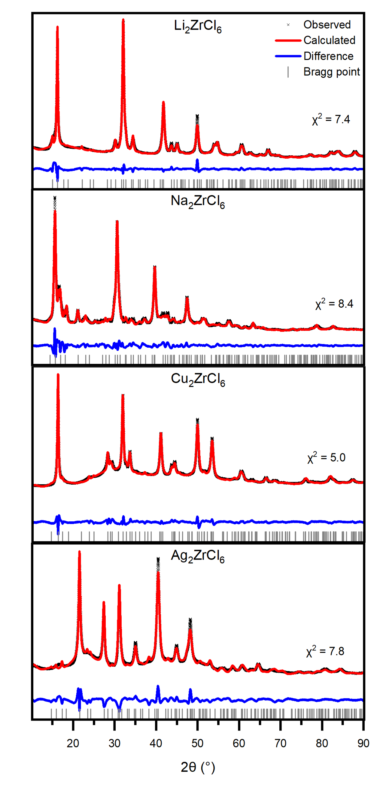
Figure S3: Rietveld refinements of A₂ZrCl₆ using their respective fully disordered $P\overline{3}m1$ starting structures. The humps observed in the diffraction patterns of Cu₂ZrCl₆ and Ag₂ZrCl₆ may indicate a small amount of amorphous phase.

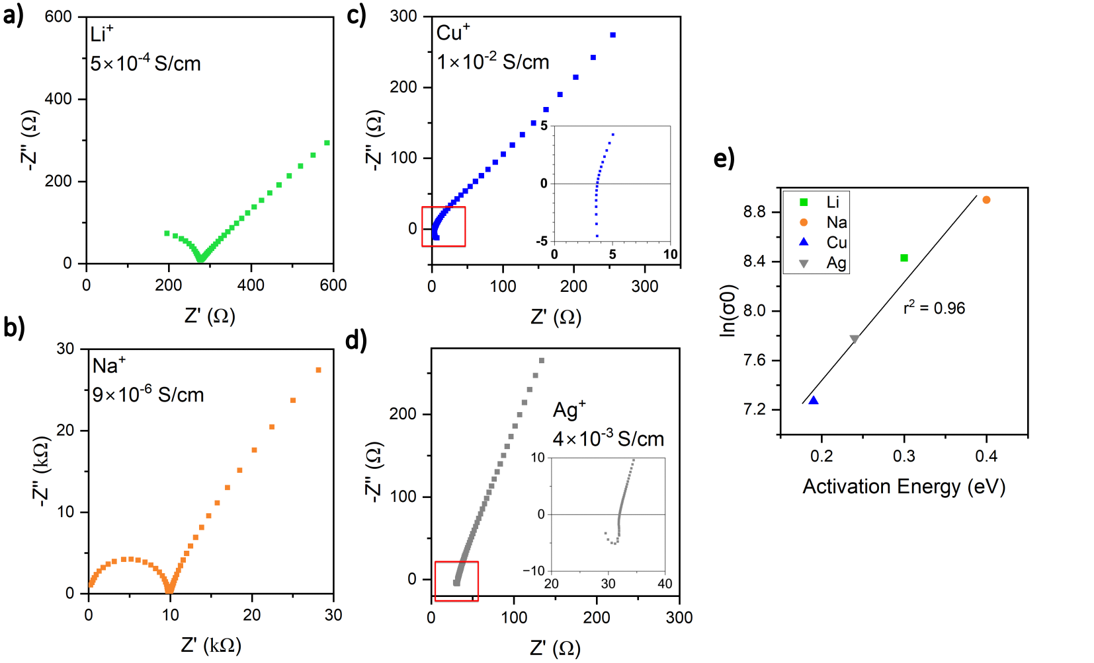
Figure S4: Nyquist plots for a) Li₂ZrCl₆, b) Na₂ZrCl₆, c) Cu₂ZrCl₆ and d) Ag₂ZrCl₆. All measurements taken at room temperature (25°C). e) Plot of activation energy vs pre-exponential factor demonstrating a Meyer-Neldel conductivity relationship.

Supplementary note 2: EIS analysis
As shown in Figure S4(e), the A₂ZrCl₆ system shows Meyer-Neldel behaviour in which a material with a higher activation energy exhibits higher ionic conductivity than a material with a lower activation energy at high temperature, as the activation energy embedded within the pre-exponential factor becomes more dominant[35].

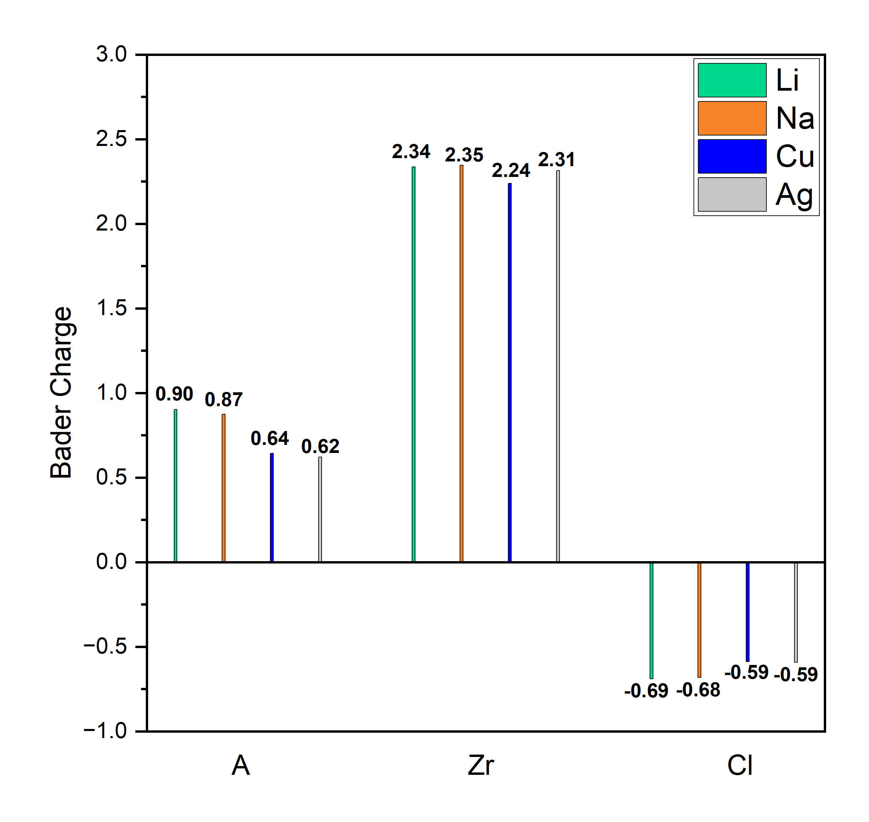
Figure S5: Mean Bader charges of the species in the ground states of A₂ZrCl₆.

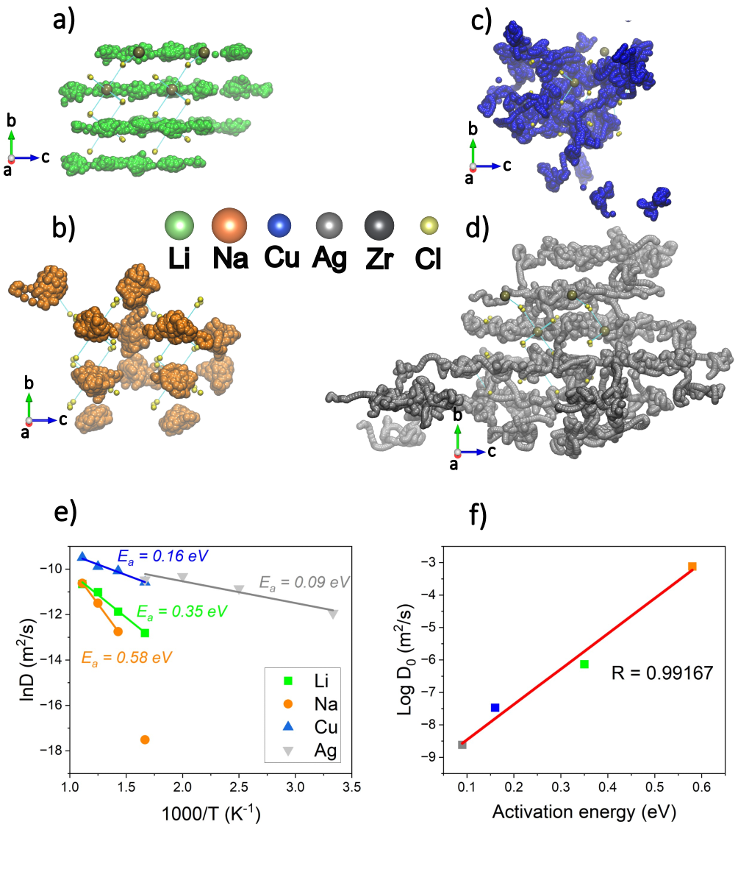

Figure S6: 50 ps AIMD trajectories at 600K of the mobile A⁺ species in a) Li₂ZrCl₆, b) Na₂ZrCl₆, c) Cu₂ZrCl₆ and d) Ag₂ZrCl₆. Trajectories are smoothed over 50 frames. e) Arrhenius plots and the associated activation energies for ion diffusion in the different structures. f) Plot of activation energy vs pre-exponential factor demonstrating a Meyer-Neldel conductivity relationship.
Supplementary note 3: Molecular dynamics analysis
The ions exhibit vastly different mobility's at 600K. Li shows more displacement in the c-direction than in the ab-plane due to the lower energy c-axis barriers, as observed via transition state searching. Na shows a slight preference for diffusion in the c-direction, however the displacement is still smaller compared to Li. Cu and Ag are much more mobile in their respective structures. Ag again displays anisotropic diffusion favouring the c-direction, whilst Cu slightly favours transport in the ab-plane, which can be attributed to the connectivity of the tetrahedral sites in Cu₂ZrCl₆. The high mobility of Ag is interesting due to the structural similarities to the Li and Na analogues, despite Ag ions having larger ionic radii than both Li and Na when octahedrally coordinated (1.15 Å vs 0.76 Å and 1.02 Å for Ag⁺, Li⁺ and Na⁺ respectively[34]).
The discrepancy between our theoretical values and those experimentally observed may arise from the low crystallinity of our samples produced by mechanochemical synthesis. Obtaining single crystals of both Cu₂ZrCl₆ and Ag₂ZrCl₆ may provide further insight to the ionic mobility's of the A⁺ ions.

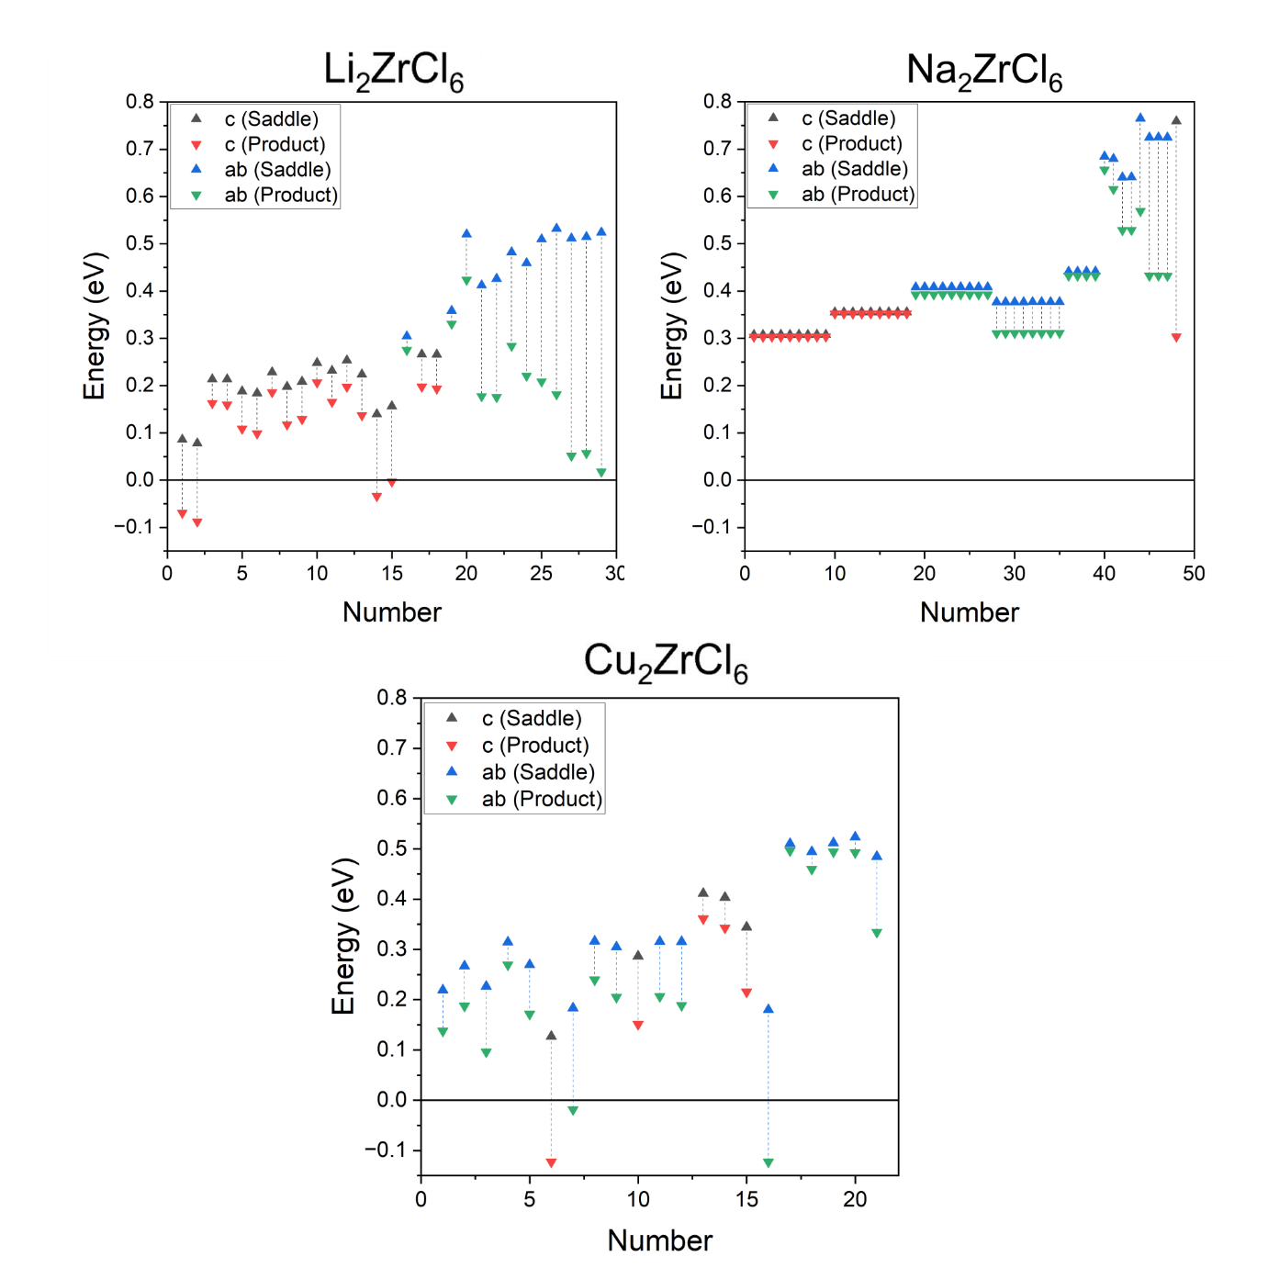

Figure S7: Total barriers found via transition state searching calculations. Energies are relative to the reactant state i.e. the ‘saddle’ energy is calculated as: E_{Saddle} - E_{Reactant}.
Supplementary note 4: Analysis of transition state searching mechanisms
In Li₂ZrCl₆, any hop where the product state results in a new pair of face sharing LiCl₆-LiCl₆ is found to be higher than that of where the resulting product state is corner or edge sharing. No barriers were observed where a Li⁺ ion moved to a position that is face sharing with Zr, suggesting that this process would have such a large barrier, it is unlikely to occur at room temperature.
The nature of the DFT ground state structure of Na₂ZrCl₆ means that any hop results in a new high energy face sharing pair (Na-Na or Na-Zr). This is directly observed by the barrier height for the forward and reverse directions; in the forward direction (product is face sharing) the activation energy is large while in the reverse (product is edge/corner sharing) the barrier is small < 0.1 eV. The forward or reverse barriers in Na₂ZrCl₆ also scale depending on whether it is transport in the ab-plane or along the c-channels (lower barriers in the c-direction). These observed anisotropic barriers suggest that the local coordination, such as Zr order/disorder, plays an important role in the available transport pathways within these materials.
No barriers were observed for Cu₂ZrCl₆ where the product state is face sharing with Zr, suggesting these sites are thermodynamically unfavourable. This leads to the bottleneck for diffusion in Cu₂ZrCl₆ being a tet-trig-oct-trig-tet hop to an adjacent cage.

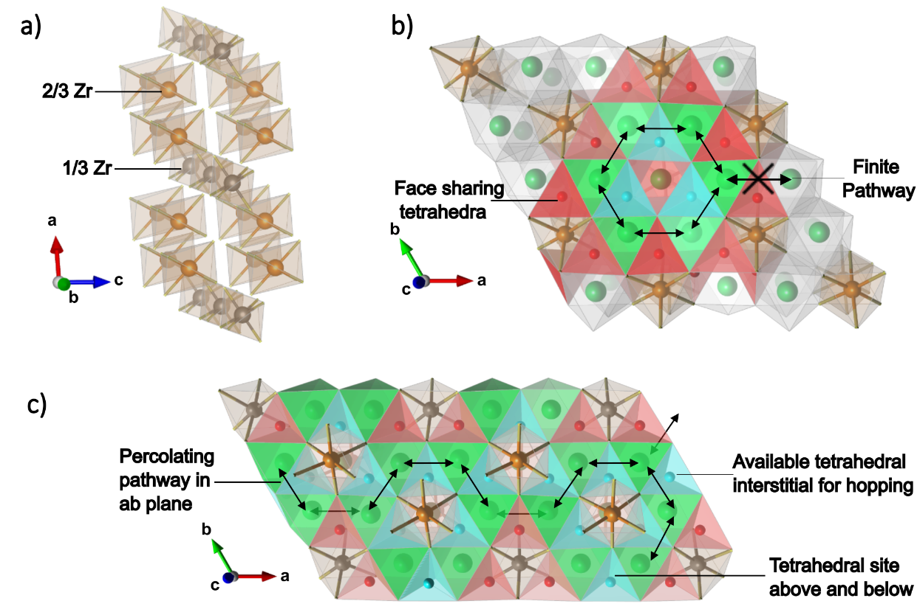
Figure S8: Schematic representations of diffusion pathways in A₂ZrCl₆. a) An ordered zirconium sublattice in A₂ZrCl₆ showing different site occupation of Zr in the layers. At c = 0, Zr = 2/3 and at c = 0.5, Zr = 1/3. b) non-percolating (finite) pathway in a layer where 2/3 Zr sites are occupied. c) Percolating pathway in a layer where 1/3 Zr are occupied.
Supplementary note 5: Percolation theory analysis
Percolation theory, known for assessing long-distance diffusion via probability, relies on the concept of site percolation, which involves sites in a lattice that either ’open’ or ’closed’. In the context of diffusion in A₂ZrCl₆, the sites are the A⁺ positions. As shown by the TSS data, sites that are face-sharing with zirconium are thermodynamically inaccessible, thus considered as closed sites. While one-dimensional ion transport along the c-chains appears to require minimal energy due to the absence of these closed sites, the two-dimensional ab-plane presents a more intricate scenario. In this plane, the presence or absence of Zr dictate the diffusion properties, hence employing site percolation theory. This choice is justified by the impact of disorder across the zirconium sites in the layers of A₂ZrCl₆ on macroscopic diffusion behavior. Notably, the triangular/hexagonal 2D lattice formed by the zirconium sublattice in the ab-plane exhibits a percolation threshold pc of 0.5, meaning that once the zirconium vacancy percentage p reaches or exceeds this value, a percolating pathway is guaranteed.
Figure S8 depicts the network situation in different layers of A₂ZrCl₆ based on MD and TSS simulations. In one layer, where the Zr site occupancy is 2/3, the occupation probability falls below the percolation threshold (p < pc), resulting in the absence of a percolating network. The presence of only 6 accessible sites encircling a zirconium vacancy in the ab-plane restricts the A⁺ ion’s movement. Conversely, in another layer with a 1/3 zirconium site occupancy, the occupation probability surpasses the percolation threshold, enabling an infinitely percolating pathway across the lattice. This phenomenon is facilitated by the additional Zr vacancy in each unit cell, allowing A⁺ ions to move freely around vacancies and between adjacent hexagons. The TSS data surprisingly indicates no significant difference in energies for diffusion in the c-direction across layers with differing Zr content. This finding implies that implementing percolation across all layers would result in uninhibited lithium ion diffusion.

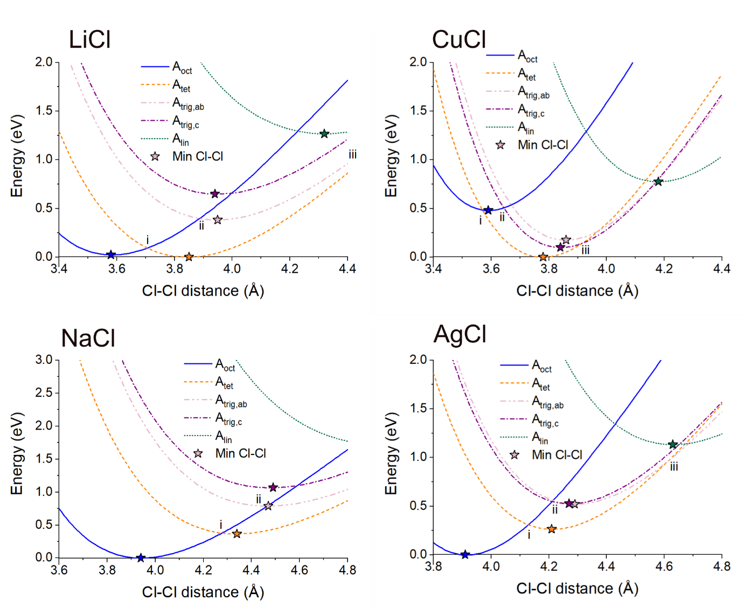
Figure S9: Energies of different octahedral (A_{oct}), tetrahedral (A_{tet}), trigonal planar (A_{trig}) and linear (A_{lin}) A-site coordinations in model HCP ACl systems at varying Cl-Cl distances. Points i, ii and iii represent the distances at which the A_{oct}/A_{tet}, A_{oct}/A_{trig} and A_{tet}/A_{trig} energies are the same respectively. Stars indicate the minimum energy for each configuration.
Supplementary note 6: Site preference in model HCP ACl systems
For HCP LiCl, the octahedral coordination shows a minimum at the smallest Cl-Cl bond distances (3.58 Å), whereas at longer bond distances (3.85 Å), the tetrahedral coordination becomes a minimum. The minimum energy tetrahedral Li configuration is predicted to be the ground state structure with r2SCAN calculations, with the octahedral configuration slightly higher in energy (24 meV/formula unit). The trigonal planar configurations along the ab (A_{trig,ab}) and c (A_{trig,c}) directions reaches a minimum in energy at X_{Cl-Cl} = 3.95 Å and 3.94 Å respectively. The trigonal planar configuration is higher in energy than the tetrahedral configuration for all Cl-Cl bond distances, and is thus expected to exist as a transition state configuration instead of a local minimum.
Similar behaviour is observed for the HCP NaCl and AgCl systems. For NaCl, A_{oct} is the ground state configuration (0 eV) when X_{Cl-Cl} = 3.94 Å. The minimum energy A_{tet} (0.37 eV), A_{trig,ab} (0.78 eV) and A_{trig,c} (0.68 eV) configurations occur at Cl-Cl bond lengths of X_{Cl-Cl} = 4.43, 4.47 and 4.46 Å, respectively. For AgCl, A_{oct} is the ground state configuration when X_{Cl-Cl} = 3.91 Å, with minimum energy A_{tet} (0.26 eV), A_{trig,ab} (0.52 eV) and A_{trig,c} (0.49 eV) configurations at Cl-Cl bond lengths of X_{Cl-Cl} = 4.21, 4.29 and 4.30 Å, respectively.
The inverse behaviour is observed for the CuCl system. The tetrahedral Cu configuration shows a deep minimum at X_{Cl-Cl} = 3.78 Å. The octahedral configuration shows a minimum at X_{Cl-Cl} = 3.59 Å, but this configuration is 0.48 eV higher than the minimum A_{tet} configuration. This is consistent with the strong preference for tetrahedral coordination in Cu₂ZrCl₆. At bond lengths of X_{Cl-Cl} = 3.86 and 3.87 Å, the A_{trig,ab} (0.18 eV) and A_{trig,c} (0.20 eV) configurations, respectively, have minimum energies. The lower energy of the A_{trig} sites compared to the A_{oct} sites indicates that the A_{oct} site will be the transition state at long Cl-Cl bond distances.

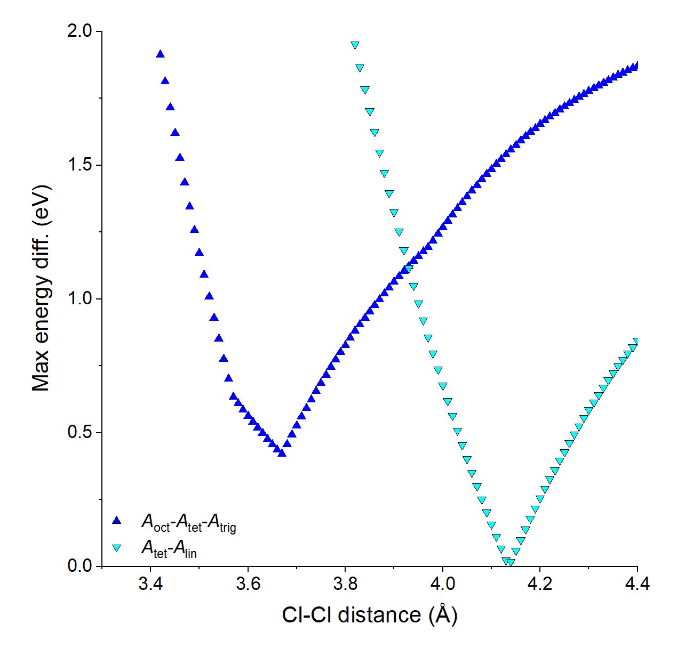

Figure S10: Plot of maximum energy difference per formula unit between A_{oct} - A_{tet} - A_{trig,ab} sites (blue) and A_{tet} – A_{lin} sites (cyan) in HCP CuCl.
Supplementary note 7: Role of linear configurations in HCP CuCl.
In Figure S9, the energy of linear (2 coordinate) Cu configurations was also investigated as Cu_{tet}-Cu_{lin}-Cu_{tet} pathways were observed in Cu₂ZrCl₆ through transition state searching. Figure S10 shows that when the Cl-Cl distance in HCP CuCl becomes longer than X_{cl-cl} = 3.93 Å, the A_{tet} – A_{lin} - A_{tet} pathway becomes increasingly lower in energy than the previous A_{tet} – A_{trig} – A_{oct} – A_{trig} - A_{tet} pathway. Importantly, there is only a single change in coordination for the A_{tet}(4) – A_{lin}(2) - A_{tet}(4) pathway; there is a single point at which the two configurations have the same energy (X_{Cl-Cl} = 4.14 Å), leading to zero intrinsic barrier, analogous to the A_{oct} - A_{trig,c} pathways in Figure 4e. The A_{lin} pathways were also calculated for LiCl, NaCl and AgCl, but the A_{tet} – A_{lin} - A_{tet} pathway was found to be higher in energy than the A_{tet} – A_{trig} – A_{oct} – A_{trig} - A_{tet} pathways until very long X_{Cl-Cl} distances, making this pathway inaccessible.

Table S1. Rietveld refinement result from the room-temperature X-ray powder diffraction data of the as-milled Li₂ZrCl₆. The space group is $P\overline{3}m1$. The refined lattice parameters are a = 10.968 Å and c = 5.930 Å.
Atoms | x | y | z | Occ. | site | Sym. | U_{iso}
Zr1 | 0 | 0 | ½ | 0.479 | 1b | 1 | 0.028
Zr2 | 0 | 0 | 0 | 0.738 | 1a | 1 | 0.060
Zr3 | 1/3 | 2/3 | 0.481 | 0.327 | 2d | 2 | 0.013
Zr4 | 1/3 | 2/3 | 0.014 | 0.460 | 2d | 2 | 0.022
Li1 | 0.316 | 0 | 0 | 0.660 | 6g | 6 | 0.054
Li2 | 1/3 | 0 | ½ | 0.340 | 6h | 6 | 0.292
Cl1 | 0.109 | 0.890 | 0.775 | 1 | 6i | 6 | 0.019
Cl2 | 0.224 | 0.775 | 0.265 | 1 | 6i | 6 | 0.014
Cl3 | 0.438 | 0.561 | 0.780 | 1 | 6i | 6 | 0.027

Table S2. Rietveld refinement result from the room-temperature X-ray powder diffraction data of the as-milled Na₂ZrCl₆. The space group is $P\overline{3}m1$. The refined lattice parameters are a = 11.526 Å and c = 6.272 Å.
Atoms | x | y | z | Occ. | site | Sym. | U_{iso}
Zr1 | 0 | 0 | ½ | 0.557 | 1b | 1 | 0.018
Zr2 | 0 | 0 | 0 | 0.716 | 1a | 1 | 0.009
Zr3 | 1/3 | 2/3 | 0.527 | 0.675 | 2d | 2 | 0.007
Zr4 | 1/3 | 2/3 | 0 | 0.050 | 2d | 2 | 0.014
Na1 | 0.366 | 0 | 0 | 0.406 | 6g | 6 | 0.212
Na2 | 0.325 | 0 | ½ | 0.593 | 6h | 6 | 0.082
Cl1 | 0.226 | 0.773 | 0.247 | 1 | 6i | 6 | 0.101
Cl2 | 0.109 | 0.890 | 0.786 | 1 | 6i | 6 | 0.061
Cl3 | 0.566 | 0.43 | 0.257 | 1 | 6i | 6 | 0.077

Table S3. Rietveld refinement result from the room-temperature X-ray powder diffraction data of the as-milled Cu₂ZrCl₆. The space group is $P\overline{3}m1$. The refined lattice parameters are a = 10.986 Å and c = 6.131 Å.
Atoms | x | y | z | Occ. | site | Sym. | U_{iso}
Zr1 | 0 | 0 | 0 | 0.704 | 1b | 1 | 0.106
Zr2 | 0 | 0 | ½ | 0.509 | 1a | 1 | 0.025
Zr3 | 1/3 | 2/3 | 0.478 | 0.244 | 2d | 2 | 0.148
Zr4 | 1/3 | 2/3 | 0.027 | 0.541 | 2d | 2 | 0.036
Cu1 | 0.230 | 0.769 | 0.438 | 0.153 | 6i | 6 | 0.006
Cu2 | 0.103 | 0.896 | 0.884 | 0.073 | 6i | 6 | 0.024
Cu3 | 0.425 | 0.574 | 0.577 | 0.298 | 6i | 6 | 0.083
Cu4 | 0.218 | 0.781 | 0.089 | 0.247 | 6i | 6 | 0.127
Cu5 | 0.892 | 0.107 | 0.406 | 0.227 | 6i | 6 | 0.039
Cl1 | 0.441 | 0.559 | 0.253 | 1 | 6i | 6 | 0.013
Cl2 | 0.107 | 0.893 | 0.271 | 1 | 6i | 6 | 0.016
Cl3 | 0.226 | 0.773 | 0.795 | 1 | 6i | 6 | 0.033

Table S4. Rietveld refinement result from the room-temperature X-ray powder diffraction data of the as-milled Ag₂ZrCl₆. The space group is $P\overline{3}m1$. The refined lattice parameters are a = 11.386 Å and c = 6.137 Å.
Atoms | x | y | z | Occ. | site | Sym. | U_{iso}
Zr1 | 0 | 0 | ½ | 0.747 | 1b | 1 | 0.232
Zr2 | 0 | 0 | 0 | 0.344 | 1a | 1 | 0.179
Zr3 | 1/3 | 2/3 | ½ | 0.807 | 2d | 2 | 0.088
Zr4 | 1/3 | 2/3 | 0 | 0.092 | 2d | 2 | 0.010
Ag1 | 0.334 | 0 | 0 | 0.613 | 6g | 6 | 0.007
Ag2 | 0.325 | 0 | ½ | 0.386 | 6h | 6 | 0.080
Cl1 | 0.219 | 0.781 | 0.251 | 1 | 6i | 6 | 0.090
Cl2 | 0.103 | 0.896 | 0.750 | 1 | 6i | 6 | 0.292
Cl3 | 0.556 | 0.444 | 0.256 | 1 | 6i | 6 | 0.246

References
- Asano, T. et al. Solid halide electrolytes with high lithium‐ion conductivity for application in 4 V class bulk‐type all‐solid‐state batteries. Advanced Materials 30, (2018).
- Peng, H., Machida, N. & Shigematsu, T. Mechano-chemical synthesis of RbAg₄I₅ and KAg₄I₅ crystals and their silver ion conducting properties. Journal of the Japan Society of Powder and Powder Metallurgy 49, 69–74 (2002).
- Abudouwufu, T. et al. Crystal structure and copper ion emission properties of Rb₄Cu₁₆I₇Cl₁₃ solid electrolyte. Vacuum 196, 110742 (2022).
- Li, X. et al. Water‐mediated synthesis of a superionic halide solid electrolyte. Angewandte Chemie 131, 16579–16584 (2019).
- Liang, J. et al. Site-occupation-tuned superionic Li_{x}ScCl_{3+x} halide solid electrolytes for all-solid-state batteries. Journal of the American Chemical Society 142, 7012–7022 (2020).
- Schlem, R. et al. Mechanochemical synthesis: A tool to tune cation site disorder and ionic transport properties of Li₃MCl₆ (m = Y, Er) superionic conductors. Advanced Energy Materials 10, (2019).
- Kim, S. Y. et al. Lithium ytterbium-based halide solid electrolytes for high voltage all-solid-state batteries. ACS Materials Letters 3, 930–938 (2021).
- Kwak, H. et al. All‐solid‐state batteries: New cost‐effective halide solid electrolytes for all‐solid‐state batteries: Mechanochemically prepared Fe³⁺ substituted Li₂ZrCl₆. Advanced Energy Materials 11, (2021).
- Kwak, H. et al. Na₂ZrCl₆ enabling highly stable 3V all-solid-state Na-Ion batteries. Energy Storage Materials 37, 47–54 (2021).
- Court-Castagnet, R. Ionic conductivity-enhancement of LiCl by homogeneous and heterogeneous dopings. Solid State Ionics 61, 327–334 (1993).
- Kanno, R., Takeda, Y., Masuyama, Y., Yamamoto, O. & Takahashi, T. Phase diagram and high copper ion conductivity of the copper(I) chloride-rubidium chloride system. Solid State Ionics 11, 221–226 (1983).
- Shao, C. et al. Structure and ionic conductivity of cubic Li₇La₃Zr₂O₁₂ solid electrolyte prepared by chemical co-precipitation method. Solid State Ionics 287, 13–16 (2016).
- Zhao, Y. & Daemen, L. L. Superionic conductivity in lithium-rich Anti-Perovskites. Journal of the American Chemical Society 134, 15042–15047 (2012).
- Kamaya, N. et al. A lithium superionic conductor. Nature Materials 10, 682–686 (2011).
- Briant, J. L. & Farrington, G. C. Ionic conductivity in Na⁺, K⁺, and Ag⁺ β-alumina. Journal of Solid State Chemistry 33, 385–390 (1980).
- Zhang, Z. et al. Na₃Zr₂Si₂PO₁₂: A stable Na⁺ ion solid electrolyte for solid-state batteries. ACS Applied Energy Materials 3, 7427–7437 (2020).
- Inaguma, Y. et al. High ionic conductivity in lithium lanthanum titanate. Solid State Communications 86, 689–693 (1993).
- Bernuy-Lopez, C. et al. Atmosphere controlled processing of Ga-substituted garnets for high Li-ion conductivity ceramics. Chemistry of Materials 26, 3610–3617 (2014).
- Le Van-Jodin, L., Ducroquet, F., Sabary, F. & Chevalier, I. Dielectric properties, conductivity and Li⁺ ion motion in LIPON thin films. Solid State Ionics 253, 151–156 (2013).
- Li, W. et al. Li⁺ ion conductivity and diffusion mechanism in α-LI₃N and β-LI₃N. Energy &amp; Environmental Science 3, 1524 (2010).
- Pogodin, A. I., Filep, M. J., Izai, V. Yu., Kokhan, O. P. & Kúš, P. Crystal growth and electrical conductivity of Ag₇PS₆ and Ag₈GeS₆ Argyrodites. Journal of Physics and Chemistry of Solids 168, 110828 (2022).
- Kuhs, W. F., Nitsche, R. & Scheunemann, K. The argyrodites — a new family of tetrahedrally close-packed structures. Materials Research Bulletin 14, 241–248 (1979).
- Hayashi, A., Noi, K., Sakuda, A. & Tatsumisago, M. Superionic glass-ceramic electrolytes for room-temperature rechargeable sodium batteries. Nature Communications 3, (2012).
- Wang, S. et al. High-conductivity argyrodite Li₆PS₅Cl solid electrolytes prepared via optimized sintering processes for all-solid-state lithium–sulfur batteries. ACS Applied Materials &amp; Interfaces 10, 42279–42285 (2018).
- Seino, Y., Ota, T., Takada, K., Hayashi, A. & Tatsumisago, M. A aulphide lithium super ion conductor is superior to liquid ion conductors for use in rechargeable batteries. Energy Environ. Sci. 7, 627–631 (2014).
- Bron, P. et al. Li₁₀SiP₂S₁₂: An affordable lithium superionic conductor. Journal of the American Chemical Society 135, 15694–15697 (2013).
- Sebti, E. et al. Synthetic control of structure and conduction properties in Na–Y–Zr–Cl solid electrolytes. Journal of Materials Chemistry A 10, 21565–21578 (2022).
- Dattelbaum, A. M., He, L., Tsui, F. & Martin, J. D. Synthesis and characterization of Cu₂ZrCl₆: A thermochromic, Van Vleck paramagnet. Journal of Alloys and Compounds 338, 173–184 (2002).
- Takahashi, T. Solid silver ion conductors. Journal of Applied Electrochemistry 3, 79–90 (1973).
- Suzuki, M. & Okazaki, H. The structure of α-AgI. Physica Status Solidi (a) 42, 133–140 (1977).
- Schlem, R., Banik, A., Ohni, S., Suard, E. & Zeier, W. Insights into the lithium substructure of the superionic conductors Li₃YCl₆ and Li₃YBr₆. Chemistry of Materials, 33, 327-337 (2021).
- Bohnsack, A. et al. Ternäre halogenide vom typ A₃MX₆. VI. Ternäre Chloride der selten‐erd‐elemente mit lithium, Li₃MCl₆ (M = Tb-Lu, Y, Sc): Synthese, Kristallstrukturen und Ionenbewegung. Zeitschrift für anorganische und allgemeine Chemie 623, 1067–1073 (1997).
- Schmidt, M. O., Wickleder, M. S. & Meyer, G. Zur Kristallstruktur von Li₃InCl₆. Zeitschrift für anorganische und allgemeine Chemie 625, 539–540 (1999).
- Shannon, R. D. Revised effective Ionic radii and systematic studies of interatomic distances in halides and chalcogenides. Acta Crystallographica Section A 32, 751–767 (1976).
- Paul, R. & Thangadurai, V. Understanding transport properties of conducting solids: Meyer-Neldel Rule Revisited. Ionics 27, 4917–4925 (2021).

