Supporting Information to
Revealing pore size distribution in cellulose and lignin-cellulose man-made fibers
– effect of draw ratio and lignin content
Jenny Bengtssonª, Erica Johnssonª, Hanna Ulmeforsª, Tobias Köhnkeª and Thaddeus Maloney^{b}
- Fiber development, Department of Polymer, Fiber and Composites, RISE Research Institutes of Sweden, Argongatan 30, 431 53 Mölndal, Sweden.
- Department of Bioproducts and Biosystems, School of Chemical Engineering, Aalto University, 00076, Aalto, Finland

Table S1. Diameters for cellulose fibers.
Sample | Diameter (µm) | Diameter water swelled state (µm)
C DR 1 ND | 95.59 ± 7.36 | -
C DR 1 Solv-exch | 38.12 ± 4.71 | 47.42 ± 9.35
C DR 1 Dried | 23.86 ± 4.08 | 27.82 ± 2.44
C DR 2 ND | 40.33 ± 3.78 | -
C DR 2 Solv-exch | 19.97 ± 1.65 | 25.72 ± 2.60
C DR 2 Dried | 18.57 ± 1.84 | 24.05 ± 2.57

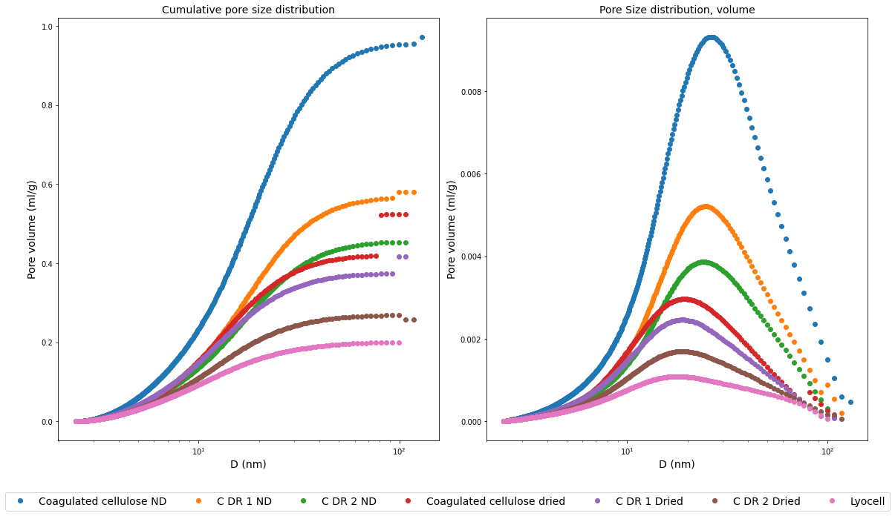
Figure S1. Results from Thermoporometry. Left: Cumulative pore size distribution. Right: Pore size distribution. ND = Never dried. C = Cellulose fiber. DR = Draw ratio. The lyocell fibers were dried.
Table S2. Results from BET-measurements. The L50 fiber contained 7% lignin after the solvent-exchange protocol.
Sample | Preparation | Pore size (Å) by volume
C DR1 | Solvent-exchanged | 68
C DR2 | Solvent-exchanged | 102
L50 DR2 | Solvent-exchanged | 61

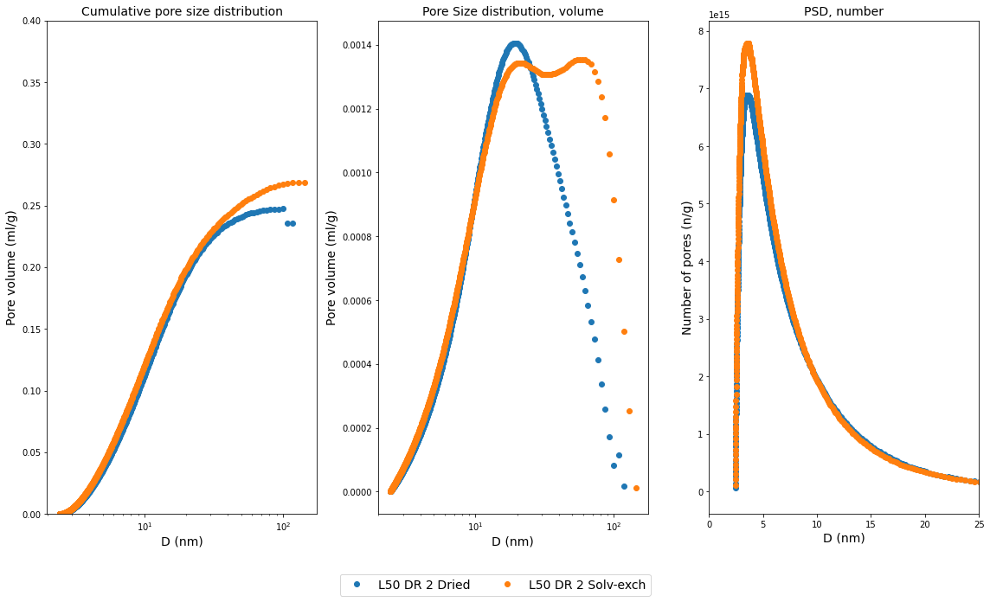Figure S2. Pore size distribution of 50% lignin fiber and solvent-exchange 50% lignin fibers with 8% lignin left, left cumulative pore size distribution., middle: based on volume, right: number of pores. Note the linear scale on the x-axis in the right plot.

