Supplemental Material

Insights into the flavonoids biotransformation during ensiling process inoculated with lactic acid bacteria

Yu Gao ¹, Hongzhang Zhou ¹, Yuan Wang ¹, Fuyu Yang ^{1, 2}, Kuikui Ni ¹
1 College of Grassland Science and Technology, China Agricultural University, Beijing 100193, China
2 College of Animal Science, Guizhou University, Guiyang 550025, China
Address correspondence to Kuikui Ni, nikk@cau.edu.cn
Telephone: +86 010-62734252
Fax: +86 010-62734252

a
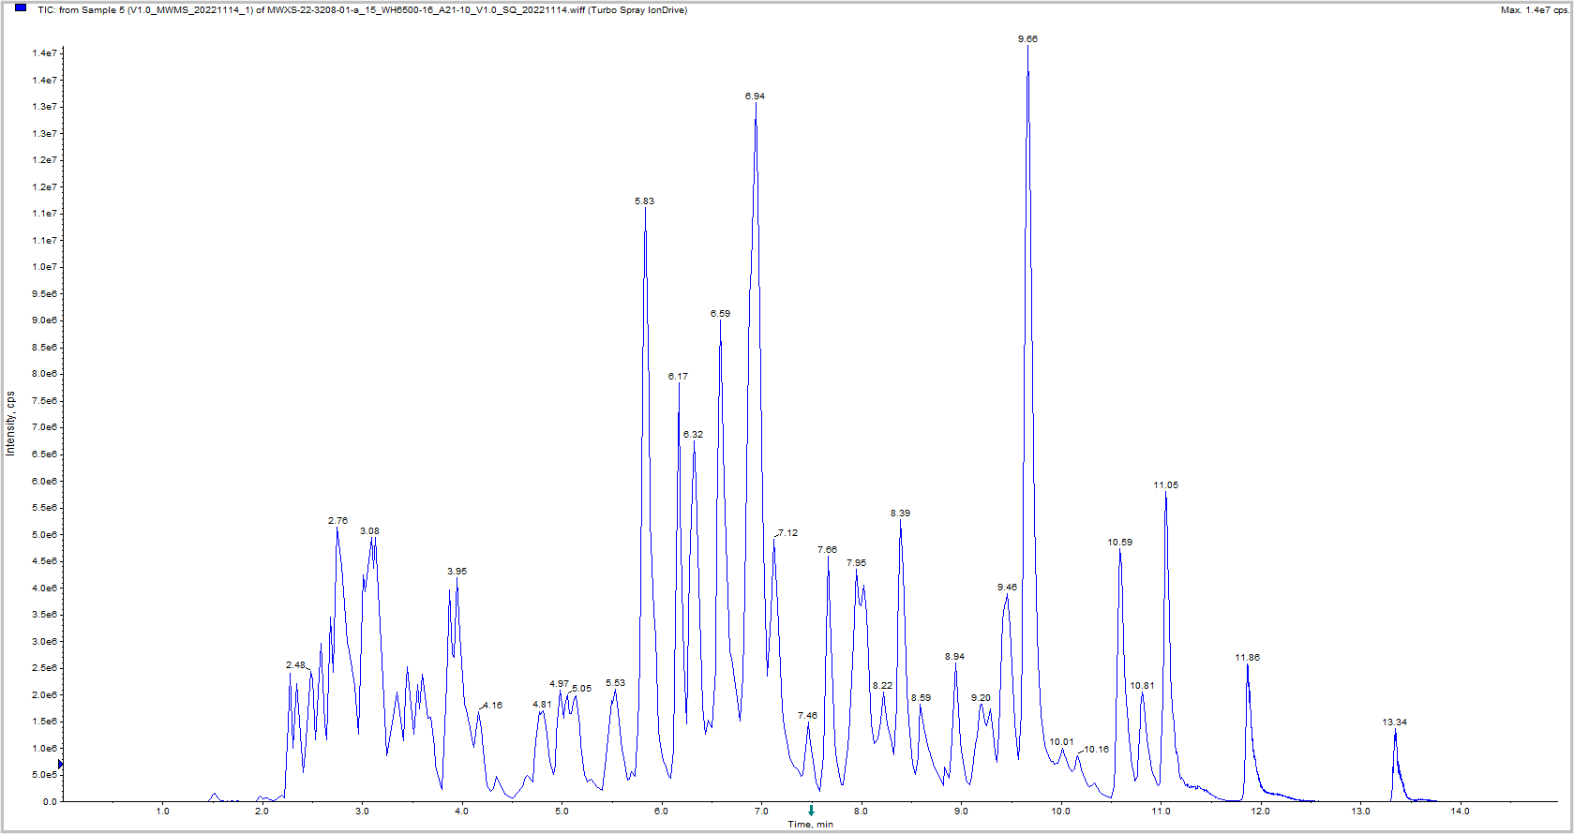
b
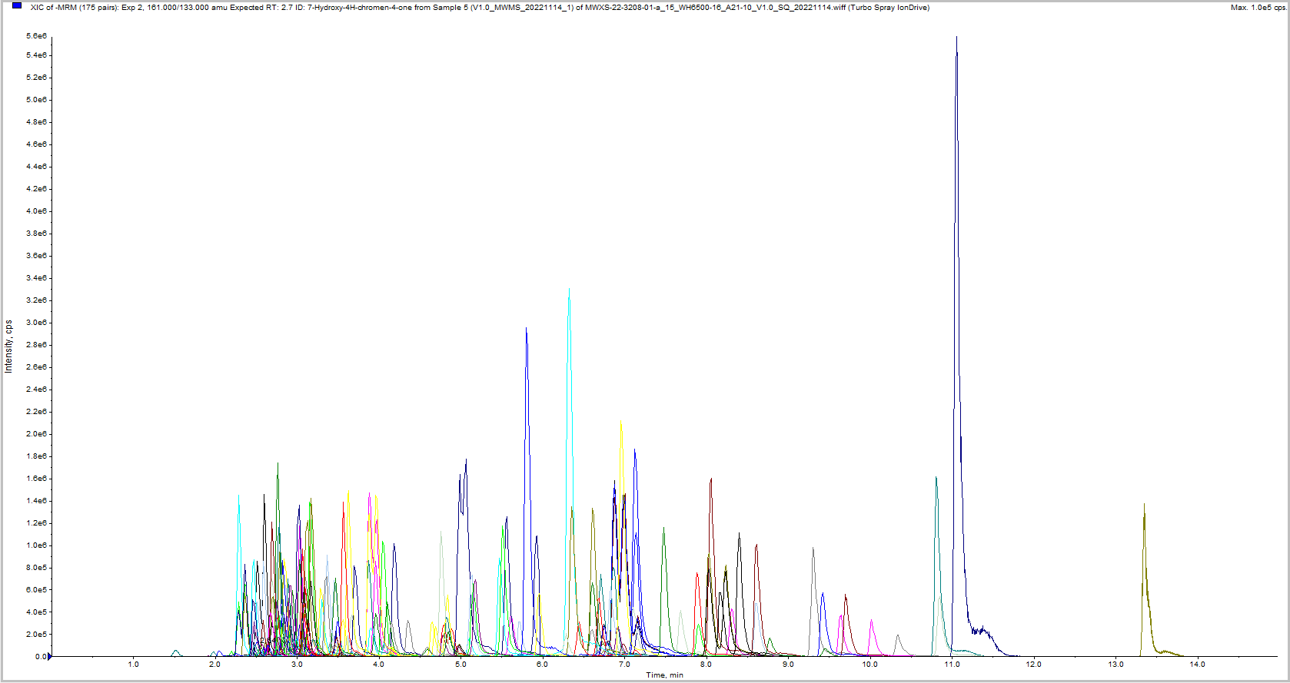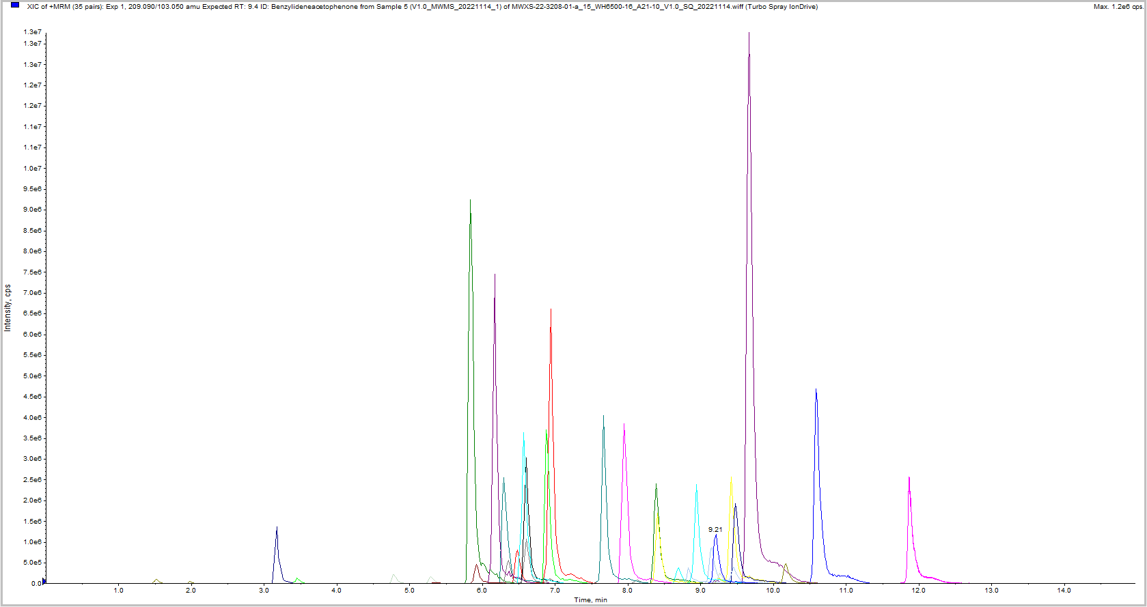
c
Fig. S1 (a) Total ion chromatogram (TIC); (b) Negative ion extracted ion chromatogram (XIC-n); (c) Positive ion extracted ion chromatogram (XIC-p)

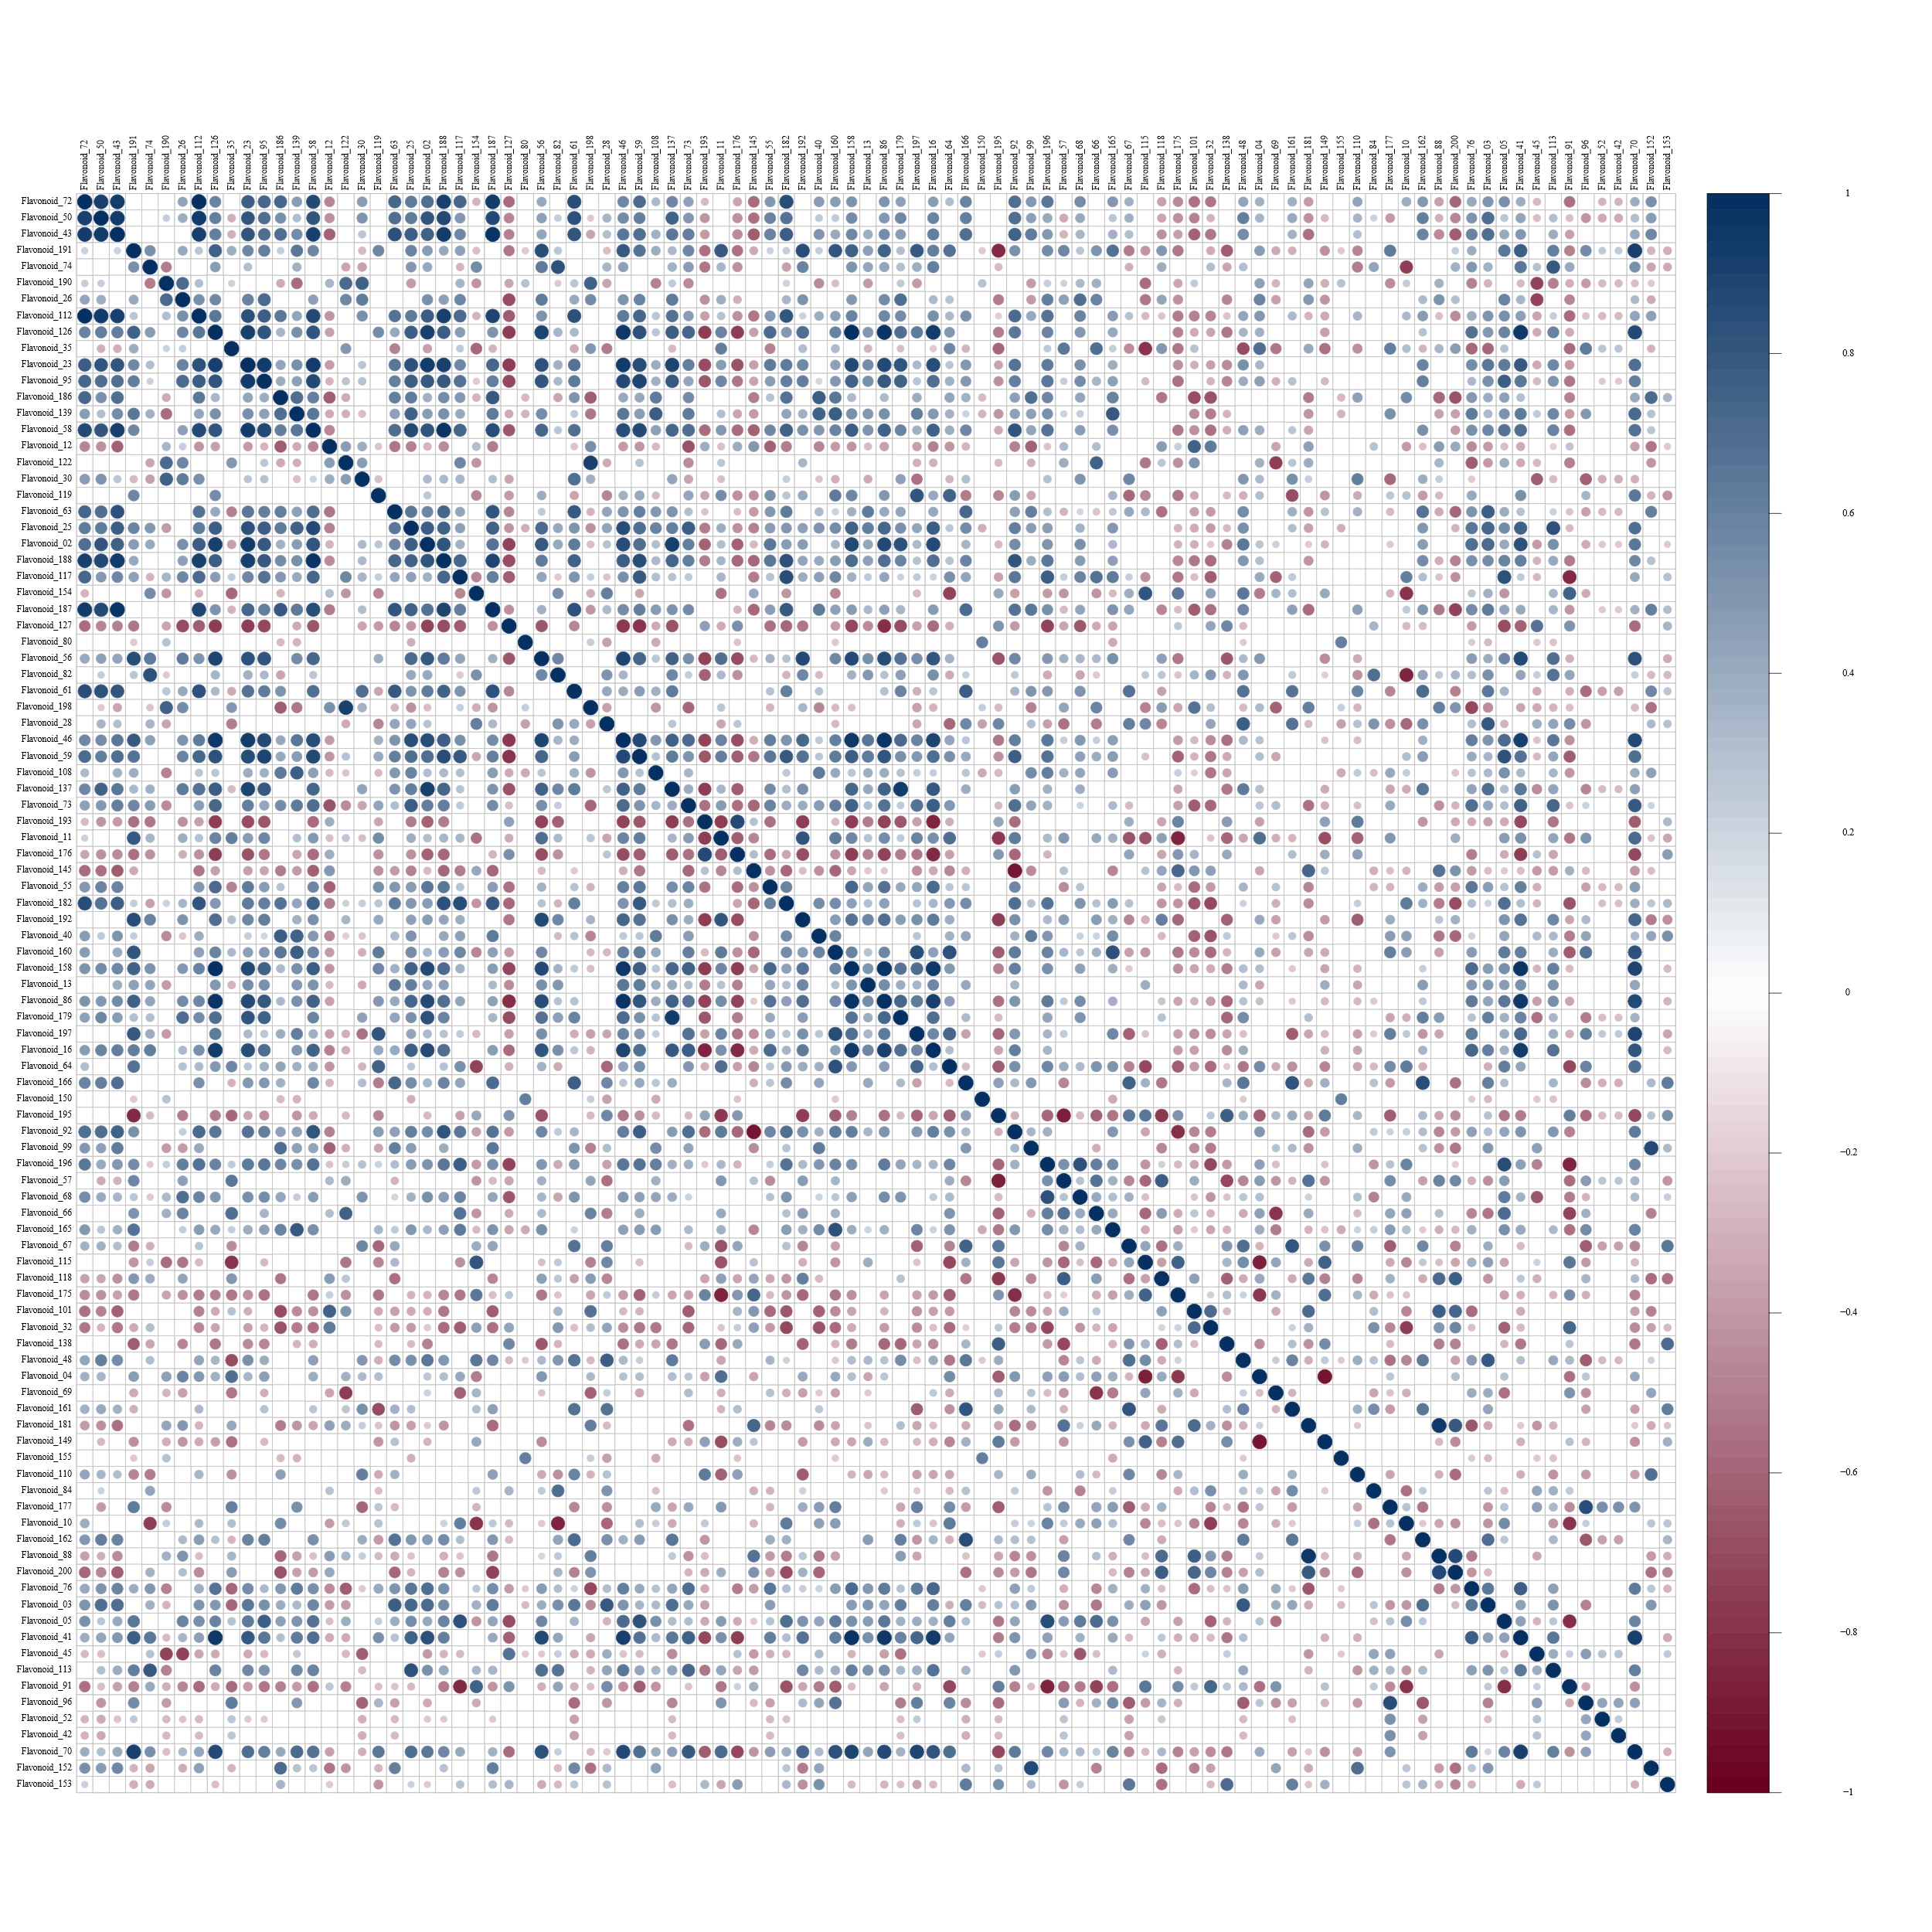Fig. S2 Pearson correlation analysis of flavonoids

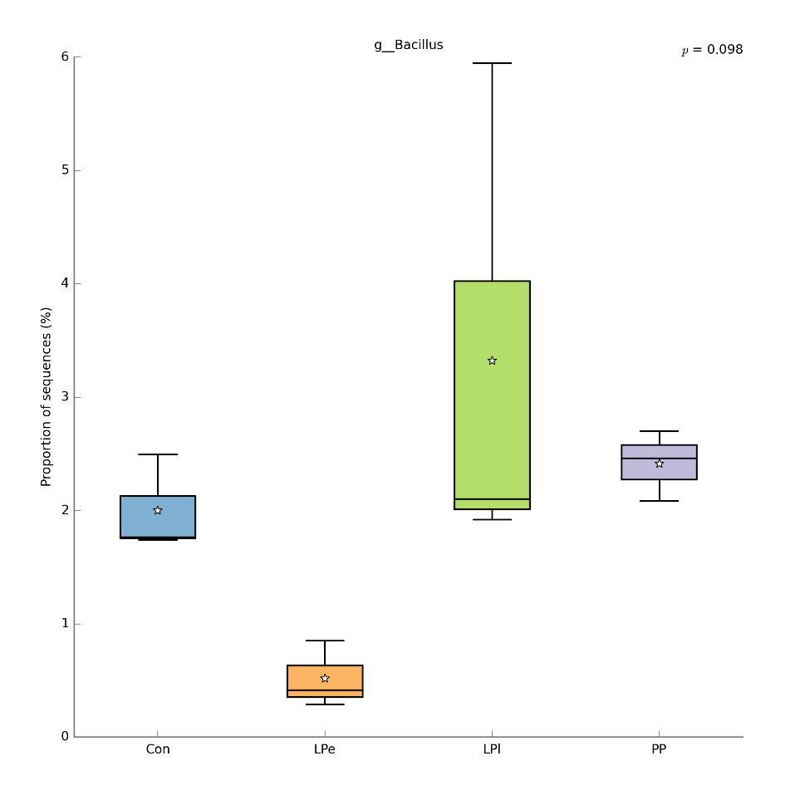
Fig. S3 Relative abundance of Bacillus genus microorganisms

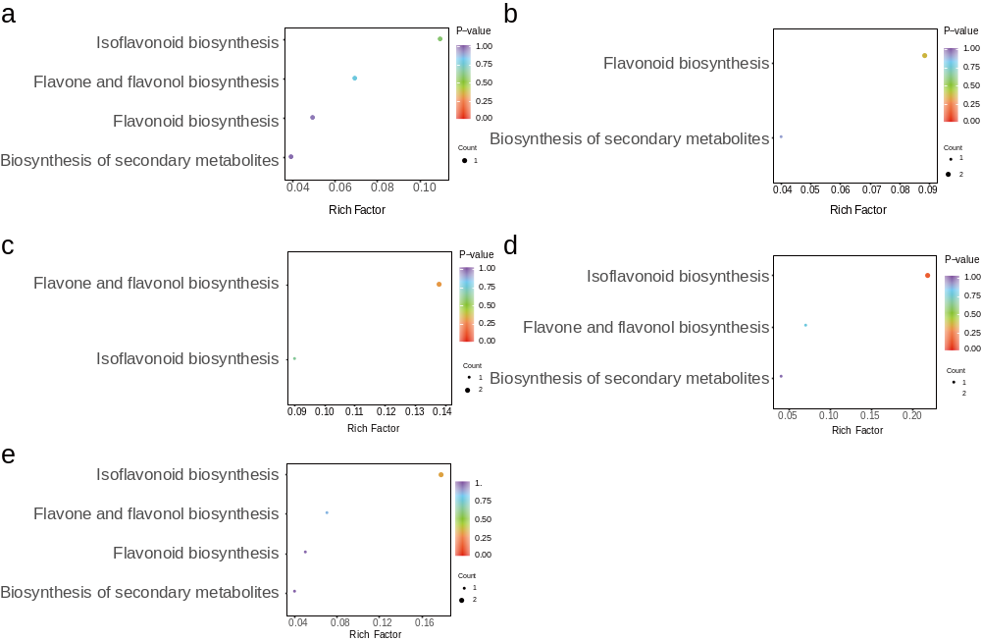
Fig. S4 Enrichment map of KEGG pathway of differential flavonoids. (a) LPe vs Control, (b) PP vs Control, (c) LPl vs Control, (d) PP vs LPe, (e) LPl vs LPe, (f) LPl vs PP

Table S1 Content and class of flavonoids in alfalfa Raw materials and silage (mean value)
Index | Compounds |  |  | Molecular Weight | Raw |  |  | CK |  |  | LPe |  |  | PP |  |  | LPl
Flavonoid_72 | Apigenin |  |  | 270.052825 | 2.9726 |  |  | 641.7335 |  |  | 588.2390 |  |  | 650.0648 |  |  | 662.8473
Flavonoid_81 | Tricin |  |  | 330.073955 | 0.2780 |  |  | 0.0000 |  |  | 0.0000 |  |  | 0.0000 |  |  | 0.0000
Flavonoid_76 | Sakuranetin |  |  | 286.084125 | 0.0032 |  |  | 0.0030 |  |  | 0.0052 |  |  | 0.0055 |  |  | 0.0042
Flavonoid_28 | Scutellarin |  |  | 462.07983 | 241.7784 |  |  | 0.3520 |  |  | 0.4472 |  |  | 0.3724 |  |  | 0.4223
Flavonoid_50 | Luteolin |  |  | 286.04774 | 0.7089 |  |  | 70.3954 |  |  | 67.1396 |  |  | 69.8333 |  |  | 71.0518
Flavonoid_198 | 5,7-Dihydroxy-3',4',5'-trimethoxyflavone |  |  | 344.089605 | 0.0122 |  |  | 0.4717 |  |  | 0.3924 |  |  | 0.3968 |  |  | 0.4019
Flavonoid_61 | Chrysin |  |  | 254.05791 | 0.0799 |  |  | 0.4881 |  |  | 0.4534 |  |  | 0.4601 |  |  | 0.4996
Flavonoid_151 | Sinensetin |  |  | 372.120905 | 0.0002 |  |  | 0.0000 |  |  | 0.0000 |  |  | 0.0000 |  |  | 0.0000
Flavonoid_118 | Narcissin |  |  | 624.16904 | 0.1155 |  |  | 0.0422 |  |  | 0.0196 |  |  | 0.0374 |  |  | 0.0000
Flavonoid_162 | Tectochrysin |  |  | 268.07356 | 0.0022 |  |  | 0.0054 |  |  | 0.0051 |  |  | 0.0045 |  |  | 0.0065
Flavonoid_160 | Apigenin 7-glucoside |  |  | 432.10565 | 17.4506 |  |  | 0.1598 |  |  | 0.1509 |  |  | 0.2442 |  |  | 0.1801
Flavonoid_99 | Acacetin |  |  | 284.068475 | 0.0003 |  |  | 0.0762 |  |  | 0.0718 |  |  | 0.1055 |  |  | 0.1925
Flavonoid_82 | Chrysosplenetin |  |  | 374.10017 | 0.0007 |  |  | 0.4969 |  |  | 0.9914 |  |  | 0.7694 |  |  | 0.3376
Flavonoid_64 | Scutellarein |  |  | 286.04774 | 0.1226 |  | 0.0959 |  |  |  | 0.0742 |  |  | 0.1330 |  |  | 0.0984
Flavonoid_165 | Homoplantaginin |  |  | 462.116215 | 3.1002 |  | 0.0524 |  |  |  | 0.0482 |  |  | 0.0637 |  |  | 0.0523
Flavonoid_25 | Apigenin-7-glucuronide |  |  | 446.084915 | 103.3344 |  | 1.3085 |  |  |  | 1.4185 |  |  | 1.6749 |  |  | 1.6207
Flavonoid_59 | Hispidulin |  |  | 300.06339 | 0.0000 |  | 0.3386 |  |  |  | 0.3031 |  |  | 0.3672 |  |  | 0.3591
Flavonoid_46 | Eupatorin |  |  | 344.089605 | 0.0017 |  | 0.3458 |  |  |  | 0.2765 |  |  | 0.6294 |  |  | 0.4277
Flavonoid_10 | 3,4'-Dihydroxyflavone |  |  | 254.05791 | 0.0000 |  | 0.0103 |  |  |  | 0.0055 |  |  | 0.0101 |  |  | 0.0125
Flavonoid_187 | Tricetin |  |  | 302.042655 | 0.0658 |  | 0.6223 |  |  |  | 0.5639 |  |  | 0.7412 |  |  | 0.8047
Flavonoid_161 | Diosmin |  |  | 608.174125 | 0.0000 |  | 0.0211 |  |  |  | 0.0180 |  |  | 0.0152 |  |  | 0.0256
Flavonoid_16 | 7,4'-Di-O-methylapigenin |  |  | 298.084125 | 0.0036 |  | 0.0993 |  |  |  | 0.1123 |  |  | 0.1295 |  |  | 0.1018
Flavonoid_90 | Cynaroside |  |  | 448.100565 | 5.9670 |  | 0.0000 |  |  |  | 0.0000 |  |  | 0.0000 |  |  | 0.0000
Flavonoid_190 | 7,4'-Dihydroxyflavone |  |  | 254.05791 | 0.8508 |  | 9.3093 |  |  |  | 8.1545 |  |  | 8.0312 |  |  | 8.1567
Flavonoid_196 | Pedalitin |  |  | 316.058305 | 0.0000 |  | 0.0718 |  |  |  | 0.0161 |  |  | 0.0736 |  |  | 0.0631
Flavonoid_166 | Genkwanin |  |  | 284.068475 | 0.0133 |  | 0.0948 |  |  |  | 0.0939 |  |  | 0.0934 |  |  | 0.1131
Flavonoid_88 | 5-O-Demethylnobiletin |  |  | 388.11582 | 0.0000 |  | 0.0052 |  |  |  | 0.0015 |  |  | 0.0009 |  |  | 0.0000
Flavonoid_193 | hydroxygenkwanin |  |  | 300.06339 | 0.0916 |  | 0.2607 |  |  |  | 0.2633 |  |  | 0.2429 |  |  | 0.2701
Flavonoid_42 | Nicotiflorin |  |  | 594.158475 | 0.6055 |  | 0.0000 |  |  |  | 0.0000 |  |  | 0.0107 |  |  | 0.0000
Flavonoid_202 | Sieboldin |  |  | 452.131865 | 0.4785 |  | 0.0000 |  |  | 0.0000 |  |  | 0.0000 |  |  | 0.0000
Flavonoid_65 | Phlorizin |  |  | 436.13695 | 0.1451 |  | 0.0000 |  |  | 0.0000 |  |  | 0.0000 |  |  | 0.0000
Flavonoid_03 | 4,4'-Dimethoxychalcone |  |  | 268.109945 | 0.0000 |  | 0.0021 |  |  | 0.0041 |  |  | 0.0031 |  |  | 0.0044
Flavonoid_70 | Licochalcone E |  |  | 338.15181 | 0.0000 |  | 0.0000 |  |  | 0.0000 |  |  | 0.0103 |  |  | 0.0000
Flavonoid_30 | Isoliquiritigenin |  |  | 256.07356 | 0.8111 |  | 2.2651 |  |  | 1.9403 |  |  | 1.8371 |  |  | 1.9419
Flavonoid_177 | Phloretin |  |  | 274.084125 | 0.0182 |  | 0.0113 |  |  | 0.0098 |  |  | 0.0157 |  |  | 0.0127
Flavonoid_112 | Echinatin |  |  | 270.08921 | 0.0373 |  | 6.7596 |  |  | 6.0328 |  |  | 6.7415 |  |  | 6.7096
Flavonoid_200 | Benzylideneacetophenone |  |  | 208.088815 | 0.0027 |  | 0.0039 |  |  | 0.0036 |  |  | 0.0034 |  |  | 0.0020
Flavonoid_191 | Naringenin chalcone |  |  | 272.068475 | 2.9701 |  | 12.9858 |  |  | 12.6380 |  | 14.3376 |  |  |  | 12.8573
Flavonoid_158 | Isosakuranetin |  |  | 286.084125 | 0.0238 |  | 0.1312 |  |  | 0.2265 |  | 0.6989 |  |  |  | 0.1163
Flavonoid_108 | Pinocembrin |  |  | 256.07356 | 0.4633 |  | 0.3136 |  |  | 0.3055 |  | 0.3325 |  |  |  | 0.3401
Flavonoid_12 | Liquiritigenin |  |  | 256.07356 | 1.0831 |  | 3.2661 |  |  | 3.1757 |  | 3.0738 |  |  |  | 2.9599
Flavonoid_69 | Liquiritin |  |  | 418.126385 | 1.7881 |  | 0.0221 |  |  | 0.0283 |  | 0.0212 |  |  |  | 0.0241
Flavonoid_41 | Hesperetin |  |  | 302.07904 | 0.0000 | 0.0007 |  |  |  | 0.0060 |  | 0.0164 |  |  |  | 0.0000
Flavonoid_101 | Hesperidin |  |  | 610.189775 | 0.0000 | 0.0340 |  |  | 0.0266 |  |  | 0.0109 |  |  | 0.0164
Flavonoid_149 | Farrerol |  |  | 300.099775 | 0.0136 | 0.0203 |  |  | 0.0354 |  |  | 0.0205 |  |  | 0.0469
Flavonoid_179 | Poncirin |  | 594.19486 |  | 0.0197 | 0.1131 |  |  | 0.0814 |  |  | 0.0858 |  |  | 0.0789
Flavonoid_126 | Eriodictyol |  | 288.06339 |  | 0.4339 | 5.7602 |  |  | 5.5474 |  |  | 8.8280 |  |  | 5.2997
Flavonoid_48 | Narirutin |  | 580.17921 |  | 0.0452 | 0.0240 |  |  | 0.0290 |  |  | 0.0221 |  |  | 0.0255
Flavonoid_04 | Isosilybin |  | 482.1213 |  | 0.0070 | 0.0233 |  |  | 0.0121 |  |  | 0.0217 |  |  | 0.0134
Flavonoid_113 | Taxifolin 7-O-rhamnoside |  | 450.116215 |  | 0.0000 | 0.0000 |  |  | 0.2446 |  |  | 0.4547 |  |  | 0.2433
Flavonoid_40 | Dihydromyricetin |  | 320.05322 |  | 0.2834 | 0.1666 |  |  | 0.1605 |  |  | 0.2027 |  |  | 0.1979
Flavonoid_117 | Engeletin |  | 434.1213 |  | 0.0829 | 0.8270 |  |  | 0.6765 |  |  | 0.8193 |  |  | 0.8358
Flavonoid_56 | Taxifolin |  | 304.058305 |  | 0.2762 | 0.5169 |  |  | 0.4891 |  |  | 0.5912 |  |  | 0.4626
Flavonoid_139 | Dihydrokaempferol |  | 288.06339 |  | 2.1437 | 3.3572 |  |  | 3.3941 |  |  | 3.7689 |  |  | 3.5380
Flavonoid_176 | Naringenin-7-glucoside |  | 434.1213 |  | 4.8571 | 0.2119 |  |  | 0.2278 |  |  | 0.0914 |  |  | 0.3025
Flavonoid_122 | 7-Hydroxy-4H-chromen-4-one |  | 162.031695 |  | 0.2673 | 2.4734 |  |  | 2.1155 |  |  | 2.2080 |  |  | 2.2917
Flavonoid_35 | Syringaldehyde |  | 182.05791 |  | 0.0000 | 4.8047 |  |  | 3.6231 |  |  | 4.8870 |  |  | 4.2943
Flavonoid_11 | Hydroxysafflor yellow A |  | 612.16904 |  | 2.1024 | 0.2583 |  |  | 0.1849 |  |  | 0.3515 |  |  | 0.2301
Flavonoid_115 | Quercitrin |  | 448.100565 |  | 0.0421 | 0.0498 |  |  | 0.1833 |  |  | 0.0812 |  |  | 0.1409
Flavonoid_23 | Quercetin |  | 302.042655 |  | 0.1809 | 4.5776 |  |  | 3.6523 |  |  | 5.5257 |  |  | 4.7364
Flavonoid_197 | Isorhamnetin 3-O-glucoside |  | 478.11113 |  | 0.6294 | 0.0993 |  |  | 0.1322 |  |  | 0.2170 |  |  | 0.1208
Flavonoid_175 | Afzelin |  | 432.10565 |  | 0.0130 | 0.0400 |  |  | 0.0770 |  |  | 0.0288 |  |  | 0.0557
Flavonoid_138 | Baimaside |  | 626.148305 |  | 0.1790 | 0.0252 |  |  | 0.0310 |  |  | 0.0254 |  |  | 0.0311
Flavonoid_188 | Laricitrin |  | 332.05322 |  | 0.5848 | 0.9544 |  |  | 0.6379 |  |  | 1.0609 |  |  | 1.0356
Flavonoid_137 | Tiliroside |  | 594.137345 |  | 0.0467 | 0.3058 |  |  | 0.2145 |  |  | 0.2352 |  |  | 0.1756
Flavonoid_43 | Kaempferol |  | 286.04774 |  | 4.0070 | 34.9054 |  |  | 32.4730 |  |  | 39.4813 |  |  | 43.0724
Flavonoid_92 | Myricetin |  | 318.03757 |  | 0.1158 | 0.0788 |  |  | 0.0598 |  |  | 0.1137 |  |  | 0.0944
Flavonoid_67 | Fisetin |  | 286.04774 |  | 0.0000 | 0.0506 |  |  | 0.0512 |  |  | 0.0415 |  |  | 0.0569
Flavonoid_45 | 3,7,4'-Trihydroxyflavone |  | 270.052825 |  | 0.0000 | 0.0000 |  |  | 4.1831 |  |  | 4.2663 |  |  | 5.6642
Flavonoid_110 | Kaempferide |  | 300.06339 |  | 0.0000 | 0.0169 |  |  | 0.0089 |  |  | 0.0000 |  |  | 0.0166
Flavonoid_119 | Astragalin |  | 448.100565 |  | 12.8236 | 1.9552 |  |  | 2.1594 |  |  | 2.7643 |  |  | 1.5706
Flavonoid_194 | Quercimeritrin |  | 464.09548 |  | 0.5516 | 0.0000 |  |  | 0.0000 |  |  | 0.0000 |  |  | 0.0000
Flavonoid_86 | Avicularin |  | 434.084915 |  | 0.4632 | 0.1207 |  |  | 0.1098 |  |  | 0.1960 |  |  | 0.1183
Flavonoid_189 | Robinin | 740.216385 |  |  | 0.0444 | 0.0000 |  |  | 0.0000 |  |  | 0.0000 |  |  | 0.0000
Flavonoid_52 | Kaempferol 3-neohesperidoside | 594.158475 |  |  | 0.0000 | 0.0000 |  |  | 0.0000 |  |  | 0.0233 |  |  | 0.0000
Flavonoid_02 | Miquelianin | 478.074745 |  |  | 0.7350 | 1.0827 |  |  | 1.0522 |  |  | 1.6839 |  |  | 0.7360
Flavonoid_58 | Isorhamnetin | 316.058305 |  |  | 0.1430 | 3.3240 |  |  | 2.7455 |  |  | 3.9670 |  |  | 3.7798
Flavonoid_57 | Rutin | 610.15339 |  |  | 0.2060 | 0.0619 |  |  | 0.0364 |  |  | 0.0597 |  |  | 0.0448
Flavonoid_74 | Schaftoside | 564.14791 |  |  | 2.9334 | 10.1147 |  |  | 11.0732 |  |  | 11.1047 |  |  | 9.9785
Flavonoid_13 | Isoorientin | 448.100565 |  |  | 0.0638 | 0.1248 |  |  | 0.1734 |  |  | 0.2100 |  |  | 0.2209
Flavonoid_155 | Spinosin | 608.174125 |  |  | 0.0000 | 0.0196 |  |  | 0.0000 |  |  | 0.0000 |  |  | 0.0000
Flavonoid_192 | Orientin | 448.100565 |  |  | 0.0560 | 0.1765 |  |  | 0.1661 |  |  | 0.1879 |  |  | 0.1643
Flavonoid_154 | Vitexin | 432.10565 |  |  | 0.0900 | 0.6358 |  |  | 0.7747 |  |  | 0.6517 |  |  | 0.6237
Flavonoid_51 | 3'-Methoxypuerarin | 446.1213 |  |  | 0.0183 | 0.0000 |  |  | 0.0000 |  |  | 0.0000 |  |  | 0.0000
Flavonoid_195 | (-)-Gallocatechin | 306.073955 |  |  | 0.1288 | 0.0794 |  |  | 0.0971 |  |  | 0.0732 |  |  | 0.0955
Flavonoid_80 | (-)-Gallocatechin gallate | 458.084915 |  |  | 3.1956 | 0.5401 |  |  | 0.0000 |  |  | 0.0000 |  |  | 0.0000
Flavonoid_184 | Afzelechin | 274.084125 |  |  | 0.0830 | 0.0000 |  |  | 0.0000 |  |  | 0.0000 |  |  | 0.0000
Flavonoid_84 | (-)-Epigallocatechin | 306.073955 |  |  | 0.5179 | 0.0150 |  |  | 0.0257 |  |  | 0.0249 |  |  | 0.0073
Flavonoid_150 | (-)-Catechin gallate | 442.09 |  |  | 0.2670 | 0.0851 |  |  | 0.0000 |  |  | 0.0000 |  |  | 0.0000
Flavonoid_147 | (-)-Epicatechin | 290.07904 |  |  | 1.6726 | 0.0000 |  |  | 0.0000 |  |  | 0.0000 |  |  | 0.0000
Flavonoid_55 | (-)-Catechin | 290.07904 |  |  | 2.8823 | 0.1857 |  |  | 0.2256 |  |  | 0.2160 |  |  | 0.2279
Flavonoid_157 | Isomangiferin | 422.084915 |  |  | 0.0313 | 0.0000 |  |  | 0.0000 |  |  | 0.0000 |  |  | 0.0000
Flavonoid_68 | Mangiferin | 422.084915 |  |  | 0.0250 | 0.0616 |  |  | 0.0524 |  |  | 0.0583 |  |  | 0.0581
Flavonoid_37 | Kurarinone | 438.20424 |  |  | 0.0022 | 0.0000 |  |  | 0.0000 |  |  | 0.0000 |  |  | 0.0000
Flavonoid_91 | Morusin | 420.15729 |  |  | 0.0000 | 0.0000 |  |  | 0.0029 |  |  | 0.0000 |  |  | 0.0000
Flavonoid_05 | 7-Methoxyisoflavone | 252.078645 |  |  | 0.0000 | 0.0012 |  |  | 0.0008 |  |  | 0.0014 |  |  | 0.0014
Flavonoid_127 | Daidzein | 254.05791 |  |  | 0.1989 | 0.5887 |  |  | 0.6818 |  |  | 0.6118 |  |  | 0.6323
Flavonoid_63 | Tectorigenin | 300.06339 |  |  | 0.0000 | 1.4587 |  |  | 1.4732 |  |  | 1.5036 |  |  | 1.6743
Flavonoid_181 | Demethyltexasin | 270.052825 |  |  | 0.0000 | 0.0207 |  |  | 0.0000 |  |  | 0.0000 |  |  | 0.0000
Flavonoid_182 | 2'-Hydroxydaidzein | 270.052825 |  |  | 0.2302 | 0.1830 |  |  | 0.0359 |  |  | 0.2405 |  |  | 0.2904
Flavonoid_26 | Formononetin | 268.07356 |  |  | 2.3843 | 6.9572 |  |  | 6.4380 |  |  | 6.6587 |  |  | 6.4654
Flavonoid_186 | Prunetin | 284.068475 |  |  | 0.4609 | 3.3765 |  |  | 3.3869 |  |  | 3.8273 |  |  | 3.9570
Flavonoid_66 | Puerarin | 416.110735 |  |  | 0.0017 | 0.0544 |  |  | 0.0431 |  |  | 0.0528 |  |  | 0.0498
Flavonoid_95 | Calycosin | 284.068475 |  |  | 0.7976 | 4.3935 |  |  | 4.2541 |  |  | 4.4657 |  |  | 4.4314
Flavonoid_32 | Daidzin | 416.110735 |  |  | 3.9438 | 0.0292 |  |  | 0.0567 |  |  | 0.0154 |  |  | 0.0000
Flavonoid_96 | Calycosin-7-O-β-D-glucoside | 446.1213 |  |  | 2.2399 | 0.0000 |  |  | 0.0000 |  |  | 0.5264 |  |  | 0.0000
Flavonoid_153 | Glycitin | 446.1213 |  |  | 1.9515 | 0.0000 |  |  | 0.0000 |  |  | 0.0000 |  |  | 0.1350
Flavonoid_152 | Ononin | 430.126385 |  |  | 1.5590 | 0.0000 |  |  | 0.0000 |  |  | 0.0000 |  |  | 0.1779
Flavonoid_73 | Genistin | 432.10565 |  |  | 0.4342 | 0.2968 |  |  | 0.3436 |  |  | 0.4285 |  |  | 0.3735
Flavonoid_145 | Procyanidin B2 | 578.14243 |  |  | 6.4895 | 0.2110 |  |  | 0.1880 |  |  | 0.0000 |  |  | 0.0000

