(a) Previous work
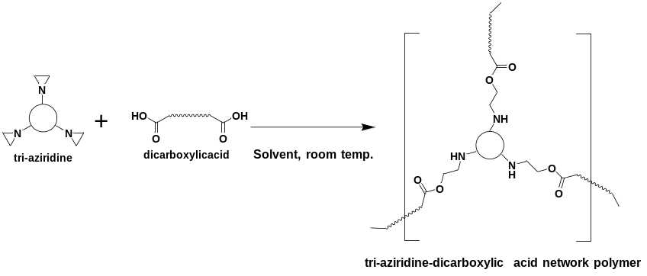
(b) This work
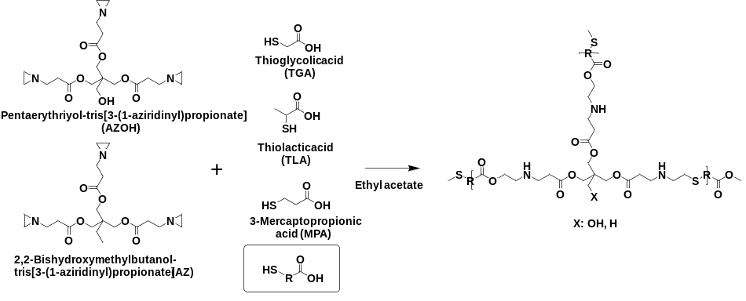

Scheme 1. Synthesis of network polymers by ring-opening addition reaction of tri-aziridine compounds: (a) reaction between tri-aziridine and liner dicarboxylic acid compounds (previous work), and (b) reaction between tri-aziridine compounds (AZOH, AZ) and thiol-carboxylic acid (TGA, TLA, MPA) compounds (this work).

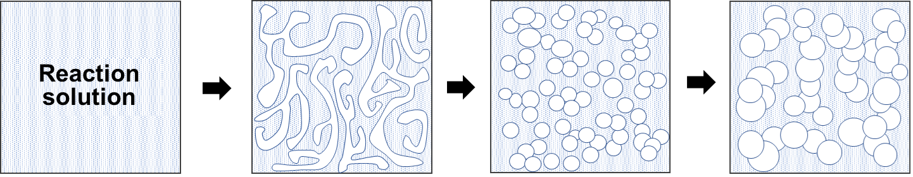

(i) (ii) (iii)

Scheme 2. A phase separation model of the present reaction systems via SD

