DFT Investigation for the Mechanisms of γ-Butyrolactones from Styrene and Acrylic Acid, Catalyzed by NMA*BF₄ and PhSSPh

Bing Yang, Da-Gang Zhou*

Chemical Synthesis and Pollution Control Key Laboratory of Sichuan Province, College of Chemistry and Chemical Engineering, China West Normal University, Nanchong, People’s Republic of China
1. The definition of the relevant parameters of excited states of R1+NMA and NMA+PhSSPh.
(1) D(Å): the distance of the centroids between the hole and the electron.
(2) Sr: the geometric mean of overlap function between the hole and the electron.
(3) H(Å): the overall average distribution breadth of electron and hole.
(4) t(Å): the degree of separation of hole and electron.
(5) E_{coul}(eV): exciton binding energy.(Coulomb attraction energy between hole and electron)
The website (http://sobereva.com/434) has all the definitions of these parameters.
2. The other paths to product P1.
IM6c1→P1
It can be seen from the paths c1, c2 and c3 that the obtained IM6c1 is a radical, and the single electron is mainly distributed on the C4 atom in Figure 10f, which is unstable and tends to get a H atom to achieve a stable structure P1. Therefore, in the next step, we explored the H-shift mechanism, in which PhSH or R2 can be as the source to supply H atom. The mechanism of PhSH supplying H has been discussed in Path c1. In Figure s1-(2), we discuss the mechanism of H supplied by R2. The calculations implied that this process needs about 30.76 kcal/mol energy to overcome barrier and the IM6c1+R2→P1+IM7c process need about 19.77 kcal/mol energy. Compared with these two paths, it is clear that the PhSH is the preferential as the H source.
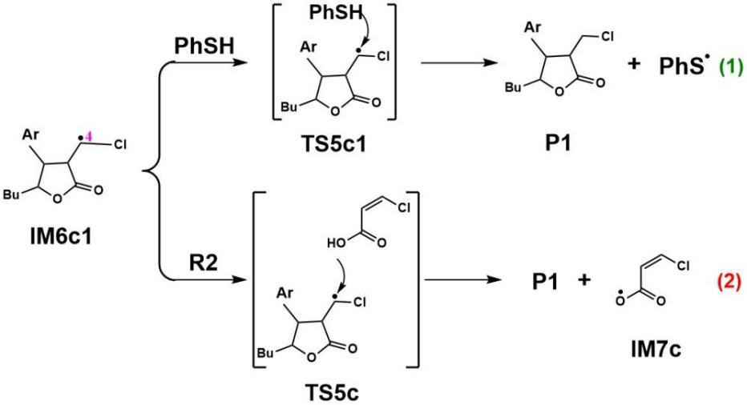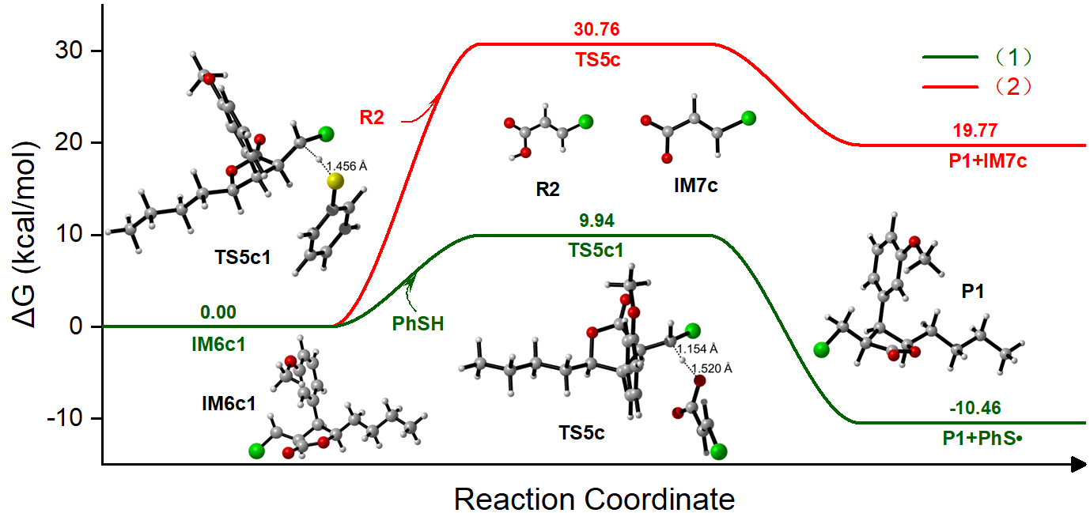
Figure s1. The detailed reaction process and the Gibbs free energy surfaces from IM6c1 to P1 via two paths.
Paths c2 (c2-4, c2-5, c2-6)
So in Path c2-4, C8(IM3c2) would have interaction with PhS⁻ anion, and this IM3c2+PhS⁻→IM4c2-4 process released about 30.66 kcal/mol energy, being an exothermic procedure. Then the following step would convert intermediate IM4c2-4 to get IM6c1 via an intramolecular H-shift reaction, which has an energy barrier of 21.33 kcal/mol. Moreover, the IM4c2-4→IM6c1+PhSH process is an exothermic step and 39.54 kcal/mol energy would be released. In Path c2-5, the C4 site of IM3c2 would have interaction with PhS⁻ anion, and this IM3c2+PhS⁻→IM4c2-5 process is an exothermic procedure(33.04 kcal/mol). Then H9 atom is easily captured by S atom, resulting in intramolecular H-shift reaction. This IM4c2-5→IM6c1+PhSH procedure is an exothermic procedure(39.74 kcal/mol). In Path c2-6, R2-1 is combined with C4(IM3c2), and the calculation results show that this IM3c2+R2-1→IM4c2-5 process is an exothermic procedure (30.68 kcal/mol). Then H9 atom is captured by O7 atom, resulting in intramolecular H-shift reaction. This IM4c2-6→IM6c1+R2 procedure is an exothermic procedure(28.47 kcal/mol). Then the following process that IM6c1→P1 is as the same as Path c1.

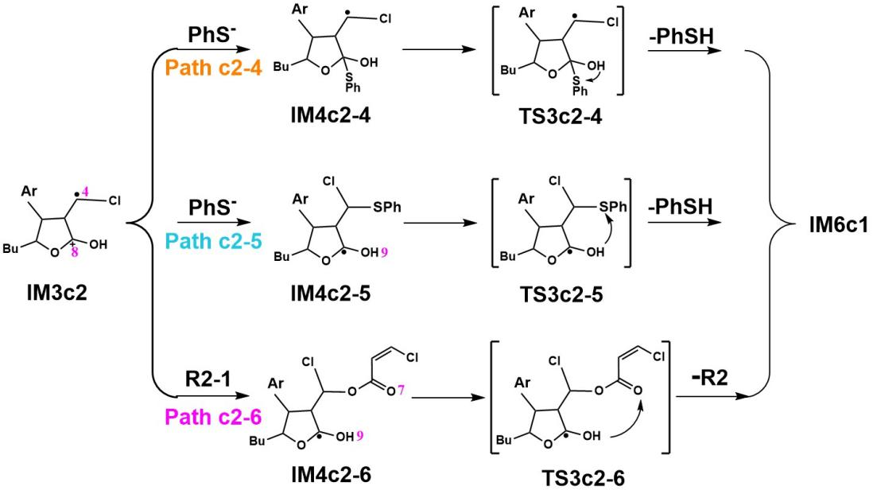
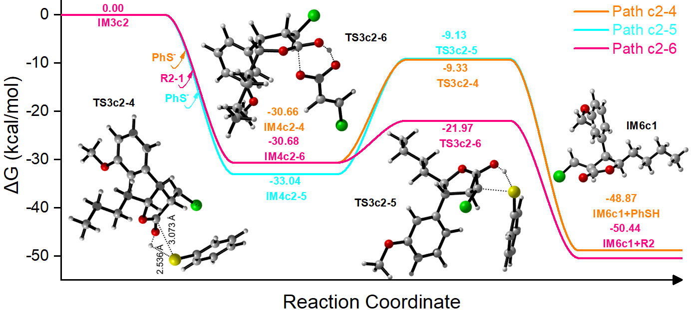Figure s2. The detailed reaction process and the Gibbs free energy surfaces from IM3c2 to IM6c1via Paths c2-4, c2-5 and c2-6.
Paths c2 (c2-7, c2-8-1, c2-8-2)
According to the electron spin density diagram of IM3c2 in Figure 10g, the single electron is mainly distributed on the C4 atom, which is unstable and tends to get a H atom to achieve a stable structure. Therefore, in Path c2-7, IM3c2 has the possibility to go through an intramolecular H-shift, and H9 atom migrates to the C4 atom, while O6=C8 double bond was formed, to get a cationic radical IM4c2-7, which needs about 28.26 kcal/mol energy to overcome the barrier via transition state TS3c1-7. This IM3c2→IM4c2-7 procedure is an exothermic procedure(21.27 kcal/mol). As in Figure 3s, IM4c2-7 obtains an electron from NMA• radical to generate target product P1 via intermolecular SET, while NMA• becomes NMA. The computational results show that this IM4c2-7+NMA•→P1+NMA procedure is an exothermic procedure(52.73 kcal/mol)
In addition to intramolecular H-shift, both PhSH and R2 can provide H for C4(IM3c2). Therefore, in Path c2-8-1, we explored the H-shift mechanism, in which PhSH can be as the source to supply H atom. The calculations implied that this process needs about 7.43 kcal/mol energy. Figure 3s shows that IM3c2+PhSH→IM4c2-8+PhS•process releases about 13.39 kcal/mol energy. In Path c2-8-2, we discuss the mechanism of H supplied by R2. The calculations implied that this process needs about 29.62 kcal/mol energy to overcome barrier via transition state TS3c2-8-2 and the energy of IM3c2+R2 is 16.84 kcal/mol lower than that of IM4c2-8+IM7c, suggesting that this step is an endothermic reaction.
Then the following step would convert intermediate IM4c2-8 to get target product P1 via an H-shift reaction. In Path c2-8a, IM7c is combined with C8(IM4c2-8), and the calculation results show that this IM4c2-8+IM7c→IM5c2-8a process releases about 20.57 kcal/mol energy. Then H9 atom is easily captured by O7 atom, resulting in intramolecular H-shift reaction. This IM5c2-8a→IM6c2-8a(IM4c2-7)+R2 procedure is an exothermic procedure(17.54 kcal/mol). The following process is as the same as in Path c2-7 (IM4c2-7→P1).
In Path c2-8b, PhS⁻ is combined with C8(IM4c2-8), and the calculation results show that this IM4c2-8+PhS⁻→IM5c2-8b process is an exothermic procedure (31.44 kcal/mol). Then in the next step, intermediate IM5c2-8b would convert to P1 via an intramolecular H-shift reaction, which has an energy barrier of 22.15 kcal/mol via transition state TS4c2-8b. Moreover, the IM5c2-8b→P1+PhSH process is an exothermic step (14.50 kcal/mol ).
In Path c2-8c, Then the intermediate IM5c2-8c would convert to P1 via an intramolecular H-shift reaction, which has an energy barrier of 10.08 kcal/mol via transition state TS4c2-8c. Moreover, the IM5c2-8c→P1+R2 process is an exothermic step (18.38 kcal/mol ).
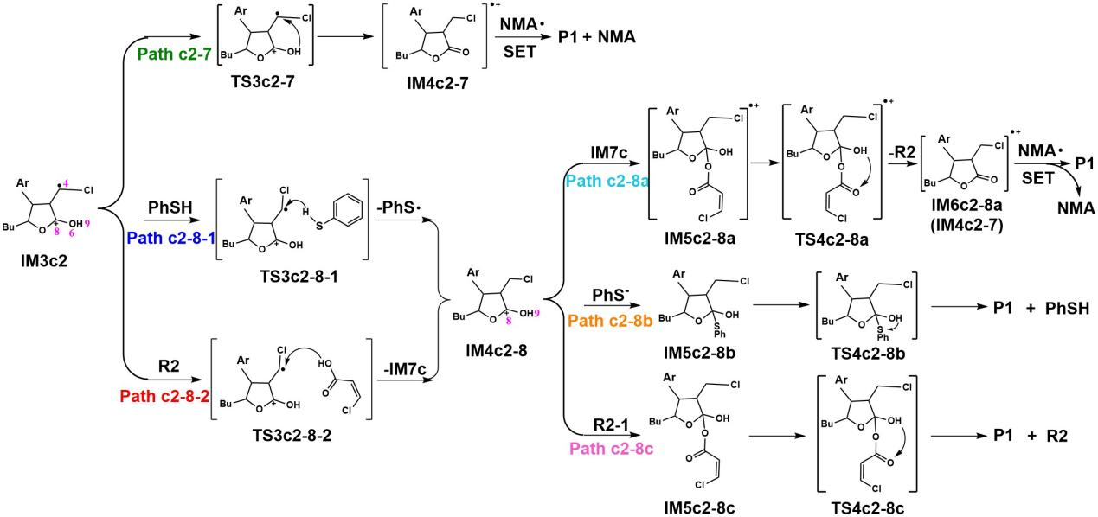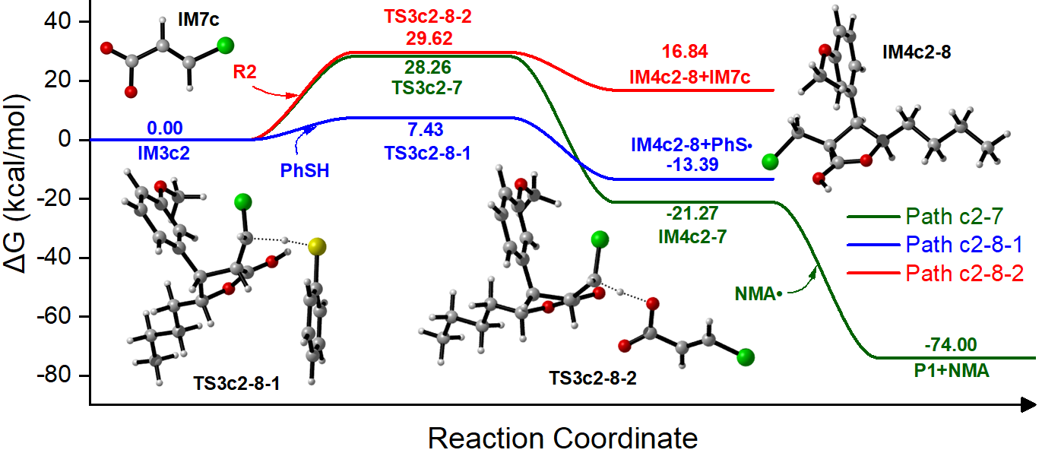
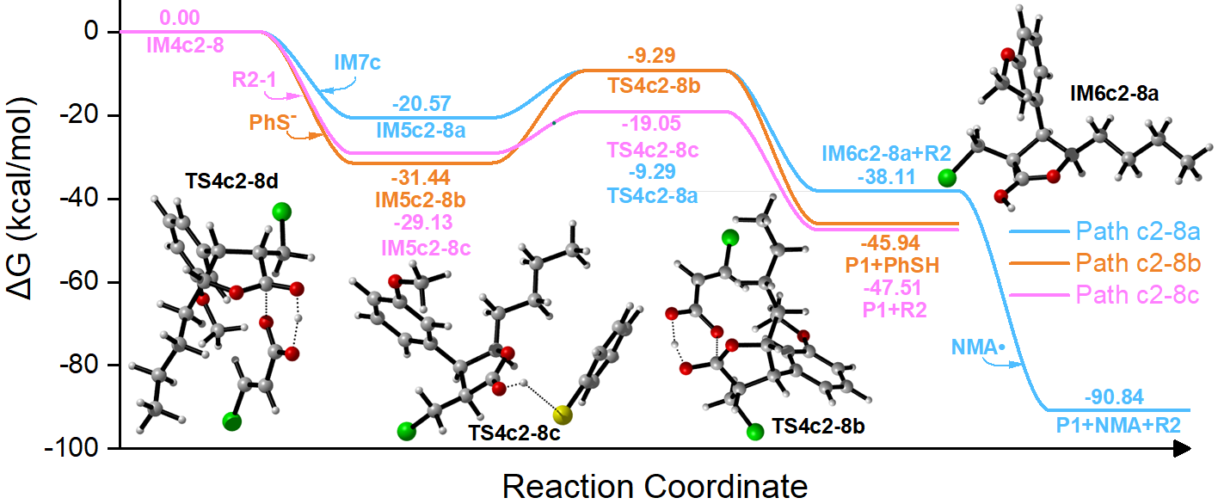
Figure s3. The detailed reaction process and the Gibbs free energy surfaces from IM3c2 to P1via Paths c2-7 and c2-8.
Path d from R1 to P1
In Path d, styrene as reactant R1 would react electrophilicly with IM7c, and the calculation results show that the R1+IM7c→IM1d process releases about 25.94 kcal/mol energy, which is an exothermic reaction and could benefit the following reactions. The structure of IM1d is the same as that of IM5c1 in Path c1, and it will undergo a closed-loop reaction to obtain IM2d (IM6c1). The following process that IM6c1→P1 is as the same as Path c1 above.
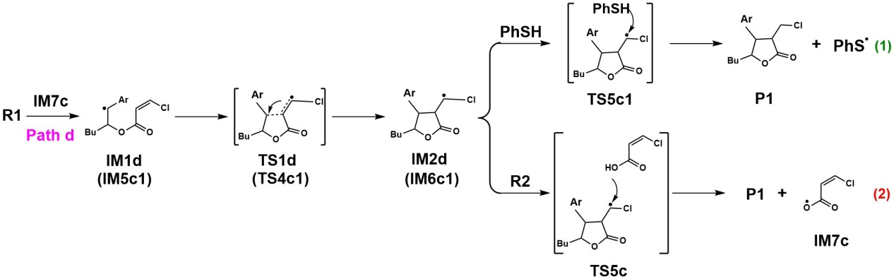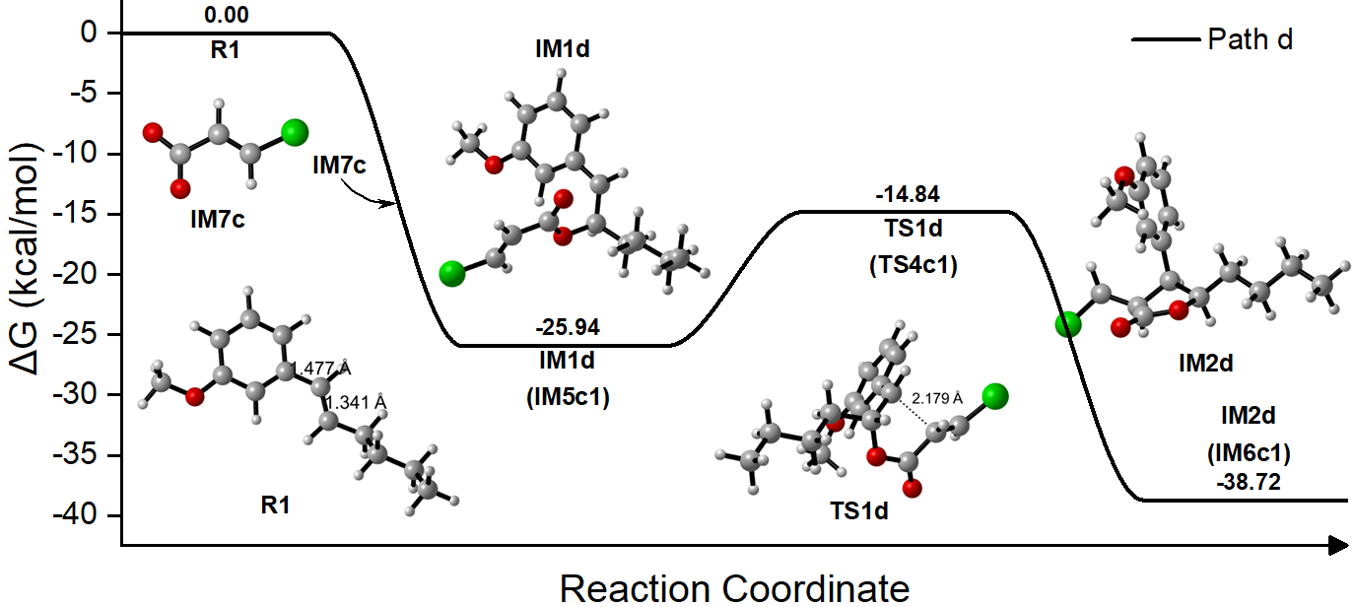
Figure s4. The detailed reaction process and the Gibbs free energy surfaces from R1 to P1via Path d
3. The Cartesian coordinates (Angstrom) for the optimized reactants, intermediates, transition states and product obtained at the M06-2X-D3/ma-def2SVP level of theory in the solvent of acetontrile.
R1
C -0.61721993 1.33817425 0.00000000
C -1.99275693 1.20609125 0.22108400
C -2.76242693 2.32533125 0.56764500
C -2.13141393 3.56608325 0.68552500
C -0.76442093 3.70129425 0.46588300
C 0.01372807 2.58135925 0.11912900
H -0.05875793 0.43953625 -0.26698700
H -3.83393893 2.24311125 0.74441200
H -2.72699693 4.44075225 0.95525300
H -0.28617493 4.67811125 0.56332400
C 1.46213207 2.76937525 -0.10337500
H 1.81570407 3.79956125 0.02126100
C 2.35665307 1.82739825 -0.43606200
H 2.03116007 0.78737625 -0.56220400
C 3.82003107 2.08450725 -0.63247700
H 4.10142107 1.80424325 -1.66320000
H 4.02470607 3.16209825 -0.52458100
C 4.69583707 1.29025425 0.34139200
H 4.42024607 1.55754325 1.37628700
H 4.48024707 0.21301125 0.23038900
C 6.18817607 1.53152825 0.13419200
H 6.45458207 1.27230125 -0.90460800
H 6.39762707 2.60880425 0.24636600
C 7.05813107 0.73688825 1.10088500
H 8.12816407 0.92945525 0.93321200
H 6.83010207 0.99936025 2.14581100
H 6.89015407 -0.34527575 0.98508900
O -2.50176093 -0.03923075 0.07744900
C -3.88498093 -0.23378575 0.28181700
H -4.07729693 -1.29898475 0.11072800
H -4.17670893 0.02542425 1.31212500
H -4.48205093 0.36042625 -0.42830200
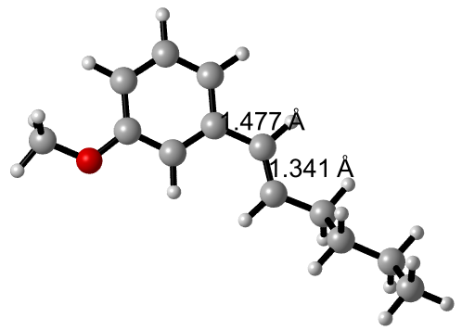

R2
C -2.90104951 -0.33733133 0.00000000
H -2.93232045 -1.42873633 0.00040172
C -4.23603751 -0.28757233 0.00023500
H -4.68355951 0.70800667 -0.00010400
Cl -1.28535156 0.26648567 -0.00054772
C -5.23092251 -1.38578033 0.00090900
O -6.42018951 -1.17223433 -0.00018400
O -4.72079051 -2.61513933 0.00020200
H -5.45552651 -3.25471733 -0.00028300
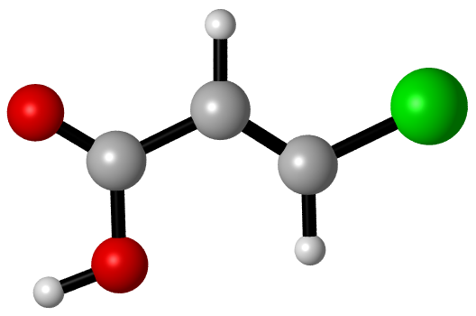

R2-1
C -2.19640182 -0.14242878 0.00000000
H -2.32940091 -1.18623725 0.28885944
C -3.52110282 -0.11027578 -0.10561700
H -3.95746882 0.85551122 -0.38400400
Cl -0.51124074 0.33686668 0.02578156
C -4.50596382 -1.24056778 0.19320400
O -5.39108282 -0.93888878 1.02278600
O -4.35112882 -2.31445578 -0.41644800
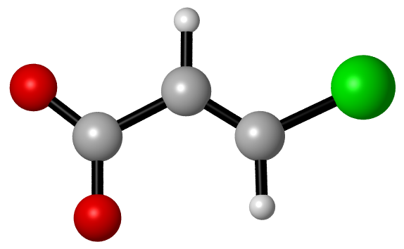

NMA
C -0.93879669 0.59128630 0.00000000
C -0.24365669 1.77403430 0.06806700
C -0.94524769 3.00913830 0.13725300
C -2.37573769 2.98948730 0.10449000
C -3.05601669 1.73361030 0.05093300
C -2.35744869 0.55909230 0.00404500
C -3.08839269 4.20306230 0.11872600
C -2.37575969 5.41665230 0.10461800
C -0.94526969 5.39702130 0.13735200
C -0.24369769 6.63214030 0.06823900
H 0.84171231 6.65894530 0.03768900
C -0.93885569 7.81488330 0.00028300
C -2.35750869 7.84705630 0.00437900
C -3.05605769 6.67252430 0.05119400
H -0.38032769 -0.34409770 -0.06530300
H 0.84175431 1.74724530 0.03754700
H -4.14646169 1.73659230 0.03918600
H -2.88120669 -0.39584470 -0.04331300
H -0.38040269 8.75027930 -0.06496800
H -2.88128269 8.80198930 -0.04288100
H -4.14650469 6.66952730 0.03948100
C -4.57938969 4.20305030 0.13087700
C -5.28116969 4.20323430 -1.08507700
C -5.25317769 4.20286630 1.36619900
C -6.68039869 4.20322930 -1.04451700
C -6.64951469 4.20287930 1.35856000
C -7.38108469 4.20305830 0.16440700
H -7.23501169 4.20336930 -1.98653200
H -7.18324369 4.20274230 2.31303900
C -8.88636269 4.20306630 0.19592100
H -9.26651269 5.08893530 0.72657400
H -9.30635769 4.20322030 -0.81802500
H -9.26653169 3.31705130 0.72631500
C -4.48335569 4.20264830 2.66093300
H -3.83386569 3.31636230 2.73595200
H -3.83373569 5.08882030 2.73618300
H -5.16387669 4.20258430 3.52121100
C -4.54425269 4.20344130 -2.39845000
H -3.89642069 5.08956930 -2.48997800
H -3.89634169 3.31739530 -2.49021500
H -5.24527969 4.20352330 -3.24203300
N -0.28254469 4.20308230 0.22438300
C 1.17744431 4.20309330 0.39239500
H 1.67463831 4.20313430 -0.58761400
H 1.47705931 5.08205530 0.96572500
H 1.47708131 3.32409730 0.96566200

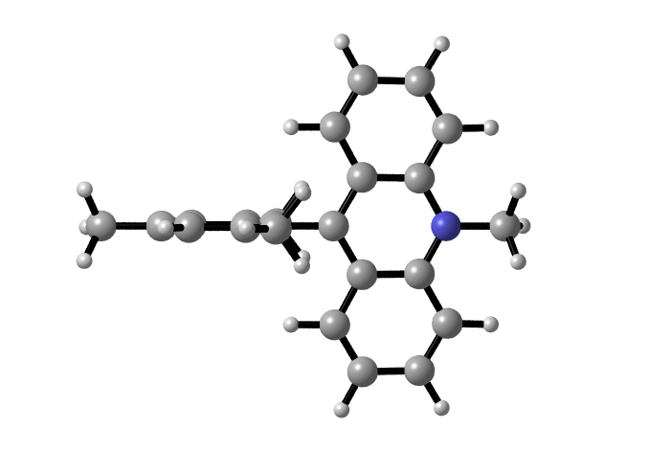
¹NMA*
C 1.28349787 0.85331451 0.00000000
C 1.95381487 2.07975651 0.01854300
C 1.24354087 3.28702451 0.02057700
C -0.18332613 3.26481551 -0.02560900
C -0.82676213 2.01631851 -0.07699400
C -0.10712613 0.81769251 -0.03707700
C -0.91224313 4.50003051 -0.10009900
C -0.17821613 5.72204851 -0.24783200
C 1.25610587 5.69736051 -0.23443900
C 1.96484287 6.90164251 -0.46051000
H 3.04938687 6.90414151 -0.50858100
C 1.28600987 8.11374051 -0.62924900
C -0.10231313 8.15343851 -0.55144500
C -0.81932013 6.96894651 -0.34243000
H 1.86425087 -0.06972449 0.00403400
H 3.04284287 2.07961251 -0.00459800
H -1.91520413 1.98631651 -0.15649900
H -0.64028613 -0.13362249 -0.04838300
H 1.85711587 9.02473951 -0.81148100
H -0.63742313 9.09781651 -0.65792600
H -1.90658013 7.00858251 -0.25036400
C -2.37437813 4.49592451 -0.09075200
C -3.10535213 4.80204451 -1.28513600
C -3.07346313 4.17154751 1.11938800
C -4.49261513 4.79038851 -1.23881300
C -4.45767813 4.19075851 1.11162700
C -5.19070213 4.49516751 -0.05456700
H -5.05797213 4.99565751 -2.15085800
H -5.00008113 3.97858251 2.03659300
C -6.68449213 4.50110351 -0.01514500
H -7.04117113 5.28174351 0.67655500
H -7.11727613 4.68512251 -1.00561800
H -7.06329513 3.54164751 0.37038100
C -2.32359613 3.89353651 2.39148700
H -1.79520913 2.92918251 2.34481000
H -1.56609213 4.66924051 2.57818000
H -3.01337513 3.86200251 3.24334600
C -2.39356813 5.04225151 -2.58618000
H -1.89282313 6.02217451 -2.59975800
H -1.61851513 4.28006751 -2.75547800
H -3.10376613 5.01401351 -3.42123400
N 1.91080387 4.49430451 0.04200800
C 3.34279987 4.48212051 0.32238200
H 3.93081087 4.37277951 -0.60306200
H 3.62492087 5.40804551 0.82677400
H 3.57088087 3.65430051 1.00131900

³NMA*
C 0.63604242 1.04240281 0.00000000
C 1.29857442 2.26832581 0.17094800
C 0.57251342 3.46121981 0.29348400
C -0.85660658 3.44350981 0.21566700
C -1.48749558 2.20808481 0.07483000
C -0.74650158 1.01092681 -0.03358500
C -1.59498158 4.67687881 0.27641700
C -0.85434158 5.91000581 0.25057300
C 0.57429842 5.88724981 0.32887700
C 1.30310442 7.08122481 0.24346100
H 2.39139042 7.07066481 0.26491600
C 0.64297742 8.31299981 0.10872900
C -0.73963258 8.34832481 0.07301800
C -1.48287858 7.15031081 0.14381900
H 1.22045242 0.12735181 -0.09549900
H 2.38679042 2.27625181 0.19126000
H -2.57752058 2.17354781 0.04185500
H -1.27531858 0.06383181 -0.14918200
H 1.22954242 9.22933281 0.04310700
H -1.26647658 9.29950481 -0.01494700
H -2.57279858 7.18738381 0.10951500
C -3.07970758 4.67682681 0.30850300
C -3.81194858 4.68858781 -0.89137900
C -3.73813458 4.66014381 1.55372700
C -5.21035058 4.68277981 -0.82688600
C -5.13462158 4.65568081 1.57484900
C -5.88891658 4.66708481 0.39491000
H -5.78344758 4.68949081 -1.75807500
H -5.65051658 4.64080681 2.53908400
C -7.39357458 4.67581481 0.45343500
H -7.76243458 5.63217581 0.85590500
H -7.83275058 4.53620181 -0.54298900
H -7.76780858 3.87918881 1.11293600
C -2.94421758 4.64399581 2.83408300
H -2.29609958 3.75515681 2.88706200
H -2.28975158 5.52674981 2.90630300
H -3.60783358 4.63675381 3.70799200
C -3.09751058 4.70459581 -2.21712400
H -2.45138658 5.59197881 -2.30705000
H -2.44946558 3.82096281 -2.32809400
H -3.81088658 4.71386581 -3.05067400
N 1.23050842 4.67040981 0.49479800
C 2.64615542 4.66595181 0.85985600
H 3.27509842 4.69528081 -0.04303500
H 2.85734642 5.53362181 1.48889700
H 2.86770142 3.76616881 1.43766200

NMA•
C -1.47821579 0.49792530 0.00000000
C -0.80168879 1.71331730 0.10246700
C -1.50727879 2.92235730 0.21375000
C -2.93674279 2.90726230 0.17259800
C -3.58967479 1.65302230 0.08030900
C -2.87714479 0.46536030 0.00112000
C -3.65670079 4.13712330 0.21426900
C -2.93497379 5.36597630 0.17443600
C -1.50551079 5.34865830 0.21562200
C -0.79811979 6.55683030 0.10632700
H 0.28992421 6.55700430 0.08474100
C -1.47282079 7.77339830 0.00578700
C -2.87169579 7.80805730 0.00683900
C -3.58600879 6.62132930 0.08411200
H -0.90430879 -0.42643370 -0.08484200
H 0.28635021 1.71158430 0.08081500
H -4.68093579 1.63817230 0.06604800
H -3.40728379 -0.48564470 -0.07173200
H -0.89749979 8.69702430 -0.07747000
H -3.40041079 8.75996630 -0.06455400
H -4.67723779 6.63780530 0.06979400
C -5.14695179 4.13764730 0.23339300
C -5.86907479 4.13944130 -0.97685700
C -5.82811979 4.13276530 1.46312200
C -7.26607079 4.13659730 -0.93435100
C -7.22894279 4.13000830 1.46611700
C -7.96548679 4.13240730 0.27869400
H -7.82638879 4.13651030 -1.87415300
H -7.75746679 4.12446030 2.42352500
C -9.47208179 4.14380730 0.29188100
H -9.86010479 5.10147830 -0.08926300
H -9.88004979 3.34909730 -0.35004200
H -9.86325379 4.00147230 1.30790200
C -5.05788379 4.12800230 2.75808600
H -4.40798679 3.24177730 2.82818100
H -4.40442179 5.01117330 2.83282200
H -5.73633079 4.12704730 3.62100100
C -5.13777879 4.14210730 -2.29383300
H -4.48841179 5.02715230 -2.38338800
H -4.48802679 3.25767430 -2.38676400
H -5.84086479 4.14357830 -3.13663100
N -0.84580679 4.13489930 0.38013600
C 0.58002421 4.13364630 0.65848500
H 1.18493621 4.13404730 -0.26334900
H 0.83627421 5.01478830 1.25544900
H 0.83507221 3.25107830 1.25386500

PhSSPh
C -2.01763488 1.95020744 0.00000000
C -2.29756388 1.25155544 -1.17179400
C -3.23923588 0.21642144 -1.15418300
C -3.89794488 -0.11439056 0.03382200
C -3.61745788 0.59376344 1.20358000
C -2.67780288 1.62299944 1.18760300
H -1.28438288 2.75831244 -0.01329200
H -1.78519688 1.49549444 -2.10406900
H -4.61899288 -0.93450756 0.03678200
H -4.13201888 0.33333744 2.12985000
H -2.45591488 2.17432044 2.10288600
S -3.59215788 -0.72411756 -2.62684900
S -1.94464188 -2.03129356 -2.62684900
C -2.29756388 -2.97183256 -1.15418300
C -1.63885488 -2.64102056 0.03382200
C -3.23923588 -4.00696656 -1.17179400
C -1.91934188 -3.34917456 1.20358000
H -0.91780688 -1.82090356 0.03678200
C -3.51916488 -4.70561856 0.00000000
H -3.75160288 -4.25090556 -2.10406900
C -2.85899688 -4.37841056 1.18760300
H -1.40478088 -3.08874856 2.12985000
H -4.25241688 -5.51372356 -0.01329200
H -3.08088488 -4.92973156 2.10288600

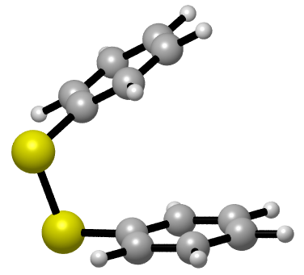

PhS•
C -0.31639005 0.77800829 0.00000000
C -0.31639005 1.98235429 0.70357300
C -0.31639005 1.99044529 2.09696100
C -0.31639005 0.77800829 2.80019400
C -0.31639005 -0.43442871 2.09696100
C -0.31639005 -0.42633771 0.70357300
H -0.31639005 0.77800829 -1.09050800
H -0.31639005 2.93138629 0.16459300
H -0.31639005 2.93779729 2.63979500
H -0.31639005 -1.38178071 2.63979500
H -0.31639005 -1.37536971 0.16459300
S -0.31639005 0.77800829 4.55745600
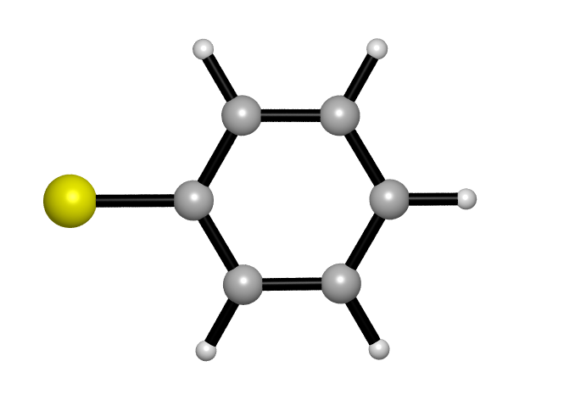

PhS⁻
C -0.00518672 0.59128630 0.00000000
C -0.00518672 1.79563230 0.70357300
C -0.00518672 1.80372330 2.09696100
C -0.00518672 0.59128630 2.80019400
C -0.00518672 -0.62115070 2.09696100
C -0.00518672 -0.61305970 0.70357300
H -0.00518672 0.59128630 -1.09050800
H -0.00518672 2.74466430 0.16459300
H -0.00518672 2.75107530 2.63979500
H -0.00518672 -1.56850270 2.63979500
H -0.00518672 -1.56209170 0.16459300
S -0.00518672 0.59128630 4.55745600

PhSH
C -2.92012452 1.36929459 0.00000000
C -2.92089752 2.06787959 1.20854200
C -2.91978152 3.46365259 1.21155900
C -2.91053852 4.16227459 0.00000000
C -2.91978152 3.46365259 -1.21155900
C -2.92089752 2.06787959 -1.20854200
H -2.92224052 0.27754459 0.00000000
H -2.92482152 1.52501959 2.15579200
H -2.92463252 4.01352759 2.15476600
H -2.92463252 4.01352759 -2.15476600
H -2.92482152 1.52501959 -2.15579200
S -2.94737152 5.95816659 0.00000000
H -1.61028852 6.14957359 0.00000000
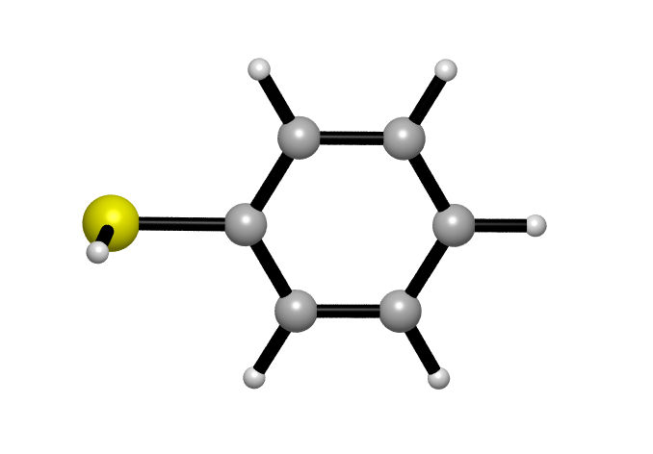
P1
C 1.09249328 -0.37533512 0.00000000
O 1.54741428 -0.39541812 -1.37497100
C 3.40013928 -0.86503812 -0.04126100
C 2.37210228 -0.11249812 0.82635800
H 0.73456728 -1.39309012 0.23007400
H 3.27787028 -1.94163512 0.16911200
H 2.26830928 -0.59701612 1.80533700
C 2.85837228 -0.65723912 -1.44706400
O 3.45277228 -0.69801912 -2.48870800
C 4.85450528 -0.47982312 0.14493900
H 5.08851528 -0.36304812 1.20953200
H 5.11753528 0.44064288 -0.38788500
Cl 5.96301828 -1.76141212 -0.47679300
C -0.04298872 0.61175088 0.14654300
H -0.27187172 0.69098888 1.22313400
H 0.29905328 1.60623588 -0.18133100
C -1.29541672 0.20538988 -0.62426700
H -1.04730472 0.10133988 -1.69370300
H -1.62933672 -0.78959412 -0.28127800
C -2.43696872 1.20546888 -0.46524200
H -2.67492072 1.31444288 0.60646700
H -2.09580172 2.19680788 -0.80750800
C -3.69074672 0.80133388 -1.23169200
H -4.06755672 -0.17434512 -0.88712500
H -4.49839272 1.53674288 -1.10253300
H -3.48366972 0.71660988 -2.30977100
C 2.68399228 1.35365088 1.05001100
C 2.60601128 1.88257688 2.34050300
C 3.02685628 2.20783788 -0.01110600
C 2.86185528 3.23816088 2.56955600
H 2.34135928 1.22888288 3.17503400
C 3.28550828 3.56027988 0.20857200
H 3.09800528 1.83811288 -1.03585700
C 3.20016228 4.07366988 1.51018900
H 2.79825928 3.63954388 3.58269700
H 3.40323528 5.13292088 1.68812800
O 3.65567228 4.48282288 -0.92528600
C 3.71131328 3.76621340 -2.16152017
H 4.45130483 2.99626756 -2.09446857
H 2.75659274 3.32680946 -2.36235061
H 3.96767574 4.43935913 -2.95275535
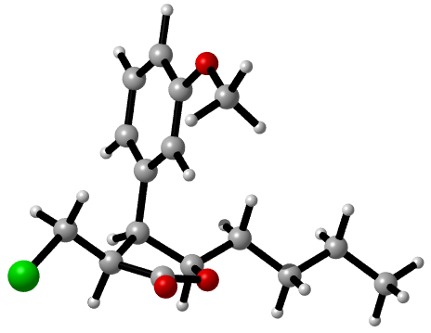

IM1
C 1.01141080 -0.48755186 0.00000000
C -0.35214920 -0.61582786 0.22132000
C -1.12298420 0.53850314 0.57476700
C -0.51576220 1.79110114 0.69906800
C 0.84064080 1.92017014 0.47924900
C 1.63568880 0.77039114 0.12154700
H 1.56445280 -1.38724086 -0.26608100
H -2.19462820 0.44498014 0.74998700
H -1.11890120 2.65777214 0.96950300
H 1.32880180 2.89129214 0.57328300
C 3.02818080 0.99402014 -0.09114400
H 3.38840880 2.01901414 0.03852000
C 3.95094880 0.03400814 -0.45229800
H 3.62046980 -1.00208086 -0.58417000
C 5.38866780 0.29672914 -0.64445100
H 5.66458380 -0.02240686 -1.66632900
H 5.60781580 1.37022214 -0.55404800
C 6.24859980 -0.51929186 0.34891000
H 5.96153480 -0.25473986 1.37956600
H 6.03287880 -1.59316986 0.22312800
C 7.74067280 -0.26542986 0.14687200
H 8.01237280 -0.52049986 -0.89045200
H 7.94377480 0.81115414 0.26566200
C 8.59811980 -1.06468686 1.12116100
H 9.66597580 -0.86724486 0.95842500
H 8.36483480 -0.80326686 2.16376800
H 8.43515380 -2.14547586 0.99908000
O -0.87925320 -1.82215686 0.09085600
C -2.26950020 -2.04399986 0.29057600
H -2.42962920 -3.11145286 0.11667100
H -2.55883820 -1.79467286 1.32195000
H -2.86414520 -1.46296386 -0.42935700
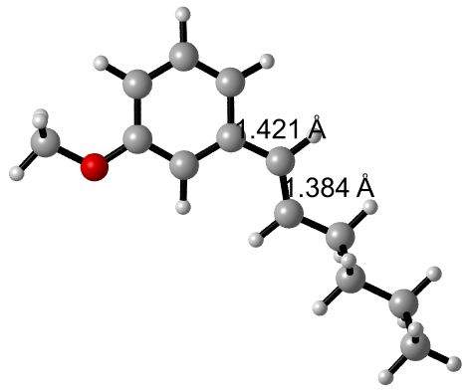
TS1
C -1.28185908 -1.41679158 0.00000000
C 0.06915792 -1.56187758 0.31460100
C 0.46840292 -2.57142758 1.20993500
C -0.49048308 -3.41474858 1.78414900
C -1.83490708 -3.26962058 1.48868500
C -2.25344008 -2.26383358 0.57755400
H -1.54820608 -0.63237058 -0.70941200
H 1.51911492 -2.70741158 1.46212500
H -0.16553308 -4.19438458 2.47389600
H -2.57745008 -3.92819958 1.94114100
C -3.64557908 -2.10692558 0.31106900
H -4.34929108 -2.70908758 0.88915800
C -4.17609008 -1.15807458 -0.62138300
C -5.64504808 -1.07243658 -0.88530500
H -5.82929708 -0.25305858 -1.59504200
H -5.88951608 -2.00487758 -1.42961300
C -6.54812308 -0.93053958 0.33705100
H -6.34033008 -1.72851158 1.06914300
H -6.31872008 0.02125642 0.84336600
C -8.02950208 -0.96339958 -0.03298200
H -8.23466408 -0.17220558 -0.77244600
H -8.25567708 -1.91871558 -0.53403000
C -8.93819608 -0.78718858 1.17767300
H -9.99701508 -0.81825558 0.88902800
H -8.77086308 -1.58314958 1.91840400
H -8.75592408 0.17804942 1.67304900
O 0.91156792 -0.69928158 -0.27376700
C 2.30121892 -0.82126158 -0.03986300
H 2.78233792 -0.03839858 -0.63340100
H 2.53745492 -0.66900958 1.02460200
H 2.67056992 -1.80508358 -0.36725000
O -3.76656408 0.51704342 0.00257000
H -3.54557408 -0.96143658 -1.49338500
C -3.48083608 0.76922842 1.18066400
O -3.98817508 0.01550942 2.12741000
C -2.59978308 1.87637142 1.54443900
C -1.97196708 2.55959342 0.57381900
H -2.45929908 2.12503442 2.59809900
H -2.11160008 2.31910742 -0.48324100
Cl -0.91167408 3.84492742 0.88736300
H -3.67905208 0.25594442 3.01336800
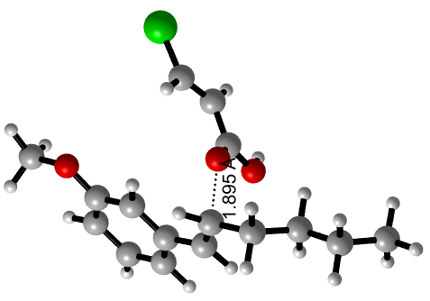
IM2
C -1.53801170 -0.55555555 0.00000000
C -0.19885770 -0.74992355 0.34583100
C 0.15446130 -1.81010255 1.19526500
C -0.84423470 -2.66176055 1.68473700
C -2.17559870 -2.47264555 1.35623200
C -2.55069470 -1.40483455 0.49892100
H -1.75362570 0.25217845 -0.70085400
H 1.19288830 -1.98578655 1.47137400
H -0.56013370 -3.48968455 2.33561400
H -2.94230570 -3.14346655 1.74629200
C -3.92852870 -1.19074255 0.20512400
H -4.67111170 -1.86227655 0.63850800
C -4.41277470 -0.05689855 -0.60804100
C -5.90911770 0.05656445 -0.80929300
H -6.10696870 0.86201145 -1.53243700
H -6.20894570 -0.88269255 -1.30442300
C -6.74038270 0.27205945 0.45223500
H -6.49648470 -0.49111855 1.21040500
H -6.48478670 1.24774345 0.90063900
C -8.24075470 0.23964945 0.16734400
H -8.47823670 0.99139445 -0.60315100
H -8.50240870 -0.73873755 -0.26745300
C -9.07989570 0.49289645 1.41354200
H -10.15327070 0.46080045 1.18464200
H -8.88161370 -0.26453855 2.18647700
H -8.86206370 1.48119645 1.84559900
O 0.67680730 0.12623245 -0.17833600
C 2.05520730 -0.03869555 0.08828000
H 2.57145030 0.76388445 -0.44718700
H 2.26229130 0.04970845 1.16619500
H 2.41486630 -1.01174855 -0.28019200
O -3.89963570 1.29615545 -0.05142200
H -3.89116770 -0.01356355 -1.57522000
C -3.60872070 1.54209145 1.15114400
O -4.12385570 0.80280545 2.08253000
C -2.73402770 2.64928445 1.47537500
C -2.10098870 3.31361245 0.48958700
H -2.59518070 2.91748445 2.52414200
H -2.22984270 3.04991545 -0.56371400
Cl -1.05478970 4.60631045 0.78357900
H -3.79173570 1.00902745 2.97055300
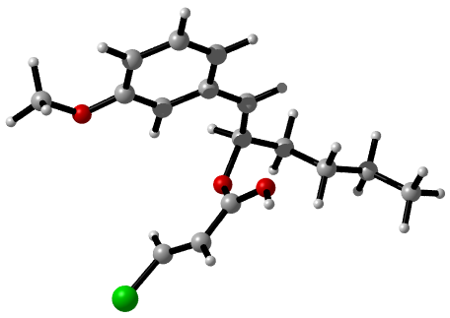
IM3c1-1
C 0.90973199 1.64315935 0.00000000
C -0.00827501 0.68909835 0.45232100
C -0.29455401 0.59023335 1.81923300
C 0.34886199 1.44853835 2.71167000
C 1.26517899 2.39342935 2.26348900
C 1.54971599 2.49396535 0.89702300
H 1.08030299 1.71685335 -1.07578100
H -1.00980001 -0.14013565 2.19391800
H 0.12330799 1.37439135 3.77658900
H 1.75541299 3.06581235 2.96954000
C 2.49239399 3.56369835 0.40416900
H 2.92368399 4.08279135 1.27273100
C 3.64844499 3.00819935 -0.42806800
C 4.59739099 4.06013035 -0.99681300
H 5.40043399 3.52415435 -1.52907200
H 4.06061599 4.64198935 -1.76306600
C 5.19895999 4.99049535 0.05061400
H 4.40457499 5.63320335 0.46841700
H 5.59966899 4.38778135 0.88384300
C 6.31004599 5.87124335 -0.51211800
H 7.10012899 5.22552535 -0.93060900
H 5.91405499 6.45921335 -1.35697800
C 6.90836499 6.80369135 0.53410500
H 7.70909299 7.42693235 0.11248700
H 6.14075199 7.47557935 0.94671600
H 7.33295799 6.22966635 1.37132400
O -0.57879201 -0.08505765 -0.49923500
C -1.50359801 -1.05950065 -0.09898500
H -1.83514501 -1.57225265 -1.00862500
H -1.04670301 -1.79549265 0.58340100
H -2.37830601 -0.60823365 0.39885900
O 4.34697199 2.15134735 0.48810100
H 3.24835799 2.39353335 -1.24909300
C 5.38154299 1.44765135 0.02778300
O 5.20147599 0.95389035 -1.21398900
C 6.50149599 1.24462135 0.80674100
C 6.65484099 1.79129735 2.07725500
H 7.29576099 0.60725735 0.41116000
H 5.89161799 2.39498535 2.56375100
Cl 8.08304399 1.50296735 2.99836100
C -1.73364801 5.67422135 2.40301100
C -0.50119701 6.31529235 2.53008800
C 0.50863099 6.07652135 1.59938900
C 0.28858899 5.18731835 0.54352700
C -0.94964001 4.55274235 0.41106600
C -1.95780101 4.79737835 1.34194100
H -2.52291701 5.86082435 3.13284500
H -0.32547101 7.00667135 3.35565800
H 1.47628799 6.57479335 1.68574600
H -1.10617601 3.85571635 -0.41348100
H -2.92072301 4.29461235 1.24054400
S 1.60131899 4.82901235 -0.60851300
H 5.98869899 0.46976835 -1.48753700
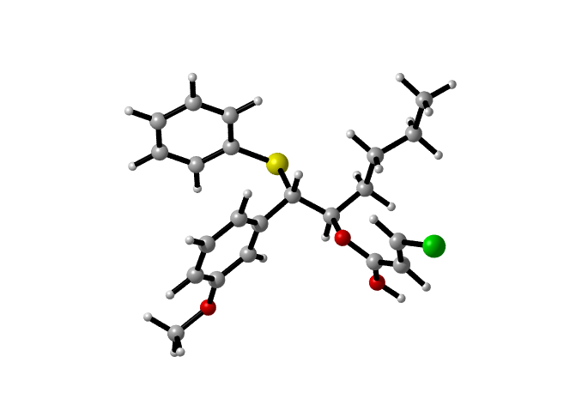

IM3c1-2
C 0.85120642 0.69699120 0.00912411
C -0.24033358 -0.17431980 -0.02178589
C -0.89447358 -0.53665780 1.16383611
C -0.43223858 -0.00834580 2.37961411
C 0.64589942 0.85579020 2.42677611
C 1.32324942 1.23180120 1.23121311
H 1.32032342 0.94904920 -0.94300289
H -1.74745558 -1.21327880 1.15647111
H -0.94139158 -0.28946880 3.30385611
H 0.99298042 1.25751120 3.38082111
C 2.42833142 2.12300320 1.30479411
H 2.70507642 2.51636620 2.28381311
C 3.17053642 2.63343520 0.11518311
C 2.55379542 3.91095020 -0.46736389
H 3.15799042 4.20480220 -1.34251689
H 1.54941242 3.65349020 -0.84097489
C 2.45231442 5.06674020 0.52129211
H 1.78090342 4.78123620 1.34935211
H 3.43992842 5.25564320 0.96793311
C 1.93462342 6.35090820 -0.12004989
H 2.60990042 6.64144520 -0.94285689
H 0.95294542 6.15417920 -0.58312689
C 1.80970742 7.49908420 0.87522911
H 1.44105042 8.41580620 0.39194111
H 1.11008442 7.24354120 1.68622711
H 2.78157842 7.73113220 1.33636311
O -0.60608758 -0.62211280 -1.24596089
C -1.71755258 -1.48403780 -1.34762689
H -1.84161558 -1.70630980 -2.41351989
H -1.54683758 -2.42461380 -0.79961989
H -2.63371258 -1.00229980 -0.96968889
O 4.54381142 2.95079120 0.41489611
H 3.16610342 1.87577220 -0.68655289
C 5.41852142 1.96036620 0.84173911
O 5.26885842 1.52032620 2.13392911
C 6.77325442 2.54208620 0.58330311
C 6.91478242 3.72231520 -0.03011489
H 7.62966042 1.96618520 0.94298411
H 6.08278042 4.32133520 -0.40102489
Cl 8.47332542 4.43729820 -0.31163789
C 4.22161242 7.94576220 2.95107911
C 4.81285642 7.74342620 1.70357111
C 5.14739442 6.45391820 1.28858411
C 4.89400242 5.36554420 2.12940511
C 4.31515242 5.56594520 3.38652611
C 3.97264742 6.85746420 3.78933711
H 3.95745642 8.95475420 3.27339911
H 5.01164842 8.59117720 1.04531911
H 5.60057842 6.28901220 0.30893011
H 4.13240642 4.71174020 4.04065911
H 3.51787542 7.01409420 4.76930211
S 5.36716542 3.71576820 1.62502411
H 6.13368848 1.38598742 2.52841875
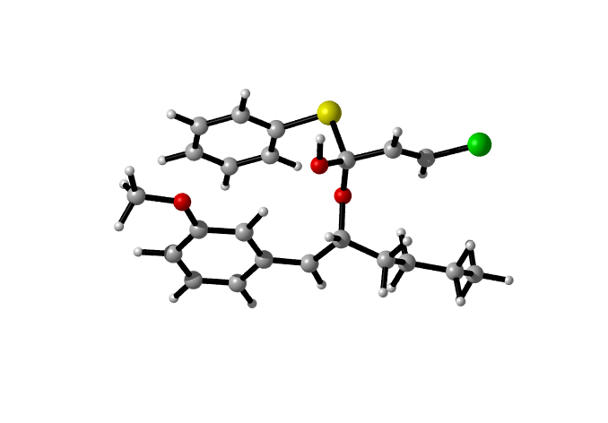

IM3c1-3
C -1.80369130 1.05704696 0.00000000
C -0.61585830 0.37534096 0.30005500
C -0.06778730 0.46214796 1.58479400
C -0.72344530 1.22489396 2.55668100
C -1.90249330 1.90199196 2.26261600
C -2.43776930 1.82866196 0.96957600
H -2.19723930 0.97756296 -1.01580900
H 0.85773470 -0.05422704 1.83669700
H -0.29751030 1.28543596 3.56012400
H -2.40871230 2.49743696 3.02501900
C -3.68799230 2.61185596 0.62287300
H -3.96361630 3.24464496 1.47484100
C -3.56522930 3.43599296 -0.66945100
C -4.77706730 4.30791396 -0.97308700
H -4.60287030 4.76634496 -1.96011800
H -5.63690230 3.62930296 -1.09525900
C -5.11980630 5.39681496 0.03801500
H -5.27494030 4.95652596 1.03785100
H -4.27217730 6.09321496 0.13561800
C -6.37329330 6.17221596 -0.36060900
H -6.22327330 6.61110396 -1.36154800
H -7.21821930 5.46923996 -0.45528000
C -6.72899030 7.27102696 0.63350700
H -7.63357730 7.81762396 0.32848700
H -6.91225730 6.85185296 1.63528500
H -5.91027630 8.00192596 0.72385600
O -0.06478830 -0.32913404 -0.71216100
C 1.13999570 -1.02719304 -0.47335200
H 1.40508170 -1.51984404 -1.41551800
H 1.94855270 -0.33756104 -0.18394000
H 1.00973670 -1.79024904 0.31048600
O -2.34545930 4.20094896 -0.73872500
H -3.46695930 2.71134696 -1.49192700
C -1.61369230 4.52143696 0.32986400
O -2.30496930 5.09472396 1.33149500
C -0.24350530 4.32325996 0.33639400
C 0.42021270 3.64136396 -0.67032700
H 0.31769770 4.70071396 1.19510600
H -0.05396230 3.22455396 -1.55736300
Cl 2.13279670 3.36145096 -0.56424900
H -1.74169630 5.20195096 2.11411700
C -6.76370430 -0.01576304 -0.30289300
H -6.21173630 0.41482796 -1.14013600
C -6.52353230 0.27033396 0.97605400
H -7.09196830 -0.17790104 1.79249300
Cl -7.99850730 -1.12928104 -0.77975000
C -5.45557530 1.21646596 1.38108400
O -5.22608330 1.49843996 2.53121600
O -4.77989930 1.72050496 0.34400500
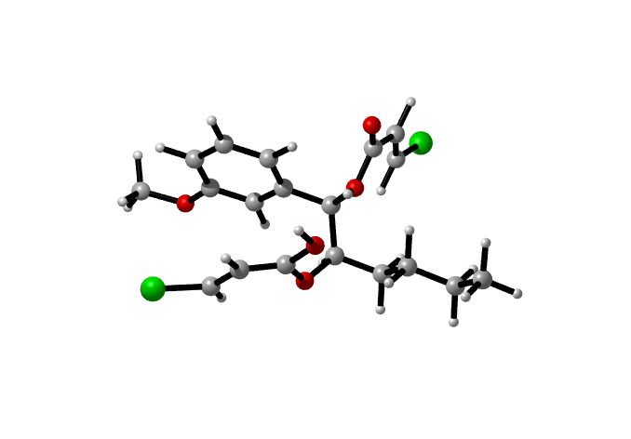

IM3c1-4
C -0.44483988 1.38790034 0.00000000
C -1.67459788 1.58784234 0.63202800
C -1.71112288 1.93615834 1.98825100
C -0.50278588 2.09781234 2.68335500
C 0.72058012 1.92340934 2.06128700
C 0.77153312 1.55397634 0.69114600
H -0.45104888 1.11858134 -1.05758400
H -2.65595888 2.09222534 2.50570300
H -0.53572988 2.38108034 3.73692200
H 1.64642312 2.10338634 2.60845500
C 2.00255012 1.39698834 -0.01369800
H 1.95596112 1.13353834 -1.07225700
C 3.36231612 1.60909234 0.57611500
C 4.45740412 0.97815934 -0.27860500
H 4.25568412 -0.10579966 -0.31808500
H 4.37005112 1.36307434 -1.30587000
C 5.86379312 1.22758634 0.25082000
H 6.05902112 2.31221234 0.24943500
H 5.92638812 0.90456534 1.30559100
C 6.93984312 0.51620534 -0.56332700
H 6.74123612 -0.56874666 -0.56095400
H 6.86354212 0.83695234 -1.61562900
C 8.34713912 0.78409434 -0.04369300
H 9.10809612 0.26818334 -0.64553800
H 8.57418612 1.86056234 -0.06374000
H 8.45363412 0.44278034 0.99713900
O -2.77243088 1.43032934 -0.13972700
C -4.03250888 1.59070934 0.45585600
H -4.77617288 1.42486534 -0.33137800
H -4.19196388 0.85730134 1.26398000
H -4.15755288 2.60838434 0.86055200
O 3.69105112 2.99302334 0.87376900
H 3.39536112 1.15358034 1.57924200
C 3.27502912 3.98372334 0.04570800
O 3.33803912 3.58638134 -1.26685300
C 4.05389512 5.25102134 0.30285900
C 5.02459812 5.31361434 1.20569300
H 3.77284412 6.11250934 -0.30856800
H 5.30472912 4.45899534 1.82211300
Cl 5.94126612 6.74862634 1.49453200
H 2.89852512 4.26913634 -1.80474500
C -1.35856388 5.14985434 -0.65307800
H -1.20484888 5.55340534 -1.65616200
C -0.34547688 4.76243834 0.11975300
H -0.48845888 4.33376434 1.11348200
Cl -2.99923988 5.03948534 -0.15404900
C 1.03499412 4.83277834 -0.41412300
O 1.88541112 4.25272534 0.42228500
O 1.35035112 5.32471334 -1.47736200

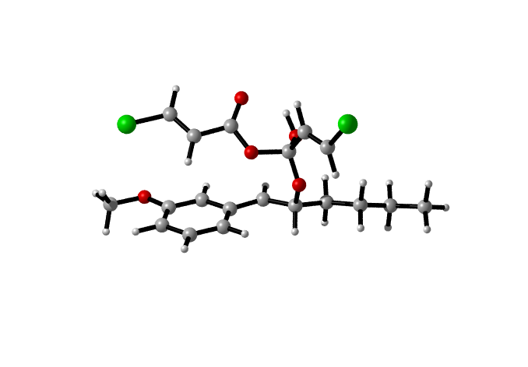

TS2c1-1
C 0.03184713 0.38216560 0.00000000
C -1.22838387 0.95367760 0.19314100
C -1.89903087 0.79553860 1.41253000
C -1.28405387 0.05848360 2.43170700
C -0.03575487 -0.51243440 2.25006200
C 0.64791513 -0.36244840 1.02021400
H 0.49141413 0.50416160 -0.98153400
H -2.88369887 1.22896360 1.57754400
H -1.80542787 -0.07512640 3.38097500
H 0.42158913 -1.10020740 3.04774500
C 1.91401013 -1.03369240 0.83825000
H 2.29365813 -1.53038340 1.73547500
C 2.92959313 -0.47733040 -0.08856400
C 3.60067013 0.80373460 0.41090800
H 4.36932613 1.09238560 -0.32547000
H 2.83342013 1.59515960 0.39561100
C 4.20881513 0.69567860 1.80612100
H 3.40100513 0.63711860 2.55406500
H 4.78283513 -0.24379340 1.90086600
C 5.12975313 1.86627760 2.13907700
H 5.94686513 1.90391360 1.39832000
H 4.57012113 2.80951460 2.02552200
C 5.71565413 1.77537960 3.54326400
H 6.37621913 2.62580260 3.76184200
H 4.91929213 1.76401860 4.30229200
H 6.30431613 0.85324060 3.66373600
O -1.73450587 1.63959260 -0.86089700
C -3.01344087 2.20594160 -0.74137400
H -3.23043487 2.69323660 -1.69791500
H -3.77645087 1.43445660 -0.54614500
H -3.04662687 2.95834060 0.06376100
O 4.03602313 -1.40737440 -0.40288300
H 2.48548913 -0.29513540 -1.07573200
C 4.47699213 -2.39002940 0.33506000
O 3.71116313 -3.25925040 0.86339800
C 5.90839313 -2.52071340 0.48898100
C 6.74687613 -1.55289640 0.07162000
H 6.26728513 -3.42693540 0.97694700
H 6.39996513 -0.64187640 -0.41782200
Cl 8.44836813 -1.65692940 0.27297300
C -2.20895587 -3.67353140 2.37859500
C -0.92553187 -4.10638840 2.71587300
C 0.13279413 -3.93750940 1.82425800
C -0.07986587 -3.32548840 0.57950700
C -1.37449087 -2.90054740 0.24254200
C -2.42846587 -3.07607740 1.13572300
H -3.03467187 -3.80509940 3.07958300
H -0.74471087 -4.58096540 3.68228700
H 1.13482213 -4.27894240 2.09331000
H -1.53905687 -2.41384940 -0.72061000
H -3.42764087 -2.73179240 0.86241200
S 1.24245713 -2.99613940 -0.53243500
H 2.71557013 -3.29130640 0.38246100
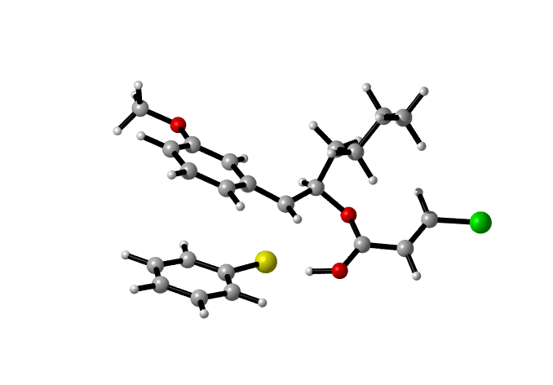

TS2c1-2
C 0.35232384 -0.42713993 -0.01118505
C -1.03711116 -0.54739693 0.07090795
C -1.67316016 -0.56775493 1.32065995
C -0.89262016 -0.46859593 2.48255895
C 0.48468984 -0.35109693 2.41703995
C 1.14241584 -0.33456093 1.15630395
H 0.80017784 -0.43201793 -1.00646205
H -2.75477416 -0.66255993 1.40247195
H -1.38890116 -0.48688593 3.45479895
H 1.08059184 -0.28349793 3.32916595
C 2.56319884 -0.26561593 1.11388095
H 3.11895284 -0.18479393 2.04961495
C 3.33631684 -0.24060193 -0.15839905
C 3.36979684 1.11685007 -0.86813705
H 3.93754784 1.01133307 -1.80695005
H 2.33196184 1.34862507 -1.15476605
C 3.94335084 2.24981407 -0.02284605
H 3.34838584 2.35967507 0.89981495
H 4.97075084 1.99795207 0.29244895
C 3.96253384 3.57935907 -0.77193305
H 4.54969884 3.46380807 -1.69838905
H 2.93546684 3.82989207 -1.08543205
C 4.53814284 4.71712907 0.06254195
H 4.53925884 5.66516007 -0.49484105
H 3.95116384 4.86882707 0.98154795
H 5.57610684 4.50229607 0.36074895
O -1.69518616 -0.64254893 -1.10693705
C -3.10021916 -0.78463893 -1.08821005
H -3.41925116 -0.85167493 -2.13421605
H -3.40096916 -1.70230393 -0.55821605
H -3.58354616 0.08602607 -0.61728405
O 4.71684884 -0.58340693 0.21800495
H 2.98260584 -1.02285293 -0.84719705
C 5.54054784 -1.08480293 -0.61540605
O 5.11316384 -1.33051693 -1.81186105
C 6.94671984 -1.13759793 -0.24741905
C 7.35176084 -0.59649193 0.90913295
H 7.63533284 -1.57877893 -0.96782305
H 6.67825784 -0.15402693 1.64500495
Cl 9.00762584 -0.57988493 1.36624195
C 1.34759984 -3.72361593 0.64602295
C 2.34364984 -3.78377893 1.62391195
C 3.68922484 -3.85383393 1.26272995
C 4.08499384 -3.87872793 -0.09188905
C 3.06608884 -3.80557393 -1.06460205
C 1.72058584 -3.72868493 -0.70015305
H 0.29473884 -3.66004693 0.92955495
H 2.07118084 -3.77061193 2.68223895
H 4.45840584 -3.90506993 2.03695495
H 3.34135884 -3.82350293 -2.12185205
H 0.95508084 -3.67490593 -1.47860305
S 5.78783684 -3.99279193 -0.53502905
H 5.65361984 -2.04451393 -2.21824705
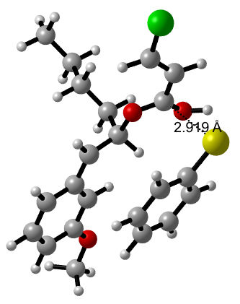

TS2c1-3
H -0.18421053 0.57894736 0.00000000
C 1.68434047 1.17580236 3.06494600
H 2.25907147 0.64749436 2.30353400
C 0.33273347 1.29950536 3.02839300
H -0.18654053 1.83153536 3.82646300
Cl 2.60921247 1.73526336 4.40519600
C -0.42593153 0.81296136 1.91842800
O -1.70223053 1.20093936 1.75289500
O -0.01141053 -0.02494064 1.06300600
C -4.47152253 1.75116036 1.59987000
C -5.83997353 1.75087336 1.90616200
C -6.31827953 2.54748236 2.95510900
C -5.41890753 3.32347936 3.68867900
C -4.05868653 3.32032236 3.39362900
C -3.58609853 2.53300836 2.33670800
H -4.12124353 1.11703536 0.78342200
H -7.37748453 2.56502036 3.20935400
H -5.79343853 3.93534336 4.51132500
H -3.36338853 3.92124836 3.98257100
C -2.12537753 2.55694136 1.96216400
H -1.54298653 3.02052836 2.77187600
C -1.87196953 3.32255836 0.65035500
C -2.47461653 4.71699336 0.59485000
H -2.27808453 5.11501836 -0.41335800
H -3.56775853 4.62236536 0.68750300
C -1.93566153 5.69379336 1.63685900
H -2.09588153 5.29688436 2.65365300
H -0.84551753 5.79553536 1.50886200
C -2.59189553 7.06756636 1.53877400
H -2.45175353 7.46342436 0.51886700
H -3.68047853 6.95488136 1.67804000
C -2.04135153 8.05808336 2.55690700
H -2.52815453 9.04033936 2.47036700
H -2.19706253 7.69502536 3.58478400
H -0.95929153 8.20597336 2.41726400
O -6.61837253 0.95851136 1.14390800
C -7.99767653 0.89391236 1.42942300
H -8.43185753 0.18650036 0.71376200
H -8.17839953 0.52852636 2.45325800
H -8.48180253 1.87585736 1.30394400
O -0.45309453 3.47481636 0.47875800
H -2.26413953 2.70537036 -0.17115500
C 0.28024047 2.48300536 -0.04176200
O -0.26517753 1.53508836 -0.70553300
C 1.68867047 2.54345936 0.16919000
C 2.25617647 3.28396936 1.15678700
H 2.28960047 1.85056536 -0.42282500
H 1.69410247 3.96310036 1.79939600
Cl 3.96030647 3.30180736 1.41618600

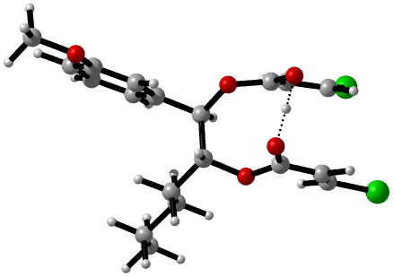

TS2c1-4-1
C 0.48797738 -0.26166902 0.00000000
H 1.06172538 -0.50444202 -0.89650500
C 1.02027738 0.30967798 1.07996200
H 0.44028438 0.54772498 1.97325000
Cl -1.18300862 -0.69554002 -0.08780100
C 2.46038738 0.66528398 1.09268100
O 3.15955538 0.39794398 0.07007100
O 2.93143738 1.22447098 2.11979100
C 1.71498538 2.35215298 -1.95145300
C 0.39207138 2.05814098 -2.28941600
C -0.66512262 2.56206398 -1.51638600
C -0.37306662 3.34237098 -0.38936500
C 0.93482638 3.63219998 -0.03590500
C 2.01360338 3.14993898 -0.82611200
H 2.51003438 1.92274698 -2.56341600
H -1.70153662 2.34152498 -1.76741900
H -1.19647662 3.72274298 0.21842800
H 1.15087038 4.23813598 0.84639300
C 3.35368638 3.46160798 -0.44910700
H 3.50777938 4.05368398 0.45534500
C 4.56325038 3.08286998 -1.24154700
C 5.77583638 3.94815098 -0.91797100
H 5.47946938 4.97331898 -1.18941200
H 5.95114038 3.94550898 0.16915200
C 7.05107538 3.54437198 -1.66864700
H 6.77895538 3.05994398 -2.62309700
H 7.61717338 4.45000798 -1.93867800
C 7.97611838 2.62174398 -0.87510100
H 8.32814438 3.15917898 0.02137200
H 7.41425438 1.75091598 -0.50448100
C 9.16912638 2.14045398 -1.69152700
H 9.83924538 1.50649498 -1.09214100
H 8.83944638 1.55017798 -2.56122700
H 9.75963538 2.98939198 -2.07039800
O 0.21469038 1.26699998 -3.37324400
C -1.10340562 0.97576998 -3.78952200
H -1.01520962 0.34373298 -4.68015300
H -1.65752262 0.42796398 -3.01116300
H -1.65071862 1.89560298 -4.05028000
O 4.89443338 1.65554698 -1.16132600
H 4.34478638 3.18087498 -2.31497100
C 4.90172738 1.02239398 -0.01165300
O 5.02334538 1.70846198 1.08490700
C 5.53361138 -0.32683402 -0.07251200
C 6.10283538 -0.77493002 -1.18663500
H 5.52096538 -0.89722202 0.85808800
H 6.13301638 -0.21611302 -2.12313800
Cl 6.88214738 -2.32126502 -1.26776600
H 4.14149538 1.53066598 1.73520200

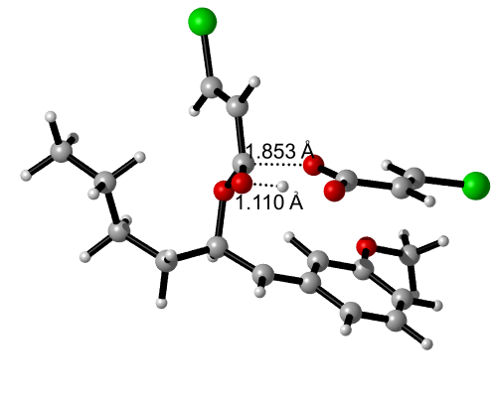
TS2c1-4-2
C -2.58344468 -0.20694259 0.00000000
H -1.66651468 -0.39858359 -0.56093700
C -3.78103468 -0.23070259 -0.58629600
H -3.78159368 -0.45153359 -1.65697300
Cl -2.26454968 0.10816041 1.67390100
C -5.14697868 -0.00473759 0.03008000
O -6.10859468 -0.19151959 -0.78010100
O -5.25093868 0.30191141 1.21946000
C -11.89667568 -0.87307659 0.97482100
C -13.17928868 -0.37474359 1.21910700
C -14.16687368 -0.46076859 0.22627100
C -13.84940868 -1.04959659 -1.00569400
C -12.58360868 -1.54680959 -1.26023400
C -11.57436968 -1.46944959 -0.26330900
H -11.15719568 -0.77857159 1.77167700
H -15.17138068 -0.07658759 0.39785300
H -14.62179768 -1.11360759 -1.77432100
H -12.34729968 -2.00352459 -2.22277100
C -10.27449668 -1.98692659 -0.53732100
H -10.07223468 -2.40725759 -1.52387400
C -9.16042068 -1.96291859 0.44559900
C -7.91452368 -2.71880659 0.02095700
H -8.23895868 -3.75073159 -0.19070400
H -7.54134068 -2.29220659 -0.92233800
C -6.80766168 -2.69966559 1.06920000
H -6.62890768 -1.66199059 1.39165600
H -7.13089768 -3.26398859 1.96134500
C -5.49169668 -3.26489159 0.54360900
H -5.62283568 -4.32430559 0.26358300
H -5.23388268 -2.72443759 -0.38281600
C -4.35708268 -3.11581859 1.55027900
H -3.40489368 -3.49628859 1.15047700
H -4.21782568 -2.05483459 1.81083500
H -4.57526968 -3.66725859 2.47874600
O -13.38113768 0.17310741 2.43475200
C -14.65822668 0.68761841 2.73728000
H -14.60501768 1.07340241 3.76161600
H -14.93305068 1.50961041 2.05684400
H -15.43045468 -0.09684159 2.68766800
O -8.77342868 -0.55265259 0.79743800
H -9.50146768 -2.30660359 1.43234300
C -8.34953468 0.27739841 -0.06171800
O -8.50115668 0.03519441 -1.32822000
C -7.89921368 1.56660341 0.44702800
C -8.00328368 2.63942041 -0.34317200
H -7.51636768 1.59270641 1.46649000
H -8.39553068 2.60036041 -1.36222000
Cl -7.54325168 4.20613241 0.17181300
H -7.61597168 0.23413641 -1.72729400
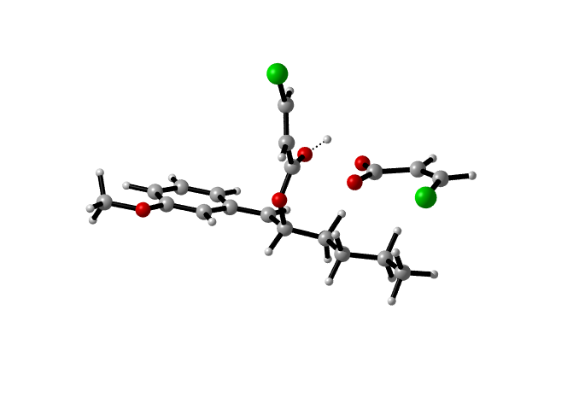

IM4c1-3
H -1.31308900 -2.59259300 1.53584400
C -3.13403200 -1.34011500 -1.41053900
H -3.70354200 -1.87249500 -0.61960800
C -1.75865100 -1.27985300 -1.35797600
H -1.12395500 -0.82216800 -2.15786700
Cl -3.97640700 -0.67649100 -2.77905400
C -1.08324700 -1.83683800 -0.29501700
O 0.22225800 -1.62926800 -0.03679100
O -1.67905300 -2.63171700 0.57381400
C 3.05263000 -0.91285500 0.25893200
C 4.40761200 -0.88062700 -0.06440600
C 4.84271400 -0.19776700 -1.19621500
C 3.90840700 0.44135000 -1.99925500
C 2.56271200 0.40846900 -1.68150300
C 2.12976500 -0.25578600 -0.53810900
H 2.77212700 -1.48656600 1.18187000
H 5.93878100 -0.20245500 -1.40727500
H 4.23201700 0.98128100 -2.92039300
H 1.79307800 0.88073300 -2.33785300
C 0.69372700 -0.28117800 -0.14406500
H 0.07790400 0.27566900 -0.91004700
C 0.47762100 0.43159200 1.16266000
C 1.11416800 1.76029200 1.27033600
H 0.83353900 2.22094200 2.25305400
H 2.22870200 1.64871600 1.21145000
C 0.68732000 2.71254800 0.21999400
H 1.07550200 2.34602200 -0.76008000
H -0.42582100 2.76959800 0.26277100
C 1.23675200 4.07378200 0.42417300
H 0.85441000 4.47878100 1.38710600
H 2.34752900 4.00610600 0.37959600
C 0.79444300 4.97155400 -0.66852900
H 1.20016200 5.99223500 -0.59240800
H 1.09242200 4.55583300 -1.64676600
H -0.30689400 5.04454900 -0.68935100
O 5.25145900 -1.52749600 0.75115900
C 6.61259900 -1.50498700 0.37705200
H 7.14291600 -2.09705100 1.14726800
H 6.74690800 -2.02892500 -0.58765500
H 6.99779500 -0.47120700 0.44708100
O -0.95747300 0.61507000 1.28194800
H 0.75402400 -0.27739500 2.00007500
C -1.65053200 -0.24580400 1.99264800
O -1.13083700 -1.08626100 2.72334400
C -3.09622300 -0.15025900 1.82498800
C -3.60106900 0.47162700 0.76593900
H -3.67291300 -0.69300900 2.62444700
H -2.95851600 0.94211600 -0.02004800
Cl -5.31753500 0.57924000 0.55389400

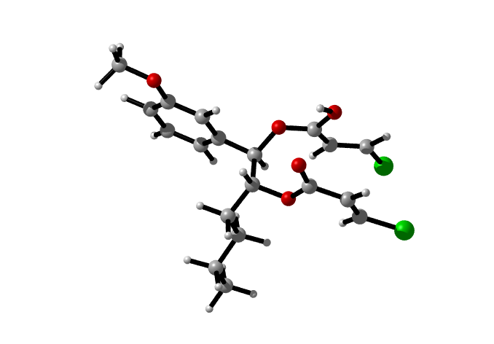

TS3c1-3
H 0.85477600 -2.20804800 -1.83327000
C 3.34017600 -2.00285400 0.93258300
H 3.79383300 -2.16637600 -0.04485900
C 2.00527300 -1.90743300 1.11582800
H 1.58654300 -1.74765300 2.11037300
Cl 4.45926400 -1.85754000 2.23237500
C 1.05842000 -1.98891100 0.03900000
O -0.18167500 -1.81634300 0.18446100
O 1.58076600 -2.17301000 -1.19313700
C -3.14833800 -0.69797400 -0.28598400
C -4.48753500 -0.94784800 0.03032300
C -4.93277100 -0.80414400 1.35013600
C -4.02174300 -0.42380000 2.34018100
C -2.68979900 -0.18851200 2.03560300
C -2.23972300 -0.31333800 0.70691300
H -2.84017900 -0.83488200 -1.32312900
H -5.97237900 -0.98643300 1.61618500
H -4.37055700 -0.31449200 3.36805900
H -1.98547800 0.10314800 2.81662200
C -0.83619500 -0.08580400 0.39245100
H -0.21287200 0.21100000 1.24113200
C -0.46473400 0.59572500 -0.89246700
C -1.05217500 2.00531300 -1.01929400
H -0.68508000 2.43343500 -1.96690400
H -2.14554100 1.91002600 -1.11441300
C -0.70601800 2.92038500 0.15153800
H -1.11620000 2.49405300 1.08368700
H 0.38976500 2.95148100 0.27702800
C -1.24267900 4.33948500 -0.01139900
H -0.83973400 4.77911800 -0.93909200
H -2.33685500 4.29756800 -0.14245600
C -0.89926700 5.23041300 1.17753800
H -1.30322200 6.24558100 1.05763800
H -1.30876200 4.81352200 2.11067500
H 0.19078900 5.31369000 1.30364900
O -5.27972800 -1.32503100 -0.99713800
C -6.62386500 -1.62372900 -0.72898100
H -7.07499700 -1.92724900 -1.67998300
H -6.71682700 -2.45060800 -0.00537700
H -7.16365200 -0.74529400 -0.33810600
O 0.96615500 0.67646500 -0.90283300
H -0.78473000 -0.00496800 -1.75623300
C 1.61017400 0.44236100 -2.05788600
O 1.05196200 0.19105800 -3.09299100
C 3.08246600 0.49023400 -1.90384700
C 3.65633100 0.71206300 -0.72114600
H 3.65942300 0.27916900 -2.80442600
H 3.07951300 0.90864000 0.18327200
Cl 5.35719800 0.66219600 -0.48170400

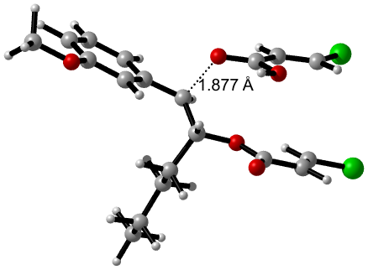

IM5c1
C 0.06742739 0.64315352 0.00000000
C 1.43624539 0.57129652 0.27428000
C 1.94038339 -0.44496748 1.09778800
C 1.05026539 -1.38445048 1.64036700
C -0.30745161 -1.32516748 1.37822100
C -0.83187461 -0.30164348 0.54288000
H -0.28164261 1.45178152 -0.64435200
H 3.00355739 -0.51593848 1.32244500
H 1.44396039 -2.17428848 2.28338400
H -0.98954361 -2.06061448 1.80927600
C -2.23439661 -0.24567148 0.28838400
H -2.87522561 -0.99717248 0.75248200
C -2.86593061 0.79338052 -0.57914600
C -4.35049561 0.58400852 -0.85072100
H -4.65744561 1.30254052 -1.62746400
H -4.44783761 -0.42048348 -1.29653700
C -5.28386161 0.70743752 0.34948700
H -4.94881561 0.04257152 1.16266600
H -5.23559261 1.73277052 0.75251000
C -6.73076761 0.38043652 -0.01222000
H -7.05741261 1.04216952 -0.83247100
H -6.77961661 -0.64800948 -0.40841800
C -7.68185361 0.52089752 1.17001400
H -8.71714961 0.27788852 0.88835600
H -7.39124261 -0.15096948 1.99258900
H -7.67389961 1.54966652 1.56247200
O 2.20731939 1.52536852 -0.29637900
C 3.59603239 1.51598452 -0.04083300
H 4.01884239 2.36509052 -0.58947800
H 3.80461039 1.63974152 1.03377100
H 4.06216839 0.58479252 -0.40040800
O -2.61691761 2.15626052 -0.12232300
H -2.34377161 0.79666652 -1.54982300
C -2.60248761 2.47434252 1.16956900
O -2.90553261 1.73057352 2.07111400
C -2.15934361 3.87343452 1.41149000
C -1.76662361 4.67260152 0.42082500
H -2.16907261 4.19655352 2.45379500
H -1.74364961 4.37851252 -0.62968500
Cl -1.23954761 6.29816552 0.70340800
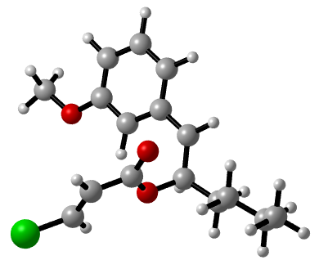
TS4c1
C 0.74212894 -0.27714749 0.01088916
O 1.42321494 -0.29313949 -1.25676584
C 3.13304894 -1.27381149 0.09567616
C 1.72965694 0.05979451 1.09802616
H 0.35175194 -1.29400749 0.19487916
H 2.54632194 -2.11370349 0.47785516
H 1.58689794 -0.47091049 2.04288716
C 2.71922594 -0.65224149 -1.20768084
O 3.45118294 -0.43929449 -2.13104784
C 4.42804594 -1.12156749 0.49388216
H 5.11449094 -0.41366749 0.02911816
Cl 5.03853694 -1.93436849 1.88115016
C -0.44254806 0.67461751 -0.10106484
H -0.94045106 0.69664851 0.88244616
H -0.06925006 1.69373151 -0.28668484
C -1.43532806 0.26663151 -1.18484584
H -0.91440306 0.22798151 -2.15477784
H -1.79582706 -0.75794849 -0.98462784
C -2.62868206 1.21350051 -1.27892784
H -3.13870106 1.25469151 -0.30181184
H -2.26230106 2.23495951 -1.47498984
C -3.62208006 0.80747751 -2.36183484
H -4.02337406 -0.19930549 -2.17130584
H -4.47149006 1.50285051 -2.41274884
H -3.14085106 0.79128951 -3.35111484
C 2.42991594 1.32568951 1.20007916
C 3.04764194 1.65713651 2.41871816
C 2.61238794 2.18004651 0.08734616
C 3.80640494 2.82207251 2.52937216
H 2.92963894 0.99451751 3.27784316
C 3.38420994 3.33437551 0.20797716
H 2.16052994 1.92562551 -0.86892484
C 3.97843194 3.66380851 1.43814116
H 4.27524094 3.07442751 3.48163316
H 4.57343294 4.57494351 1.50067116
O 3.61385594 4.18710051 -0.81296984
C 3.10689494 3.86364351 -2.08637284
H 3.48868294 2.88994251 -2.43307184
H 2.00487394 3.83934851 -2.08233184
H 3.44655094 4.65299051 -2.76469084
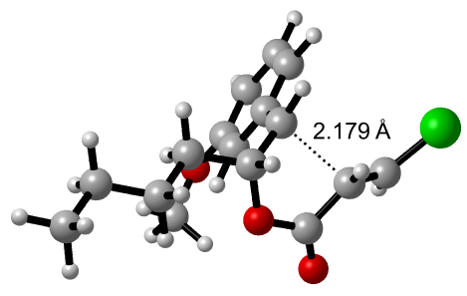
IM6c1
C -0.58310991 -0.16085791 0.00000000
O -0.20104591 -0.10580891 -1.39684800
C 1.73845009 -0.58410491 -0.17745300
C 0.72893909 0.09848909 0.77290000
H -0.90273691 -1.19778591 0.19792200
H 1.66182109 -1.67587391 -0.02722300
H 0.68922709 -0.43504291 1.73029000
C 1.10385909 -0.34247891 -1.55393700
O 1.64109909 -0.35904891 -2.62567600
C 3.15505309 -0.16744391 -0.06719500
H 3.47518309 0.87278009 -0.02546300
Cl 4.39179809 -1.29102791 -0.47909000
C -1.73615291 0.78435709 0.24983000
H -1.90816391 0.81016409 1.33946000
H -1.44180791 1.80194409 -0.05126100
C -3.01637991 0.37271009 -0.47103700
H -2.82356291 0.32197109 -1.55565400
H -3.30322591 -0.64561691 -0.15519600
C -4.17522791 1.33013009 -0.20845400
H -4.35925391 1.38500509 0.87788500
H -3.88017591 2.34522309 -0.52275600
C -5.45594491 0.92230109 -0.92690100
H -5.78662391 -0.07859191 -0.60830600
H -6.27588991 1.62645409 -0.72281400
H -5.30385491 0.89168709 -2.01697900
C 1.02340409 1.55849909 1.05052800
C 1.10199809 2.00312709 2.37181600
C 1.21489109 2.48469709 0.01142500
C 1.36267109 3.34804109 2.65423800
H 0.95919509 1.29150009 3.18840000
C 1.47434009 3.82707709 0.28434100
H 1.16273309 2.17952109 -1.03555100
C 1.54725709 4.25619009 1.61724800
H 1.42241809 3.68397509 3.69113700
H 1.75185609 5.30738309 1.83631900
O 1.68049409 4.82808509 -0.82426900
C 1.54532209 4.21595009 -2.07473700
H 0.56327111 3.80066613 -2.16426420
H 2.27222690 3.43666900 -2.17081182
H 1.69706984 4.94226889 -2.84566736
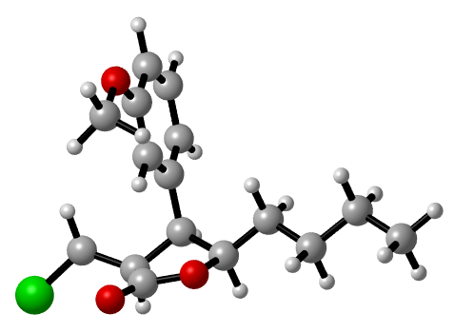

TS5c1
C -2.11107911 0.60321715 0.02763554
O -1.73827811 0.16160215 -1.30192346
C -3.33190811 -1.34326185 -0.50165546
C -2.66606411 -0.66326685 0.71223254
H -2.93994511 1.32068515 -0.09866446
H -4.27515911 -0.80601685 -0.71977346
H -3.42600811 -0.36757085 1.44561554
C -2.39202311 -0.95041685 -1.64933046
O -2.23535811 -1.49912385 -2.70237546
C -3.61171011 -2.80127985 -0.37747646
H -2.83032011 -3.48027585 -0.02234546
Cl -4.60114111 -3.51046585 -1.61011946
C -0.93670011 1.28866115 0.68734554
H -1.21011411 1.46283815 1.74222454
H -0.07365111 0.60481615 0.69038454
C -0.55935711 2.60901015 0.02229254
H -0.32986011 2.42988215 -1.04155446
H -1.42731711 3.29107815 0.04560254
C 0.63491289 3.28411615 0.69004754
H 0.40889389 3.44438815 1.75791654
H 1.49876389 2.59925915 0.65741554
C 1.00628189 4.61087515 0.03879654
H 0.16787289 5.32322315 0.08764354
H 1.87066989 5.07721215 0.53400254
H 1.26288489 4.47079315 -1.02280246
C -1.62901011 -1.51670885 1.41462454
C -1.75002111 -1.75001085 2.78589454
C -0.54371411 -2.08138985 0.72407254
C -0.80346611 -2.52856285 3.45949754
H -2.59357711 -1.32074285 3.33136254
C 0.40571989 -2.85629585 1.38854854
H -0.41015011 -1.92375085 -0.34787146
C 0.26947089 -3.07819485 2.76597154
H -0.90885111 -2.70506785 4.53157954
H 1.01058789 -3.68628985 3.29128954
C -7.36509811 1.00945115 -0.15029446
C -7.58078211 -0.27490185 -0.65425946
C -7.04753011 -1.38538585 0.00067954
C -6.27174211 -1.21166685 1.15451954
C -6.06934411 0.07676015 1.66738054
C -6.61647811 1.18241915 1.01570054
H -7.78790711 1.87588315 -0.66238246
H -8.17405711 -0.41673585 -1.55970846
H -7.22528511 -2.39057585 -0.38571646
H -5.47798211 0.20972915 2.57608254
H -6.45603011 2.18318015 1.42171354
S -5.53888511 -2.61659185 1.97129854
H -4.55219911 -2.85233385 0.92833754
C 2.08916584 -2.49120535 -0.44365946
H 1.42905798 -2.53483957 -1.28464321
H 2.09798727 -1.49693501 -0.04837644
H 3.07761604 -2.76133982 -0.75170746
O 1.60390196 -3.47061939 0.64117560
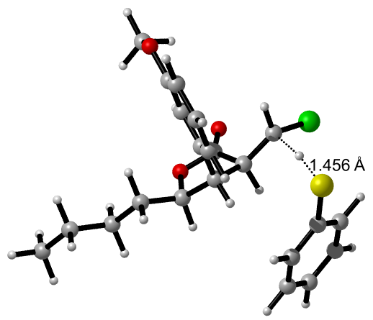

TS2c2
C -3.02098954 0.39730134 0.00000000
O -2.96402654 0.69082634 1.46054300
C -4.93359154 -0.63079866 1.50119300
C -4.47420054 0.37847634 -0.38608200
H -2.60524254 -0.61652266 -0.10316900
H -4.53245754 -1.54601066 1.05214200
H -4.75238654 -0.43096166 -1.06465100
C -3.94325254 0.24460434 2.12988300
O -3.99176554 0.63735134 3.34771800
C -6.24660654 -0.55870466 1.89823200
H -6.67303254 0.28967434 2.43927300
Cl -7.38194354 -1.71661866 1.37157500
C -2.13502154 1.40161134 -0.71832300
H -2.44986154 1.38302734 -1.77303400
H -2.35725354 2.41249534 -0.34462000
C -0.63941154 1.10357834 -0.63232700
H -0.44328054 0.11868334 -1.09013200
H -0.11651754 1.84318034 -1.25967600
C -0.04304154 1.13720434 0.77301500
H -0.32167154 2.08433434 1.26517900
H -0.48131154 0.33341634 1.38658000
C 1.47316946 0.98817834 0.75494300
H 1.94360046 1.80757234 0.19008400
H 1.89123646 0.99723334 1.77174200
H 1.77066946 0.04191534 0.27698800
C -5.33795054 1.54119634 -0.40194200
C -6.57989754 1.43260634 -1.05715800
C -5.04593754 2.72950334 0.30461400
C -7.48822154 2.48689334 -1.02505300
H -6.82347854 0.51271834 -1.59358000
C -5.95331654 3.78295534 0.33405300
H -4.10633854 2.85532034 0.84320300
C -7.17969154 3.65759234 -0.33522200
H -8.44579754 2.39429434 -1.54000100
H -7.89451354 4.48364534 -0.30931300
H -4.71948054 0.20833434 3.84670700
C -4.33931754 4.89230334 1.89010100
H -4.47118354 4.09745734 2.59418300
H -3.52314154 4.65977234 1.23842200
H -4.12972154 5.80154834 2.41378300
O -5.62587654 5.06232634 1.06096900

IM3c2
C -0.46246648 0.18766756 0.00000000
O -1.00720048 -0.04494244 1.38019200
C -2.74913748 -0.47997644 -0.08604000
C -1.73798048 0.42031756 -0.83523700
H -0.00368648 -0.77617844 -0.26556300
H -2.53271848 -1.53747844 -0.36040600
H -1.56702348 0.02061156 -1.84178700
C -2.22052848 -0.38310044 1.31861600
O -2.82802148 -0.61624144 2.41264200
C -4.19216448 -0.17645744 -0.27601800
H -4.55873248 0.42223556 -1.10976400
Cl -5.34043248 -1.21768344 0.47712900
C 0.56343852 1.28636856 0.06693600
H 0.82430852 1.52408456 -0.97832400
H 0.10117852 2.19175356 0.48997000
C 1.81616552 0.90174556 0.84784600
H 1.53842252 0.61910256 1.87724400
H 2.27342052 0.00953856 0.38680000
C 2.83820652 2.03394656 0.89456000
H 3.09827452 2.32579856 -0.13676800
H 2.37199452 2.91906456 1.35834500
C 4.10270152 1.65917356 1.65742900
H 4.60301652 0.79535656 1.19290700
H 4.82079152 2.49173356 1.67674500
H 3.87123852 1.39201856 2.70015200
C -2.16109848 1.87085656 -0.93784200
C -1.96909348 2.55144256 -2.14062700
C -2.71247248 2.55560356 0.15535300
C -2.31668048 3.90123856 -2.24815200
H -1.54508848 2.02412656 -2.99839600
C -3.06105848 3.90162656 0.05650400
H -2.88771248 2.06570156 1.11639600
C -2.85882048 4.57251256 -1.15718200
H -2.16531148 4.42664656 -3.19266000
H -3.13366648 5.62688056 -1.24285000
H -3.76772648 -0.87278844 2.29538400
C -3.80900125 3.70919422 2.43970698
H -4.46365700 2.90246569 2.18374817
H -2.85225580 3.31807308 2.71640609
H -4.22174125 4.25652636 3.26127452
O -3.64974748 4.64545356 1.22741300

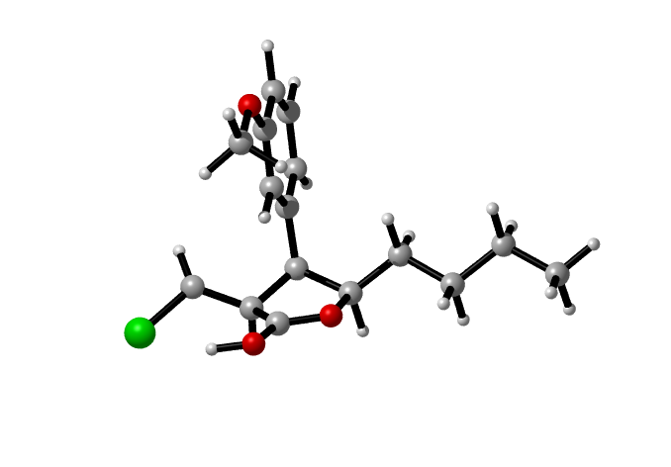

IM4c2-1
C 1.01024892 -0.09516837 0.00000000
O 0.54595992 -0.60784837 1.33358700
C -1.34660008 -0.45335937 0.00229100
C -0.28137208 0.48747863 -0.60994600
H 1.30557592 -1.00640937 -0.54067000
H -1.30338208 -1.41984537 -0.54950400
H -0.24454308 0.33775463 -1.69527800
C -0.70158508 -0.78993337 1.31895400
O -1.24814108 -1.24061537 2.37726900
C -2.74381008 0.05140363 0.05879600
H -3.08299908 0.89930363 -0.53561300
Cl -3.96685108 -1.02921037 0.60797100
C 2.18355792 0.82166363 0.21123600
H 2.41019592 1.25206063 -0.77924600
H 1.88417292 1.66115463 0.85788000
C 3.41480492 0.11662963 0.77105200
H 3.17672892 -0.31831837 1.75642500
H 3.68638792 -0.72519637 0.11117800
C 4.60643892 1.05948363 0.91010900
H 4.83371992 1.49802663 -0.07598600
H 4.32492592 1.90105763 1.56467300
C 5.84566692 0.36829163 1.46421000
H 6.16376892 -0.45800037 0.80959000
H 6.68897192 1.06828563 1.55394400
H 5.65154892 -0.05251637 2.46299500
C -0.50318508 1.95805763 -0.32037100
C -0.32220708 2.87941363 -1.34920600
C -0.85085208 2.40555763 0.96558900
C -0.48230108 4.24770463 -1.09687200
H -0.05458208 2.53237363 -2.34905700
C -1.00753308 3.77283363 1.21154500
H -1.00306408 1.70063163 1.78435800
C -0.82208908 4.69706163 0.16958500
H -0.34269808 4.96895263 -1.90395100
H -0.95444208 5.75898363 0.38243200
C -1.51670308 3.40715763 3.50511200
H -2.34114008 2.70102163 3.31664700
H -0.59220508 2.84808063 3.72097600
H -1.76991408 4.03239663 4.36806500
O -1.33721608 4.28525963 2.41289800
H -0.71352388 -1.42204288 3.15371499
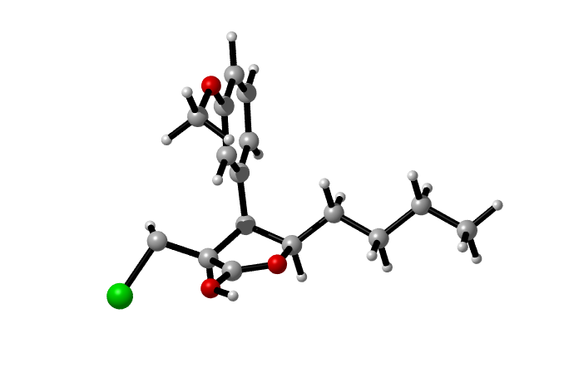

IM4c2-2
C -4.39929342 0.21201413 0.00000000
C -4.15372942 -0.93554387 2.13329300
C -4.45959842 -1.20820887 0.63068700
H -3.85138742 0.15595013 -0.95448100
H -3.66846342 -1.80905987 2.58842400
H -3.57200342 -1.73695887 0.25938000
O -2.95864742 0.94215913 3.09353200
C -5.29227142 -0.49055987 2.97802400
H -5.65043042 0.53585513 3.03625200
Cl -5.96776342 -1.57242687 4.13150600
C -5.70396542 0.95341013 -0.23120500
H -6.32425442 0.35423413 -0.91806300
H -6.25187242 1.02911613 0.72115500
C -5.47755742 2.34184913 -0.82638900
H -4.88742642 2.94762413 -0.11925000
H -4.86424442 2.23949513 -1.73750300
C -6.77112142 3.08079113 -1.17105400
H -6.51077942 4.03586013 -1.65430000
H -7.33392342 2.49931613 -1.92114200
C -7.66449942 3.35895813 0.03454500
H -7.10696442 3.88990313 0.82281800
H -8.52543042 3.98396213 -0.24489600
H -8.06280442 2.43211313 0.47362000
C -5.64298542 -2.08598087 0.29569200
C -5.42284542 -3.23308287 -0.47284900
C -6.95037942 -1.79212687 0.72069900
C -6.48739342 -4.07501187 -0.81201900
H -4.41176442 -3.47198387 -0.80830200
C -8.01038642 -2.63729487 0.38031800
H -7.13901442 -0.90148187 1.31553700
C -7.77760442 -3.78675587 -0.39046700
H -6.30257942 -4.96814287 -1.41186800
H -8.62058742 -4.43155687 -0.64384000
H -2.36813842 1.68302713 2.87474300
O -3.59415742 0.98080613 0.91906700
C -3.14040442 0.20681613 1.96576100
O -1.89961842 -0.43838687 1.56562600
C -0.82873642 0.31961613 1.31134100
C 0.30788958 -0.43857987 0.73961500
C 0.21606458 -1.74092587 0.47093600
H -0.67819742 -2.33946987 0.65220200
H 1.21446358 0.13834213 0.55048900
Cl 1.53008658 -2.63776087 -0.20179600
O -0.77882442 1.50779913 1.53210100
O -9.29155842 -2.41560287 0.75256000
C -9.58683842 -1.26285387 1.51203200
H -9.05401042 -1.27123587 2.47612500
H -9.33030542 -0.34492187 0.95907100
H -10.66645242 -1.28098787 1.69764100

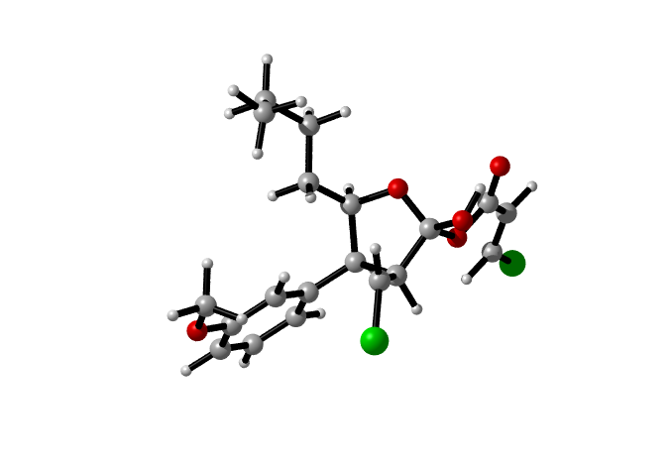

TS3c2-2
C -1.26591234 -0.79915133 0.00000000
O -0.42760034 -1.77208033 -0.68391000
C -2.51087334 -2.78598133 -0.72808500
C -2.71605434 -1.39424733 -0.04216700
H -1.20570234 0.09747867 -0.62991400
H -2.77086034 -2.65551833 -1.79690600
H -3.29571134 -0.77321633 -0.73386200
C -1.01506034 -2.94115933 -0.77592200
O -0.44360934 -3.86684433 -1.45576300
C -3.21853034 -3.98429733 -0.22117400
H -2.72055834 -4.90343933 0.08226000
Cl -4.91873934 -4.08300933 -0.45775600
C -0.69573634 -0.48983233 1.37351200
H -1.23889634 0.39026467 1.75564900
H -0.91345034 -1.31652133 2.06205200
C 0.80580366 -0.22378233 1.36836500
H 1.33376866 -1.13441133 1.03692600
H 1.05259366 0.56047867 0.63137000
C 1.32259966 0.17969867 2.74673500
H 0.88022966 1.14858967 3.03265800
H 0.96251066 -0.55115333 3.49117800
C 2.84260266 0.26021967 2.81042200
H 3.23340066 0.97836667 2.07267300
H 3.18944466 0.57746967 3.80482900
H 3.29542266 -0.72035833 2.59393600
C -3.46490934 -1.37137833 1.27623900
C -4.34878634 -0.31680633 1.51691300
C -3.29369334 -2.36026333 2.25788000
C -5.04579834 -0.24286333 2.72780200
H -4.49694434 0.45022867 0.75380000
C -4.02279234 -2.30243033 3.44874400
H -2.58802634 -3.17055733 2.08646500
C -4.89286634 -1.22938433 3.69322500
H -5.73045034 0.58758767 2.91026500
H -5.44602234 -1.20104933 4.63328100
H 0.48951066 -4.05159133 -0.93484800
C 0.50345266 -3.37750533 3.52595600
H -0.49478334 -2.94171933 3.44333900
C 1.16556866 -3.90107733 2.49501700
H 2.16864466 -4.32060433 2.59044200
Cl 1.15731366 -3.32985233 5.12621600
C 0.56530066 -3.87840933 1.13383500
O 1.30992966 -4.16457133 0.16102600
O -0.65484634 -3.55021033 1.01099700
O -3.94347234 -3.24917833 4.41285700
C -3.26707634 -4.45473933 4.12138400
H -3.68021934 -4.93065433 3.21693000
H -2.18620334 -4.29581633 3.98416600
H -3.42165734 -5.11423833 4.98264000

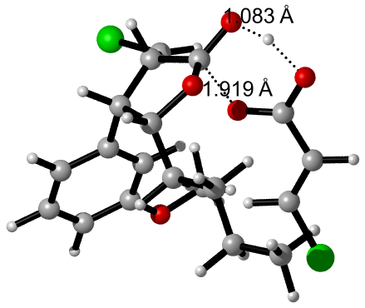

BF₄-
B 0.32028471 0.67615657 0.00000000
F 1.13003171 1.48590357 0.80974700
F -0.48946229 1.48590357 -0.80974700
F 1.13003171 -0.13359043 -0.80974700
F -0.48946229 -0.13359043 0.80974700
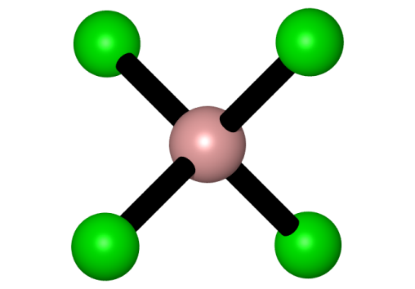

BF₃
B -0.92526694 -1.44128112 0.00000000
F -0.92526694 -0.13114312 0.00000000
F 0.20934606 -2.09635012 0.00000000
F -2.05987994 -2.09635012 0.00000000
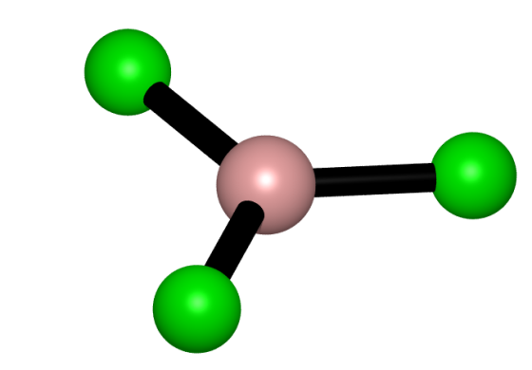

HF
F -3.11387914 -0.14234875 0.00000000
H -3.99387914 -0.14234875 0.00000000

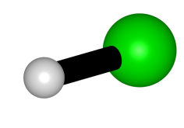

TS5c
C -2.30498000 0.76683700 -0.90949400
O -2.64580500 1.49076200 0.29977800
C -0.43391200 2.03853100 -0.21325400
C -0.75981700 0.69406700 -0.89859200
H -2.61837500 1.40251400 -1.75431100
H -0.51665500 2.82499500 -0.98200500
H -0.39811700 0.70651900 -1.93288700
C -1.62393100 2.23550900 0.72221100
O -1.67583000 2.92528600 1.70291600
C 0.88291100 2.18993700 0.51787500
H 0.86415700 1.84876100 1.56050000
Cl 1.51388400 3.84414300 0.49574200
C -3.05516100 -0.54456400 -0.94632700
H -2.68665000 -1.10712900 -1.82109600
H -2.79272000 -1.13557500 -0.05428000
C -4.56820200 -0.37363500 -1.03787900
H -4.92304500 0.20878800 -0.17119700
H -4.81741800 0.21761000 -1.93642800
C -5.30788100 -1.70741600 -1.08723600
H -4.94738200 -2.28890000 -1.95275600
H -5.04740800 -2.29583800 -0.19136900
C -6.82059300 -1.54462700 -1.17224700
H -7.10789600 -0.98181700 -2.07416200
H -7.33049300 -2.51855500 -1.20889300
H -7.20779900 -0.99582700 -0.29963600
C -0.19144800 -0.53070400 -0.21446700
C 0.41052900 -1.52259200 -0.98929600
C -0.27165800 -0.69481500 1.17760700
C 0.94299700 -2.66352200 -0.37897400
H 0.47143900 -1.39815700 -2.07305300
C 0.26218700 -1.83669600 1.78305100
H -0.75277300 0.06409200 1.79553300
C 0.87522000 -2.82555500 0.99764400
H 1.42368800 -3.43216300 -0.98798700
H 1.29432000 -3.70402300 1.49078200
C 4.35725200 -1.47702800 -1.58075700
H 4.02252319 -1.05648557 -0.63019850
C 3.62956800 -0.55405100 -2.21196600
H 3.63886200 -0.55395900 -3.30424400
Cl 5.41454681 -2.82275943 -1.38382750
C 2.73623300 0.49485300 -1.63419200
O 2.01702500 1.17486900 -2.33421700
O 2.81229400 0.60079900 -0.32619000
H 1.71122300 1.53351000 0.03375000
O 0.22931700 -2.06007600 3.11427000
C -0.37731600 -1.09510000 3.94905200
H 0.13596900 -0.12299900 3.87364900
H -1.44329700 -0.96654800 3.70219900
H -0.28688100 -1.47103100 4.97406900
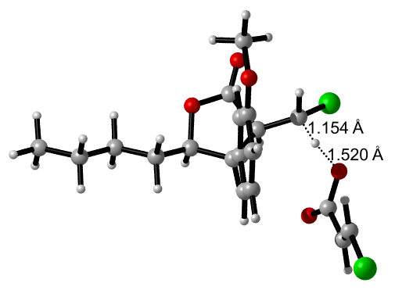

IM7c
C -1.71649459 0.20239880 -0.02247015
H -1.83225450 -0.88319267 -0.02248211
C -3.04893259 0.24756480 -0.02246215
H -3.55013859 1.21758480 -0.02245015
Cl -0.06964769 0.72045426 -0.02246718
C -3.95504659 -0.91866120 -0.02247515
O -5.16484359 -0.85762520 -0.02248415
O -3.41810959 -2.12514120 -0.02245015
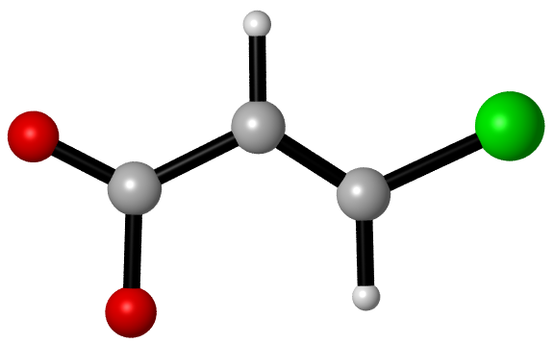

IM4c2-4
C 1.06568363 0.89812331 0.00000000
O 1.71063263 0.21861431 1.08584000
C 0.04391163 -1.20920869 0.20582800
C -0.34382937 0.29144031 -0.03013800
H 1.57578263 0.60477231 -0.93780500
H 0.38398563 -1.58973969 -0.77174800
H -0.79360937 0.40563331 -1.02562500
C 1.28995563 -1.10501769 1.14713500
O 1.08960463 -1.47070169 2.46489800
C -0.99840137 -2.11636669 0.73188500
H -1.23393437 -2.23754169 1.78832900
Cl -2.22028937 -2.65900469 -0.35940500
C 1.20257663 2.39599831 0.17501100
H 0.68492263 2.87399931 -0.67351700
H 0.68342963 2.72022131 1.08969500
C 2.65897063 2.85098231 0.22212900
H 3.16342563 2.35313231 1.06695000
H 3.17839863 2.51644031 -0.69360000
C 2.80661863 4.36254731 0.36563200
H 2.31205363 4.85938631 -0.48628400
H 2.26605863 4.69081931 1.26950800
C 4.26140563 4.80910831 0.44924800
H 4.81810963 4.51689531 -0.45498900
H 4.34503363 5.90075731 0.55528200
H 4.76504663 4.34811031 1.31331100
C -1.31741237 0.76508931 1.02639000
C -2.69205737 0.79639031 0.75870900
C -0.89877437 1.00811531 2.33671000
C -3.60950137 1.02045331 1.78749600
H -3.04911037 0.62055631 -0.25901300
C -1.80560537 1.16091331 3.38480600
H 0.16432263 1.05103331 2.57047100
C -3.17454137 1.17149431 3.10631200
H -4.67804237 1.03808331 1.56391800
H -3.89941037 1.28223531 3.91609100
H 0.65626163 -0.75723269 2.96530900
C 6.09680663 -0.99531069 3.09985800
C 5.84346863 -0.32533669 1.90102500
C 4.77391863 -0.71595569 1.09505900
C 3.95052963 -1.77527569 1.49291900
C 4.20499663 -2.44843369 2.69254800
C 5.27854063 -2.05611669 3.49367600
H 6.93661063 -0.69161969 3.72807200
H 6.48223363 0.50363431 1.58963700
H 4.56951263 -0.19848969 0.15593400
H 3.55904163 -3.27395869 2.99597400
H 5.47619563 -2.58267669 4.42948100
S 2.58029063 -2.25553969 0.46008700
C -0.09816319 0.21108998 4.88371869
H -0.40514357 -0.71484208 4.44404509
H 0.76029680 0.58464616 4.36564319
H 0.14728673 0.05306652 5.91312771
O -1.24514637 1.23353431 4.78058200
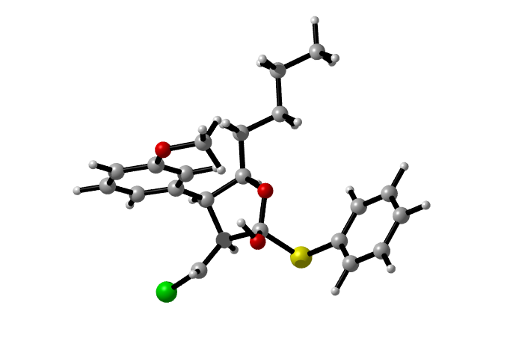

IM4c2-5
C -3.02013445 2.13087245 0.00000000
O -2.45335445 1.83738745 -1.28846900
C -0.68156145 1.99999345 0.25513900
C -1.88208045 2.84704245 0.75809300
H -3.21394645 1.16925145 0.50962200
H -0.65718245 1.08606845 0.87371300
H -2.02147545 2.70502145 1.83746900
C -1.12093645 1.61571945 -1.16169300
O -0.46015045 2.04485345 -2.27181200
C 0.69050755 2.65304145 0.32752000
H 0.73961655 3.55506645 -0.29420900
Cl 1.00799555 3.21404845 2.02500200
C -4.32218045 2.88137145 -0.16756900
H -4.67002745 3.16696745 0.83997700
H -4.13390345 3.81655945 -0.71885000
C -5.39792345 2.06286545 -0.87493400
H -5.04342345 1.79019245 -1.88293600
H -5.55350945 1.11445345 -0.33098500
C -6.72717645 2.80350945 -0.98862500
H -7.07776545 3.07280445 0.02221100
H -6.56431645 3.75552345 -1.52135700
C -7.79942745 1.99112645 -1.70469100
H -7.99394345 1.04338045 -1.17855800
H -8.75017645 2.54094745 -1.76645700
H -7.48767345 1.74379745 -2.73144700
C -1.79425145 4.33185445 0.47844800
C -2.07242545 5.23788445 1.50328400
C -1.46452245 4.81780845 -0.79825600
C -2.02053745 6.61443845 1.25950400
H -2.32376845 4.86718945 2.49917500
C -1.40264745 6.19496145 -1.03248500
H -1.25883845 4.12192245 -1.61017900
C -1.68592145 7.09955445 0.00205100
H -2.23786245 7.31727045 2.06624800
H -1.63381345 8.17000945 -0.20295000
H 0.43189655 1.66366945 -2.27778700
C -0.74331145 5.85694845 -3.28953900
H 0.13040655 5.23611045 -3.03275300
H -1.58996545 5.20295245 -3.55200000
H -0.49627745 6.48997445 -4.14895700
O -1.07691145 6.73058145 -2.23060100
C 5.58500255 3.94477645 -1.47526700
C 5.50141955 2.57298945 -1.72528800
C 4.37547655 1.85337145 -1.33251600
C 3.32032055 2.50575945 -0.67939100
C 3.40158155 3.87690045 -0.41918100
C 4.53400155 4.58794645 -0.82393100
H 6.46719255 4.50824445 -1.78394100
H 6.31674455 2.05576445 -2.23473100
H 4.31454655 0.78187145 -1.53824900
H 2.60766755 4.40714045 0.10687200
H 4.58865855 5.65837245 -0.61729200
S 1.94083555 1.47302345 -0.22429100
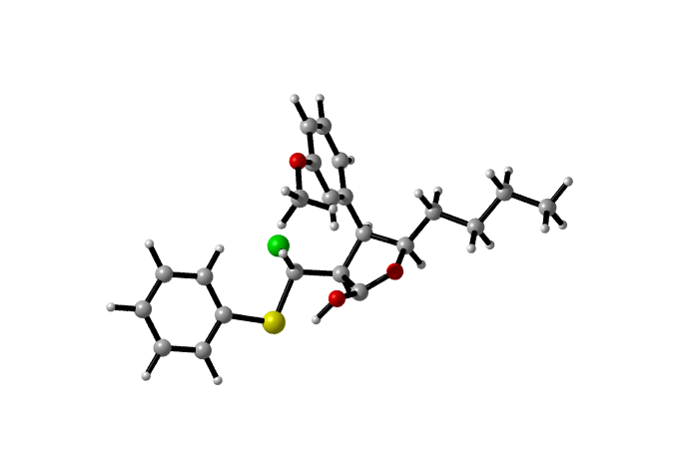

IM4c2-6
C -1.61091952 -1.42596172 0.00483864
O -2.28354752 -1.95170772 1.15694964
C -3.91075252 -1.02130372 -0.26045836
C -2.55687152 -0.33604172 -0.54318436
H -1.56922052 -2.23724072 -0.74716336
H -4.12284752 -1.76639872 -1.05245336
H -2.40883452 -0.21790672 -1.62450736
C -3.62280252 -1.74518472 1.03484664
O -4.35949152 -2.82357372 1.38978264
C -5.10854852 -0.10250172 -0.17123036
H -4.95505552 0.74440628 0.50724764
Cl -5.46748852 0.60506128 -1.78241836
C -0.19833652 -1.01931972 0.36289264
H 0.25641248 -0.55098472 -0.52649136
H -0.23090352 -0.24445972 1.14336064
C 0.64790348 -2.19720072 0.83494364
H 0.13065348 -2.68894772 1.67479464
H 0.71516448 -2.95076972 0.03057464
C 2.05213948 -1.78432372 1.26368364
H 2.55496648 -1.27744072 0.42281464
H 1.97409848 -1.03255872 2.06687264
C 2.89720648 -2.96026772 1.73826764
H 3.02004948 -3.70646972 0.93875564
H 3.89924648 -2.63862772 2.05438664
H 2.41991748 -3.46578272 2.59114064
C -2.42668052 1.02419928 0.11213064
C -2.37169752 2.16843828 -0.68032136
C -2.40793552 1.15228628 1.51242264
C -2.29427952 3.43204728 -0.08366436
H -2.40182652 2.07678028 -1.76729836
C -2.33424852 2.41581128 2.10155764
H -2.44027752 0.25449328 2.12704364
C -2.27568252 3.56308528 1.29509664
H -2.25467652 4.32473228 -0.70973836
H -2.21935652 4.53607628 1.78333064
H -5.28583652 -2.57563372 1.26967864
C -2.42784552 1.50047528 4.27850564
H -3.36299952 0.94748628 4.08955664
H -1.57800852 0.80922128 4.15178164
H -2.43232752 1.87973128 5.30618164
O -2.31481852 2.61820428 3.43642164
C -9.47374052 -0.60979472 1.66387764
H -9.56335052 0.46110428 1.86108864
C -8.37273352 -1.12120472 1.11032164
H -8.26274152 -2.18444672 0.89565764
Cl -10.83086152 -1.55192972 2.10982864
C -7.26982452 -0.19285672 0.77145664
O -6.20663352 -0.87404372 0.26126164
O -7.27537552 0.99310928 0.92040564

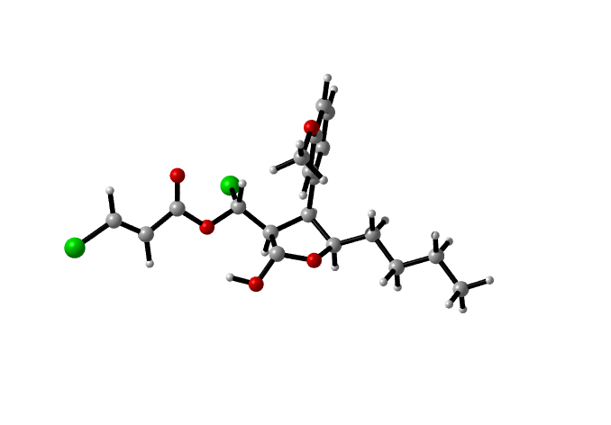

TS3c2-4
C 0.85120642 -1.32707773 0.00000000
O 0.29196842 -1.03972373 1.34967600
C -0.62369758 0.53787927 -0.08908400
C 0.68119442 0.01653427 -0.73999800
H 0.15574542 -2.07063573 -0.41924900
H -1.48427758 -0.00915973 -0.53343900
H 0.50194742 -0.19495773 -1.80050300
C -0.54070858 -0.08733473 1.27171300
O -1.20847758 0.32120227 2.27199300
C -0.90544758 1.99508627 -0.11971400
H -0.13958258 2.76161327 -0.01472500
Cl -2.53147958 2.50400427 0.00791400
C 2.23418242 -1.90221173 0.15394500
H 2.65577742 -1.96805373 -0.86330600
H 2.86708242 -1.19642073 0.71391900
C 2.24135142 -3.27702973 0.81552700
H 1.79234542 -3.20467373 1.82035700
H 1.60129742 -3.96315273 0.23513200
C 3.64514742 -3.86378373 0.93038900
H 4.09247642 -3.92651873 -0.07582300
H 4.27956842 -3.17144373 1.50869700
C 3.65604642 -5.23963373 1.58497900
H 3.05119542 -5.95592773 1.00767200
H 4.67625142 -5.64376973 1.65798500
H 3.23888742 -5.19522973 2.60291800
C 1.86249442 0.95809627 -0.62304100
C 2.60597742 1.26118227 -1.76941800
C 2.24552942 1.52549227 0.59779900
C 3.70778442 2.11181027 -1.68998600
H 2.31458942 0.82842127 -2.72911800
C 3.34871242 2.38025527 0.68632000
H 1.68534742 1.31747527 1.51629300
C 4.08172242 2.67082527 -0.46780000
H 4.27932442 2.34472327 -2.59047400
H 4.94045642 3.33893327 -0.40105000
H -1.41703058 -0.43890573 2.87677600
C -5.66741358 0.98913727 0.12523100
C -5.31944758 0.92592727 1.47688800
C -4.42673958 -0.04146273 1.93767700
C -3.84515658 -0.98422473 1.06425200
C -4.20557958 -0.89952673 -0.29834700
C -5.10005458 0.06701927 -0.75776900
H -6.36800158 1.74509527 -0.23502800
H -5.74910758 1.63835727 2.18599700
H -4.17360758 -0.07858873 3.00026700
H -3.77845058 -1.61947673 -1.00154400
H -5.35678758 0.09777727 -1.81984400
S -2.71756658 -2.21679673 1.63759400
O 3.71054742 2.97194927 2.02530000
C 4.87995311 3.78766864 1.91579078
H 4.69170009 4.59140710 1.23500794
H 5.12857508 4.18560031 2.87742350
H 5.69459365 3.19636164 1.55300046

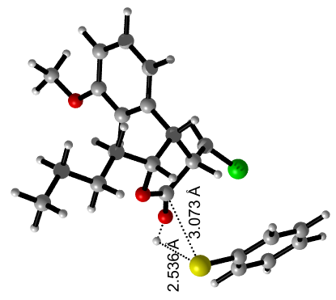

TS3c2-5
C 1.11842108 -0.10526316 0.00000000
O 1.79920008 -1.37156516 -0.25019000
C 3.34044108 0.30463684 -0.83466300
C 1.92467208 0.94498084 -0.78435200
H 1.21469708 0.07334784 1.08444100
H 3.92731908 0.68650784 0.02830100
C 3.00964408 -1.13425816 -0.67398100
O 3.80061108 -2.12582116 -0.85774700
C 4.19745908 0.46220584 -2.07131700
H 3.90589008 -0.15004716 -2.93424800
Cl 4.34601508 2.15073584 -2.55438100
C -0.33476792 -0.22975716 -0.39034300
H -0.78442892 0.77131684 -0.27382400
H -0.38696992 -0.48247216 -1.46295800
C -1.10612192 -1.25338216 0.43605300
H -0.62471792 -2.23996416 0.33440600
H -1.04019492 -0.98250516 1.50425600
C -2.57342092 -1.35696916 0.03031600
H -3.04697692 -0.36581816 0.13004400
H -2.63365792 -1.61902716 -1.03921900
C -3.34412992 -2.38141516 0.85512200
H -2.90789092 -3.38542916 0.74342400
H -3.31979092 -2.12498716 1.92502900
H -4.39770392 -2.43695016 0.54778100
C 1.85869808 2.31319384 -0.15346600
C 2.45648908 2.55836684 1.09415600
C 1.19008008 3.34476684 -0.80316700
C 2.37934208 3.82556984 1.65810400
H 2.99733408 1.76947284 1.62310000
C 1.11048808 4.62136084 -0.22965000
H 0.73057308 3.19211184 -1.78147200
C 1.70894308 4.86664984 1.00953700
H 2.85402208 4.01590384 2.62209300
H 1.66571408 5.85111584 1.47244900
H 4.73999808 -1.76582716 -1.08970600
C 0.35493108 6.85879884 -0.43631700
H -0.18171492 6.87637884 0.52649900
H 1.35449308 7.30389384 -0.30313000
H -0.20584292 7.44461684 -1.17219000
O 0.44257508 5.55256484 -0.94711000
C 6.28130508 0.23944884 0.11960100
C 6.64386508 1.59141884 0.28439700
C 6.62087108 2.17750384 1.54534700
C 6.25507608 1.43196484 2.67132600
C 5.93153608 0.08080584 2.52275200
C 5.94384408 -0.51415616 1.26332100
H 6.91177908 2.17828584 -0.59564900
H 6.88665508 3.23091584 1.65158800
H 6.23570108 1.89711984 3.65797700
H 5.66552908 -0.51764516 3.39648000
H 5.68788308 -1.57073216 1.15741300
S 6.17396208 -0.44324616 -1.49495300
H 1.52863808 0.99813884 -1.81118700
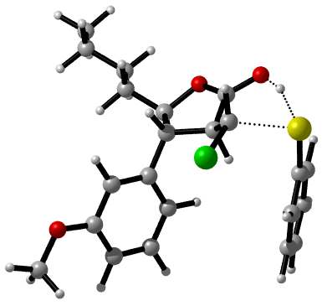

TS3c2-6
C -1.35184981 1.26277355 -0.05193308
O -2.15093481 0.11554855 0.30670392
C -3.41949881 1.14833055 -1.34176408
C -2.15499081 2.02995355 -1.15734408
H -0.43580681 0.84196155 -0.49202708
H -3.22247781 0.43577955 -2.16343608
H -1.57654881 1.94739055 -2.08537808
C -3.38352381 0.19859655 -0.13495308
O -4.12169381 -0.83090245 -0.03445208
C -4.70518781 1.81513655 -1.65291508
H -4.98933481 2.79860255 -1.28591308
Cl -5.93666381 0.89740855 -2.40528208
C -0.98645881 2.02457655 1.20891892
H -0.41917581 2.92288455 0.91465092
H -1.91030681 2.36928255 1.69578192
C -0.17404181 1.17682055 2.18188992
H -0.75021081 0.27164455 2.43259092
H 0.75187419 0.82910755 1.68985992
C 0.18251619 1.92878855 3.46038792
H 0.75908419 2.83277355 3.20100792
H -0.74614681 2.28666055 3.93505392
C 0.97154019 1.07718255 4.44738492
H 1.91451219 0.72708855 4.00069692
H 1.21977719 1.63828655 5.35904992
H 0.39577619 0.18782255 4.74437492
C -2.35283481 3.51909455 -0.94117208
C -1.68910881 4.41256655 -1.79532908
C -3.15504181 4.03879455 0.07327692
C -1.83279081 5.78524455 -1.62597608
H -1.05835181 4.02743755 -2.59869408
C -3.30150081 5.42035255 0.24269192
H -3.68854981 3.38199555 0.75784892
C -2.63654181 6.30609155 -0.61122808
H -1.31282181 6.47056655 -2.29715408
H -2.73629181 7.38458655 -0.49980108
H -5.14802281 -0.46955845 0.23500592
C -4.30624081 7.17435255 1.47512392
H -3.35873481 7.68819955 1.70795892
H -4.76994481 7.65845055 0.59949792
H -4.98232881 7.26280355 2.33252692
O -4.10766381 5.80229155 1.25888592
C -7.42301281 2.07260155 2.38293392
H -7.99256781 1.24567155 1.95400492
C -6.11141481 2.19495455 2.17929192
H -5.52500681 3.01801255 2.59133692
Cl -8.34003281 3.18185155 3.32114592
C -5.40941281 1.19240055 1.33365092
O -4.16641581 1.36328755 1.15971492
O -6.06348981 0.25337155 0.81238492

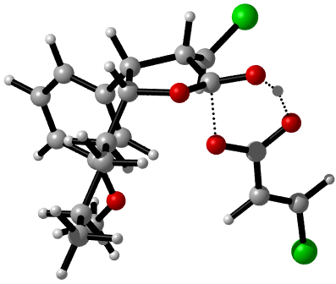

TS3c2-7
C -2.25669955 0.83921014 0.00000000
O -2.47753955 0.44525214 1.42267600
C -4.55189455 0.24650914 0.32889200
C -3.67211155 1.23483014 -0.49550900
H -1.94662955 -0.09103986 -0.49827300
H -4.43059255 -0.75135086 -0.13484900
H -3.73020555 0.99689114 -1.56464600
C -3.70831255 0.14083914 1.57686000
O -4.23099655 -0.16090386 2.66382400
C -5.97662455 0.39580514 0.80422300
H -6.35773155 1.42296714 0.84062900
Cl -7.14680355 -0.56454486 -0.15666500
C -1.15578655 1.86915914 -0.03192000
H -1.09803255 2.24879914 -1.06609900
H -1.43611855 2.72095614 0.60975300
C 0.20066245 1.31288914 0.39121600
H 0.12503445 0.89430114 1.40867300
H 0.47429145 0.47621214 -0.27401400
C 1.29892945 2.37106314 0.35976800
H 1.36612745 2.79091314 -0.65807500
H 1.01325045 3.20625814 1.02095300
C 2.65733145 1.82478514 0.78129800
H 3.43184445 2.60474914 0.74963700
H 2.62174645 1.42835414 1.80780300
H 2.97772245 1.00644614 0.11807200
C -3.97588755 2.69762914 -0.30626900
C -3.70706755 3.58629214 -1.38912500
C -4.45916155 3.21752914 0.87460800
C -3.91705055 4.97663614 -1.28402800
H -3.34116355 3.16947814 -2.32928200
C -4.66373355 4.62500014 0.98980200
H -4.68141055 2.59029914 1.73706900
C -4.40150055 5.50352714 -0.11586000
H -3.70818855 5.62069014 -2.13832600
H -4.59899855 6.56882814 0.01193000
H -5.38829865 -0.09307501 2.18670947
C -5.44364955 4.44391214 3.24704700
H -6.29114555 3.78902214 3.00977600
H -4.58039755 3.86284514 3.59305300
H -5.73018555 5.18309414 3.99793600
O -5.08634555 5.20146814 2.07511200
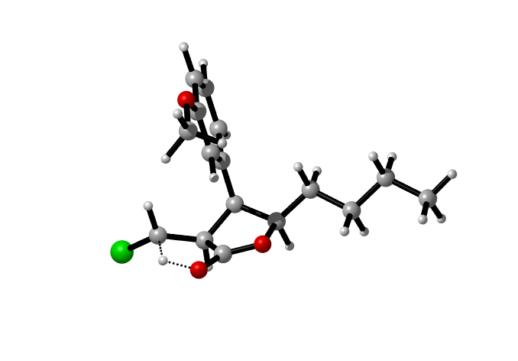

IM4c2-7
C 0.23458445 -0.32171581 0.00000000
O 0.76530845 -0.40871981 -1.33802300
C 2.51368345 -0.92376781 0.11579600
C 1.48767245 -0.07160281 0.88436200
H -0.16253055 -1.31552781 0.26426600
H 2.29078545 -1.97347281 0.37566500
H 1.30716445 -0.47698281 1.88751700
C 2.06141045 -0.75780781 -1.32807900
O 2.70447345 -0.88494781 -2.32958500
C 3.98547245 -0.65727881 0.37489100
H 4.17242745 -0.55092781 1.44993000
H 4.35949945 0.22828919 -0.15083100
Cl 5.00111345 -2.03394281 -0.18707300
C -0.86892655 0.71109619 0.04980600
H -1.14459455 0.84954119 1.10997300
H -0.48043555 1.67591219 -0.31603100
C -2.10044655 0.31280219 -0.75788900
H -1.80885655 0.14051219 -1.80716600
H -2.49103555 -0.64678181 -0.37726900
C -3.20056055 1.36871319 -0.70303300
H -3.47627755 1.54821419 0.35008000
H -2.80091055 2.32346119 -1.08458600
C -4.43990455 0.97821119 -1.49896000
H -4.87252755 0.03934119 -1.11986800
H -5.21736055 1.75375519 -1.43888600
H -4.19632155 0.82812819 -2.56205500
C 1.81114845 1.39461219 0.99929200
C 1.42580245 2.08121119 2.20871000
C 2.39606245 2.12914119 -0.01046400
C 1.62756345 3.46433219 2.38331100
H 0.96634945 1.50023619 3.01104600
C 2.61061545 3.51538019 0.15728600
H 2.70741245 1.68866119 -0.95842100
C 2.21619745 4.18118319 1.37482700
H 1.32265245 3.94454319 3.31298000
H 2.39802245 5.25407819 1.46830300
O 3.23823645 4.33064119 -0.89973500
C 3.58106663 3.55457118 -2.05085741
H 4.27025426 2.78567225 -1.77029573
H 2.69684565 3.10996648 -2.45752671
H 4.03262318 4.18737935 -2.78607881

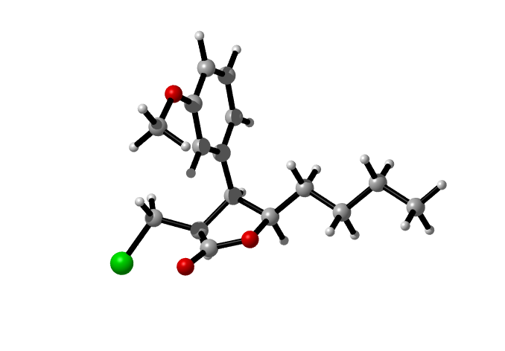

TS3c2-8-1
C -1.50805274 0.88579794 0.00000000
O -1.96300074 0.63751194 -1.40359200
C -2.83005474 -1.07976706 -0.11450200
C -1.57210874 -0.51239606 0.62855900
H -2.30921974 1.50880094 0.42532000
H -3.71309674 -0.59333306 0.34985900
H -1.81444474 -0.41002806 1.69259800
C -2.69180174 -0.39910106 -1.44836800
O -3.20898974 -0.71831306 -2.55700100
C -3.07384274 -2.55618106 -0.11329500
H -3.28067474 -3.02004506 0.85647600
Cl -2.16135374 -3.55175506 -1.18751600
C -0.21015874 1.64857494 -0.01731000
H 0.11311926 1.71911694 1.03448000
H 0.56366326 1.07547894 -0.54643700
C -0.35206874 3.04280594 -0.62211100
H -0.72566174 2.95603994 -1.65610600
H -1.11419874 3.60928794 -0.06050700
C 0.96341826 3.81481194 -0.62331000
H 1.33587926 3.89369794 0.41149200
H 1.71948626 3.23556394 -1.17887400
C 0.82789726 5.20421594 -1.23260400
H 0.09853126 5.81114094 -0.67444000
H 1.78668626 5.74191394 -1.22607800
H 0.48251426 5.14503694 -2.27619400
C -0.34741774 -1.38921106 0.48298400
C 0.03540226 -2.17312406 1.56906600
C 0.34556226 -1.49490706 -0.73425500
C 1.10851626 -3.06333906 1.44373700
H -0.50455874 -2.09251706 2.51441700
C 1.41601626 -2.38555706 -0.85386300
H 0.05183926 -0.89488406 -1.59538300
C 1.79540726 -3.17399906 0.24582200
H 1.40773126 -3.67597106 2.29574200
H 2.63293826 -3.86262206 0.12648200
H -3.89515474 -1.46263806 -2.48744800
C 1.77507026 -1.79804006 -3.12106700
H 0.74146326 -2.01256906 -3.43814800
H 1.88118626 -0.71679306 -2.93509600
H 2.46458526 -2.09417706 -3.91917700
O 2.12837326 -2.55203206 -1.98286100
C -7.16397574 1.34947794 0.12496500
C -6.71395874 1.35601194 -1.19522200
C -6.21930374 0.18732394 -1.77478900
C -6.18730574 -0.99449506 -1.02574000
C -6.65768274 -1.01051706 0.29326000
C -7.13452774 0.16657494 0.86672700
H -7.54444374 2.26688494 0.57647800
H -6.74244074 2.27561694 -1.78165600
H -5.86354474 0.19675894 -2.80716500
H -6.64864174 -1.93963206 0.86649100
H -7.49436174 0.15599294 1.89671400
S -5.54919274 -2.48946606 -1.76613600
H -4.52353874 -2.71103506 -0.74990600

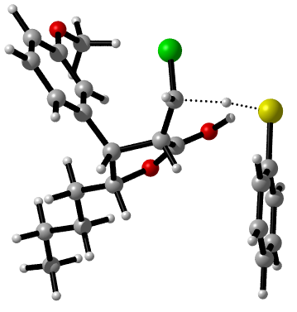

TS3c2-8-2
C -0.60029284 0.05124451 0.00000000
O 0.15370316 0.12022651 1.30640500
C 1.28927116 -1.37143349 -0.03664600
C -0.17398084 -1.31697349 -0.56504700
H -0.14441584 0.85323651 -0.59881900
H 1.86505016 -0.64238649 -0.64225300
H -0.14558984 -1.23879749 -1.65793800
C 1.14517516 -0.66445749 1.26355700
O 1.92881916 -0.81560449 2.25140200
C 2.09855516 -2.64403649 -0.05108000
H 2.14016916 -3.08741149 -1.05368400
Cl 1.65912616 -3.87920849 1.12561200
C -2.05563884 0.33341551 0.25600900
H -2.57133584 0.13230851 -0.69830200
H -2.45823484 -0.38314249 0.98596500
C -2.32098884 1.76673151 0.70769300
H -1.75671284 1.97287651 1.63310700
H -1.94215384 2.46714251 -0.05573300
C -3.80394684 2.03031751 0.95266800
H -4.36538984 1.80937151 0.02970300
H -4.17352184 1.32451451 1.71505200
C -4.08385084 3.46067251 1.39665600
H -3.75019084 4.18325951 0.63602700
H -5.15755184 3.62554351 1.56704200
H -3.55589784 3.69442551 2.33413300
C -1.03070284 -2.50752349 -0.18912900
C -1.40261884 -3.39793649 -1.19435100
C -1.40731984 -2.76067849 1.14092200
C -2.14517884 -4.54210949 -0.87559200
H -1.11186584 -3.20368849 -2.22862000
C -2.14738784 -3.90330449 1.45241300
H -1.11544584 -2.08144249 1.94233600
C -2.51813984 -4.79824249 0.43442500
H -2.43485484 -5.23814149 -1.66462000
H -3.09525684 -5.68500149 0.70099800
C -2.16967084 -3.37831349 3.77102800
H -1.07324984 -3.31656449 3.86285700
H -2.58718884 -2.36645049 3.64534400
H -2.58277184 -3.82783049 4.68033900
O -2.54348484 -4.22187149 2.70181000
H 3.20326216 -2.37800449 0.22032600
C 7.16502816 -1.30174049 0.89479700
H 7.04256516 -2.32527949 0.53368200
C 6.16666916 -0.42546049 1.02417600
H 6.31312216 0.59941051 1.37379400
Cl 8.79426716 -0.88713449 1.27193400
C 4.76802516 -0.77908549 0.65271800
O 3.93583416 0.03550551 0.32119300
O 4.54669616 -2.07375349 0.75856400
H 1.70023716 -0.24958349 3.02362100
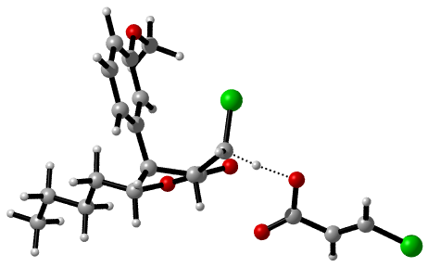

IM4c2-8
C -0.19033675 -1.16398241 0.00000000
O -0.60927375 -1.64175241 1.37300000
C -2.56655075 -1.44159941 0.14422600
C -1.49654675 -0.55529741 -0.54940000
H 0.05286425 -2.10027341 -0.52579400
H -2.61624675 -2.41476441 -0.38461200
H -1.52764275 -0.72996241 -1.63242200
C -1.86673575 -1.76031041 1.42156700
O -2.45237775 -2.12661141 2.49292800
C -3.97829975 -0.88145441 0.25535800
H -4.28935575 -0.51052241 -0.72858000
H -4.03863975 -0.05476841 0.97177700
Cl -5.12799675 -2.14688141 0.75901600
C 1.02574925 -0.28927841 0.13476800
H 1.20801825 0.12904759 -0.87043400
H 0.79037725 0.57013159 0.78043400
C 2.26345425 -1.03250141 0.63157400
H 2.05956825 -1.47067941 1.62325400
H 2.48283325 -1.87705141 -0.04412900
C 3.48818125 -0.12517541 0.72315000
H 3.68338925 0.31623459 -0.26786300
H 3.26213125 0.71862259 1.39562200
C 4.72886825 -0.86107741 1.21489300
H 4.99190325 -1.68895741 0.54024700
H 5.59449225 -0.18817141 1.27025600
H 4.56865225 -1.28297241 2.21810700
C -1.67889575 0.92671159 -0.29414300
C -1.78377475 1.78891959 -1.37898300
C -1.75015775 1.43835659 1.01600000
C -1.95683975 3.16483359 -1.16510300
H -1.73269775 1.39926659 -2.39721500
C -1.92341175 2.80940459 1.22334500
H -1.65782775 0.78142659 1.88277700
C -2.02715775 3.67434159 0.11761200
H -2.03903875 3.83870759 -2.01850300
H -2.16396175 4.73889559 0.30829000
O -2.00086275 3.38498459 2.43256800
C -1.91228475 2.58797559 3.58789700
H -2.73247175 1.85168259 3.62623300
H -0.94062675 2.06921959 3.63929300
H -2.00138575 3.26598659 4.44197400
H -1.83374575 -2.31920341 3.22385500
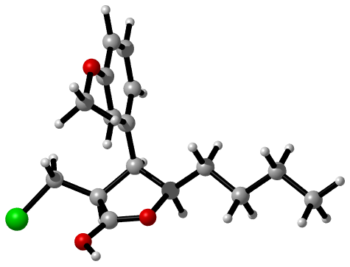

IM5c2-8a
C -0.26501768 0.95406359 0.00000000
O 0.37966232 0.62945859 1.23227700
C 0.75205932 -1.14826641 -0.25681800
C -0.56853168 -0.43412941 -0.61085800
H 0.46062232 1.45371159 -0.66652700
H 1.47744132 -0.84685341 -1.02430300
H -0.67789668 -0.34989741 -1.69886100
C 1.19505532 -0.46702241 1.07724400
O 1.08584832 -1.23238841 2.20122500
C 0.70716632 -2.65886241 -0.21336900
H 0.31132032 -3.06307641 -1.15276500
H 0.11969432 -3.04563441 0.62602500
Cl 2.37007532 -3.31724841 -0.01107300
C -1.42693668 1.88411659 0.26889200
H -1.98170368 2.01507759 -0.67565200
H -2.11408968 1.40903959 0.98767900
C -0.97935568 3.24121459 0.80389200
H -0.39672868 3.08780759 1.72689600
H -0.29452468 3.71121759 0.07738400
C -2.14641668 4.18208259 1.08524200
H -2.73067768 4.31981959 0.15980100
H -2.82727568 3.70510259 1.81015600
C -1.69672368 5.53701659 1.61685700
H -1.04064868 6.04638259 0.89434100
H -2.55273168 6.19748959 1.81661500
H -1.13268868 5.42416059 2.55546200
C -1.83407568 -1.02657441 -0.04380000
C -2.99872268 -1.06802841 -0.87212700
C -1.93510668 -1.45156241 1.26153900
C -4.24424468 -1.53158441 -0.39435400
H -2.91748668 -0.72716041 -1.90609600
C -3.19336468 -1.91677541 1.74908900
H -1.07650768 -1.42488041 1.93267400
C -4.35682468 -1.95517441 0.90159800
H -5.10591268 -1.54782041 -1.06137300
H -5.29091168 -2.32191841 1.32813900
O -3.37507868 -2.32454541 2.96349200
C -2.30238268 -2.34360741 3.92155900
H -1.50682068 -3.01181041 3.56685500
H -1.92059368 -1.32451041 4.06463100
H -2.74288768 -2.72487141 4.84581800
C 6.03476932 -0.14908441 1.43769900
H 6.14644432 -0.97958241 2.13898000
C 4.84576332 0.25031559 0.98363200
H 4.72528832 1.07794159 0.28386900
Cl 7.50767832 0.59683559 0.96850900
C 3.63828332 -0.46697741 1.44642100
O 2.53815232 0.04656259 0.89229200
O 3.64939532 -1.39646641 2.22464500
H 1.94894432 -1.67079041 2.37105000
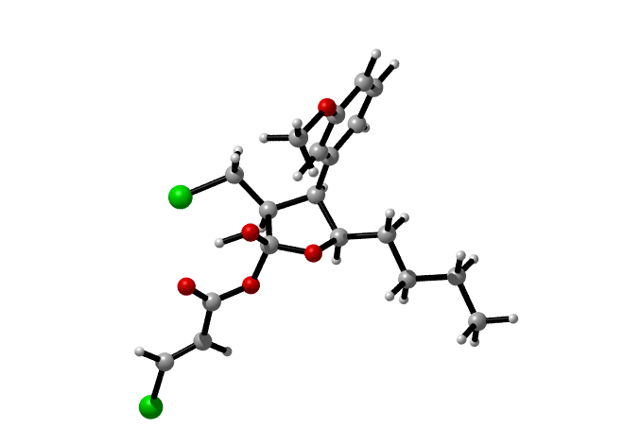

IM5c2-8b
C -0.79488563 0.38241067 -0.34380872
O -0.04546696 0.14739998 0.87104877
C -0.84293886 -1.84949929 -0.17817855
C -1.83054582 -0.74910149 -0.28986333
H -0.17103284 0.27089399 -1.20591731
H -0.29017777 -1.86515163 -1.09423649
H -2.46197334 -0.81733780 -1.15104380
C 0.05214938 -1.32174444 0.96046364
O -0.41535014 -1.68783186 2.26137860
C -1.40064332 -3.26328831 0.07029172
H -2.03292805 -3.54573353 -0.74534181
H -1.96621362 -3.26901566 0.97862046
Cl -0.06760130 -4.40493328 0.20184104
C -1.42647282 1.78626895 -0.38556579
H -2.00728320 1.89010553 -1.27822733
H -2.05790623 1.91914610 0.46797381
C -0.31214089 2.84950545 -0.37089397
H 0.26844862 2.74500799 0.52181867
H 0.31910643 2.71619150 -1.22458693
C -0.94136141 4.25450944 -0.41238820
H -1.52138820 4.35911087 -1.30532579
H -1.57287072 4.38762771 0.44094704
C 0.17319152 5.31739209 -0.39678254
H 0.80499959 5.18432765 -1.24998213
H -0.26435111 6.29346501 -0.42573436
H 0.75318813 5.21294730 0.49630401
C -2.75105062 -0.64047585 0.94022918
C -4.00776094 -0.03134542 0.82262561
C -2.33264265 -1.15031165 2.17677680
C -4.84581819 0.06824930 1.94133220
H -4.32750120 0.35774058 -0.12155684
C -3.17067981 -1.05039164 3.29564881
H -1.37348510 -1.61577842 2.26659807
C -4.42714622 -0.44106360 3.17792308
H -5.80542686 0.53317837 1.85127910
H -5.06692035 -0.36482279 4.03221522
O -2.74403359 -1.57009794 4.55759814
C -1.87094414 -2.68239617 4.34450569
H -2.39015938 -3.44427975 3.80168082
H -1.01734341 -2.36350525 3.78367462
H -1.55214152 -3.07170419 5.28887519
H 0.16272371 -1.30871049 2.92765283
C 4.43481990 -0.33355885 3.94884871
C 3.34477246 0.42578314 3.50244249
C 2.52555452 -0.06496138 2.54103960
C 2.76831957 -1.33163378 1.99300188
C 3.85846670 -2.09101000 2.43921254
C 4.67767225 -1.60031652 3.40070959
H 5.08153668 0.05387474 4.70805182
H 3.15938252 1.39297281 3.92072031
H 1.69316793 0.51467039 2.20017655
H 4.04394305 -3.05802976 2.02077177
H 5.50985702 -2.18003283 3.74154576
S 1.69167558 -1.97535327 0.73031874
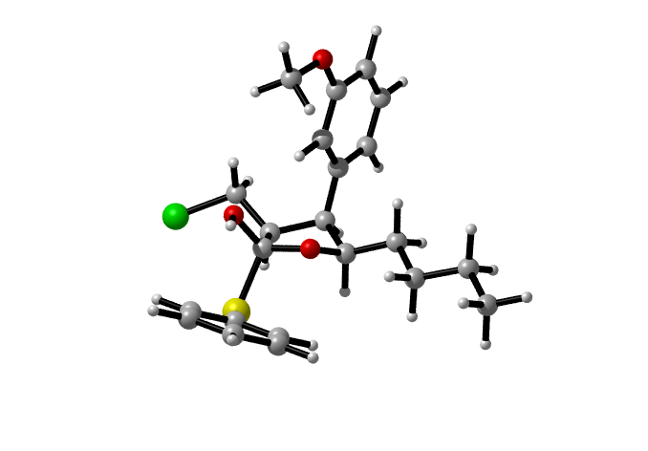

IM5c2-8c
C -2.19081279 -1.60777383 0.00000000
O -1.54613279 -1.93237883 1.23227700
C -1.17373579 -3.71010383 -0.25681800
C -2.49432679 -2.99596683 -0.61085800
H -1.46517279 -1.10812583 -0.66652700
H -0.44835379 -3.40869083 -1.02430300
H -2.60369179 -2.91173483 -1.69886100
C -0.73073979 -3.02885983 1.07724400
O -0.83994679 -3.79422583 2.20122500
C -1.21862879 -5.22069983 -0.21336900
H -1.61447479 -5.62491383 -1.15276500
H -1.80610079 -5.60747183 0.62602500
Cl 0.44428021 -5.87908583 -0.01107300
C -3.35273179 -0.67772083 0.26889200
H -3.90749879 -0.54675983 -0.67565200
H -4.03988479 -1.15279783 0.98767900
C -2.90515079 0.67937717 0.80389200
H -2.32252379 0.52597017 1.72689600
H -2.22031979 1.14938017 0.07738400
C -4.07221179 1.62024517 1.08524200
H -4.65647279 1.75798217 0.15980100
H -4.75307079 1.14326517 1.81015600
C -3.62251879 2.97517917 1.61685700
H -2.96644379 3.48454517 0.89434100
H -4.47852679 3.63565217 1.81661500
H -3.05848379 2.86232317 2.55546200
C -3.75987079 -3.58841183 -0.04380000
C -4.92451779 -3.62986583 -0.87212700
C -3.86090179 -4.01339983 1.26153900
C -6.17003979 -4.09342183 -0.39435400
H -4.84328179 -3.28899783 -1.90609600
C -5.11915979 -4.47861283 1.74908900
H -3.00230279 -3.98671783 1.93267400
C -6.28261979 -4.51701183 0.90159800
H -7.03170779 -4.10965783 -1.06137300
H -7.21670679 -4.88375583 1.32813900
O -5.30087379 -4.88638283 2.96349200
C -4.22817779 -4.90544483 3.92155900
H -3.43261579 -5.57364783 3.56685500
H -3.84638879 -3.88634783 4.06463100
H -4.66868279 -5.28670883 4.84581800
C 4.10897421 -2.71092183 1.43769900
H 4.22064921 -3.54141983 2.13898000
C 2.91996821 -2.31152183 0.98363200
H 2.79949321 -1.48389583 0.28386900
Cl 5.58188321 -1.96500183 0.96850900
C 1.71248821 -3.02881483 1.44642100
O 0.61235721 -2.51527483 0.89229200
O 1.72360021 -3.95830383 2.22464500
H 0.02314921 -4.23262783 2.37105000
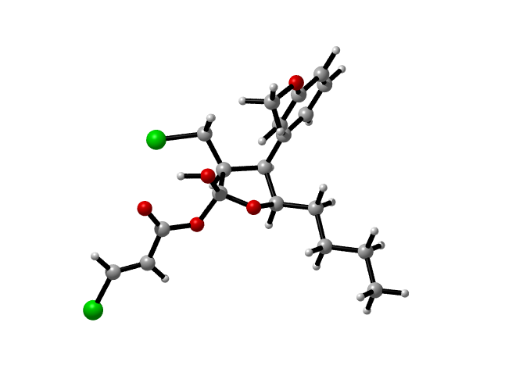

TS4c2-8a
C -1.45907480 -1.86832737 0.00000000
O -1.96647480 -2.70809937 -1.05280600
C 0.15626320 -2.17723437 -1.81013800
C -0.01354580 -1.43940437 -0.45463400
H -1.37452780 -2.53105437 0.87221900
H 0.67220820 -3.12914337 -1.60157900
H 0.69321320 -1.88430437 0.25453400
C -1.24355580 -2.61870737 -2.15613600
O -1.44990180 -3.42232837 -3.11886700
C 0.90243920 -1.50453437 -2.94279900
H 1.00059120 -2.20116637 -3.78400000
Cl 2.54969720 -1.05362337 -2.40270700
C -2.44634180 -0.76072337 0.31938400
H -2.06009580 -0.20059437 1.18846300
H -2.48841980 -0.05540637 -0.52091000
C -3.85453480 -1.27575537 0.60079900
H -4.19424080 -1.87488237 -0.25982600
H -3.83529780 -1.96201937 1.46428900
C -4.84649180 -0.14548237 0.86153100
H -4.50280180 0.45266663 1.72215600
H -4.84986280 0.53958963 -0.00499000
C -6.26008880 -0.65412937 1.11478000
H -6.28858080 -1.31534137 1.99299900
H -6.95854580 0.17346363 1.29494000
H -6.63071680 -1.22799237 0.25277300
C 0.31182420 0.03790263 -0.48443500
C 1.36048820 0.50038263 0.37479400
C -0.27651880 0.93889963 -1.34576200
C 1.80779520 1.83871363 0.37201300
H 1.83507520 -0.21503437 1.04918100
C 0.19520320 2.28490263 -1.37788800
H -1.05887380 0.59855863 -2.02635100
C 1.23990220 2.73367063 -0.49247000
H 2.60681920 2.14624063 1.04650900
H 1.54738020 3.77803763 -0.55750300
H -2.46493880 -3.20967937 -3.45929100
C -3.98395680 0.95896763 -2.79496700
H -3.21047980 1.04458663 -2.03024000
C -4.08028880 -0.12032337 -3.56962100
H -4.87976980 -0.25541437 -4.29970300
Cl -5.03475480 2.31276863 -2.86705700
C -3.13844580 -1.25647137 -3.37193100
O -3.50650380 -2.38657537 -3.73158400
O -2.00530280 -1.01300637 -2.81438900
O -0.24128580 3.19258963 -2.19280800
C -1.26693180 2.96708763 -3.17021300
H -1.16616280 1.97447763 -3.62780000
H -2.24765180 3.08325263 -2.68833400
H -1.13243580 3.75141263 -3.91999300
H 0.40045320 -0.59873637 -3.29839500
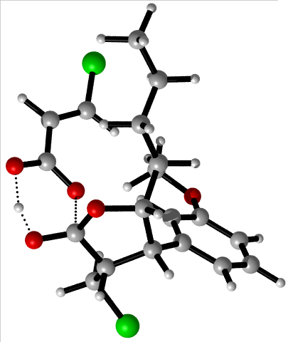

TS4c2-8b
C -1.52866239 -0.35031847 0.00000000
O -1.29934439 -0.70826047 1.40045700
C -2.82341639 -2.25154547 0.55068700
C -2.92300839 -0.94747047 -0.27952800
H -0.76541139 -0.92098747 -0.55980900
H -2.30421839 -3.01446847 -0.04876500
H -3.00775039 -1.18708747 -1.34666100
C -1.85187539 -1.84915347 1.63971700
O -1.80128339 -2.36178847 2.81889300
C -4.10089839 -2.86318347 1.09890200
H -4.68157439 -2.15331847 1.69820300
H -3.87604339 -3.75227547 1.69793500
Cl -5.14759739 -3.37623847 -0.26197700
C -1.31797839 1.13200353 -0.17991200
H -1.61692539 1.37803853 -1.21313700
H -2.00446339 1.68231953 0.48161400
C 0.12823861 1.54537353 0.07351200
H 0.42739361 1.22172753 1.08418300
H 0.79293161 1.00205653 -0.61969500
C 0.35332661 3.04672453 -0.07298100
H 0.05269661 3.36456953 -1.08580100
H -0.31121039 3.58360953 0.62479300
C 1.80162861 3.44649553 0.18512300
H 2.47967461 2.93488453 -0.51486100
H 1.95007261 4.52949053 0.07185600
H 2.10885061 3.16462153 1.20363200
C -4.07709239 -0.04406347 0.10484500
C -5.01722439 0.31284953 -0.85751800
C -4.21831839 0.43864953 1.41893500
C -6.08864339 1.14836853 -0.51871600
H -4.92247339 -0.06952647 -1.87505000
C -5.28943339 1.27013853 1.75171700
H -3.48472639 0.17796353 2.18097300
C -6.23094339 1.62720153 0.77307000
H -6.82230539 1.42206653 -1.27820300
H -7.05798839 2.27652753 1.06043100
O -5.49138839 1.77308353 2.98832800
C -4.58133539 1.44517253 4.00927300
H -4.55376439 0.35782053 4.18798400
H -3.56520039 1.79777653 3.76845400
H -4.93352739 1.95042353 4.91421000
H -0.81885339 -2.80632347 2.76273900
C 3.34120861 0.15178553 1.05464700
C 2.65486361 -0.07434847 2.24844500
C 1.73297161 -1.11565247 2.34892500
C 1.47933261 -1.96206247 1.25583300
C 2.17480461 -1.72114647 0.05681100
C 3.09306061 -0.67734647 -0.04100000
H 4.06582961 0.96417053 0.97975100
H 2.84062161 0.56350553 3.11523400
H 1.21099661 -1.28997547 3.29191900
H 1.99737261 -2.38018347 -0.79563900
H 3.62563261 -0.51586247 -0.98062500
S 0.33980761 -3.30603247 1.35553900
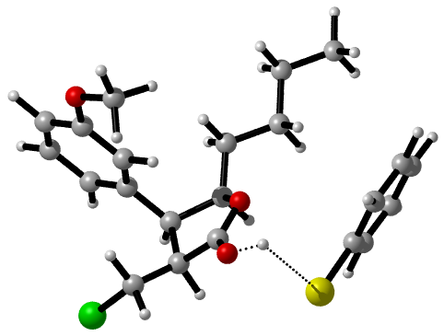

TS4c2-8c
C -0.51601426 1.37010674 0.00000000
O -1.10316626 0.29491874 -0.77612600
C 0.91012074 0.66409574 -1.87360800
C 0.91486174 1.57212574 -0.60751400
H -0.42968026 0.95915874 1.01424000
H 1.49120774 -0.24440126 -1.64453400
H 1.60982774 1.10721774 0.09969700
C -0.50104126 0.14923074 -1.93605800
O -0.83597226 -0.83782326 -2.67897100
C 1.41506474 1.17991474 -3.20555100
H 1.22467274 0.43078074 -3.98368700
Cl 3.19087874 1.44352674 -3.14340700
C -1.46215826 2.55933374 0.04040600
H -1.05276926 3.27786674 0.76929700
H -1.48429726 3.06715574 -0.93147700
C -2.88806026 2.17276974 0.42059400
H -3.28475226 1.46911374 -0.33168600
H -2.89081026 1.62730674 1.38067800
C -3.81167226 3.38387074 0.51410900
H -3.44858226 4.05724074 1.30847300
H -3.74698326 3.95899374 -0.42600900
C -5.26227726 3.00169574 0.77761300
H -5.35836126 2.43649174 1.71756400
H -5.90799326 3.88868974 0.85085300
H -5.65296926 2.36710374 -0.03319600
C 1.39957074 2.99990574 -0.76920600
C 2.48711474 3.41358874 0.00425400
C 0.81947474 3.90632274 -1.67390000
C 2.99844874 4.70725574 -0.12544000
H 2.94607674 2.71399974 0.70530200
C 1.32999274 5.20368174 -1.79441800
H -0.02363126 3.58477074 -2.28460400
C 2.42954174 5.60167074 -1.01946500
H 3.85196774 5.01775174 0.47985300
H 2.80854874 6.61772874 -1.13740200
H -1.89394226 -0.65716326 -2.88295500
C -3.14450426 3.63389674 -3.25996900
H -2.12728826 3.89090274 -2.96329200
C -3.53323326 2.36879774 -3.40864500
H -4.54492826 2.08308774 -3.70033200
Cl -4.16915326 4.99447774 -3.50901200
C -2.56213426 1.27762174 -3.12542800
O -2.99233726 0.09845774 -3.13194600
O -1.35826326 1.59067474 -2.86221800
O 0.83072174 6.13822574 -2.63294600
C -0.39809626 5.88679574 -3.26998500
H -0.34230826 5.01731874 -3.94587200
H -1.19764526 5.72941374 -2.52605000
H -0.63589726 6.77874174 -3.86122100
H 0.95837774 2.12713574 -3.50086700
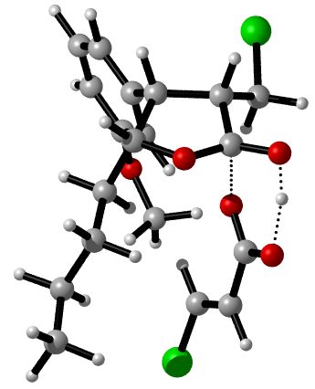

R1+PhSSPh (PBE1PBE-D3/ma-def2-SVP)
C -14.69830534 4.90157126 1.34959907
C -15.67075034 5.88827326 1.20050507
C -16.71650234 5.97550326 2.12378507
C -16.78978034 5.07732926 3.19410407
C -15.81894234 4.08798926 3.33198707
C -14.77315834 4.00140126 2.41269707
H -13.87152134 4.84292126 0.64011607
H -15.62341234 6.60162326 0.37656407
H -17.60169934 5.16117026 3.91929507
H -15.87504634 3.39098226 4.16942307
H -14.00903034 3.23007326 2.52731707
S -17.94048534 7.26504326 1.96433207
S -19.52640534 6.20610426 1.08689607
C -20.06282734 5.23317626 2.48267407
C -19.89662434 3.84724926 2.44601307
C -20.61640034 5.84399926 3.61364707
C -20.28545134 3.07199726 3.54020207
H -19.44277134 3.38668526 1.56706007
C -20.98650734 5.06826626 4.70799807
H -20.73739534 6.92877526 3.62841107
C -20.82272334 3.68054726 4.67216807
H -20.15181934 1.98957726 3.51082507
H -21.41430934 5.54540226 5.59128007
H -21.11621134 3.07478926 5.53088807
C -14.01918834 7.02018426 4.06193007
C -15.23077734 7.56494326 4.49430807
C -15.74550534 8.71044026 3.87519707
C -15.04119234 9.28065826 2.81314007
C -13.84339434 8.73202426 2.37319607
C -13.31760334 7.58654926 2.99611507
H -13.65545334 6.13300826 4.58102207
H -16.68758734 9.15157726 4.19649507
H -15.44736634 10.16730226 2.32361707
H -13.30576234 9.18517926 1.53827607
C -12.05939734 7.01010926 2.48841207
H -11.52224534 7.62686926 1.75886807
C -11.54224134 5.81923726 2.81554107
H -12.07637934 5.18222526 3.53066807
C -10.24598034 5.27886526 2.29309907
H -10.42605734 4.31688626 1.78065907
H -9.83341634 5.96751626 1.53806007
C -9.21447834 5.05184426 3.40240507
H -9.02635034 6.00851026 3.91811807
H -9.63978134 4.37374026 4.16285007
C -7.89788134 4.47590526 2.89041407
H -8.09760234 3.52380926 2.37047207
H -7.47931134 5.15591526 2.12971607
C -6.87748534 4.25408626 4.00077207
H -5.93605734 3.84275126 3.61061007
H -6.64482334 5.19839326 4.51533207
H -7.26413634 3.55269326 4.75545107
O -15.85271034 6.91133626 5.50252307
C -17.13441534 7.34477626 5.88027407
H -17.49480834 6.63895326 6.63763507
H -17.10654434 8.35698326 6.31768407
H -17.82680034 7.34295726 5.02018307

NMA+PhSSPh (PBE1PBE-D3/ma-def2-SVP)
C -6.44433369 2.95663686 0.85499483
C -7.81920969 2.75142986 0.93035283
C -8.66327469 3.39437986 0.01928883
C -8.13545069 4.23513786 -0.96569517
C -6.75679769 4.43275886 -1.03655817
C -5.91370269 3.79532786 -0.12778617
H -5.78170769 2.45431486 1.56104283
H -8.24710369 2.09554286 1.69013883
H -8.80878969 4.72896486 -1.66924717
H -6.34168269 5.08613986 -1.80512217
H -4.83517869 3.94862886 -0.18585617
S -10.42734769 3.16092286 0.09873783
S -10.91871569 4.58991886 1.55842083
C -10.54773169 6.08526386 0.65754483
C -9.42124169 6.83319686 1.01381283
C -11.34048669 6.48524986 -0.42559017
C -9.09841569 7.98778686 0.29543683
H -8.78984669 6.49238186 1.83663283
C -11.00666069 7.62867086 -1.14709317
H -12.20556469 5.87998086 -0.70750417
C -9.88549269 8.38324086 -0.78509017
H -8.21296369 8.56402286 0.56792083
H -11.61726469 7.92728886 -2.00168817
H -9.61754069 9.27210886 -1.35851417
C -15.04479169 9.18818886 -1.53992517
C -14.24732169 9.14587586 -0.42158417
C -14.20715569 7.97467586 0.38236283
C -15.04022069 6.86971786 0.02268783
C -15.84064969 6.95207686 -1.15773217
C -15.84042169 8.08165286 -1.92870017
C -15.06721469 5.71606086 0.83513483
C -14.29496769 5.69162286 2.01047083
C -13.45706469 6.80587686 2.32854483
C -12.69967269 6.77080886 3.52922583
H -12.08085169 7.61316486 3.82583383
C -12.76860769 5.67146586 4.35189783
C -13.57554969 4.55093486 4.03307683
C -14.32182769 4.56425086 2.88754483
H -15.06863569 10.10240686 -2.13501517
H -13.68024669 10.03201386 -0.15099917
H -16.45677569 6.09060686 -1.41934517
H -16.45628269 8.14019986 -2.82581117
H -12.18536669 5.66751886 5.27397883
H -13.59951169 3.68995786 4.70046683
H -14.95635569 3.71932786 2.61595483
C -15.91678569 4.55379586 0.45479983
C -17.25175069 4.50535886 0.88872983
C -15.37043669 3.53851986 -0.35142217
C -18.03610769 3.41783186 0.49465683
C -16.19273469 2.47408486 -0.71935717
C -17.52824269 2.39541986 -0.30969417
H -19.07589369 3.37141586 0.82684283
H -15.77781669 1.68147986 -1.34725217
C -18.38392969 1.23061286 -0.72879317
H -17.98898869 0.29010686 -0.31746717
H -19.41834369 1.34671986 -0.38292717
H -18.39549969 1.12893186 -1.82328017
C -13.94090969 3.61393086 -0.82117017
H -13.81509169 4.41110086 -1.57292817
H -13.25196969 3.83280086 0.00996783
H -13.62409469 2.67143586 -1.28424217
C -17.82242769 5.60046886 1.75298583
H -17.26179369 5.69975286 2.69520883
H -17.77852369 6.57575586 1.24374783
H -18.87068669 5.39743786 2.00269583
N -13.39983069 7.88181386 1.48449583
C -12.39574769 8.91859786 1.75108383
H -12.75253569 9.61973886 2.51833083
H -11.46904269 8.43298186 2.07471783
H -12.16111069 9.44982486 0.82830683

R1+NMA (PBE1PBE-D3/ma-def2-SVP)
C -1.38790042 0.40925266 0.00000000
C -0.16583042 0.97678466 0.37451000
C 0.81321858 0.18701366 0.98478600
C 0.55435858 -1.16953634 1.19411200
C -0.64592242 -1.74038934 0.79634600
C -1.63167842 -0.95397834 0.17734200
H -2.13780242 1.06962466 -0.43768400
H 1.76922058 0.61283266 1.28274100
H 1.31726558 -1.79452534 1.66289300
H -0.81739842 -2.80924834 0.93445900
C -2.86191242 -1.60540034 -0.30694300
H -3.00540842 -2.63705634 0.03400900
C -3.77314542 -1.08083934 -1.13704600
H -3.64349142 -0.05420434 -1.50242700
C -5.00843942 -1.79045134 -1.60291400
H -4.98664742 -1.88590834 -2.70329500
H -5.01987242 -2.81555534 -1.19874600
C -6.29626542 -1.06337934 -1.20646300
H -6.33028942 -0.96439434 -0.10846100
H -6.27153642 -0.03389634 -1.60492800
C -7.55693342 -1.76656934 -1.69911800
H -7.50665142 -1.87127834 -2.79604800
H -7.57711442 -2.79328734 -1.29695300
C -8.83564642 -1.03487234 -1.30878500
H -9.73028342 -1.56135734 -1.66928000
H -8.91744442 -0.94262634 -0.21532800
H -8.85153542 -0.01788934 -1.72885600
O -0.00419642 2.29125966 0.08859700
C 1.17109158 2.92150366 0.54052300
H 1.11741258 3.96334166 0.20613200
H 1.23507658 2.88748866 1.64101300
H 2.07309558 2.45907766 0.10524100
C 2.81487258 3.43159666 -2.55507800
C 1.75803558 2.57495866 -2.68965500
C 1.88387358 1.19053766 -2.35275500
C 3.19735658 0.70455566 -1.90891800
C 4.26711558 1.64791866 -1.79230600
C 4.10151558 2.97118066 -2.07956000
C 3.34619958 -0.65946634 -1.62190000
C 2.25966058 -1.53242934 -1.73002700
C 0.98054258 -1.02555334 -2.25310700
C -0.04950142 -1.97861834 -2.52721400
H -0.98722742 -1.67720234 -2.98820700
C 0.11074658 -3.29988934 -2.21826600
C 1.32521958 -3.78856434 -1.60501400
C 2.35537358 -2.92301834 -1.39577400
H 2.68423458 4.48105866 -2.82300700
H 0.81656258 2.97016166 -3.06371900
H 5.23795758 1.27396766 -1.45853300
H 4.92887258 3.67238166 -1.97834700
H -0.69858042 -3.99625134 -2.44316800
H 1.41893158 -4.84186934 -1.34250300
H 3.29686558 -3.27710634 -0.96945900
C 4.69773658 -1.19527034 -1.27294000
C 5.47350258 -1.77985634 -2.29165200
C 5.19389958 -1.10804434 0.03701800
C 6.74085658 -2.27035534 -1.97323700
C 6.46649658 -1.61564634 0.31465900
C 7.25502658 -2.20235934 -0.67553600
H 7.34597258 -2.71937534 -2.76558200
H 6.85024758 -1.54801434 1.33616000
C 8.61228958 -2.77182834 -0.35561500
H 8.56010558 -3.86590734 -0.24326900
H 9.33215358 -2.55872934 -1.15794300
H 9.00785758 -2.35907434 0.58197800
C 4.36518958 -0.47822134 1.12489600
H 4.21470258 0.59629866 0.93255200
H 3.36926658 -0.94235834 1.16176100
H 4.84417858 -0.59190234 2.10579000
C 4.94695358 -1.87808934 -3.70017600
H 4.09543858 -2.57384634 -3.75219100
H 4.58539658 -0.90132234 -4.05416500
H 5.72705058 -2.23261934 -4.38590800
N 0.85712558 0.30693266 -2.50659700
C -0.41903242 0.85199366 -2.96874900
H -0.35821242 1.10791466 -4.03610400
H -1.21995942 0.13403766 -2.79686700
H -0.64338742 1.74808466 -2.37982700
4. The number of imaginary frequencies and Electronic Energy + Thermal Free Energy Correction for the optimized reactants, product and transition states obtained at the M06-2X-D3/ma-def2SVP level in the processes.
Table 1. The number of imaginary frequencies and the relative Gibbs free energy of transition states in the reaction of R1+R2 to P1.
Transition states | Imaginary frequency (cm⁻¹) | Electronic Energy + Thermal Free Energy Correction (a.u)
TS1 | -246.64 | -1306.565954
TS2c1-1 | -1879.46 | -1936.094226
TS2c1-2 | -108.35 | -1936.099375
TS2c1-3 | -2078.92 | -2032.433771
TS2c1-4-1 | -593.30 | -2032.444726
TS2c1-4-2 | -100.29 | -2032.417240
TS3c1-3 | -920.84 | -2032.437628
TS4c1 | -544.41 | -1306.162803
TS5c1 | -814.38 | -1936.156091
TS2c2 | -525.05 | -1306.549905
TS3c2-2 | -454.81 | -2032.456568
TS5c | -544.60 | -2032.451731
TS3c2-4 | -177.61 | -1936.108920
TS3c2-5 | -3123.39 | -1936.108589
TS3c2-6 | -463.64 | -2032.455373
TS3c2-7 | -2611.22 | -1306.536133
TS3c2-8-1 | -967.98 | -1936.540401
TS3c2-8-2 | -747.09 | -2032.833853
TS4c2-8a | -486.57 | -2032.869035
TS4c2-8b | -102.83 | -1936.761158
TS4c2-8c | -462.40 | -2033.103031

Table 2. The relative Gibbs free energy of reactants, intermediates and product in the reaction of R1 to IM1 at the PBE1PBE-D3/ma-def2-SVP level in the processes.
Names | Electronic Energy + Thermal Free Energy Correction (a.u)
R1 | -580.365778
NMA | -942.616701
¹NMA* | -942.515876
³NMA* | -942.547065
NMA• | -942.759338
(R1+NMA)* | -1522.912212
IM1 | -580.148417

Table 3. The relative Gibbs free energy of reactants, intermediates and product in the reaction of R1+R2 to P1 at the M06-2X-D3/ma-def2SVP level in the processes.
Names | Electronic Energy + Thermal Free Energy Correction (a.u)
R1 | -580.518412
R2 | -726.299886
R2-1 | -725.839193
NMA | -942.929236
NMA• | -943.078635
PhSSPh | -1258.757728
PhS• | -629.340100
PhS- | -629.512875
PhSH | -629.971064
P1 | -1306.848504
IM1 | -580.292868
IM2 | -1306.571504
IM3c1-1 | -1936.143399
IM3c1-2 | -1936.122890
IM3c1-3 | -2032.456385
IM3c1-4 | -2032.452085
IM4c1-3 | -2032.462631
IM5c1 | -1306.180499
IM6c1 | -1306.200865
IM3c2 | -1306.581172
IM4c2-1 | -1306.719434
IM4c2-2 | -2032.470801
BF₄- | -424.198497
BF₃ | -324.240946
HF | -100.349529
IM7c | -725.620744
IM4c2-4 | -1936.14290
IM4c2-5 | -1936.146706
IM4c2-6 | -2032.469250
IM4c2-7 | -1306.615071
IM4c2-8 | -1307.233479
IM5c2-8a | -2032.886996
IM5c2-8b | -1936.796451
IM5c2-8c | -2033.119088

- The Scan of partial transition states.

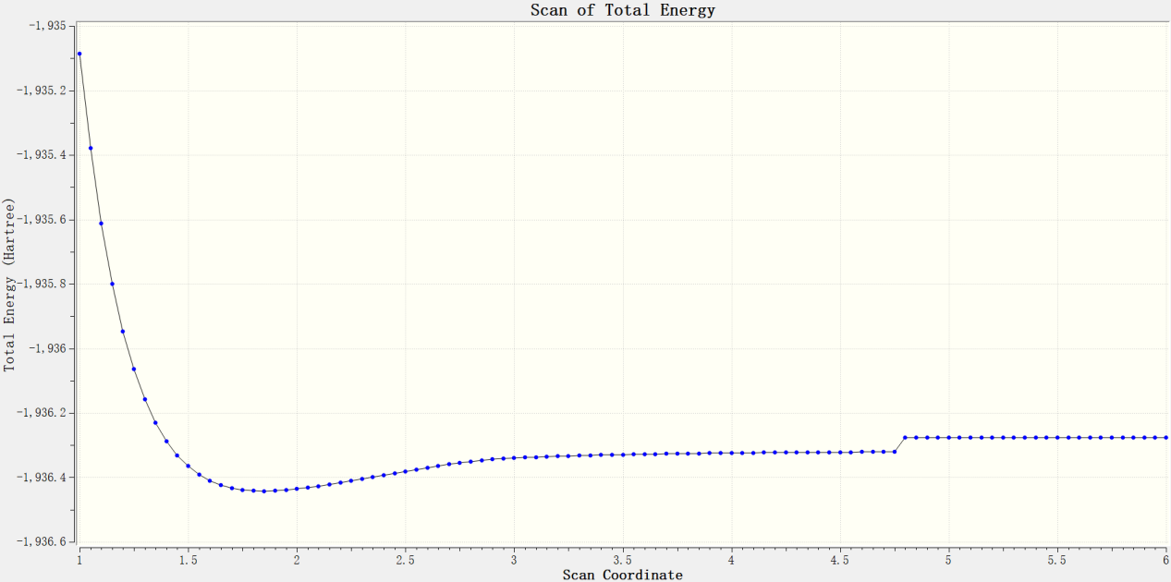Figure s5. The Scan of the electrophilic addition reaction of IM2 and PhS⁻ in Path c1-1.

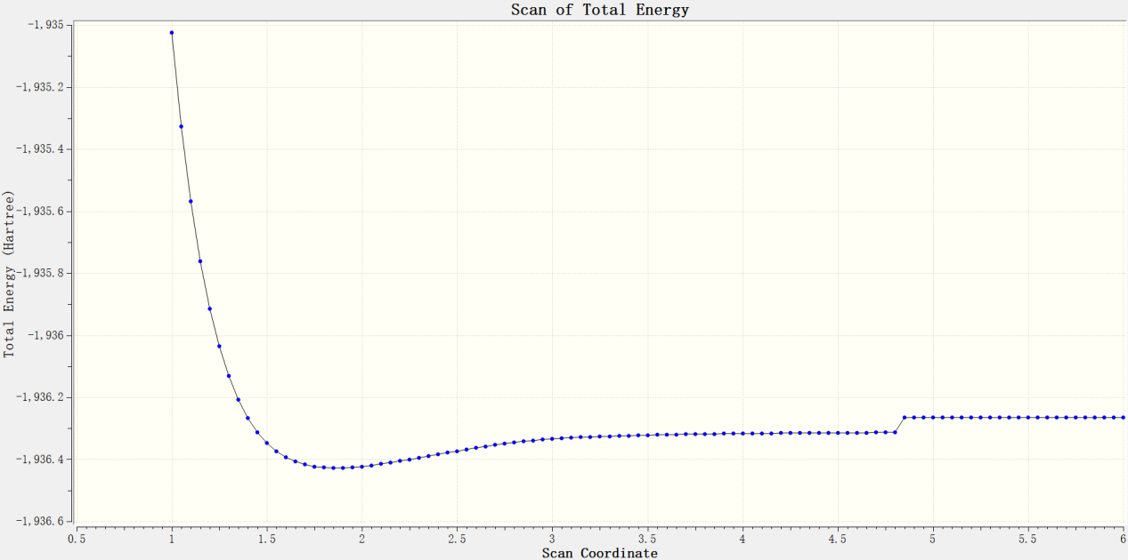
Figure s6.The Scan of the electrophilic addition reaction of IM2 and PhS⁻ in Path c1-2.

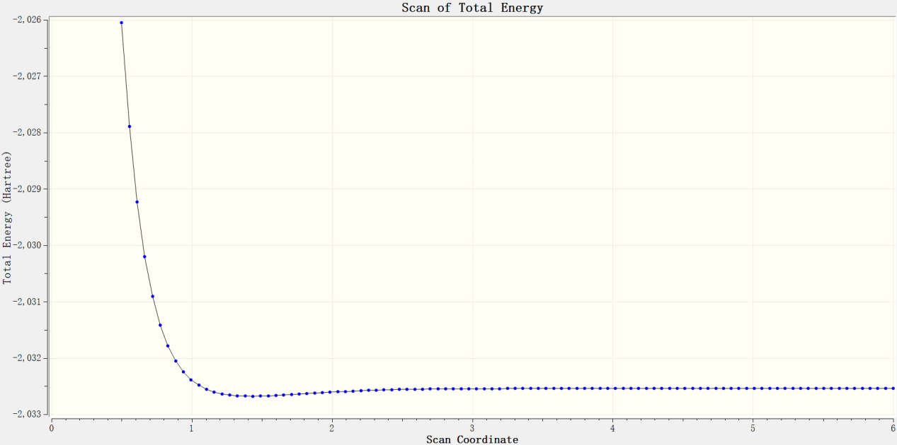
Figure s7. The Scan of the electrophilic addition reaction of IM2 and R2-1 in Path c1-3.

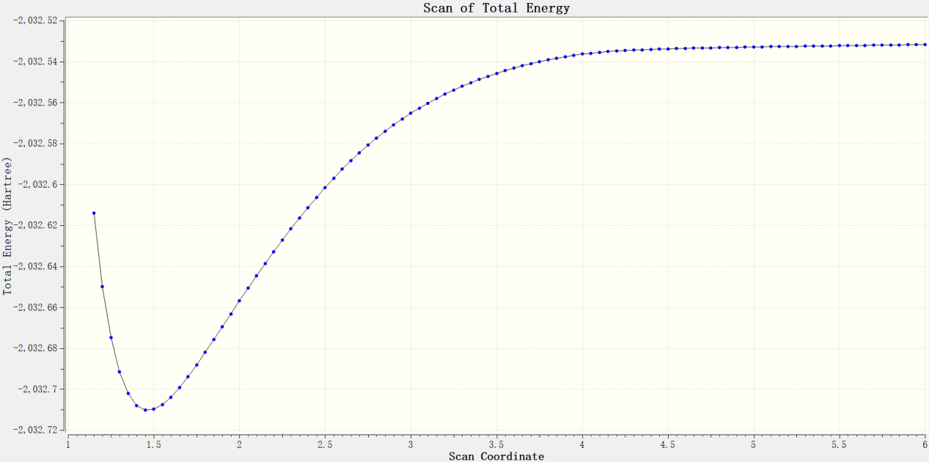
Figure s8. The Scan of the electrophilic addition reaction of IM2 and R2-1 in Path c1-4.

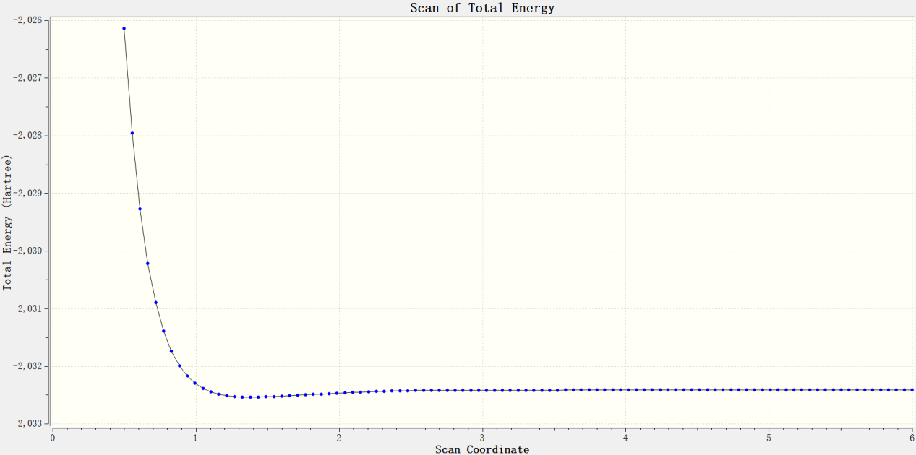Figure s9. The Scan of the electrophilic addition reaction of IM3c2 and R2-1 in Path c2-2.

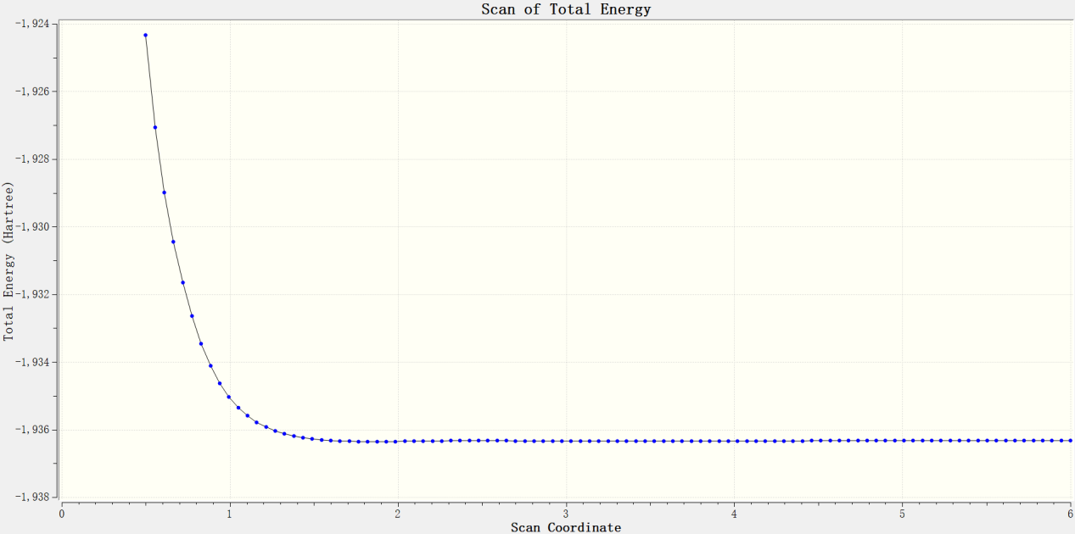
Figure s10. The Scan of the electrophilic addition reaction of IM3c2 and PhS⁻ in Path c2-4.

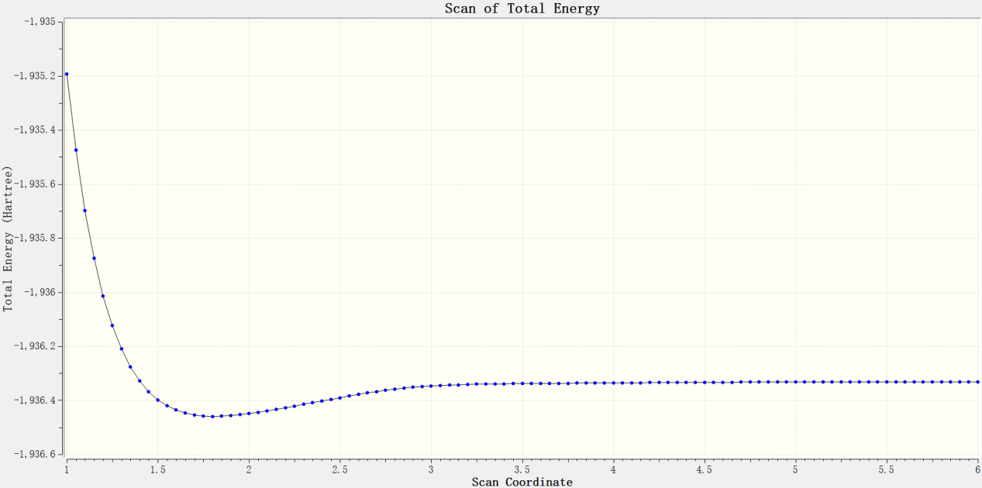Figure s11. The Scan of the electrophilic addition reaction of IM3c2 and PhS⁻ in Path c2-5.

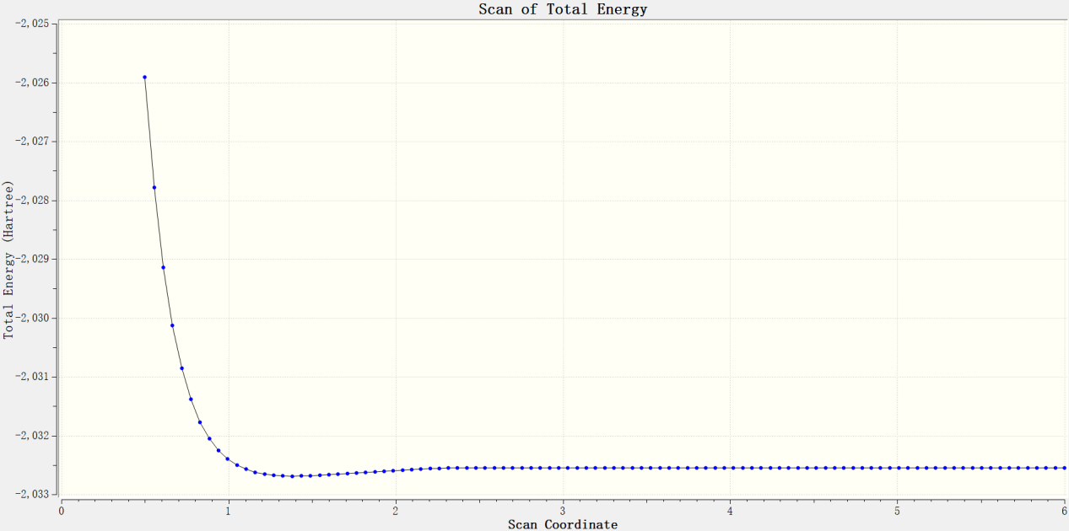
Figure s12. The Scan of the electrophilic addition reaction of IM3c2 and R2-1 in Path c2-6.

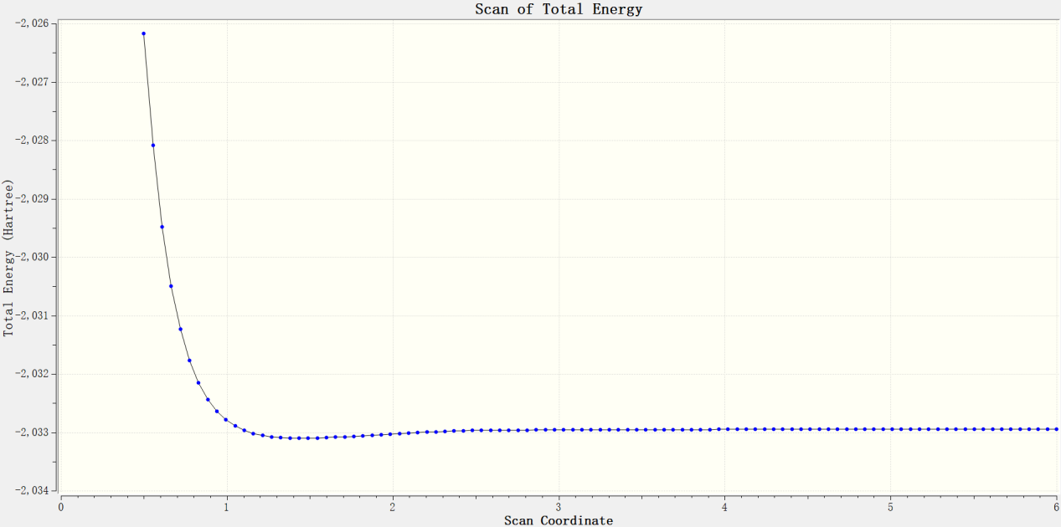Figure s13. The Scan of the electrophilic addition reaction of IM4c2-8 and IM7c in Path c2-8a.

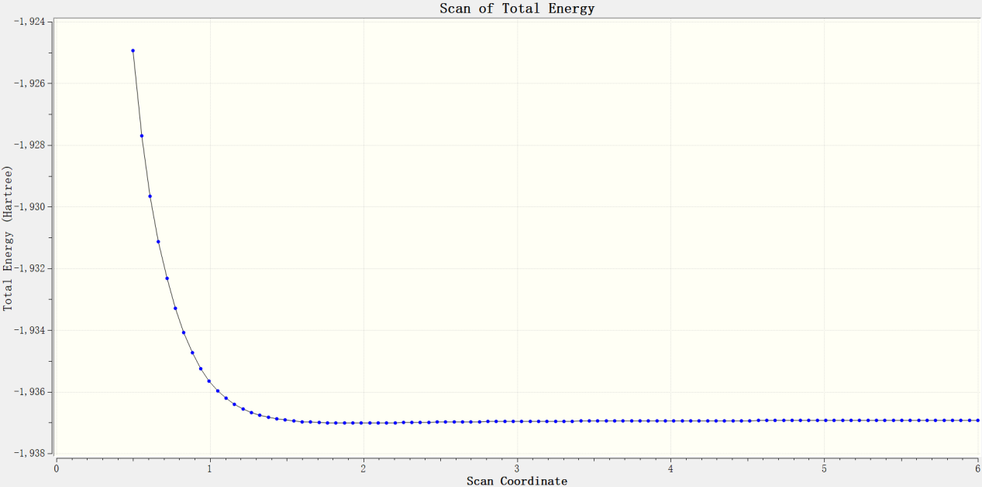
Figure s14. The Scan of the electrophilic addition reaction of IM4c2-8 and PhS⁻ in Path c2-8b.

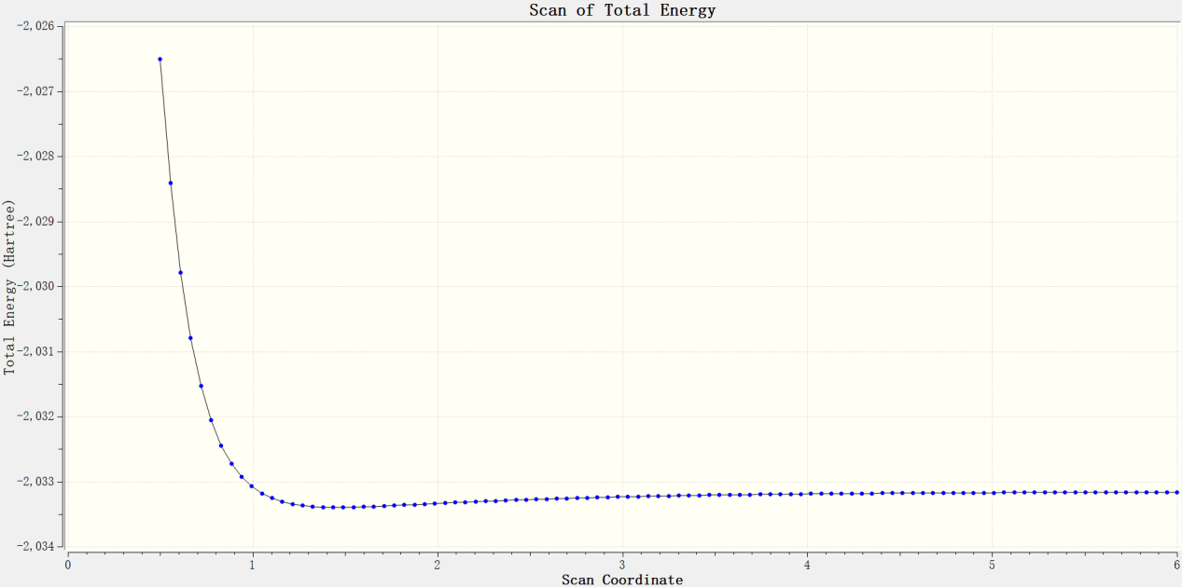Figure s15. The Scan of the electrophilic addition reaction of IM4c2-8 and R2-1 in Path c2-8c.

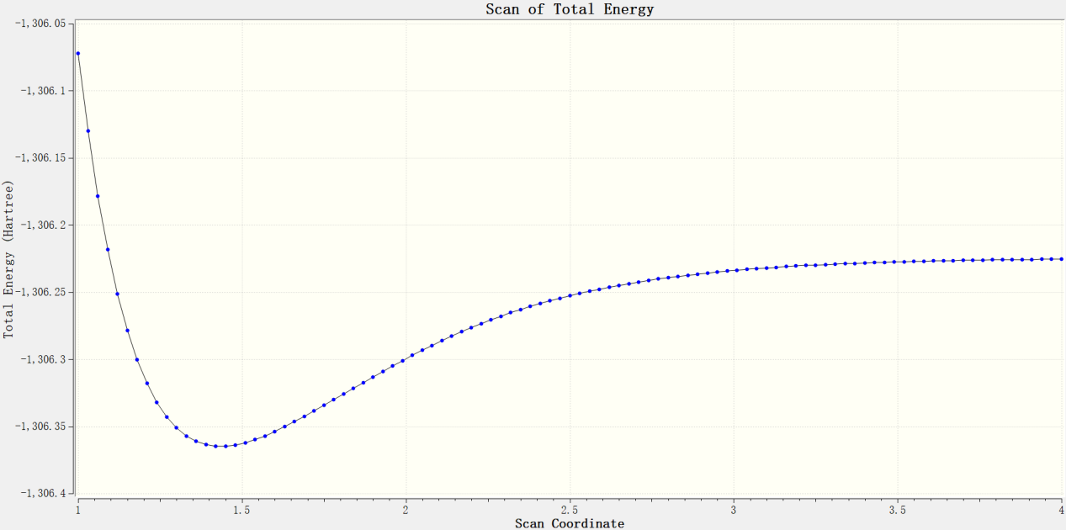
Figure s16. The Scan of the electrophilic addition reaction of R1 and IM7c in Path d.

