SUPPLENTARY MATERIAL

Table S1. Changes related to photosystem II activity in leaves of 31-day old rice plants exposed to multiple treatments (control, heat, salt, and salt + heat).
Φ PSII, effective quantum yield of PSII; qP, photochemical quenching; NPQ, non-photochemical quenching; and Fo, initial fluorescence of PSII.

Treatments | ФPSII | 1-qP | NPQ | F₀
Control | 0.34 a | 0.32 b | 0.44 a | 388.33 ab
Heat | 0.36 a | 0.28 b | 0.39 b | 376.01 b
Salt | 0.34 a | 0.33 b | 0.37 c | 391.50 ab
Salt + heat | 0.26 b | 0.44 a | 0.59 d | 383.52 ab
Different letters represent significant differences among treatments at a confidence level of 0.05. The data are presented as average from four replicates compared by the Tukey’s test.

Table S2. Activities of catalases (CAT), phenol peroxidases (GPOD), and glycolate oxidases (GO) and contents of reduced ascorbate (ASA) and glutathione (GSH) non-enzymatic antioxidant in leaves of 31-day old rice plants exposed to multiple treatments (control, heat, salt, and salt + heat).

Treatments | CAT | GPOD | GO | GSH | ASA
 | (µmol H₂O₂ mg⁻¹ prot min⁻¹) | (µmol pyrogallol mg⁻¹ prot min⁻¹) | (ηmol H₂O₂ mg⁻¹ prot min⁻¹) | (µmol g⁻¹ FW)
Control | 54.00 a | 4.83 c | 62.41 c | 1.29 a | 5.70 b
Heat | 47.00 b | 4.43 c | 77.53 a | 1.08 b | 7.09 a
Salt | 51.33 a | 6.90 b | 79.95 a | 0.64 c | 4.48 c
Salt + heat | 36.67 c | 7.73 a | 71.85 b | 0.49 d | 2.52 d
Different letters represent significant differences among treatments at a confidence level of 0.05. The data are averages of four replicates and compared by the Tukey’s test.

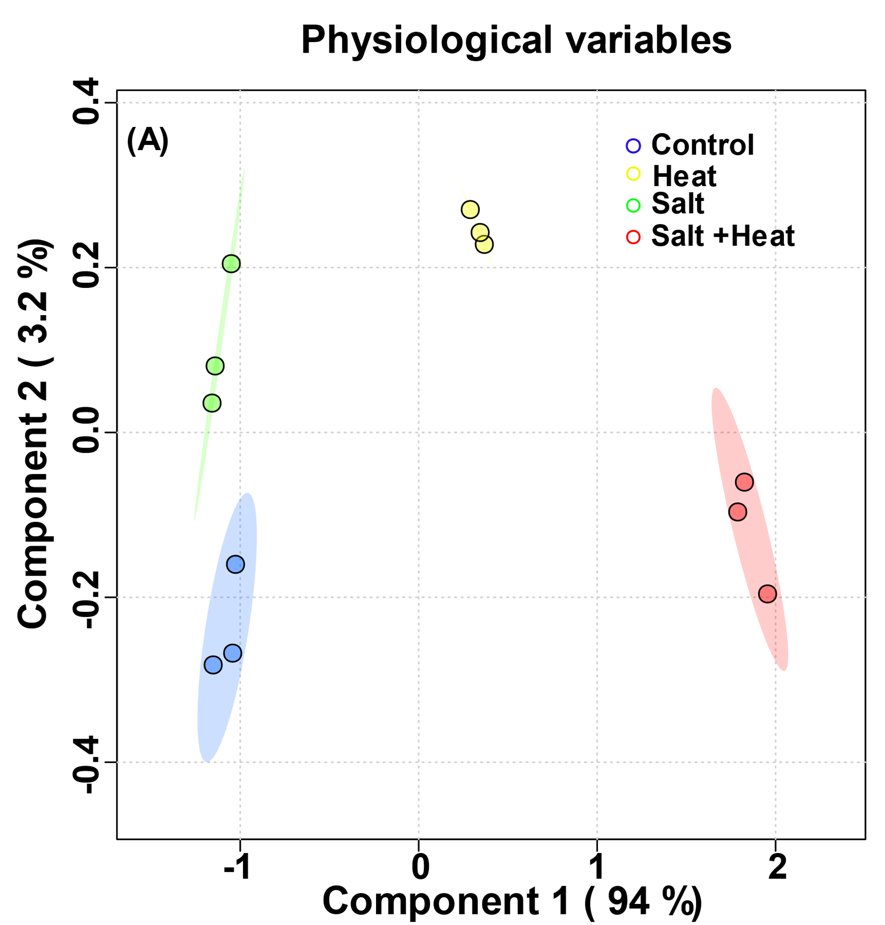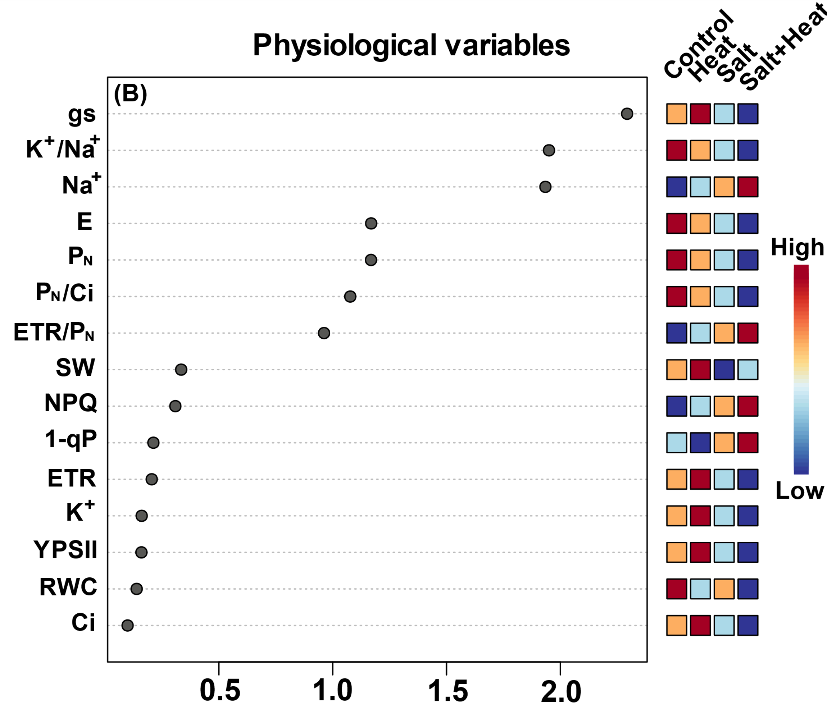
Figure S1. Group discrimination analysis reveals that combination of heat and salt display strong and unique interaction. (A) Partial least squares discriminant analysis (PLS-DA) for group discrimination and (B) variable importance in projection (VIP) scores using physiological (photosynthetic and ionic homeostasis) data in leaves of 31-day old rice plants under multiple treatments (control, heat, salt, and salt + heat). The heat map localized at right side of (B) represents changes (decreased or increased) of specific variables within each treatment. These analyses were carried out using Metaboanalyst.

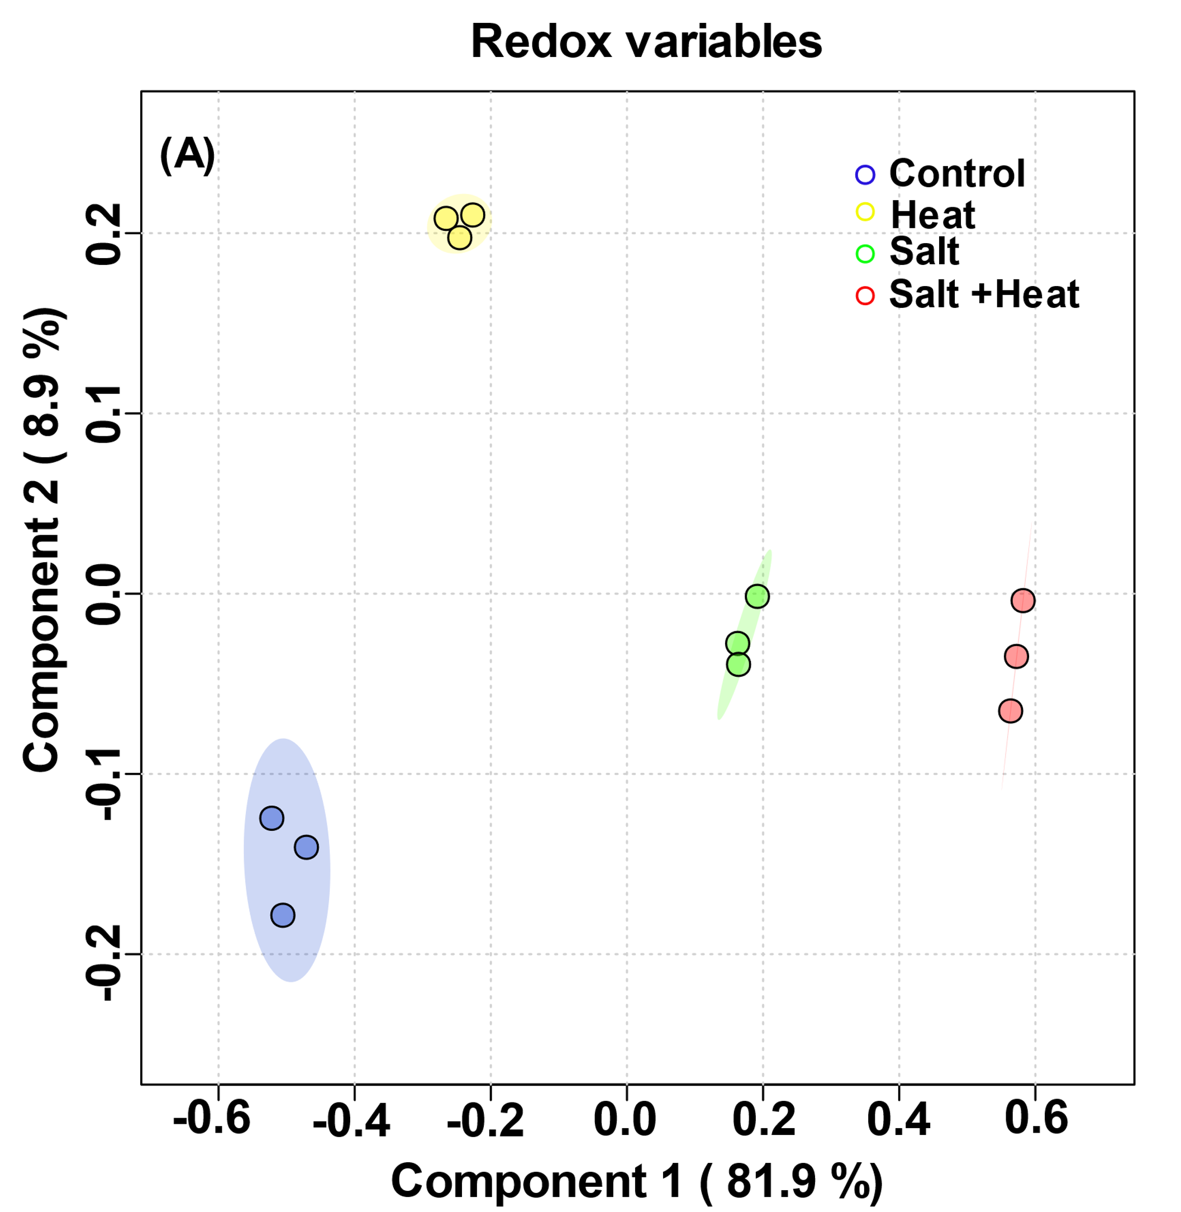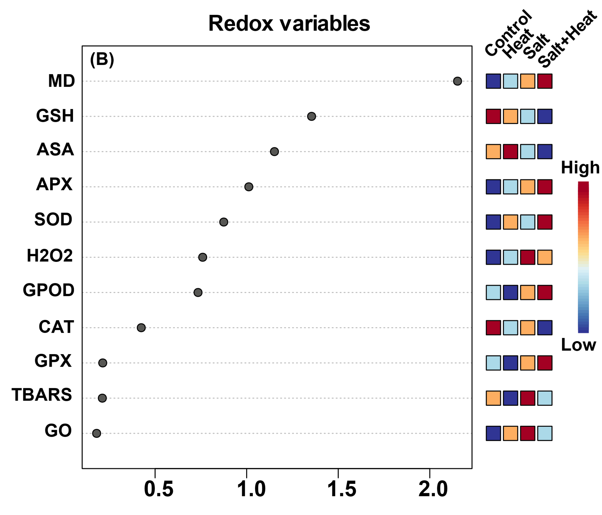

Figure S2. Group discrimination analysis reveals that combination of heat and salt display using redox metabolism variables are less distinct in comparison with isolated salt. (A) Partial least squares discriminant analysis (PLS-DA) for group discrimination and (B) variable importance in projection (VIP) scores using redox metabolism data in leaves of 31-day old rice plants under multiple treatments (control, heat, salt, and salt + heat). The heat map localized at right side of (B) represents changes (decreased or increased) of specific variables within each treatment. These analyses were carried out using Metaboanalyst.

