Supplementary table 1: population characteristics at the diagnosis of meningeal carcinomatosis
 |  | N (%)
Gender
Women |  | 108 (99.1%)
Men |  | 1 (0.9%)
Biological subtype
HR+/HER2neg |  | 81 (74.3%)
HER2 positive |  | 10 (9.2%)
Triple negative |  | 18 (16.5%)
Pathological subtype
NST* |  | 70 (64.2%)
Lobular |  | 32 (29.4%)
Other |  | 6 (5.5%)
Visceral metastases |  | 67 (61.5%)
Liver metastases |  | 61 (56.0%)
Other |  | 6 (5.5%)
 | Brain metastasis at MC diagnosis | 44 (40.4%)
 | Prior CNS radiation therapy | 32 (72.7%)
 | Number of systemic therapy lines before MC
 | 0 | 21 (19.3%)
 | 1 | 15 (13.8%)
 | 2 | 24 (22.0%)
 | 3 | 17 (15.6%)
 | 4 | 18 (16.5%)
 | 5 and more | 14 (12.9%)
*NST: non-specific type

Supplementary table 2: Detail of intrathecal therapies

 | HR+  N=81 | HER2+  N=10 | TNBC  N=18 | All patients  n=109
Methotrexate | 76 (93.8%) | 10 (100%) | 17 (94.4%) | 103 (94.5%)
Thiotepa | 32 (39.5%) | 3 (30%) | 7 (38.9%) | 42 (11.0%)
IT therapy (L1) | 82* (100%) | 10 (100%) | 18 (100%) | 110* (100%)
IT therapy (L2) | 26 (32.1%) | 3 (30%) | 6 (33.3%) | 35 (32.1%)
*One patient received methotrexate and thiotepa as part of the first line of IT therapy

Supplementary table 3: Overall survival, 24-weeks survival and progression free survival univariate analyses
 | Categories | Overall survival  HR (95% CI) |  | 24-weeks survival  HR (95% CI) |  | Progression free survival  HR (95% CI)
Visceral metastases | No  Yes | 1§  1.30 (0.85-1.99) | P=0.2185 | 1  1.49 (0.75-2.96) | P=0.255 | 1  1.02 (0.63-1.63) | P=0.951
Brain metastases | No  Yes | 1  1.02 (0.69-1.52) | P=0.916 | 1  1.07 (0.57-2.01) | P=0.826 | 1  1.02 (0.67-1.58) | P=0.919
Number of previous lines | 0-2  3+ | 1  1.04 (0.71-1.55) | P=0.82 | 1  1.68 (0.91-3.11) | P=0.096 | 1  0.88 (0.57-1.35) | P=0.558
Triple negative subtype | No  Yes | 1  1,81 (0,96-3,40) | P=0.0675 | 1  1.23 (0.54-2.79) | P=0.625 | 1  0.93 (0.48-1.79) | P=0.835
Neurological symptoms at baseline | No  Yes | 1  1.17 (0.57-2.41) | P=0.674 | 1  1.21 (0.33-4.43) | P=0.768 | 1  1.29 (0.58-2.89) | P=0.524
CSF tumor cells | No  Yes | 1  0.76 (0.46-1.28) | P=0.305 | 1  1.36 (0.65-2.83) | P=0.418 | 1  0.81 (0.46-1.42) | p=0.457
CSF proteins | Normal  Elevated | 1  0.81 (0.45-1.47) | P=0.489 | 1  1.58 (0.68-3.66) | P=0.287 | 1  1.01 (0.54-1.88) | P=0.968
Baseline CSF Cyfra 21-1 | Normal  Elevated | 1  1.45 (0.78-2.69) | P=0.234 | 1  2.41 (0.89-6.51) | P=0.083 | 1  1.72 (0.89-3.29) | P=0.105
Baseline CSF Cyfra 21-1 value | ≤ 79 ng/mL  > 79 ng/mL | 1  1.68 (0,99-2,84) | P=0.0544 | 1  1.61 (0.77-3.35) | P=0.203 | 1  1.24 (0.71-2.17) | P=0.445
Baseline CSF Cyfra 21-1 > median value | No  Yes | 1  1.31 (0.86-2.00) | P=0.204 | 1  1.80 (0.95-3.42) | P=0.070 | 1  1.26 (0.79-1.99) | P=0.330
1-month clinical response | A*  B**  C*** | 1  1.23 (0.79-1.93)  1.85 (1.07-3.18) | P=0.036 | 1  1.57 (0.79-3.15)  6.29 (2.60-15.20) | P<0.0001 | -
1-month clinical response | A + B  C | 1  1.93 (1.14-3.28) | P=0.015 | 1  13.38 (5.69-31.45) | P<0.0001 | -
1-month CSF tumor cells | No  Yes | 1  1.26 (0.85-1.87) | P=0.245 | 1  2.08 (1.12-3.85) | P=0.019 | -
1-month Cyfra 21-1 | Nomal  Elevated | 1  1.09 (0.63-1.90) | P=0.76 | 1  1.11 (0.39-3.19) | P=0.845
*A : improvement; **B : stability; ***C: worsening. HR: hazard ratio. 95% CI: 95% confidence interval. §1 denotes the reference category.

Supplementary Figure 1 24-weeks survival
- 24-weeks survival according to a 3-class prognostic score
- 24-weeks survival according to a 2-class prognostic score

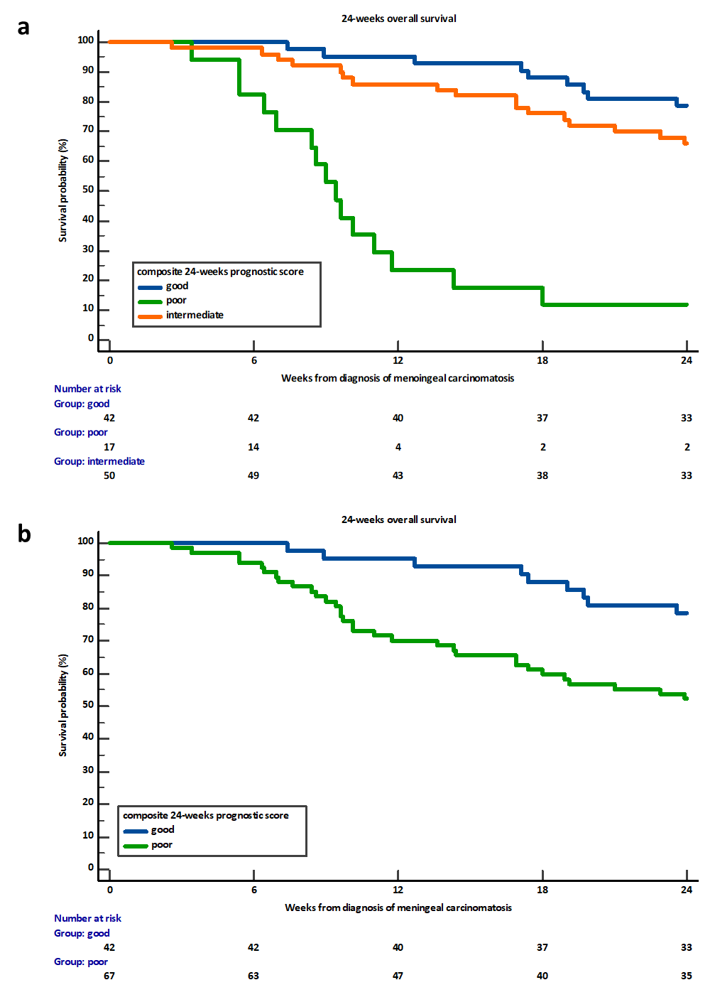

Supplementary Figure 2 Overall survival in patients with luminal breast cancer, according to the 3-class composite prognostic score.

