Supplementary Table 1
Mean daily clear-sky DNI and GHI for September 2019 and 2020 that were used as inputs to a model of PV output for a 1 MW stationary PV installation located in the listed 13 cities across CONUS.

 |  |  | September 2019 |  | September 2020
Location | Latitude | Longitude | Clear-sky DNI | Clear-sky GHI | Clear-sky DNI | Clear-sky GHI
Los Angeles, CA | 34.13 | -118.42 | 827.06 | 645.79 | 585.65 | 585.41
Modesto, CA | 37.65 | -121.02 | 820.23 | 620.17 | 558.45 | 554.70
Phoenix, AZ | 33.57 | -112.10 | 813.01 | 638.75 | 732.39 | 626.27
Denver, CO | 39.77 | -104.86 | 891.35 | 628.10 | 771.77 | 609.40
Portland, OR | 45.53 | -122.66 | 791.96 | 550.54 | 641.40 | 516.39
Spokane, WA | 47.65 | -117.42 | 819.35 | 543.15 | 717.18 | 520.87
Bozeman, MT | 45.69 | -111.06 | 833.00 | 569.06 | 764.10 | 555.85
Omaha, NE | 41.25 | -96.06 | 765.94 | 573.25 | 691.74 | 565.20
Minneapolis, MN | 44.97 | -93.26 | 763.37 | 547.59 | 680.39 | 536.92
Dallas, TX | 32.81 | -96.78 | 753.52 | 621.05 | 688.55 | 610.09
Atlanta, GA | 33.77 | -84.42 | 781.72 | 631.57 | 773.25 | 627.46
New York, NY | 40.73 | -73.90 | 755.11 | 579.16 | 729.04 | 572.73
Portland, ME | 43.69 | -70.26 | 806.74 | 570.34 | 758.08 | 558.68

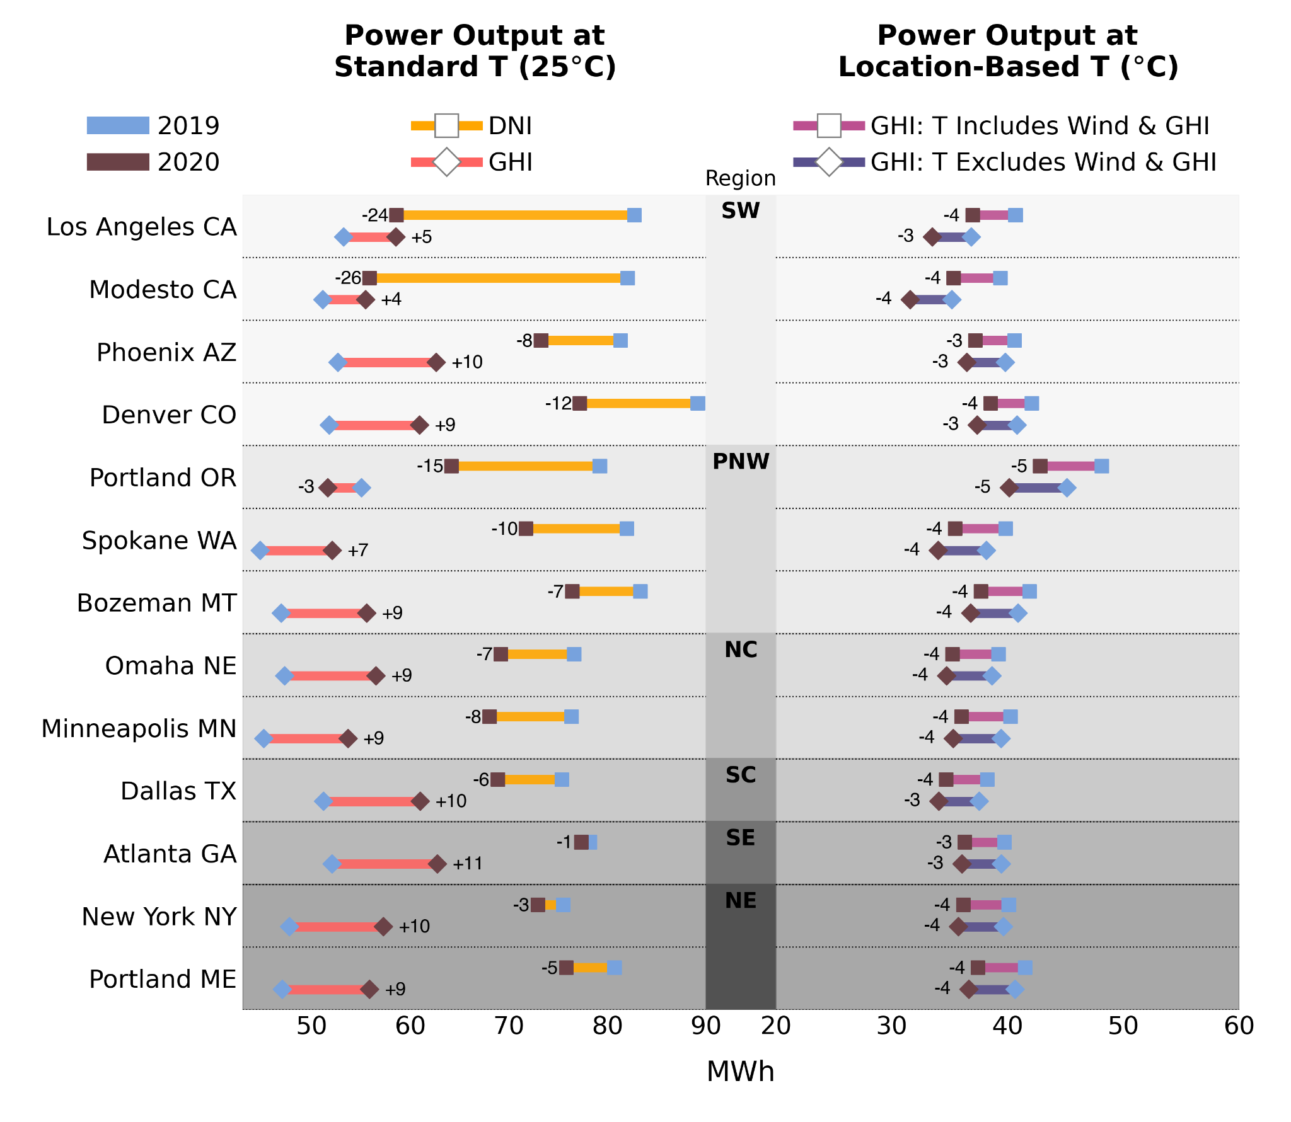
Supplementary Figure 1: Comparison of modeled average daytime power output (MWh) in September for 1 MW PV installations of CdTe panels at 13 locations across CONUS in a low (blue; 2019) and high (brown; 2020) smoke year. Each site’s region is indicated with grayscale shading consistent with the map in Figure 4. Power output was modeled using four approaches: two with panel temperatures set to a standard temperature of 25℃ (left panel) and two with panel temperatures determined by location (right panel). At 25℃, power output was modeled using clear-sky DNI (orange) and clear-sky GHI (red) as the irradiance input. At location-based temperatures, power output was modeled using clear-sky GHI as the irradiance input, but temperature was determined either including (light purple) or excluding (dark purple) the cooling effects of wind and warming effects of radiation. The clear-sky DNI and GHI for each location were determined using the data underlying Figure 3 and are reported in Supplementary Table 1.

Supplementary Table 2
Monthly Pearson’s correlation (r) and simple linear regression (a₁ = slope, a₀ = intercept) results comparing daily regional smoke coverage (fraction from 0-1) and clear-sky DNI and GHI (W/m²) from April-October of 2006-2021.

 |  | Clear-sky DNI |  |  |  |  | Clear-sky GHI
Region | Month | a₁ | a₀ | r | R² | significance | Slope | Intercept | r | R2 | significance
Southwest | April | -48.0 | 897.9 | -0.14 | 0.02 | p < 0.01 | 14.6 | 710.3 | 0.07 | 0.00
Southwest | May | 36.9 | 880.1 | 0.08 | 0.01 |  | 38.2 | 734.2 | 0.21 | 0.04 | p < 0.001
Southwest | June | -44.1 | 884.7 | -0.30 | 0.09 | p < 0.001 | -10.7 | 739.6 | -0.17 | 0.03 | p < 0.001
Southwest | July | -97.1 | 862.6 | -0.58 | 0.33 | p < 0.001 | -21.6 | 717.1 | -0.33 | 0.11 | p < 0.001
Southwest | August | -143.7 | 878.0 | -0.81 | 0.65 | p < 0.001 | -35.3 | 696.9 | -0.56 | 0.31 | p < 0.001
Southwest | September | -125.1 | 894.3 | -0.68 | 0.46 | p < 0.001 | -16.2 | 645.9 | -0.21 | 0.04 | p < 0.001
Southwest | October | -77.6 | 911.5 | -0.40 | 0.16 | p < 0.001 | 16.1 | 569.1 | 0.09 | 0.01 | p < 0.05
Pacific Northwest | April | -9.7 | 872.4 | -0.04 | 0.00 |  | 14.8 | 651.6 | 0.08 | 0.01
Pacific Northwest | May | -29.6 | 862.9 | -0.12 | 0.02 | p < 0.01 | -6.4 | 688.4 | -0.07 | 0.01
Pacific Northwest | June | -15.7 | 875.8 | -0.10 | 0.01 | p < 0.05 | -2.4 | 699.1 | -0.04 | 0.00
Pacific Northwest | July | -79.3 | 882.8 | -0.56 | 0.31 | p < 0.001 | -22.7 | 689.2 | -0.51 | 0.26 | p < 0.001
Pacific Northwest | August | -156.1 | 892.7 | -0.68 | 0.46 | p < 0.001 | -29.8 | 652.1 | -0.44 | 0.19 | p < 0.001
Pacific Northwest | September | -146.6 | 888.4 | -0.65 | 0.43 | p < 0.001 | -2.0 | 576.3 | -0.02 | 0.00
Pacific Northwest | October | -59.1 | 877.5 | -0.30 | 0.09 | p < 0.001 | 46.2 | 482.5 | 0.19 | 0.04 | p < 0.001
North Central | April | 19.1 | 796.4 | 0.05 | 0.00 |  | -2.7 | 643.0 | -0.02 | 0.00
North Central | May | -3.4 | 784.9 | -0.02 | 0.00 |  | 6.1 | 670.5 | 0.09 | 0.01 | p < 0.05
North Central | June | -25.6 | 785.8 | -0.19 | 0.04 | p < 0.001 | -4.9 | 675.9 | -0.12 | 0.02 | p < 0.01
North Central | July | -55.3 | 790.5 | -0.41 | 0.17 | p < 0.001 | -9.3 | 664.3 | -0.26 | 0.07 | p < 0.001
North Central | August | -60.4 | 786.0 | -0.40 | 0.16 | p < 0.001 | -9.8 | 631.5 | -0.19 | 0.04 | p < 0.001
North Central | September | -76.9 | 809.4 | -0.46 | 0.21 | p < 0.001 | 4.6 | 571.2 | 0.06 | 0.00
North Central | October | -38.5 | 833.9 | -0.15 | 0.02 | p < 0.01 | 40.4 | 491.3 | 0.20 | 0.04 | p < 0.001
South Central | April | -38.5 | 789.9 | -0.10 | 0.01 | p < 0.05 | -4.5 | 687.8 | -0.03 | 0.00
South Central | May | -49.9 | 759.9 | -0.21 | 0.05 | p < 0.001 | -8.0 | 698.7 | -0.12 | 0.01 | p < 0.01
South Central | June | -17.4 | 745.3 | -0.14 | 0.02 | p < 0.01 | -0.7 | 691.2 | -0.02 | 0.00
South Central | July | -34.8 | 730.3 | -0.25 | 0.06 | p < 0.001 | -4.7 | 681.1 | -0.13 | 0.02 | p < 0.01
South Central | August | -24.9 | 733.8 | -0.19 | 0.04 | p < 0.001 | -3.3 | 663.2 | -0.08 | 0.01
South Central | September | -53.2 | 772.5 | -0.31 | 0.09 | p < 0.001 | 2.4 | 627.2 | 0.04 | 0.00
South Central | October | -29.6 | 829.4 | -0.13 | 0.02 | p < 0.01 | 28.7 | 571.9 | 0.22 | 0.05 | p < 0.001
Northeast | April | -92.9 | 803.4 | -0.11 | 0.01 | p < 0.05 | -35.4 | 646.2 | -0.11 | 0.01 | p < 0.05
Northeast | May | -47.6 | 788.1 | -0.16 | 0.03 | p < 0.001 | -6.5 | 672.0 | -0.07 | 0.00
Northeast | June | -48.8 | 779.2 | -0.20 | 0.04 | p < 0.001 | -10.3 | 676.0 | -0.14 | 0.02 | p < 0.01
Northeast | July | -54.6 | 759.6 | -0.28 | 0.08 | p < 0.001 | -11.0 | 659.7 | -0.20 | 0.04 | p < 0.001
Northeast | August | -46.0 | 766.2 | -0.26 | 0.07 | p < 0.001 | -7.6 | 629.9 | -0.12 | 0.02 | p < 0.01
Northeast | September | -77.0 | 797.6 | -0.30 | 0.09 | p < 0.001 | -5.0 | 574.5 | -0.05 | 0.00
Northeast | October | -45.1 | 824.9 | -0.11 | 0.01 | p < 0.05 | 27.4 | 491.4 | 0.10 | 0.01 | p < 0.05
Southeast | April | -1.4 | 782.5 | 0.00 | 0.00 |  | -2.3 | 679.4 | -0.01 | 0.00
Southeast | May | -55.4 | 755.5 | -0.18 | 0.03 | p < 0.001 | -7.1 | 691.8 | -0.08 | 0.01
Southeast | June | -34.5 | 725.4 | -0.18 | 0.03 | p < 0.001 | -3.5 | 683.0 | -0.07 | 0.00
Southeast | July | -66.9 | 707.4 | -0.32 | 0.10 | p < 0.001 | -10.5 | 672.3 | -0.21 | 0.04 | p < 0.001
Southeast | August | -67.0 | 715.3 | -0.32 | 0.11 | p < 0.001 | -7.1 | 654.1 | -0.13 | 0.02 | p < 0.01
Southeast | September | -50.3 | 761.9 | -0.22 | 0.05 | p < 0.001 | -0.1 | 619.2 | 0.00 | 0.00
Southeast | October | -29.0 | 813.0 | -0.08 | 0.01 |  | 30.2 | 561.1 | 0.15 | 0.02 | p < 0.01

