Additional file 1: Characteristics of the participants with congenital limb deficiency
Subject ID | Prosthesis, orthosis or foot support use | Dominance | Compensatory body part use | Apparence of the limbs
S1 | None | Right | Feet˃ Mouth ˃ Residual limb | 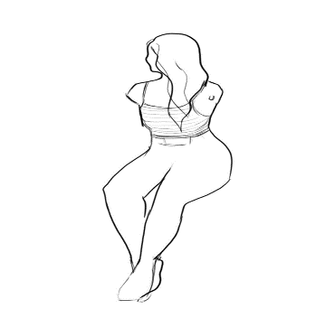
S2 | Lower limb  orthosis | Right | Feet˃ Mouth ˃ Residual limb | 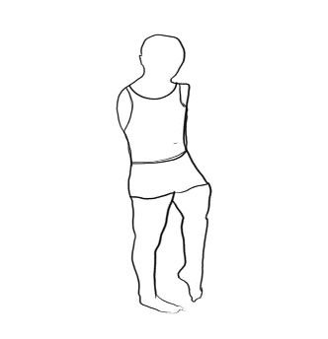
S3 | Foot support | Right | Feet˃ Mouth ˃ Residual limb | 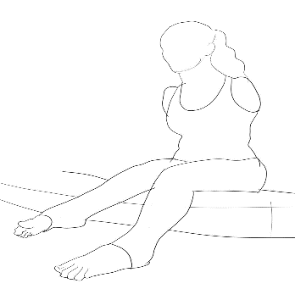
S4 | Only lower limb prosthesis | Right | Residual limb˃ Mouth | 