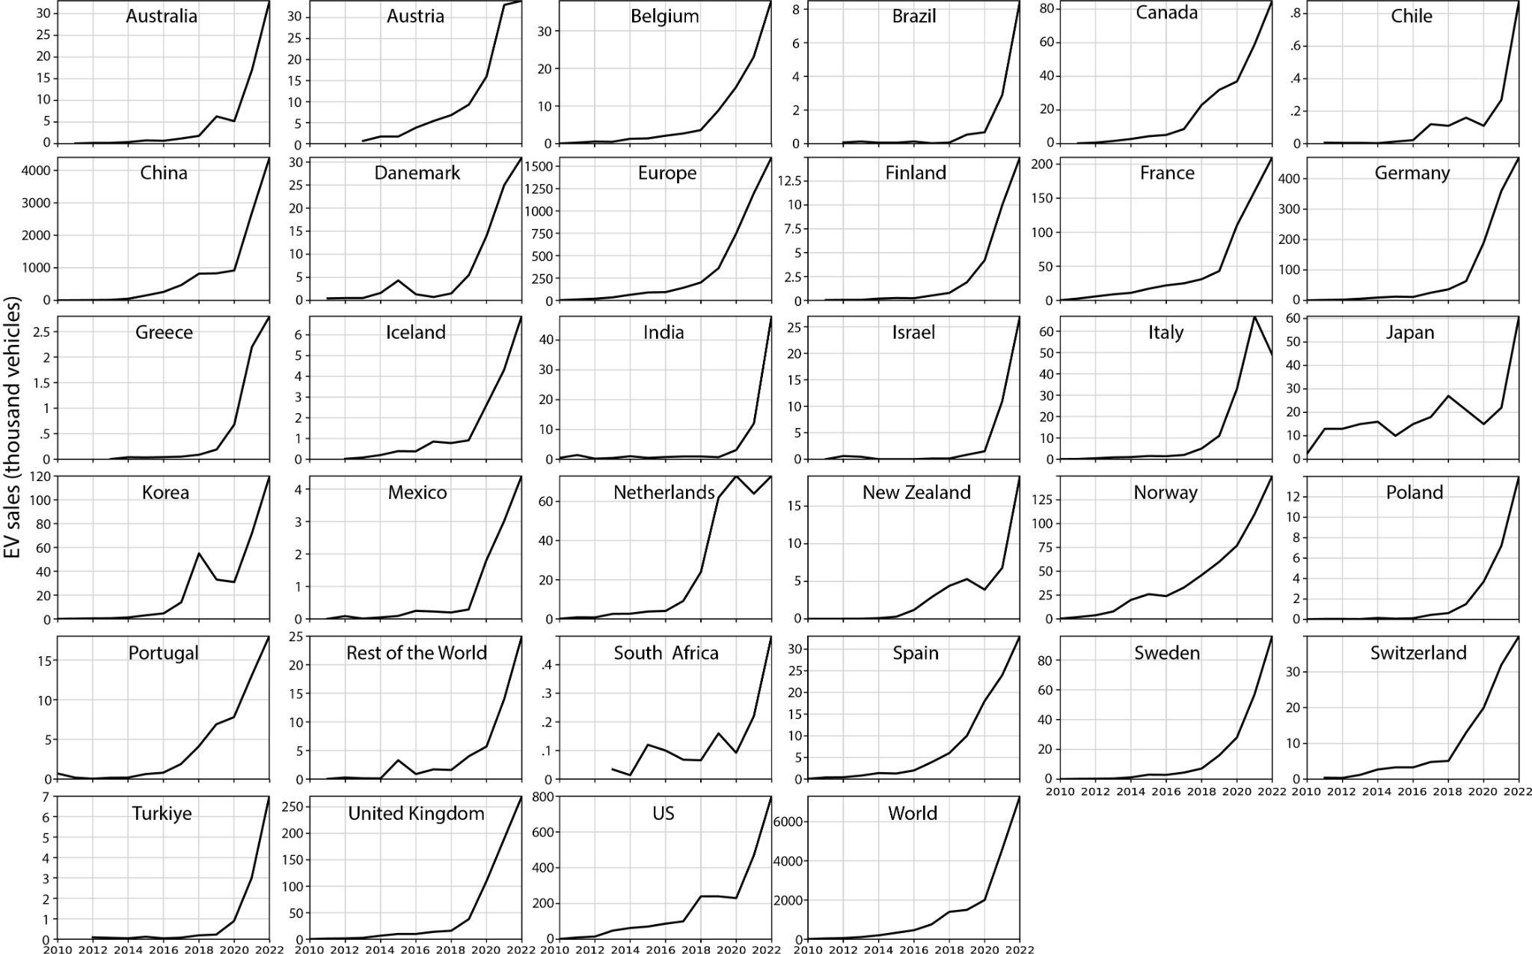
Ext. Fig. 1 | Historical EV sales in 31 countries between 2010 and 2022. The trends rise exponentially, notably with R² greater than 0.8 for the US, EU countries and China.

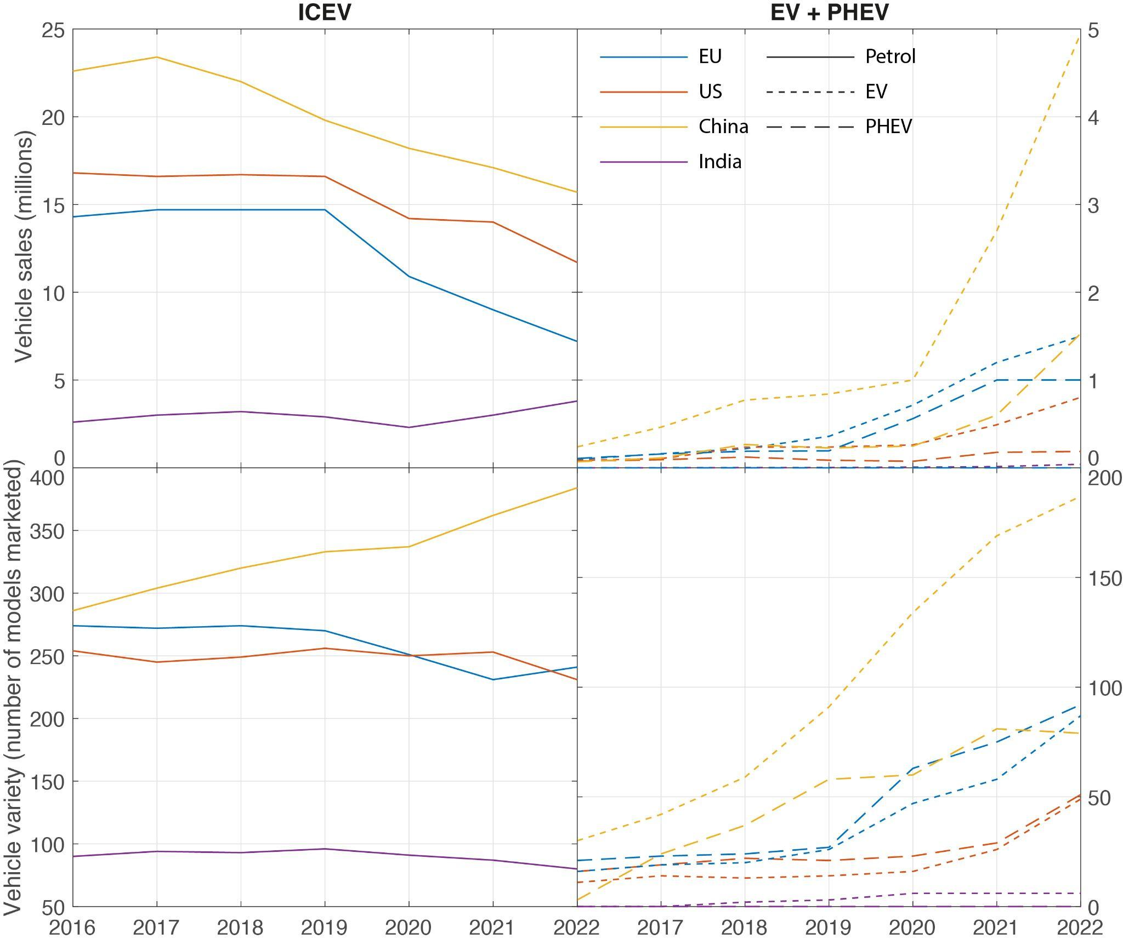
Ext. Fig 2 | Evolution of market variety in lead markets plus India.
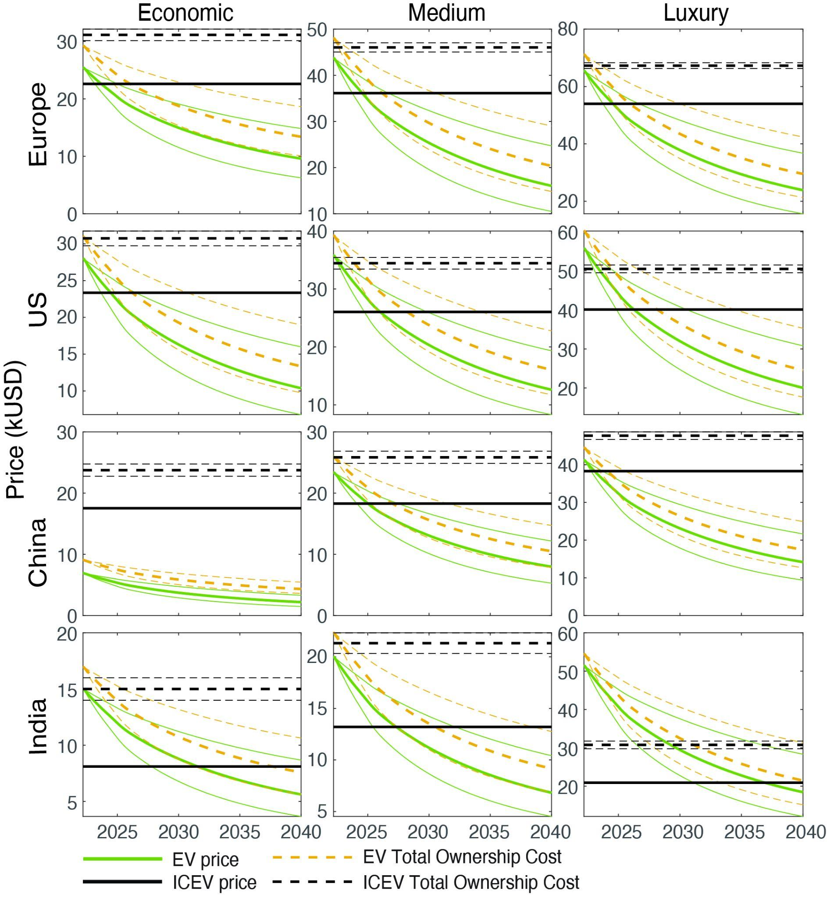
Ext. Fig. 3 | Projected price and ownership cost for EVs against ICEVs for four key markets. Trajectory of total ownership costs (dashed lines) and prices (solid lines) of EVs/ICEVs, using median (thick lines) and 95% confidence range learning rates (thin lines).

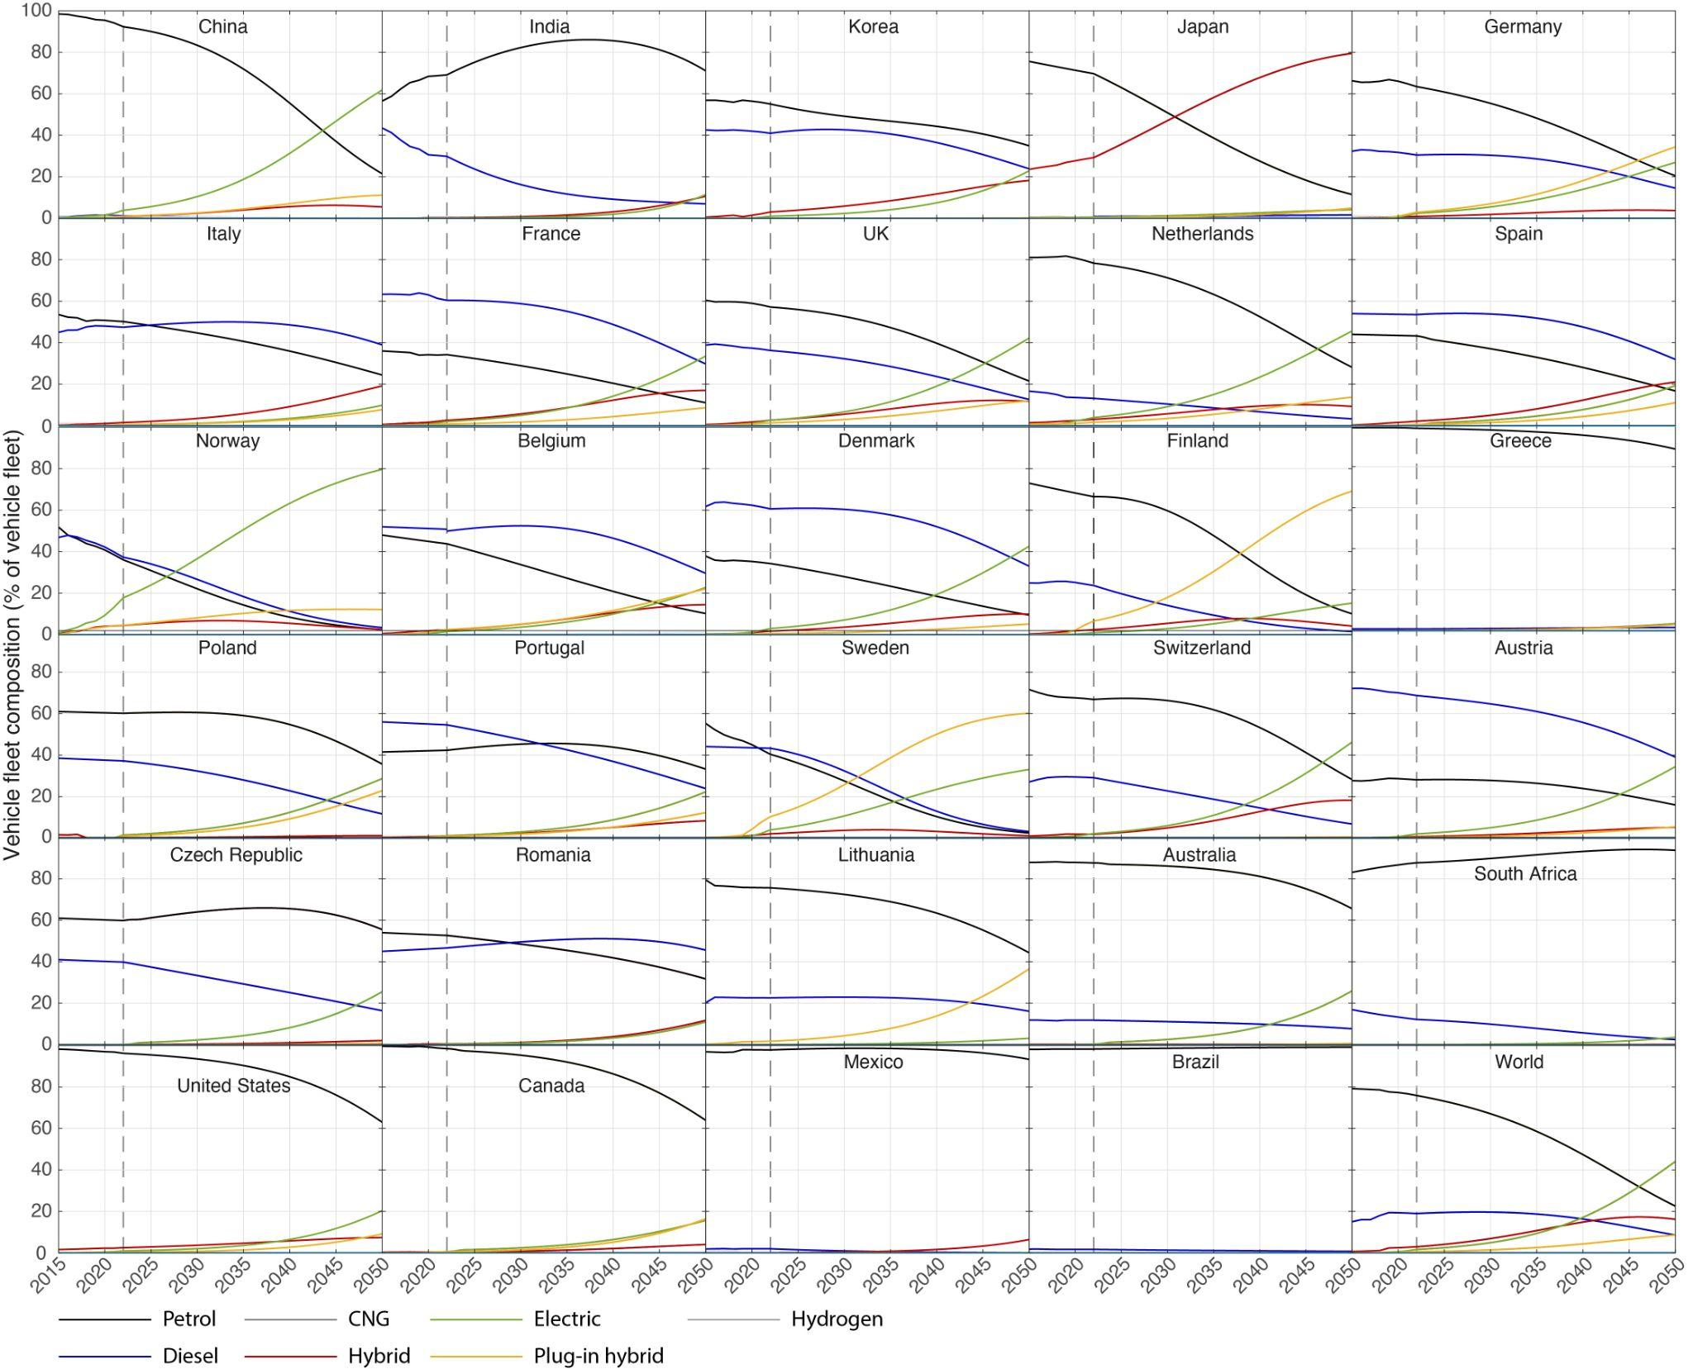
Ext. Fig. 4 | Baseline fleet shares of different technologies using FTT:Transport.

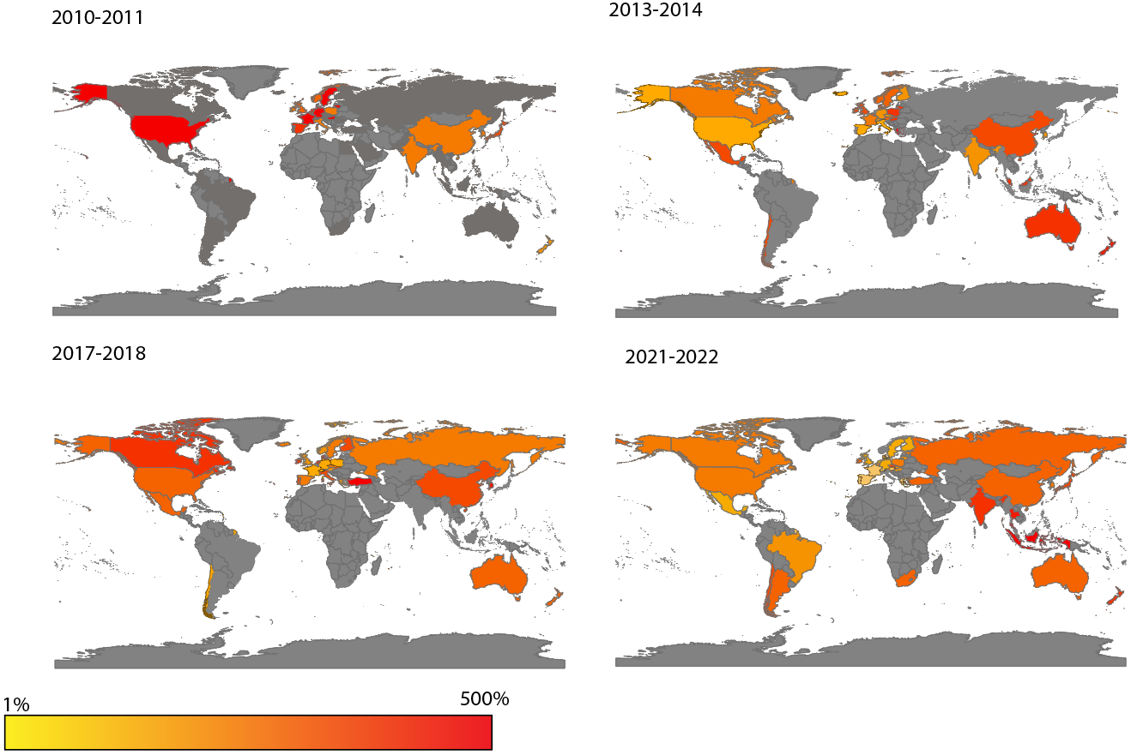
Ext. Fig. 5 | Growth of EV market shares by country between 2010 and 2022.

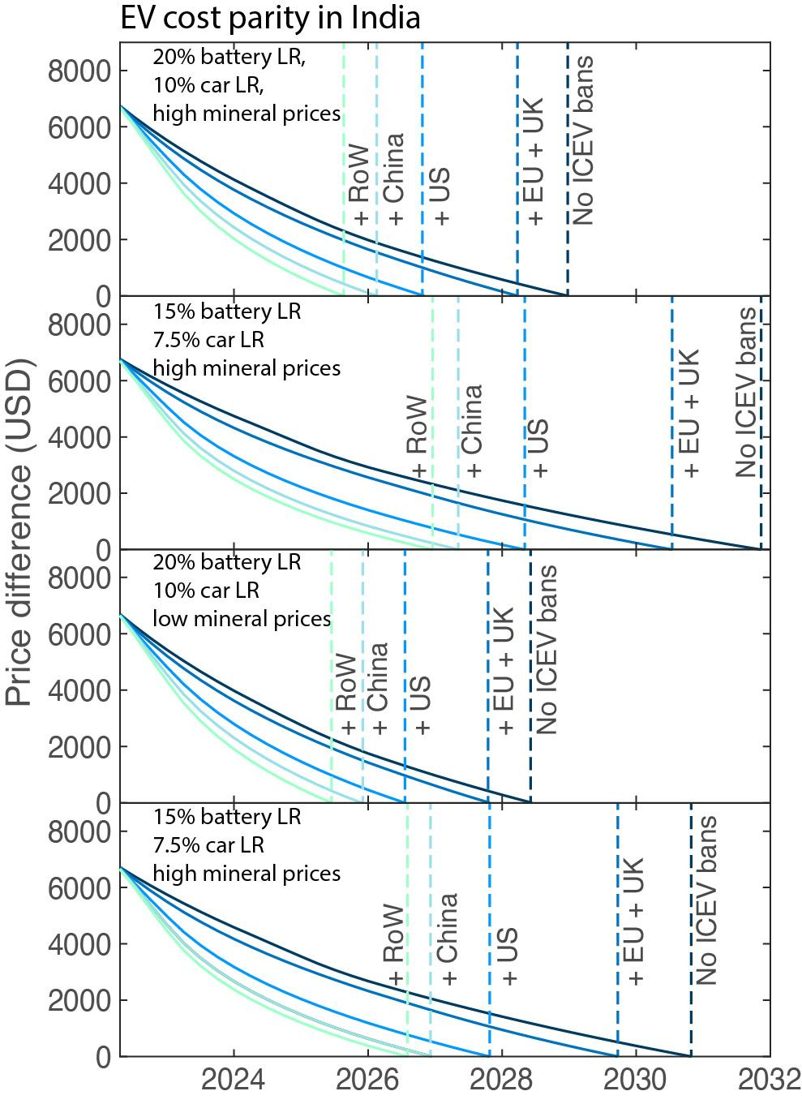
Ext. Fig. 6 | Trajectories for achieving cost parity for mid-range EVs in India under various sensitivities. Scenarios and sensitivities include variations on assumed battery and vehicle learning rates as well as mineral prices.

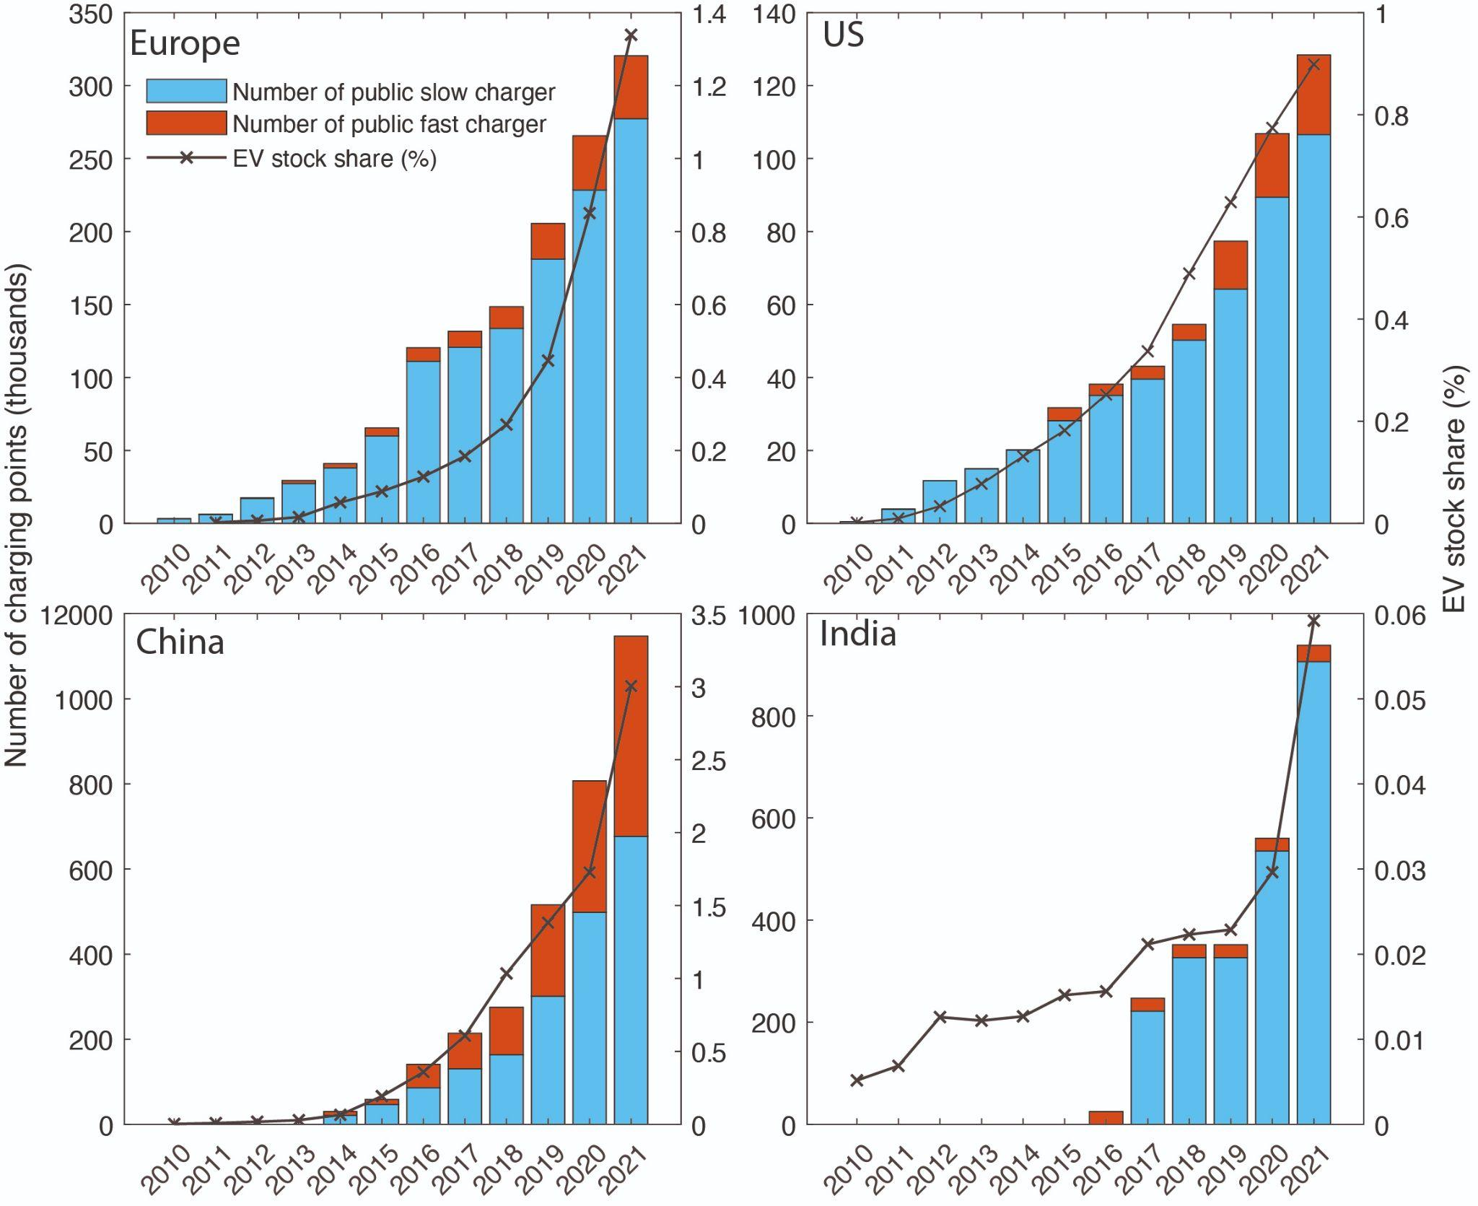
Ext. Fig. 7 | Historical diffusion of charging points (left axis and bars) and EV market shares (right axis and lines).

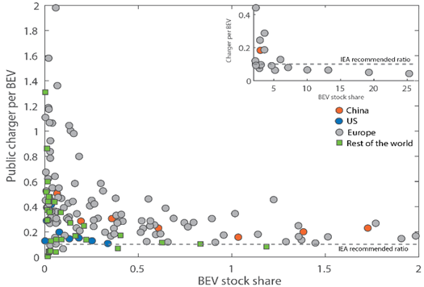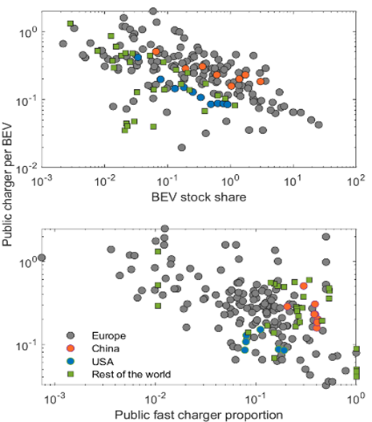
Ext. Fig. 8. Charging point numbers per EV as EVs penetrate markets. a) Charging point per BEV relative to BEV LDV stock. b) Charging point per EV as the proportion of public fast charger increases.

Ext. Tab. 1 | Vehicle database coverage and sources.
Variable | Region coverage | Time frame | Note | Source
Vehicle sales by model | Austria, Belgium, Bulgaria, Croatia, Republic of Cyprus, Czech Republic, Denmark, Estonia, Finland, France, Germany, Greece, Hungary, Ireland, Italy, Latvia, Lithuania, Luxembourg, Malta, Netherlands, Poland, Portugal, Romania, Slovakia, Slovenia, Spain, Sweden, UK, China, India, USA. | 2016-2022 | Fig. 3,  Ext. Fig. 2 | Marklines
Annual vehicle sales statistics (by technology) | Australia, Austria, Belgium, Brazil, Canada, Chile, China, Denmark, Finland, France, Germany, Greece Iceland, Israel, India, Italy, Japan, Korea, Mexico, Netherlands, New Zealand, Norway, Poland, Portugal, South Africa, Spain, Sweden, Switzerland, Turkey, UK, US. | 2010-2022 | Fig. 2,  Fig. 6,  Ext. Fig. 1, Ext. Fig. 5 | International Energy Agency
Vehicle price by model | France, Germany,, China, India, USA, Japan, Korea, Australia, Brazil, Canada, UK | 2016-2022 | Fig. 3,  Ext. Fig. 3 | Marklines, Manufacturer websites

