Atranorin is a novel potential candidate drug for treating myelodysplastic syndrome
Konstantin N. Semenov^{a,b*}, Ilya A. Prokopiev^{c}, Natalya V. Petukhovaª, Uliana A. Kremenetskaya^{b}, Dina A. Senichkinaª, Olga S. Epifanovskayaª, Andrei M. Rumiantsev^{b}, Pavel A. Andoskinª, Sergei V. Ageev^{a,b}, Yurii A. Anufrikov^{b}, Egor E. Zakharovª, Ivan S. Moiseevª, Vladimir V. Sharoyko^{a,b*}
ªPavlov First Saint Petersburg State Medical University, 6–8 L’va Tolstogo Street, Saint Petersburg, 197022, Russia
^{b}Saint Petersburg State University, 7–9 Universitetskaya Embankment, Saint Petersburg, 199034, Russia
^{c}Komarov Botanical Institute of the Russian Academy of Sciences, 2 Professor Popov Street, Saint Petersburg, 197376, Russia
Conflict of Interest and Disclosure: There are no conflicts to declare.
All sources of support for research: The work was carried out with the financial support of the Ministry of Health of the Russian Federation №123030200028-7 «Development of small molecule checkpoint modulators for the treatment of myelodysplastic syndrome».
The equipment of the following Resource Centres of the Research Park of Saint Petersburg State University was used: Computing Centre, the Centre for Diagnostics of Functional Materials for Medicine, Pharmacology and Nanoelectronics, Magnetic Resonance Research Centre, Centre for Chemical Analysis and Materials Research, Thermogravimetric and Calorimetric Research Centre.

*Corresponding authors at: 6–8 L’va Tolstogo Str., Saint Petersburg, 197022, Russia.
E-mail addresses: knsemenov@gmail.com (K. N. Semenov), sharoyko@gmail.com (V. V. Sharoyko).
ADMET Properties Prediction
The generated atranorin hits were subjected to ADMET prediction using the QikProp- module of the Schrodinger suite⁵⁰. For each compound, a list of descriptors was predicted, including molecular #stars (drug-likeness - number of property or descriptor values that fall outside the 95% range of similar values for known drugs); (weight (mol_MW), drug-likeness (#Stars), dipole moment (dipole), total solvent accessible surface area (SASA), number of hydrogen bond donors and acceptors (donorHB and acceptHB), predicted octanol-water partitioning (QPlogPo/w), predicted aqueous solubility (QPlogS), estimated binding to HSA (QPlogKhsa), number of the possible metabolites (# metab), predicted blood-brain partitioning (QPlogBB), percentage of human oral absorption, predicted IC₅₀ for inhibiting HERG-K⁺ channels (QPogHERG), central nervous system activity (CNS), the number of reactive functional groups present (#rtvFG); number of violations of Lipinski’s rule of five (the rules are: mol_MW < 500, QPlogPo/w < 5, donorHB ≤ 5, accptHB ≤ 10; RuleOfFive - compunds that satisfy these rules are considered drug-like); number of violations of Jorgensen’s rule of three (the three rules are: QPlogS > -5.7, QPPCaco > 22 nm/s, # Primary Metabolites < 7; RuleOfThree); and other properties available in QikProp module (https://gohom.win/ManualHom/Schrodinger/Schrodinger_2012_docs/general/qikprop_props.pdf).
Comparison of both inhibition sites between AKT homologs
The initial protein models 4GV1 and 3O96 were structurally aligned in order to evaluate the colocalization of two inhibition sites: the alignment score was 0.211; resulting RMSD was 2.287Å. The amino acid composition of both binding sites were evaluated within 5Å of bound ligands and compared between AKT homologs. Binding site within 5Å of bound ligands in ATP-competitive site (PDB ID 4GV1) consists of residue positions 156, 157, 158, 159, 161, 162, 163, 164, 177, 179, 180, 181, 211, 227, 228, 229, 230, 234, 276, 278, 279, 281, 291, 292, 293, 294, 295, 298, 438, 501. The analogous allosteric binding site (PDB ID 3O96) includes residue numbers 54, 79, 80, 82, 83, 84, 85, 191, 194, 197, 198, 200, 201, 202, 203, 204, 205, 210, 211, 264, 268, 270, 271, 272, 273, 274, 290, 291, 292, 293, 294, 295, 296, 297, 298, 308, 310, 326, 444. These binding sites were compared between AKT homologs sequences: only one substitution was found between ATP-competing sites of homologs compared to AKT1 (A230V in AKT3).
ADMET results and description
This module provides the quick and reliable prediction of many physicochemical properties along with other descriptors, such as the number of possible metabolites and the number of reactive functional groups, to evaluate the usefulness of the investigated compounds by describing and determining their drug-likeness, physicochemical properties, and expected toxicity profiles.
Docking details and description

The AKT-complexes with ATP-competing and allosteric inhibitors were retrieved from the protein data bank (PDB)⁷⁹ (https://www.rcsb.org/), which were then prepared and energy minimized using Schrodinger’s PPW⁸⁰. For the docking experiment, a grid box around the corresponding binding site of the co-crystallized inhibitors was generated. The defined grid box at the binding site located the pocket where the docking was taking place. The docking method was validated by redocking the initial co-crystalized inhibitor and calculating the docking score as a control. The docking of the prepared 3D-molecular structures was carried out using an extra-precision (XP) scoring function for maximum accuracy. The docking results included a list of atranorin hits, which were ranked based on their docking scores and approximated free energy of the binding of each AKT homolog. Different docking scores were generated for each ligand, including Emodel, Glide Score, and XP GScore. The XP GScore was used to select the best pose for the docked compounds. The model with highest XP GScore was then applied for MD simulation and interaction analysis (Table S3).

Table S1. Reagents characterisation.
Sample | Supplier | Mass fraction purity
ABTS | Sigma-Aldrich, USA | ≥98%
ADP | Sigma-Aldrich, USA | ≥0.950
Adrenaline | Sigma-Aldrich, USA | ≥0.950
Collagen | Biolot LLC | —
DMSO | Vekton JSC, Russia | ≥0.997
DPPH | Sigma-Aldrich, USA | ≥97 %
FBS | BioFroxx, Germany | —
Griess reagent | Vekton JSC, Russia | —
HSA | Biolot, Russia | ≥95 %
Isopropanol | Vekton JSC, Russia | 99.7%
Metanol | Vekton JSC, Russia | ≥99.5
MTT | PanEco, Russia | 98 %
NPA | Vekton JSC, Russia | 98%
Octan-1-ol | Panreac, Spain | 99%
PBS | Vekton JSC, Russia | —
Sodium azide | Sigma-Aldrich, USA | ≥99.5 %
Sodium chloride | Vekton JSC, Russia | ≥99.9 %
Sodium citrate | Vekton JSC, Russia | ≥0.999
Acetic acid | Vekton JSC, Russia | ≥96 %

Table S2. Predicted ADME (absorption, distribution, metabolism, and excretion) properties of generated atranorin hits using QikProp.
molecule | Lig1 | Lig2 | Lig3 | Lig4 | Lig5 | Lig6 | Range or recommended values
#stars | 0 | 0 | 0 | 0 | 0 | 0 | 0-5
#amine | 0 | 0 | 0 | 0 | 0 | 0 | 0-1
#amidine | 0 | 0 | 0 | 0 | 0 | 0 | 0-1
#acid | 0 | 0 | 0 | 0 | 0 | 0 | 0
#amide | 0 | 0 | 0 | 0 | 0 | 0 | 0-1
#rotor | 7 | 7 | 7 | 7 | 7 | 7 | 0-15
#rtvFG | 2 | 2 | 2 | 2 | 2 | 2 | 0-2
CNS | -2 | -2 | -2 | -2 | -2 | -2 | –2 (inactive) to +2 (active) scale
mol_MW | 374.346 | 374.346 | 374.346 | 374.346 | 374.346 | 374.346 | 130.0 – 725.0
dipole | 4.147 | 4.333 | 5.132 | 9.024 | 4.748 | 5.799 | 1.0 – 12.5
SASA | 638.048 | 645.064 | 646.744 | 652.293 | 646.818 | 647.122 | 300.0 – 1000.0
FOSA | 300.452 | 297.011 | 308.221 | 311.059 | 307.346 | 307.820 | 0.0 – 750.0
FISA | 237.197 | 247.802 | 246.878 | 247.429 | 246.629 | 246.550 | 7.0 – 330.0
PISA | 100.399 | 100.250 | 91.645 | 93.804 | 92.842 | 92.752 | 0.0 – 450.0
WPSA | 0.000 | 0.000 | 0.000 | 0.000 | 0.000 | 0.000 | 0.0 – 175.0
volume | 1137.081 | 1140.097 | 1146.418 | 1148.649 | 1146.196 | 1146.610 | 500.0 – 2000.0
donorHB | 0.000 | 0.000 | 0.000 | 0.000 | 0.000 | 0.000 | 0.0 – 6.0
accptHB | 5.750 | 5.750 | 5.750 | 5.750 | 5.750 | 5.750 | 2.0 – 20.0
dip^2/V | 0.0151214 | 0.0164691 | 0.0229778 | 0.0708894 | 0.0196706 | 0.0293326 | 0.0 – 0.13
ACxDN^.5/SA | 0.0000000 | 0.0000000 | 0.0000000 | 0.0000000 | 0.0000000 | 0.0000000 | 0.0 – 0.05
glob | 0.8257329 | 0.8181951 | 0.8190834 | 0.8131690 | 0.8188843 | 0.8186958 | 0.75 – 0.95
QPpolrz | 35.816 | 35.935 | 36.106 | 36.216 | 36.109 | 36.124 | 13.0 – 70.0
QPlogPC16 | 11.152 | 11.253 | 11.246 | 11.288 | 11.251 | 11.254 | 4.0 – 18.0
QPlogPoct | 15.231 | 15.315 | 15.451 | 16.130 | 15.406 | 15.543 | 8.0 – 35.0
QPlogPw | 7.671 | 7.759 | 7.698 | 7.730 | 7.704 | 7.704 | 4.0 – 45.0
QPlogPo/w | 2.389 | 2.335 | 2.373 | 2.386 | 2.374 | 2.378 | –2.0 – 6.5
QPlogS | -4.158 | -4.291 | -4.323 | -4.428 | -4.324 | -4.330 | –6.5 – 0.5
CIQPlogS | -5.075 | -5.075 | -5.075 | -5.075 | -5.075 | -5.075 | –6.5 – 0.5
QPlogHERG | -4.831 | -4.952 | -4.896 | -5.002 | -4.905 | -4.908 | concern below –5
QPPCaco | 55.791 | 44.258 | 45.160 | 44.620 | 45.406 | 45.485 | <25 poor, >500 great
QPlogBB | -2.178 | -2.326 | -2.312 | -2.353 | -2.310 | -2.311 | –3.0 – 1.2
QPPMDCK | 21.854 | 17.015 | 17.390 | 17.165 | 17.492 | 17.525 | <25 poor, >500 great
QPlogKp | -4.865 | -5.061 | -5.075 | -5.077 | -5.066 | -5.065 | –8.0 – –1.0
IP(eV) | 9.262 | 9.449 | 9.164 | 9.435 | 9.312 | 9.296 | 7.9 – 10.5
EA(eV) | 0.752 | 0.796 | 0.792 | 0.817 | 0.816 | 0.853 | –0.9 – 1.7
#metab | 6 | 6 | 6 | 6 | 6 | 6 | 1 – 8
QPlogKhsa | 0.084 | 0.092 | 0.111 | 0.117 | 0.110 | 0.111 | –1.5 – 1.5
HumanOralAbsorption | 3 | 2 | 2 | 2 | 2 | 2 | 1, 2, or 3 for low, medium, or high
PercentHumanOralAbsorption | 72.194 | 70.078 | 70.455 | 70.439 | 70.507 | 70.539 | >80% is high, <25% is poor
SAfluorine | 0.000 | 0.000 | 0.000 | 0.000 | 0.000 | 0.000 | 0.0 – 100.0
SAamideO | 0.000 | 0.000 | 0.000 | 0.000 | 0.000 | 0.000 | 0.0 – 35.0
PSA | 155.576 | 154.797 | 156.050 | 154.750 | 155.439 | 155.272 | 7.0 – 200.0
#NandO | 8 | 8 | 8 | 8 | 8 | 8 | 2 – 15
RuleOfFive | 0 | 0 | 0 | 0 | 0 | 0 | maximum is 4
RuleOfThree | 0 | 0 | 0 | 0 | 0 | 0 | maximum is 3

Table S3. The best atranorin poses and corresponding XP-GScores for docked ligands into AKT proteins.
AKT protein | Atranorin best XP Glide score / kcal/mol
AKT1 (ATP-competing site) | –6.107
AKT1 (allosteric-inhibition site) | –9.14
AKT2 (allosteric-inhibition site) | –7.806
AKT3 (allosteric-inhibition site) | –9.635

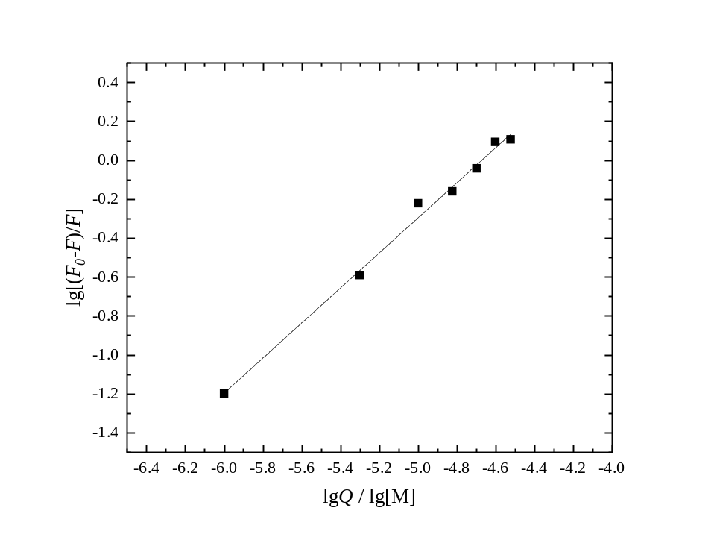

Fig. S1. Dependence in Hill coordinates for the binding of atranorin with RatCol.

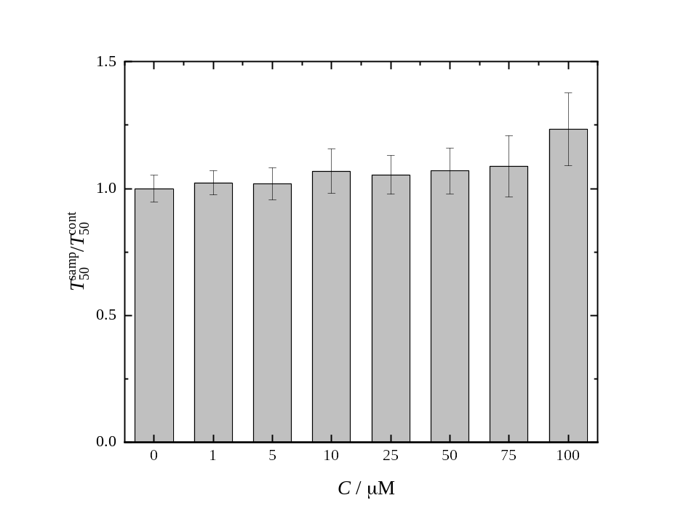

Fig. S2. Effect of atranorin on photoinduced haemolysis. C is molar concentrations of atranorin.

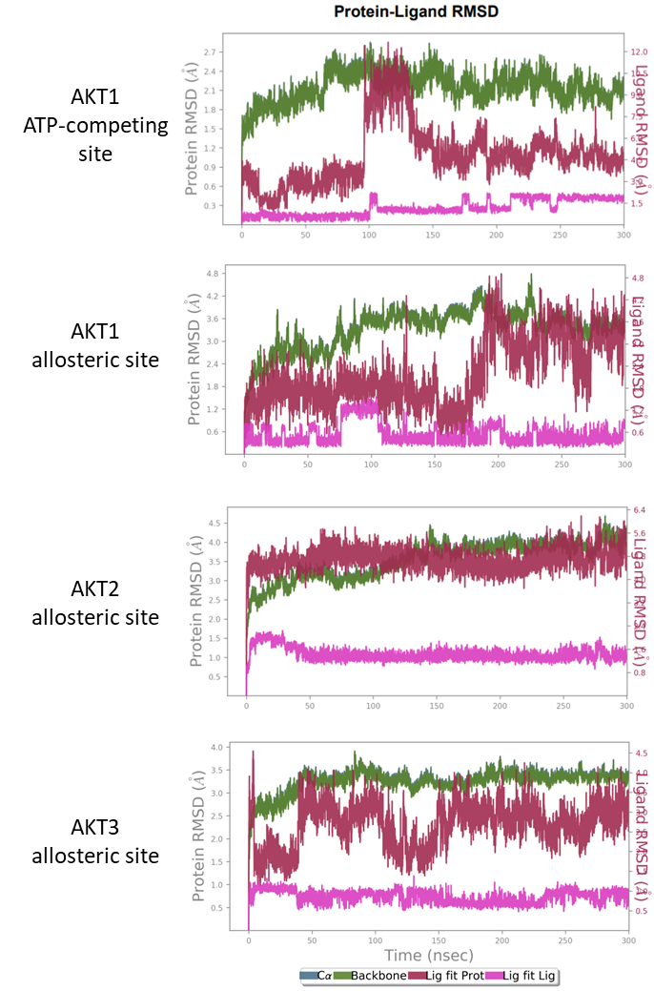

Fig. S3. RMSD plots of complex AKT protein with atranorin during 300 ns MD simulation. Green line corresponds to the protein backbone RMSD; 'Lig fit Prot' shows the RMSD of a ligand when the protein-ligand complex is first aligned on the protein backbone of the reference and then the RMSD of the ligand heavy atoms is measured. 'Lig fit Lig' shows the RMSD of a ligand that is aligned and measured just on its reference conformation. This RMSD value measures the internal fluctuations of the ligand atoms.

a)
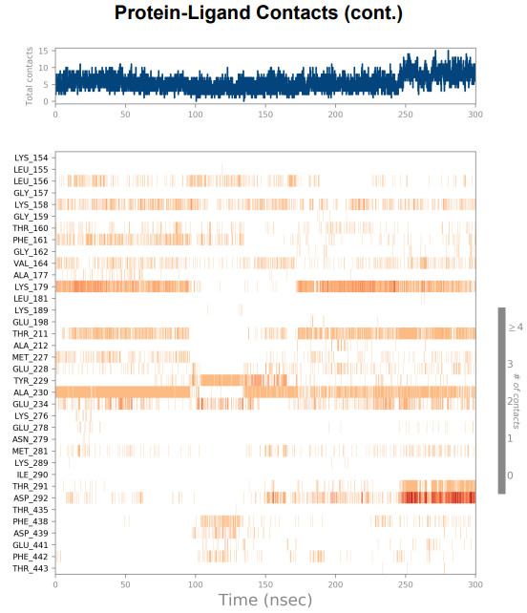

Fig. S4 (a). A timeline representation of the interactions and contacts (H-bonds, Hydrophobic, Ionic, Water bridges) summarized for MD simulation of AKT1-atranorin docked into an ATP-competing site. The top panel shows the total number of specific contacts the protein makes with the ligand over the course of the trajectory. The bottom panel shows which residues interact with the ligand in each trajectory frame. Some residues make more than one specific contact with the ligand, which is represented by a darker shade of orange, according to the scale to the right of the plot.
b)
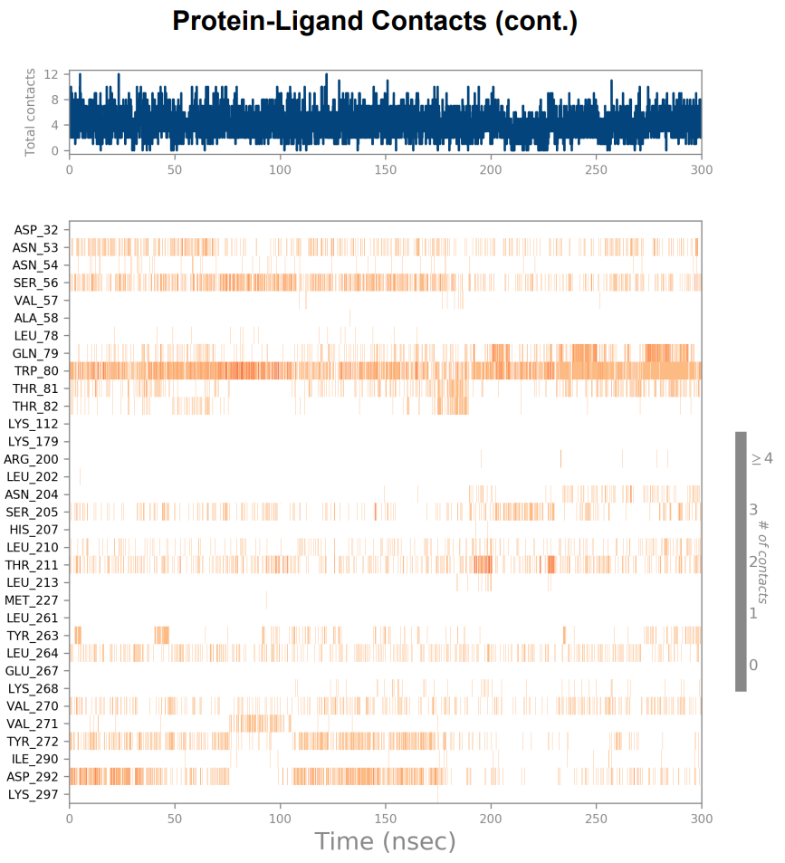

Fig. S4 (b). A timeline representation of the interactions and contacts (H-bonds, Hydrophobic, Ionic, Water bridges) summarized for MD simulation of AKT1-atranorin docked into an allosteric site. The top panel shows the total number of specific contacts the protein makes with the ligand over the course of the trajectory. The bottom panel shows which residues interact with the ligand in each trajectory frame. Some residues make more than one specific contact with the ligand, which is represented by a darker shade of orange, according to the scale to the right of the plot.
c)
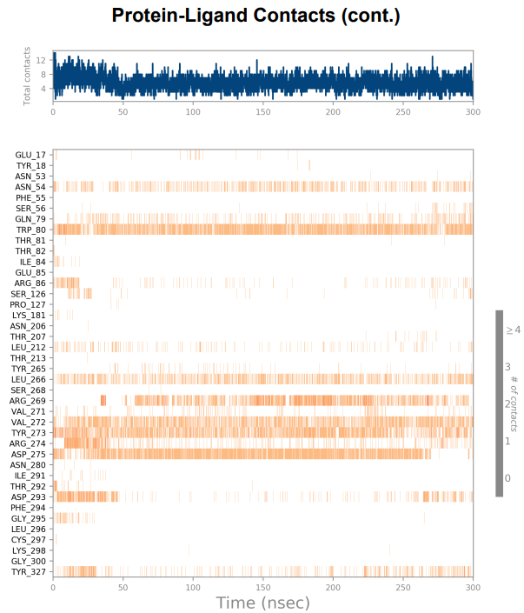

Fig. S4 (c). A timeline representation of the interactions and contacts (H-bonds, Hydrophobic, Ionic, Water bridges) summarized for MD simulation of AKT2-atranorin docked into an allosteric site. The top panel shows the total number of specific contacts the protein makes with the ligand over the course of the trajectory. The bottom panel shows which residues interact with the ligand in each trajectory frame. Some residues make more than one specific contact with the ligand, which is represented by a darker shade of orange, according to the scale to the right of the plot.

d)
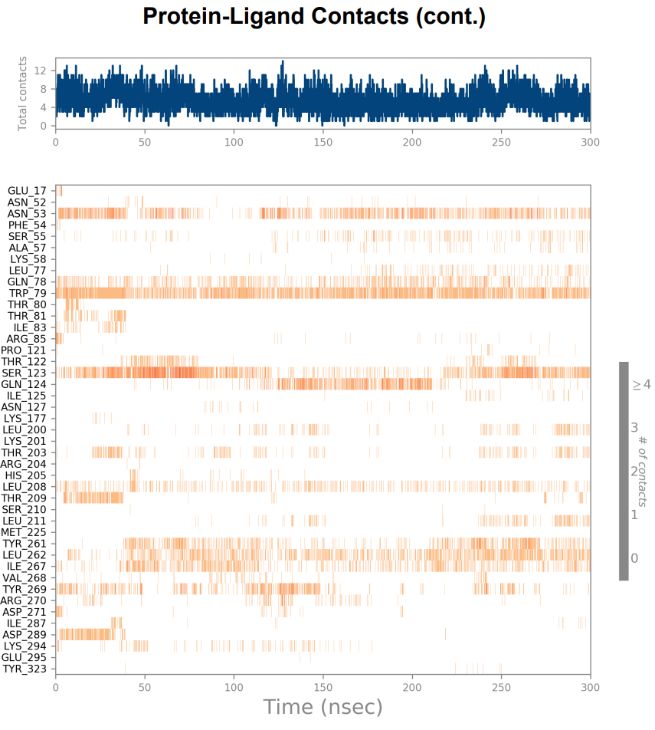

Fig. S4 (d). A timeline representation of the interactions and contacts (H-bonds, Hydrophobic, Ionic, Water bridges) summarized for MD simulation of AKT3-atranorin docked into an allosteric site. The top panel shows the total number of specific contacts the protein makes with the ligand over the course of the trajectory. The bottom panel shows which residues interact with the ligand in each trajectory frame. Some residues make more than one specific contact with the ligand, which is represented by a darker shade of orange, according to the scale to the right of the plot.

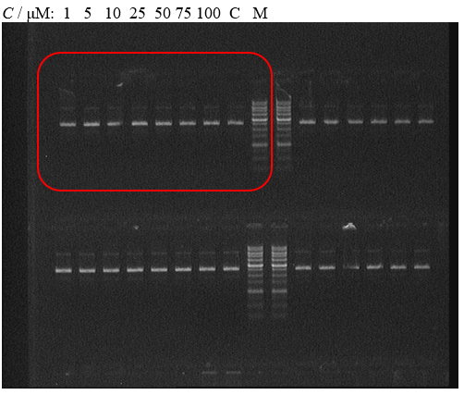

Fig. S5. Effect of atranorin on genotoxicity in the model experiment containing pBR322 plasmid (inside the red rectangle) (full gel). C — control, M — molecular mass marker.

