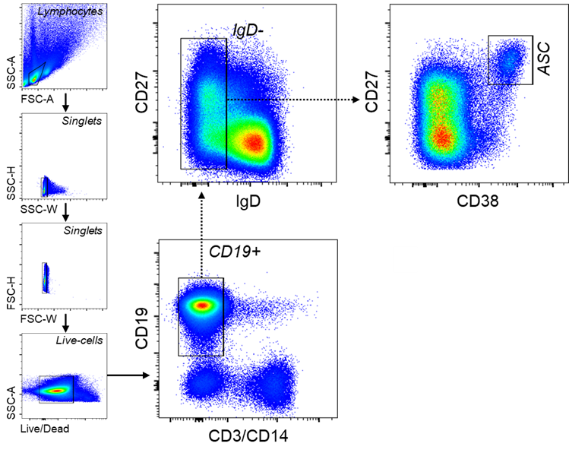

Suppl. Fig. S1. General FACS gating strategy used for sorting blood ASC. PBMC were first gated for lymphocytes, singlets, and viable cells (based on their FSC/SSC and Live/Death properties). CD3 and CD14 were then used as dump markers to capture CD19⁺ and CD19⁻ B cell populations. Subsequent sub-gating using CD38 versus CD27 on the IgD⁻ fraction (of CD19⁺ population) allows for sorting for blood ASC (CD27^{hi}CD38^{hi}). See Methods for antibody panels.
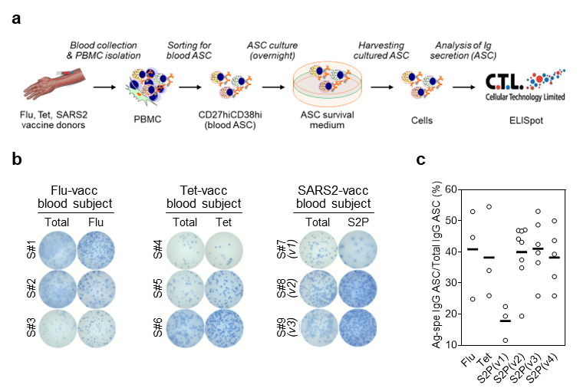
Suppl. Fig. S2. Assessment of Ag-specific ASC and validation of Ag specificities with blood ASC. (a) Summary of the techniques and the experimental design. From the cultures of blood ASC, the cells were collected and ELISpot-quantitated for validating Ag specificities. (b) Representative ELISpot scanned images shown. Blood ASC from subjects at the peak (ie 5-7 days post-vaccine) assayed for Flu-, Tet-, and S2P-specific IgG. The numbers of input ASC that were incubated were ~894, ~1,124, and ~796 (Total), and ~4,471, ~4,496, and ~2,388 (Flu-specific) for S#1, S#2, and S#3, respectively (far left); ~1K, ~1K, and ~1K (Total), and ~3K, ~4K, and ~4K (Tet-specific) for S#4, S#5, and S#6, respectively (left); ~712, ~1,415, and ~1,386 (Total), and ~2,139, ~4,245, and ~5,544 (S2P-specific) for S#7, S#8, and S#9, respectively (right). (c) Each circle represents an individual vaccinee (far right). S, subject; K, 1,000; vacc, vaccinated; Flu, influenza; Tet, tetanus; v, (SARS-CoV-2 mRNA) vaccine dose. All ASC assayed at day 1 in culture.
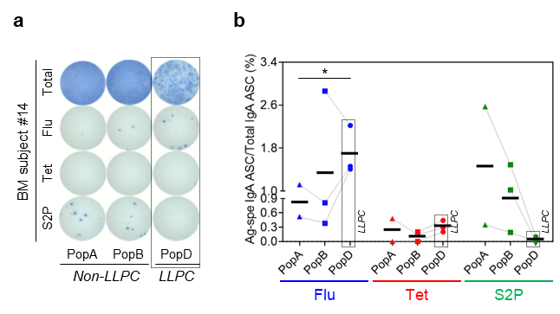
Suppl. Fig. S3. Exclusion of SARS-CoV-2-specific BM IgA LLPC in COVID-19 mRNA vaccinees. (a) Representative ELISpot scanned images. The numbers of input ASC that were incubated were ~9.6K, ~3.7K, and ~1.2K (Total) and ~58K, ~22K, and ~7.2K (Ag-specific) for PopA, PopB, and PopD, respectively (left). Unlike Flu-specific, S2P-specific BM IgA ASC emerged in the CD19⁺ (SLPC) compartment (PopA and PopB). (b) Each symbol represents an individual vaccinee. K, 1,000; LLPC, long-lived plasma cell (dotted boxes); Flu, influenza; Tet, tetanus. All ASC assayed at day 1 in culture. All comparisons by unpaired t-test between any two subsets for any Ag showed no statistically significant difference (now shown) except for comparison of PopD vs PopA for total IgA; *p <0.05.
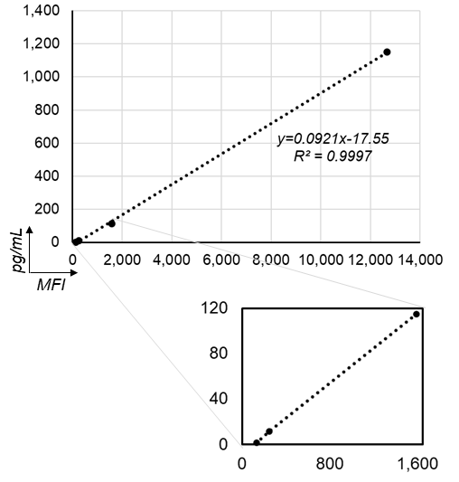
Suppl. Fig. S4. The human IgG standardized concentrations vs MFI values. The displayed equation was used for the purpose of normalization of MFI values generated by MBBA for detection of antibodies in the culture supernatants of BM ASC.
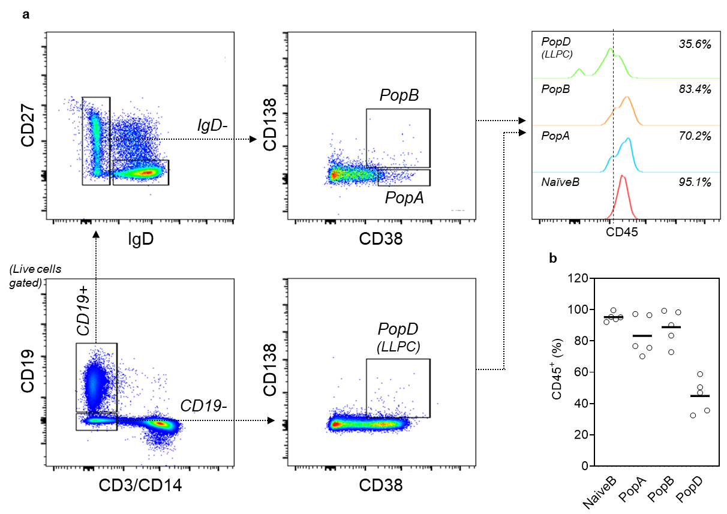
Suppl. Fig. S5. Downregulation of CD45 in LLPC (PopD). (a) Representative FACS gating strategy and CD45 staining for BM ASC subsets. For details on BM ASC gating, see Fig. 1b. For the antibody panel, see Methods. (b) CD45 staining is downregulated in LLPC (PopD). Each circle represents an individual healthy BM donor.

