Appendix – I (to Section 4)
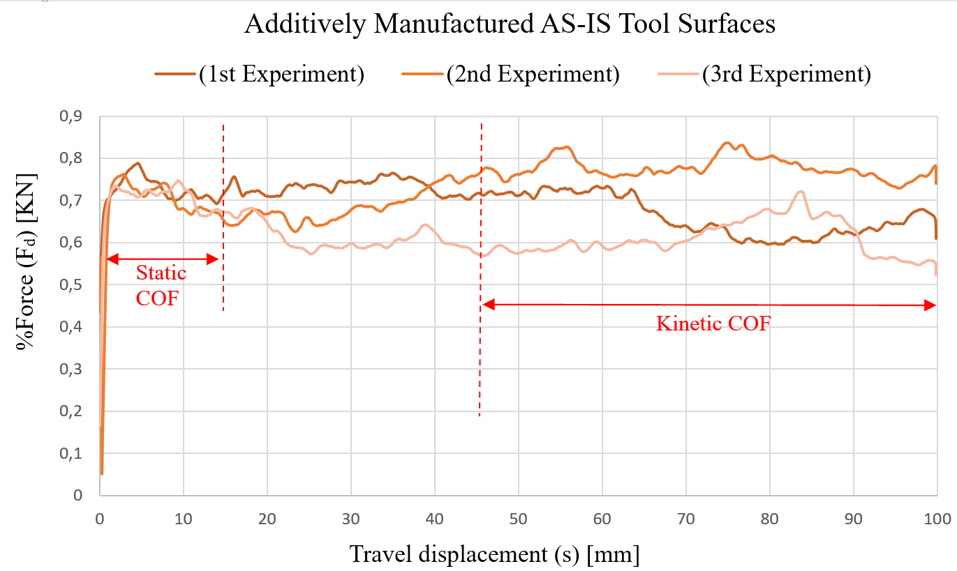
Appendix – II (to Section 4)
