Appendix

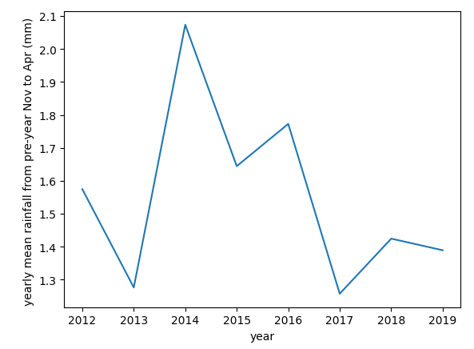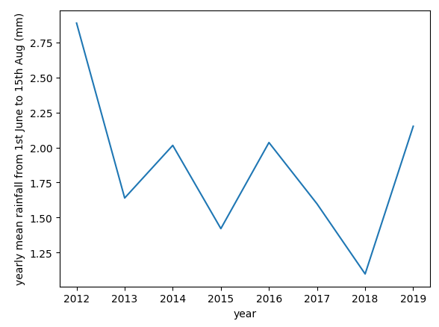
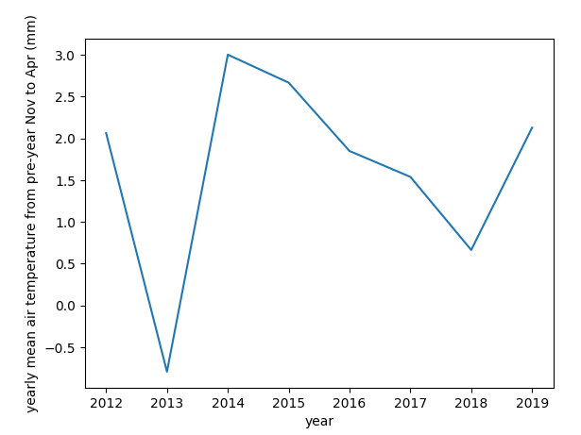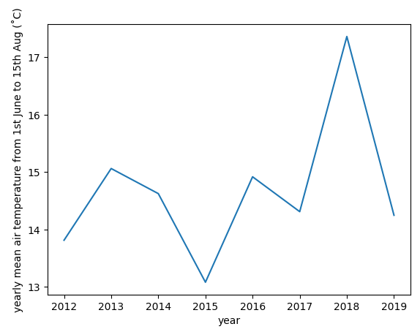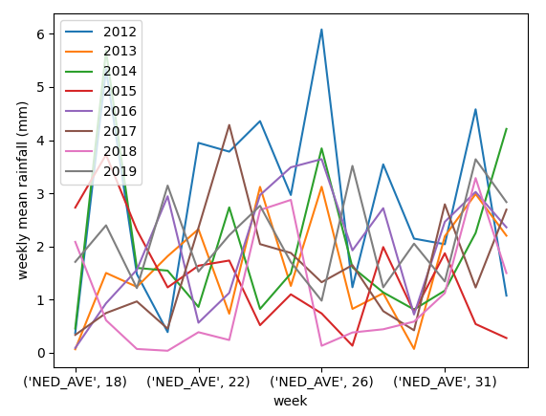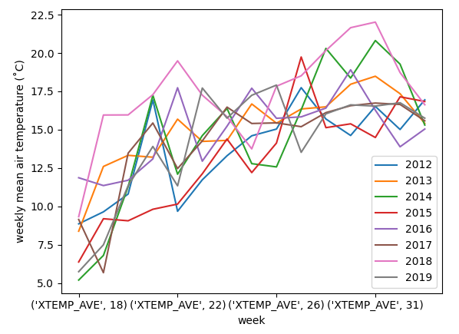

Figure A1.The variation of monthly and weekly rainfall and temperature changes from year 2012 to 2019.

The measured DON contamination and prediction results of DON contamination (in three contamination levels) in oats in Sweden are presented in Figure 5 as contamination maps, which were drawn using geo-referenced grid points. They were combined contamination maps for these years, so records of DON contamination in different years overlap in one grid. DON contamination is very unevenly distributed over the years, so the pattern of the contamination map varies a lot between years. The prediction results of DON contamination (Figure 5b, 5c, 5d) have a similar pattern as the map with the measured DON contamination (Figure 5a), which indicates a good spatial prediction performance of the model developed. The models developed in this study all resulted in a classification accuracy of > 0.72 using the internal validation data from dataset 1 (20% of the data randomly selected from 2012 to 2019 except 2016) (Figure A3).

Figure A3 shows the prediction results for DON contamination (low, medium, high) in oats in Sweden between 2012 and 2019 except in 2016 using weather data only. The confusion matrix (upper) visualized the internal model validation results (using the testing dataset 1) by comparing the actual and predicted class. Take SS-model as an example (upper left), 552+6+8 samples were predicted as low-contamination level where 552 samples were correctly predicted as belonging to the low-contamination class, and 6+8 samples were wrongly predicted, their true levels are the medium and high-contamination class, respectively. Normalized matrix for the SS-model (lower left) indicates the prediction accuracies for high, medium, and low contamination are 0.76, 0.57, and 0.58 respectively and the total accuracy (all the correct predicted samples divided by all the samples) for the SS-model is 0.72. For the MS and the FS-models, the corresponding total accuracies were 0.72 and 0.73.
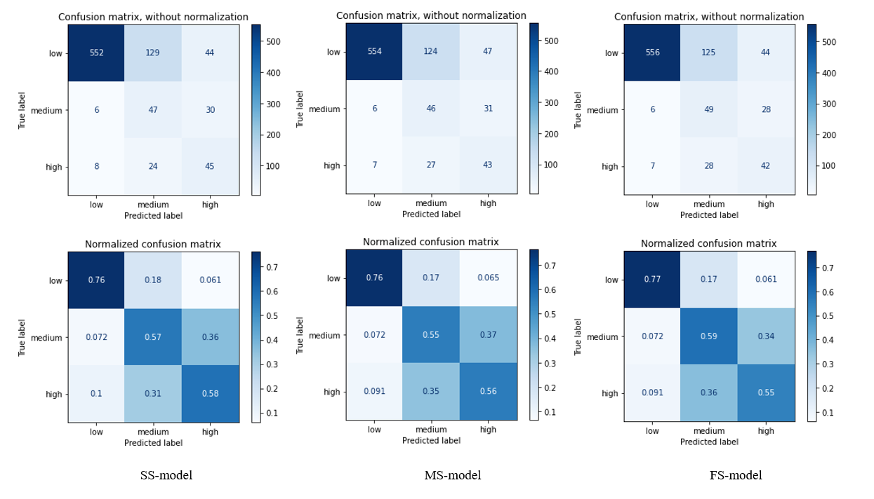

Figure A3. Prediction results using weather data only. The confusion matrix(upper) presents internal model validation results using the test dataset 1 (20% of 2012 - 2019 except 2016) to predict the contamination levels (low contamination, medium contamination, and high contamination) of DON in oats in Sweden between 2012 and 2019 except 2016.
Figure A4 shows the prediction results for DON contamination (low contamination, medium contamination, high contamination) in oats in Sweden between 2016 and 2017 using weather data only (from dataset 2). The total accuracy for each model was 0.82, 0.81, and 0.88.
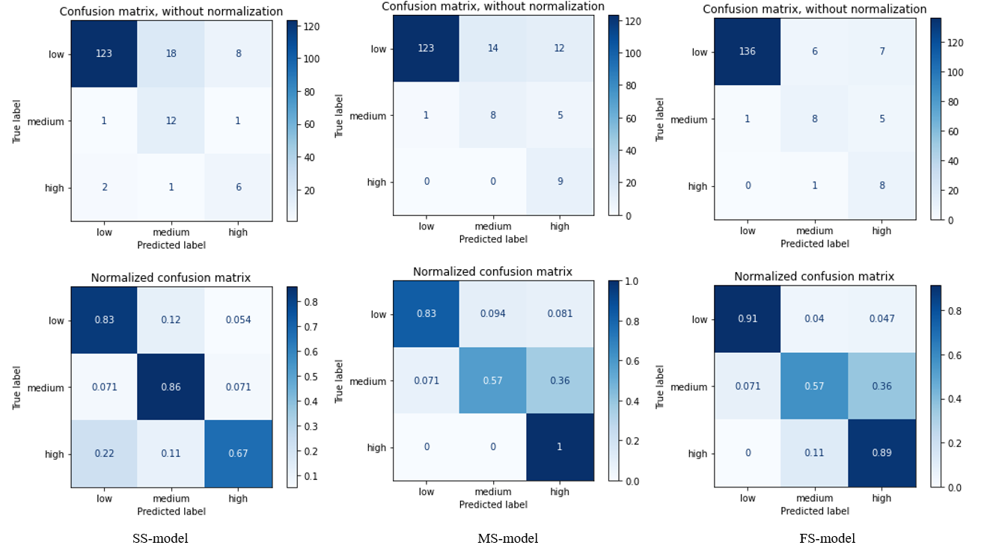
Figure A4. Prediction results using importance using weather data only. The confusion matrix(upper) presents internal model validation results using the test dataset (2016 and 2017) to predict the contamination levels (low contamination, medium contamination, high contamination) of DON in oats in Sweden between 2016 and 2017.

Figure A5 shows the external validation result for the prediction of DON contamination (low level, medium level, high level) in oats in Sweden in 2016 using the model trained on weather data and crop variety from 2012 to 2019 except 2016. The prediction accuracies for low, medium, and high DON contamination levels were 0.99, 0, and 0 for the SS-model, around 0.21, 0.72, and 0.64 for the MS-model, 0.75, 0.051, and 0.8 for the FS-model, respectively. The total classification accuracy for SS-model, MS-model, and FS-model were 0.83, 0.28, 0.71, respectively. The low performance in SS-model for the contamination level of medium and high further confirmed that the weather features, after flowering and before harvest, affect the DON contamination a lot and thus affect the model prediction performance. The prediction performance of SS models is good for low contamination level and poor for medium and high contamination levels, since most of the samples were predicted as belonging to the low level class. The prediction performance of MS models is good for medium contamination level but poor for low contamination level, since most of the samples were predicted as belonging to the medium level when actually samples belonged to the low contamination class. The prediction performance of ES models is good for high-contamination and low contamination levels but poor for medium contamination class, since most of the samples were predicted as belonging to the high and low level when actually samples belonged to the medium-contamination class. However, most of the high-contamination regions were correctly predicted (or predicted as a medium class) at the expense of low-contamination regions, which is very important to the stakeholders. In addition, results showed that data for the full season improved the models external validation result compared with only using data from parts of the season, which means data for full season improved the robustness of the predictive model.
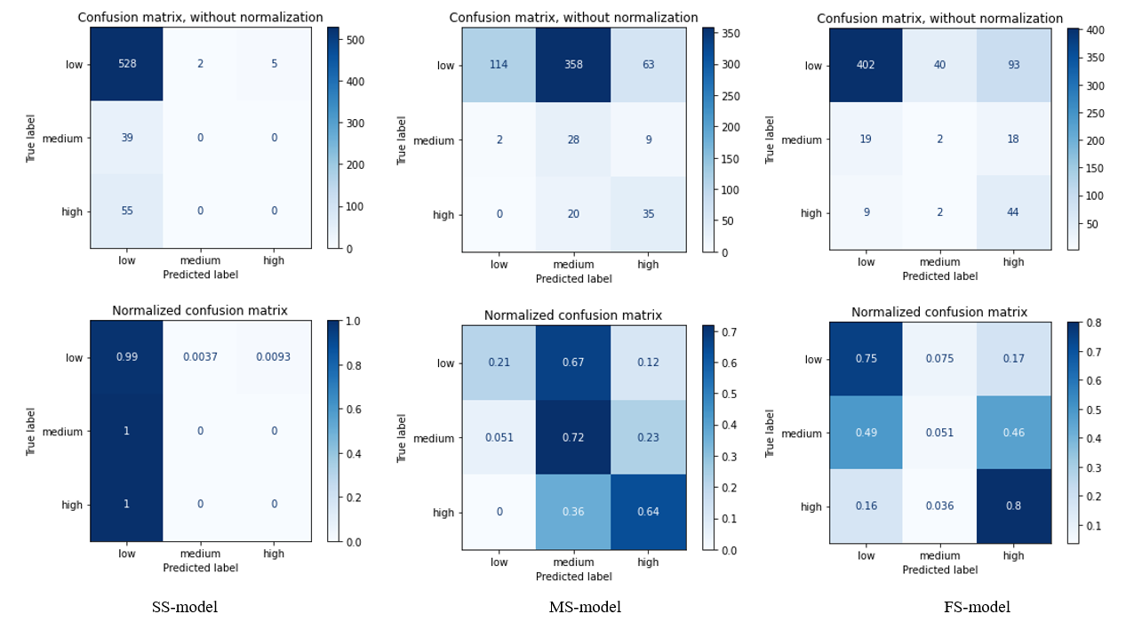
Figure A5. External validation results using weather data and crop variety. The confusion matrix(upper) presents internal model validation results using the external validation dataset (2016) to predict the contamination levels (low contamination, medium contamination, and high contamination) of DON in oats in Sweden in 2016.

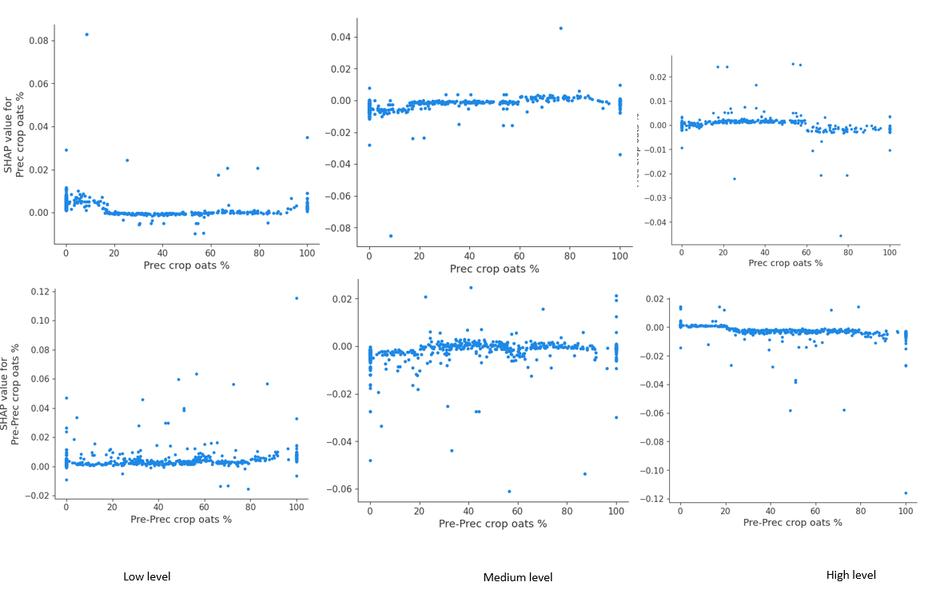
Figure A6. Feature dependency analysis for agronomic features (dataset 2) for the FS-model. Figure shows examples of the feature dependency of the crop rotation on the impact of the low, medium, and high contamination levels.

