Supplemental Figure 1:
A) Immunofluorescent staining of parental (AIW002-02) and SNCA-KO iPSCs for pluripotency markers. B) Karyotype analysis of SNCA-KO iPSCs. C) Genome stability analysis of SNCA-KO iPSCs. D) Protein levels of alpha-synuclein in control versus SNCA-KO iPSCs after differentiation into dopaminergic neurons. E) Pluripotency marker expression in CTSB-KO iPSCs. F) Karyotype analysis of CTSB-KO iPSCs. G) Genome stability analysis of CTSB-KO iPSCs. H) Protein levels of cathepsin B in control versus CTSB-KO iPSCs after differentiation into dopaminergic neurons.

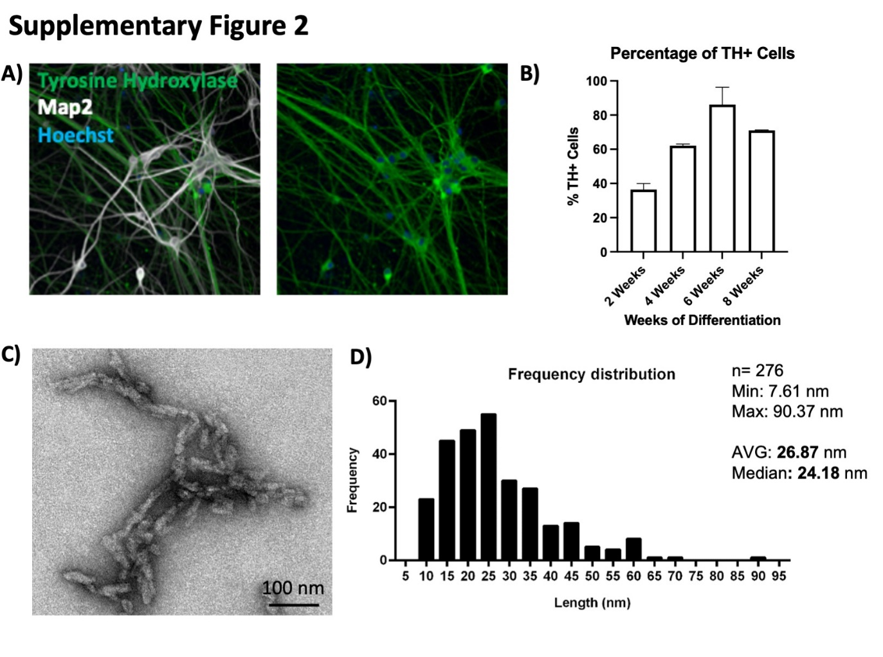
Supplemental Figure 2:
A) Differentiation of AIW002-2 iPSCs into dopaminergic neurons labelled for Map2 and tyrosine hydroxylase (TH). B) Percentage of TH-positive neurons at 2 , 4, 6 and 8 weeks of differentiation. C) Representative electron microscopy imaging of α-syn PFFs. D) Measurement of α-syn PFF fibril size.

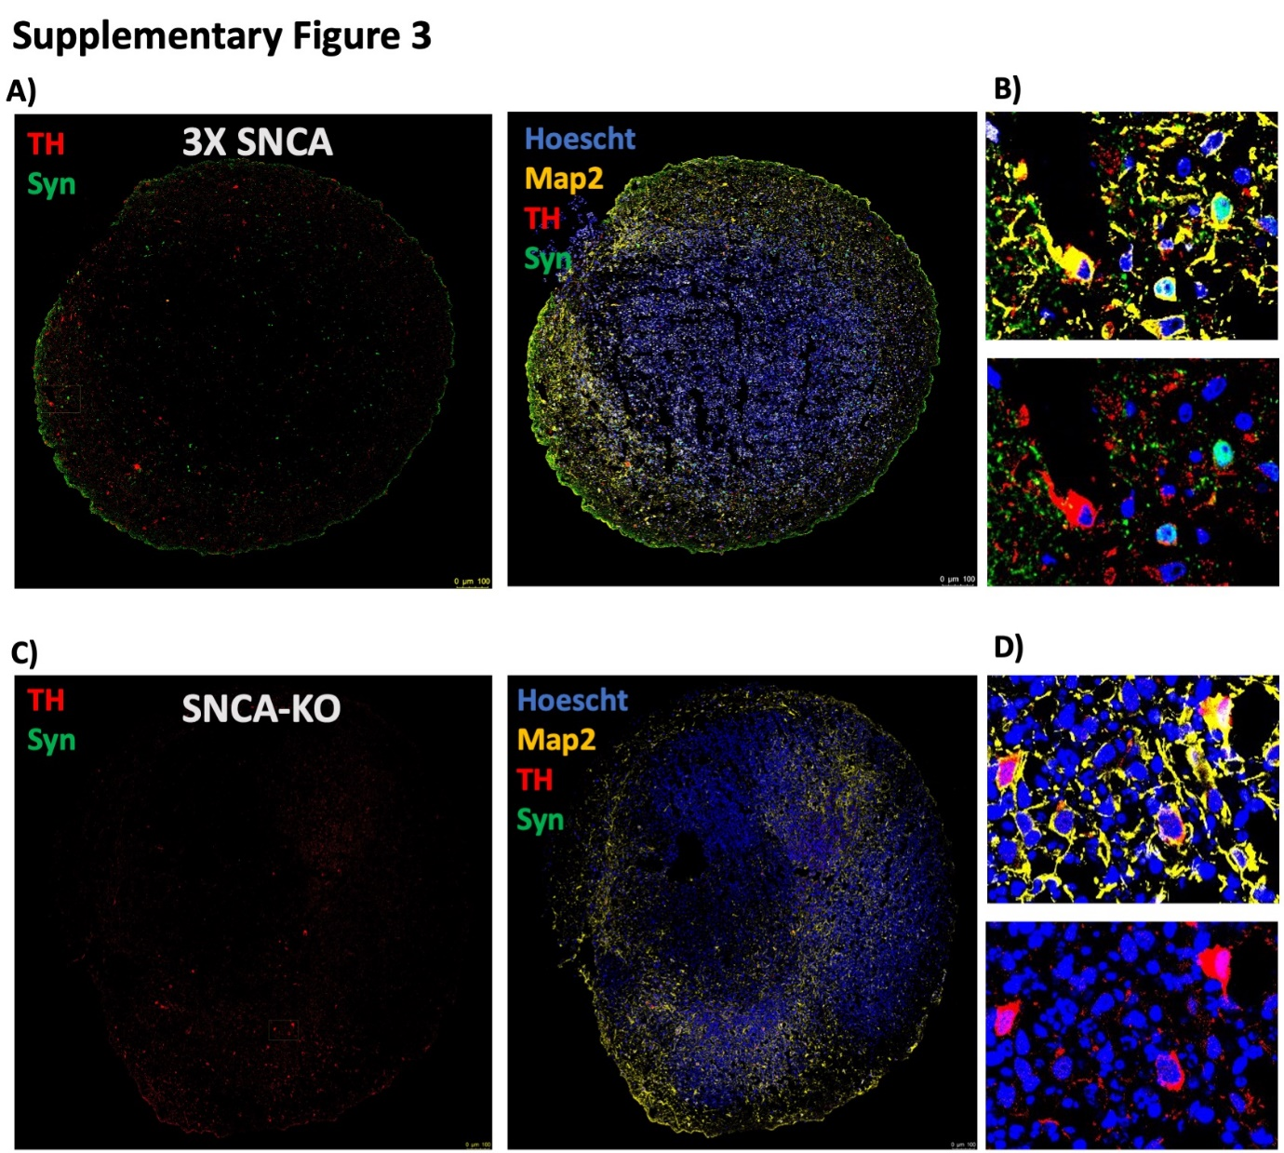
Supplementary Figure 3:
Immunofluorescent characterization of 5-month old midbrain organoids generated from SNCA triplication or SNCA-KO iPSCs. A, C) Representative immunofluorescent images depicting the entire organoid structure. B, D) Magnified images depicting individual cells. Nuclei are indicated in blue (Hoechst), total neuronal content indicated in yellow (Map2), dopaminergic neurons are stained in red (TH – tyrosine hydroxylase), and α-syn is shown in green.
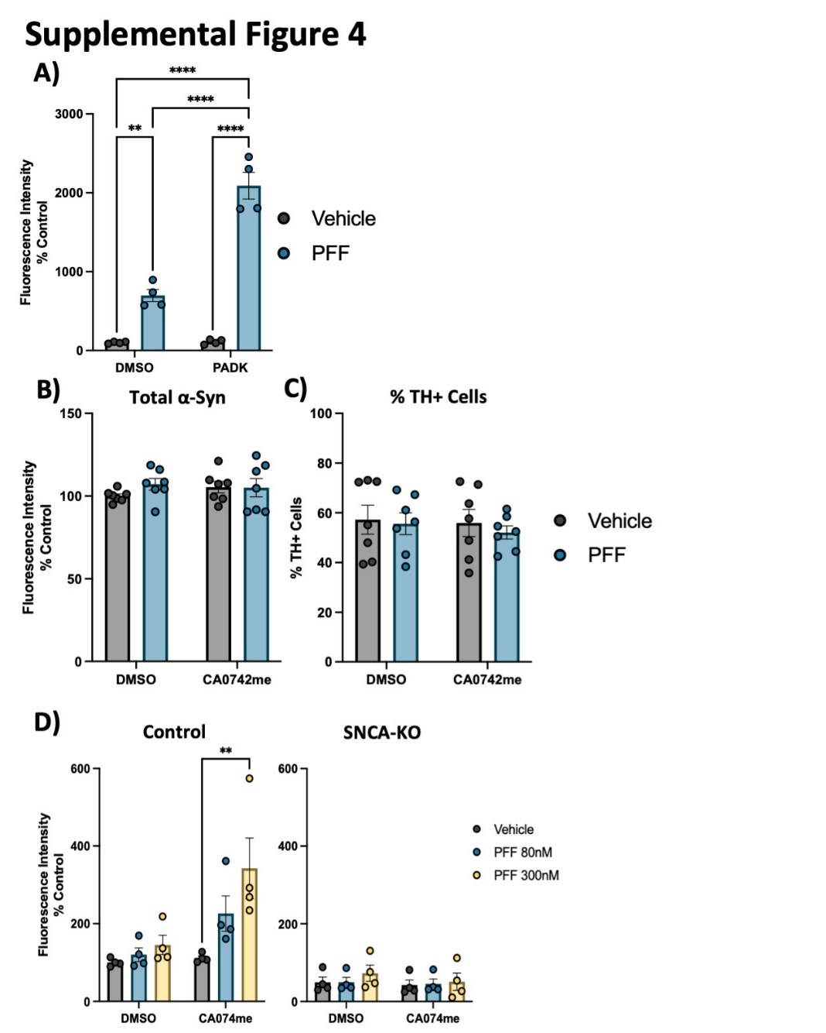
Supplemental Figure 4:
A) Quantification of pSyn-S129 in Map2-positive cells 4-weeks after exposure to PFF and/or PADK. B) Immunofluorescent quantification of total α-syn levels by high-content microscopy using the SYN1 antibody. C) Percentage of TH-positive cells in DA neuron cultures treated with CA074me (1 μM) and/or α-syn PFFs (300 nM). D) Quantification of pSyn-S129 in Map2-positive cells 3-weeks after PFF and/or CA074me treatment in either Control (AIW002-2) DA neurons or isogenic neurons lacking endogenous α-syn (AIW002-2 SNCA-KO). Bonferroni-corrected t-tests, ** p < 0.01, **** p < 0.0001.

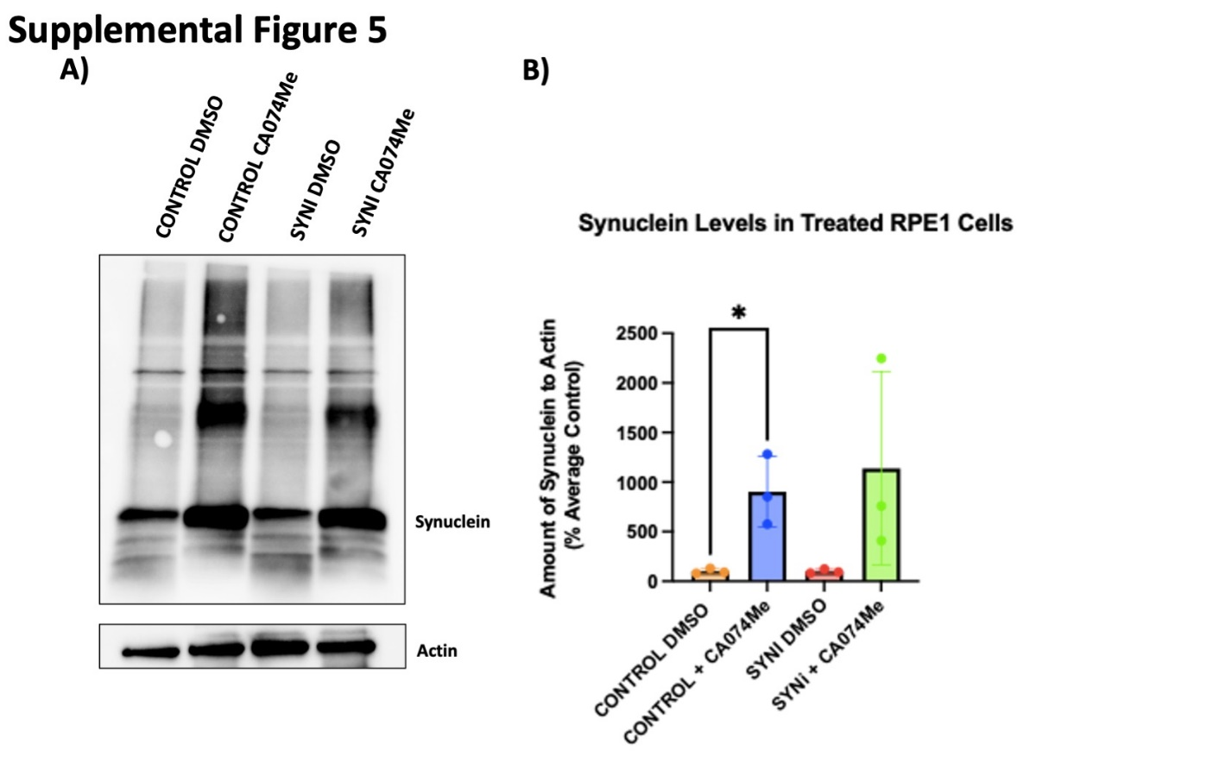
Supplemental Figure 5:
A) Representative western blot depicting protein levels of α-syn (SYN1 antibody) and actin 48-hours after treatment of RPE1 cell lines with 300nM of α-syn PFFs and/or CA074me. B) Western blot quantifications depicting levels of α-syn (SYN1 antibody – quantification of whole lane) relative to actin in PFF and/or CA074me treated RPE1 cells. T-test or Bonferroni-corrected t-tests, * p < 0.05.

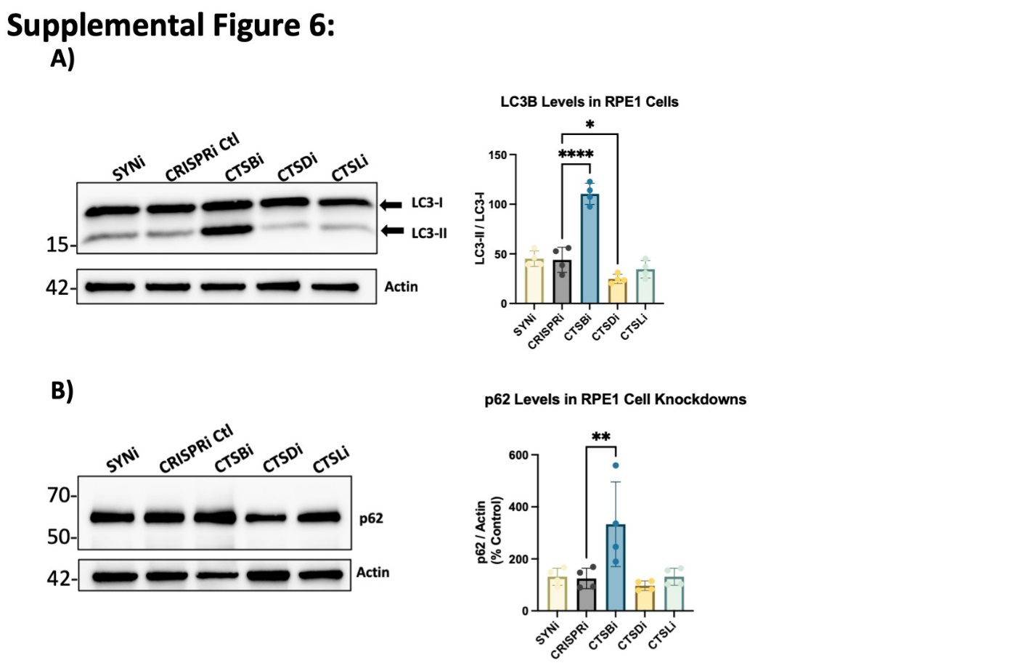
Supplemental Figure 6:
A) Representative western blots and quantification of western blots of LC3B and actin in RPE1 cell lines. B) Representative western blots and quantification of western blots of p62 and actin in RPE1 cell lines. Bonferroni-corrected t-tests, * p < 0.05, ** p < 0.01, *** p < 0.001, **** p < 0.0001.

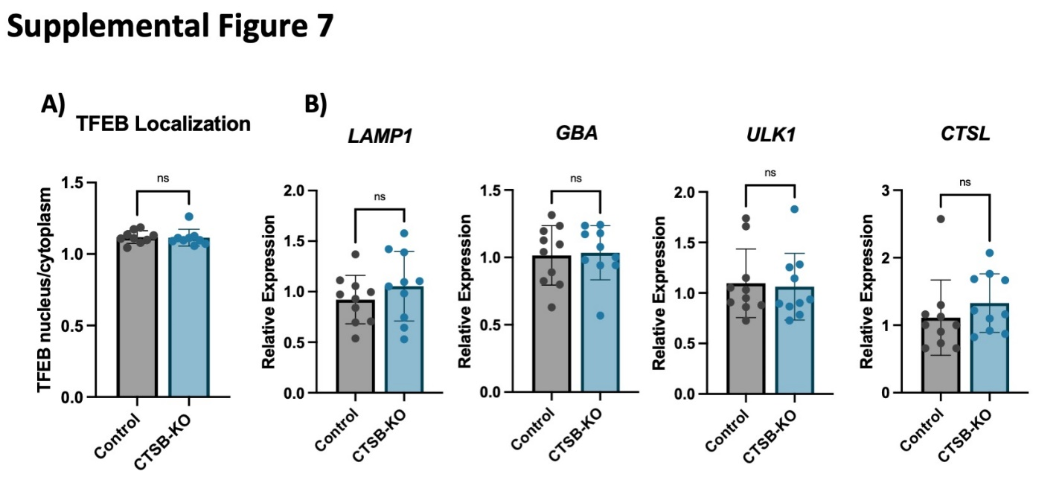
Supplementary Figure 7:
A) High-content confocal imaged-based quantification of the ratio of nuclear to cytoplasmic TFEB in iPSC-derived DA neurons based on immunofluorescence using Map2 to define the cell body area and Hoechst to define the nuclear area. B) Relative expression level of the indicated genes measured by RT-qPCR in iPSC-derived DA neurons.

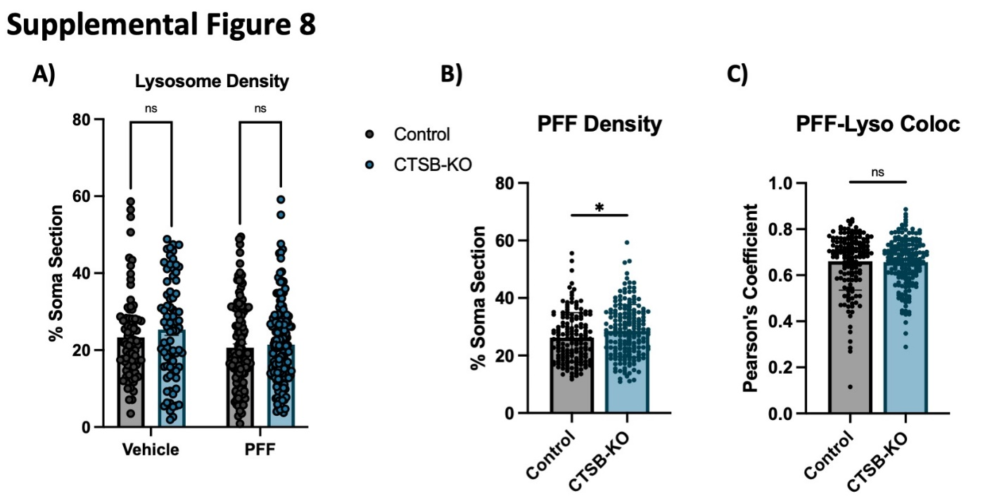
Supplemental Figure 8:
A) Quantification of lysosome density per cell body from live-cell confocal images of DA neuron cell bodies stained with lysotracker-green 72-hours after exposure to alexa-633 labelled α-syn PFFs (80 nM) and measured as the percentage of lysotracker-positive area per cell soma. B) PFF density per cell body, measured as the percentage of PFF-633-positive area per cell soma. C) Colocalization of lysotracker and PFF-633 measured using Pearson’s coefficient per cell soma. T-test, * p < 0.05, ** p < 0.01.

List of Supplemental Tables

Supplementary Table 1: QTL datasets used for analyses

Supplementary Table 2. Study population

Supplementary Table 3: Coverage details for CTSB

Supplemental Table 4: Primer and gRNA sequences used in the generation of CTSB-KO iPSC lines

Supplementary Table 5: Cell Culture Reagents and Media Compositions

Supplemental Table 6: CRISPRa and CRISPRi gRNA sequences

Supplemental Table 7: Antibodies

Supplemental Table 8: qPCR Primer sequences

Supplementary Table 9: GCTA-COLOC results

Supplementary Table 10: FINEMAP results of the nominated variants in CTSB

Supplementary Table 11: CTSB locus SMR and HEIDI analyses

Supplemental Table 12: Burden analysis for CTSB rare variants

Supplemental Table 13: Proteomics quantifications

