Table 1. The basic characteristics of the severe group and the non-severe group
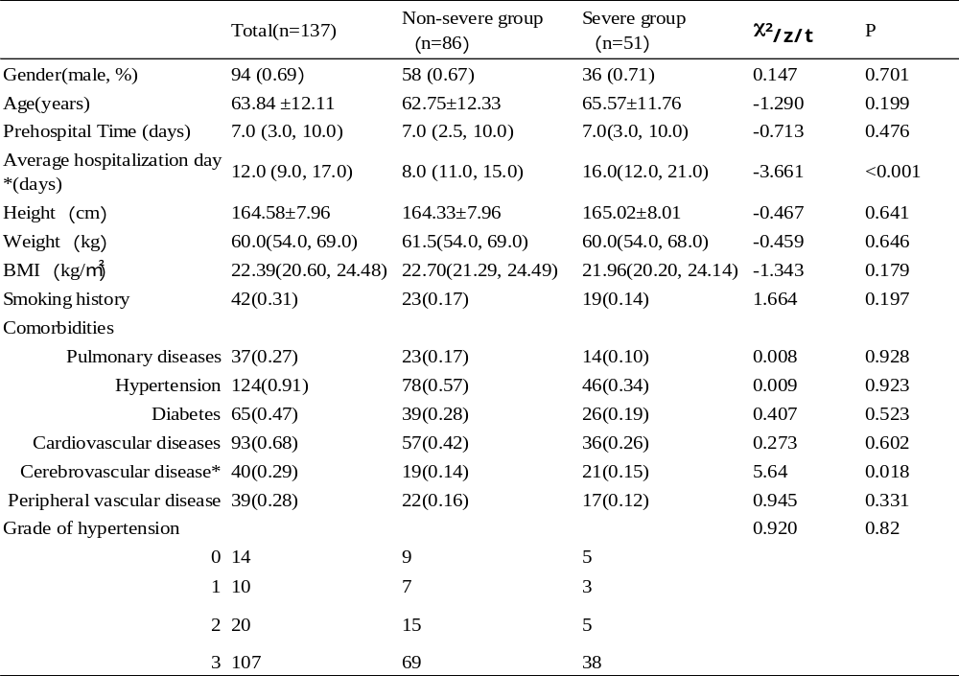 Prehospital Time: Time from onset of infection to hospital admission. Cerebrovascular Disease: Refers to various diseases of the brain blood vessels, including cerebral atherosclerosis, thrombosis, stenosis, occlusion, cerebral arteritis, cerebral arterial injury, cerebral aneurysm, intracranial vascular malformations, and cerebral arteriovenous fistula. They commonly result in ischemic or hemorrhagic accidents in brain tissues, leading to disability or even death in patients. The incidence rate accounts for 1/4 to 1/2 of all neurological inpatient cases.

Table 2. Laboratory Characteristics of the severe group and the non-severe group

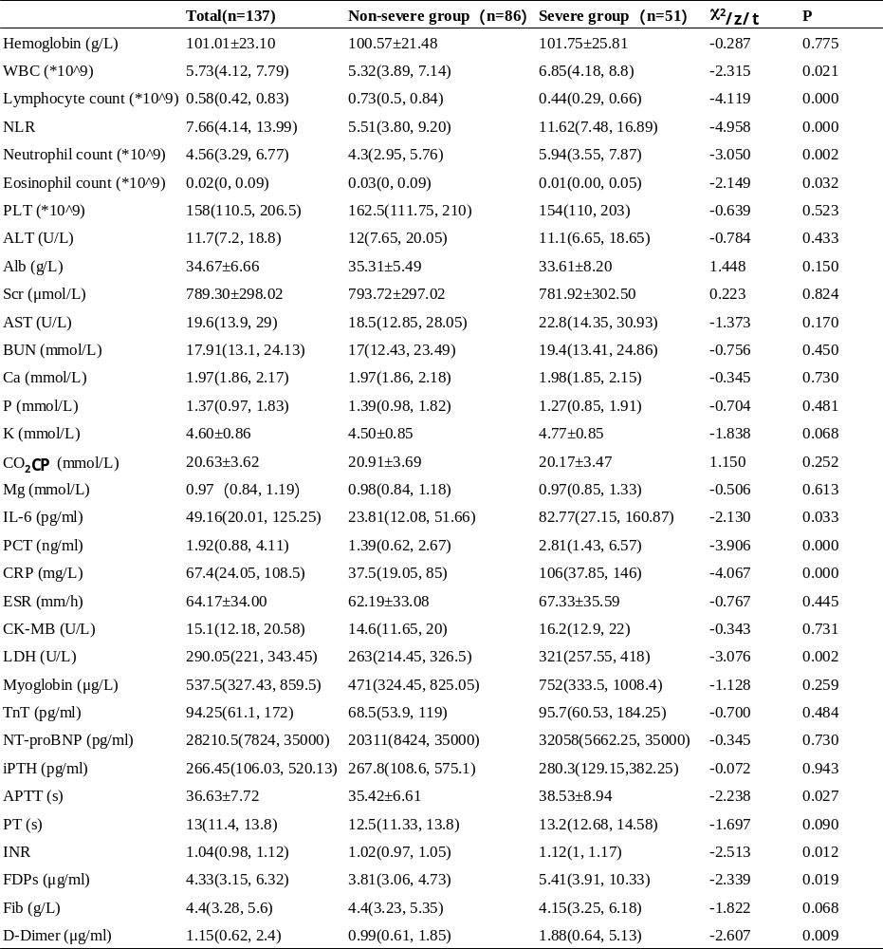 WBC: white blood cells, PLT: platelets, NLR: neutrophil to lymphocyte ratio, ALT: alanine aminotransferase, AST: aspartate aminotransferase, Alb: serum albumin, BUN: blood urea nitrogen, Scr: serum creatinine, K: serum potassium, Ca: serum calcium, P: serum phosphorus, Mg: serum magnesium, CO₂CP: carbon dioxide combining power, PCT: procalcitonin, CRP: C-reactive protein, ESR: erythrocyte sedimentation rate, IL-6: interleukin-6, ferritin, CK-MB: creatine kinase isoenzyme, LDH: lactate dehydrogenase, NT-proBNP: N-terminal pro-brain natriuretic peptide, iPTH: intact parathyroid hormone, APTT: activated partial thromboplastin time, PT: prothrombin time, INR: International Normalized Ratio, FDPs: fibrinogen Degradation Products, Fib: fibrinogen.
Table 3. Analysis of Risk Factors for Severe COVID-19 Infection in MHD Patients
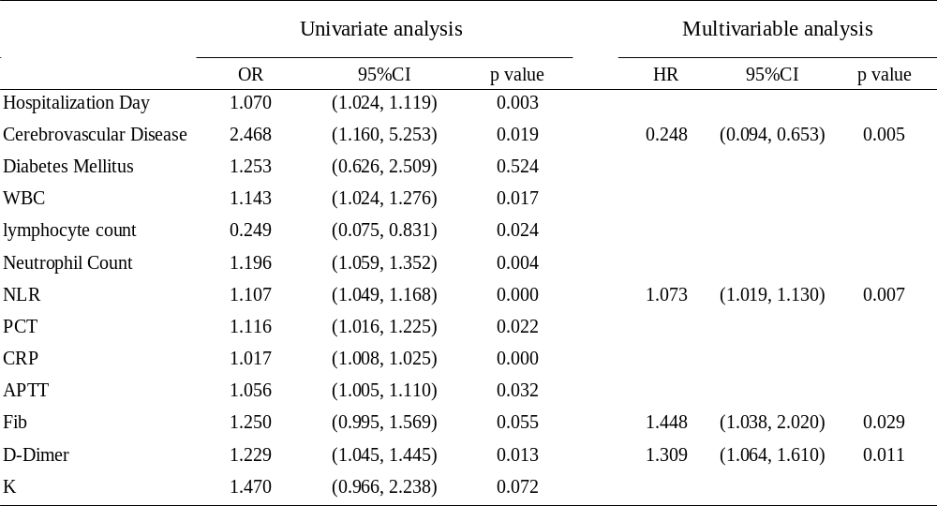

Table 4. Univariate and multivariate analysis of survival in COVID-19 infected patients
