Supporting information.
Figure S1 Potential distribution patterns for different climate scenarios conditions except contemporary climatic conditions.
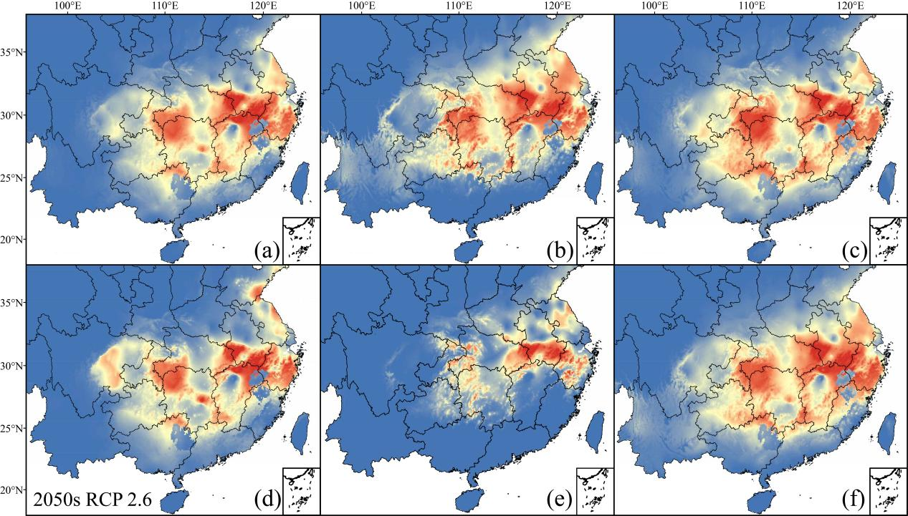
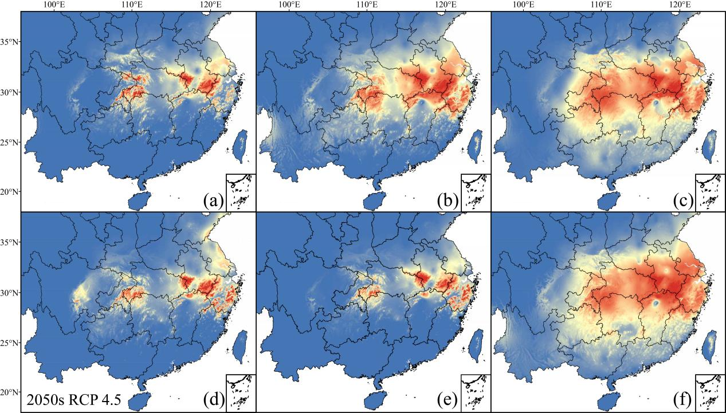
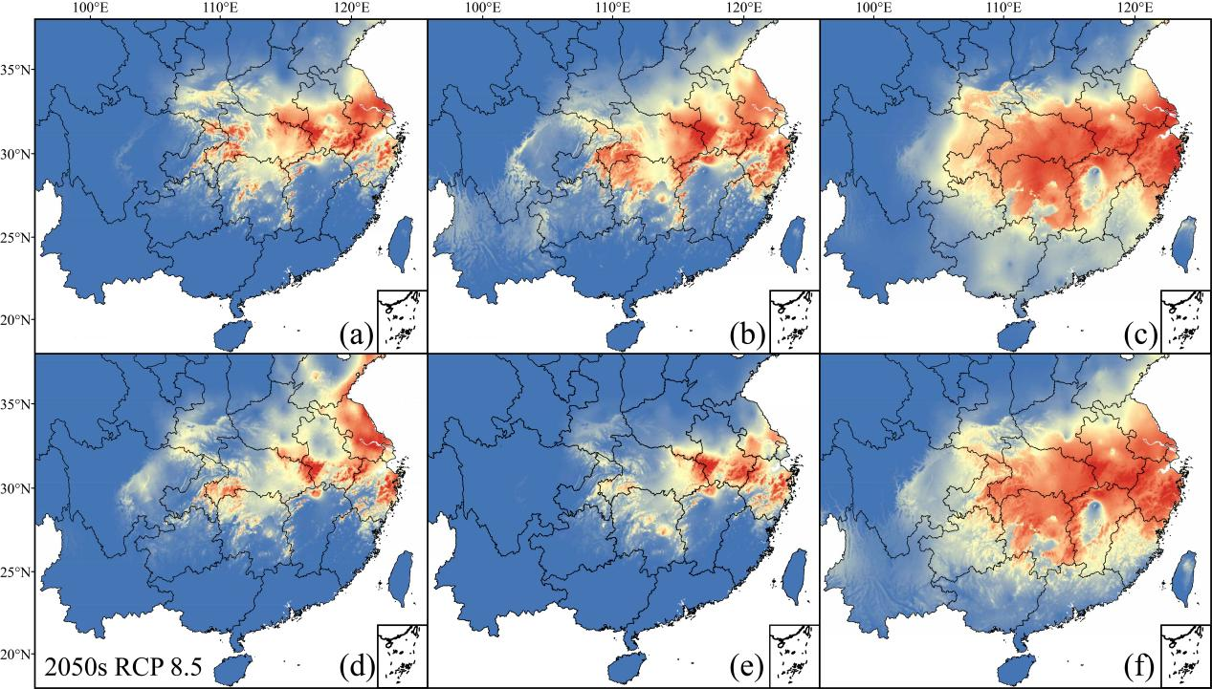
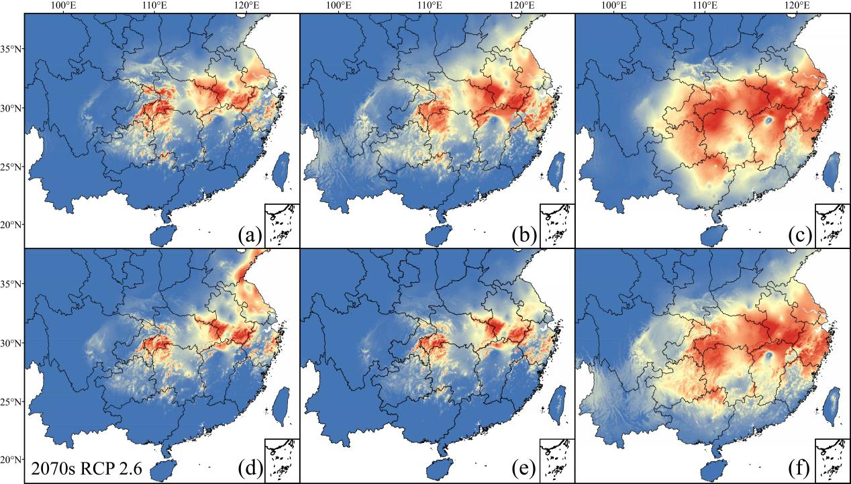
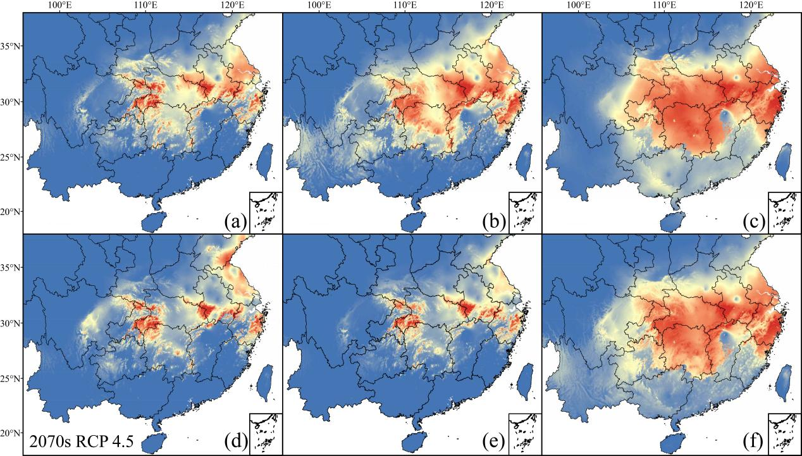
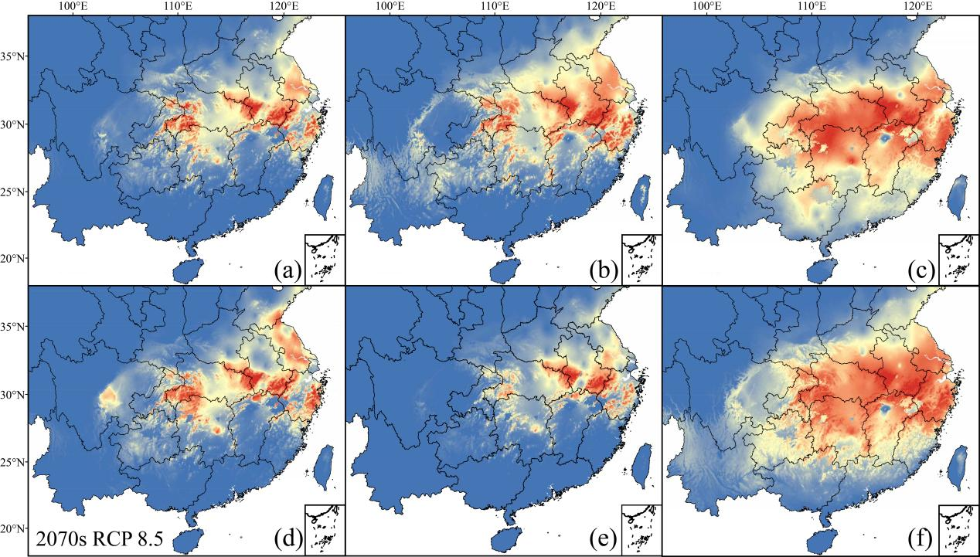

Table S1 Six sets of distribution data for this study.
Num. | Lon | Lat | Location | Resource
1 | 119.43045 | 30.33988 | Tianmu Mountain, Lin'an Conuty, Hangzhou City, Zhejiang Province. | CVH; Geng et al., 2017. Sci. Rep.
2 | 119.0015 | 30.04316 | Qingliang Mountain, Lin'an Conuty, Hangzhou City, Zhejiang Province. | CVH; Geng et al., 2017. Sci. Rep.
3 | 118.97306 | 30.03688 | Daming Mountain, Lin'an Conuty, Hangzhou City, Zhejiang Province. | CVH; Geng et al., 2017. Sci. Rep.
4 | 116.54883 | 31.05646 | Shucheng Conuty, Anqing City, Anhui Province. | CVH; Geng et al., 2017. Sci. Rep.
5 | 116.06971 | 31.0315 | Yuexi Conuty, Anqing City, Anhui Province. | CVH; Geng et al., 2017. Sci. Rep.
6 | 114.99985 | 31.8417 | Jigong Mountain, Xinyang City, Anhui Province. | CVH; Geng et al., 2017. Sci. Rep.
7 | 112.01433 | 33.53566 | Nanzhao Conuty, Nanyang City, Anhui Province. | CVH; Geng et al., 2017. Sci. Rep.
8 | 112.0007 | 33.51875 | Nanzhao Conuty, Nanyang City, Anhui Province. | CVH; Geng et al., 2017. Sci. Rep.
9 | 110.45608 | 31.57976 | Shennongjia forestry district, Hubei Province. | Yang et al., 2018, J. Green Sci. Technol.
10 | 111.94913 | 33.47106 | Baotianman, Neixiang Conuty, Nanyang City, Anhui Province. | CVH
11 | 111.88049 | 33.62065 | Song Conuty, Luoyang City, Anhui Province. | CVH
12 | 115.76637 | 31.16413 | Baimazhai, Jinzhai City, Lu'an City, Anhui Province. | CVH
13 | 116.21261 | 31.2774 | Huoshan Conuty, Lu'an City, Anhui Province. | CVH
14 | 118.63066 | 30.14395 | Jixi Conuty, Xuancheng City, Anhui Province. | CVH
15 | 118.83808 | 29.88974 | She Conuty, Huangshan City, Anhui Province. | CVH
16 | 118.83641 | 29.61234 | Chun'an Conuty, Hangzhou City, Zhejiang Province. | CVH
17 | 121.02821 | 29.19197 | Tiantai Mountain, Tiantai Conuty, Tiantai City, Zhejiang Province. | CVH
18 | 115.79836 | 30.82973 | Yingshan City, Hubei Province. | CVH
19 | 118.84008 | 32.06338 | Ming Xiaoling Mausoleum, Nangjing City, Jiangsu Province. | CVH
20 | 120.12551 | 30.26051 | Hangzhou Botanical Garden, Hangzhou City, Zhejiang Province. | CVH
21 | 115.96899 | 29.5986 | Jiujiang City, Jiangxi Province. | CVH
22 | 102.74918 | 25.14646 | Kunming Botanical Garden, Kunming City, Jiangxi Province. | CVH
23 | 114.30536 | 25.67648 | Congyi County, Ganzhou City, Jiangxi Province. | CVH
24 | 111.51968 | 23.41995 | Fengkai County, Zhaoqing City, Jiangxi Province. | CVH
25 | 118.61116 | 28.73906 | Jiangshan County, Qujiang City, Zhejiang Province. | CVH
26 | 107.86838 | 25.98558 | Sandu Shui Autonomous County, Yunnan Province. | CVH
27 | 119.455097 | 30.340834 | Tianmu Mountain, Lin'an Conuty, Hangzhou City, Zhejiang Province. | CVH
28 | 118.83641 | 29.61234 | Chunan County, Hangzhou City, Zhejiang Province. | CVH
29 | 118.913359 | 30.114319 | Qingliang Mountain, Lin'an Conuty, Hangzhou City, Zhejiang Province. | CVH
30 | 119.014479 | 30.032257 | Daming Mountain, Lin'an Conuty, Hangzhou City, Zhejiang Province. | CVH
31 | 119.224435 | 30.168569 | Chnaghua vallege, Lin'an County, Hangzhou City, Zhejiang Province. | CVH
32 | 119.567251 | 30.412984 | Taihuyuan, Lin'an County, Hangzhou City, Zhejiang Province. | CVH
33 | 121.04204 | 29.162747 | Tiantai Mountain, Tiantai Conuty, Tiantai City, Zhejiang Province. | CVH
34 | 118.838081 | 29.889742 | She Conuty, Huangshan City, Anhui Province. | CVH
35 | 116.21261 | 31.2774 | Huoshan Conuty, Lu'an City, Anhui Province. | CVH
36 | 116.085813 | 30.988115 | Yuexi Conuty, Anqing City, Anhui Province. | CVH
37 | 116.201703 | 31.002492 | Qingtian Vallage, Yuexi Conuty, Anqing City, Anhui Province. | CVH
38 | 115.766373 | 31.164134 | Baimazhai, Jinzhai City, Lu'an City, Anhui Province. | CVH
39 | 114.083414 | 31.81925 | Jigong Mountain, Xinyang City, Anhui Province. | CVH
40 | 111.919478 | 33.51763 | Baotianman, Neixiang Conuty, Nanyang City, Anhui Province. | CVH
41 | 111.880495 | 33.620659 | Shangzhuangping, Song County, Henan Province. | CVH
42 | 115.79836 | 30.82973 | Yingshan City, Hubei Province. | CVH
Note：1-18 (dataset 1); 1-22 (dataset 2); 1-18, 23-26 (dataset 3); 27-42 (dataset 4); 1-9 (dataset5); 1-26(dataset 6)

Table S2 Climatic variables in the Pearson correlations analysis.
Climatic variable
BIO1 = Annual Mean Temperature
BIO2 = Mean Diurnal Range (Mean of monthly (max temp - min temp))
BIO3 = Isothermality (BIO2/BIO7) (×100)
BIO4 = Temperature Seasonality (standard deviation ×100)
BIO5 = Max Temperature of Warmest Month
BIO6 = Min Temperature of Coldest Month
BIO7 = Temperature Annual Range (BIO5-BIO6)
BIO8 = Mean Temperature of Wettest Quarter
BIO9 = Mean Temperature of Driest Quarter
BIO10 = Mean Temperature of Warmest Quarter
BIO11 = Mean Temperature of Coldest Quarter
BIO12 = Annual Precipitation
BIO13 = Precipitation of Wettest Month
BIO14 = Precipitation of Driest Month
BIO15 = Precipitation Seasonality (Coefficient of Variation)
BIO16 = Precipitation of Wettest Quarter
BIO17 = Precipitation of Driest Quarter
BIO18 = Precipitation of Warmest Quarter
BIO19 = Precipitation of Coldest Quarter

Table S3 Contribution rates and AUC values of variables in each period under the MaxEnt model.
Period | Correct (dataset 1) |  |  | Cultivated (dataset 2)
Period | variables | Contribution | AUC | variables | Contribution | AUC
Present | Bio18 | 61.7% | 0.997 | Bio18 | 61.8% | 0.997
Present | Bio4 | 25.2% | 0.997 | Bio4 | 23.3% | 0.997
Present | Bio11 | 8.8% | 0.997 | Bio6 | 7.8% | 0.997
2050 Rcp2.6 | Bio18 | 64.5% | 0.997 | Bio18 | 56.2% | 0.996
2050 Rcp2.6 | Bio4 | 27% | 0.997 | Bio4 | 24.1% | 0.996
2050 Rcp2.6 | Bio15 | 5.3% | 0.997 | Bio6 | 15.1% | 0.996
2050  Rcp4.5 | Bio18 | 55.7% | 0.998 | Bio18 | 54.8% | 0.997
2050  Rcp4.5 | Bio4 | 21.3% | 0.998 | Bio4 | 23.1% | 0.997
2050  Rcp4.5 | Bio11 | 13.9% | 0.998 | Bio6 | 17.5% | 0.997
2050  Rcp8.5 | Bio18 | 51% | 0.998 | Bio18 | 54.2% | 0.997
2050  Rcp8.5 | Bio4 | 21.9% | 0.998 | Bio4 | 24.3% | 0.997
2050  Rcp8.5 | Bio11 | 15.4% | 0.998 | Bio6 | 19.4% | 0.997
2070  Rcp2.6 | Bio11 | 57.6% | 0.998 | Bio18 | 60% | 0.996
2070  Rcp2.6 | Bio18 | 23.4% | 0.998 | Bio4 | 24% | 0.996
2070  Rcp2.6 | Bio2 | 11.7% | 0.998 | Bio6 | 13.9% | 0.996
2070  Rcp4.5 | Bio18 | 61.9% | 0.998 | Bio18 | 55.7% | 0.996
2070  Rcp4.5 | Bio4 | 22.8% | 0.998 | Bio6 | 22.8% | 0.996
2070  Rcp4.5 | Bio11 | 11.4% | 0.998 | Bio4 | 18.6% | 0.996
2070  Rcp8.5 | Bio18 | 62.7% | 0.997 | Bio18 | 58.9% | 0.997
2070  Rcp8.5 | Bio4 | 22.8% | 0.997 | Bio4 | 19.8% | 0.997
2070  Rcp8.5 | Bio11 | 8.3% | 0.997 | Bio6 | 19.6% | 0.997
Period | Specimen (dataset 4) |  |  | Misleading (dataset 3)
Period | variables | Contribution | AUC | variables | Contribution | AUC
Present | Bio18 | 63.9% | 0.997 | Bio18 | 64.6% | 0.996
Present | Bio4 | 23.8% | 0.997 | Bio4 | 24.8% | 0.996
Present | Bio11 | 7.2% | 0.997 | Bio15 | 5.5% | 0.996
2050 Rcp2.6 | Bio18 | 65.8% | 0.997 | Bio18 | 61.5% | 0.995
2050 Rcp2.6 | Bio4 | 28.5% | 0.997 | Bio4 | 25.8% | 0.995
2050 Rcp2.6 | Bio7 | 5% | 0.997 | Bio15 | 7.3% | 0.995
2050  Rcp4.5 | Bio18 | 61.5% | 0.997 | Bio18 | 57.8% | 0.996
2050  Rcp4.5 | Bio4 | 25.3% | 0.997 | Bio4 | 23.8% | 0.996
2050  Rcp4.5 | Bio11 | 7.4% | 0.997 | Bio15 | 10.2% | 0.996
2050  Rcp8.5 | Bio18 | 54.7% | 0.997 | Bio18 | 54.8% | 0.995
2050  Rcp8.5 | Bio4 | 26.3% | 0.997 | Bio4 | 25.6% | 0.995
2050  Rcp8.5 | Bio11 | 12% | 0.997 | Bio15 | 9% | 0.995
2070  Rcp2.6 | Bio18 | 62.2% | 0.997 | Bio18 | 62.5% | 0.996
2070  Rcp2.6 | Bio4 | 23.8% | 0.997 | Bio4 | 26.6% | 0.996
2070  Rcp2.6 | Bio11 | 9.4% | 0.997 | Bio15 | 6.2% | 0.996
2070  Rcp4.5 | Bio18 | 63% | 0.997 | Bio18 | 58.9% | 0.995
2070  Rcp4.5 | Bio4 | 24.3% | 0.997 | Bio4 | 25.2% | 0.995
2070  Rcp4.5 | Bio11 | 7.4% | 0.997 | Bio15 | 8.2% | 0.995
2070  Rcp8.5 | Bio18 | 64.9% | 0.997 | Bio18 | 63.4% | 0.996
2070  Rcp8.5 | Bio4 | 25.3% | 0.997 | Bio4 | 25.3% | 0.996
2070  Rcp8.5 | Bio7 | 5.2% | 0.997 | Bio7 | 6.8% | 0.996
Period | Population (dataset 5) |  |  | All (dataset 6)
Period | variables | Contribution | AUC | variables | Contribution | AUC
Present | Bio15 | 58.8% | 0.998 | Bio18 | 64.6% | 0.996
Present | Bio2 | 28.7% | 0.998 | Bio4 | 24.5% | 0.996
Present | Bio18 | 5.2% | 0.998 | Bio6 | 4% | 0.996
2050 Rcp2.6 | Bio18 | 48.7% | 0.998 | Bio18 | 59.7% | 0.995
2050 Rcp2.6 | Bio2 | 27.3% | 0.998 | Bio4 | 23.9% | 0.995
2050 Rcp2.6 | Bio4 | 11.3% | 0.998 | Bio6 | 9.8% | 0.995
2050  Rcp4.5 | Bio15 | 50.6% | 0.998 | Bio18 | 57% | 0.995
2050  Rcp4.5 | Bio18 | 21.3% | 0.998 | Bio4 | 24.8% | 0.995
2050  Rcp4.5 | Bio2 | 10.9% | 0.998 | Bio6 | 12.5% | 0.995
2050  Rcp8.5 | Bio15 | 76.4% | 0.999 | Bio18 | 48.4% | 0.995
2050  Rcp8.5 | Bio2 | 9.3% | 0.999 | Bio6 | 22.7% | 0.995
2050  Rcp8.5 | Bio18 | 5.6% | 0.999 | Bio4 | 17% | 0.995
2070  Rcp2.6 | Bio2 | 33.8% | 0.998 | Bio18 | 61.3% | 0.995
2070  Rcp2.6 | Bio15 | 27.4% | 0.998 | Bio4 | 23.3% | 0.995
2070  Rcp2.6 | Bio18 | 8.1% | 0.998 | Bio6 | 11.1% | 0.995
2070  Rcp4.5 | Bio15 | 46.1% | 0.998 | Bio18 | 57.8% | 0.994
2070  Rcp4.5 | Bio2 | 28.7% | 0.998 | Bio4 | 21.7% | 0.994
2070  Rcp4.5 | Bio18 | 12.1% | 0.998 | Bio6 | 12.2% | 0.994
2070  Rcp8.5 | Bio18 | 68.9% | 0.997 | Bio18 | 63.1% | 0.994
2070  Rcp8.5 | Bio2 | 13.4% | 0.997 | Bio4 | 22.9% | 0.994
2070  Rcp8.5 | Bio4 | 10.6% | 0.997 | Bio6 | 11.2% | 0.994

Table S4 Cumulative variability of PCA analysis.
Type | PC1 | PC2 | PC3
dataset 1 | 61.82% | 89.25%
dataset 2 | 42.71% | 76.74% | 95.51%
dataset 3 | 47.02% | 72.83% | 94.07%
dataset 4 | 41.5% | 81.1%
dataset 5 | 52.74% | 78.72% | 95.89%
dataset 6 | 62.26% | 93.84%

