Supplementary Information
For
E-waste Challenges of Generative Artificial Intelligence
Peng Wang^{1,2,6,*}, Ling-Yu Zhang ^{1,6}, Asaf Tzachor^{3,4,*}, Eric Masanet⁵, and Wei-Qiang Chen^{1,2*}
¹ Key Lab of Urban Environment and Health, Institute of Urban Environment, Chinese Academy of Sciences, Xiamen, China.
² University of Chinese Academy of Sciences, Beijing, China
³ Reichman University, School of Sustainability, Herzliya, Israel
⁴ University of Cambridge, Centre for the Study of Existential Risk, Cambridge, UK
⁵ Bren School of Environmental Science and Management, University of California, Santa Barbara, CA, USA
⁶ These authors contributed equally: Peng Wang, Ling-Yu Zhang.

- Model Framework
In this study, we develop the Computational Power-driven Material Flow Analysis (CP-MFA) model to predict the global scale of large language model (LLMs) related E-waste in data centers and use it for multi-objective analysis, including scenario analysis and material recycling analysis. The framework of CP-MFA consists of three modules: LLMs scale prediction, E-waste amount prediction, and recycling material amount prediction. The overall framework is illustrated in Fig. S1 with details as follows:
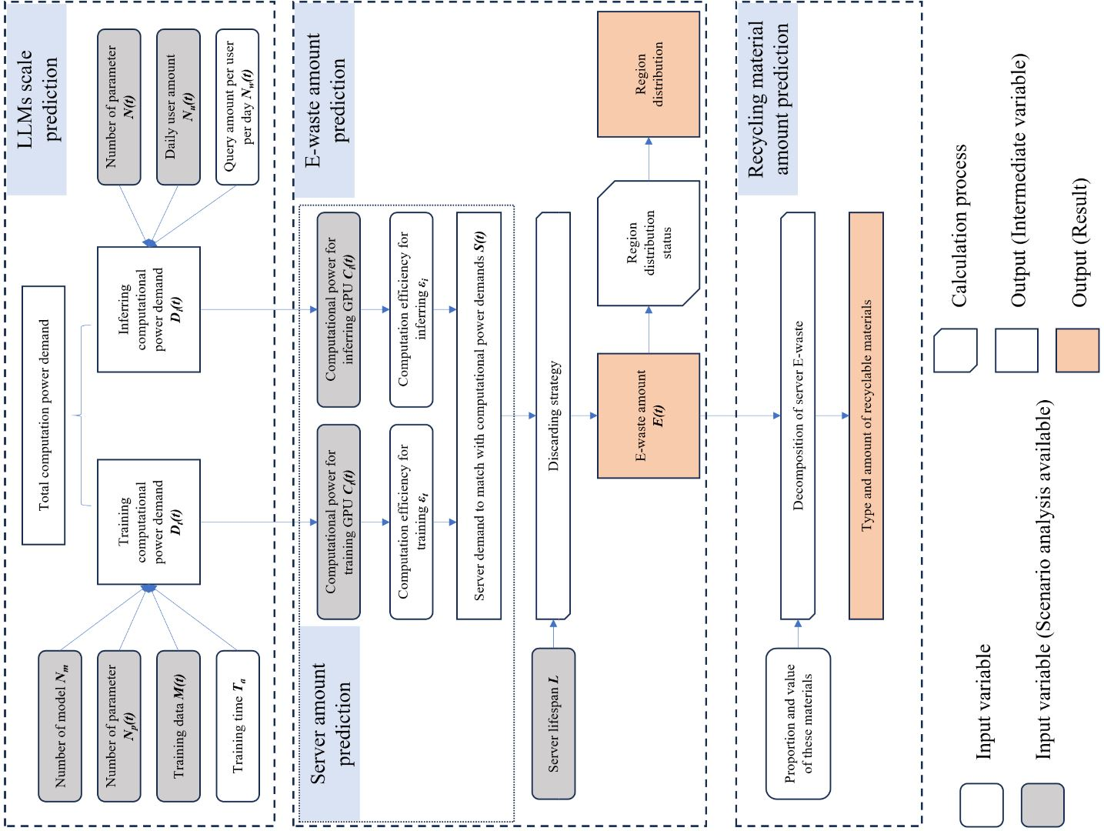
Fig. S1 The flowchart of CP-MFA
Notably, it’s challenging to obtain the precise number of servers inside data centers due to the lack of transparency in their operators of manufactures. Accordingly, we applied a model to generate the estimation of those results, which is based on the balance of supply relationship, i.e., the total computation power provided by GPU servers should meet with total demand of LLMs computation. To describe this equilibrium, models at two ends should be established: the computational power demands of LLMs (LLMs scale prediction, $D_{t}(t)+D_{i}(t)$) and the number of servers to provide so much computational power (server amount prediction, $S(t)$). After the number of servers are found, the amount of E-waste can be derived through predefined discarding strategy. In this model, the input parameters (enclosed in grey rounded rectangle) can be set to different values to conduct different scenario analysis. As the E-waste amount is clear, further regional analysis and material recycling analysis can be proceeded.
S1.1. LLMs scale prediction
The aim of this module is to present the global LLMs computation demands with an objective value. Some studies estimate that the development of LLMs is exponential, with an increase index [1]. However, this hypothesis is too much simplified as the bottleneck factors are ignored such as training data size. Here we choose to use unit pfs-day (PFlop/s-days, i.e., the computational power with 24-hours computing at 1 PFlops/second), a well-known measure to estimate the number of operations or the floating-point number that are calculated [2]. The conversion relationship between pfs-day and Flops is:
$$\begin{aligned}1pfs-day=86400PFlops=8.64×{10}^{19}Flops\#\left(1\right)\end{aligned}$$
Similar to kW-hr for energy, pfs-day is used to measure the scale of an AI model. Regarding to LLMs computation task, it consists of two stages: training stage and inferring stage. Training refers to the development and regular maintenance of LLMs by its developers, and inferring refers to the interactive usage of LLMs by end users. From the perspective of both measuring logic and hardware allocation, these two stages are separated from each other. In training stage, each training token takes 6 Flops to conduct the forward and backward add-multiply operation, while in inferring stage it takes only 2 Flops [2][3]. Let’s assume a LLMs to possess $N_{p}$ parameters inside its neural network in average, to require $M$ tokens of language data as its training dataset, to be allocated $T_{a}$ days to finish one training task, and $N_{m}$ models exist worldwide. It’s interesting to note the number of models $N_{m}$ means the number of individual model architectures, rather than the number of secondary developed commercial LLMs applications or platforms using the API of basic model architecture. For example, OpenAI’s GPT and Huawei’s Pangu are 2 different models while ChatGPT and Bing-GPT are the same model because they all use GPT architecture. Thus, the global daily computational power demand for training session is:
$$\begin{aligned}D_{t}=\frac{6N_{m}N_{p}M}{T_{a}}Flops=\frac{6N_{m}N_{p}M}{8.64×{10}^{19}T_{a}}pfs-day\#\left(2\right)\end{aligned}$$
In inferring stage, assuming the number of daily active user to be $N_{u}$, and each user will query $N_{w}$ tokens with LLMs (1 word equals to approximately 1.25 tokens) in their daily interaction. Therefore, the daily computational power demand for inferring session is:
$$\begin{aligned}D_{i}=2N_{p}N_{u}N_{w}Flops=\frac{2N_{p}N_{u}N_{w}}{8.64×{10}^{19}}pfs-day\#\left(3\right)\end{aligned}$$
Equation 2 and 3 enables the dynamic description of global LLMs computation scale. Among all these input parameters, some can be hypothesized as constant while some are surely time-varying. The time-varying parameters are $N_{p}$, $M$, and $N_{u}$, making their values significant to the result of model.
The size of language training data, $N_{u}$, was studied by Villalobos et al., where they indicated stock of language data will be exhausted soon near 2030 [4]. Here we implement the trend curve provided in their research and set an upper limit at 1000 trillion words in 2030. The number of parameters inside LLMs, $N_{p}$, has been increasing exponentially in the past decade with the rapid development of deep neural networks. The amount of LLMs parameter has been doubling every 3-4 months starting from 2020 [5]. This growing speed can be used as the current trend however the exponential growth cannot keep going on unlimitedly. The scaling law provides a slow down for the fast growth [6]. It indicates that the size of LLMs should synchronize with the size of training data to achieve the most efficiency computational resources usage. Therefore, we assume that the growth of parameter follows the same trend of growth of language training data size, as is shown in Fig. S2. At last, the number of daily active users, $M$, has witnessed a dramatic increase since the publish of ChatGPT: from 7 million in December 2022 to 15 million March 2023. Its future data can be predicted by drawing on the developing trend of other Internet platforms.
In the baseline scenario, we assume LLMs will eventually become preferable by basically every netizen. Thus, the history trend of Facebook can be applied [7]. In the moderate scenario, LLMs will have a specific but wide-ranged target user, like the case of Tiktok [8]. In the conservative scenario, LLMs will serves only to those who get used to this interaction mode, analogy to voice assistant such as Apple Siri and Google Assistant [9]. The evolution of daily active user for LLMs under three scenarios is shown in Fig. S3.
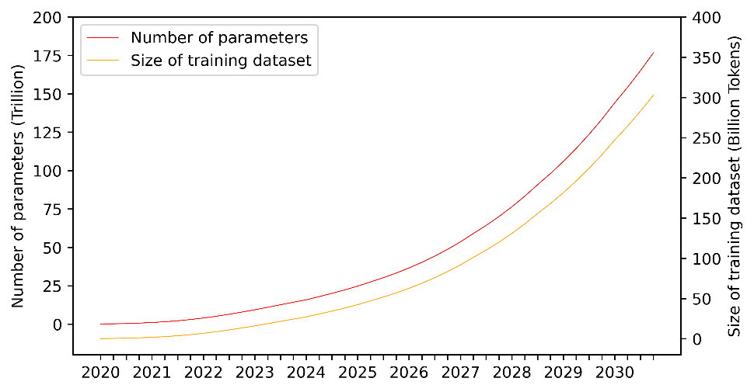
Fig. S2 Prediction of Number of parameters and training data size
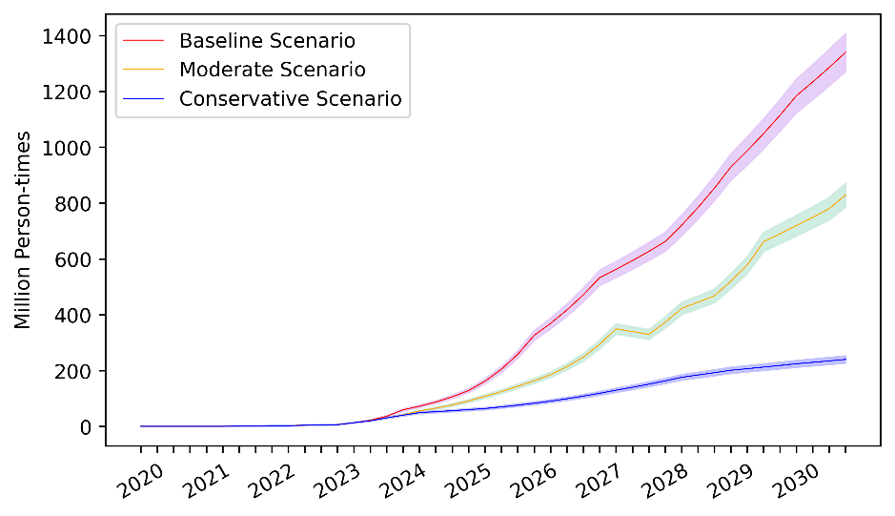
Fig. S3 Prediction of LLMs daily active user under different scenarios

S1.2. E-waste amount prediction
This module demonstrates how the E-waste amount is calculated with knowing the scale of LLMs.
As the key of prediction model is to find equilibrium between LLMs computational power demand and GPU server computational power supply, the computational power of individual server is the critical value. In recent 2 years, the most widely deployed training servers use Nvidia A100 and inferring servers use Nvidia A40, delivering 0.156 PFlops/s of TF32 computing for training and 0.495 PFlops/s of INT8 computing for inferring, respectively [10]. The future growth trend for both training computing $C_{t}(t)$ and inferring computing $C_{i}(t)$ will follow the Moore’s Law, i.e., doubles every 18 months. See Fig. S4 for detailed information.
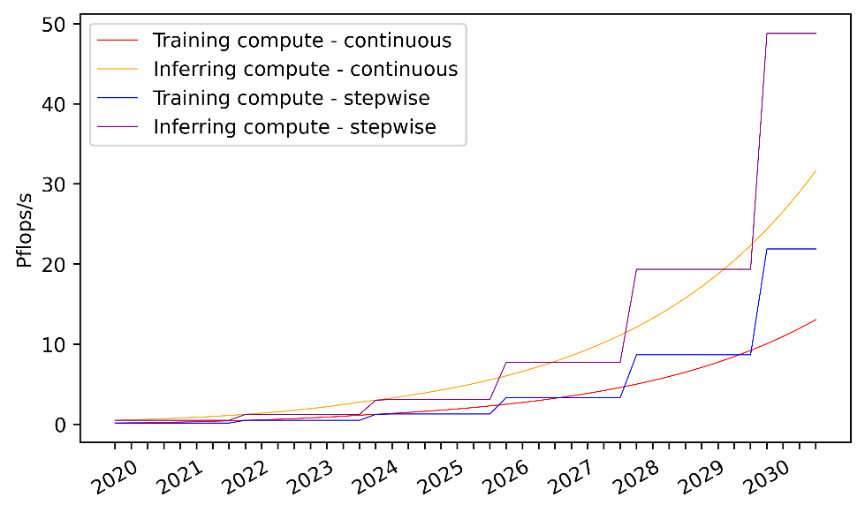
Fig. S4 Evolution GPU computational power under different hypothesis
Generally, divide $D(t)$ by $C(t)$ and computation efficiency $ε$ can we obtain the number of servers $S(t)$ required to match the computational power demand. However, this is not true for the dynamic variable $S(t)$, which is determined by the emerging computation demands at current time frame and the on stock computational power in previous time frames. In our model, $S(t)$ is implicitly expressed by:
$$\begin{aligned}S\left(t\right)=\frac{D\left(t\right)-D\left(t-1\right)+C\left(t-L\right)×S\left(t-L\right)}{C\left(t\right)}\#\left(4\right)\end{aligned}$$
Where $L$ refers to the average lifespan of servers. By settling this parameter, we assume that each server will only get discarded when it reaches the end of lifespan. This hypothesis, is also the discarding strategy mentioned in Figure1, indicating the transform method from server demand $S(t)$ to E-waste generation amount $E(t)$ – by setting a $L$-year deployment-to-obsolescence lag coefficient. Thus:
$$\begin{aligned}E\left(t\right)=S\left(t-L\right)\#\left(5\right)\end{aligned}$$
To convert the number of waste servers to the weight of E-waste, an average weight per server 0.13 kg is given. This is the typical weight for an 8-units GPU server [11]. A modification coefficient $a=1.1$ is added to count on the weight of accessory equipment such as shelves and cables.
$$\begin{aligned}E_{ton}\left(t\right)=0.13aE\left(t\right)\#\left(6\right)\end{aligned}$$
In conclusion, the value configuration for input parameters in the LLMs scale prediction model and E-waste amount prediction model is shown in Table S1.
Table S1 Parameter configuration
Input parameter | Symbol | Value in our prediction
Number of models | $$N_{m}$$ | 20 in baseline scenario  14 in moderate scenario  10 in conservative scenario
Number of parameters inside each model | $$N_{p}(t)$$ | See Fig. S2
Size of training language data / token | $$M(t)$$ | See Fig. S2
Training length / day | $$T_{a}$$ | 14
Number of daily active user / person | $$N_{u}(t)$$ | See Fig. S3
Query amount per user per day / token | $$N_{w}$$ | 10000
Individual computational power for training GPU / PFlops/s | $$C_{t}(t)$$ | See Fig. S4
Individual computational power for inferring GPU / PFlops/s | $$C_{i}(t)$$ | See Fig. S4
Computation efficiency for training | $$ε_{t}$$ | 0.33 [1]
Computation efficiency for inferring | $$ε_{i}$$ | 0.46 [12]
Lifespan of server / year | $$L$$ | 3

S1.3. Recycling & toxic material amount prediction
From the dismantle perspective, a GPU server can be decomposed into printed circular boards (PCBs), lead-acid battery, and structural components. Numerous studies have focused on the weight ratio of recyclable materials for PCBs [12-15] and lead-acid battery [17], as is summarized in Table S2.
With the weight of these materials, we can calculate the recycling value using the metal price collected from London Metal Exchange.
Table S2 Material component of an obsolete server
wt% | PCB | Lead-acid battery | Structural component | Overall
wt% of this component in a server | 30 | 10 | 30 | /
Cu | 20 | / | / | 6
Pb | 2.3 | 75 | / | 1.44
Al | 1.8 | / | 90 | 27.54
Sn | 1.8 | / | / | 0.6
Fe | 1.3 | / | 10 | 3.39
Ni | 0.43 | / | / | 0.13
Zn | 0.27 | / | / | 0.09
Au | 0.02 | / | / | 0.006
Ag | 0.05 | / | / | 0.015
Pt | 0.005 | / | / | 0.0015
Pd | 0.015 | / | / | 0.0045
Ba | 0.19 | / | / | 0.063
Cd | 0.0009 | / | / | 0.0003
Cr | 0.027 | / | / | 0.009
Sb | 0.22 | / | / | 0.073
As | 0.001 | / | / | 0.0033
Hg | 0.0002 | / | / | 0.0001

- The regional distribution of LLMs
As AI server E-wastes are regional concentrated and highly related to the its holder companies’ location, the global distribution can be calculated by counting the number of existing LLMs (in 2023) in main regions (North America, Europe, and East Asia). Here we find 56 LLMs [18] and their development companies to represent the proportion of E-waste generated worldwide (see Table S3).
Table S3 LLMs and their developing entities
LLMs | Corporation | Country/Region | LLMs | Corporation | Country/Region
T5 | Google | US | LLaMA | Meta | US
mT5 | Google | US | CodeGeeX | Tsinghua | China
PanGu-a | Huawei | China | Pythia | EleutherAI | US
CPM-2 | Tsinghua | China | GPT-3 | OpenAI | US
T0 | BigScience | Europe Union | Gshard | Google | US
CodeGen | Saleforce | US | Codex | OpenAI | US
GPT-NeoX-20B | / | US | ERNIE 3.0 | Baidu | China
UL2 | Google | US | Jurassic-1 | AI21 | Isreal
OPT | Meta | US | HyperCLOVA | / | Korea
NLLB | Meta | US | FLAN | Google | US
GLM | Tsinghua | China | Yuan 1.0 | Langchao | China
Flan-T5 | Google | US | Claude | Anthropic | US
BLOOM | BigScience | Europe Union | WebGPT | OpenAI | US
mT0 | BigScience | Europe Union | Gopher | DeepMind | UK
Galactica | Meta | US | ERNIE 3.0 Titan | Baidu | China
BLOOMZ | BigScience | Europe Union | GLaM | Google | US
OPT-IML | Meta | US | LaMDA | Google | US
WeLM | Tencent | China | MT-NLG | Microsoft | US
U-PaLM | Google | US | AlphaCode | DeepMind | UK
Flan-PaLM | Google | US | InstructGPT | OpenAI | US
Flan-U-PaLM | Google | US | Chinchilla | DeepMind | UK
GPT-4 | OpenAI | US | PaLM | Google | US
PanGu-e | Huawei | China | AlexaTM | Amazon | US
Alpaca | Stanford | US | Sparrow | DeepMind | UK
Koala | Berkerly | US | Cerebras-GPT | / | US
Vicuna | Google | US | GeoV | / | US
WebGLM | Tsinghua | China | SparkDesk | Xunfei | China
MOSS | Fudan | China | Qwen-7B | Alibaba | China

- Scenario development
  - The optimistic scenario (baseline scenario)
The optimistic scenario represents an ‘expectation-meeting’ situation where AI, together with LLMs, will gradually become a ubiquitous tool for people’s daily life. It aims at evaluating the most severe situation where more E-wastes are generated and less measures are taken. The major characteristics of optimistic scenario lie in: radical prediction of parameters ‘number of modules $N_{m}$’ and ‘daily active users $N_{p}$’, and no recycling measures to address the arising E-waste problem. $N_{p}$ follows the trend of Facebook, an Internet platform used by literally everyone. And $N_{m}$ is set to 20 under this circumstance. The configurations of other parameters are referred in previous tables or figures.
  - The moderate and conservative scenario
The moderate and conservative scenarios represent another developing trend of LLMs rather than the ‘fully mature trend’ in the optimistic scenario. In these two cases, the LLMs will go beyond expectation of ubiquitous application. As mentioned in Supplementary Information Section 1.1 and Figure 3, the parameter $N_{p}$ follows the trend of Tiktok in moderate scenario and voice assistant in conservative scenario. As for $N_{m}$, the value is set to 14 and 10, respectively. The reconfiguration of these two parameters should be able to distinguish the three scenarios judging different development status.
  - Scenarios when the circular methods apply
This section illustrates the scenario configuration for circular strategy analysis, including lifespan extension, stepwise upgrade and module reuse. As a reference source, the circular measures related to each data centers operators and solution providers are listed in Table S4.
(1) Lifespan extension
Lifespan extension is an intuitive method to control the E-waste. It refers to deployment of servers at the end of $L$-years lifespan to downcycled server applications, such as less intensive AI computation or non-AI computation. In this scenario, we keep the parameter $L$ in 3 years but change the deployment-to-obsolescence lag coefficient from $L$-year in normal case to $L+1$ year.

Table S4 Circular strategies implemented by data center operators and solution providers
Corporation | Circular Strategy | Details
Google[19] | Lifespan extension / Module reuse | Google’s repairs process at the data centers enables longer life expectancy of the servers. In 2015, 75% of components consumed in the spares program were refurbished inventory.  Once servers from data centers are decommissioned, they are sent back to the central hub. At the hub servers are dismantled and de-kitted to their usable components (CPU, motherboard, Flash devices, hard disks, memory modules and other components). After quality inspection, components are stored to be reused as refurbished inventory.
Microsoft[20] | Module reuse | Using machine learning, we will process servers and hardware that are being decommissioned onsite. We’ll sort the pieces that can be reused and repurposed by us, our customers, or sold. We will use our learnings about reuse, disassembly, reassembly and recycling with design and supply chain teams to help improve the sustainability of future generations of equipment.
ABB[21] | Lifespan extension | Implement condition monitoring and predictive maintenance of key systems, such as the temperature around critical components, by using sensors and a digital predictive maintenance solution.  Replace only the components that have become outdated, rather than the entire system. This not only drives notable cost efficiencies, but also promotes circularity.

(2) Stepwise upgrade
Stepwise upgrade focus on parameter $C_{t}(t)$ and $C_{i}(t)$. Despite the computational power of GPU evolves following Moore’s Law, it’s a continuous value in the baseline scenario. Which means during the 18-months doubling period, $C_{t}(t)$ and $C_{i}(t)$ augments continuously. It’s a decent assumption as the publishing of new generation GPU is not strictly at 18-months interval, but rather randomly distributed along the time line. However in stepwise upgrade, we want to check if it evolves discretely like a stepwise (i.e., $C_{t}(t)$ and $C_{i}(t)$ stays the same during 18 months and get doubled at the end of this period). This scenario can describe a data center where the upgrade of servers will only be taken when there are major upgrades of on-sale GPU, thus does not always contribute to positive effect. The difference of continuous evolution and discrete evolution of $C_{t}(t)$ and $C_{i}(t)$ is shown in Fig. S4.
(3) Module reuse
Module reuse refers to the dismantling, renovation and remanufacturing of key modules of an obsolete GPU server, e.g., GPU modules, CPU modules, memory modules or communication modules. The ultimate goal of this strategy is similar to lifespan extension strategy: extend the using phase of certain computational power. But it differs from lifespan extension in two aspects: First, the remanufacturing yields extra material therefore extra E-waste are bounded to reuse servers, while this doesn’t exist in lifespan extension case. Second, the renovated and remanufactured servers is reendowed with a full $L$-year lifespan, rather than merely 1-year addition life in lifespan extension case. In our analysis, we suppose that 50 wt% components of total server are reused, and the other half becomes E-waste immediately. In another word, the reborn servers will reduce the number of new server manufacturing but will bring with additional 50% E-wastes themselves.

  - Scenarios when the technical barriers exist
This section illustrates the scenario configuration for technical barrier situation and the countermeasure analysis, including simple technical barrier, varying technical barrier (technical barrier while catch up) , technical barrier with measures.
(1) Technical barrier
Technical barrier means export regulations of certain GPU servers to certain countries or regions. Under this circumstance, the barriered countries will have to use the servers with weaker computational power to conduct LLMs computing tasks. For instance, Nvidia H800 is the specific adaptation version of H100 for Chinese market due to the technical barrier implemented in August 2022. The difference between them is the drop of interconnect bandwidth, which leads to longer computing time. This is equivalent to a lag in computational power of pfs-day, described with a time-dependent lag for $C_{t}(t)$ and $C_{i}(t)$.Which is to say, the barriered countries have $C_{t}(t-b)$ and $C_{i}(t-b)$ in timeframe $t$, where $b$ is lagging time length indicating the severity of barriers. In this technical barrier scenario, we suppose 25% of LLMs computation is conducted with 1-year lag.
(2) Varying technical barrier (Technical barrier while catch up)
It’s not likely for barriered countries or regions to accept the lagged servers without doing anything. They will develop their semiconductor industry and gradually make up for this lag of computational power. This is defined as the varying technical barrier scenario. We assume that this 25% countries will gradually catch up with the main trend of computing power evolution in 2030. See detailed evolution curve in Fig. S5.
(3) Technical barrier with lifespan extension measures
In this scenario, we want to investigate the performance of lifespan extension strategy in compensating the harm caused by technical barrier. Therefore, server lifespan $L$ is set to 4 years on the basis of technical barrier scenario.

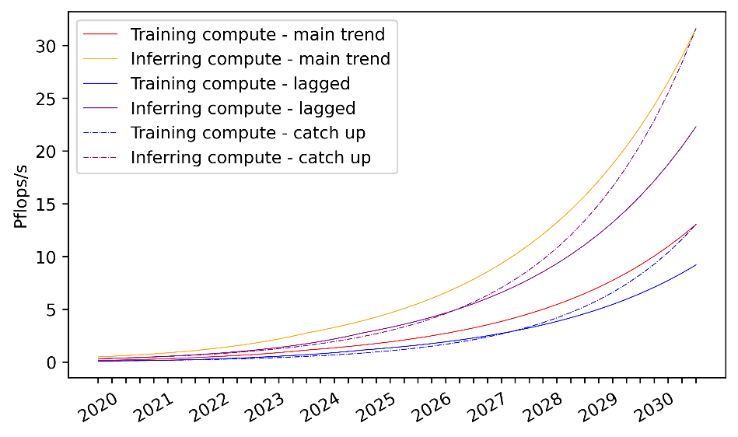
Fig S5 Evolution of GPU computational power under different technical barrier scenarios

- Review of material recycling technics for AI servers
AI servers are material enriched E-waste enriched in three component categories: PCBs, batteries, and structural parts. The latter, structural parts, are mostly whole-piece aluminum plate, making it easy to handle. PCB is the most metal enriched and valuable part inside AI servers with all type of IC chips attached on it. To collect metals, PCBs are firstly crushed into small pieces before metals are concentrated from non-metal materials. Then, each type of metal is filtered out and refined given to its unique physical or chemical characteristics. Froth flotation method and pneumatic separation method can reach 88% and 75% metal concentration rate, including 5.8% and 9.4% rare metals, respectively [22]. Magnetic metal like Fe and Ni can be filtered out by magnetic separator [23] while 99% Al and 97% Sb can be removed by wet dismantling process [24]. There are also some dedicated technics to address specific PCB products like memory modules to increase the recycling rate [25]. The uninterruptible power supply (UPS) system on AI servers mainly uses lead-acid battery. Recent technologies permit more than 95% lead recycling rate from metallic lead grids and lead paste [26]. Though present technics permit a healthy circular cycle, further efforts on expanding recycling scales while maintain its performance are still needed to catch up with the acceleration of AI development.

- Circular economy practices of data center operators
Sustainability is becoming an important indicator of today’s data centers. To achieve higher efficiency goals, as well as to meet the commitments on environmental responsibility, data center operators have actively launched initiatives to exhibit their sustainability visions targeting at carbon negative, water positive, and waste disposal. While recycling policy is cited by most operators, Google, Microsoft and Apple extend their behaviors to achieve zero operation waste particularly.
  - Microsoft [27]
Microsoft announced to reach the zero-waste goal by 2030. Regarding to equipment in Azure data centers, 90% of servers and components for all cloud hardware will be reused and recycled by 2025. This is supported by their Circular Centers, which have been proven efficient in Amsterdam, Boydton, Chicago, Dublin and Singapore. To accelerate recycling, Microsoft is working on hardware supply chains to implement 100% recycled tin solder paste and gold material in produced PCBs. More patented methodologies (e.g. intelligent disposition and routing system-IDARS), technologies and standards are pushing forward to secure highly accurate and manipulatable recycling systems.
  - Google [28]:
Google set goal at achieving zero waste to landfill for global data center operations. Though a specific date is not applicable, it’s proven possible by its data center in Mayes County, Oklahoma. Google’s seasonal Excess and Obsolescence (E&O) process analyzes the life cycle stage of components to determine E&O levels, with the selected ones being refurbished, resold or recycled. In 2021, they have reached the 29% level of refurbished inventory components used for server upgrades and 4.9 million level of resold units into the secondary market for reuse.
  - Apple [29]
Apple measures its waste management efforts by focusing on waste diversion rate. From the comprehensive operation perspective, they have reinforced their capacity from 68% in 2021 to 71% in 2022, limiting global landfill waste to 16,000 tons. Regarding to data centers, the upgrades are implemented globally to turn them into zero-waste-to-landfill data centers. This involves recycling, compost and material reuse, reaching the target at 90% in 2023.

Reference
- Shiqiang Zhu et al (2023), Intelligent Computing: The Latest Advances, Challenges, and Future. Intell Comput.;2:0006. 10.34133/icomputing.0006
- OpenAI (2018), AI and compute, https://openai.com/research/ai-and-compute
- Sunyan (2023), The Economics of Large Language Models,
https://sunyan.substack.com/p/the-economics-of-large-language-models
- Pablo V, Jaime M, Lennart H, Tamay B, Marius H and Anson H (2022), Will we run out of data? An analysis of the limits of scaling datasets in Machine Learning, arXiv.2211.04325
- Adnan M and Anthony K (2022), Brain-inspired computing needs a master plan, Nature, 604, 255-260
- Kaplan J, McCandlish S, Henighan T, Brown T.B et al. (2020), Scaling Laws for Neural Language Models, arXiv:2001.08361
- Richter F (2021), Facebook Keeps on Growing, Statista,
https://www.statista.com/chart/10047/facebooks-monthly-active-users/
- Iqbal M (2023), TikTok Revenue and Usage Statistics,
https://www.businessofapps.com/data/tik-tok-statistics/
- Kinsella B and Mutchler A (2018), Voice assistant consumer adoption report, Voicebot
- www.nvidia.com
- https://resources.nvidia.com/en-us-dgx-systems/ai-enterprise-dgx
- Aakanksha C, Sharan N, Jacob D, Maarten B et al. (2022). PaLM: Scaling Language Modeling with Pathways
- Kumar V, Lee J, Jeong J et al. (2015), Recycling of printed circuit boards (PCBs) to generate enriched rare metal concentrate, Journal of Industrial and Engineering Chemistry, 21, 805-813
- Razi K (2016), Resourceful recycling process of waste desktop computers: A review study, Resources, Conservation and Recycling, 2016, 110, 30-47
- Zhu M et al. (2020), Metal recycling from waste memory modules efficiently and environmentally friendly by low-temperature alkali melts, Science China Technological Sciences, 63, 2275-2282
- Oguchi M, Sakanakura H and Terazono A (2012). Toxic metals in WEEE: Characterization and substance flow analysis in waste treatment processes. The Science of the total environment. 463
- Sun Z et al. (2017), Spent lead-acid battery recycling in China – A review and sustainable analyses on mass flow of lead, Waste Management, 64, 190-201
- Zhao W et al. (2023) A Survey of Large Language Models, arXiv:2303.18223
- Shobhit Rana, Kate Brandt (2016) Circular economy at work in Google data centers.
- Brad Smith (2020) Microsoft commits to achieve ‘zero waste’ goals by 2030. https://blogs.microsoft.com/blog/2020/08/04/microsoft-direct-operations-products-and-packaging-to-be-zero-waste-by-2030/
- ABB White Paper (2023): Sustainability – making your data center carbon neutral
- Kumar, Vinod & Lee, Jae-chun & Jeong, Jinki & Jha, Manis & Kim, Byung-Su & Singh, Ratnakar. (2015). Recycling of printed circuit boards (PCBs) to generate enriched rare metal concentrate. Journal of Industrial and Engineering Chemistry. 21. 805-813. 10.1016/j.jiec.2014.04.016.
- Veit, H.M., Bernardes, A.M., Ferreira, J.Z., Tenório, J.A.S., Malfatti, C.F., 2006. Recovery of copper from printed circuit boards scraps by mechanical processing and electrometallurgy. J. Hazard. Mater. 137 (3), 1704–1709. http://dx.doi.org/10.1016/j.jhazmat.2006.05.010.
- Pinho, Sílvia & Ferreira, Marco & Almeida, Manuel. (2018). A wet dismantling process for the recycling of computer printed circuit boards. Resources, Conservation and Recycling. 132. 71-76. 10.1016/j.resconrec.2018.01.022.
- Zhu, MingWei & Ma, HaoBo & He, Jie & Bin, Chen & Zhang, Lili & Jiang, Hongxiang & Sun, XiaoJun & Jiuzhou, Zhao. (2020). Metal recycling from waste memory modules efficiently and environmentally friendly by low-temperature alkali melts. Science China Technological Sciences. 63. 10.1007/s11431-020-1624-8.
- Li W, Jiang L, Zhan J and Zhang C (2011), Status and progress of recycling technology of waste lead-acid battery, China Nonferrous Metallurgy, 12(6)
- Mircrosoft Environmental sustainability report 2022
- Google Environmental report 2022
- Apple Environmental progress report 2023

