Support Information

A universal platform of molecular orbital energy level prediction and molecular design for organic materials
Xinyu Peng^{a,1}, Jiaojiao Liang^{a,1}, Kuo Wang ^{a,b}, Xiaojie Zhaoª, Zhiyan Pengª, Zhennan Liª, Jinhui Zengª, Zheng Lanª, Min Lei^{a,*}, Di Huang^{a,*}
ª Hunan University of Technology, Zhuzhou 412008, Hunan, China
^{b} Department of Physics, Gyeongsang National University, Jinju 52828, South Gyeongsang Province, Republic of Korea
* Corresponding authors.
E-mail addresses: leimin0606@hotmail.com (M. Lei), dihuang@hut.edu.cn (D. Huang).
¹ These authors contributed equally to this work.

Dataset collection and feature transformation

This study utilizes 11,627 data points from the Harvard open source database[1] as training data and test data. SMILES, a linear notation for describing chemical structures, employs short ASCII strings to represent a molecule's atoms and bonds. Fingerprint Conversion is performed using the RDKit[2] tool, incorporating methods like Estate (79 bits), KR (4860 bits), MACCS (166 bits), and Sub (307 bits).
The initial Random Forest (RF) model, as seen in Table S1, demonstrates that the correlation coefficients of the input features with the HOMO and LUMO models are 0.88 and 0.94 in KR, 0.57 and 0.67 in Estate fingerprints, 0.78 and 0.88 in MACCS fingerprints, and 0.62 and 0.76 in Sub fingerprints, respectively. It is clear that KR fingerprints have HOMO and LUMO correlation coefficients of KR fingerprints were better than the other three fingerprints, respectively. And the model develop in this experiment use HOMO and LUMO as predictors and face high data dimensions, we need to adopt more diverse and detailed feature characterization to fully capture and express the complex information of all molecules. Among the four fingerprints, the KR fingerprint is the longest spanning with 4860 bits and KR fingerprints consider diverse structural features in their encoding, offering richer structural information during the transcoding process. Therefore, the prediction model’s accuracy and more accurately captures the relationship between molecular structure and HOMO/LUMO energy levels is enhanced. Subsequently, we did variance and intercorrelation analysis on the 4860-bit KR molecular fingerprints.
Table S1. The performance comparison of HOMO and LUMO fitting under four different fingerprint transformations using RF model
Type (RF) | Estate | KR | MACCS | Sub
HOMO(R²) | 0.57 | 0.88 | 0.78 | 0.62
LUMO(R²) | 0.67 | 0.94 | 0.88 | 0.76

To diminish the redundancy of the input features that affects the model’s generalization ability and to reduce noise in the feature matrix for enhancing model accuracy, the features with an inter-feature correlation greater than 0.8 and variance less than 0.1 are eliminated. Ultimately, 45 structural input features were selected, as depicted in Fig. S1.

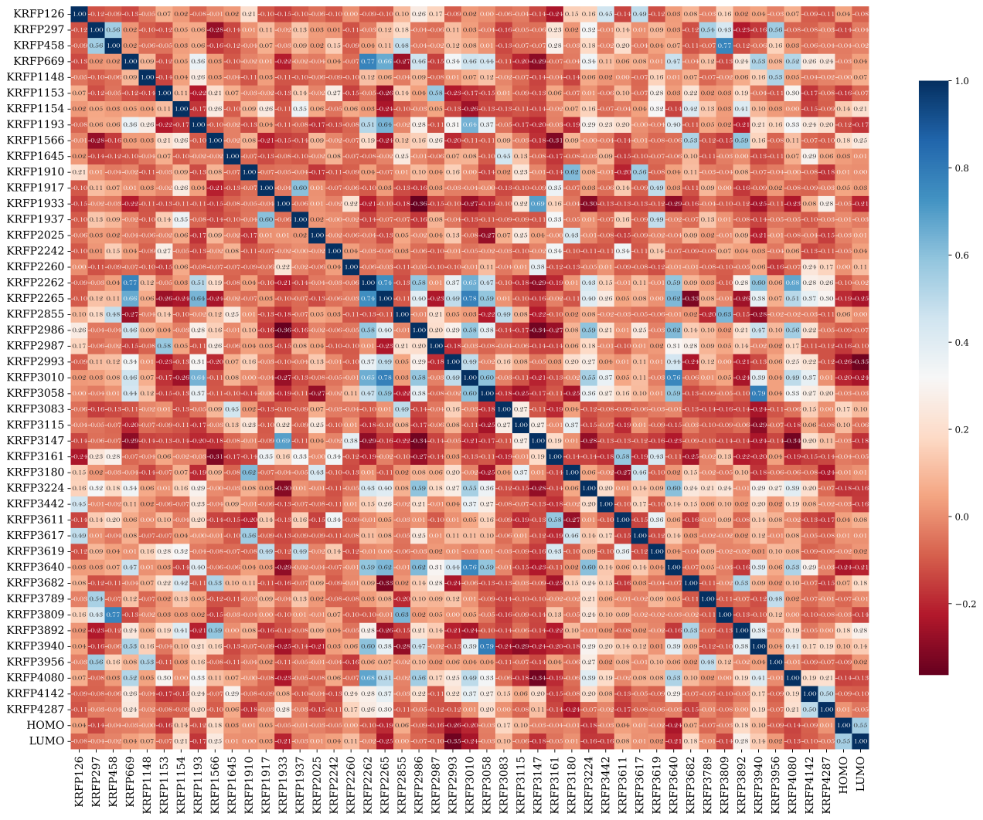
Figure S1. Heat map of 45 model input feature correlations after feature intercorrelation and variance screening

Model performance metrics

To assess the model’s predictive performance in this study, we employ R² (coefficient of determination), MAE (mean absolute error), RMSE (root mean square error), R (Pearson’s correlation coefficient), MAPE (mean absolute percentage error), and model fitting time. R², ranging from 0 to 1, measures the regression model’s goodness-of-fit. The R² values closer to 1 indicating better fit. A higher R² value means that the model explains more variance in the target variable and is better fitted. MAE measures the model’s prediction error, calculated as the average of absolute differences between predicted and actual values. RMSE, calculated as the square root of the mean squared errors between the predicted and actual values, measures the model’s prediction error. R assesses the linearity of the model’s predictions with the true values. A Pearson’s correlation coefficient close to 1 or -1 indicates a strong positive or negative correlation, respectively, between the model’s predictions and the actual values.
Here N is the number of data points in the dataset; R_{i} and P_{i} represent the real and predicted value;‾R_{i} and‾P_{i} are the mean values for the real and predicted value, respectively. Var(R_{i}) stands for the variance of the sample data.

Model selection

In this ML supervised learning task for discrete big data prediction, we utilize six algorithms: Linear Regression (LR), K-Nearest Neighbors (KNN), RF, GBT, Support Vector Regression (SVR), and eXtreme Gradient Boosting Trees (XGBT). These algorithms are highly adaptable for processing data in high-dimensional feature spaces and handling a large number of input features. For instance, LR models a linear relationship between input features and continuous output variables. KNN, a nearest-neighbor-based regression method, selects the K closest neighbors to input samples and performs voting (classification) or averaging (regression) based on their labels. RF, a random-forest-based regression method, constructs multiple decision trees from randomly selected data and feature subsets, averaging or voting on their results to enhance model stability and generalization. GBT, an ensemble learning algorithm, incrementally builds multiple weak learners (usually decision trees), each correcting the errors of its predecessor, and combines them into a robust predictive model. SVR makes regression predictions by identifying an optimal hyperplane in the feature space, minimizing the sum of distances from the closest samples (support vectors) to that hyperplane. XGBT, a gradient-boosted tree-based regression method, is similar to GBT but employs a more stochastic approach in feature selection and sample sampling to enhance the model’s generalization ability and speed. Therefore, we use 45 features as inputs to test the fit of each of the six algorithms. And R², and normalized MAE treated as evaluation metrics, and 5-fold cross-validation is used to assess model robustness. This approach allowed us to evaluate the fit, generalization ability, and stability of the algorithms with respect to the input features. The specific performance parameters are detailed in Fig S2.

（a） | （b）
Figure S2. The performances with six algorithms for (a) HOMO (b) LUMO energy level prediction

For the HOMO energy level, RF exhibit the best performance on the training set, compare to XGBT and SVR, while on the test set, XGBT has the top performance, compare to SVR and RF. In the 5-fold cross-validation, the smallest MAE fluctuation is observed in KNN, followed by LR and SVR. The smallest R² fluctuation occurs with LR, followed by SVR and GBT. For the LUMO energy level, RF again perform best on the training set, followed by XGBT and SVR, while on the test set, the best results are achieved by XGBT, then SVR and RF. In the 5-fold cross-validation for LUMO, MAE and R² fluctuation are minimized by XGBT, followed by LR and SVR. And given its generalization ability, stability, and consistent interpretability, XGBT has been selected as the algorithm for the final model construction. Finally, the generalized prediction platform is built by the XGBT algorithm and KR fingerprints

Platform Explanation

SHAP (Shapley Additive exPlanations) interprets machine learning model predictions based on Shapley values from game theory, breaking down predictions into contributions from individual features.Interpreting the model with SHAP values provides insights into:
1. Feature Importance: SHAP values gauge the contribution of each feature to the model’s predictions, identifying features with greater impact and aiding in understanding their importance.
2. Interpretation of Predictions: SHAP values assist in interpreting the model’s predictions for each sample, elucidating its prediction approach and decision-making process.
In addition, we conducted SHAP analysis on the 45 input features to elucidate the relationships between the predictor variables and these inputs. Through SHAP analysis, we pinpointed 13 features out of the 45 that exhibit distinct trends in their influence on HOMO and LUMO, as depicted in Fig. S3.

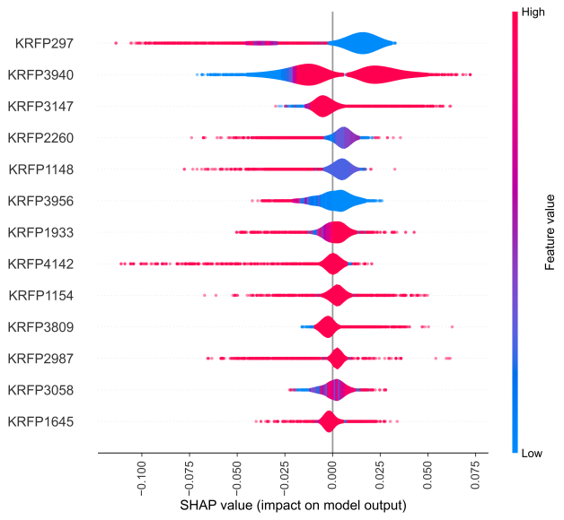 | 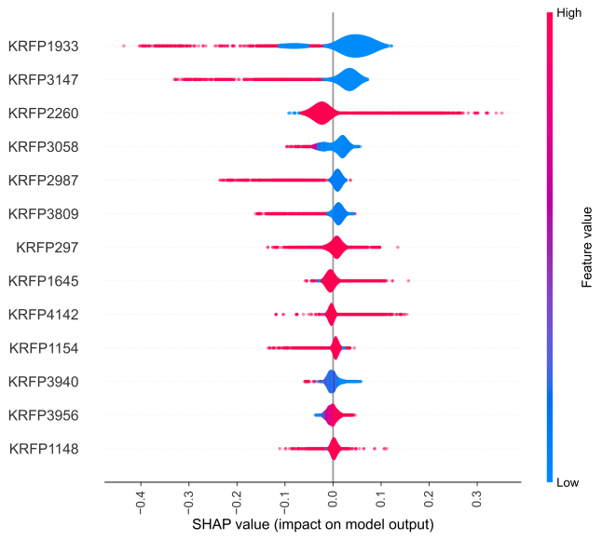
（a） | （b）
Figure S3. (a) HOMO (b) LUMO SHAP value summary plots for 13 top important features based on the generalized prediction platform

In order to individually analyze these 13 screened features, Fig. S4 displays a heat map showing the correlations among these features, as well as between HOMO and LUMO. The heat map reveals a striking correlation of 0.76 between KRFP_3940 and KRFP_3058 molecular fragments, indicating a highly linear relationship. Additionally, a high correlation between KRFP_297 and KRFP_3809, as well as KRFP_3956, and a strong correlation between KRFP_3956 and KRFP_1148, each with coefficients above 0.5. implying that there is likely to be a coexistence between these structures. In the correlation analysis with HOMO and LUMO, KRFP_2987 and KRFP_3940 exhibit high correlation with HOMO, while KRFP_1154 and KRFP_1933 show the highest correlation with LUMO. Specifically, a negative correlation coefficient with HOMO suggests that the absence of the KRFP_2987 molecular structure corresponds to a higher HOMO value, while a positive coefficient indicates that the presence of KRFP_3940 elevates the HOMO value.
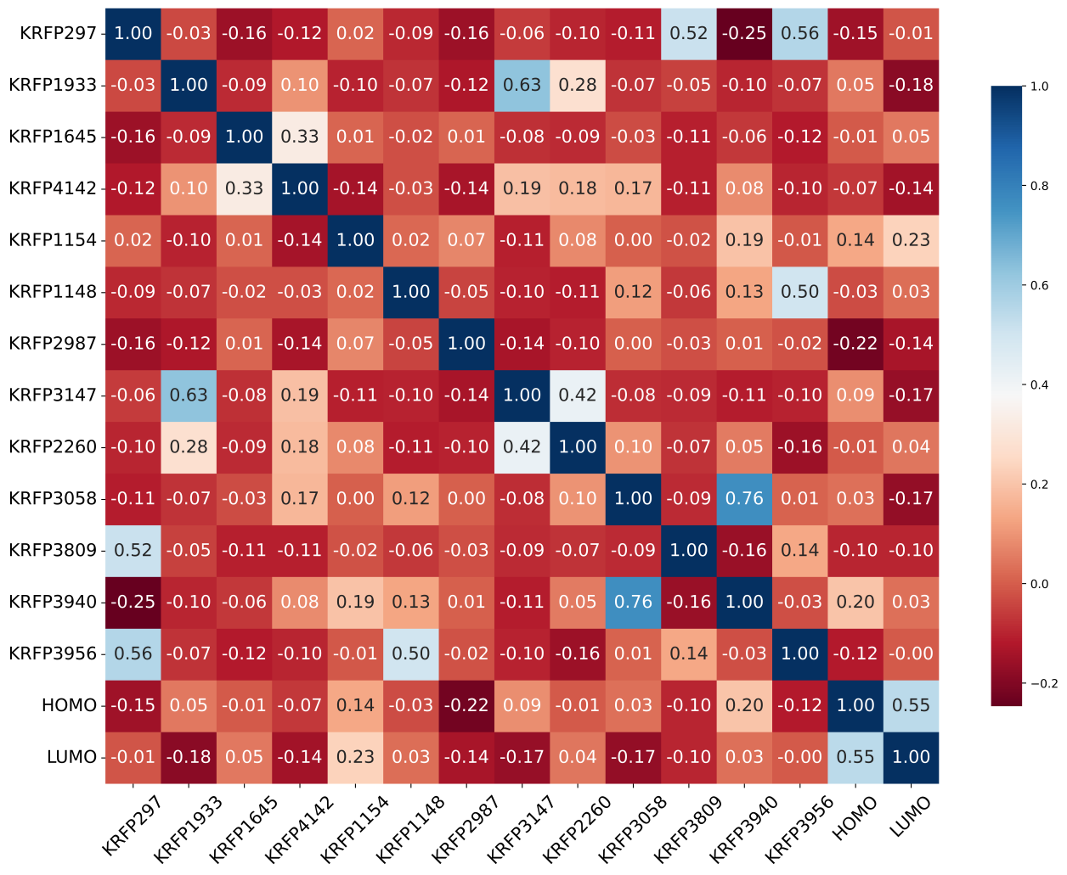
Figure S4. Heat map of correlation between 13 features and correlation between HOMO and LUMO.

Theoretical calculations

All theoretical calculations are performed using the Gaussian16[4] software package. The Polarizable Continuum Model (PCM) was employed to simulate the chloroform solvent environment. To identify a suitable computational method for the Y6 system and its derivatives, the geometric structure of Y6 was optimized in chloroform using the B3LYP/631+G(d)[3] function and basis set. All structural optimizations were conducted to ensure stability, with no spurious frequencies detected. Finally, the frontier molecular orbital energy levels are calculated using the B3LYP/631+G(d) function and basis set. The calculated results and their distribution are illustrated in Fig. S5.

Figure S5. Plot of frontier molecular orbital energy levels and their distribution by DFT calculation

Reference
1. Lopez, S. A. et al. The Harvard organic photovoltaic dataset. Sci Data 3, 160086 (2016).
2. Landrum, G. RDKit Documentation.
3. Tao, M., Peng, L. & Gu, F. L. Theoretical Studies on the Effects of π-Bridge Engineering on the Photoelectric Performance of Y6.
4. Gaussian 16. William & Mary https://www.wm.edu/offices/it/services/researchcomputing/using/software/gaussian/.

