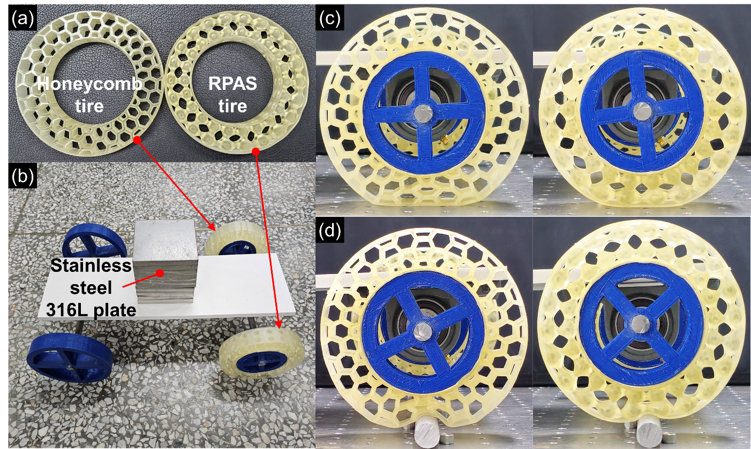

Fig. S.1. (a) 3D printed airless tires. (b) Customized cart equipped with the airless tires. To facilitate easier observation of tire deformation, a stack of ten stainless steel 316L plates was placed on the cart. Comparison of deformation between the honeycomb tire and RPAS tire: (c) deformation on flat ground and (d) deformation against an obstacle.

