Additional file 1

Oral Enzyme-Responsive Nanoprobes for Targeted Theranostics of Inflammatory Bowel Disease

Lin Cao^{1#}, Dengyi Duan^{1#}, Yunfei Guo^{1#}, Xinwen Li¹, Qi Cao³, Jianmin Li², Kangkang Liu², Yiming Li¹, Wenyi Zhang¹, Shuang Liu¹, Xuening Zhang¹, Jing Peng^{1*}, Yang Zhao^{1,2*}

1. Department of Radiology, The Second Hospital of Tianjin Medical University, Tianjin 300211, China.
2. Tianjin Institute of Urology, The Second Hospital of Tianjin Medical University, Tianjin 300211, China.
3. Department of Reproductive Medicine, First Teaching Hospital of Tianjin University of Traditional Chinese Medicine, Tianjin 300380, China.

#Equal contribution

*Correspondence: Jing Peng, Yang Zhao
E-mail: jing.peng@tmu.edu.cn (JP); yang.zhao@tmu.edu.cn (YZ)

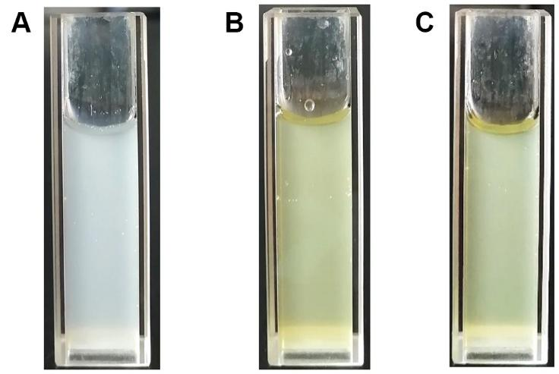
Fig. S1. Appearance photo of (A)HA/CeO₂, (B)Cur@PLGA and (C)Cur@PC-HA/CeO₂ NPs in deionized(DI) water.

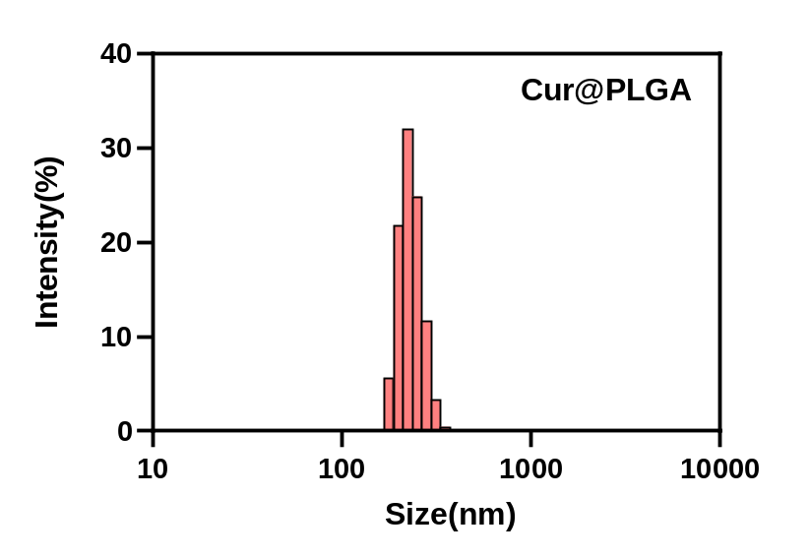
Fig. S2. Dynamic light scattering (DLS) distribution of Cur@PLGA NPs.

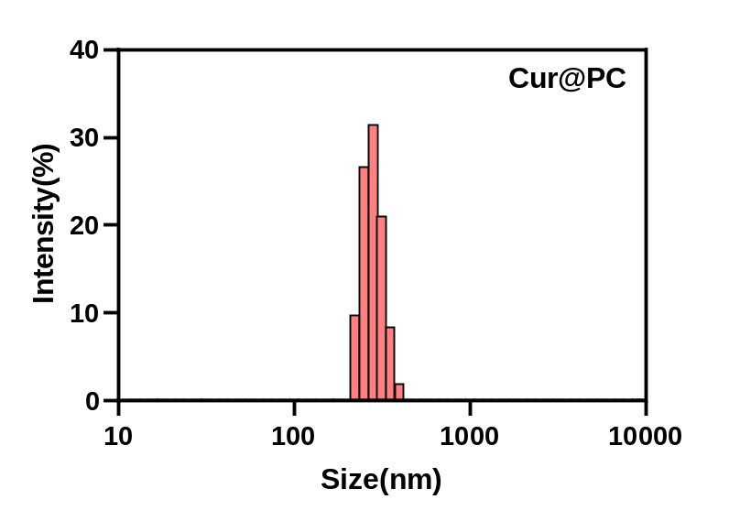
Fig. S3. Dynamic light scattering (DLS) distribution of Cur@PC NPs.

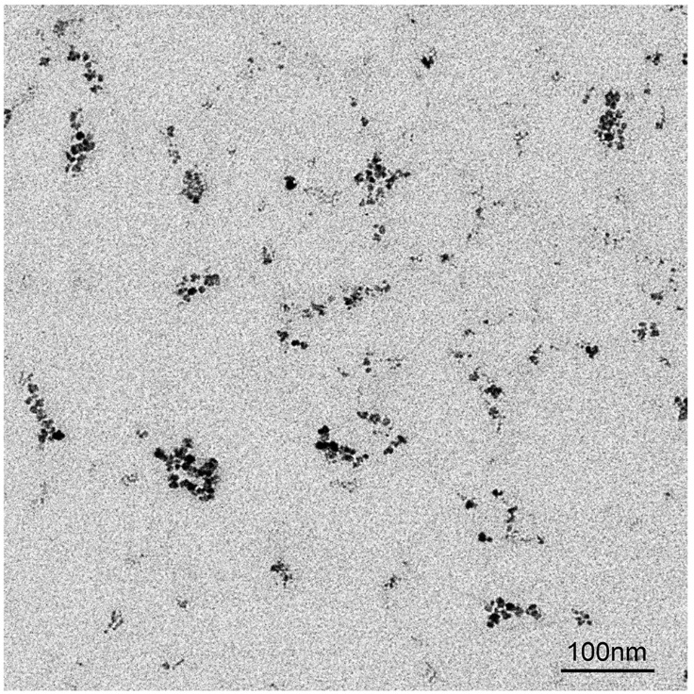
Fig. S4. Transmission electron microscopy (TEM) image of the HA/CeO₂ NPs.

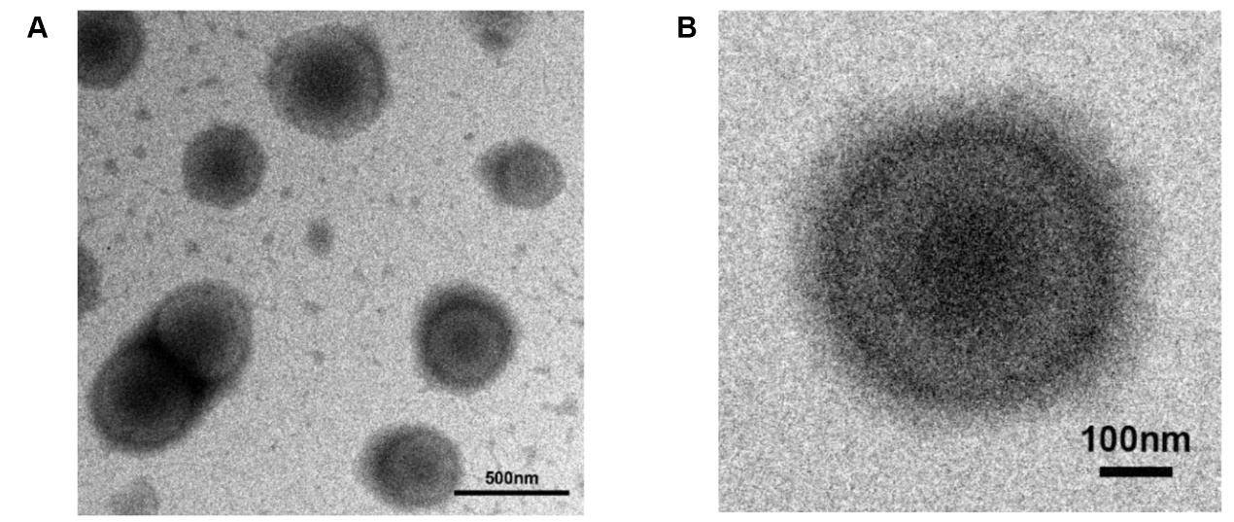
Fig. S5. Transmission electron microscopy (TEM) image of the Cur@PC NPs NPs.

Fig. S6. X-ray photoelectron spectroscopy (XPS) spectrum of HA/CeO₂ NPs.

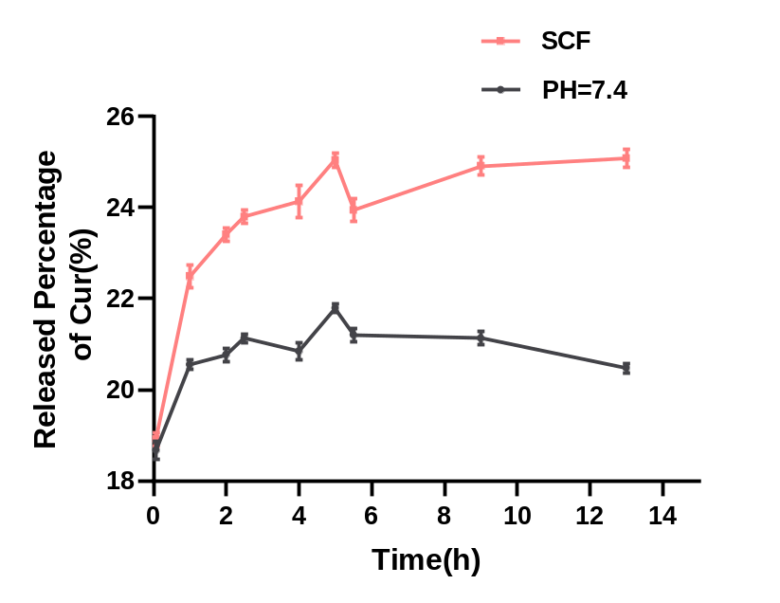
Fig. S7. In vitro release kinetics of curcumin from LMW-HA NPs under simulated colonic fluid (SCF) and pH=7.4 media.

Fig. S8. In vitro CT imaging of different concentrations (0-64mM I) of ioversol at 40,60,80,100,120 and 140 KeV.

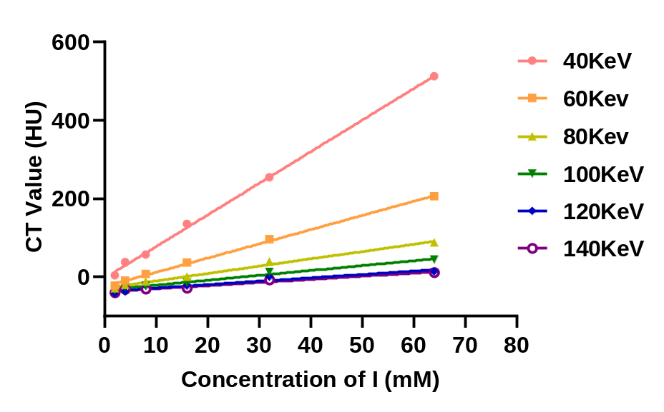
Fig. S9. The CT values versus molar concentration of I when ioversol was scanned with different monochromatic energy.
Fig. S10. Representative 3D-rendered CT images of GIT in healthy C57BL/6 mice after administration of Cur@PC-HA/CeO₂ nanoprobes (1mL, 5mg/mL) by enema.. “SI” indicates the small intestine, and “LI” indicates the large intestine.
Fig. S11. Representative 3D-rendered CT images of GIT in DSS-induced colitis C57BL/6 mice after administration of Cur@PC-HA/CeO₂ (1mL, 5mg/mL) nanoprobes by enema. “SI” indicates the small intestine, and “LI” indicates the large intestine. The white dashed oval indicates Cur@PC-HA/CeO₂ NPs accumulation in an area of colitis.
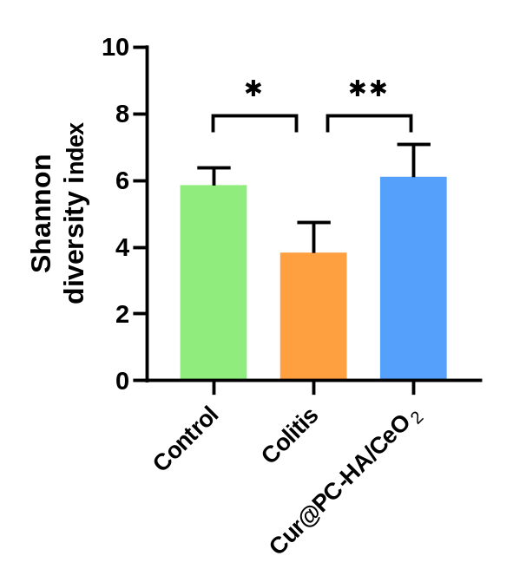
Fig. S12. Gut microbiota α diversity of Shannon diversity index.

Fig. S13. Nonmetric multidimensional scaling (NMDS) analysis of the microbiota composition.

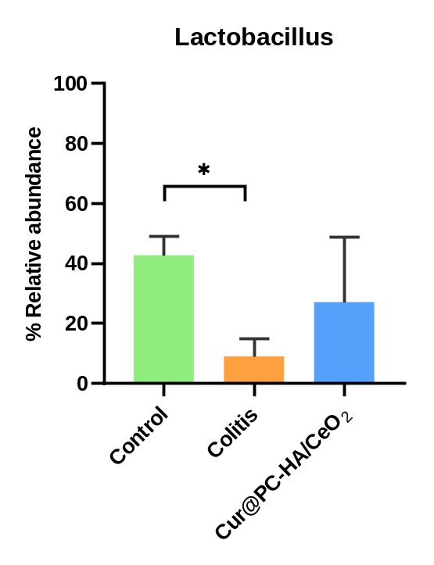
Fig. S14. Relative abundance of selected taxa at the genus-level, data are presented as mean ± SD (n = 4).

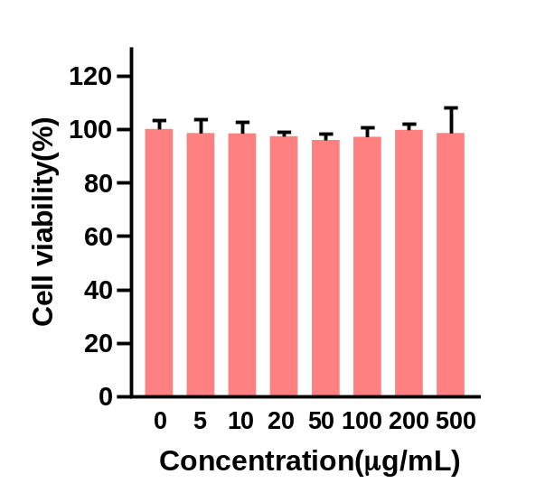
Fig. S15. Relative cell viability of HT-29 cells after incubated with HA/CeO₂ NPs for 24 h.

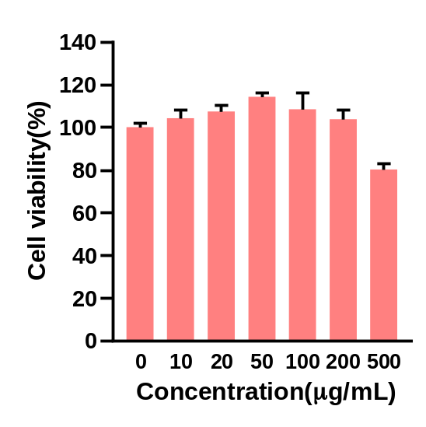
Fig. S16. Relative cell viability of HT-29 cells after incubated with Cur@PC-HA/CeO₂ NPs for 24 h.

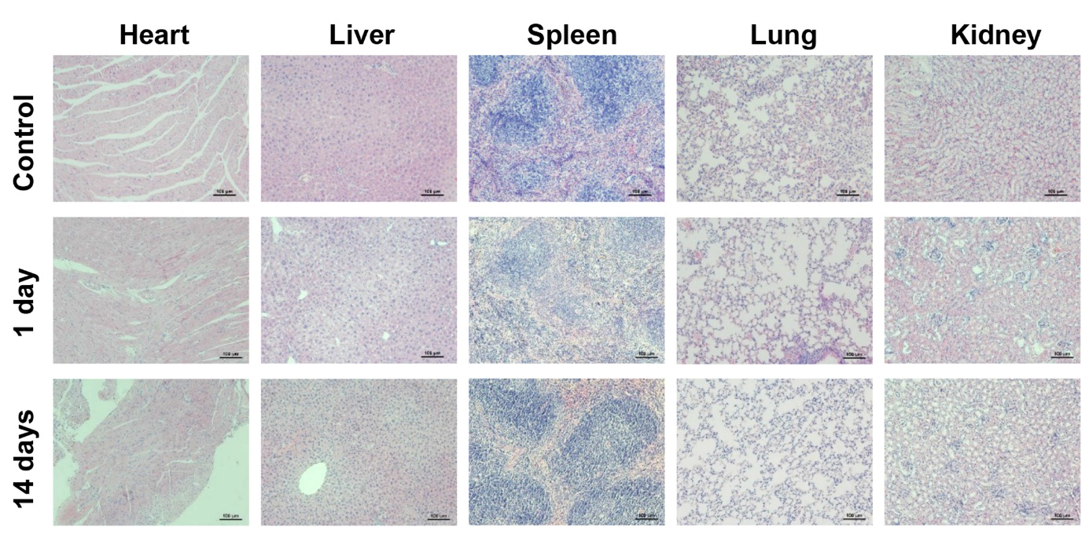
Fig. S17. H&E-stained histological sections of major organs (heart, liver, spleen, lung, and kidney) at 1 day or 14 days post oral administration of Cur@PC-HA/CeO₂ NPs in C57BL/6 mice. PBS treatment as a control group.

