Rationally designed catalytic nanoplatform for enhanced chemoimmunotherapy via deploying endogenous plus exogenous copper and remodeling tumor microenvironment

Daxi Sun^{a,1}, Liting Yu^{a,1}, Gang Wang^{b,1}, Yuxue Xuª, Peng Wangª, Ningning Wangª, Zhengyan Wu^{c,d*}, Guilong Zhangª, Jia Zhang^{c,d}, Yunjiao Zhang^{e}, Geng Tian^{a,*}, Pengfei Wei^{a,*}

ª School of Pharmacy, Shandong Technology Innovation Center of Molecular Targeting and Intelligent Diagnosis and Treatment, Binzhou Medical University, Yantai, 264003, China
^{b} Institute of Functional Nano & Soft Materials (FUNSOM), Jiangsu Key Laboratory for Carbon-Based Functional Materials and Devices, Soochow University, Suzhou, 215123, China
^{c} Key Laboratory of High Magnetic Field and Ion Beam Physical Biology, Hefei Institutes of Physical Science, Chinese Academy of Sciences, Hefei 230031, P.R. China.
^{d} University of Science and Technology of China, Hefei 230026, P.R. China
^{e} The Second Affiliated Hospital, School of Medicine, South China University of Technology, Guangzhou 510006, P. R. China.

* Corresponding authors. Email address: pfwei@bzmc.edu.cn (P. Wei); tiangeng@bzmc.edu.cn (G. Tian); zywu@ipp.ac.cn (Z. Wu)

¹ Equal contributions to this work.

Materials and methods

Synthesis of Copper oxide (CuO)
Copper oxide nanospindles were synthesized according to a method reported previously[1]. Briefly, 0.511 g of CuCl₂·2H₂O was added to 150 mL of deionized water under stirring conditions followed by addition of 500 μL of glacial acetic acid. The solution was heated to 100 °C, and under vigorous stirring, 0.65 g of NaOH was added and left for 10 min. The black precipitate was washed multiple times with deionized water to obtain a phase pure CuO nanoparticles.
H₂O₂ Release
Ti (SO4)₂ was used as an H₂O₂ indicator, and its color changed from colorless to yellow when reacting specifically with H₂O₂. H₂O₂ solution was added to 1 mL of Ti (SO₄)₂ solution (1 mg/mL), resulting in H₂O₂ working concentrations of (62.5, 125, 250, 500 μM). Detected the absorbance at 410 nm and established a standard curve for H₂O₂, and studied the relationship between the visible spectral absorbance of different mixtures and H₂O₂ concentration. Different concentrations of CP were dispersed in 1mL of Ti (SO₄)₂ solution (1 mg/mL) under the conditions of pH 5.5.
GSH depletion by CP
The consumption of GSH was detected by the indicator DTNB. CP ([Cu]= 100 μg/mL) and GSH (2 mM) were dispersed in PBS (pH 5.5) at 37 ℃ to form a reaction solution, at different time points (0, 1, 2, 4 h), the indicator DTNB were added, after 10min of incubation, then by observing the absorbance change at 412 nm to test the GSH depletion. The groups at different pH treatments were also measured.
•OH generation detection
The indicator MB was used to measure the •OH produced by the Fenton-like reaction. First, the prepared CP ([Cu]=50 μg/mL) were dispersed in PBS of pH 5.5 and incubated at 37 °C with gentle shaking for 4 h. After centrifugation, GSH was added to the supernatant to react for 1 h ([GSH]=0,1, 2, 4, 8 and 16 mM), then the detection reagent MB (50 μg/mL) was added and incubated for another 2 h. Then, the UV-vis absorption of the mixed solution was measured. And under the presence of 4 mM GSH, UV-vis absorption was obtained under different pH conditions. And with the same pretreatment, the UV spectra of CP and CC@LPF under different pH conditions were measured in the presence of 4 mM GSH. After preprocessing CP and CC@LPF ([Cu]=50 μg/mL) under the different pH conditions and adding TMB reagent (40 μg/mL) in the presence of GSH 4 mM for another 2 h, the results were also obtained by UV vis absorption to measure the •OH production.
Hoechst 33342/PI double staining
CT-26 cells were seeded into 6-well plates and incubated overnight. Then the cells were treated with different formulations for 24 h. Then, Hoechst 33342 (10 μg/mL) and PI (2 μg/mL) were added and staining cells for 20 min in the dark at 37 ◦C. The results were captured under fluorescence microscope.
Cu²⁺ Released from CC@LPF
1 mg CC@LPF was dispersed in 2 mL of solution with different pH values (7.4, 6.5, and 5.5), and the mixture was stirred for 0.25, 0.5, 1, 2, 4, 8, 16 h. Next, the supernatants were collected by centrifugation; the concentrations of Cu²⁺ were determined by ICP-OES.
Cell uptake of CC@LPF
CT-26 cells were passed into 6-well plate at 20 0000 cells/well and incubated at 37 ◦C until the confluence achieved nearly 80%. Then the cells were incubated with different treatments for 12 h. The cells were washed with phosphate-buffered saline (PBS) for three times. Then the cells were digested overnight with nitric acid. The concentrations of Cu²⁺ were determined by ICP-OES.
Preparation of FITC/CC@LPF
Briefly, 1 mg CP and 4 mg CQ were dissolved in DIwater and incubated overnight at room temperature under dark. Then, the mixture was centrifuged at 12 000 g for 10 min. The precipitation was collected and resuspended with DI water (denoted as A solution).
Then A solution was incubated with FITC. On the other hand, HSPC, cholesterol and DSPE-PEG2000-FA were dissolved in 10 mL chloroform with the molar ratio of 6:4:0.5. The solvent was evaporated under vacuum by a rotary evaporator (Hei-VAP Core, Heidolph) to form a thin film. Then, solution A and FITC was added to a rotating steam bottle and rotated for 3 minutes. The bottle was removed and treated with ultrasound for 30 min. Finally, the mixture was centrifuged at 12 000 g for 10 min. After three times of washing, the sediment was dispersed in the saline.
Apoptosis analysis
The apoptosis-inducing ability of different nanoparticles was assessed by flow cytometry after double staining with ANXA5-FITC and PI. CT26 cells were inoculated into 6-well plates, cultured overnight and then incubated for 12 hours with different formulations. Cells were then collected and co-stained with ANXA5-FITC and PI for 15 min. Fluorescence intensity was analyzed using a flow cytometer (FACSCanto II, BD).
Calcein AM and PI double staining
Live and dead cells were analyzed by Calcein-AM/PI cell assay kits. In detail, CT26 cells were seeded into 6-well plates and incubated at 37 ◦C until the confluence achieved nearly 80%. CT-26 cells were treated with different formulations for 24 h. Then, Calcein AM (2 μM) and PI (5 μM) were added and staining cells for 30 min in the dark at 37 ◦C. The results were captured under CLSM.
Preparation of ICG/CC@LPF, ICG/CC@LP
The preparation method of ICG/CC@LPF was referred to 1.8, the FITC was replaced by ICG, and the preparation of ICG/CCLP is similar to the above, the DSPE-PEG2000-FA was replaced by DSPE-PEG2000. Then unpackaged ICG was removed by centrifugation. Lastly, ICG/CC@LPF and ICG/CC@LP were quantified using a fluorescence spectrophotometer (RF-6000, Shimadzu).

Reference
1. Chakraborty S, Prakash P, Shah J, Mayya C, Singh S, Ranganathan R, Soppina V, Jones EV, Misra SK: CuO Nanoparticles as Copper-Ion Reservoirs for Elesclomol-Mediated Intracellular Oxidative Stress: Implications for Anticancer Therapies. ACS Applied Nano Materials 2022, 5:1607-1620.
Supplementary Figures

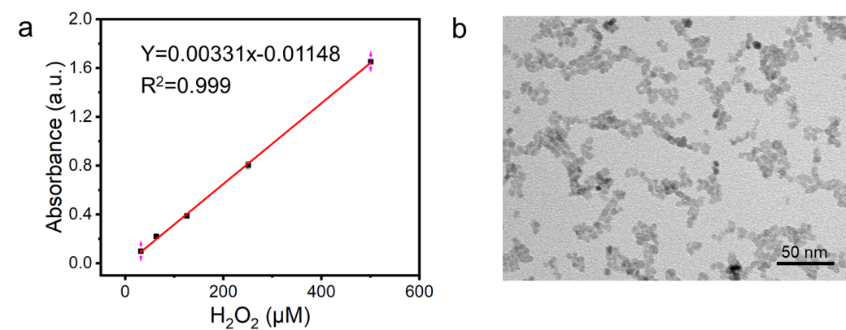
Figure S1 Additional data including: (a) Plot of absorbance versus concentrations of H₂O₂, based on the different absorbance at 410 nm wavelength; (b) TEM image of CuO nanoparticles.

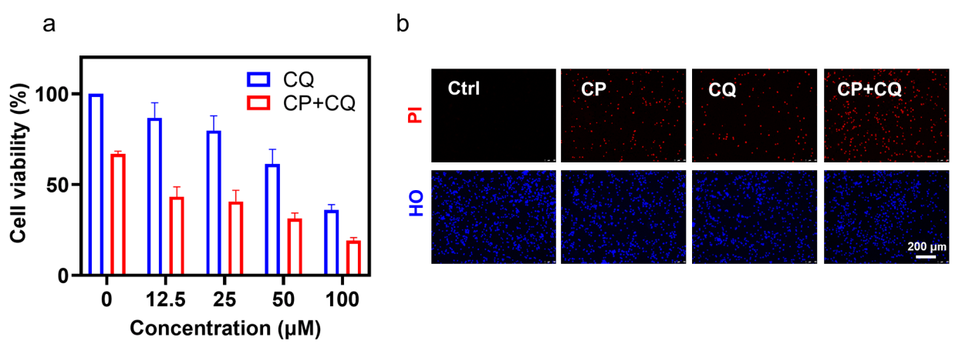
Figure S2 CQ demonstrated obvious synergistic inhibition of tumor cell viability and elicitation of cell death with CP. (a) Cell viability analysis of CT-26 cells treated with the indicated treatments for 24 h. CP, 15 μg/mL. The experiments were repeated thrice. (b) Cell death analysis of CT-26 cells treated with CP (15 μg/mL) or/and CQ (50 μM) for 24 h. Hoechst 33342 (HO), 10 μg/mL; PI, 2 μg/mL.

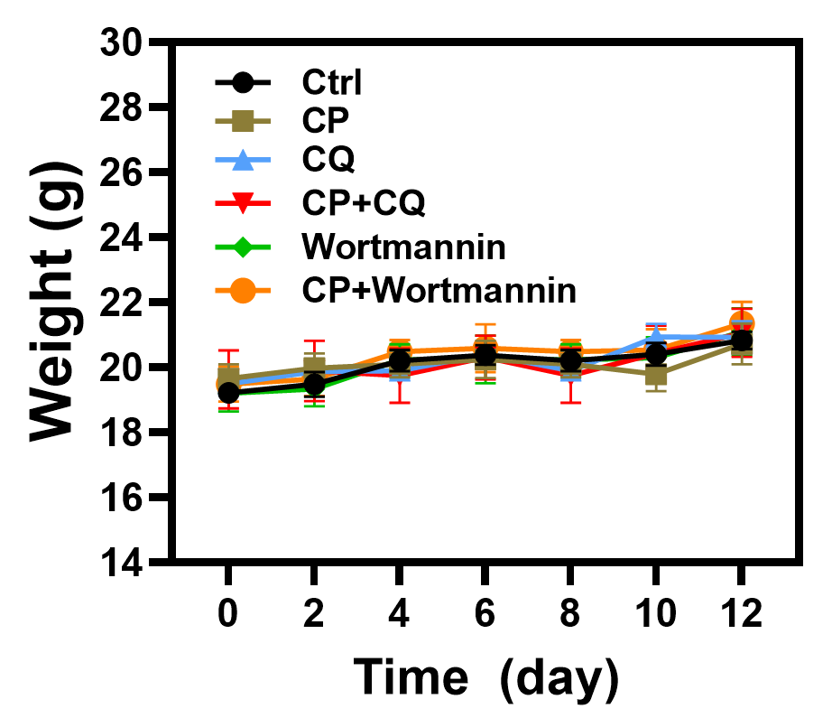
Figure S3 Body weights of mice in different groups during the different treatments by introtumor injection. CP, 5 mg/kg; CQ, 8.56 mg/kg; wortmannin (Wort), 0.35 mg/kg. Mean ± S.E.M., n=5.

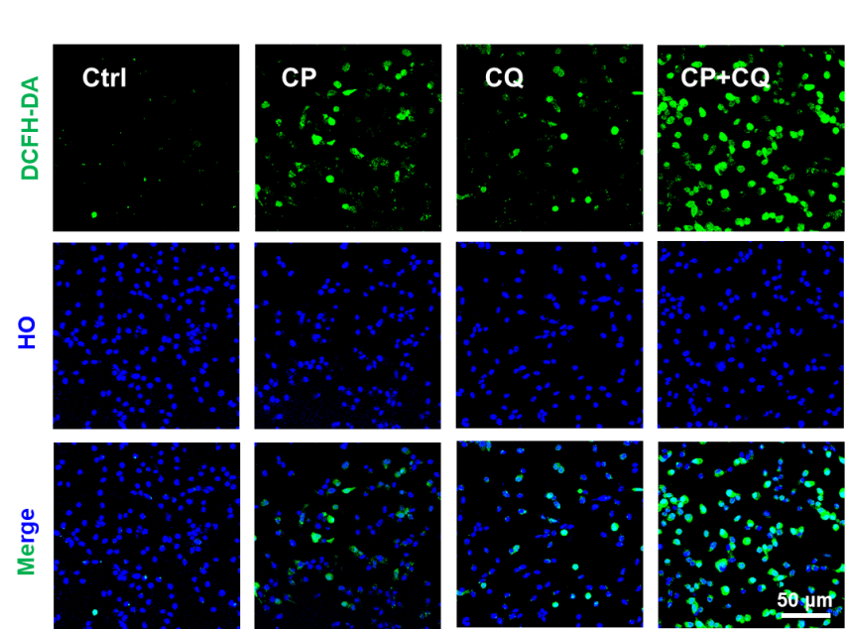

Figure S4 ROS analysis under CLSM after CT-26 cells exposed to the indicated treatments for 6 h and then stained with DCFH-DA (10 μM; 20 min). Hoechst 33342 (HO), 10 μg/mL.

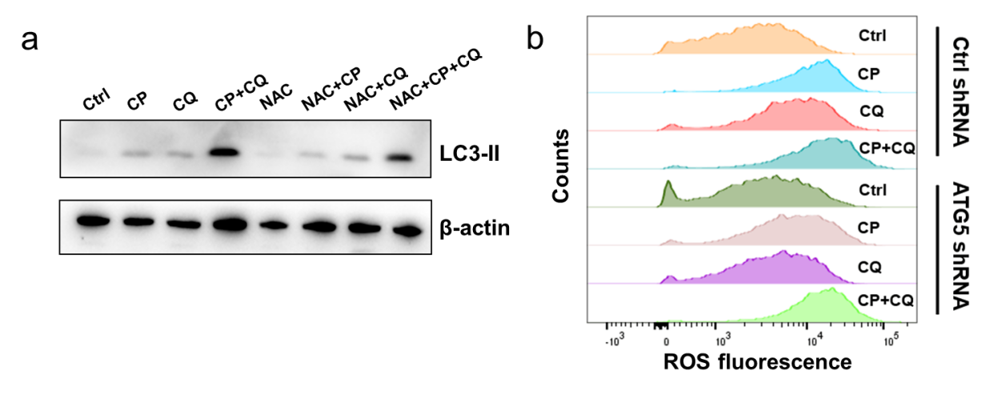
Figure S5 The relationship of ROS and accumulated autophagosomes. (a) Western blot analysis of LC3 proteins in CT-26 cells after the indicated treatments for 12 h. CP, 15 μg/mL; CQ, 50 μΜ; NAC, 5 mM. (b) ROS analysis by flow cytometry after CT-26 cells exposed to the indicated treatments for 6 h in the presence or absence of ATG5 expression attenuation,and then stained with DCFH-DA (10 μM; 20 min). CP, 15 μg/mL; CQ, 50 μΜ.
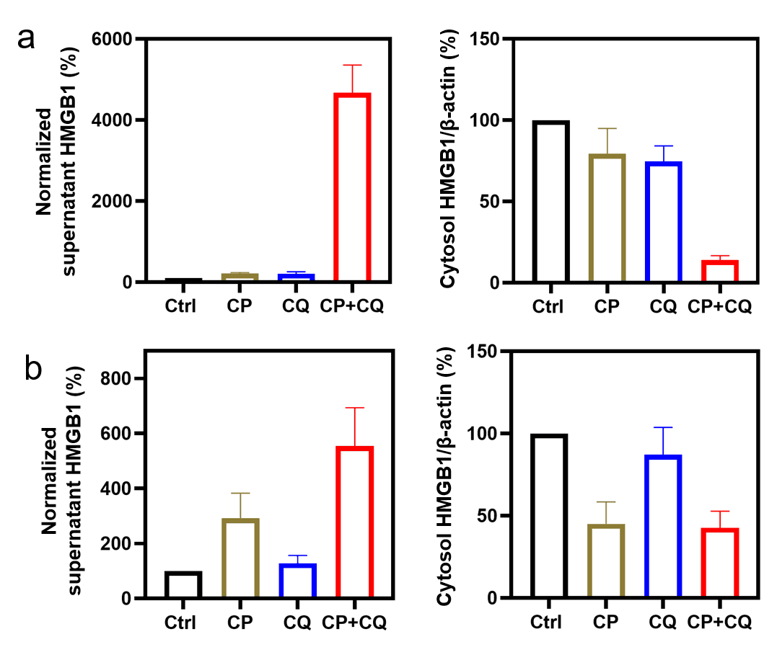
Figure S6 The statistical data from Figure 4B. (a, b) Western blot analysis of HMGB1 in the supernatant (SN) and cytosol (CS) after CT-26 cells exposed to the indicated treatments for 12 h (a) or 24 h (b), CP, 15 μg/mL; CQ, 50 μM. The results were also quantified by Image J software.
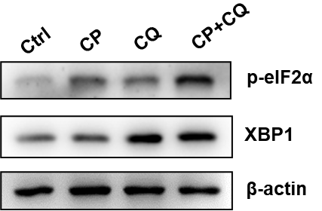

Figure S7 Western blot analysis of p-eIF2α and XBP1 proteins in CT-26 cells after the indicated treatments for 12 h. CP, 15 μg/mL; CQ, 50 μΜ.
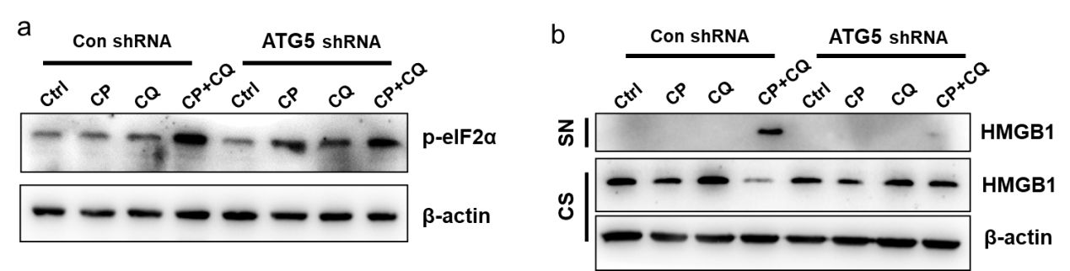
Figure S8 Tremendous accumulation of autophagosomes by the joint use of CP and CQ contributed to ER stress and HMGB1 release. (a, b) CT-26 cells exposed to the indicated treatments for 12 h in the presence or absence of ATG5 expression attenuation were subjected to western blot analysis for phosphorylated eIF2α (p-eIF2α) (a), HMGB1 in supernatant (SN) and cytosol (CS) (b), CP, 15 μg/mL; CQ, 50 μM.

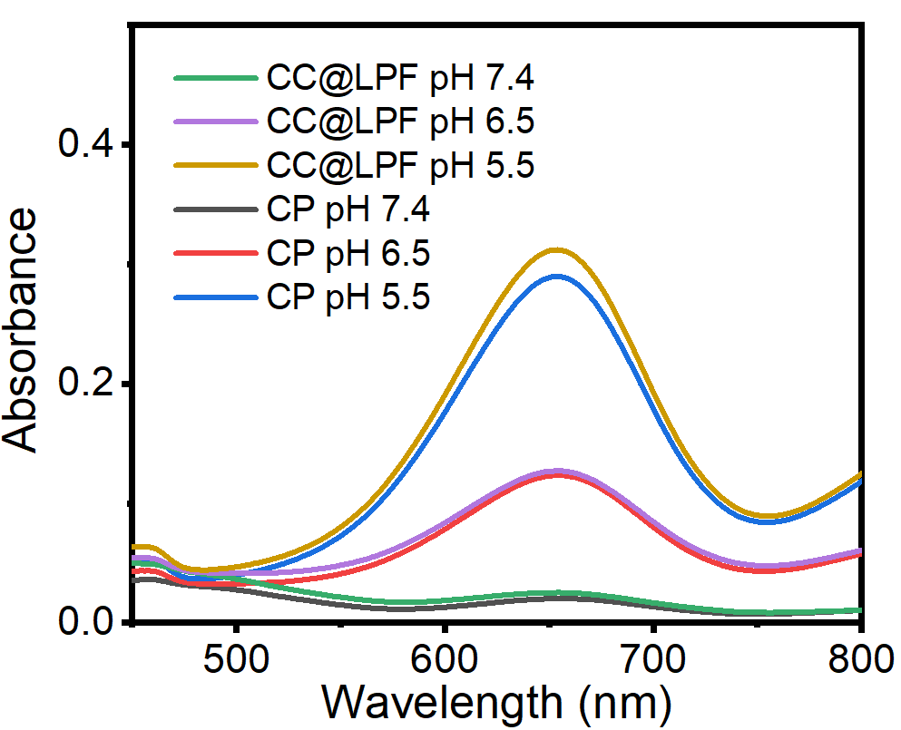
Figure S9 UV–vis spectra of TMB solution after reacting with CP (50 µg/mL) or CC@LPF (50 µg/mL) under various pH values with the existence of 4 mM GSH.

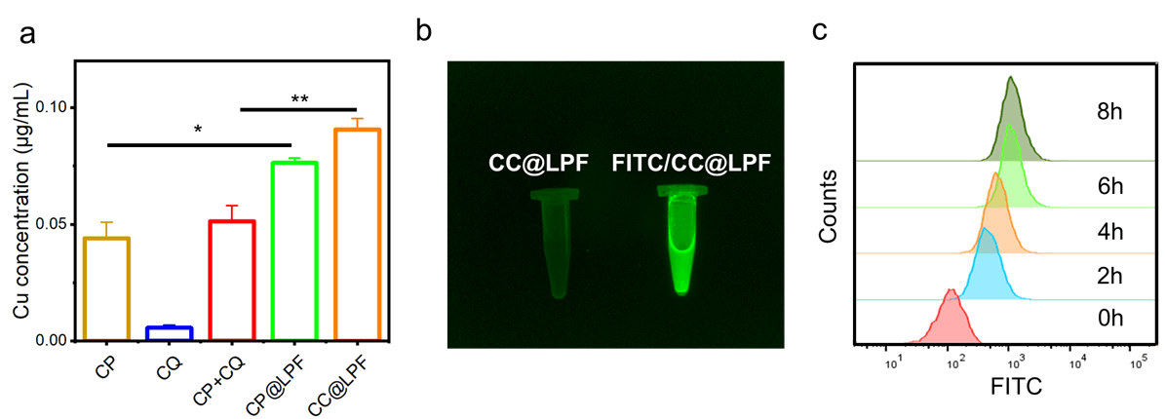

Figure S10 Additional results demonstrated the enhanced cell uptake of CC@LPF. (a) CT-26 cells after treated with the indicated treatments were subjected to ICP-OES for the determination of total copper ion concentrations. The CC@LPF and FITC/CC@LPF concentration equivalent to copper ions (15 μg/mL), The experiment was repeated thrice. (b) CC@LPF and FITC/CC@LPF were observed by Azure Imaging Systems (c600, azure biosystems) (c) Cell uptake analysis by flow cytometry after CT-26 cells exposed to the FITC/CC@LPF (15 μg/mL) at different time points.
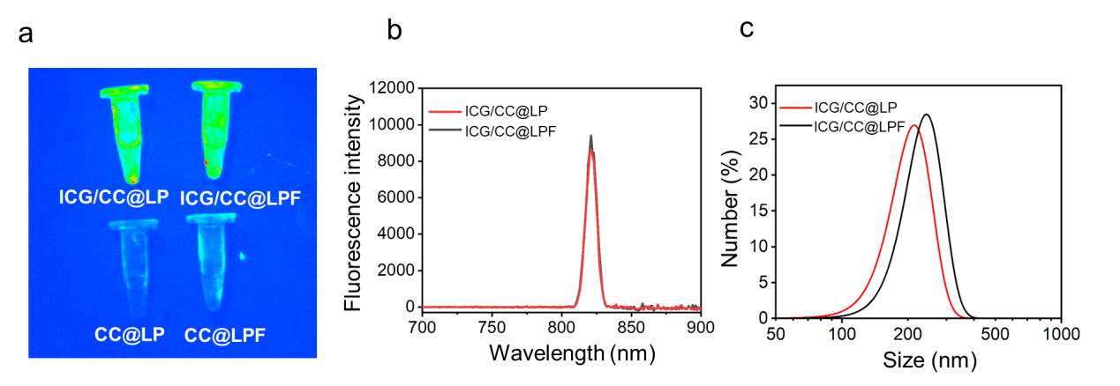
Figure S11 Preparation and characterization of ICG/CC@LP and ICG/CC@LPF. (a) CC@LP, CC@LPF, ICG/CC@LP and ICG/CC@LPF were observed by a near infrared live imaging instrument (NIRvana 640, Princeton Instruments). (b) DLS size distributions of ICG/CC@LP and ICG/CC@LPF. (c) Fluorescence intensity of ICG/CC@LP and ICG/CC@LPF.

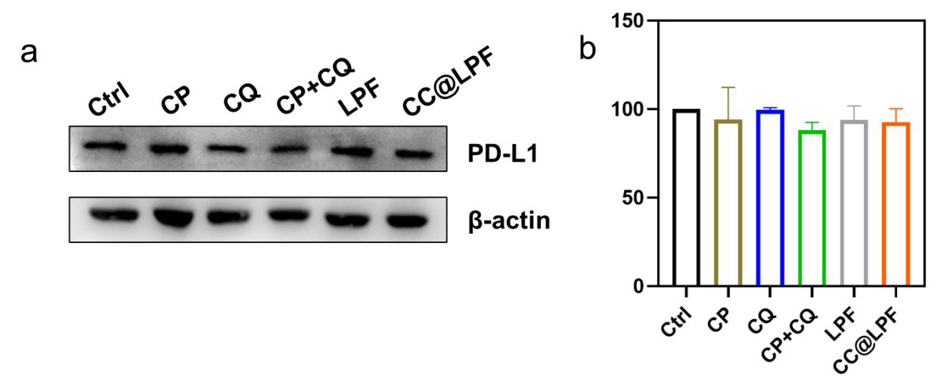

Figure S12 PD-L1 expressions after the different treatments. (a) Western blot analysis of PD-L1 expression in CT-26 cells exposed to the indicated treatments for 24 h. The concentrations used of all groups were equivalent to that of copper ions (15 μg/mL). (b) The results were also quantified by Image J software. Triple individual experiments were performed.

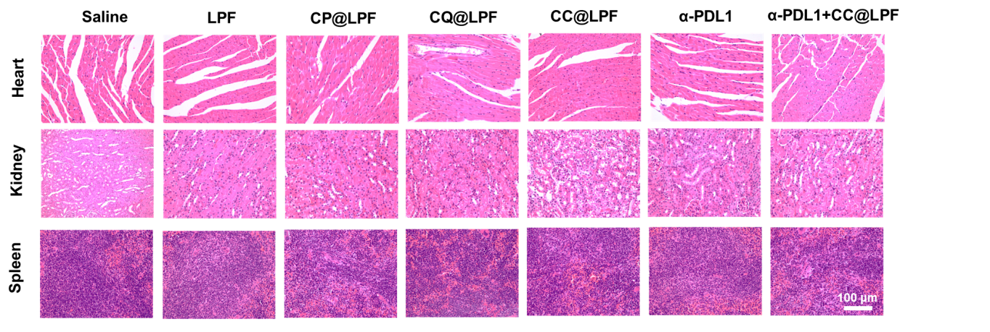
Figure S13 H&E staining pathological analysis of the vital organs including heart, kidney and spleen gathered from CT-26 tumor bearing mice after different treatments.

