Rapid Emergence of Extreme Sea Level in the Indian Ocean under global warming

P Sreeraj*^{,1,2}, P Swapna¹, Manmeet Singh¹ and R Krishnan¹
¹Centre for Climate Change Research, Indian Institute of Tropical Meteorology, Pune, India
²Department of Atmospheric and Space Sciences, Savitribai Phule Pune University, Pune, India

Supplementary figures and tables

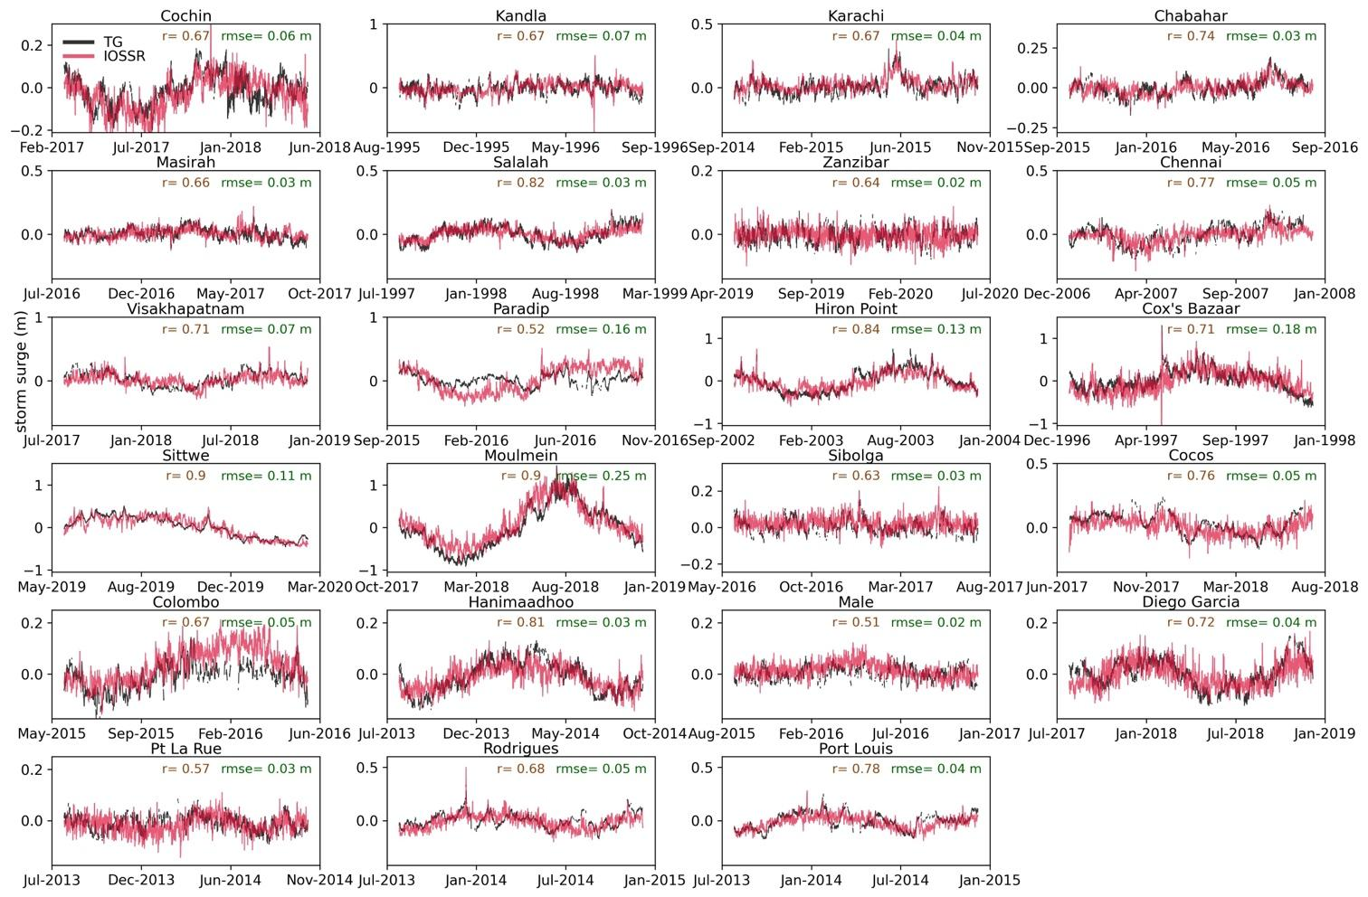

Fig. S1| Validation of storm surge reconstruction. Comparison of hourly storm surge data from selected tide gauge stations (black) with IOSSR (red) during LSTM validation period. Corresponding correlation and mean squared error (MSE) values are shown in the top right corner of each panel. Training and validation periods are shown in supplementary table 1.

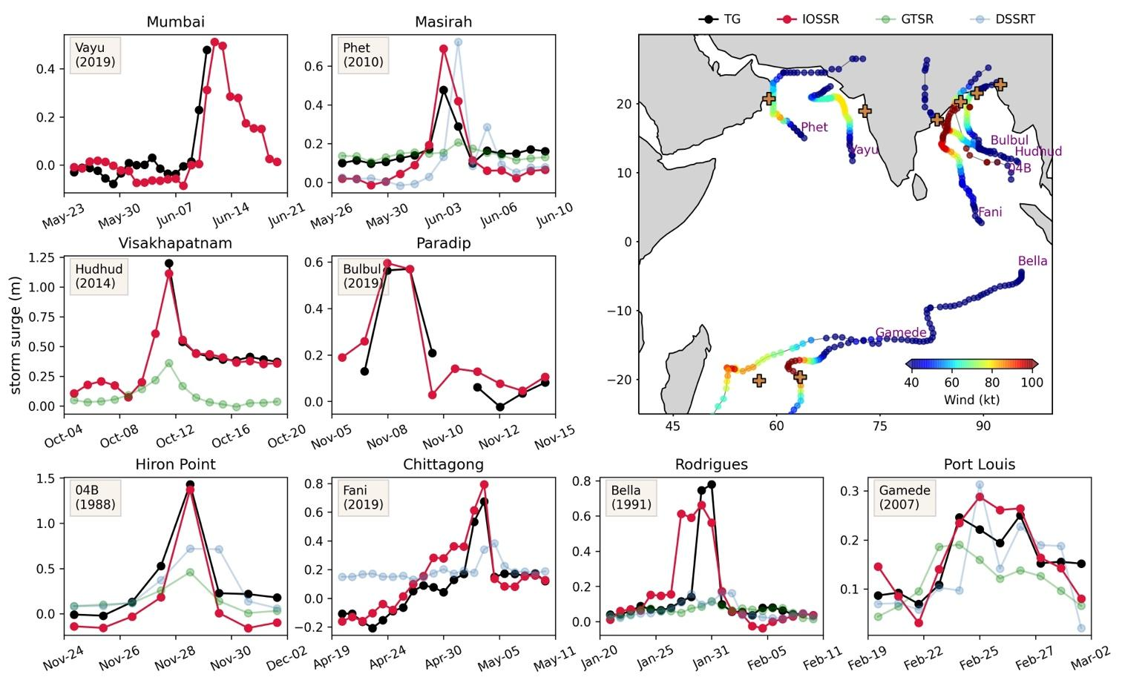

Fig. S2| Validation of storm surge reconstruction during tropical cyclones. Daily maxima storm surge from tide gauge observations (black), IOSSR (red), GTSR (green), and DSSRT (blue) during selected tropical cyclone (TC) events. The spatial map displays the name, track, and wind speed of the corresponding TC events. The amplitude of storm surge is slightly lower in both IOSSR (red) and observations (black) as the data were smoothed using a 12-hour running mean. DSRRT and GTSR data are not shown in specific locations due to a lack of data. TCs during LSTM training period are not considered.

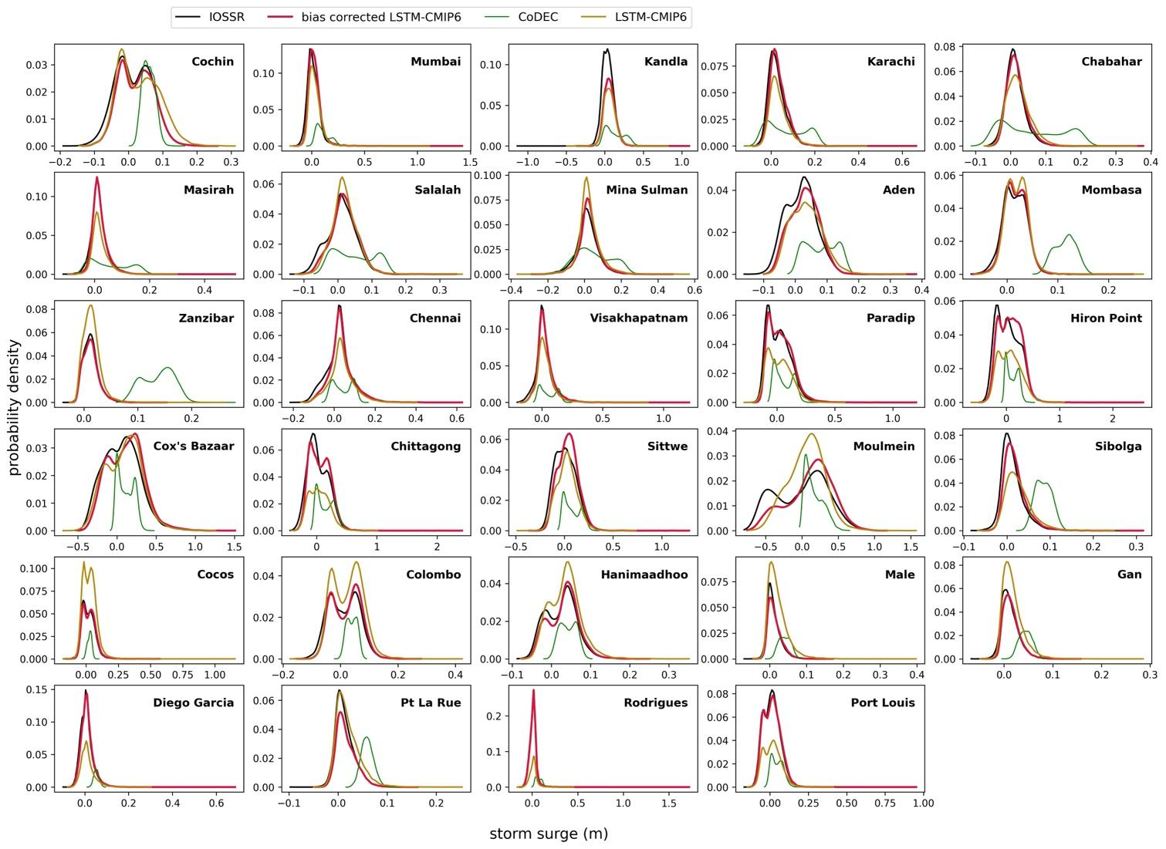

Fig. S3 | Comparison of historic storm surge distribution. Distribution of historic daily maxima storm surge from 6 hourly IOSSR (black), LSTM trained with CMIP6 predictors (yellow), LSTM from CMIP6 predictors with bias correction applied (red) and CoDEC ensemble (green), for the period 1980-2014.

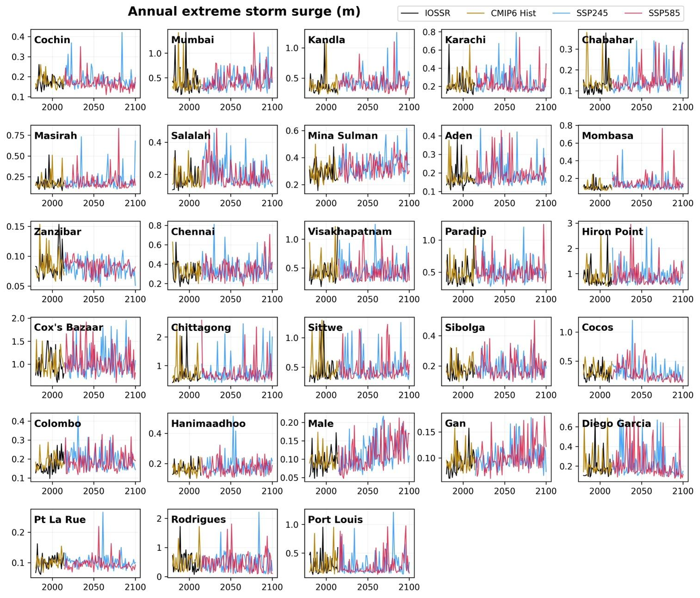

Fig. S4| LSTM simulated storm surge using CMIP6 predictors. Annual extreme storm surge from 6-hourly IOSSR (black) and bias-corrected LSTM simulation (yellow) using CMIP6 predictors. Future projections under SSP245 (blue) and SSP585 (red) predictors are also illustrated.

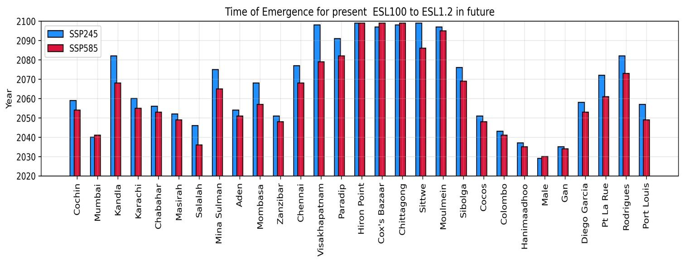
Fig. S5| Time of emergence of ESL₁₀₀ under climate change. Year when the present-day ESL₁₀₀ becomes an annual event under SSP245 (blue) and SSP585 (red) along the Indian Ocean TG stations.

No | Station (country) | LSTM training period | LSTM validation period
1 | Cochin (IND) | 2012-01-01 : 2017-01-31 | 2017-03-01 : 2018-05-31
2 | Mumbai (IND) | 2012-01-01 : 2017-01-31 | 2017-02-01 : 2017-12-31
3 | Kandla (IND) | 1991-01-01 : 1995-08-30 | 1995-09-01 : 1996-08-30
4 | Karachi (PAK) | 2009-01-01 : 2014-09-30 | 2014-10-01 : 2015-10-31
5 | Chabahar (IRN) | 2010-01-01 : 2015-08-31 | 2015-10-01 : 2016-08-31
6 | Masirah (OMN) | 2011-01-01 : 2016-07-31 | 2016-08-01 : 2017-08-30
7 | Salalah (OMN) | 1991-08-01 : 1997-07-31 | 1997-08-01 : 1999-02-28
8 | Mina Sulman (BHR) | 1991-01-01 : 1996-12-31 | 1997-01-01 : 1997-12-31
9 | Aden (YMN) | 2008-01-01 : 2013-12-31 | 2014-01-01 : 2014-12-31
10 | Mombasa (KEN) | 2014-01-01 : 2018-12-31 | 2019-01-01 : 2019-12-31
11 | Zanzibar (TZA) | 2014-10-01 : 2019-04-30 | 2019-05-01 : 2020-06-30
12 | Chennai (IND) | 2001-04-11 : 2006-12-30 | 2007-01-01 : 2007-12-31
13 | Visakhapatnam (IND) | 2012-01-01 : 2017-07-31 | 2017-08-01 : 2018-12-31
14 | Paradip (IND) | 2011-01-01 : 2015-09-30 | 2015-10-01 : 2016-10-31
15 | Hiron Point (BGD) | 1998-01-01 : 2002-09-30 | 2002-10-01 : 2003-12-31
16 | Cox's Bazaar (BGD) | 1991-01-01 : 1996-12-31 | 1997-01-01 : 1997-12-31
17 | Chittagong (BGD) | 2008-01-01 : 2013-05-31 | 2013-06-01 : 2014-09-30
18 | Akyab (MMR) | 2016-01-01 : 2019-05-31 | 2019-06-01 : 2020-02-28
19 | Moulmein (MMR) | 2012-03-01 : 2017-10-30 | 2017-11-01 : 2018-12-30
20 | Sibolga (IDN) | 2011-01-01 : 2016-05-31 | 2016-06-01 : 2017-07-30
21 | Cocos Island (AUS) | 2012-01-01 : 2017-06-30 | 2017-07-01 : 2018-07-30
22 | Colombo (SRL) | 2010-01-01 : 2015-05-31 | 2015-06-01 : 2016-05-30
23 | Hanimaadhoo (MDV) | 2008-01-01 : 2013-07-31 | 2013-08-01 : 2014-09-30
24 | Male (MDV) | 2010-01-01 : 2015-07-31 | 2015-08-01 : 2016-12-30
25 | Gan (MDV) | 2012-01-01 : 2017-06-30 | 2017-07-01 : 2018-11-30
26 | Diego Garcia (IOT) | 2012-01-01 : 2017-07-31 | 2017-08-01 : 2018-12-30
27 | Pt La Rue (SYC) | 2008-01-01 : 2013-07-31 | 2013-08-01 : 2014-10-03
28 | Rodrigues (MUS) | 2008-01-01 : 2013-07-31 | 2013-08-01 : 2014-12-31
29 | Port Louis (MUS) | 2008-01-01 : 2013-07-31 | 2013-08-01 : 2014-12-31

Table S1 | LSTM training details. Listed training and validation period chosen for LSTM model for each TG station with country code.

