High Dose Inhaled Corticosteroid Increased the Incidence of Idiopathic Pulmonary Fibrosis: Nationwide Population based Study

Hyewon Lee^{1,2}, Hee-Young Yoon³

¹Department of Health Administration and Management, College of Medical Sciences, Soonchunhyang University, Asan, Republic of Korea
²Department of Software Convergence, Soonchunhyang University Graduate School, Asan, Republic of Korea
³Division of Allergy and Respiratory Diseases, Department of Internal Medicine, Soonchunhyang University Seoul Hospital, Seoul, Republic of Korea

Fig. S1. Covariate balance before and after IPTW treatment
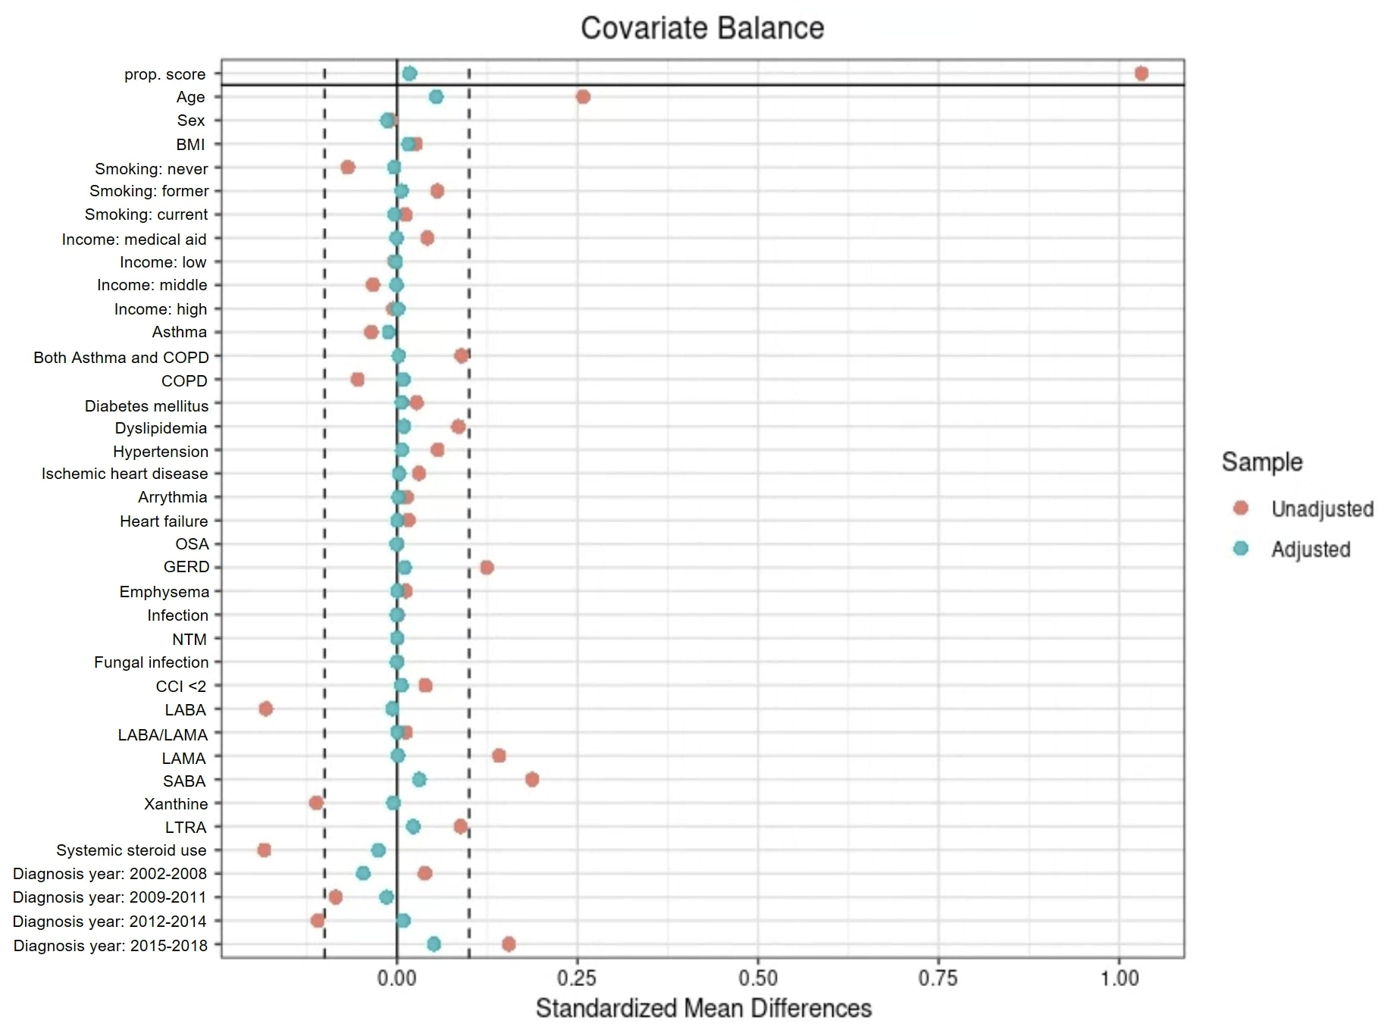
IPTW, inverse probability of treatment weighting; COPD, chronic obstructive pulmonary disease; NTM, non-tuberculous mycobacteria; CCI, Charlson comorbidity index; ICS, inhaled corticosteroids; BMI, body mass index; OSA, obstructive sleep apnoea; GERD, gastroesophageal reflux; LABA, long-acting beta agonist; LAMA, long-acting muscarinic antagonist; SABA, short-acting beta agonist; LTRA, leukotriene receptor antagonist

Table S1. Prescription details of ICS
Variables | N = 9,492 | Median dose (IQR), ug/day
ICS ingredient
Fluticasone | 4,709 (49.6) | 200 .0 (100.0-250.0)
Beclometasone | 1,189 (12.5) | 100.0 (100.0-100.0)
Budesonide | 5,478 (57.7) | 500.0 (228.6-500.0)
Ciclesonide | 375 (4.0) | 160.0 (160.0-221.5)
Quartiles
Q1 | 2,203 (23.2) | 100.0 (100.0-105.6)
Q2 | 1,969 (20.7) | 176.0 (160.0-200.0)
Q3 | 2,226 (23.5) | 278.2 (250.0-362.7)
Q4 | 3,094 (32.6) | 500.0 (500.0-870.0)
Data summarized as medians (IQR) or numbers (%).
ICS, inhaled corticosteroid; IQR, interquartile range

