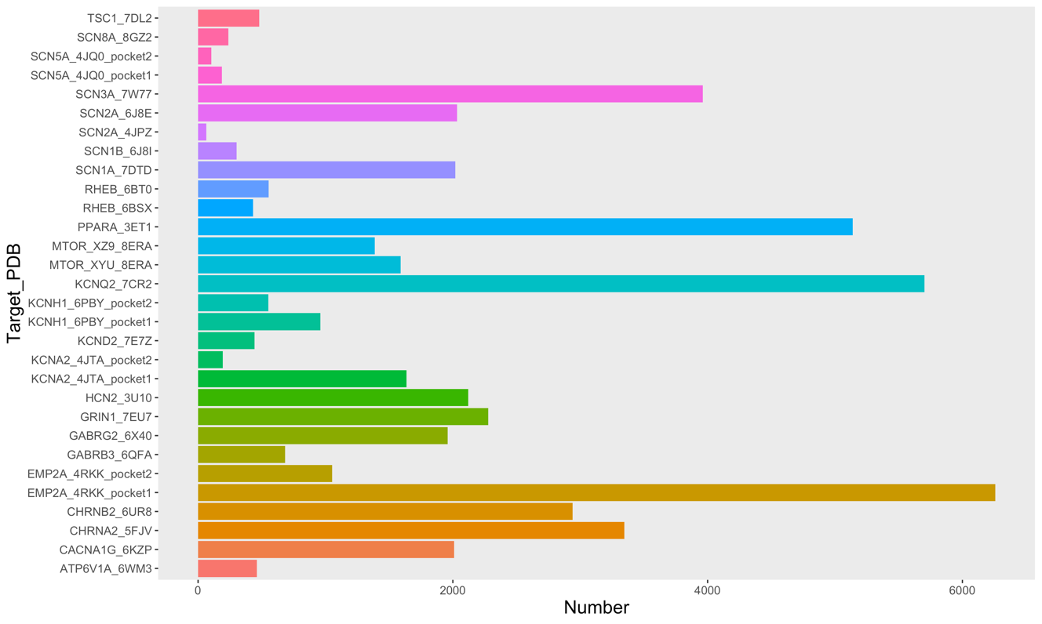

Fig S1 The number of candidates after docking filter using -7.0 as threshold criterion.

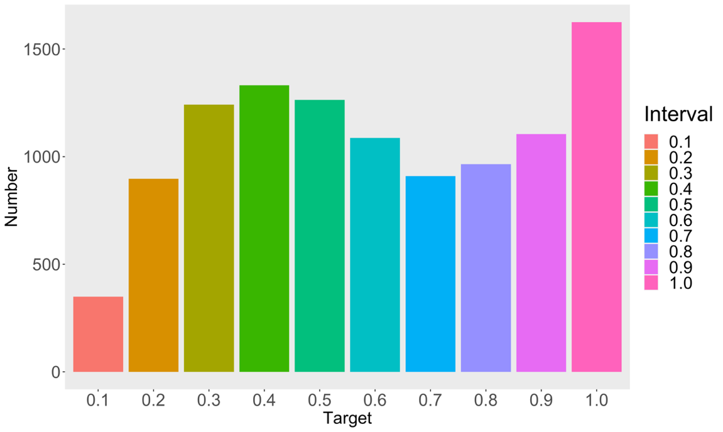
Fig S2 The distribution of predicted BBB permeability probability for compounds from DrugBank database.

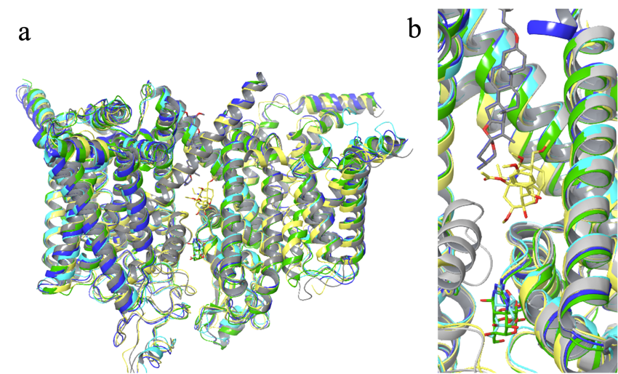
Fig S3 The five voltage-gated sodium channel structures. a. Using SCN1A (7DTD:gray) as a reference structure, the other four structures were aligned using protein (cartoon). The RMSD for SCN2A (6J8E:blue), SCN3A (7W77:yellow), SCN8A (8GZ2:cyan) and SCN9A (6J8I:green) are 1.664 $Å$, 1.373 $Å$, 1.779 $Å$ and 1.664 $Å$, respectively. b. The close-up view of panel a. These ligands are represented by stick with the same color of corresponding protein in panel a.

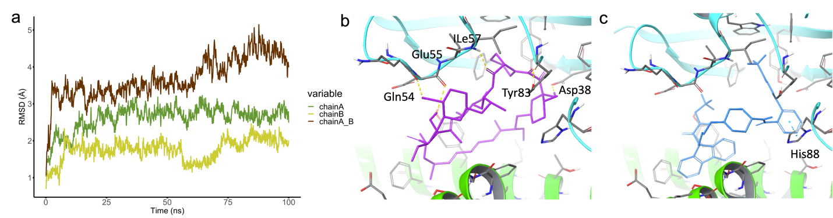
Fig. S4 The RMSD plot and ligand-receptor interaction for the target (PDB ID: 8ERA). Panel a, RMSD plot for the protein backbone, calculated across 8ERA complex and its chain A and B during the 100ns production phase. In panel b and c, chain A encoded by MTOR gene and chain B encoded by FKBP1A gene was highlighted in green and cyan, respectively. The co-crystal XYU (panel b) and Lomitapide (panel c) were colored by purple and blue, respectively.

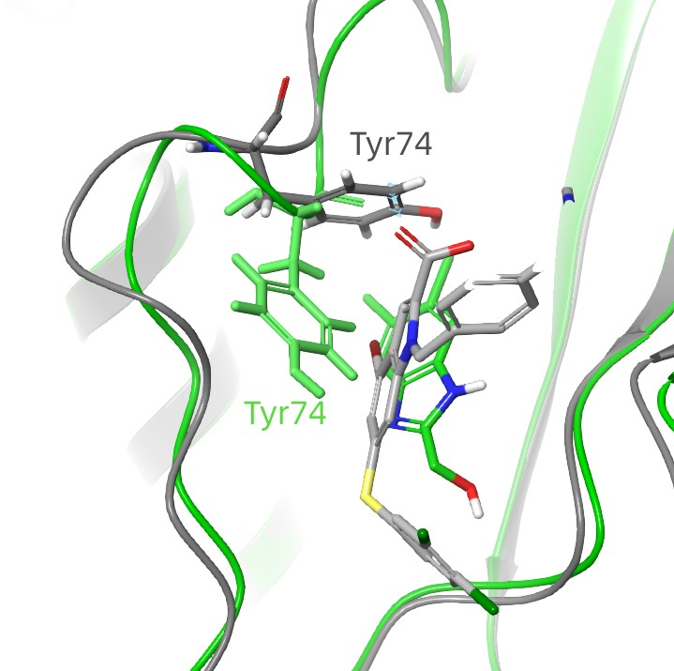

Fig S5 The two conformations of Tyr74 in 6BT0 (gray) and 6BSX (green) crystal structures. For RHEB target, the binding poses of ligand E7V (gray) and E7S (green) are shown.

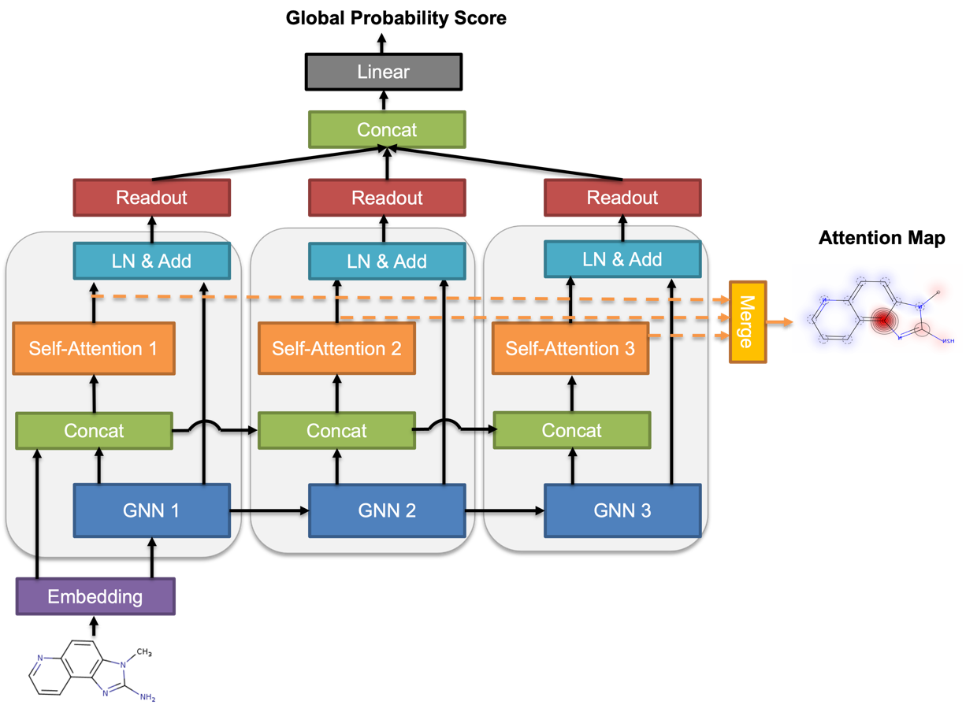
Fig S6 Ligandformer architecture. This is a multi-layer single-head self-attention-based Graph Neural Network framework, for predicting compound chemical property with robust interpretation. Facilitated with visualization technique, the map shows insights on AI model’s rationales on judging which parts of an input molecule impact certain property predictions.

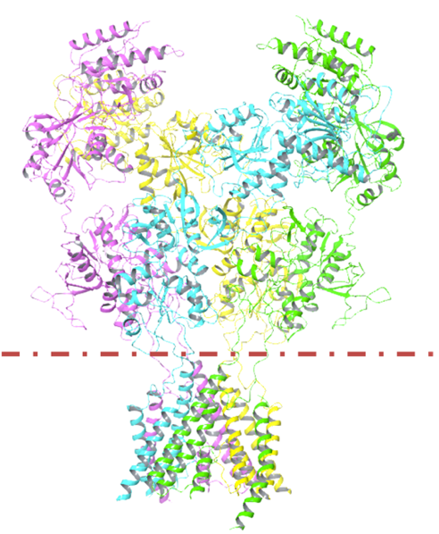
Fig. S7 The structure of 7EU7. Only transmembrane region was retained in 100-ns MD simulation (below dotted line.)

Table S1 The BBB permeable probability of anti-epileptic drugs in market predicted by Ligandformer model
Drug | ID | Probability
Carbamazepine | DB00564 | 0.9117
Valproic acid | DB00313 | 0.9282
Phenytoin sodium | DB00252 | 0.8325
Oxcarbazepine | DB00776 | 0.94
Diazepam | DB00829 | 0.97
Levetiracetam | DB01202 | 0.95
Fosphenytoin | DB01320 | 0.8445
Flunarizine | DB04841 | 0.9560

Movie S1-S10 The 100-ns MD simulation for lomitapide in EMP2A (PDB ID: 4RKK), CHRNA2 (PDB ID: 5FJV), CACNA1G (PDB ID: 6KZP), KCNH1 (PDB ID: 6PBY), GABRB3 (PDB ID: 6QFA), SCN1A (PDB ID: 7DTD), KCND2 (PDB ID: 7E7Z), GRIN1 (PDB ID: 7EU7), SCN3A (PDB ID: 7W77), MTOR (PDB ID: 8ERA) targets.

