Efficacy of Axicabtagene Ciloleucel Compared to Historical Treatments for Relapsed/Refractory Diffused Large B-cell Lymphoma of Asian Descent: A Matching Adjusted Indirect Comparison of ZUMA-1 vs REAL-TREND

Supplementary materials

Table of Contents

Supplementary Methods 3
Estimation of Weights for ZUMA-1 3
Identifying Prognostic Factors and Effect-Modifiers 5
Adjusting for High ECOG Patients in REAL-TREND 6
Supplementary Results 7
Patient Recruitment and Refractory Status 7
Comparison to SCHOLAR-1 10
Weight Derivation 11

Supplementary Methods

Estimation of Weights for ZUMA-1
The IPD from ZUMA-1 were weighted to match the marginal distributions (mean, variance) of the published REAL-TREND data. In this framework, the patients from the REAL-TREND study were the target population. Therefore, patients from the IPD of ZUMA-1 were removed if they did not meet the inclusion criteria of the REAL-TREND study.
A logistic propensity score model was used to estimate weights for the IPD such that the weighted mean baseline characteristics of interest for the index trial matches those reported in the comparator population. The factors included in the logistic regression were the characteristics that were identified as prognostic factors that are shared between populations, irrespective of whether there is an imbalance across studies. These steps produce an IPD dataset with a weighted study population matching those of the comparator studies of interest for the included covariates. Using these weights, outcomes for the index treatment were then predicted for the population in the trial of the competing intervention by reweighting the observed outcomes from the index trial. Treatment comparisons were made across the balanced study populations.
For this analysis, the propensity score was defined as the probability of treatment assignment conditional on baseline covariates. This was determined via logistic regression, based on the IPD from the index trial:
$$logit\left(T\right)= β_{0}+ \sum_{i=1}^{C}{X_{i}}$$ | (1)
where T represents the treatment group and X_{i} are the i=1…C covariates under consideration. In cases where the algorithm used to estimate the weights does not converge, variables will be removed in stepwise fashion in a predetermined order until convergence is achieved. Outcomes for the index treatment can then be predicted for the target population by reweighting the observed outcomes from the index trial.
MAIC models estimate the mean outcomes in a target population by taking a weighted average of the outcomes of individuals in the index trial. The weighting is defined as:
$$\hat{Y_{(T)}}= \frac{\sum_{i=1}^{N}{Y_{i(I)}w_{i}}}{\sum_{i=1}^{N}{w_{i}}}$$ | (2)
where $\hat{Y_{(T)}}$ is the estimated mean outcome in the target population, $Y_{i(I)}$ is the observed outcome for individual i in the index population, w_{i} is the weight for individual i, and N is the number of individuals in the index trial. When the weights are estimated with a propensity score logistic regression model, these weights represent the odds of being enrolled in the target trial versus the index trial.
The validity of a MAIC model depends upon the overlap between the IPD and the aggregate population. When there is little overlap between the populations, the estimates become heavily influenced by relatively few individuals. The extent of overlap is represented with the effective sample size (ESS):
$$ESS= \frac{{(\sum_{t=1}^{T}{\sum_{i=1}^{N}{w_{it})}}}^{2}}{\sum_{t=1}^{T}{\sum_{i=1}^{N}{w_{it}^{2}}}}$$ | (3)
ESS is an adjustment of the sample size that accounts for the weighting of the observations, and the resulting correlations between estimated responses. As with the typical sample size, a large value is preferable to a small value, as the larger sample contains more information. It is recommended that the ESS be reported when performing MAICs. The National Institute for Health and Care Excellence Decision Support Unit technical support document 18 reports that in a sample of three studies that used an MAIC, the effective sample size was reduced by 80% of the original sample size on average.¹⁷
The validity of the MAIC depends on how well the propensity score weights account for differences between the index trial and the target population in each comparator study. This method cannot be considered as strong as other approaches such network meta-analyses (NMA) of only randomized controlled trials (RCT) because there will always be uncertainty regarding any unknown or unmeasured prognostic factors and effect-modifiers that may influence the outcome of interest but are not captured in the chosen model.

Identifying Prognostic Factors and Effect-Modifiers
Studies conducted on different populations and under different conditions can lead to erroneous judgements of treatment effect, as any variables other than the treatment can affect the outcomes. Comparisons that do not account for these other factors are at risk of bias. For this particular study, the prognostic factors were identified through review of the ZUMA-1 vs SCHOLAR-1 study. All patient characteristics available in the REAL-TREND study were identified as potential prognostic factors in the aforementioned study, and were therefore included for consideration in the model.
The prognostic factors included in this weighting were as follows:
- Age ≥60
- Male
- Proportion of patients with 3 or more prior lines of therapy
- Ann Arbor Stage 3-4
- IPI (0-1 vs 2 vs 3 vs 4-5)
- Primary refractory
- Refractory to previous line of therapy (LoT)
- Refractory to SCT
There are other known prognostic factors that were not available for the REAL-TREND cohort. These include: elevated lactate dehydrogenase (LDH), increased C-reactive protein (CRP), having multiple extranodal sites, and high total metabolic tumor volume (TMTV).¹⁸ As these were not reported in REAL-TREND, they could not be adjusted for. Nonetheless, it should be noted that the IPI score captures five characteristics: age, elevated LDH, high Ann Arbor stage, ECOG performance score ≥ 2, and having ≥ extranodal sites. Therefore, the inclusion of IPI implicitly addresses three of the listed prognostic factors. Of the remaining prognostic factors, elevated CRP and high TMTV are uncommonly reported on and as a result are rarely included in these models.

Adjusting for High ECOG Patients in REAL-TREND
One important difference between ZUMA-1 and REAL-TREND was the inclusion of patients with an ECOG PS of 2-4 in REAL-TREND. As there was no direct access to the OS KM data for ECOG 2-4 patients in REAL-TREND, an algorithm was developed to estimate the outcomes from ECOG 0-1 patients. The information at our disposal was the HR for OS among ECOG 2-4 patients compared to ECOG 0-1 patients. The steps taken to create this algorithm were as follows:
- Sample patients from the pseudo IPD such that the resulting hazard ratio from Cox PH regression is within 1.82-1.92 (i.e., within 0.05 of the reported HR for ECOG).
- Conduct the MAIC using the sample obtained in Step 1 to represent a single instance of a potential ECOG 0-1 sample.
- Repeat steps 1 to 2 ensuring that the obtained sample is unique relative to previous samples (repeat 100 times).
- Combine the estimate by taking the mean of the estimates to represent the overall estimate and calculate the standard error as the combination of the mean within sample standard error and the between sample standard error (akin to a random-effects).
Note that all steps were conducted on the inverse hazards for numerical reasons.

Supplementary Results

Patient Recruitment and Refractory Status

The method by which patients were recruited into the REAL-TREND cohort is presented in Figure S1. Two important features arise from this recruitment: 1) The frequency of second-line, third line and fourth line or higher patients, and 2) The difference in refractory definitions with ZUMA-1.
Figure S1: Flow diagram of REAL-TREND enrollment¹¹
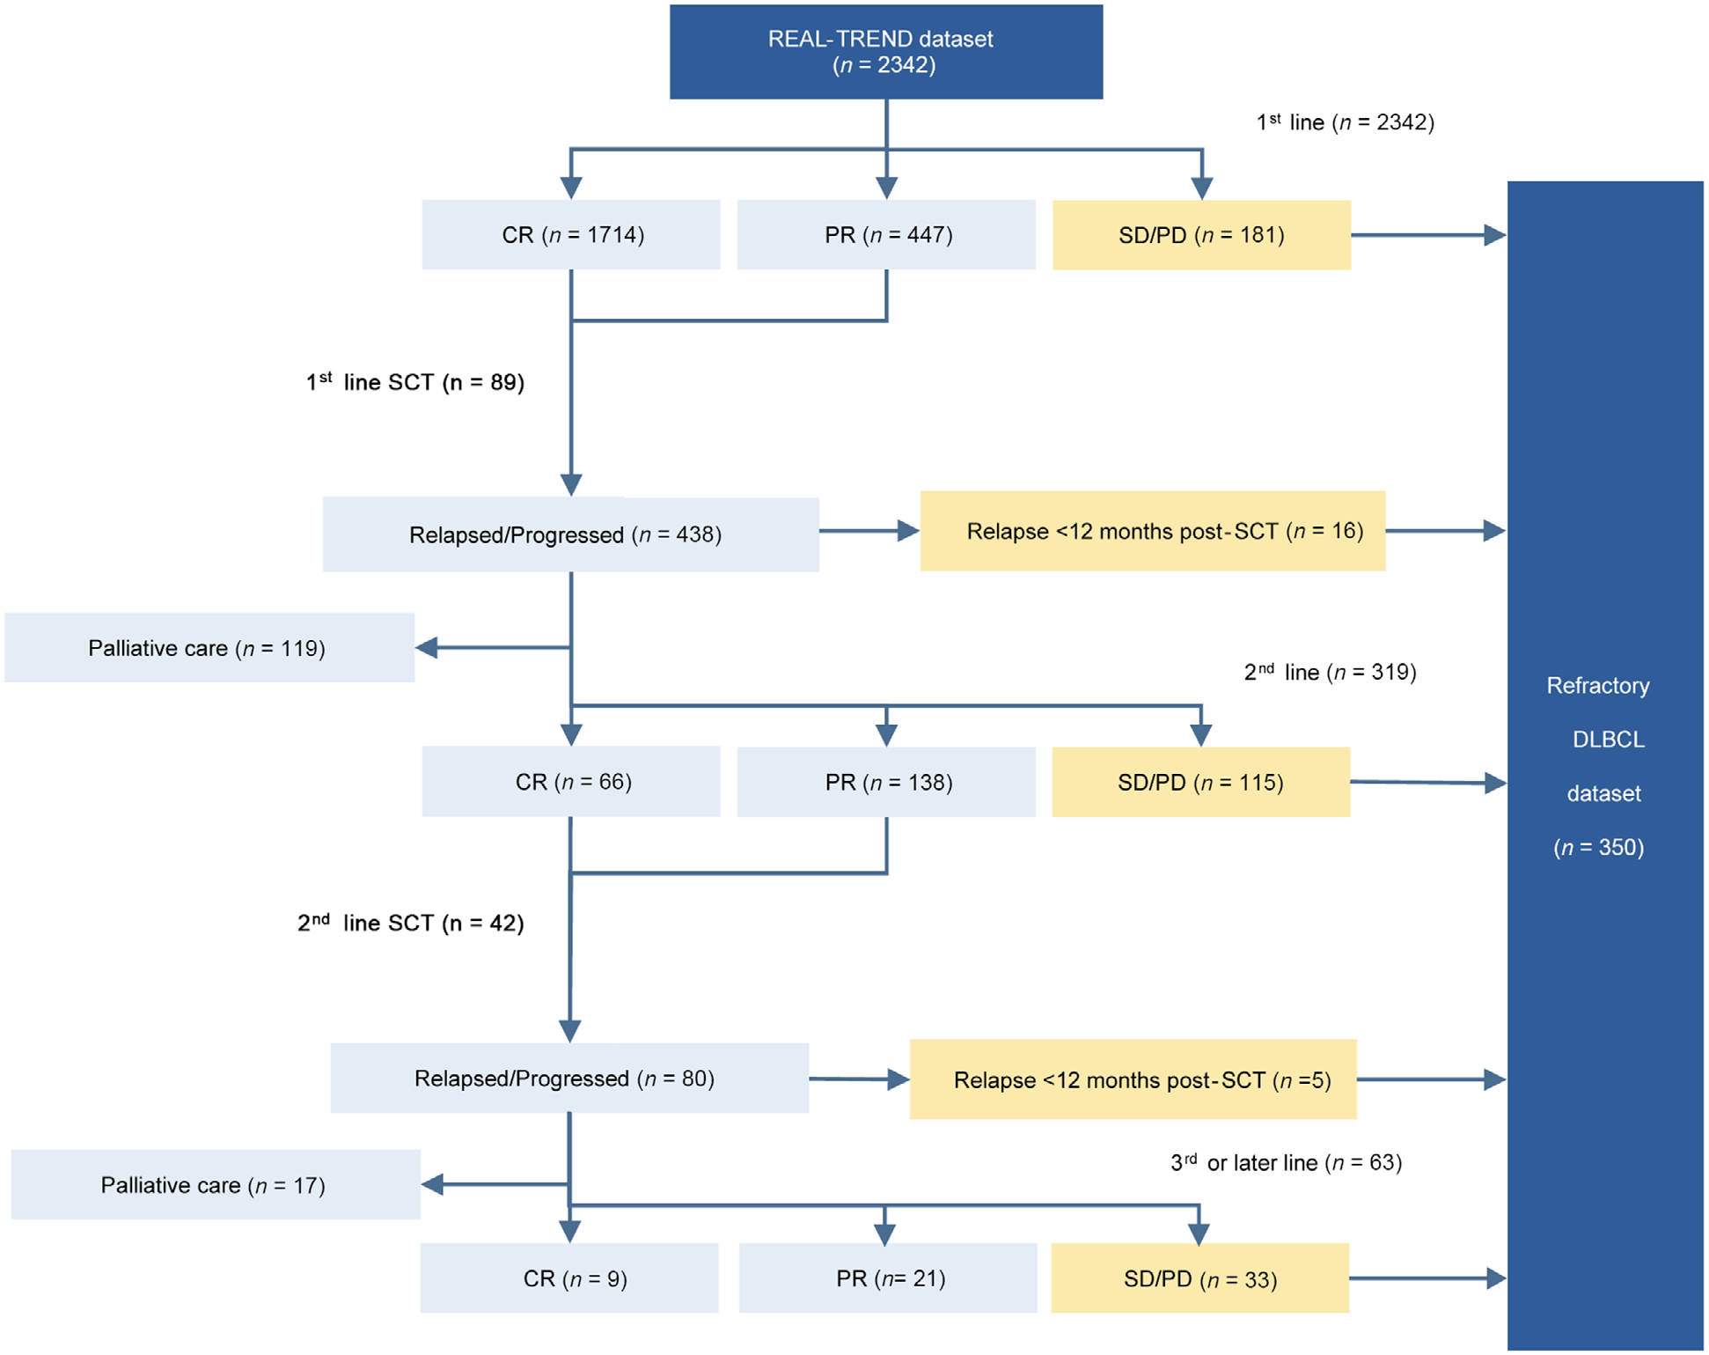
CR, complete response; PR, partial response; SD, stable disease; PD, progressive disease; DLBCL, diffuse large B-cell lymphoma.
The ZUMA-1 trial led to the regulatory approval axi-cel for 3L+ relapsed/refractory LBCL patients; however the trial itself was restricted to refractory patients only. Moreover, the definition of refractory allowed for second-line patients refractory to first-line to be included in the trial. Patients were identified as refractory if they met any of the following criteria:
- Second-line patients refractory to first-line therapy;
- Third-line or higher patients refractory to prior line (and relapsed to first-line);
- Relapsed within 12 months of ASCT.
The algorithm used in REAL-TREND (above) aligns perfectly with this definition. Furthermore, the selection algorithm for SCHOLAR-1 (Figure S2) matches perfectly with REAL-TREND as well.
Figure S2: Flow diagram of SCHOLAR-1 enrollment³
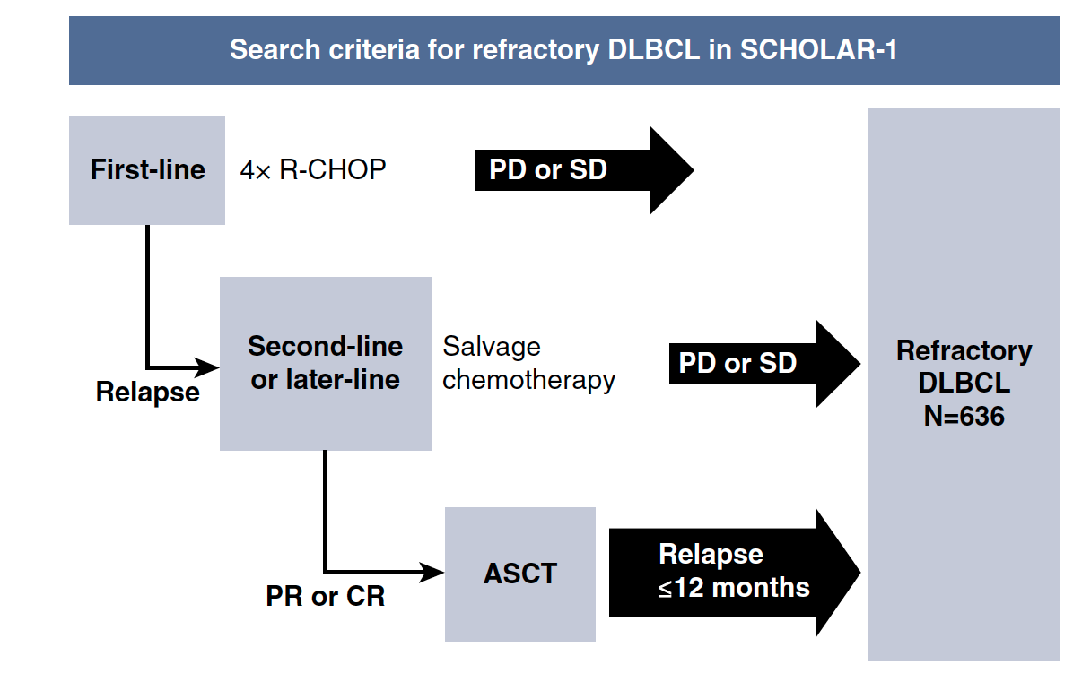
ASCT, autologous stem-cell transplant; CR, complete response; DLBCL, diffuse large B-cell lymphoma; PD, progressive disease;. PR, partial response; R-CHOP, rituximab, cyclophosphamide, doxorubicin, vincristine, and prednisone; SD, stable disease.
A key feature of patient selection in REAL-TREND (and SCHOLAR-1) was that they were selected at their first eligible line (i.e., their index line was the first eligible line). This meant that patients who were refractory to first-line were all included as second line patients (Figure S3A). As a results, all patients who were at third-line or higher were necessarily not primary refractory patients (they were relapsed at first-line). This is the difference that led to the recategorization of primary refractory for ZUMA-1 when it was compared to SCHOLAR-1. In ZUMA-1, primary refractory patients could be included at ≥2nd line (Figure S3B). For this reason, primary-refractory was re-derived for ZUMA-1 when compared to SCHOLAR-1 to include patients at any line who were refractory to first-line. Importantly, the same re-derivation was used in the ZUMA-1 vs SCHOLAR-1 analyses. More specifically, the reported number of primary refractory patients in the ZUMA-1 primary publication was 3, but when considered as a non-mutually exclusive category, there were 28 primary refractory patients (Error! Reference source not found.). Note that in REAL-TREND, patients who were primary refractory may have become refractory to a subsequent line or to SCT, but there is no information regarding at what frequency they did so and none of them were initiated at a later line.
Figure S3: Primary refractory patients and eligible lines of therapy between studies
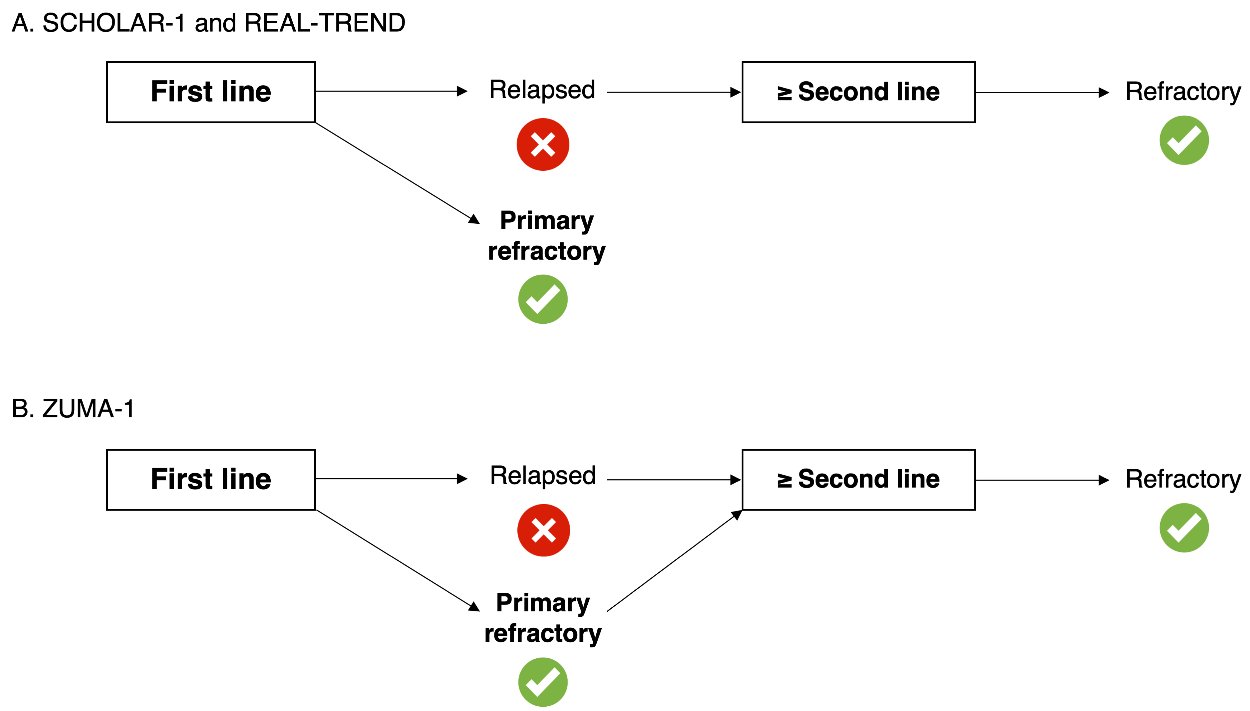
Green ticks indicate lines after which patients are eligible for inclusion. The eligibility criteria did not differ between the studies, but ≥2nd line patients in SCHOLAR-1 and REAL-TREND had to be relapsed to first line, whereas ≥2nd line patients in ZUMA-1 could be relapsed or refractory to 1st line.

As patients who were refractory to first-line were automatically included as second-line patients in REAL-TREND, the proportion of second-line patients was much higher in REAL-TREND compared to ZUMA-1. Few patients in ZUMA-1 (3/111) were second-line, whereas 181 out of 350 patients in REAL-TREND were second-line (Table S1). This issue was also present for the ZUMA-1 versus SCHOLAR-1 comparison, but to a lesser degree. When primary refractory was redefined as refractory to first-line, the proportions aligned better. Another key difference was the presence of ECOG 2-4 patients in REAL-TREND. This was also present in the SCHOLAR-1 vs ZUMA-1 comparison, but again to a lesser degree than in the REAL-TREND to ZUMA-1 comparison.
Table S1: Key differences in the ZUMA-1 and REAL-TREND populations and how these
compare to SCHOLAR-1
Study | 2nd line patients refractory to first line | Primary refractory patients | ECOG ≥2 patients
ZUMA-1 | 2% | 25% | 0%
REAL-TREND | 52% | 52% | 30%
SCHOLAR-1 | 28% | 28% | 14%

Comparison to SCHOLAR-1

As REAL-TREND sought to follow in the footsteps of SCHOLAR-1, there are some ties between the three studies (ZUMA-1, SCHOLAR-1 and REAL-TREND) that are helpful to understand. The SCHOLAR-1 cohort (N = 636) was developed to act as an historical SoC arm for comparison with ZUMA-1,³ and this dataset consisted of individual patient-level data among refractory LBCL patients from 4 cohorts located in the United States, Canada, and France:
- MD Anderson Cancer Center (MDACC); United States
- University of Iowa/Mayo Clinic (IA/MC) SPORE; United Sates
- Canadian Cancer Trials Group (CCTG) LY.12 Phase 3 randomized study; Canada
- Lymphoma Academic Research Organization (LYSARC) CORAL randomized study; France
The analysis comparing ZUMA-1 to SCHOLAR-1 consisted of propensity score analyses adjusting for the following covariates:
- Age
- Sex
- Number of prior lines of therapy (≤2 vs >2)
- Disease type
- Relapse within 12 months of ASCT
- Primary refractory (refractory to first-line, irrespective of whether the patient was 2nd line or ≥3rd line)
- Whether or not a patient was refractory to ≥2 consecutive lines of chemotherapy
As the SCHOLAR-1 dataset was comprised of r/r LBCL patients eligible for ZUMA-1 who had received various types of non-CAR T-cell salvage chemotherapy, propensity score matching was used to create a common support dataset for the comparison of ZUMA-1 with SCHOLAR-1. This common support dataset consisted of patients who met the eligibility criteria for both studies.
The key differences in the variable selection between the REAL-TREND comparison and the SCHOLAR-1 comparison were the more extensive refractory definitions in SCHOLAR-1 and the inclusion of IPI in REAL-TREND. IPI is very much a prognostic factor, designed to include multiple components of the disease, so adjusting for it can be seen as a strength.

Weight Derivation
The planned model included all three refractory categories; however, this model did not converge and led to a very highly weighted patient (Figure S4). Following the failure to fit the model with all three categories, each combination of two categories (e.g., primary refractory and refractory to SCT, but not refractory to last line) were modeled. None of these models converged, so ultimately only one category was included. Note that this applied to both mITT and ITT analyses.
All three models – one for each category of refractory category – were fit. We selected the model aligning on refractory to second-line or higher as the primary analysis and provided results to the alternative models in the sensitivity analysis section. The selection of the model aligning on refractory to second-line or higher as the primary analysis by process of elimination. Refractory to SCT represented the smallest group, likely leading to the least reduction in potential bias. Primary refractory captured information on both refractory status and line of therapy for REAL-TREND but not for ZUMA-1, therefore refractory to second-line or higher was the best variable on which to align. Again, all three approaches were conducted.
Figure S4: Distribution of weights with all available variables for the mITT model
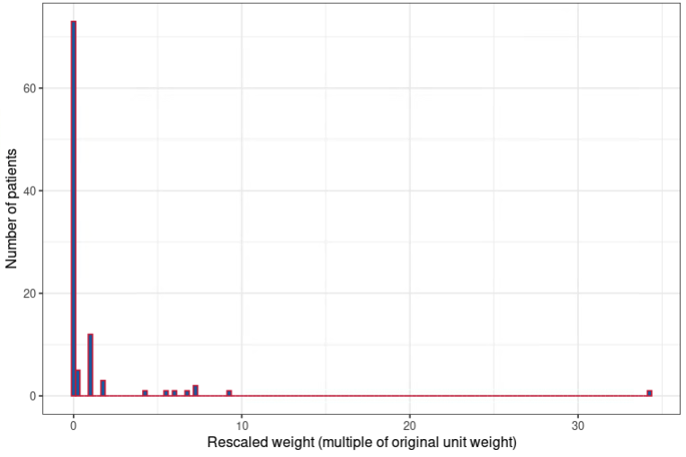

The ESS was reduced to 31.1 in the mITT and 50.1 in the ITT dataset. The remaining refractory variables were more misaligned after the alignment on refractory to second-line or higher, with refractory to SCT being the largest discrepancy. The weight distribution figures for the primary analyses are presented in Figure S5.
Figure S5: Distribution of weights for the primary analysis
