Supplementary Methods and Results: GHESI Validation

Unless the variables being tested were unavailable, we used the Census granular data to assess the construct and criterion validity of the GHESI.

Construct validation
To assess whether the GHESI accurately measures the intended concept, it was correlated against a common attribute of poverty defined as income below a locally set threshold (50%), relative to median household income by household sizes.^{40,41} Against a uniform distribution of households in the territory across the GHESI’s ten deciles, the proportion of households with household income below the set threshold (S Figure 2) rises from 0% in D1 (the most well-off decile) to 8·0% in D4, 25.1% in D7 and 60·0% in D10 (the least well-off decile), which is a statistically significant (p-value<0·0001) trend under the Cochran-Armitage test. In summary, 57·9% of these below-threshold-income households are concentrated in D8–D10.
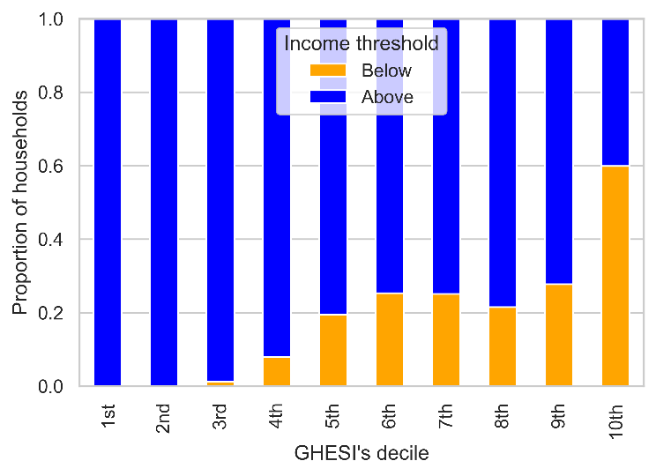
In addition to the above household-based evaluation, we also correlated, on a small area basis, the proportion of households with below-threshold income against the mean decile value among 209 small TPU groups. S Figure 3 shows a significant negative correlation between the two variables with the Pearson correlation coefficient at +0·73 (p-value<0·0001).

S Figure 2. Proportion of households with below-threshold income across the territory-wide GHESI’s 10 decile groups
The 1st decile represents the top 10% most well-off and the 10th decile represents the bottom 10%.
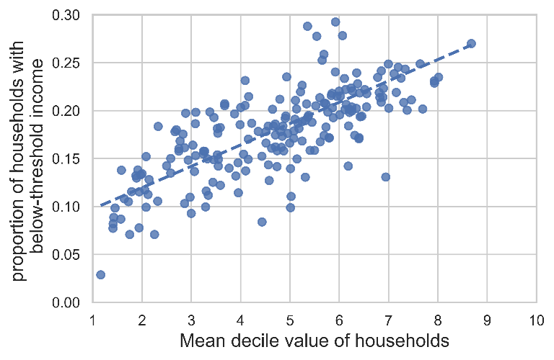
S Figure 3. Mean GHESI decile value of households versus proportion of households with below-threshold income among 209 TPU groups
The 1st decile represents the top 10% most well-off and the 10th decile represents the bottom 10%.

Criterion validation

To assess whether the GHESI accurately measures the intended concrete outcome, we identified the external criterion by referring to the Hong Kong Commission on Poverty. The Commission has designated subdivided units, single-parent households and elderly households as target groups of poverty alleviation.⁴² The Cochran-Armitage test also found a statistically significant linear trend (p-value<0·0001) in the proportion of these three disadvantaged groups across the ten decile groups, with subdivided unit households accounting for 0·0%/1·2%/5·2%/12·6% (S Figure 4), single-parent households for 1·0%/1·5%/2·1%/8·7% (S Figure 5), and elderly households for 9·2%/14·7%/18·2%/10·9% (S Figure 6) in D1/D4/D7/D10, respectively.

The three disadvantaged groups are defined as follows:

Subdivided unit households: Subdivided units (SDUs) are created by dividing a unit into two or more “internally connected” and “externally accessible” units, typically for rental purposes.³⁷ Non-structural partition walls in the original units may be removed while new ones are erected to form the SDUs.

Single-parent households: Households with at least one parent who is never married, widowed, divorced or separated, and with child(ren) aged under 18 residing in the same household (excluding foreign domestic helpers).
Elderly households: Households with all members aged 65+ (irrespective of household size and excluding foreign domestic helpers).

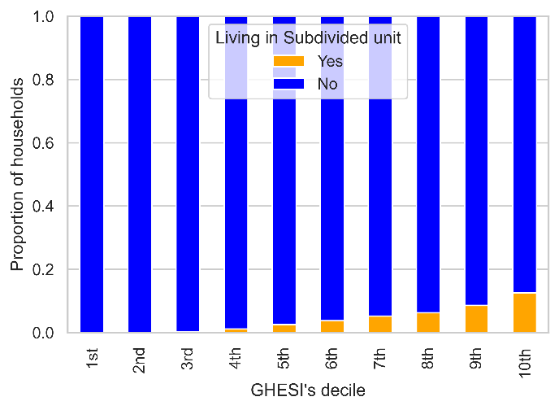  S Figure 4. Proportion of households living in subdivided units across the territory-wide GHESI’s 10 decile groups  The 1st decile represents the top 10% most well-off and the 10th decile represents the bottom 10%. |  | 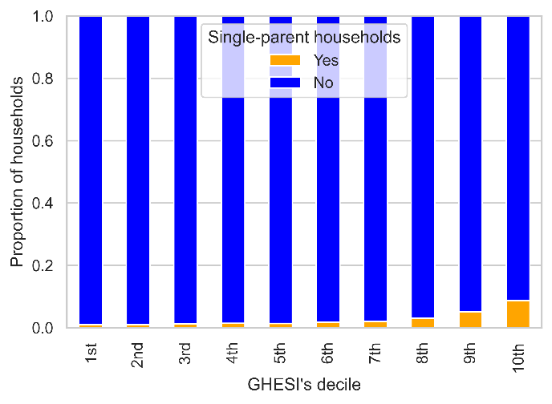  S Figure 5. Proportion of single-parent households across the territory-wide GHESI’s 10 decile groups  The 1st decile represents the top 10% most well-off and the 10th decile represents the bottom 10%.

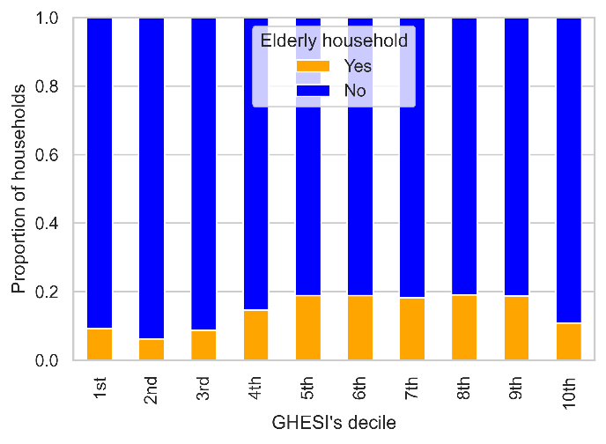

S Figure 6. Proportion of elderly households across the territory-wide GHESI’s 10 decile groups
The 1st decile represents the top 10% most well-off and the 10th decile represents the bottom 10%.

Furthermore, using data obtained from the Hong Kong Hospital Authority, we also correlated, on a TPU basis, the mean GHESI’s decile value of households against service utilisation rate of public General Outpatient Clinics (GOPC), which provide highly government subsidised and affordable community-based primary healthcare services, targeted mainly at low-income persons.⁴³ Among 209 small TPU groups on the scatter plot (S Figure 7), the Pearson correlation coefficient is +0·57 (p-value<0·0001).
For criterion validity, we conducted a posteriori evaluation on the association of the GHESI with the three excluded social-related variables (education, occupation and employment). On a TPU basis, the mean GHESI decile value of households was respectively correlated against the proportion of population aged 15 or above with a degree or above, the proportion of employed persons, and the proportion of professionals (as defined according to the International Standard Classification of Occupations) in working population. Among the 209 small TPU groups, the higher the proportion of these three population subgroups, the higher the household economic status (as indicated by a lower mean decile value) is observed. As depicted in the scatter plots (S Figures 8–10) a strong negative linear relationship was found with the Pearson correlation coefficient at -0·94, -0·81 and -0·83, respectively (all with p-value<0·0001).
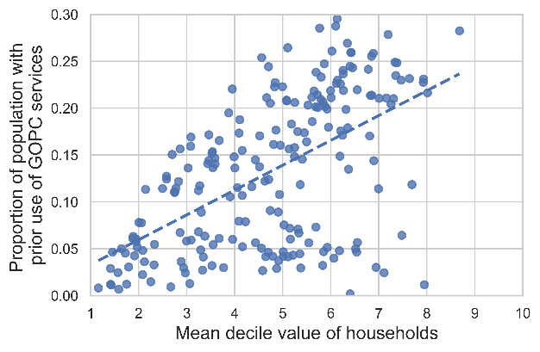  S Figure 7. Proportion of population with prior use of GOPC services against mean GHESI decile value of households among 209 small TPU groups  The 1st decile represents the top 10% most well-off and the 10th decile represents the bottom 10%. |  | 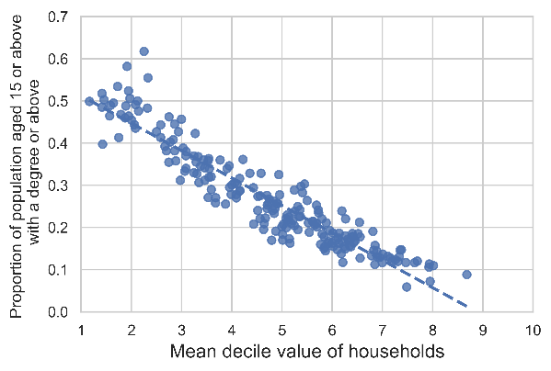  S Figure 8. Proportion of population aged 15 or above with a degree or above against mean GHESI decile value of households among 209 small TPU groups  The 1st decile represents the top 10% most well-off and the 10th decile represents the bottom 10%.
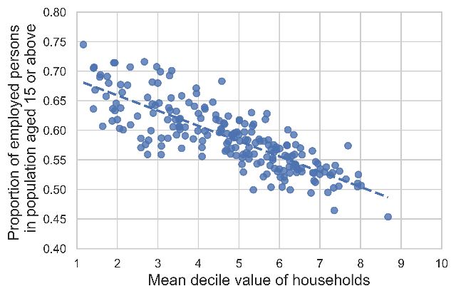  S Figure 9. Proportion of employed persons against mean GHESI decile value of households among 209 small TPU groups  The 1st decile represents the top 10% most well-off and the 10th decile represents the bottom 10%. |  |  | 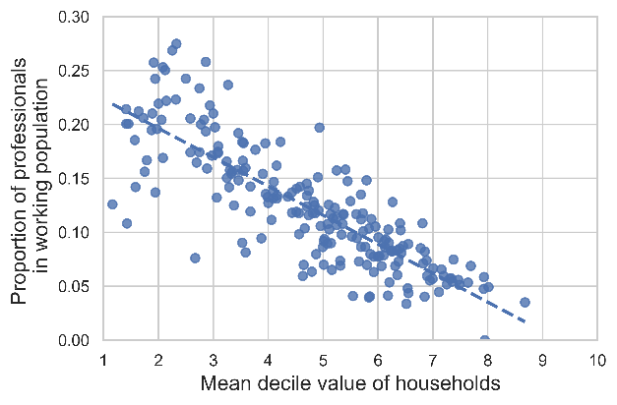  S Figure 10. Proportion of professionals in working population against mean GHESI decile value of households among 209 small TPU groups  The 1st decile represents the top 10% most well-off and the 10th decile represents the bottom 10%.

