Supplementary Results: Four moments of the frequency distribution of households by GHESI’s decile groups among SSUGs

The 2,252 SSUGs in this study were classified into seven coloured Categories on the ternary plot according to the rules outlined in Figure 1.

S Table 3. Number of SSUGs by Category
Category | No. of SSUGs
A | 411 | 18·3%
B | 762 | 33·8%
C | 68 | 3·0%
D | 566 | 25·1%
E | 6 | 0·3%
F | 326 | 14·5%
G | 113 | 5·0%

S Figure 1 below shows the boxplots of the mean, SD, skewness and kurtosis of the frequency distribution of households by GHESI’s decile groups among SSUGs in each Category. The green triangle represents the mean of each statistical measure among SSUGs in each Category. Circles represent outliers (outside 1·5 times the interquartile range above the upper quartile and below the lower quartile).

The mean decile value of SSUGs in the seven Categories follows roughly the order of A<B<C≈D≈E<F<G. Category A generally contains most well-off SSUGs whereas Category G contains the least well-off ones as indicated by mean decile value. Although C≈D≈E in terms of mean decile value, their SSUGs have significantly different SDs with C<D<E. For skewness of frequency distributions, those of SSUGs in Categories A and B are in general positively skewed, but mildly skewed for Categories C, D and E and negatively skewed for Categories F and G. The kurtosis is the lowest in Category E and highest in Categories A and G. None of the Categories can be simply described by one moment or combination of any of these four moments as outlined, suggesting the necessity to study the whole relative distribution of households across ten deciles at individual small areas (i.e. SSUGs).

S Figure 1. Distribution of four moments related to the frequency distribution of households by GHESI’s decile groups among SSUGs by Category on the ternary plot
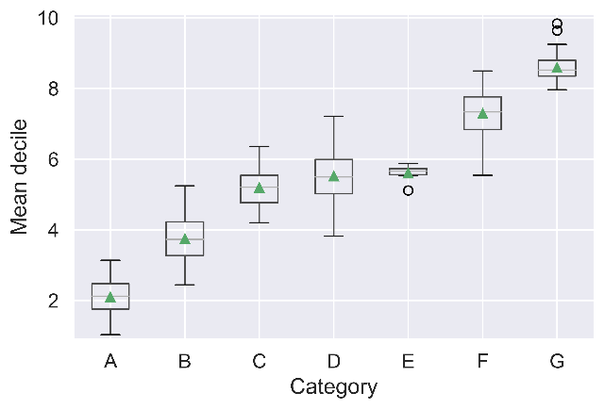 | 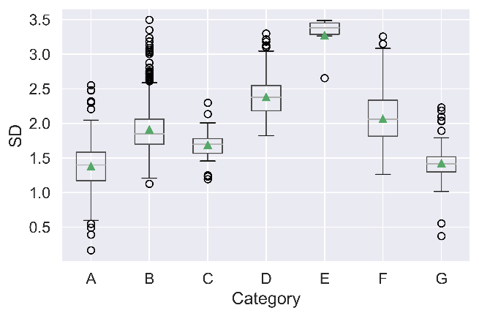
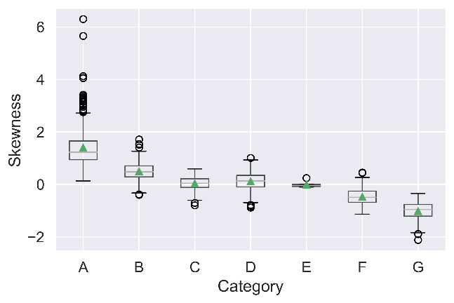 | 