Supplementary Material:
Mental well-being improvements in older adults attending ceremonial psychedelic group sessions: A prospective cohort study

 | YA unmatched  (N=430) | YA matched  (N=62) | OA  (N=62)
Age in years
Mean (SD) | 41.4 (9.8) | 46.5 (10.0) | 65.1 (4.02)
Median [Min, Max] | 41.0 [21.0, 59.0] | 49.0 [24.0, 59.0] | 64.0 [60.0, 75.0]
Gender
Male | 239 (55.6%) | 31 (50.0%) | 31 (50.0%)
Female | 188 (43.7%) | 31 (50.0%) | 31 (50.0%)
Other | 3 (07%) | - | -
Education/degrees
None | 3 (0.7%) | 0 (0%) | 1 (1.6%)
High school | 20 (4.7%) | 2 (3.2%) | 3 (4.8%)
Technical degree | 32 (7.4%) | 5 (8.1%) | 4 (6.5%)
College diploma | 141 (32.8%) | 18 (29.0%) | 11 (17.7%)
Master | 152 (35.3%) | 30 (48.4%) | 19 (30.6%)
PhD/MD/Law degree | 82 (19.1%) | 7 (11.3%) | 24 (38.7%)
Psychiatric diagnoses
Yes | 146 (34.0%) | 15 (24.2%) | 16 (25.8%)
No | 284 (66.0%) | 47 (75.8%) | 46 (74.2%)
Psychedelic use #
Never | 169 (39.3%) | 28 (45.2%) | 35 (56.5%)
1-5 times | 143 (33.3%) | 10 (16.1%) | 15 (24.2%)
> 5 times | 118 (27.4%) | 24 (38.7%) | 12 (29.3%)
WEMWBS baseline
Mean (SD) | 45.1 (9.03) | 48.8 (9.79) | 48.5 (7.79)
Median [Min, Max] | 46.0 [20.0, 70.0] | 50.5 [20.0, 70.0] | 50.0 [31.0, 63.0]
Psychedelic dose
Mean (SD) | 2.33 (0.632) | 2.13 (0.586) | 2.10 (0.646)
Median [Min, Max] | 2.00 [1.00, 3.00] | 2.00 [1.00, 3.00] | 2.00 [1.00, 3.00]
Supplementary Table 1. Demographic characteristics of the excluded YA sample. OA=older adults; SD: Standard Deviation; WEMWBS: Warwick-Edinburgh Mental Wellbeing Scale; YA: younger adults

Term | β | SE | t-value | p
Intercept | 3.67 | 1.47 | 2.50 | .01
Age 60+ | 1.34 | 17.49 | 0.08 | .94
2-week endpoint | -3.11 | 14.30 | -0.22 | .83
4-week endpoint | 16.27 | 14.43 | 1.13 | .26
EDI | 0.00 | 0.01 | -0.58 | .56
EBI | -0.02 | 0.01 | -1.43 | .16
CEQ | -0.06 | 0.07 | -0.86 | .39
COMS | 0.14 | 0.15 | 0.93 | .35
COMS_{PR} | 0.16 | 0.31 | 0.53 | .60
PIS | 0.02 | 0.01 | 1.95 | .05
Age 60+:2-week endpoint | 2.46 | 19.15 | 0.13 | .90
Age 60+:4-week endpoint | -22.89 | 17.66 | -1.30 | .20
EDI:Age 60+ | 0.01 | 0.01 | 0.90 | .37
EDI:2-week endpoint | 0.00 | 0.01 | -0.22 | .82
EDI:4-week endpoint | 0.00 | 0.01 | 0.01 | .99
EBI:Age 60+ | 0.02 | 0.01 | 1.66 | .10
EBI:2-week endpoint | 0.03 | 0.01 | 2.63 | .01
EBI:4-week endpoint | 0.02 | 0.01 | 2.13 | .04
CEQ:Age 60+ | 0.02 | 0.10 | 0.25 | .81
CEQ:2-week endpoint | -0.12 | 0.07 | -1.57 | .12
CEQ:4-week endpoint | -0.05 | 0.08 | -0.62 | .54
COMS:Age 60+ | -0.11 | 0.22 | -0.49 | .62
COMS:2-week endpoint | -0.36 | 0.16 | -2.28 | .02
COMS:4-week endpoint | -0.18 | 0.16 | -1.12 | .26
COMS_{PR}:Age 60+ | 0.05 | 0.37 | 0.13 | .90
COMS_{PR}:2-week endpoint | 0.27 | 0.30 | 0.89 | .38
COMS_{PR}:4-week endpoint | -0.32 | 0.31 | -1.06 | .29
PIS:Age 60+ | -0.03 | 0.02 | -2.01 | .05
PIS:2-week endpoint | 0.01 | 0.01 | 0.72 | .48
PIS:4-week endpoint | 0.01 | 0.01 | 1.30 | .20
EDI:Age 60+:2-week endpoint | 0.03 | 0.12 | 0.25 | .80
EDI:Age 60+:4-week endpoint | 0.02 | 0.11 | 0.217 | .83
EBI:Age 60+:2-week endpoint | -0.22 | 0.10 | -2.354 | .02
EBI:Age 60+:4-week endpoint | -0.21 | 0.09 | -2.416 | .02
CEQ:Age 60+:2-week endpoint | 0.08 | 0.11 | 0.788 | .43
CEQ:Age 60+:4-week endpoint | 0.09 | 0.10 | 0.855 | .39
COMS:Age 60+:2-week endpoint | 0.18 | 0.25 | 0.727 | .47
COMS:Age 60+:4-week endpoint | -0.06 | 0.24 | -0.24 | .81
COMS_{PR}:Age 60+:2-week endpoint | -0.02 | 0.38 | -0.04 | .97
COMS_{PR}:Age 60+:4-week endpoint | 0.68 | 0.38 | 1.793 | .08
PIS:Age 60+:2-week endpoint | 0.00 | 0.02 | -0.16 | .87
PIS:Age 60+:4-week endpoint | 0.00 | 0.02 | -0.234 | .82
Supplementary Table 2. Main effects, two-way and three-way interactions showing differential salutogenic mechanisms for older and younger adults. CEQ: Challenging Experience Questionnaire; COMS: Communitas Scale; EBI: Emotional Breakthrough Inventory; EDI: Ego-Dissolution Inventory; PR: Post-retreat; PIS: Psychological Insight Scale; SE: Standard Error.

Supplementary Figure 1 Comparison of wellbeing changes from before to after a psychedelic experience in OA vs YA

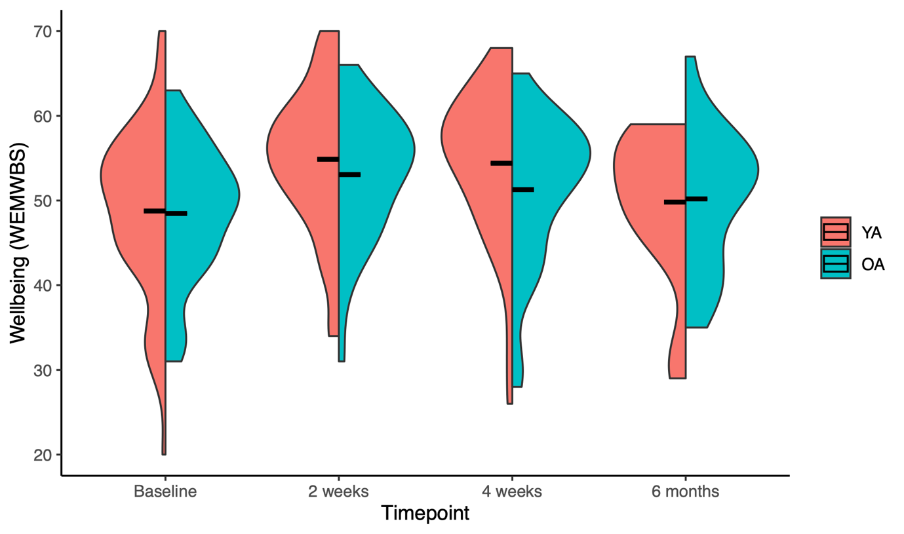
Figure S1. Mental well-being increases in OA and YA following a psychedelic group session. Violinplots showing the distribution of WEMWBS scores in OA and YA at each time point. Bars represent mean scores. OA: older adults; WEMWBS: Warwick-Edinburgh Mental Wellbeing Scale; YA: younger adults
**:p<.01, ***:p<.001

