Homocysteine thiolactone and other sulfur-containing amino acid metabolites are associated with fibrin clot properties and the risk of ischemic stroke
Marta Sikora ¹, Ewa Bretes ², Joanna Perła-Kaján ², Olga Utyro ², Kamila Borowczyk ³, Justyna Piechocka ³, Rafał Głowacki ³, Izabela Wojtasz ⁴, Radosław Kaźmierski ^{5,6} & Hieronim Jakubowski ^{2, 7,}*

Supplementary Information
Figure S1. Illustration of clotting and lysis variables. Variables examined in the present study, fibrin CLT and fibrin Abs_{max}, are highlighted in bold.
Figure S2. Stroke abrogates influence of urinary sulfur-containing amino acid metabolites on fibrin clot properties. Levels of uHcy (A-D), uCysGly (E-H), and uGSH (I, J) are plotted vs. fibrin CLT (A, C, E, G) and Abs_{max} (B, D, F, H) in healthy individuals (A, B, E, F, I) and ischemic stroke patients (C, D, G, H, J).
Figure S3. Relationships between age and urinary sulfur-containing amino acid metabolites. Levels of uHcy (A, B), uCys (C, D), uCysGly (E, F), uHTL (G, H), and uGSH (I, J) are plotted vs. age in healthy individuals (A, C, E, G, I) and ischemic stroke patients (B, D, F, H, J).
Figure S4. Relationships between age and plasma sulfur-containing amino acid metabolites. Levels of pHcy (A, B), pCys (C, D), pCysGly (E, F), and pGSH (G, H) are plotted vs. age in healthy individuals (A, C, E, G) and ischemic stroke patients (B, D, F, H).
Figure S5. Relationships between glomerular filtration rate (GFR) and urinary sulfur-containing amino acid metabolites. Levels of uHcy (A, B), uCys (C, D), uCysGly (E, F), uHTL (G, H), and uGSH (I, J) are plotted vs. GFR in healthy individuals (A, C, E, G, I) and ischemic stroke patients (B, D, F, H, J).
Table S1. Descriptive statistics of the variables analyzed in the present study.
Table S2. Pearson correlation coefficients for relationships between turbidimetric clotting and lysis variables in ischemic stroke patients and healthy individuals.
Table S3. P values for correlations between fibrin clot properties vs. plasma sulfur-containing amino acid metabolites and creatinine (pCreat) in ischemic stroke patients and healthy individuals.
Table S4. Contribution of urinary and plasma sulfur-containing amino acid metabolites to the risk of ischemic stroke.

Figure S1.

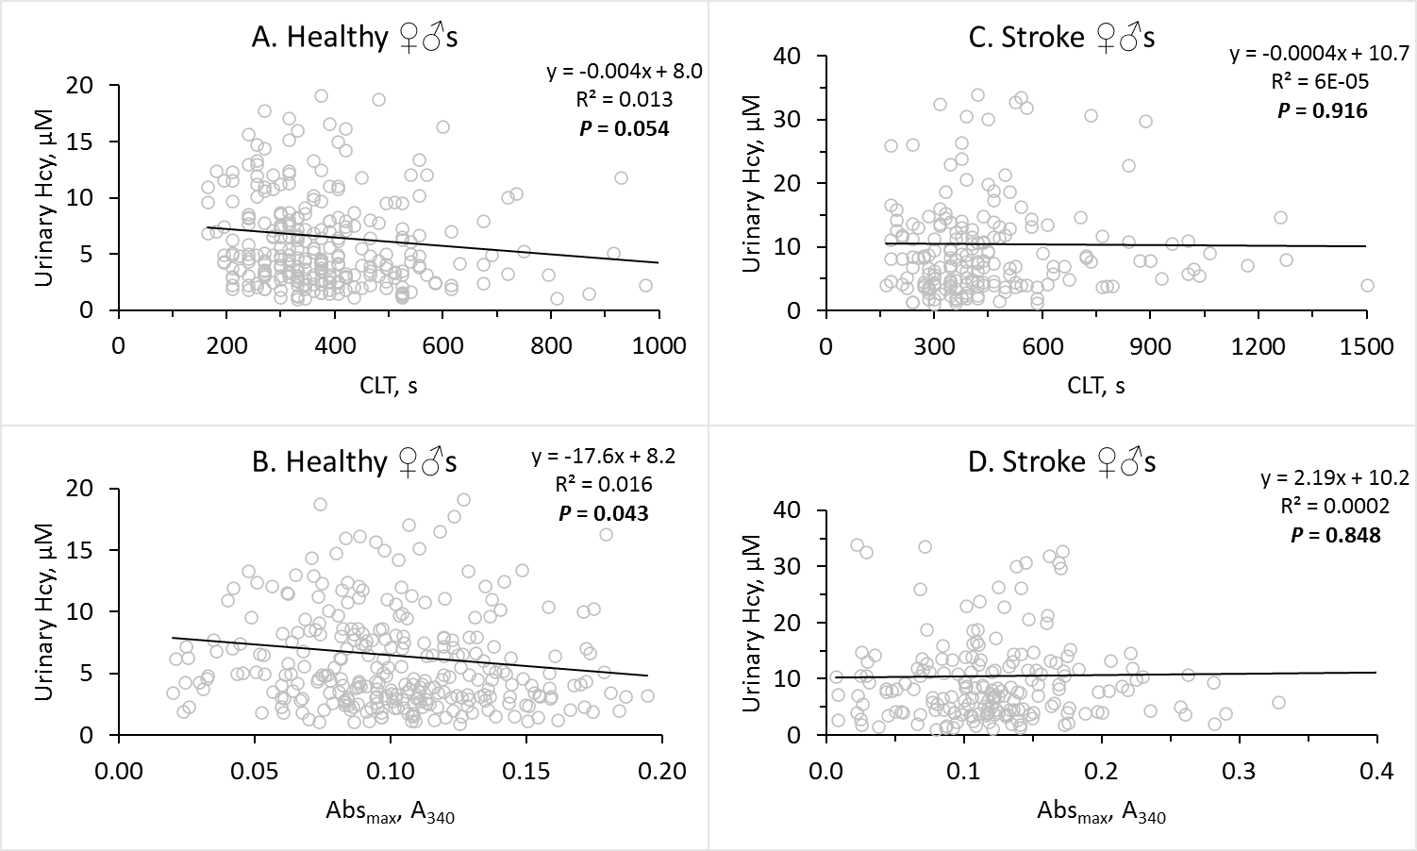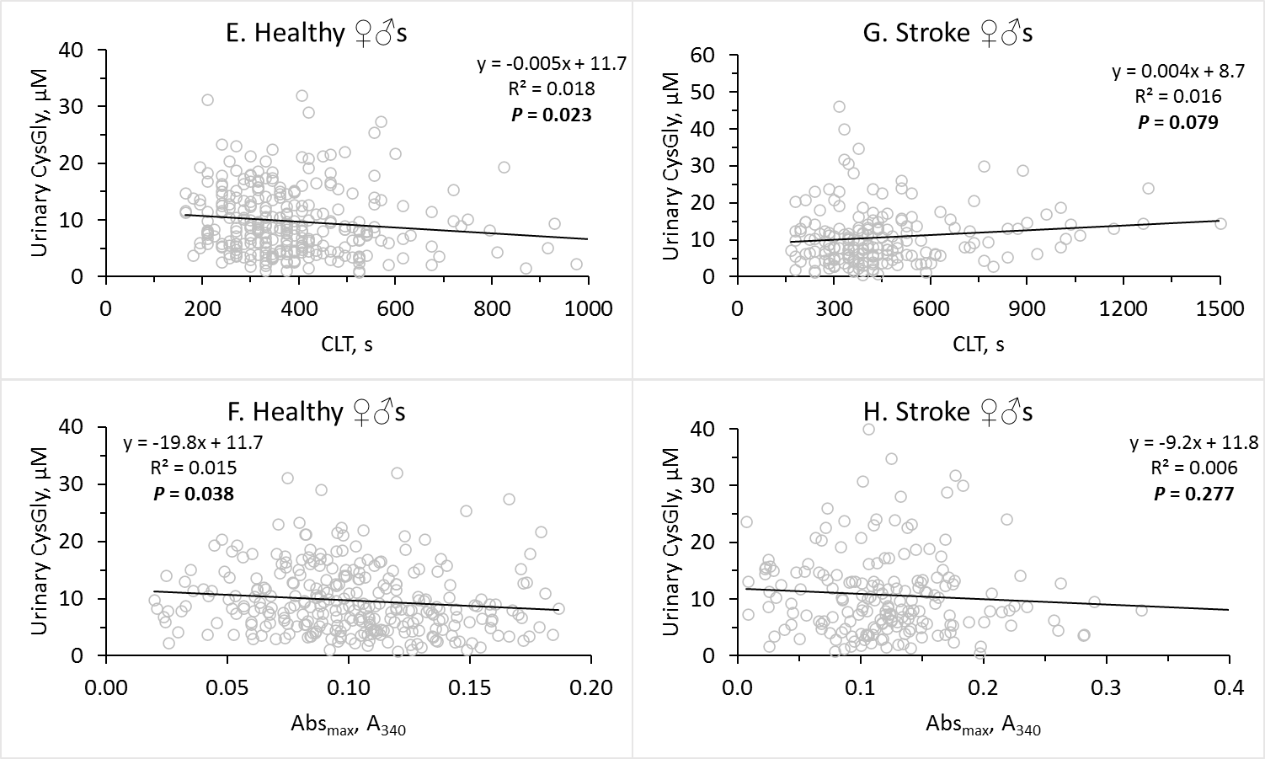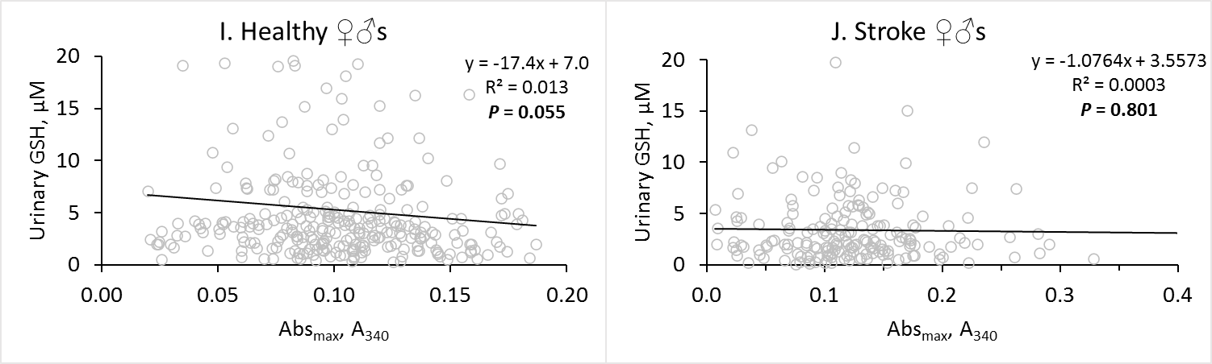
Figure S2
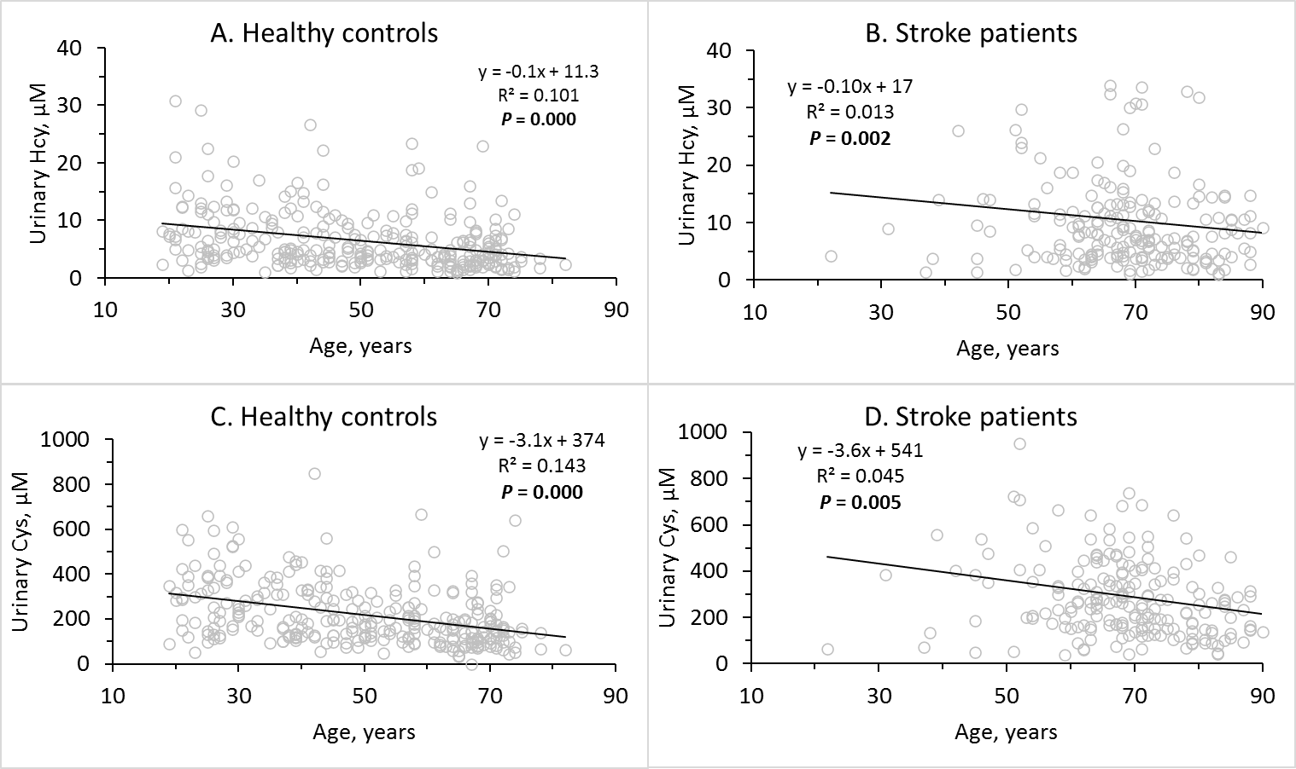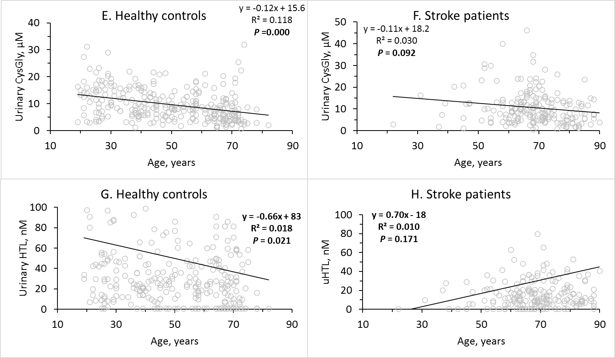
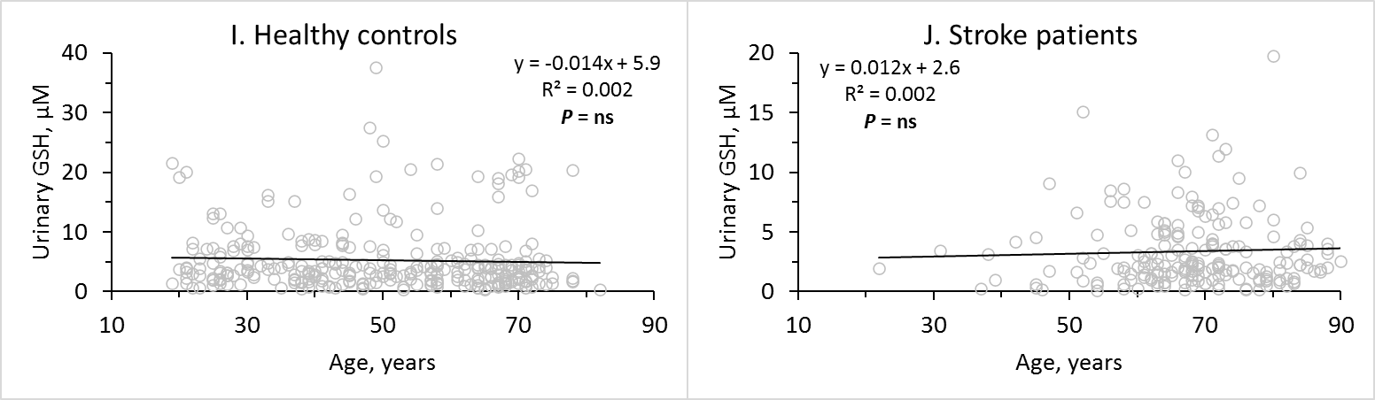
Figure S3

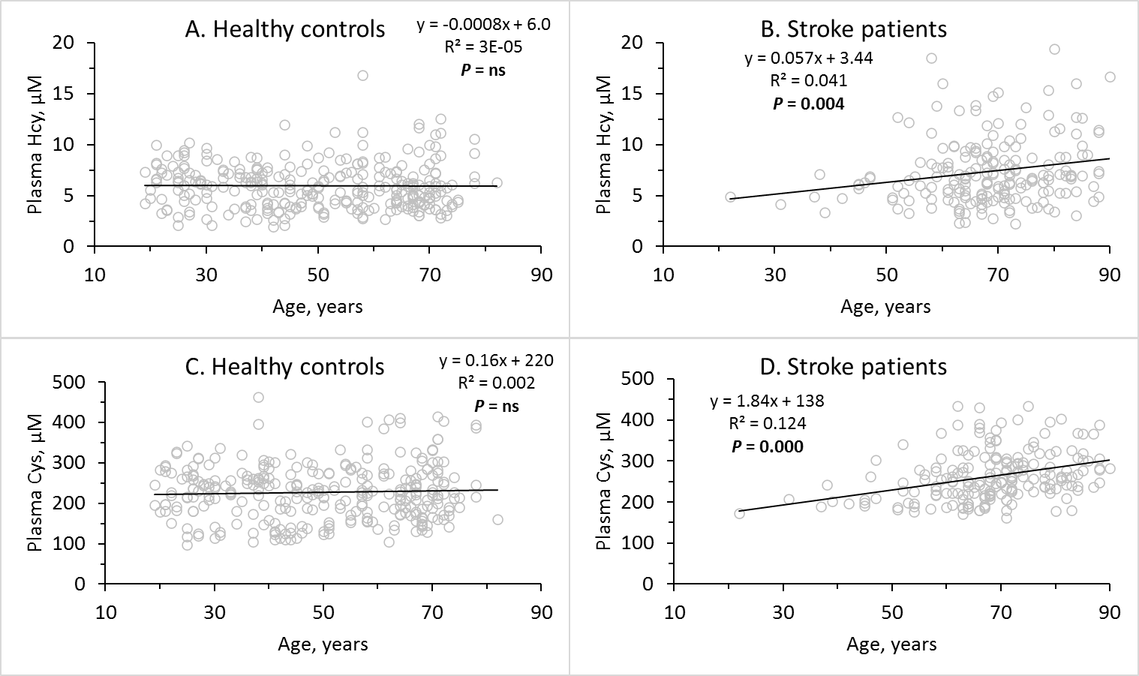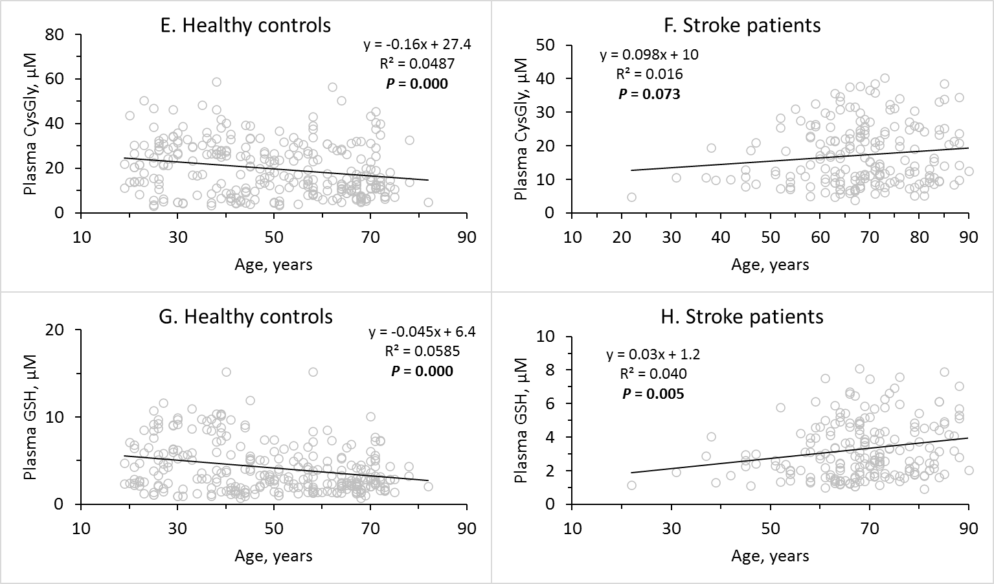
Figure S4

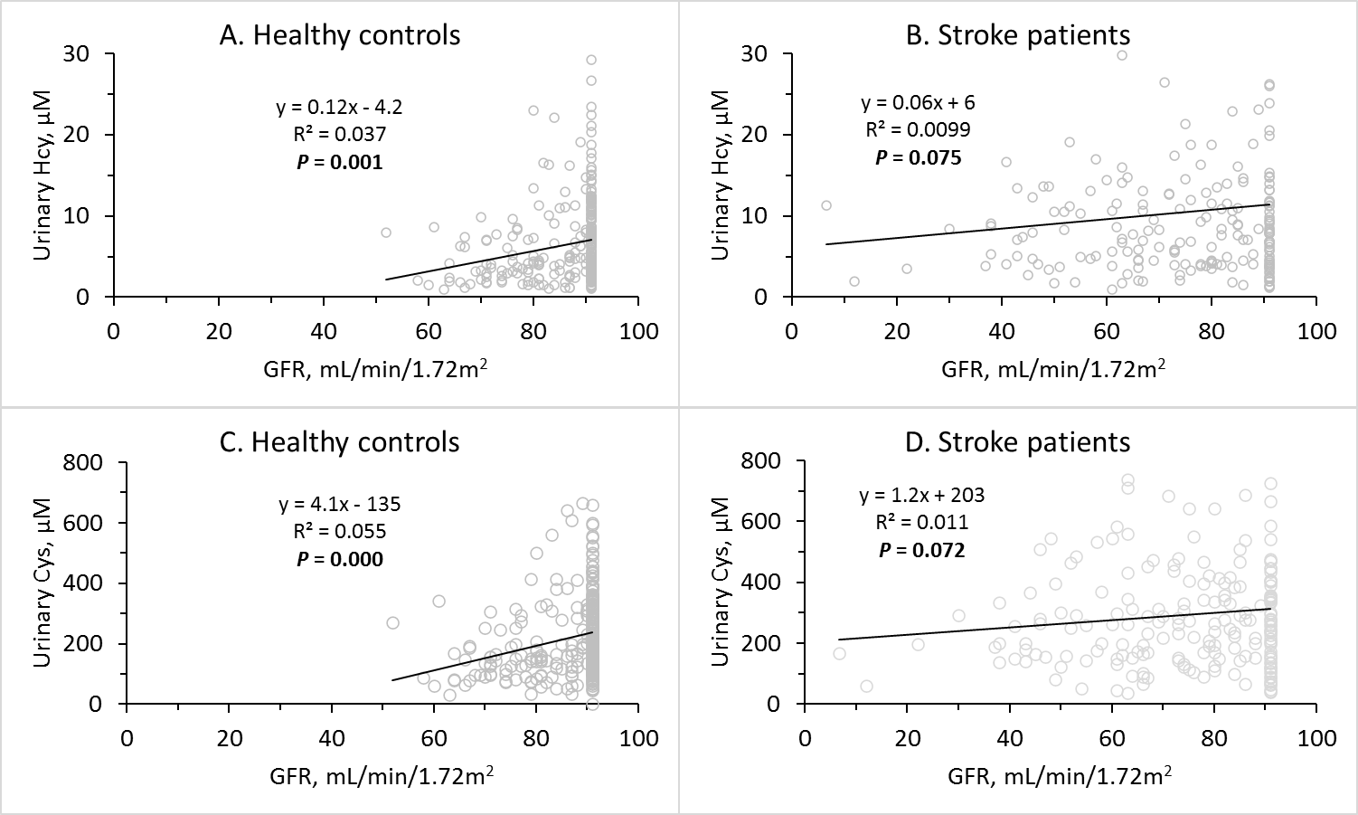
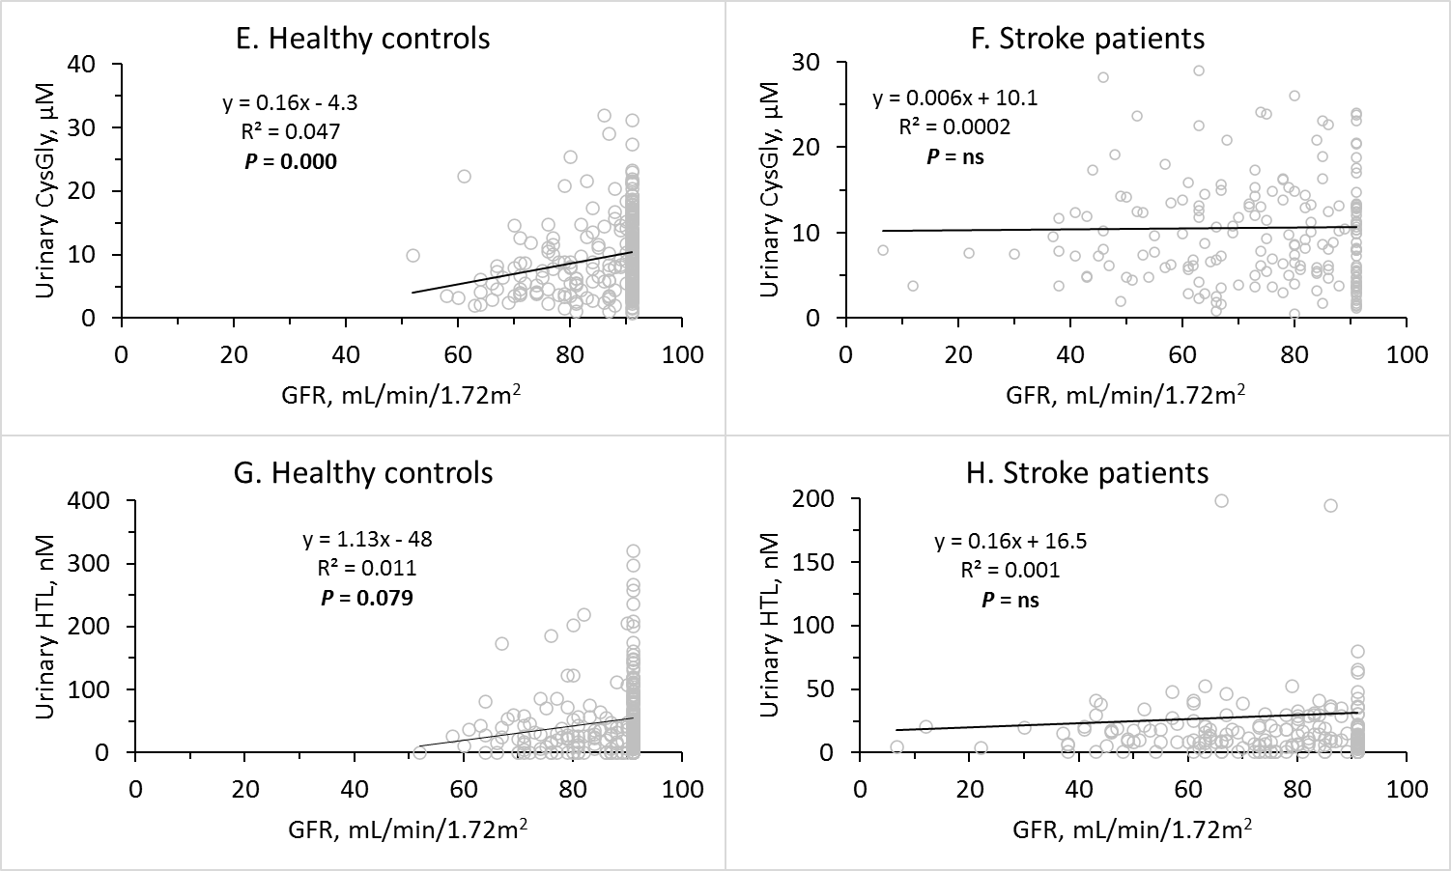
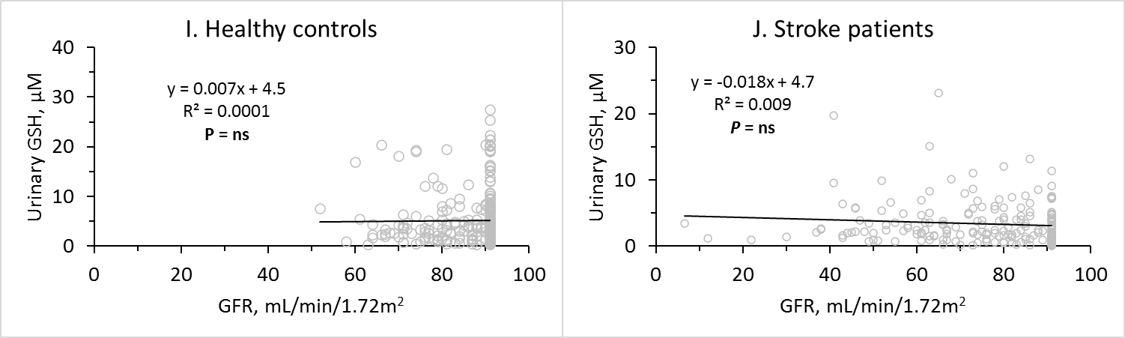Figure S5
Table S1. Characteristics of stroke patients and healthy controls*.
Variable | Stroke patients  (n = 200) | Healthy controls  (n = 300) | P value
Fibrin clot properties
Fibrin Abs_{max}, A₃₄₀ | 0.123±0.065 | 0.101±0.036 | 0.000
Fibrin CLT, s | 452±226 | 391±154 | 0.001
Urinary metabolites
uHcy, μM | 10.4±10.2 | 6.5±5.0 | 0.000
uCys, μM | 293±199 | 221±136 | 0.000
uCysGly, μM | 10.6±7.5 | 9.7±5.8 | 0.136
uGSH, μM | 3.4±3.3 | 5.3±5.4 | 0.000
uHTL, nM | 30±83 | 51±83 | 0.006
uCreatinine, mM | 11.4±7.2 | 13.1±8.6 | 0.021
Plasma metabolites
pCreatinine, μM | 86±34 | 70±13 | 0.000
pHcy, μM | 7.4±3.3 | 6.0±2.4 | 0.000
pCys, μM | 263±61 | 228±68 | 0.000
pCysGly, μM | 17.3±9.0 | 19.7±11.8 | 0.016
pGSH, μM | 3.3±1.8 | 4.2±3.1 | 0.000
pMet, μM | 41±18 | 42±19 | 0.429
Anti-N-Hcy, A₄₉₂ | 0.095±0.126 | 0.074±0.087 | 0.039
Plasma glucose, mM | 6.5±2.7 | 5.6±0.7 | 0.000
Total cholesterol, mM | 179±49 | 208±40 | 0.000
LDL cholesterol, mM | 104±42 | 119±37 | 0.000
HDL cholesterol, mM | 52±28 | 66±18 | 0.000
Triglycerides, mM | 132±68 | 114±79 | 0.006
Established risk factors
BMI, kg/m² | 26.3±4.7 | NA
GFR, mL/min/1.73 m² | 74.2±17.5 | 86.4±7.8 | 0.000
Earlier CVD, % | 23.3 | 2.3 | 0.000
Earlier MI #6, % | 8.7 | 0.7 | 0.000
Other heart disease, % | 22.5 | 4.3 | 0.000
Hypertension, % | 77.5 | 21.7 | 0.000
Diabetes, % | 24.0 | 3.7 | 0.000
Smoking, % | 47.5 | NA
Medications, % | 78.3 | 7.7 | 0.000
Age, years | 68±12 | 50±17 | 0.000
Female sex, % | 45.0 | 59.4 | 0.926
GFR, glomerular filtration rate; BMI, body mass index; CVD, cardiovascular disease; HDL, high-density lipoprotein; LDL, low-density lipoprotein; Abs_{max}, maximum absorbance at 335 nM; CLT, clot lysis time; Anti N-Hcy, anti-N-Hcy-protein autoantibodies; NA, not available. Urinary and plasma metabolites are shown by a letter ‘u’ or ‘p’, respectively, preceding the metabolite’s name. Hcy, homocysteine; HTL, Hcy-thiolactone; Cys, cysteine; CysGly, cysteinylglycine’ Met, methionine.

Table S2. Pearson correlation coefficients for relationships between turbidimetric clotting and lysis variables in stroke patients and healthy individuals. Nomenclature is after Carter et al., Arterioscler Thromb Vasc Biol 2007; 27:2783-2789. The clotting and lysis variables are illustrated in Figure S1.
* Terms Abs_{max} and CLT, referring to terms MaxAbs and Lysis50_{MA}, respectively, of Carter el al. ATVB 2007, have been use in the present study. P values for these correlations were <0.000 except where written otherwise.
 | Clotting/lysis correlation coefficients
Variable | MaxAbs, Abs_{max}* | Clot Rate | Lys50_{t0} | Lys50_{tlag} | Lysis50_{MA}, CLT* | Lysis Rate | Lysis Area  AUC
 | Stroke patients (n = 200)
Lag | -0.61 | -0.65 | 0.45 | -0.02  (P=0.801) | -0.01 (P=0.929) | 0.44 | 0.41
AbsMax,  Abs_{max}* |  | 0.89 | -0.10  (P=0.183) | 0.21  (P=0.003) | 0.29 | -0.77 | 0.88
Clot Rate |  |  | -0.45 | -0.16  (P=0.026) | 0.01  (P=0.837) | -0.72 | 0.61
Lys50_{t0} |  |  |  | 0.89 | 0.86 | -0.07  (P=0.204) | 0.65
Lys50_{tlag} |  |  |  |  | 0.75 | -0.05  (P=0.553) | 0.51
Lysis50_{MA}, CLT* |  |  |  |  |  | -0.05  (P=0.527) | 0.58
Lysis Rate |  |  |  |  |  |  | -0.54
 | Healthy controls (n = 291)
Lag | -0.60 | -0.51 | 0.17  (P=0.003) | -0.29 | -0.14 (P=0.013) | 0.44 | 0.42
AbsMax,  Abs_{max}* |  | 0.88 | -0.32 | 0.60 | 0.55 | -0.70 | 0.88
Clot Rate |  |  | 0.00  (P=0.982) | 0.25 | 0.35 | -0.70 | 0.64
Lys50_{t0} |  |  |  | 0.89 | 0.86 | -0.07  (P=0.204) | 0.65
Lys50_{tlag} |  |  |  |  | 0.91 | -0.27 | 0.82
Lysis50_{MA}, CLT* |  |  |  |  |  | -0.28 | 0.79
Lysis Rate |  |  |  |  |  |  | -0.48

Table S3. P values for Pearsons’s correlations of fibrin clot properties vs. plasma sulfur-containing amino acid metabolites and creatinine in stroke patients and healthy individuals.
Variable | Fibrin clot properties |  | Sulfur-containing amino acid metabolites |  |  |  |  | pCreatinine
Variable | CLT | Abs_{max} | pHcy | pCys | pCysGly | pGSH | pMet | pCreatinine
Healthy individuals, P values
CLT |  | 0.000(+) | ns | ns | ns | ns | ns | ns
Abs_{max} | 0.000(+) |  | ns | ns | ns | ns | ns | ns
pHcy | ns | ns |  | 0.000(+) | 0.000(+) | 0.000(+) | ns | 0.000(+)
pCys | ns | ns |  |  | 0.000(+) | 0.000(+) | ns | ns
pCysGly | ns | ns |  |  |  | 0.000(+) | ns | 0.008(+)
pGSH | ns | ns |  |  |  |  | ns | ns
pMet | ns | ns |  |  |  |  |  | ns
Stroke patients, P values
CLT |  | 0.000(+) | ns | ns | ns | 0.021(-) | ns | ns
Abs_{max} | 0.000(+) |  | ns | ns | ns | ns | 0.009(-) | ns
pHcy | ns | ns |  | 0.000(+) | 0.000(+) | 0.000(+) | ns | 0.035(+)
pCys | ns | ns |  |  | 0.000(+) | 0.000(+) | ns | 0.040(+)
pCysGly | 0.057(-) | ns |  |  |  | 0.000(+) | ns | ns
pGSH | 0.021(-) | ns |  |  |  |  | ns | ns
pMet | ns | 0.009(+) |  |  |  |  |  | ns
 | * P values for associations affected by stroke are highlighted in bold. Symbols (-) and (+) show negative and positive correlations, respectively. CLT, clot lysis time; Abs_{max}, maximum absorbance at 335 nm.

Table S4. Contribution of urinary and plasma sulfur-containing amino acid metabolites to the risk of ischemic stroke*.
 | Cox & Snell R² | Risk of stroke, % | Nagelkerke R² | Risk of stroke, % | Avg risk of stroke, %
Model 3 | 53 |  | 71
-uHTL | 52 | 1 | 70 | 1 | 1
-uHcy | 52 | 1 | 71 | 0 | 0.5
-uCys | 52 | 1 | 71 | 0 | 0.5
-uGSH | 51 | 2 | 70 | 1 | 1.5
-uHTL, -uHcy, -uCys, -uGSH | 47 | 6 | 64 | 7 | 6.5
-pHcy | 53 | 0 | 71 | 0 | 0
-pCys | 51 | 2 | 70 | 1 | 1.5
-pCysGly | 52 | 1 | 71 | 0 | 0.5
-pGSH | 53 | 0 | 71 | 0 | 0
-pHcy, -pCys, -pCysGly,  -pGSH | 51 | 2 | 70 | 1 | 2
-uHTL, -uHcy, -uCys, -uGSH,  -pHcy, -pCys, -pCysGly,  -pGSH | 45 | 8 | 61 | 10 | 9
Model 1 | 48 |  | 65
-uHTL | 47 | 1 | 64 | 1 | 1
-uHcy | 48 | 0 | 65 | 0 | 0
-uCys | 47 | 1 | 64 | 1 | 1
-uCysGly | 48 | 0 | 65 | 0 | 0
-uGSH | 47 | 1 | 64 | 1 | 1
-uHTL, -uHcy, -uCys,  -uCysGly, -uGSH | 40 | 8 | 54 | 9 | 8.5
-pHcy | 48 | 0 | 65 | 0 | 0
-pCys | 46 | 2 | 63 | 2 | 2
-pCysGly | 47 | 1 | 64 | 1 | 1
-pGSH | 48 | 0 | 65 | 0 | 0
-pHcy, -pCys, -pCysGly,  -pGSH | 46 | 2 | 62 | 3 | 2.5
-uHTL, -uHcy, -uCys, -uGSH,  -pHcy, -pCys, -pCysGly,  -pGSH | 36 | 12 | 49 | 16 | 14
* Risk of stroke was calculated by subtracting an R² value for a model w/o shown metabolite from R² value for Model 1 or 3. CLT, clot lysis time; Abs_{max}, maximum absorbance at 335 nM.

