Adolescent social isolation supplementary materials
Appendix 1: Summary statistics for percent time spent on the open, closed arms, center zone and total number of arm entries on the elevated plus maze performed on PD 90

Percent time spent on open arms
Source | Type III Sum of Squares | df | Mean Square | F | Sig. | Partial Eta Squared
Corrected Model | 0.218ª | 5 | 0.044 | 2.428 | 0.044 | 0.151
Intercept | 3.709 | 1 | 3.709 | 206.330 | <0.001 | 0.752
Stress group | 0.105 | 2 | 0.053 | 2.924 | 0.061 | 0.079
Sex | 0.023 | 1 | 0.023 | 1.280 | 0.262 | 0.018
Stress group * Sex | 0.095 | 2 | 0.048 | 2.647 | 0.078 | 0.072
Error | 1.222 | 68 | .018
Total | 5.097 | 74
Corrected Total | 1.441 | 73
a. R Squared = 0.151 (Adjusted R Squared = 0.089)

Percent time spent in center zone
Source | Type III Sum of Squares | df | Mean Square | F | Sig. | Partial Eta Squared
Corrected Model | 0.197ª | 5 | 0.039 | 4.523 | 0.001 | 0.250
Intercept | 2.599 | 1 | 2.599 | 297.967 | <0.001* | 0.814
Stress group | 0.023 | 2 | 0.012 | 1.324 | 0.273 | 0.037
Sex | 0.099 | 1 | 0.099 | 11.396 | 0.001 | 0.144
Stress group * Sex | 0.056 | 2 | 0.028 | 3.199 | 0.047 | 0.086
Error | 0.593 | 68 | 0.009
Total | 3.450 | 74
Corrected Total | 0.790 | 73
a. R Squared = 0.250 (Adjusted R Squared = 0.194)

Percent time spent in closed arms
Source | Type III Sum of Squares | df | Mean Square | F | Sig. | Partial Eta Squared
Corrected Model | 0.168ª | 5 | 0.034 | 1.267 | 0.288 | 0.085
Intercept | 24.542 | 1 | 24.542 | 925.523 | <0.001 | 0.932
Stress group | 0.052 | 2 | 0.026 | 0.989 | 0.377 | 0.028
Sex | 0.021 | 1 | 0.021 | 0.774 | 0.382 | 0.011
Stress group * Sex | .094 | 2 | 0.047 | 1.769 | 0.178 | 0.049
Error | 1.803 | 68 | 0.027
Total | 27.202 | 74
Corrected Total | 1.971 | 73
a. R Squared =.0,085 (Adjusted R Squared = 0.018)

Total number of arm entries
Source | Type III Sum of Squares | df | Mean Square | F | Sig. | Partial Eta Squared
Corrected Model | 199.925ª | 5 | 39.985 | 5.643 | <0.001 | 0.293
Intercept | 7370.017 | 1 | 7370.017 | 1040.057 | <0.001 | 0.939
Stress group | 26.745 | 2 | 13.372 | 1.887 | 0.159 | 0.053
Sex | 94.916 | 1 | 94.916 | 13.395 | <0.001 | 0.165
Stress group * Sex | 76.386 | 2 | 38.193 | 5.390 | 0.007 | 0.137
Error | 481.859 | 68 | 7.086
Total | 8162.000 | 74
Corrected Total | 681.784 | 73
a. R Squared = 0.293 (Adjusted R Squared = 0.241)

Appendix 2 Summary statistics and figure for distance travelled on the open field test on PD 92

Total distance travelled in centimeters
Source | Type III Sum of Squares | df | Mean Square | F | Sig. | Partial Eta Squared
Corrected Model | 104544676.325ª | 5 | 20908935.265 | 10.990 | <0.001 | 0.426
Intercept | 1599865722.946 | 1 | 1599865722.946 | 840.902 | <0.001 | 0.919
Stress group | 2681346.934 | 2 | 1340673.467 | 0.705 | 0.498 | 0.019
Sex | 98016872.555 | 1 | 98016872.555 | 51.518 | <0.001 | 0.410
Stress group * Sex | 384375.104 | 2 | 192187.552 | 0.101 | 0.904 | 0.003
Error | 140789289.024 | 74 | 1902557.960
Total | 1885351120.590 | 80
Corrected Total | 245333965.349 | 79
a. R Squared = 0.426 (Adjusted R Squared = 0.387)

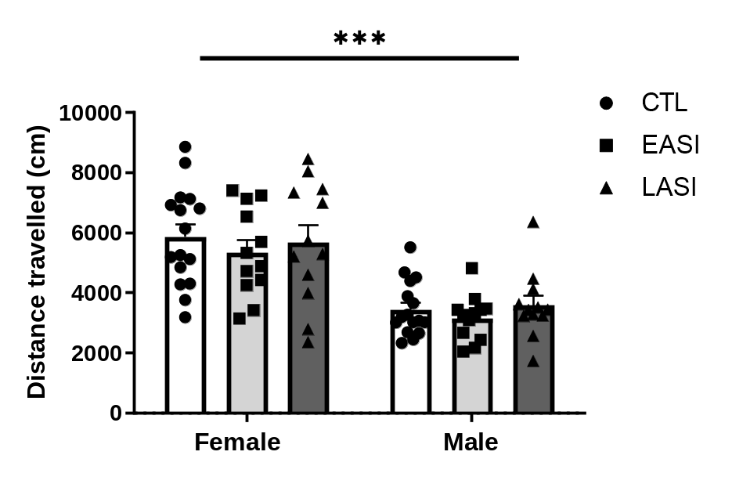

Adolescent social isolation did not influence adult performance on the open field test. Females rats travelled a longer distance during the 30 min OFT compared to males (F (1. 74) = 51.395 p < 0.000001. ηp2 = 0.410) in a sex-typical manner. Data shown with individual data points and µ±SEM.

Appendix 3: Summary statistics, figure for rats’ discrimination ability as a percent of time spent investigating the novel vs. the familiar object during the test phase of the novel object recognition test performed on PD 94 and an image of the objects used for the test.

Object discrimination ability
Source | Type III Sum of Squares | df | Mean Square | F | Sig. | Partial Eta Squared
Corrected Model | 984.050ª | 5 | 196.810 | 1.695 | 0.146 | 0.103
Intercept | 328494.910 | 1 | 328494.910 | 2829.237 | <0.001 | 0.975
Stress group | 212.435 | 2 | 106.218 | .915 | 0.405 | 0.024
Sex | 342.046 | 1 | 342.046 | 2.946 | 0.090 | 0.038
Stress group * Sex | 530.102 | 2 | 265.051 | 2.283 | 0.109 | 0.058
Error | 8591.937 | 74 | 116.107
Total | 346407.000 | 80
Corrected Total | 9575.988 | 79
a. R Squared = 0.103 (Adjusted R Squared = 0.042)

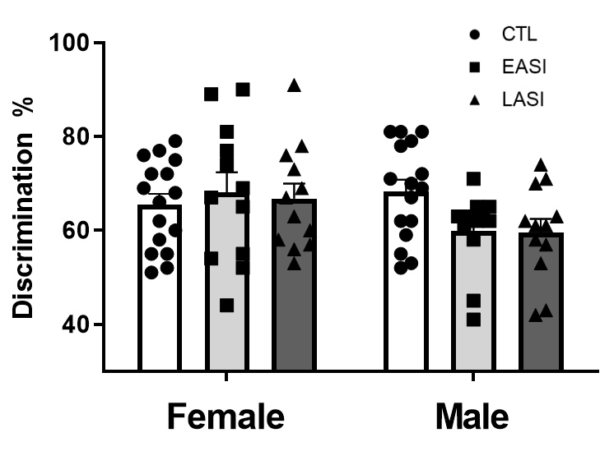
Adolescent social isolation did not influence adult novel object recognition (F _{(1. 74)} = 51.395 p < 0.000001. ηp2 = 0.410). Data shown with individual data points with µ±SEM.

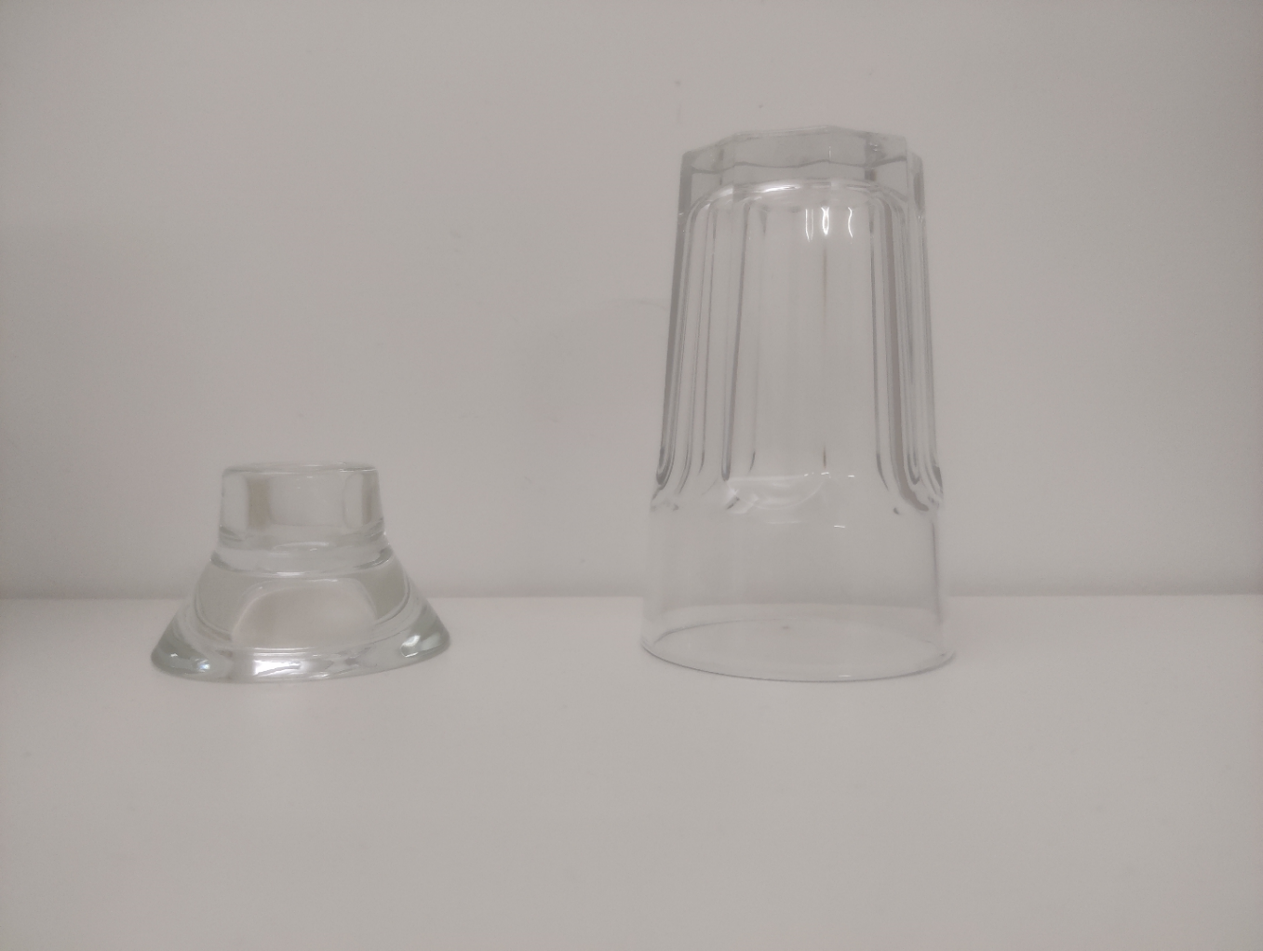
Both glassware was purchased from Ikea (www.ikea.com)

Appendix 4: Summary statistics for time spent in social interactions, frequency of anogenital sniffing, non-anogenital sniffing and rearing bouts in the social interaction test performed on PD 96

Total time spent in social interactions

Source | Type III Sum of Squares | df | Mean Square | F | Sig. | Partial Eta Squared
Corrected Model | 7349.117ª | 5 | 1469.823 | 3.736 | 0.005 | 0.202
Intercept | 176054.190 | 1 | 176054.190 | 447.494 | <0.001 | 0.858
Stress group | 7110.002 | 2 | 3555.001 | 9.036 | <0.001 | 0.196
Sex | 12.963 | 1 | 12.963 | 0.033 | 0.856 | 0.000
Stress group * Sex | 225.502 | 2 | 112.751 | .287 | 0.752 | 0.008
Error | 29113.271 | 74 | 393.423
Total | 221455.000 | 80
Corrected Total | 36462.387 | 79
a. R Squared = 0.202 (Adjusted R Squared = 0.148)

Anogenital sniffing bouts
Source | Type III Sum of Squares | df | Mean Square | F | Sig. | Partial Eta Squared
Corrected Model | 141.217ª | 5 | 28.243 | 1.334 | 0.260 | 0.083
Intercept | 6465.690 | 1 | 6465.690 | 305.283 | <0.001 | 0.805
Stress group | 127.102 | 2 | 63.551 | 3.001 | 0.056 | 0.075
Sex | 9.281 | 1 | 9.281 | 0.438 | 0.510 | 0.006
Stress group * Sex | 6.302 | 2 | 3.151 | 0.149 | 0.862 | 0.004
Error | 1567.271 | 74 | 21.179
Total | 8535.000 | 80
Corrected Total | 1708.488 | 79
a. R Squared = 0.083 (Adjusted R Squared = 0.021)

Non-anogenital bouts
Source | Type III Sum of Squares | df | Mean Square | F | Sig. | Partial Eta Squared
Corrected Model | 1332.179ª | 5 | 266.436 | 8.743 | <0.001 | 0.371
Intercept | 11927.463 | 1 | 11927.463 | 391.408 | <0.001 | 0.841
Stress group | 334.190 | 2 | 167.095 | 5.483 | 0.006 | 0.129
Sex | 751.781 | 1 | 751.781 | 24.670 | <0.001 | 0.250
Stress group * Sex | 178.790 | 2 | 89.395 | 2.934 | 0.059 | 0.073
Error | 2255.021 | 74 | 30.473
Total | 16288.000 | 80
Corrected Total | 3587.200 | 79
a. R Squared = 0.371 (Adjusted R Squared = 0.329)

Rearing bouts
Source | Type III Sum of Squares | df | Mean Square | F | Sig. | Partial Eta Squared
Corrected Model | 3348.800ª | 5 | 669.760 | 5.939 | <0.001 | .0.286
Intercept | 56774.668 | 1 | 56774.668 | 503.473 | <0.001 | 0.872
Stress group | 2004.352 | 2 | 1002.176 | 8.887 | <0.001 | 0.194
Sex | 326.296 | 1 | 326.296 | 2.894 | 0.093 | 0.038
Stress group * Sex | 978.935 | 2 | 489.468 | 4.341 | 0.017 | 0.105
Error | 8344.688 | 74 | 112.766
Total | 69421.000 | 80
Corrected Total | 11693.488 | 79
a. R Squared = 0.286 (Adjusted R Squared = 0.238)

Appendix 5: Summary statistics for duration spent in investigating the novel, familiar, both conspecifics and social discrimination ability in the social recognition memory test performed on PD 96

Duration spent investigating the novel conspecific
Source | Type III Sum of Squares | df | Mean Square | F | Sig. | Partial Eta Squared
Corrected Model | 228.029ª | 5 | 45.606 | .314 | 0.903 | 0.021
Intercept | 39176.727 | 1 | 39176.727 | 269.984 | <0.001 | 0.785
Stress group | 104.363 | 2 | 52.181 | 0.360 | 0.699 | 0.010
Sex | 34.186 | 1 | 34.186 | 0.236 | 0.629 | 0.003
Stress group * Sex | 74.054 | 2 | 37.027 | 0.255 | 0.775 | 0.007
Error | 10737.958 | 74 | 145.108
Total | 51421.000 | 80
Corrected Total | 10965.988 | 79
a. R Squared = 0.021 (Adjusted R Squared = 0.045)

Duration spent investigating familiar conspecific
Source | Type III Sum of Squares | df | Mean Square | F | Sig. | Partial Eta Squared
Corrected Model | 1163.533ª | 5 | 232.707 | 3.360 | 0.009 | 0.185
Intercept | 14131.410 | 1 | 14131.410 | 204.030 | <0.001 | 0.734
Stress group | 930.085 | 2 | 465.043 | 6.714 | 0.002 | 0.154
Sex | 2.660 | 1 | 2.660 | 0.038 | 0.845 | 0.001
Stress group * Sex | 222.935 | 2 | 111.468 | 1.609 | 0.207 | 0.042
Error | 5125.354 | 74 | 69.262
Total | 19887.000 | 80
Corrected Total | 6288.888 | 79
a. R Squared = 0.185 (Adjusted R Squared = 0.130)

Total interaction duration for both conspecifics
Source | Type III Sum of Squares | df | Mean Square | F | Sig. | Partial Eta Squared
Corrected Model | 636.596ª | 5 | 127.319 | 0.415 | 0.837 | 0.027
Intercept | 100366.501 | 1 | 100366.501 | 327.166 | <0.001 | 0.816
Stress group | 487.523 | 2 | 243.761 | 0.795 | 0.456 | 0.021
Sex | 17.774 | 1 | 17.774 | 0.058 | 0.810 | 0.001
Stress group * Sex | 134.623 | 2 | 67.311 | 0.219 | 0.804 | 0.006
Error | 22701.354 | 74 | 306.775
Total | 124300.000 | 80
Corrected Total | 23337.950 | 79
a. R Squared = 0.027 (Adjusted R Squared = 0.038)

Social discrimination ability
Source | Type III Sum of Squares | df | Mean Square | F | Sig. | Partial Eta Squared
Corrected Model | 3468.638ª | 5 | 693.728 | 5.641 | <0.001 | 0.276
Intercept | 316774.486 | 1 | 316774.486 | 2575.626 | <0.001 | 0.972
Stress group | 2896.597 | 2 | 1448.298 | 11.776 | <0.001 | 0.241
Sex | 67.145 | 1 | 67.145 | .546 | 0.462 | 0.007
Stress group * Sex | 449.974 | 2 | 224.987 | 1.829 | 0.168 | 0.047
Error | 9101.210 | 74 | 122.989
Total | 342966.495 | 80
Corrected Total | 12569.848 | 79
a. R Squared = 0.276 (Adjusted R Squared = 0.227)

Appendix 6: Summary statistics for latency (s) to a thermal pain stimulus (52.5°C) on the hotplate test performed on PD 98 in study 1A

Latency to a thermal pain stimulus
Source | Type III Sum of Squares | df | Mean Square | F | Sig. | Partial Eta Squared
Corrected Model | 227.299ª | 5 | 45.460 | 8.432 | <0.001 | 0.363
Intercept | 5622.039 | 1 | 5622.039 | 1042.781 | <0.001 | 0.934
Stress group | 36.449 | 2 | 18.225 | 3.380 | 0.039 | 0.084
Sex | 42.116 | 1 | 42.116 | 7.812 | 0.007 | 0.095
Stress group * Sex | 127.695 | 2 | 63.848 | 11.843 | <0.001 | 0.242
Error | 398.963 | 74 | 5.391
Total | 6447.134 | 80
Corrected Total | 626.262 | 79
a. R Squared = ,363 (Adjusted R Squared = ,320)

Appendix 7: Summary statistic for [¹²⁵I]-OVTA receptor binding sites (fmol/mg) from male and female rats separately

Males
Binding sites | Region | CTL ♂ | EASI ♂ | LASI ♂ | F-value | Interaction  P-value
([¹²⁵I]-OVTA | DLS | 0.619±0.4  N = 8 | 0.546±0.05  N = 8 | 0.608±0.02  N= 8 | 1.301 (1. 37) | 0.284
 | DMS | 0.678±0.01  N = 8 | 0.632±0.03  N = 8 | 0.655±0.02  N = 8 | 1.430 (1. 36) | 0.237
 | CPU | 0.291±0.03  N = 7 | 0.273±0.04  N = 8 | 0.250±0.05  N = 6 | 0.571 (1. 28) | 0.721
 | ACB | 0.291±0.03  N = 8 | 0.210±0.02  N = 7 | 0.26±0.07  N = 4 | 0.817 (1. 30) | 0.547
 | PVN | 0.205±0.01  N = 5 | 0.143±0.02  N = 3 | 0.199±0.07  N = 3 | 80.267 (1. 21) | 0.002
 | CEA | 0.663±0.08  N = 4 | 1.008±0.08  N = 5 | 0.919±0.11  N = 6 | 30.519 (1. 21) | 0.048
 | BLA | 0.121±0.00  N =4 | 0.193±0.05  N = 5 | 0.164±0.02  N = 6 | 2.018 (1. 19) | 0.1220.
 | PVT | 0.239±0.02  N = 6 | 0125±0.01  N = 6 | 0.257±0.02  N = 4 | 150.791 (1. 29) | 0.00003
 | vCA1 | 0.869±0.08  N = 5 | 1.173±0.13  N = 6 | 1.070±0.04  N = 4 | 1.520 (1. 25) | 0.219

Females
Binding sites | Region | CTL ♁ | EASI ♁ | LASI ♁ | F-value | P-value
([¹²⁵I]-OVTA | DLS | 0.614±0.3  N = 6 | 0.628±0.02  N = 7 | 0.688±0.03  N = 6 | 1.301 (1. 37) | 0.284
 | DMS | 0.696±0.02  N = 5 | 0.643±0.02  N = 8 | 0.711±0.02  N = 6 | 1.430 (1. 36) | 0.237
 | CPU | 0.359±0.04  N = 4 | 0.261±0.04  N = 4 | 0.295±0.03  N = 5 | 0.571 (1. 28) | 0.721
 | ACB | 0.308±0.04  N = 4 | 0.234±0.06  N = 6 | 0.284±0.03  N = 6 | 0.817 (1. 30) | 0.547
 | PVN | 0.124±0.01  N = 3 | 0.295±0.02  N = 6 | 0.192±0.01  N = 7 | 80.267 (1. 21) | 0.002
 | CEA | 0.705±0.05  N =4 | 0.822±0.09  N = 4 | 0.465±0.04  N =4 | 30.519 (1. 21) | 0.048
 | BLA | 0.182±0.04  N = 4 | 0.179±0.00  N = 4 | 0.089±0.00  N = 4 | 2.018 (1. 19) | 0.1220.
 | PVT | 0.124±0.01  N = 4 | 0.299±0.02  N = 8 | 0.316±0.02 N = 7 | 150.791 (1. 29) | 0.00003
 | vCA1 | 1.072±0.07  N = 6 | 1.032±0.09  N = 5 | 1.205±0.09  N = 5 | 1.520 (1. 25) | 0.219

Table 2: [¹²⁵I]-OVTA receptor autoradiography in ASI male and female rats. All receptor/transporter autoradiography was performed under saturated conditions. Kd-values, the dissociation equilibrium constant describing the affinity for a specific receptor, as well as Bmax-values, describing the maximum density of the receptor in the specified regions. DLS. dorsal-lateral striatum; DMS. dorsal-medial striatum; CPU. caudate putamen; ACB. nucleus accumbens core; PVN. paraventricular nucleus of the hypothalamus.; CeA. central amygdala; BLA. basolateral amygdala; PVT. paraventricular nucleus of the thalamus; vCA1. ventral cornu Ammonis 1. Statistics performed across all groups and both sexes. All values shown in fmol/g with Mean±SEM.

Appendix 8: Summary statistics and bar graphs for sex comparisons for OT receptor autoradiography (fmol/p/g) for PVT, PVN and CeA

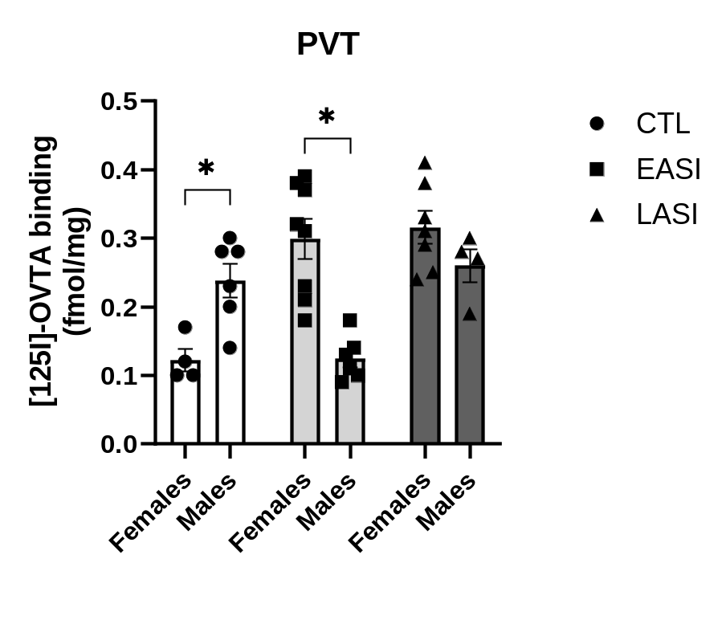
Bar graph shows sex comparisons between groups in OTR bindings sites (fmol/mg) in the PVT measured by saturated [125I] OVTA receptor autoradiography. Data shown with individual data points, µ±SEM. *p < 0.5. Summary statistics, and pair-wise comparisons for the PVT are shown below.

Tests of Between-Subjects Effects
Dependent Variable: PVT
Source | Type III Sum of Squares | df | Mean Square | F | Sig. | Partial Eta Squared
Corrected Model | 0.202a | 5 | 0.040 | 100.842 | <0.001 | 0.651
Intercept | 10.684 | 1 | 10.684 | 4510.852 | <0.001 | 0.940
Sex | 0.013 | 1 | 0.013 | 30.421 | 0.075 | 0.106
Stress group | 0.059 | 2 | 0.029 | 70.871 | 0.002 | 0.352
Sex * Stress group | 0.118 | 2 | 0.059 | 150.791 | <0.001 | 0.521
Error | 0.108 | 29 | 0.004
Total | 20.290 | 35
Corrected Total | 0.310 | 34
a. R Squared = 0.651 (Adjusted R Squared = 0.591)

Pairwise Comparisons: Sex * Stress group
Dependent Variable: PVT
Stress group | (I) Sex |  | (J) Sex |  |  | Mean Difference (I-J) | Std. Error | Sig. |  | 95% Confidence Interval
 |  |  |  |  |  |  |  |  |  | LB | UB
CTL |  | female |  | male | -0.115* |  | 0.039 | 0.007 | -0.195 |  | -0.034
EASI |  | female |  | male | 0.174* |  | 0.033 | <0.001 | 0.107 |  | 0.242
LASI |  | female |  | male | 0.059 |  | 0.038 | 0.134 | -0.019 |  | 0.137
Based on estimated marginal means
*. The mean difference is significant at the 0.05 level.

Pairwise Comparisons: Stress * Sex
Dependent Variable: PVT
Sex | (I) Stress group | (J) Stress group | Mean Difference (I-J) | Std. Error | Sig. | 95% Confidence Interval
 |  |  |  |  |  | LB | UB
female | CTL | EASI | -0.175* | 0.037 | <0.001 | -0.252 | -0.099
female | CTL | LASI | -0.192* | 0.038 | <0.001 | -0.270 | -0.113
female | EASI | CTL | 0.175* | 0.037 | <0.001 | 0.099 | 0.252
female | EASI | LASI | -0.016 | 0.032 | 0.609 | -0.081 | 0.048
female | LASI | CTL | 0.192* | 0.038 | <0.001 | 0.113 | 0.270
female | LASI | EASI | 0.016 | 0.032 | 0.609 | -0.048 | 0.081
male | CTL | EASI | 0.113* | 0.035 | 0.003 | 0.041 | 0.185
male | CTL | LASI | -0.018 | 0.039 | 0.649 | -0.099 | 0.062
male | EASI | CTL | -0.113* | 0.035 | 0.003 | -0.185 | -0.041
male | EASI | LASI | -0.131* | 0.039 | 0.002 | -0.212 | -0.051
male | LASI | CTL | 0.018 | 0.039 | 0.649 | -0.062 | 0.099
male | LASI | EASI | 0.131* | 0.039 | 0.002 | 0.051 | 0.212
Based on estimated marginal means
*. The mean difference is significant at the 0.05 level.
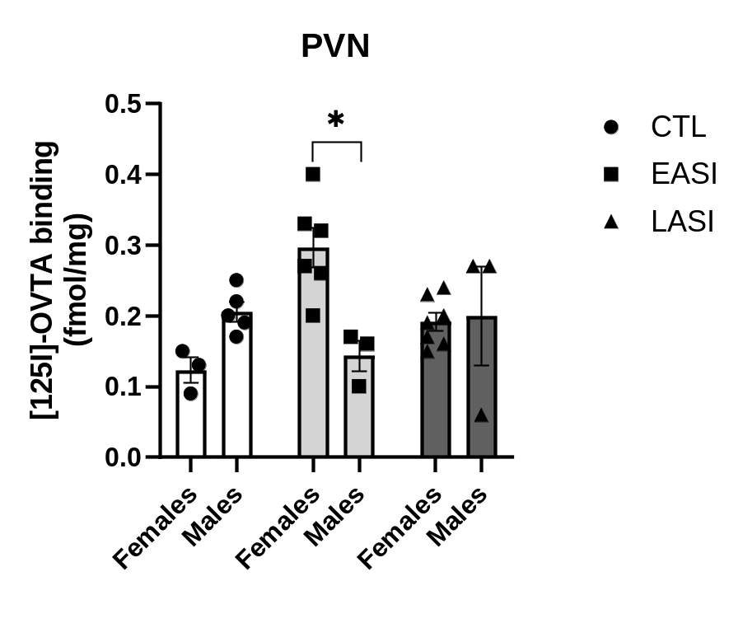
Bar graph shows sex comparisons between groups in OTR bindings sites (fmol/mg) in the PVN measured by saturated [125I] OVTA receptor autoradiography. Data shown with individual data points, µ±SEM. *p < 0.5. Summary statistics, and pair-wise comparisons for the PVN are shown below.

Tests of Between-Subjects Effects
Dependent Variable: PVN
Source | Type III Sum of Squares | df | Mean Square | F | Sig. | Partial Eta Squared
Corrected Model | 0.081ª | 5 | 0.016 | 40.835 | 0.004 | 0.535
Intercept | 0.892 | 1 | 0.892 | 2660.926 | <0.001 | 0.927
Sex | 0.003 | 1 | 0.003 | 0.821 | 0.375 | 0.038
Stress group | 0.011 | 2 | 0.006 | 10.703 | 0.206 | 0.140
Sex * Stress group | 0.055 | 2 | 0.028 | 80.267 | 0.002 | 0.441
Error | 0.070 | 21 | 0.003
Total | 10.291 | 27
Corrected Total | 0.151 | 26
a. R Squared = 0.535 (Adjusted R Squared = 0.424)

Pairwise Comparisons: Sex * Stress group
Dependent Variable: PVN
Stress group | (I) Sex | (J) Sex |  | Mean Difference (I-J) | Std. Error | Sig. |  | 95% Confidence Interval
 |  |  |  |  |  |  |  | LB | UB
CTL | female | male | -0.081 |  | 0.042 | 0.069 | -0.169 |  |  | 0.007
EASI | female | male | 0.152* |  | 0.041 | 0.001 | 0.067 |  |  | 0.237
LASI | female | male | -0.007 |  | 0.040 | 0.869 | -0.090 |  |  | 0.076
Based on estimated marginal means
*. The mean difference is significant at the 0.05 level.

Pairwise Comparisons: Stress * Sex
Dependent Variable: PVN
Sex | (I) Stress group | (J) Stress group | Mean Difference (I-J) | Std. Error | Sig. | 95% Confidence Interval
 |  |  |  |  |  | Lower Bound | Upper Bound
female | CTL | EASI | -0.170* | 0.041 | <0.001 | -0.255 | -0.085
female | CTL | LASI | -0.068 | 0.040 | 0.105 | -0.151 | 0.015
female | EASI | CTL | 0.170* | 0.041 | <0.001 | 0.085 | 0.255
female | EASI | LASI | 0.103* | 0.032 | 0.004 | 0.036 | 0.170
female | LASI | CTL | 0.068 | 0.040 | 0.105 | -0.015 | 0.151
female | LASI | EASI | -0.103* | 0.032 | 0.004 | -0.170 | -0.036
male | CTL | EASI | 0.062 | 0.042 | 0.156 | -0.026 | 0.150
male | CTL | LASI | 0.007 | 0.042 | 0.877 | -0.081 | 0.094
male | EASI | CTL | -0.062 | 0.042 | 0.156 | -0.150 | 0.026
male | EASI | LASI | -0.056 | 0.047 | 0.252 | -0.154 | 0.043
male | LASI | CTL | -0.007 | 0.042 | 0.877 | -0.094 | 0.081
male | LASI | EASI | 0.056 | 0.047 | 0.252 | -0.043 | 0.154
Based on estimated marginal means
*. The mean difference is significant at the 0.05 level.

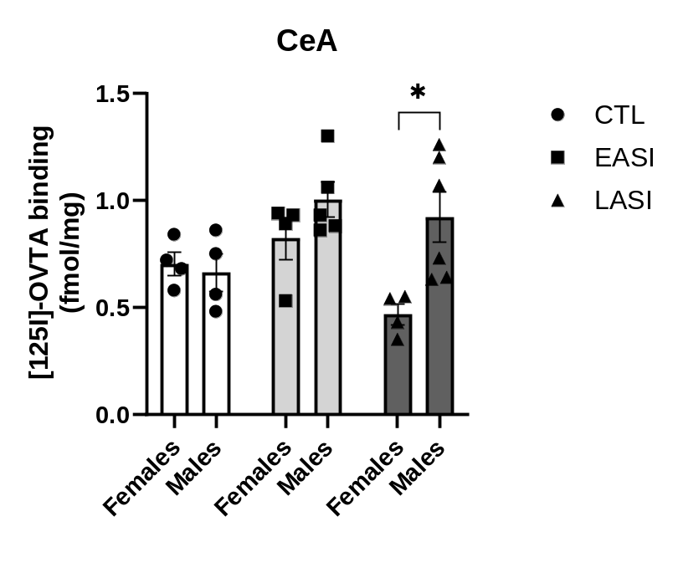
Bar graph shows sex comparisons between groups in OTR bindings sites (fmol/mg) in the CeA measured by saturated [125I] OVTA receptor autoradiography. Data shown with individual data points, µ±SEM. Summary statistics, and pair-wise comparisons for the CeA are shown below.

Tests of Between-Subjects Effects
Dependent Variable: CeA
Source | Type III Sum of Squares | df | Mean Square | F | Sig. | Partial Eta Squared
Corrected Model | 0.856a | 5 | 0.171 | 40.429 | 0.007 | 0.513
Intercept | 150.377 | 1 | 150.377 | 3970.592 | <0.001 | 0.950
Stress group | 0.302 | 2 | 0.151 | 30.904 | 0.036 | 0.271
Sex | 0.262 | 1 | 0.262 | 60.772 | 0.017 | 0.244
Stress group * Sex | 0.272 | 2 | 0.136 | 30.519 | 0.048 | 0.251
Error | 0.812 | 21 | 0.039
Total | 180.291 | 27
Corrected Total | 10.669 | 26
a. R Squared = 0.513 (Adjusted R Squared = 0.397)

Pairwise Comparisons: Sex * Stress group
Dependent Variable: CeA
Stress group | (I) Sex | (J) Sex | Mean Difference (I-J) | Std. Error | Sig. | 95% Confidence Interval
 |  |  |  |  |  | LB | UB
CTL | female | male | 0.042 | 0.139 | 0.764 | -0.247 | 0.332
EASI | female | male | -0.186 | 0.132 | 0.173 | -0.460 | 0.088
LASI | female | male | -0.455* | 0.127 | 0.002 | -0.719 | -0.191
Based on estimated marginal means
*. The mean difference is significant at the 0.05 level.

Pairwise Comparisons: Stress * Sex
Dependent Variable: CeA
Sex | (I) Stress group | (J) Stress group | Mean Difference (I-J) | Std. Error | Sig. | 95% Confidence Interval
 |  |  |  |  |  | LB | UB
female | CTL | EASI | -0.116 | 0.139 | 0.413 | -0.405 | 0.173
female | CTL | LASI | 0.240 | 0.139 | 0.098 | -0.049 | 0.530
female | EASI | CTL | 0.116 | 0.139 | 0.413 | -0.173 | 0.405
female | EASI | LASI | 0.357* | 0.139 | 0.018 | 0.068 | 0.646
female | LASI | CTL | -0.240 | 0.139 | 0.098 | -0.530 | 0.049
female | LASI | EASI | -0.357* | 0.139 | 0.018 | -0.646 | -0.068
male | CTL | EASI | -0.345* | 0.132 | 0.016 | -0.619 | -0.070
male | CTL | LASI | -0.257 | 0.127 | 0.056 | -0.521 | 0.007
male | EASI | CTL | 0.345* | 0.132 | 0.016 | 0.070 | 0.619
male | EASI | LASI | 0.088 | 0.119 | 0.468 | -0.160 | 0.336
male | LASI | CTL | 0.257 | 0.127 | 0.056 | -0.007 | 0.521
male | LASI | EASI | -0.088 | 0.119 | 0.468 | -0.336 | 0.160
Based on estimated marginal means
*. The mean difference is significant at the 0.05 level.

