Stock assessment using Bayesian state-space surplus production models: the case of bonga shad, Ethmalosa fimbriata (Bowdich, 1825), in the Eastern Central Atlantic Ocean.
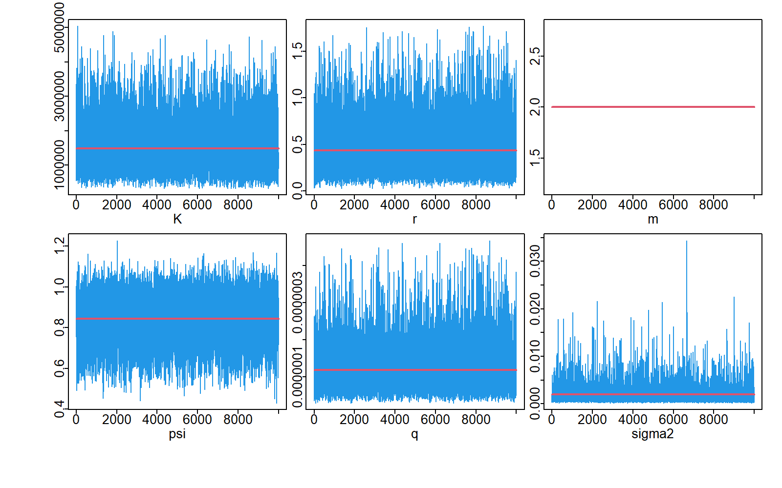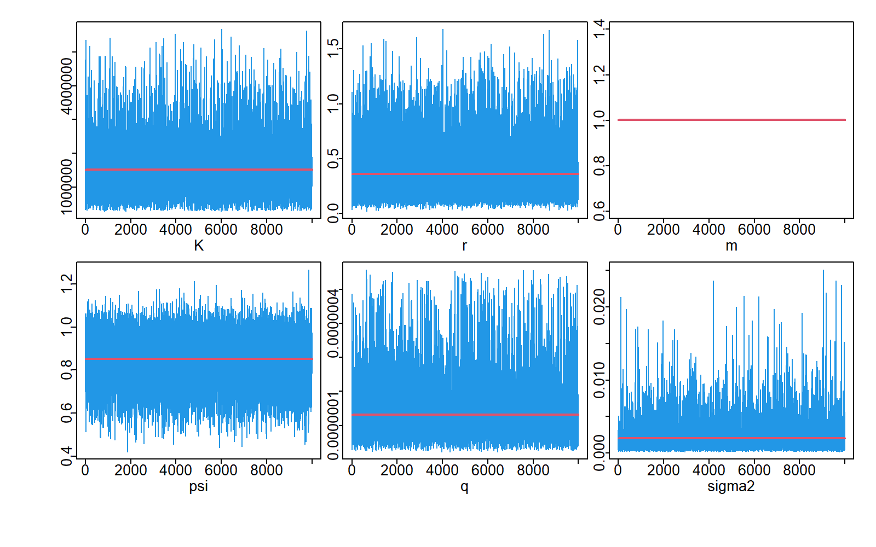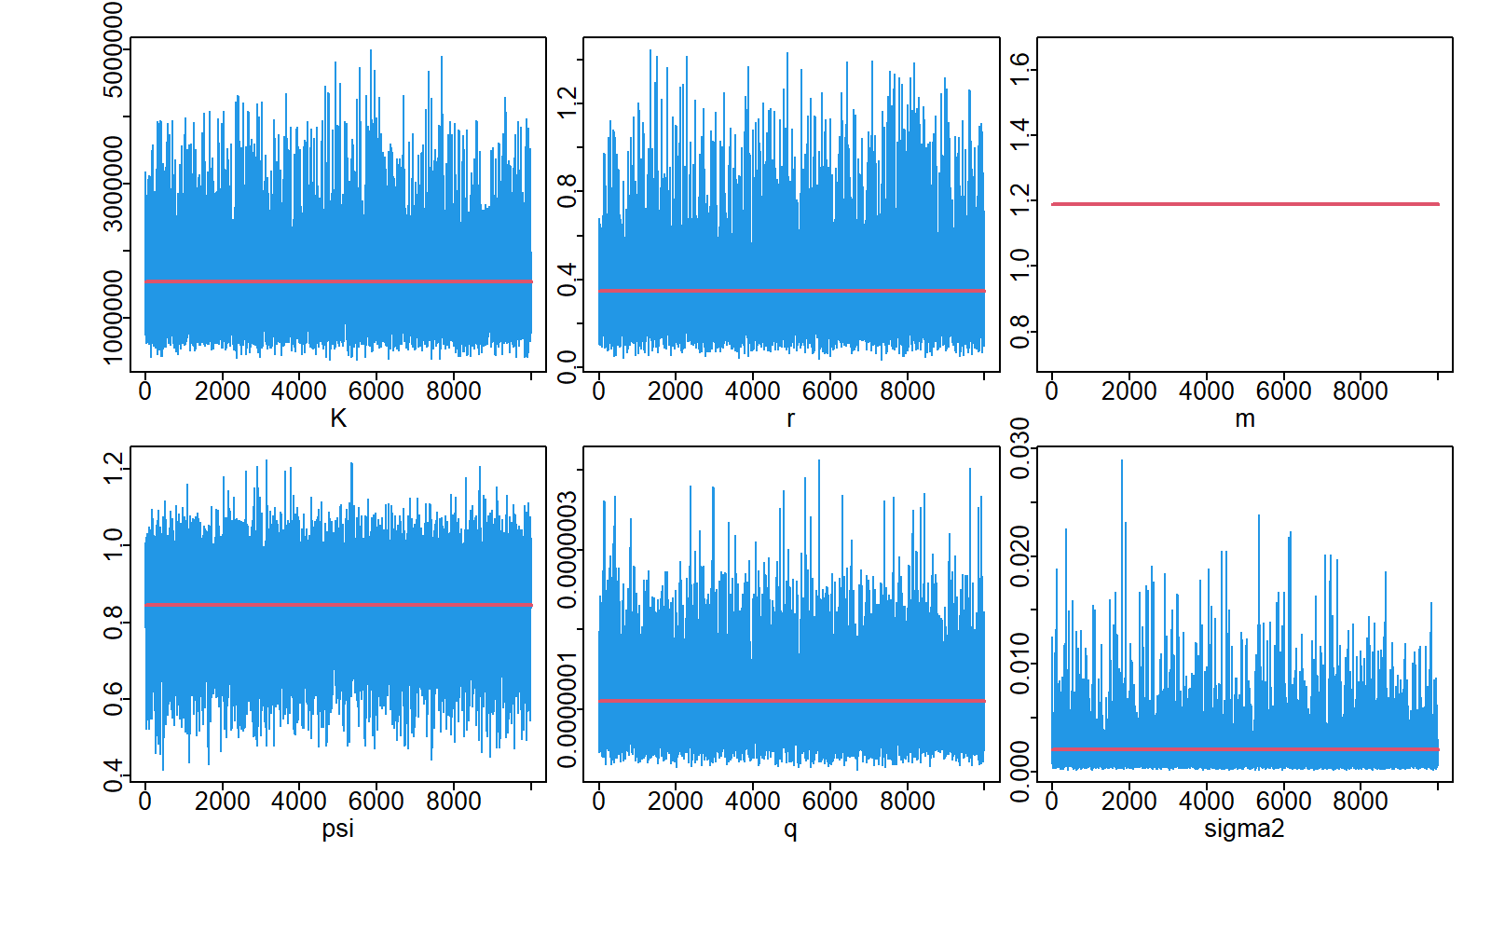
Pella
Fox
Schaefer
Fig. S1 MCMC Trrace plots showing adequate model convergence in JABBA

Table S1 Heidelberger and Welch test statistics
Schaefer | Median | LCI | UCI | Geweke.p | Heidel.p
K | 1361642 | 515554.3 | 3324471 | 0.307 | 0.652
r | 0.361 | 0.095 | 1.13 | 0.437 | 0.183
q | 0 | 0 | 0 | 0.668 | 0.162
psi | 0.849 | 0.594 | 1.055 | 0.154 | 0.792
sigma2 | 0.001 | 0 | 0.007 | 0.645 | 0.288
tau2 | 0.003 | 0 | 0.023 | 0.074 | 0.057
m | 2 | 2 | 2 | NA | NA
Fox | Median | LCI | UCI | Geweke.p | Heidel.p
K | 1333724 | 401621.7 | 3576349 | 0.138 | 0.096
r | 0.285 | 0.08 | 1.085 | 0.54 | 0.463
q | 0 | 0 | 0 | 0.185 | 0.122
psi | 0.863 | 0.591 | 1.059 | 0.662 | 0.661
sigma2 | 0.001 | 0 | 0.008 | 0.042 | 0.123
tau2 | 0.003 | 0 | 0.024 | 0.025 | 0.27
m | 1.001 | 1.001 | 1.001 | NA | NA
Pella | Median | LCI | UCI | Geweke.p | Heidel.p
K | 1423652 | 617408.2 | 3191982 | 0.492 | 0.489
r | 0.304 | 0.104 | 0.909 | 0.016 | 0.148
q | 0 | 0 | 0 | 0.768 | 0.686
psi | 0.856 | 0.579 | 1.056 | 0.113 | 0.666
sigma2 | 0.001 | 0 | 0.008 | 0.852 | 0.716
tau2 | 0.003 | 0 | 0.023 | 0.483 | 0.89
m | 1.188 | 1.188 | 1.188 | NA | NA

Table S2 Mohn's rho matrix predicted for the reference points (B, MSY, BMSY, FMSY, B/BMSY, F/FMSY) in Shaefer, Fox and Pella-Tomlinson models in JABBA.
Schaefer | B | MSY | B_{MSY} | F_{MSY} | B/B_{MSY} | F/F_{MSY}
2021 | 0.165 | 0.039 | 0.043 | 0.021 | 0.106 | -0.131
2020 | -0.032 | -0.008 | -0.013 | 0.027 | -0.032 | 0.045
2019 | 0.156 | 0.026 | 0.069 | -0.016 | 0.055 | -0.085
2018 | 0.096 | 0.007 | 0.046 | -0.024 | 0.009 | -0.018
2017 | 0.112 | 0.024 | 0.045 | -0.005 | 0.042 | -0.067
2016 | 0.144 | 0.064 | 0.048 | 0.023 | 0.081 | -0.133
Mean | 0.107 | 0.025 | 0.04 | 0.004 | 0.043 | -0.065
Fox | B | MSY | B_{MSY} | F_{MSY} | B/B_{MSY} | F/F_{MSY}
2021 | 0.082 | 0.019 | 0.031 | -0.006 | 0.033 | -0.05
2020 | 0.123 | 0.042 | 0.071 | -0.027 | 0.049 | -0.088
2019 | 0.048 | 0.012 | 0.038 | -0.035 | 0.018 | -0.029
2018 | 0.094 | 0.049 | 0.054 | -0.015 | 0.027 | -0.068
2017 | 0.036 | 0.013 | 0.02 | -0.018 | 0.011 | -0.022
2016 | 0.196 | 0.116 | 0.086 | 0.029 | 0.099 | -0.183
Mean | 0.097 | 0.042 | 0.05 | -0.012 | 0.04 | -0.073
Pella | B | MSY | B_{MSY} | F_{MSY} | B/B_{MSY} | F/F_{MSY}
2021 | 0 | -0.004 | 0.003 | -0.017 | -0.004 | 0.008
2020 | -0.035 | -0.005 | -0.021 | -0.001 | -0.01 | 0.015
2019 | -0.084 | -0.039 | -0.035 | -0.006 | -0.04 | 0.085
2018 | -0.052 | -0.025 | -0.03 | -0.009 | -0.017 | 0.045
2017 | 0.01 | 0.006 | 0.006 | -0.001 | 0.003 | -0.012
2016 | 0.058 | 0.05 | 0.028 | 0.02 | 0.042 | -0.084
Mean | -0.017 | -0.003 | -0.008 | -0.002 | -0.004 | 0.009

