Sr no. | Input | Predicted Output
1. | 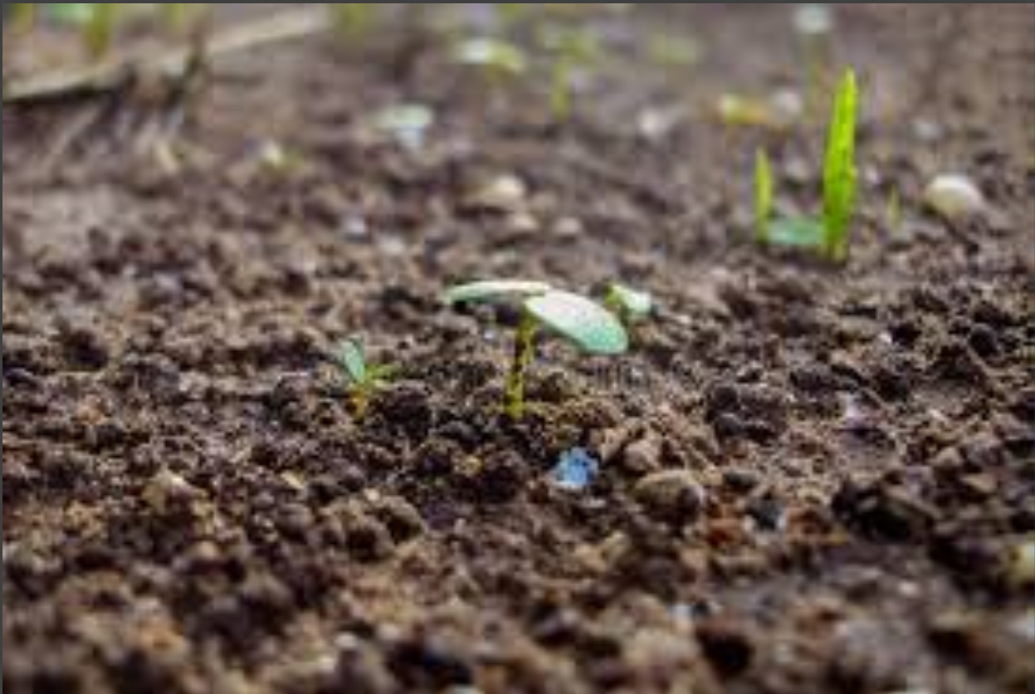 | Black Soil
2. | 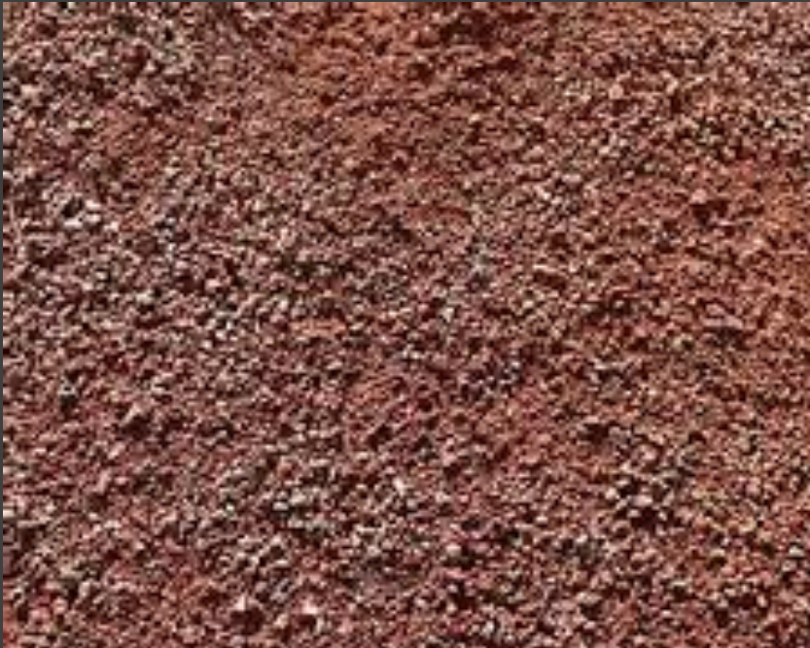 | Cinder Soil
3. | 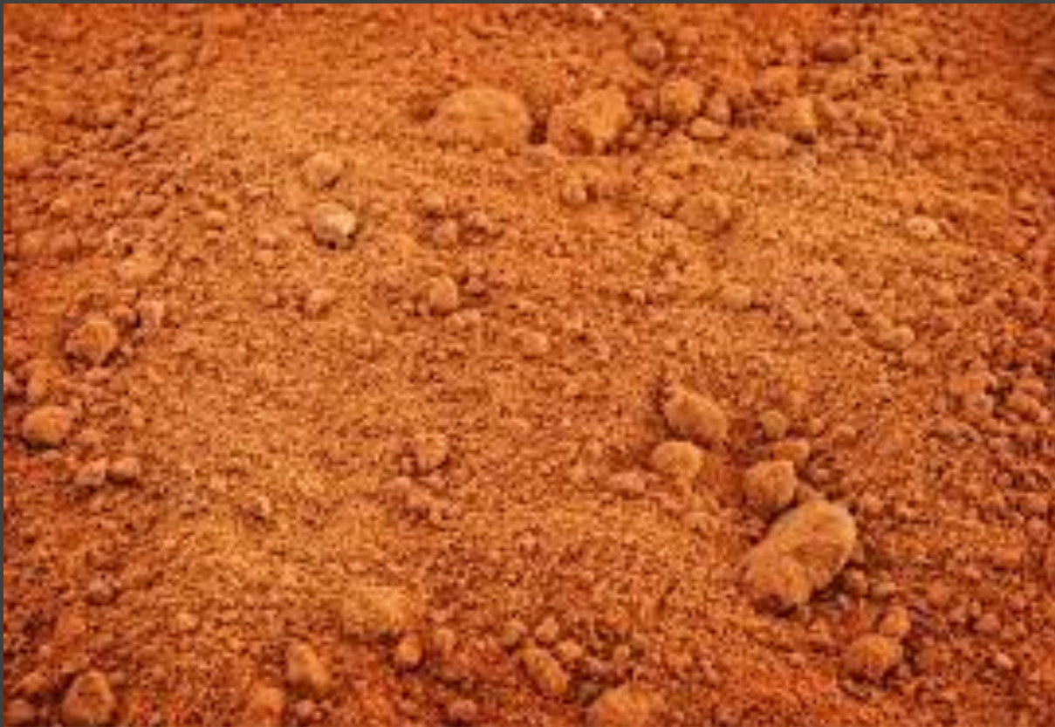 | Laterite Soil
4. | 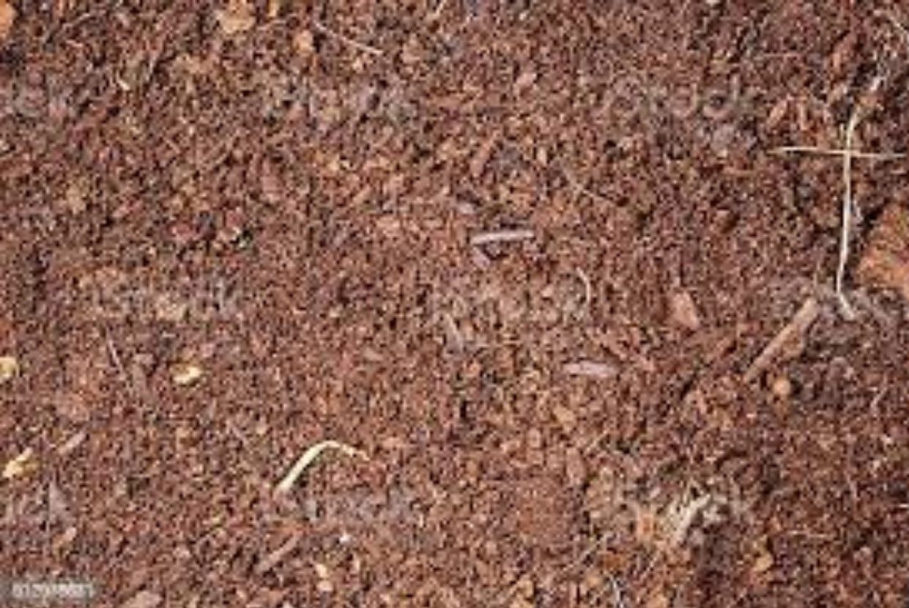 | Peat Soil
5. | 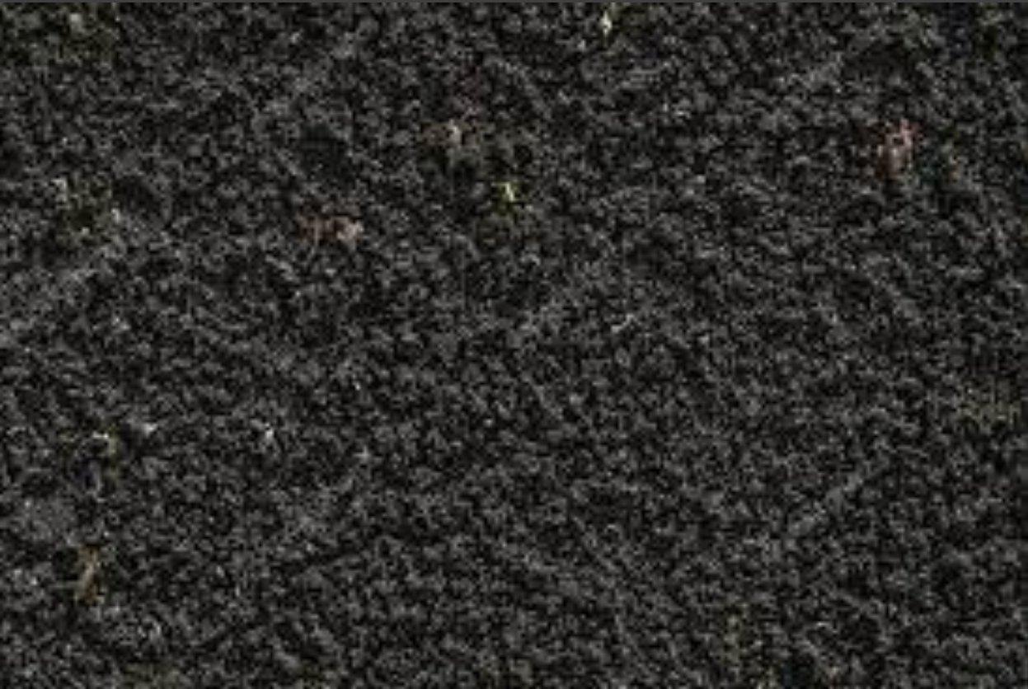 | Black Soil
6. | 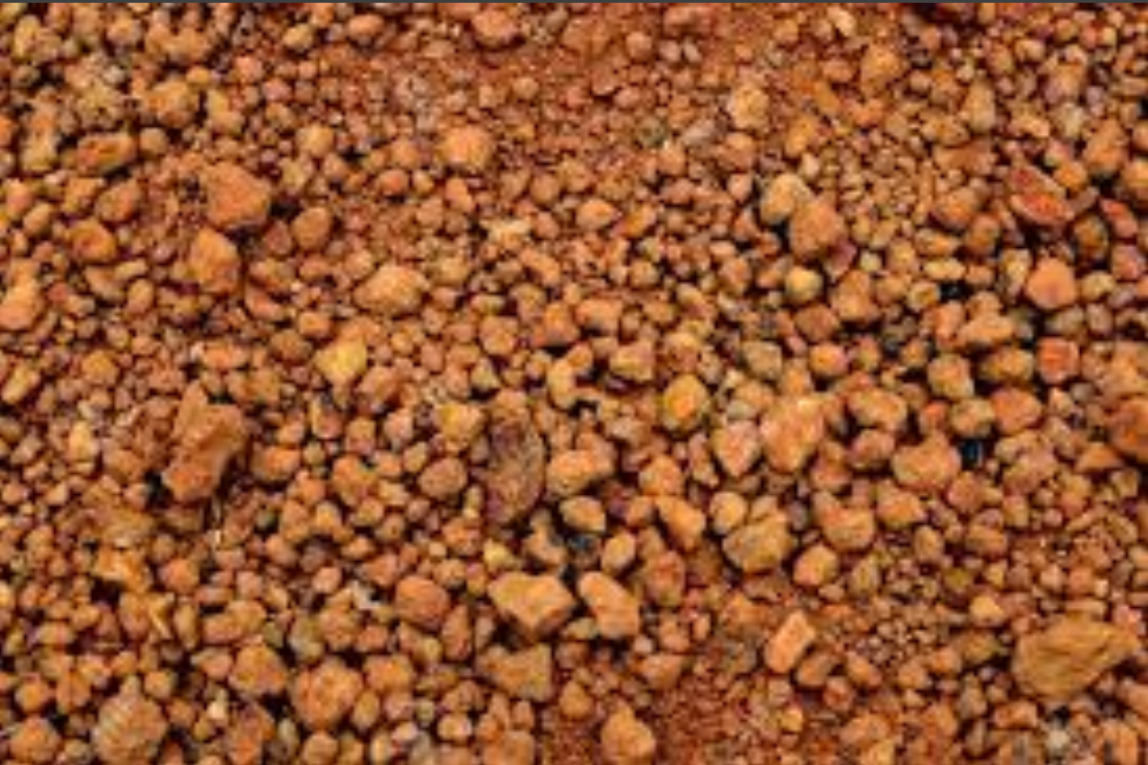 | Laterite Soil
7. | 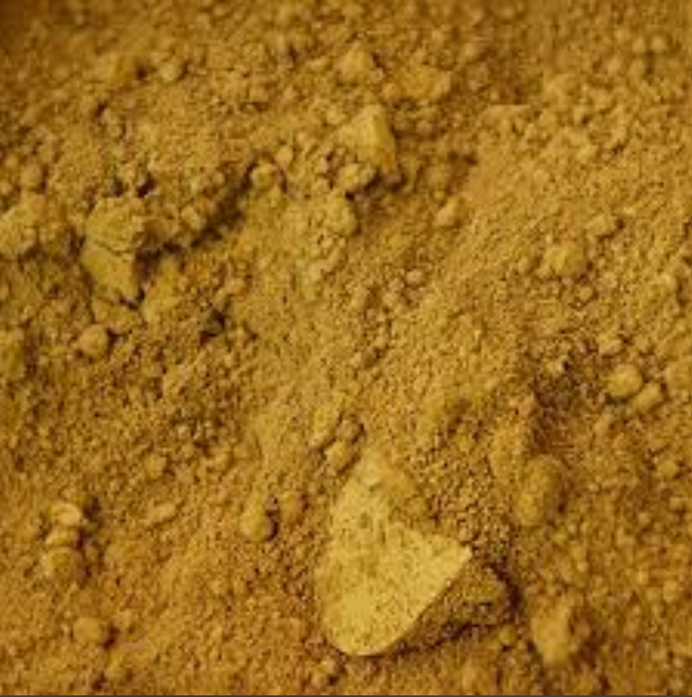 | Yellow Soil
8. | 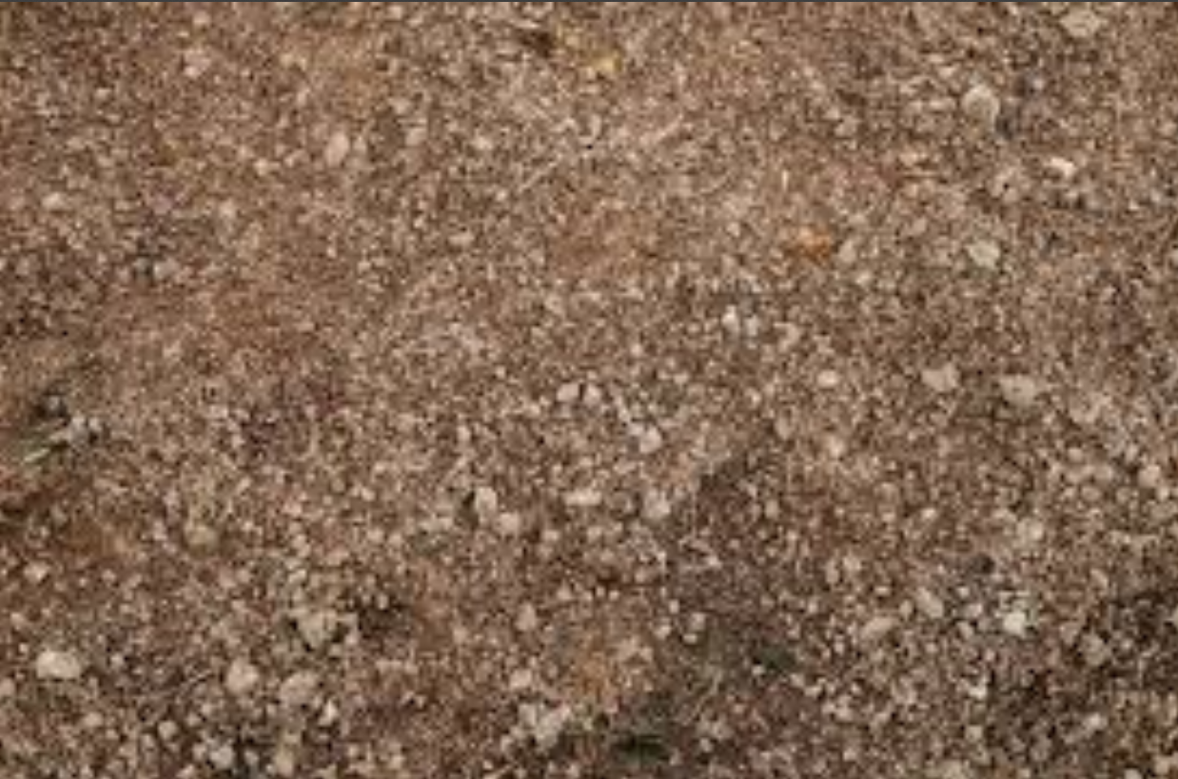 | Peat Soil
9. | 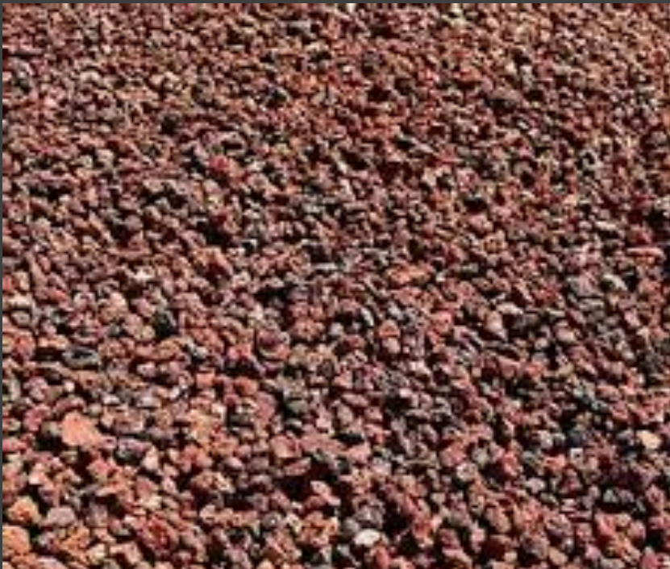 | Cinder Soil
10. | 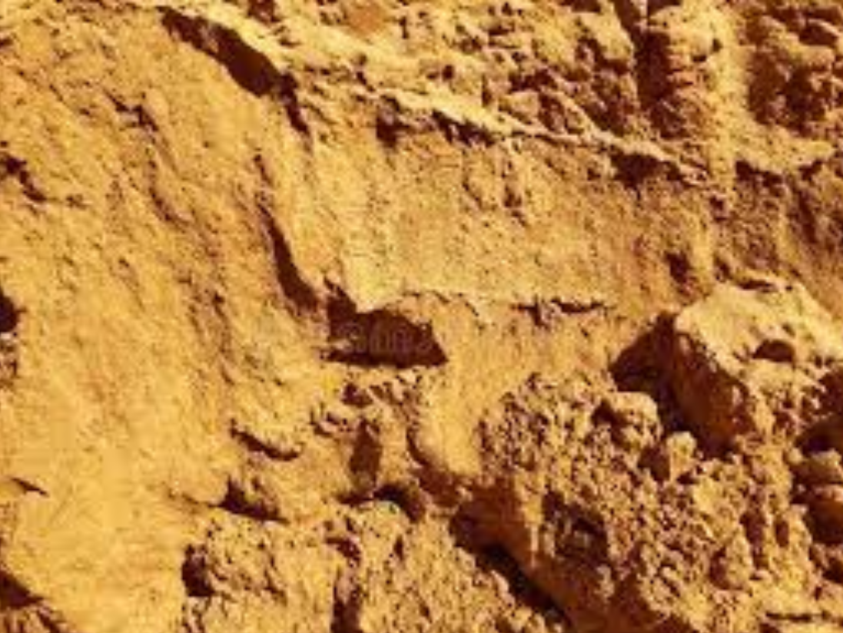 | Yellow Soil
Table 13: Soil Classification Result

