Knockdown of PTEN Disrupts PINK1/Parkin-mediated Mitophagy and Promotes Hippocampal Neuronal Cell Death Following Status Epilepticus

Supplementary materials
For validation of virtually continuous epileptic activity occurred after lithium-pilocarpine induced experimental status epilepticus and corresponded to seizure severity, in some animals, radiotelemetry recording of electroencephalogram (EEG) was measured by rodent PACK (EMKA Technologies, Paris, France) (Fig. S1).
After Zoletil 50 (50 mg/kg, Virbac, Carros, France) given intraperitoneally to induce anesthesia, the head of the animal was fixed to a stereotaxic headholder (Kopf, Tujunga, CA, USA) and the rest of the body was placed on a heating pad to maintain body temperature at 37°C. Animals were implanted with rodent PACK head connectors with cortical electrodes and reference electrodes (EMKA Technologies) under sterile precautions. The biopotential electrodes were affixed subdurally in the frontal cortex region using screws and dental cement. Animals were injected intraperitoneally with lithium (3 meq/kg; Sigma, St. Louis, MO, USA) 18 h before pilocarpine (60 mg/kg; Sigma) intraperitoneal injection. 30 min before pilocarpine injection, animals were injected intraperitoneally with methyl-scopolamine (25 mg/kg; Sigma) to minimize peripheral cholinergic effects. Wireless EEG activity was sampled at 1,000 Hz with a filter cutoff of 50 Hz. Data acquisition and analysis were performed with rodentPACK EEG analysis software (IOX software v.2.10.0, EMKA Technologies) via rodent PACK transmitter and a receiver placed underneath home-cages. The seizure severity was scored by Racine’s scale:
Stage 1: mouth and facial movement.
Stage 2: head nodding.
Stage 3: forelimb clonus.
Stage 4: rearing with forelimb clonus.
Stage 5: rearing and falling with forelimb clonus (generalized motor convulsions).
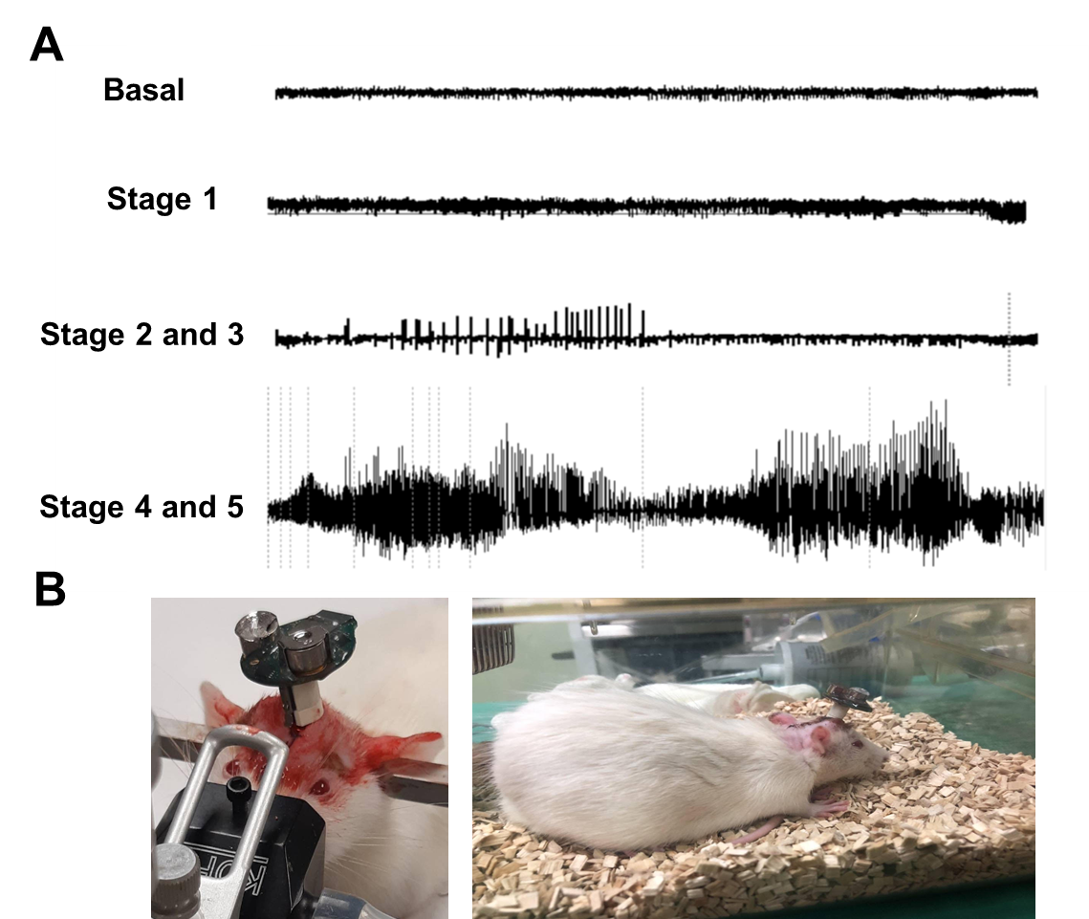
Fig. S1. Radiotelemetry recording of electroencephalogram (EEG) in lithium-pilocarpine induced experimental status epilepticus in the rat. (A) After pilocarpine (60 mg/kg) intraperitoneal injection, the EEG was recorded by rodent PACK (EMKA Technologies, Paris, France) and extracted according to the seizure behavior scored by Racine’s scale. (B) The biopotential lead was implanted into rat’s cranium and affixed subdurally in the frontal cortex region with dental cement fixation and connecting to signal transducer. After surgery, rats were waiting for the wound recovery before the following experimental status epilepticus and EEG analysis.
Graphical abstract
We have identified altered characteristics of damaged mitochondria-induced mitophagy during status epilepticus (SE) and demonstrated important insights into its possible molecular mechanism. We outline a novel possible signaling pathway for PTEN/PINK1/Parkin in SE-induced mitophagy/apoptosis of hippocampal neuronal cells.
