Supplementary material

Title
Acquisition of a single stranded DNA plant virus differentially alters methylation patterns in two cryptic species of a hemipteran vector

Authors
Michael A. Catto ¹, Sudeep Pandey ¹, Saptarshi Ghosh ¹, Banani Mondal ¹, Alvin Simmons ², Brendan G. Hunt ^{1, *}, & Rajagopalbabu Srinivasan ^{1, *}

Affiliations
¹ Department of Entomology, University of Georgia, Griffin, GA 30223, USA
² U.S. Department of Agriculture, Charleston, SC 29414, USA

Corresponding Authors
* huntbg@uga.edu (B.G.H); babusri@uga.edu (R.S)

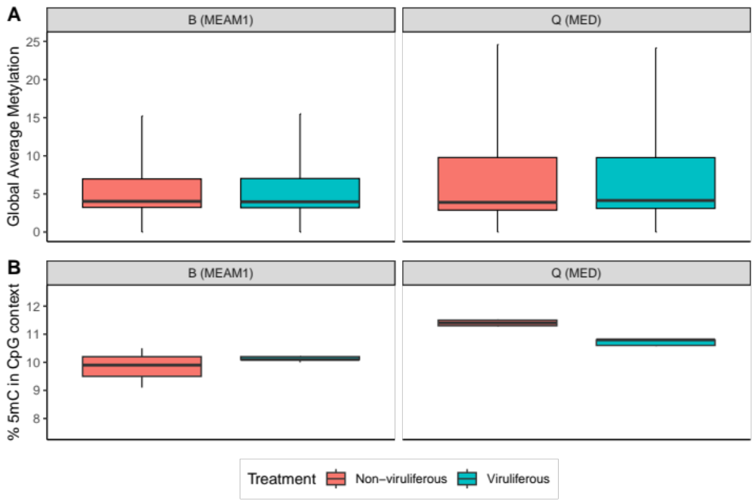
Figure S1. Comparison of non-viruliferous and viruliferous treatment groups from B and Q genomes relating to (A) global average methylation and (B) CpG methylation.

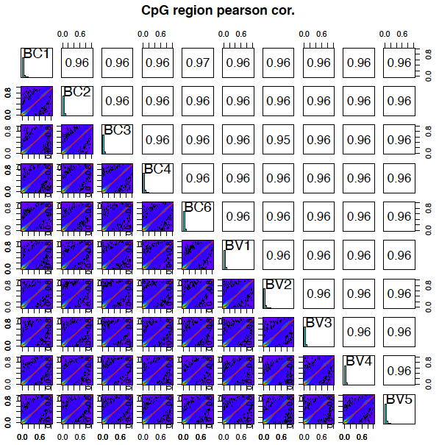
Figure S2. Correlation matrix showing the Pearson correlation of CpG methylation in the B genome for non-viruliferous (BC) and viruliferous (BV) samples. Histograms showed the CpG methylation for each sample with 1kb tiling used for CpG detection. The red line indicates linear regression to model the differential methylation between a pairwise comparison between two individual samples. Low levels of differential methylation were detected between sample types.

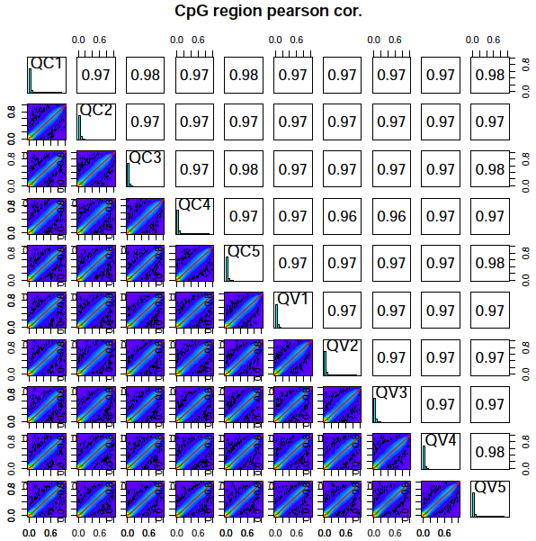
Figure S3. Correlation matrix showing the Pearson correlation of CpG methylation in the Q genome for non-viruliferous (QC) and viruliferous (QV) samples. Histograms showed the CpG methylation for each sample with 1kb tiling used for CpG detection. The red line indicates linear regression to model the differential methylation between a pairwise comparison between two individual samples. Low levels of differential methylation were detected between sample types.

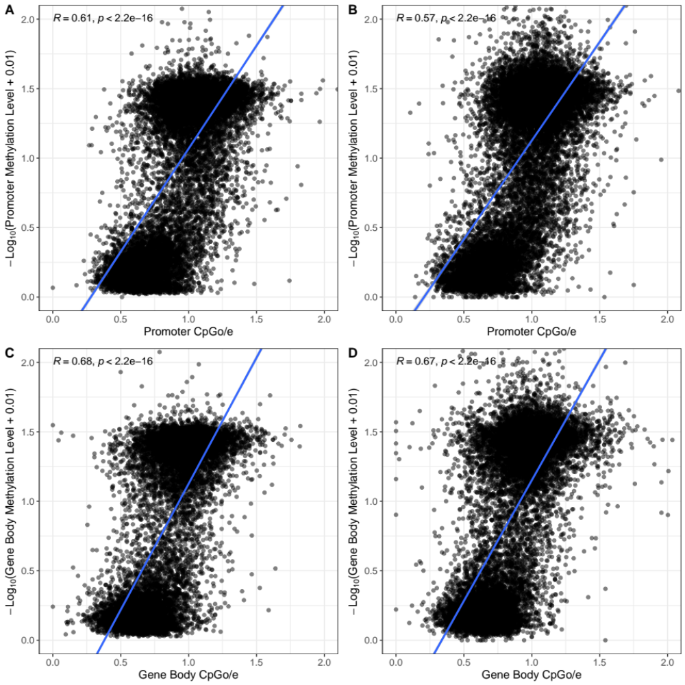
Figure S4. Spearman’s rho between CpGo/e and methylation levels. Comparison of promoter methylation and CpGo/e in (A) B and (B) Q. Comparison of gene body methylation and CpGo/e in (C) B and (D) Q.

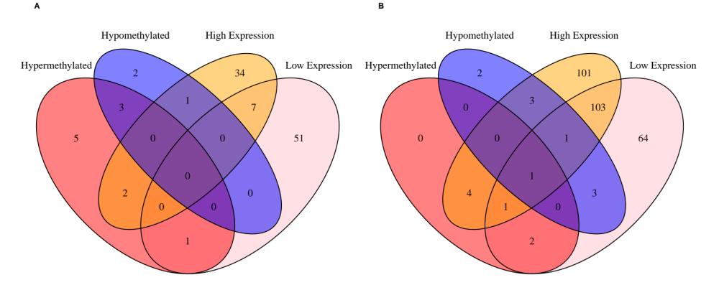
Figure S5. Venn diagrams of gene families within each cryptic species relating to the numbers of differential expressed genes (high expression and low expression) and differentially methylated genes (hypermethylated and hypomethylated). (A) B and (B) Q differentially methylated gene families compared to transcript derived differentially expressed genes.

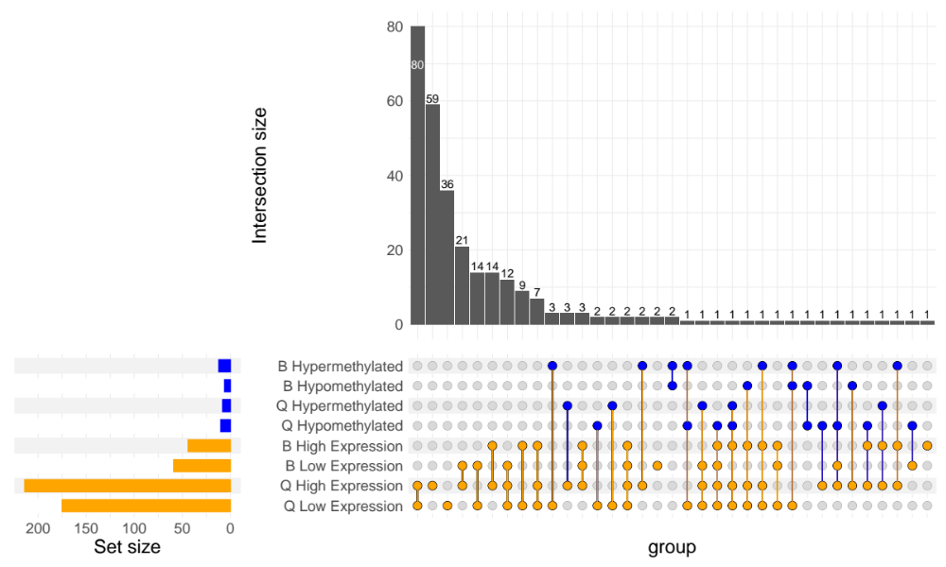
Figure S6. Upset plot of gene families within B and Q relating to the numbers of differential expressed genes (high expression and low expression) and differentially methylated genes (hypermethylated and hypomethylated).

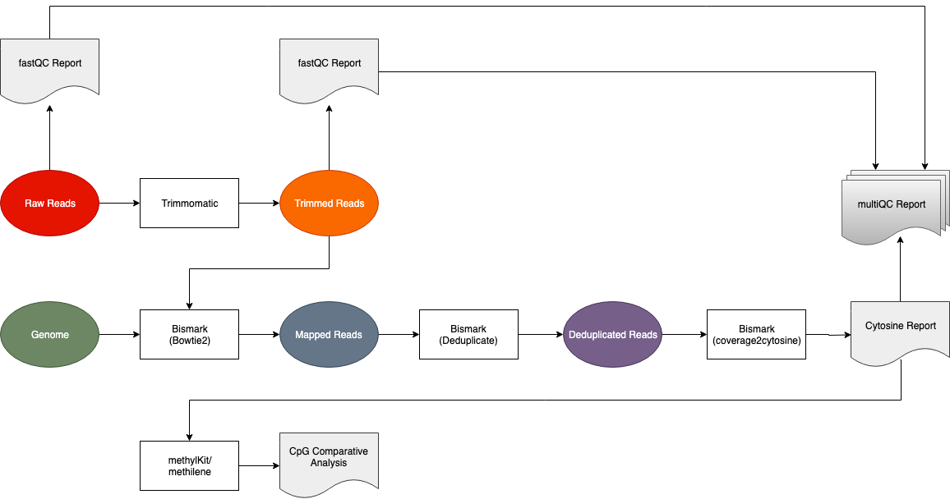
Figure S7. Bioinformatics pipeline for processing bisulfite converted sequences. B and Q reads were mapped to the respective genome.

Table S1. Counts of transposable elements from the B and Q genome assemblies.
TE annotation | B | Q
CACTA TIR transposon | 1,513 | 1,640
Copia LTR retrotransposon | 46 | 63
Gypsy LTR retrotransposon | 94 | 97
HAT TIR transposon | 10,334 | 10,391
helitron | 498 | 415
LTR retrotransposon | 193 | 246
Mutator TIR transposon | 1,461 | 1,931
PIF Harbinger TIR transposon | 212 | 200
Tc1 Mariner TIR transposon | 69 | 64

Table S2. Methylation patterns of transposable elements in the B genome. See Additional file 2.
Table S3. Methylation patterns of transposable elements in the Q genome. See Additional file 2.
Table S4. CpGo/e of the coding sequences in B genome. See Additional file 3.
Table S5. CpGo/e of the coding sequences in Q genome. See Additional file 3.
Table S6. Differentially methylated regions found within the B genome. See Additional file 4.
Table S7. Differentially methylated regions found within the Q genome. See Additional file 4.
Table S8. Differentially methylated regions with annotations found within the B genome. See Additional file 4.
Table S9. Differentially methylated regions with annotations found within the Q genome. See Additional file 4.
Table S10. Transcript expression statistics in the B genome. See Additional file 5.
Table S11. Transcript expression statistics in the Q genome. See Additional file 5.
Table S12. Differential exon usage in the B genome. See Additional file 5.
Table S13. Differential exon usage in the Q genome. See Additional file 5.
Table S14. Methylation compared to differential expression and alternative splicing events in the B genome. See Additional file 5.
Table S15. Methylation compared to differential expression and alternative splicing events in Q genome. See Additional file 5.
Table S16. Alignment statistics of orthologous genes detected between B and Q. See Additional file 5.
Table S17. B and Q orthologous gene family clusters between the differentially methylated and transcript differential expression. See Additional file 5.

Table S18. Read alignment of sequences from non-infected and TYLCV-infected samples to the B genome.
ID | Sequence pairs analyzed in total | Number of paired-end alignments with a unique best hit | Mapping efficiency | Percent deduplicated
BC1 | 73,988,392 | 35,132,312 | 47.5% | 83.1%
BC2 | 74,174,172 | 34,458,873 | 46.5% | 83.8%
BC3 | 71,576,564 | 32,791,596 | 45.8% | 82.4%
BC4 | 72,066322 | 33,869,793 | 47.0% | 82.0%
BC6 | 75,869,517 | 35,104,189 | 46.3% | 83.7%
BV1 | 71,942,050 | 33,314,594 | 46.3% | 81.8%
BV2 | 74,275,916 | 34,263,050 | 46.1% | 79.5%
BV3 | 72,266,872 | 34,970,387 | 48.4% | 79.9%
BV4 | 74,213,834 | 33,351,468 | 44.9% | 81.7%
BV5 | 73,985,566 | 35,051,302 | 47.4% | 81.6%

Table S19. Read alignment of sequences from non-infected and TYLCV-infected samples to the Q genome.
ID | Sequence pairs analyzed in total | Number of paired-end alignments with a unique best hit | Mapping efficiency | Percent deduplicated
QC1 | 73,857,679 | 23,687,306 | 32.1% | 82.0%
QC2 | 69,627,706 | 20,334,958 | 29.2% | 81.6%
QC3 | 74,393,629 | 22,084,114 | 29.7% | 81.2%
QC4 | 71,010,135 | 19,498,248 | 27.5% | 82.3%
QC5 | 75,185,708 | 23,978,055 | 31.9% | 81.1%
QV1 | 75,775,299 | 22,132,159 | 29.2% | 82.0%
QV2 | 70,183,130 | 21,552,895 | 29.1% | 82.9%
QV3 | 75,608,576 | 22,021,104 | 29.1% | 83.1%
QV4 | 72,731,434 | 21,142,005 | 29.1% | 83.2%
QV5 | 79,938,274 | 25,045,045 | 31.3% | 79.8%

Table S20. Total number of methylated cytosine found within the B genome for noninfected (BC) and TYLCV-infected (BV) samples.
Sample | meth chg | meth chh | meth cpg | percent chg meth | percent chh meth | percent cpg meth | total c | unmeth chg | unmeth chh | unmeth cpg
BC1 | 8495244 | 38265606 | 31450688 | 3.4 | 4.1 | 10.5 | 1485715910 | 240780784 | 897276761 | 269446827
BC2 | 8933585 | 39807674 | 30059710 | 3.5 | 4.2 | 9.5 | 1527684478 | 247667718 | 913308277 | 287907514
BC3 | 8403541 | 37063079 | 27665832 | 3.5 | 4.2 | 9.1 | 1429211234 | 232498056 | 848738637 | 274842089
BC4 | 8412607 | 37239611 | 29464348 | 3.5 | 4.2 | 9.9 | 1418299167 | 232108154 | 842915873 | 268158574
BC6 | 8904454 | 39940525 | 31772414 | 3.5 | 4.2 | 10.2 | 1531390364 | 247954713 | 921908235 | 280910023
BV1 | 8126020 | 36326950 | 28979714 | 3.5 | 4.2 | 10.1 | 1388715882 | 225649144 | 832728835 | 256905219
BV2 | 7500975 | 34030237 | 31966238 | 3.2 | 3.9 | 11.8 | 1385277187 | 223849033 | 849795920 | 238134784
BV3 | 8365391 | 37138667 | 30043674 | 3.4 | 4.1 | 10.1 | 1447782528 | 235146392 | 870069265 | 267019139
BV4 | 8285569 | 36907529 | 29554277 | 3.4 | 4.1 | 10 | 1436185792 | 233047669 | 862838498 | 265552250
BV5 | 8669431 | 38701470 | 31060960 | 3.5 | 4.1 | 10.2 | 1491896977 | 241685563 | 898494444 | 273285109

Table S21. Total number of methylated cytosine found within the Q genome for noninfected (QC) and TYLCV-infected (QV) samples.
Sample | meth chg | meth chh | meth cpg | percent chg meth | percent chh meth | percent cpg meth | total c | unmeth chg | unmeth chh | unmeth cpg
QC1 | 5269619 | 23523486 | 22520233 | 3.1 | 3.6 | 11.4 | 1012230348 | 164054613 | 621814880 | 175047517
QC2 | 4548475 | 20643248 | 19032907 | 3.2 | 3.9 | 11.5 | 835295730 | 136234421 | 508468353 | 146368326
QC3 | 4680690 | 21048368 | 21250021 | 3.1 | 3.6 | 12 | 911232521 | 148527770 | 559340413 | 156385259
QC4 | 4386612 | 19966534 | 18554615 | 3.1 | 3.7 | 11.3 | 838216287 | 136104644 | 513289607 | 145914275
QC5 | 5162503 | 23072586 | 21759316 | 3.1 | 3.6 | 11 | 1004758909 | 163137956 | 615595550 | 176030998
QV1 | 5507363 | 25156459 | 20355444 | 3.5 | 4.2 | 10.8 | 949443358 | 153144764 | 576562811 | 168716517
QV2 | 5302142 | 23887308 | 19574457 | 3.4 | 4.1 | 10.6 | 916458133 | 148622050 | 554105658 | 164966518
QV3 | 5608700 | 25384150 | 19390275 | 3.5 | 4.3 | 9.9 | 949083314 | 154627179 | 567324869 | 176748141
QV4 | 5013579 | 23065703 | 19966849 | 3.3 | 4 | 11.2 | 903903586 | 146492356 | 551513558 | 157851541
QV5 | 5408230 | 23916841 | 22784704 | 3.1 | 3.6 | 10.8 | 1056921179 | 171899293 | 644965061 | 187947050

